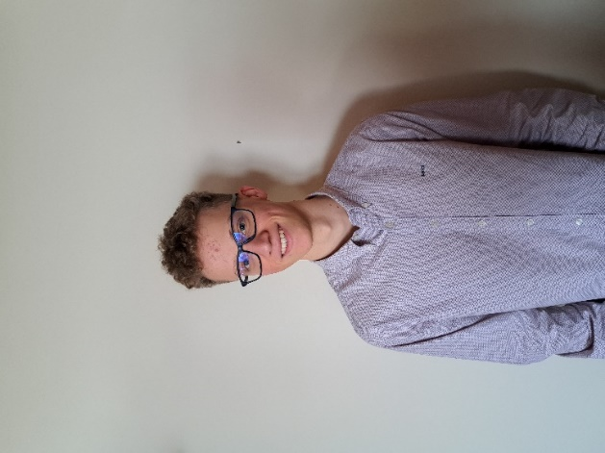**Personal Information**

* **Name:** Matteo De Moor
* **City:** Aalst
* **Email:** matteo.de.moor@skynet.be
* **Student Email:** matteo.demoor@student.hogent.be
* **Date of Birth:** 16/04/2004
* **Nationality:** Belgian

**Education**

* **Hogent, Aalst**  
  *2022 - Present*  
  Professional bachelor’s in applied computer science, 2nd Year AI & Data Engineering
* **DVM Humaniora, Aalst**  
  *2016 - 2022*  
  Sciences – Mathematics
* **Stedelijke Tinnenhoek School, Aalst**  
  *2015 – 2016*  
  Dactylo
* **Stedelijke Tinnenhoek School, Moorsel**  
  *2007 – 2016*  
  Primary Education

**Experience**

* **Bartender Barbaar (Middelkerke)**  
  *4 years*  
  student job
* **Shelf Stocker Spar (Middelkerke)**  
  *1 year*  
  student job

**Projects**

* **Personal website**  
  *https://github.com/MatteoDeMoor/MatteoDeMoor.github.io*  
  Independently designed and implemented my personal website. Utilizing HTML and CSS, I created a responsive and visually appealing platform that highlights my web development capabilities.
* **AI** **& Data Engineering project**  
  https://github.com/Robbevanherpe1/DEP1-2023-2024-groep30  
  As a key contributor to a collaborative AI & Data Engineering project, I leveraged advanced data analysis and machine learning techniques to solve complex problems.

**Language Proficiency**

* Dutch (Native)
* English (Proficient)
* French (Intermediate)
* German (Basic)

**Computer Skills**

* **Office:** Word, Excel, PowerPoint, Email
* **Programming Languages:** Python, Java, CSS, HTML, JavaScript, SQL
* **IDEs :** Visual Studio Code, Eclipse, IntelliJ
* **Virtualizations:** Oracle VM Virtual Box, Azure, Docker, AWS
* **Databases:** MySQL, SQL Server
* **OS:** Windows, Debian, Mint, Ubuntu

**Hobbies**

* Travelling
* Football
* Mountain Biking
* Fitness

**Skills**

* Accurate
* Stress-resistant
* Flexible
* Eager to Learn
* Teamwork