04/07/2017



In this document, we are going to present all the design solutions we came up with for the Hypermedia Applications course project. In the first part, we are going to use the IDM notation to describe how we decided to arrange all the contents, then we are going to describe the chosen scenarios. Finally, we show the pictures of our wireframes. We used Balsamiq Mockups 3 as our prototyping tool.

Matteo Marziali (826475)

Matteo.marziali@mail.polimi.it

Xhimi Hypi (827580)

xhimi.hypi@mail.polimi.it

Mirko Mantovani (831922)

mirko.mantovani@mail.polimi.it

Hypermedia applications

Design Document

Sommario

**IDM schemas2**

C-IDM2

C-IDM comments3

L-IDM4

L-IDM comments5

P-IDM6

P-IDM comments7

**Scenarios8**

First scenario8

Second scenario9

Third scenario10

**Wireframes11**

C-IDM

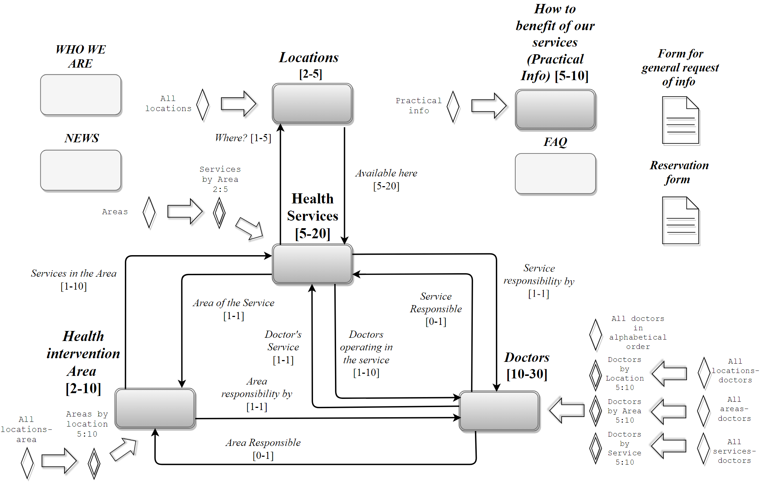

**C-IDM comments:**

The C-IDM is pretty standard as it accurately follows the specification given. One thing that needs to be mentioned is how we decided to represent the “specials”: we introduced the following notation for forms



because it reminds the actual appearance of a page in which you put information rather than a page that shows content.

L-IDM

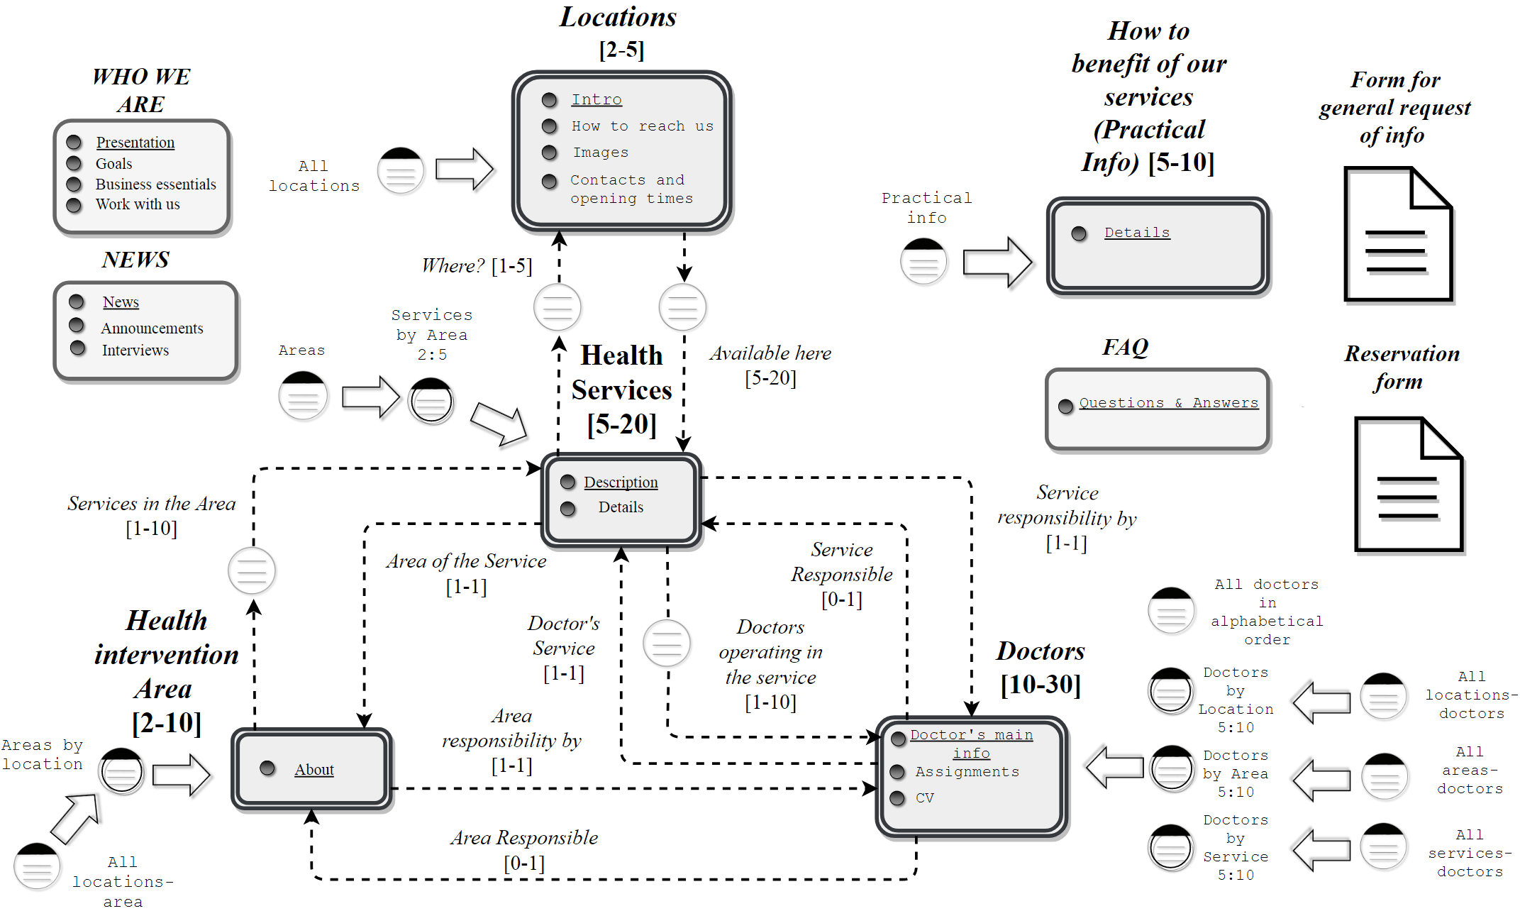

**L-IDM comments:**

We followed the general rules and translated the C-IDM schema into the L-IDM schema without any relevant adjustment, in fact we kept almost the same object notation for the forms. We decided here to put for each relation that has a max-cardinality greater than 1 a Transition Dialogue Act because we thought that at this level, thinking about the need for an intermediate page between two topics was premature, so we postponed this issue later on the P-IDM section.

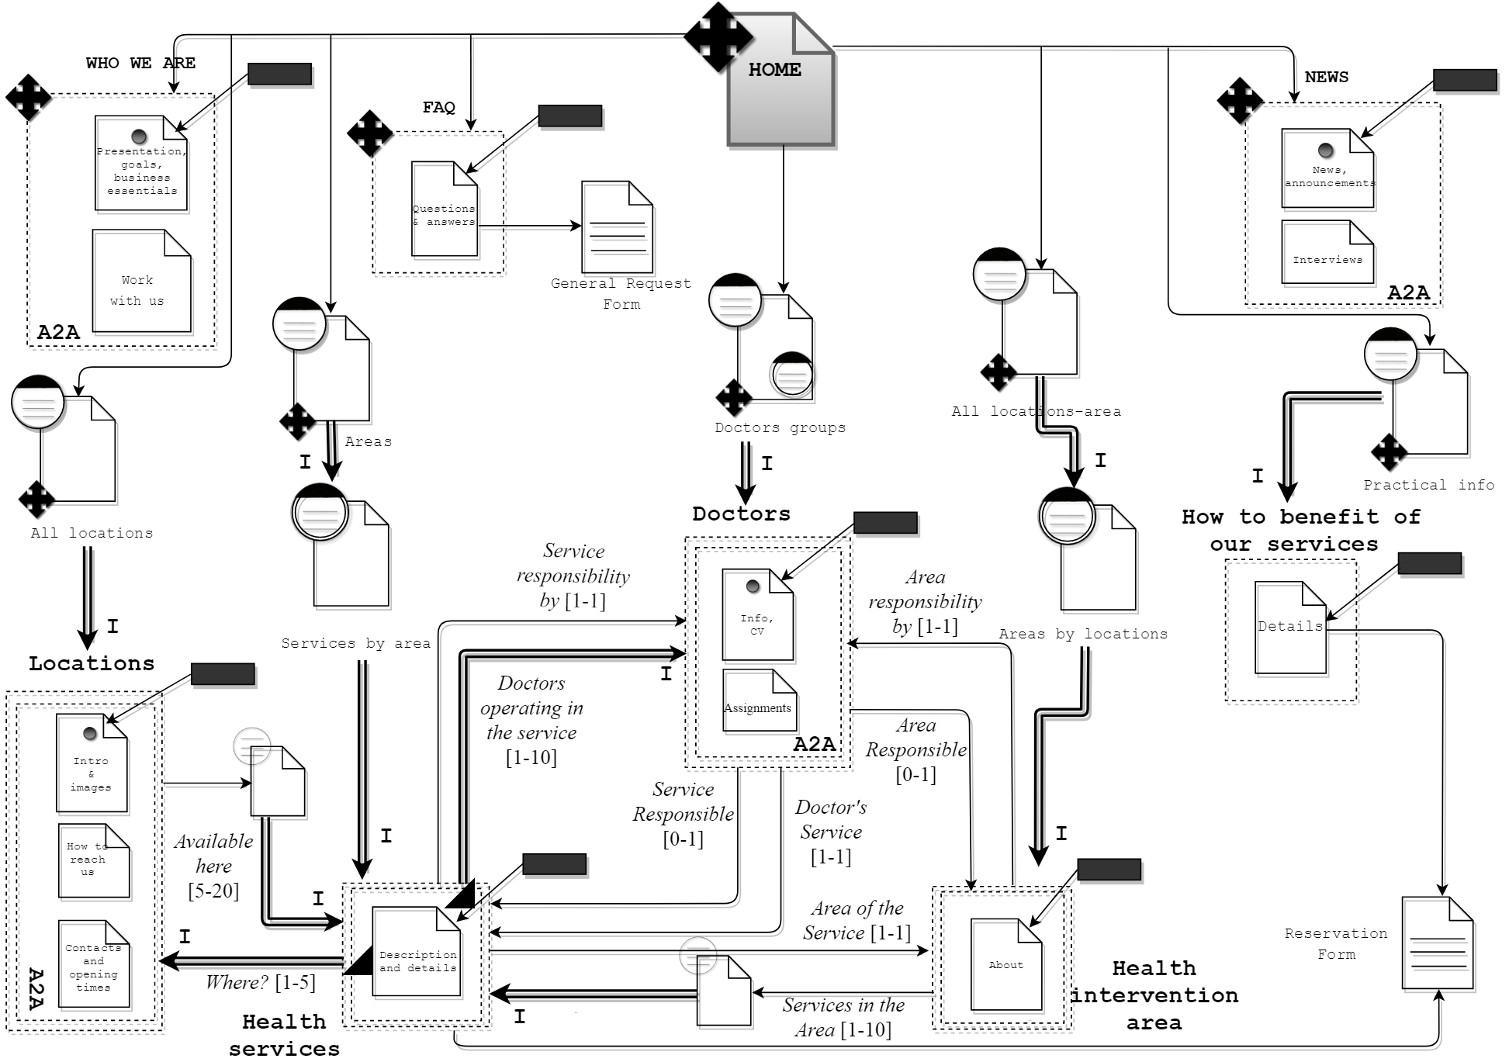

P-IDM

**P-IDM comments:**

In these section we translated the L-IDM schema into the P-IDM schema without special adjustments too. The object notation for the forms is the same but we now decided to relate each form with all the pages in which the related form is accessible, trying to be consistent with the P-IDM notation purposes. An important thing we agreed is to avoid putting a Transition Page for each Transition Dialogue Act defined in the L-IDM schema. We are talking about the “Where?”and “Doctors operating in the service” relations: for the first one, the low cardinality suggested us not to put a Transition Page, while for the second our arguments were more about the semantic of the page rather than the mere syntactic translation of L-IDM schema. We thought that a doctor list inside a specific service was definitely more coherent with the topic itself rather than having it on a separate page. The last design solution we want to mention is the merge of the Introductory Dialogue Acts related to the “Doctors” topic: in this case the great number of these acts suggested us to merge them all in order to convey a neater sense of navigation and not to overload the user with many way to group the doctors.

Scenarios

**Scenario one:**

A student, who doesn’t have large economic means, is trying to find a new clinic that will take care of his teeth, since his current dentist asked for a huge amount of money for an ordinary service. Bumping into the MJM clinic while surfing the internet, the student finds out that this could be what he’s searching for, he notices the clinic offers big tax relief for students, and that he can benefit of an additional discount, living near enough to the clinic (**Practical info** ->**Who can benefit of our services and facilitations**).

The second operation he’s interested to do is to check if there’s a dentist in the small location of his town, to do so, the student clicks on the landmark link: **Doctors** and then choosesthe group **Doctors by location,** he selects the right location (**Segrate**) and writes down the only few doctors there are. After he goes back to the **Doctors Group** page using the orientation info and he accesses the group **Doctors by area** selecting the area **Odontology** and he immediately spots one of the previous doctors (**Kaniel Outis**).

He then tries to determine whether the doctor is available for an appointment this weekend in the doctor page and then in the **FAQs** (landmark). Not finding anything he decides to compile and send the **form for general request of info** (link from the FAQs page) asking for an answer to this question.

**Scenario two:**

A Doctor who wants to find a job, comes to know from his mother’s friend about the MJM clinic and decides to visit the clinic website. Firstly he tries to find out the goals and the purposes of MJM company by reading the **Who we are** page.

After that he looks for the **locations** where he could work at, due to his medical specialization. He surfs in this part of the website to answer to these questions: Are there workplaces near my house? Where these places are in the map and how I can reach them? What kind of buildings and medical instruments have this clinic? Thinking about **Segrate** as the perfect location for him, he clicks on the related image, bumps in that specific location page and looks for the information about **how** **to** **reach** that location.

Finally he goes in the **news** section with the intention to learn something more about the MJM clinic and through a recent article about the opening of a staff recruitments period, bumps into a “**work with us**” redirection link, where he opens **job opportunities** and he applies uploading his CV.

**Scenario three:**

The scenario that I’m about to present deals with a user who has already signed up for the MJM clinic website and who wants to set up an appointment with the physiotherapist for a specific service. At first the user will just log-in using the specific section that can be reached by clicking the “log-in button”, present on the right-top part of most of the pages, accessing to the login area and then entering his credentials. (**login “button” -> login area**)

With that being done, the user will look for the area of interest, which in this case is physiotherapy, by searching it among all the health service areas, listed in the group **Services provided** that can be reached from a landmark link. Once he finds the one that affects his concerns (**Physiotherapy**), he will have to select that particular service in the **Service by area** list (the specific service is “**functional bandages**”).

After that he will find the page about the **Description and the details** of the service and especially he will find a list of all the doctors that provides the service “functional bandages”. There he will be able to find the nearest doctor, which is **Sara Gibson** and get to the page about the **Doctor** where he can finally get all the information and contacts to finally set up the appointment by visiting **reservations** inthe **Practical info** section.

Wireframes:

## (Please see the relative documents for comments on the low-fidelity wireframes)

