07/05/2017



Matteo Marziali (826475)

matteo.marziali@mail.polimi.it

Xhimi Hypi (827580)

xhimi.hypi@mail.polimi.it

Mirko Mantovani (831922)

mirko.mantovani@mail.polimi.it

This document is a short evaluation of TIM website, made by identifying three surfing scenarios, which are analyzed through some heuristics about content, navigation, visual, semiotic and cognitive aspects. The evaluation is accompanied by some screenshots and links of the pages where we found the biggest problems.

Hypermedia applications

Usability Exercise

Summary

* Introduction…………………………………………………………pag.2
* Evaluation Table……………………………………………….pag.3
* Scenario one…………………………………………………...pag.5
* Scenario two……………………………………………………pag.6
* Scenario three………………………………………………….pag.7
* Problems detected & screenshots - Scenario one………pag.8
* Problems detected & screenshots - Scenario one………pag.11
* Problems detected & screenshots - Scenario one………pag.15

Introduction

TIM website is the subject of our analysis. Considering the huge dimension of the whole site we defined three scenarios in order to reduce the target of the evaluation by simulating a limited number of surf actions made by an actor for each scenario. In a specific scenario, all the members of the group gave a mark for a sub-set of heuristics, in order to create a final table with average values and provide a realistic evaluation of the site.

Scenarios

**Scenario one:**

This scenario is about a rich uncle who is trying to find some presents for his nephews.

He starts his exploration of the TIM website in the homepage, where he notices some offers in evidence.

Not satisfied he continues his visit navigating through “**PRODOTTI**” -> “**Smartphone e telefoni**” where he opens some cell phones and decides to buy a P9, when he tries to add the product in the cart he finds out there’s no clue on how to do that so he writes down the specific model in order to be able to come back later and buy it with all the other items he is going to choose.

He then goes on opening another category of products: “**PRODOTTI**” -> “**Tablet e computer**” and again opens some products but he gets frustrated when he understands that no tablet can be bought online because there’s no “**Acquista**” option but just a mere “**Avvisami**” button, (Avvisami of what?). Persisting in the same category of products he thinks that maybe a computer should be better for his older nephew, but when he doesn’t find any in the category, that I recall is called “Tablet e **Computer**” he decides that maybe it would be better to do online shopping somewhere else.

**Scenario two:**

A customer cannot afford to buy a new tablet “all at once” so he decides to look for an offer in order to buy it in installments and he chooses TIM as the provider because he already has a TIM phone line.

At first he gets to the **HOMEPAGE** where he clicks “**OFFERTE**” and than he spots the section “**Mobile**” where it is said that, there, he will be able to find tablets and iPads in installments so he clicks “**Scopri**” in order to get to the offers list.

He thinks he will find a numerous list, so he tries at first to filter it, but he then realises that there are very few products on sale. So he is now interested in the iPad Pro 9.7” but for any unknown reason the number of installments is absent and, for this lack of information, he clicks on “**Dettagli**” and so he is led to the page of the iPad. There, he wants to know how much it would be to get a 256GB storage one and again he is not able to find how many installments and how much it is for each installment.

Anyway he is determinded to buy the iPad so he is going to ask directly the TIM staff in order to get that information, by contacting them by his own.

**Scenario three:**

A Dad whose family recently settled in Italy from the United States, is looking for an offer that provides both internet connection and a phone line to his house, and eventually mobile services.

He chooses the national company of communication services: TIM.

Firstly he goes in the section “**OFFERTE**” and selects “**Fisso + Mobile**” to find out the best offer for him. The prices are too high so he goes back to “**OFFERTE**” and visits the page “**Fisso**”, where he analyzes the whole offers pack.

The next step is to find a mobile offer for his daughter, so he switches from the page “**Fisso**” to the page “**Mobile**”, and he opens some offers to make comparisons and to choose the best one for him.

Finally, the Dad wants to satisfy his Son’s request about the chance to watch on TV some films and sport events provided with paid subscriptions so he surfs in the section “**OFFERTE**” -> “**TV** **&** **Entertaiment**”.

Problems detected & Screenshots

**Scenario one:**

1. In the homepage under the first big landscape image there are four main rectangles displaying offers, this presents many inconsistencies and problems:

* The first three have a button named “**Scopri**”, the last one “**Ti chiamiamo gratis**” and has different content.
* If you click on the second one the button “**Scopri**” opens the link automatically in another Tab, the other three in the same Tab.
* The last two rectangles present problems of visibility, they’re transparent and their texts results to be overlying on an image, sometimes with similar colors, this makes the reading very difficult.

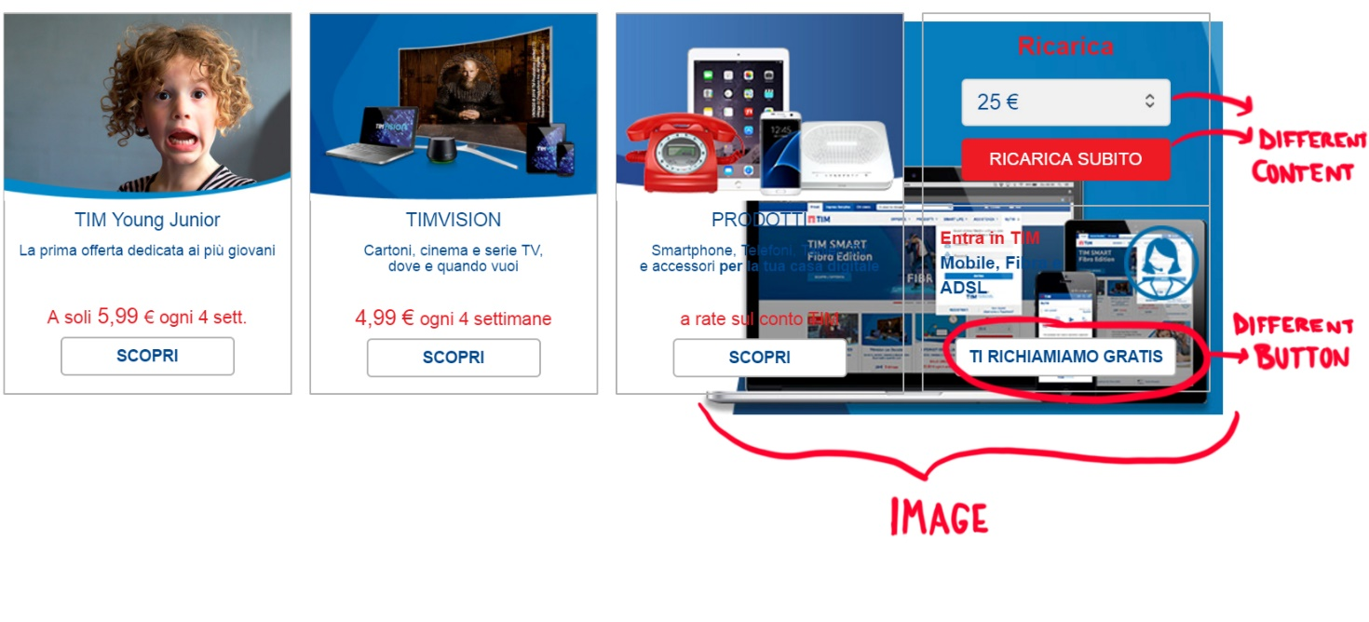

1. Going in “PRODOTTI” -> “Tablet e computer” and choosing an iPad to buy, the page displays a button that says “AVVISAMI” without an explanation on what is it it’s going to alert you on. The page should provide information stating that the product is currently finished, and that you can receive an alert when it will be available again.

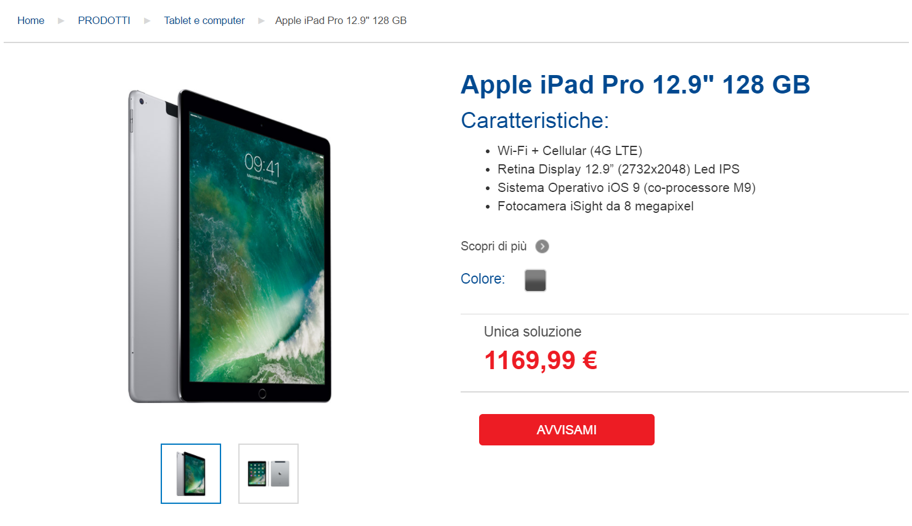

1. Going in “**PRODOTTI**” -> “**Smartphone** **e** **telefoni**”, choosing a cell phone and then looking for a way to pay, it can be noticed another inconsistency:

[https://www.tim.it/prodotti/smartphone-e-telefoni/huawei- p9#section4](https://www.tim.it/prodotti/smartphone-e-telefoni/huawei-%20%20p9#section4)

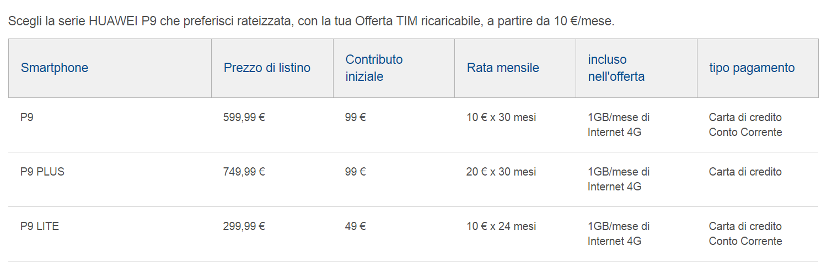

How is it possible to add thing in the Cart? There’s a cart but you can’t put things inside.

1. Good **segmentation** in products:

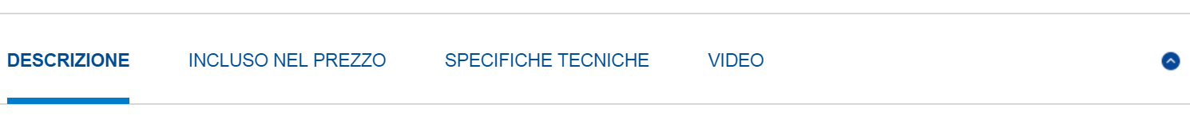

Different conventions for orientation info in products:

<https://www.tim.it/prodotti/smartphone-e-telefoni?N=1473316359>



<https://www.tim.it/prodotti/smartphone-e-telefoni/huawei-p9>

**Scenario two:**

In the main pages related to the third scenario detected, there can be easily found many evident mistakes:

1. In the “MOBILE” section of the “OFFERTE” menu, there are three sub-sections with a button “SCOPRI” inside and some information about the offer related. As shown in Screenshot 1, the third button is half the button height off upwards and by watching it carefully, it can be noticed that spaces are not equally divided to display the information. The same happens to the content itself: it is shown in different position with respect to the frame that contains it. Thus, this content arrangement is a clear example of visual inconsistency, and more specifically a MiLE heuristic “Icon inconsistency”.

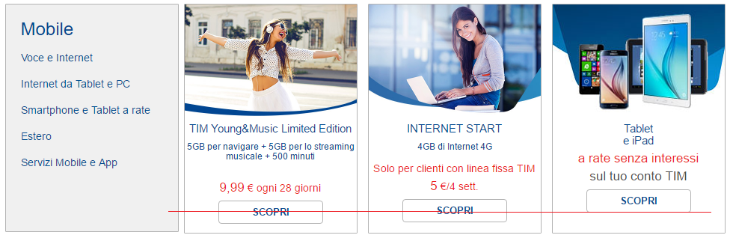 Screenshot 1: icon inconsistency of the SCOPRI buttons and the content

1. The second issue that I’d like to point up is about the filter tab located on the left of the page that shows the list of the products available. At first in the “Tipologia” section, right above “Prezzo” there is a symbol “>>”. If you click on it, the filter options list unfolds and many other options are shown to the user (Screenshot 2).

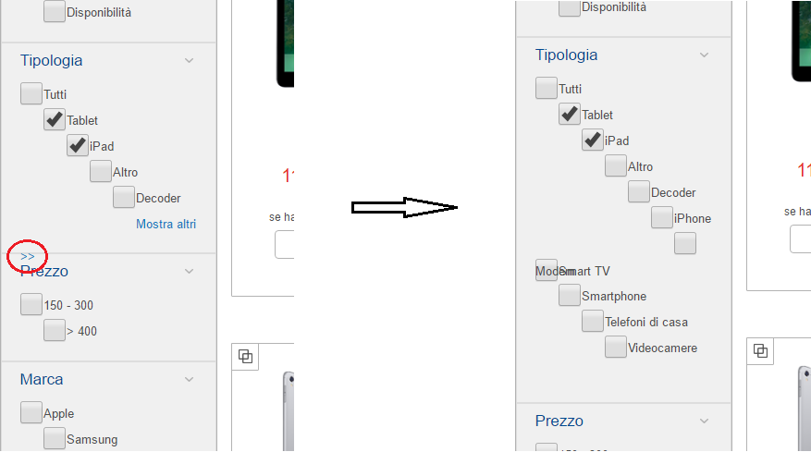

Screenshot2:

Visual proximity issues. The symbol ”>>” is referred to “Tipologia” but is visually located on the “Prezzo” section on the left, and on the right, the entry “Modem” doesn’t have its checkbox and the string overlaps with “Smart TV” check box and string.

There are a lot of issues related to this tab:

first, the “>>” symbol is presented without any clue to guess the meaning of it, in a position that is totally inconsistent with its actual effect. In fact, what it does is to show more filtering options in the “Tipologia” section, so it has the exact same meaning as the “Mostra altri” link and this is a redundancy. After that the complete list shows up, among the first things that jump out we can find the fact that there is not a way to hide the added options back. After that another evident issue is how the options are arranged in their containers: they are listed in a diagonal pattern, that (at least IMO) conveys a disorganized and confusing structure of the list. The striking example of this problem is the overlap of the “Modem” (that is what I guess it is written) option and the “SmartTV” one. In addition, for the “Modem” option there is no checkbox, so there is no need to have it as an option.

Another thing that can annoy the user is the fact you can’t check the “SmartTV” checkbox, unless you click right few pixels above the “Modem” string.

Due to all these particularities, MiLE Heuristic “Visual proximity” is not used in the most appropriate way for the filter tab which however isn’t the most significant part of the semantic of the site.

1. If a user wants to know how many installments he has to pay in order to get an “Apple iPad pro 9.7”, as can be seen in the Screenshot 3, he can’t notice it directly from the list as it happens for all the other products, but he must navigate to the topic page related to the product.

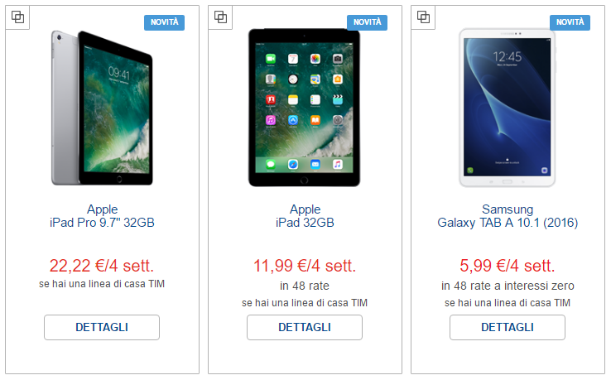

Screenshot 3:

The ipad pro presents a lack of information, because it isn’t shown the number of installments as it is for the other two products

Once there the 32GB ipad page shows the number of installments, but the 128 GB and 256 GB version still lack of this kind of information and so the only way to get the information he needs is to directly contact TIM.

(iPad Pro 9, 128 GB): <https://www.tim.it/prodotti/tablet-e-computer/apple-ipad-pro-9-128-gb>

The problem related to this case is the content consistency among all the products.

1. The last one I want to mention is about the orientation clue: clicking on “OFFERTE” and than through the “MOBILE” section I get to the topic page about the product and I get the following orientation path:



As it can be easily noticed that path is totally different from the real path followed.

This has the drawback to make a website mental map hard to be done for the user who, as a direct consequence, can get easily disoriented.

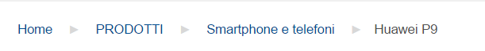

**Scenario three:**

1. In the section “OFFERTE” there are four links: FISSO, FISSO + MOBILE, MOBILE, TV & ENTERTAIMENT. If you open the link FISSO + MOBILE (page on the left) the page layout is totally different from the page layout of the three other links (e.g. FISSO on the right), this is an example of link inconsistence.

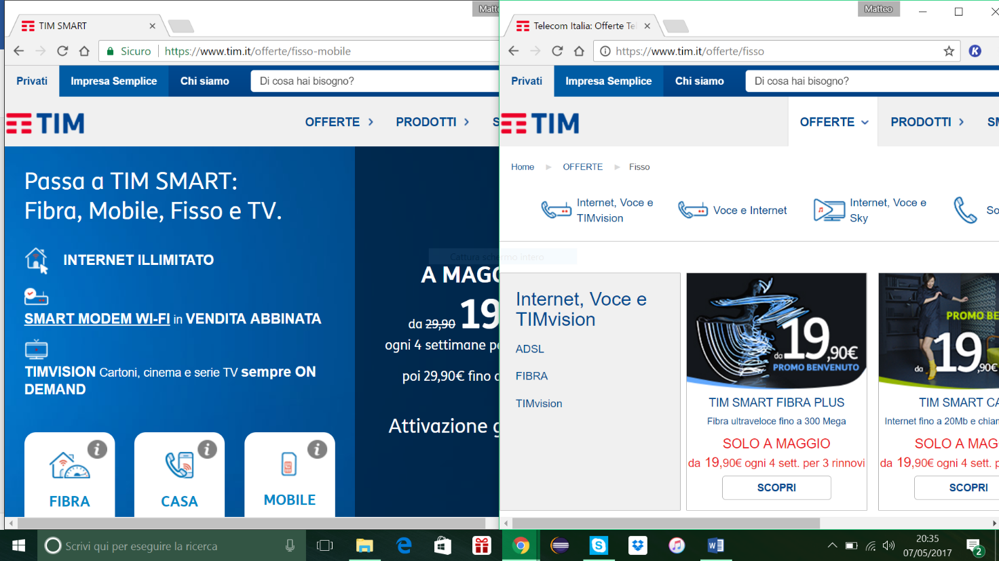

1. There is a chromatic inconsistence between the page “Mobile” and “TV & Entertainment” in section “OFFERTE” about the “Scopri” buttons, blue in “TV & Entertainment” page (on the right) and white in the other one (on the left).

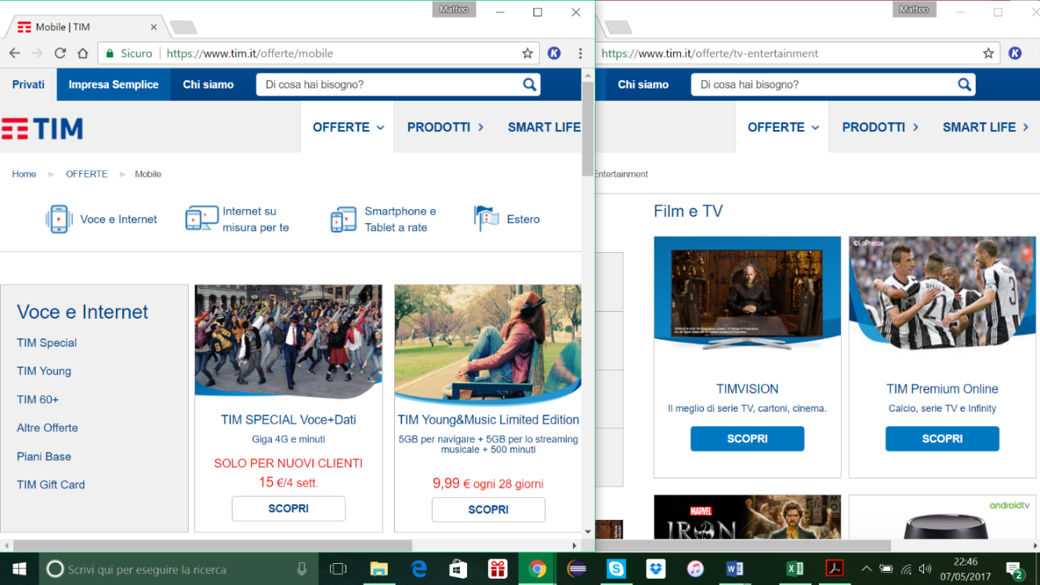

1. The orientation clues – topic heuristic is violated in the page “**Fisso + Mobile**” in the section “**OFFERTE**” where the orientation info is absent.

<https://www.tim.it/offerte/fisso-mobile>

1. The site is unavailable in languages different from Italian!!
2. In the whole “OFFERTE” section the “go back” button is not present, the Heuristic with the same name is severely violated.