Best parameters found:

{'activation': 'tanh', 'alpha': 0.5, 'hidden_layer_sizes': (19, 30, 30, 2), 'learning_rate': 'constant', 'solver': 'sgd'}

MSE test = 83.33788117609956

MSE train = 77.87441220994876)

1 2

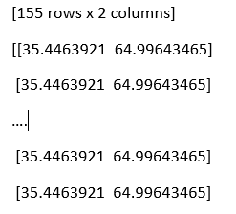370 35.5 64.5

609 44 56

402 36.5 63.5

15 17 83

722 48 52

.. ... ...

474 39 61

484 39.5 60.5

223 30 70

589 43 57

574 42.5 57.5

Best parameters found:

{'activation': 'logistic', 'alpha': 0.0001, 'hidden_layer_sizes': (19, 50, 2), 'learning_rate': 'adaptive', 'solver': 'sgd'}

MSE test = 83.26566851495903,

MSE train = 77.80792433935008)

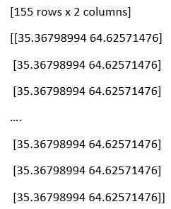 1 2

370 35.5 64.5

609 44 56

402 36.5 63.5

15 17 83

722 48 52

.. ... ...

474 39 61

484 39.5 60.5

223 30 70

589 43 57

574 42.5 57.5

Best parameters found:

{'activation': 'relu', 'alpha': 0.5, 'hidden_layer_sizes': (19, 20, 2), 'learning_rate': 'constant', 'solver': 'adam'}

MSE test = 167.77652465556142

MSE train = 85.37491770600927

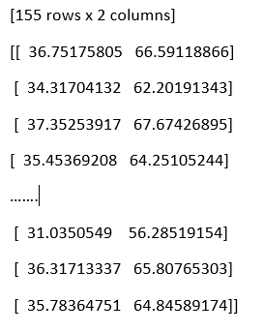 1 2

370 35.5 64.5

609 44 56

402 36.5 63.5

15 17 83

722 48 52

.. ... ...

474 39 61

484 39.5 60.5

223 30 70

589 43 57

574 42.5 57.5