

SCHOOL OF COMPUTER SCIENCES
UNIVERSITI SAINS MALAYSIA

CPC351/CPM351 Principles of Data Analytics
Academic Session: Semester 1, 2025/2026

Assignment 1
Group:G20
Associate Professor Dr. Wong Li Pei

NAME | MATRIC NUMBER
LIN WEI | 23101733
OOI PEI YEN | 22305434
MATTEO THIOUNN | BB9489

6. Sudoku puzzle
The program in this part is designed to check the feasibility of a 12 by 12 Sudoku puzzle. The puzzle is composed of digits 1 through 9 and letters A, B, C. Each symbol must occur only once in each row, each column, and each block of 3 by 4. For that, the table() function is useful, it takes a vector and outputs each symbols found in the vector and how many time they occur. So we create the find_duplicates() function to check and return each duplicate found from a given vector. Using this function we create 3 new ones that separate the rows, columns and blocks (as vectors), returning the violations found. With that a last function validate the Sudoku and print each violation if not.

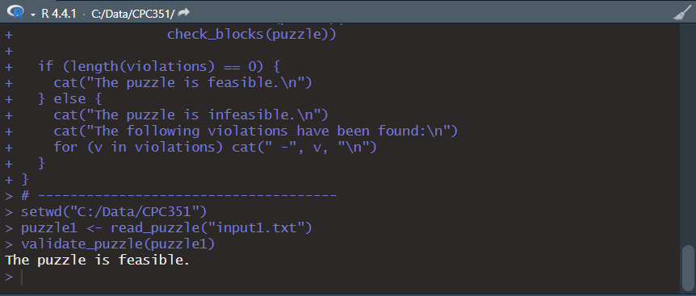
Output of the 1st puzzle
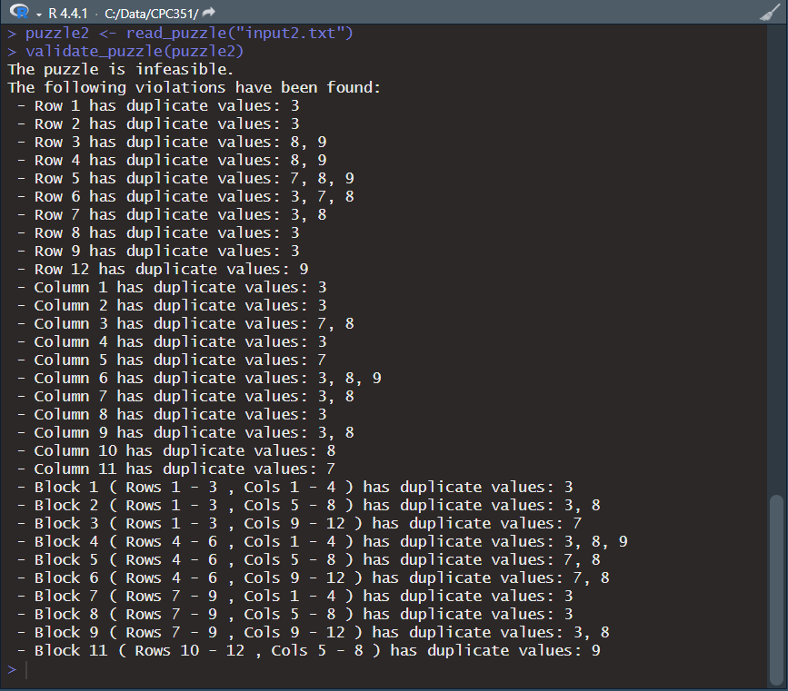
Output of the 2nd puzzle

