MATSim Tutorial

*Turn off McAfee Virus Scanning (right-click “M” symbol on lower-right corner of desktop->Quick Settings->On-Access Virus Scanning - off) before attempting to run MATSim, or any other programs. Click “yes” if a pop-up appears and requests access. It speeds up the process dramatically.*

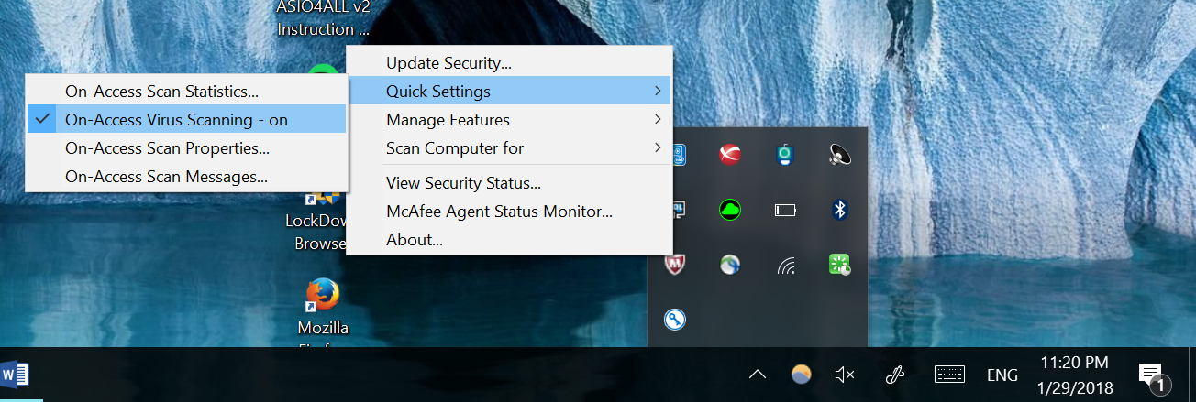

Step 0: Download MATSim

To use MATSim ourselves, we must have a copy downloaded first. The .zip file is available on the MATSim website, and the link is below:

<https://github.com/matsim-org/matsim/releases/download/matsim-0.9.0/matsim-0.9.0.zip>

Simply unzip the files, and install the program as instructed.

When completed, navigate to the “matsim-0.9.0” folder. It should look something like this:

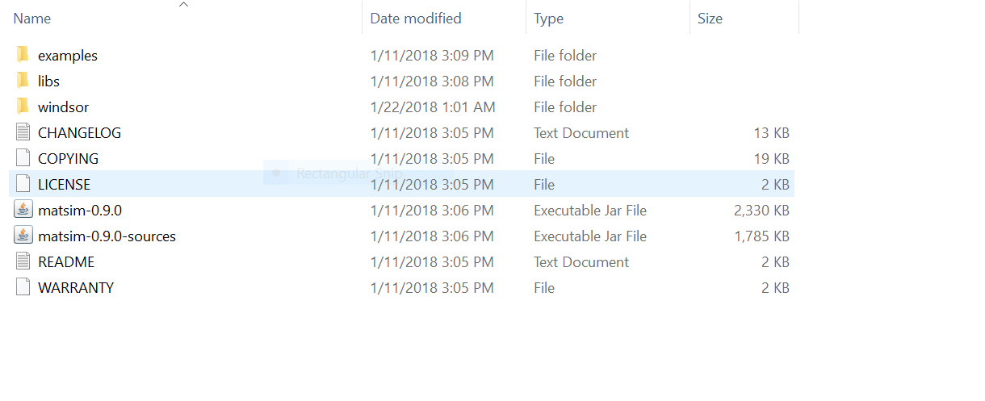

Step 1: Test MATSim, generate events.xml file

In the folder shown above, open the matsim-0.9.0 Executable Jar File. (For your convenience, consider pinning the program to the Start Menu or taskbar.) Make sure to disable McAfee (instructions on top), and the file should open, displaying a simple user interface shown below:

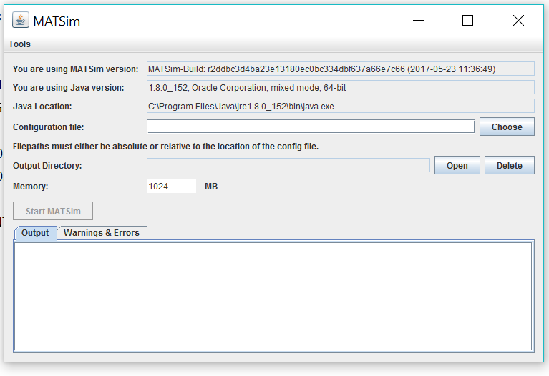

If the Java version/Java location are slightly different it should be fine. Memory can be adjusted, but I felt that it did not change performance significantly.

We do not know how to write config files yet, so we will use a provided example. There are quite a few examples in the “examples” folder. I used the config.xml file from the “berlin” folder, shown below:

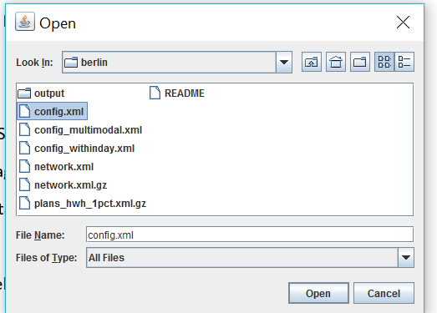

After running MATSim, it should generate an “output” folder. In our “berlin” example, the folder is below:

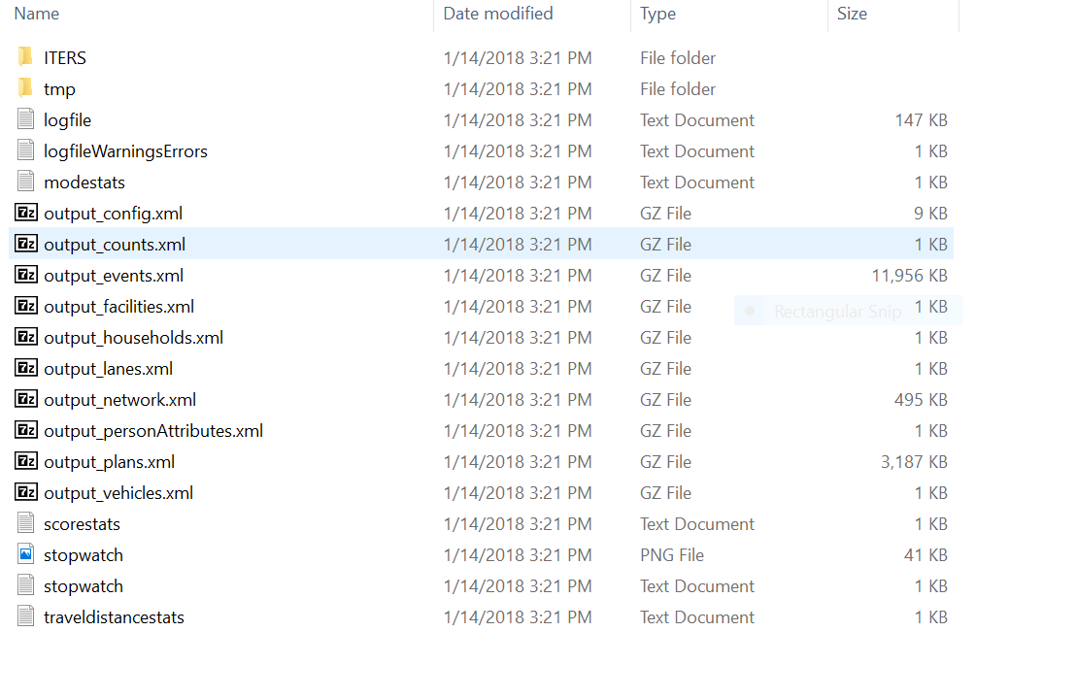

Of all these files, the output_events.xml.gz file is the one we are most interested in. We shall use it below in Via.

Step 2: Install Via

Via is a software used to visualize MATSim results. Downloads are available on their website, link below:

<https://via.senozon.com/download/file/via-win64.zip>

As with MATSim, unzip the file and install it as you choose.

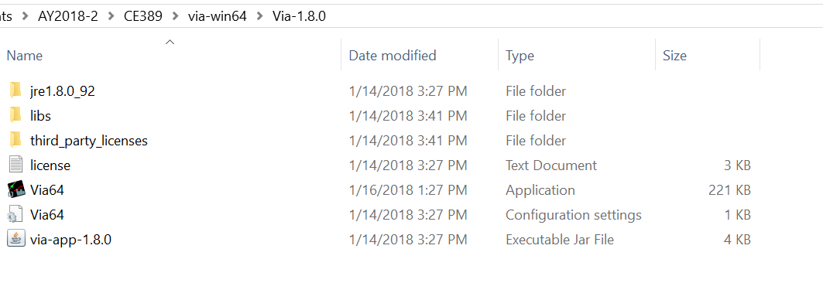

Navigate to the “Via-1.8.0” folder, as shown above, and open the Via64 application. Again, you may pin the Application to your start menu or taskbar, for convenience.

Step 3: Run simulation in MATSim

To visualize results in MATSim, we need a network.xml file (the one selected below, not the .gz file) and the output_events.xml.gz file (which we generated in step 1). We import these files, using the “+” button shown below. Make sure the console is in “Data Sources” layer.

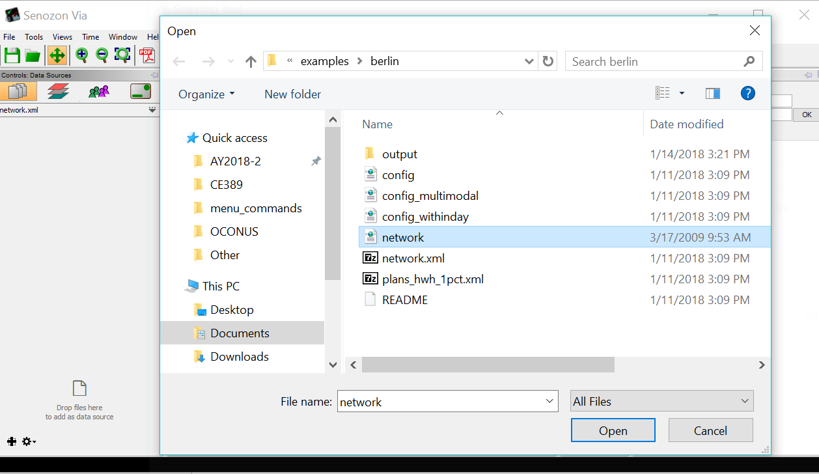

After importing these files, navigate to the “Layers” screen in Via to start visualizing our files. Again, use the “+” button to add layers. Change the background color if black is hard to see.

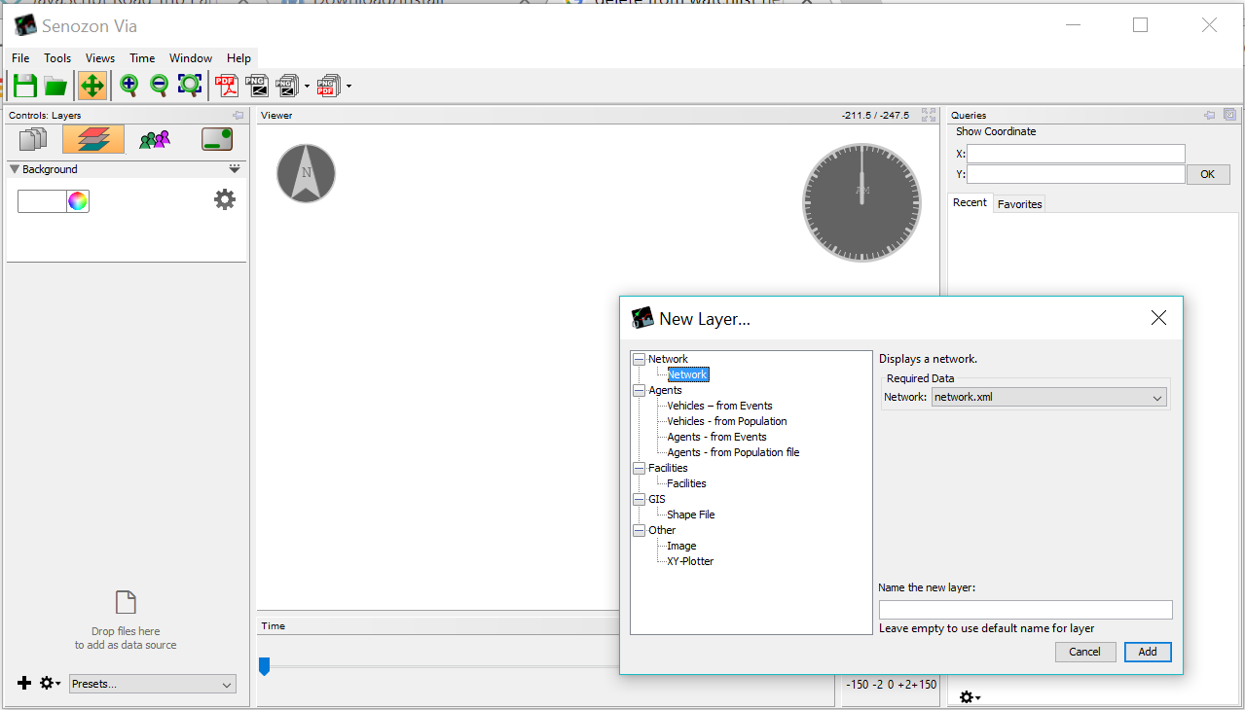

From “Network”, add the network from the network.xml file. From Agents, add “Vehicles –from Events” and “Agents –from Events” to the layers. Make sure to click the “Load Data” button, and the map should automatically populate itself.

*Since this is the free version of Via, only first 500 vehicles, agents displayed*

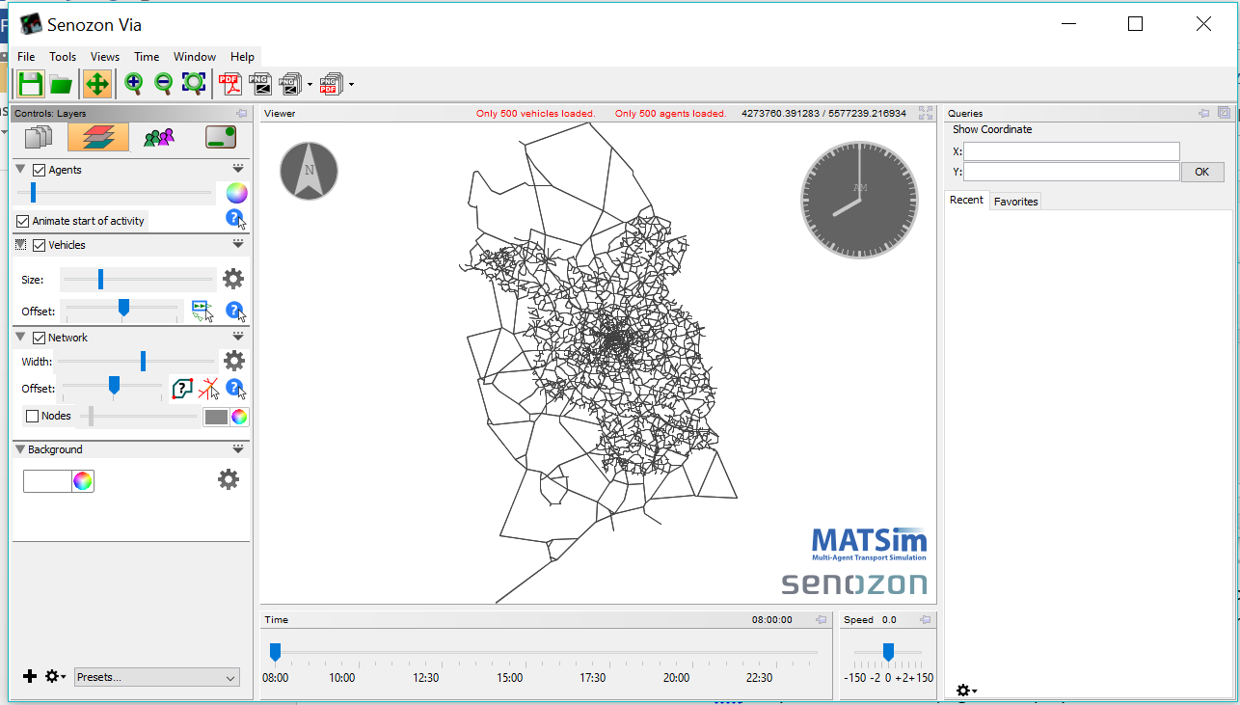

Notice that nothing is changing on the screen. That is because the speed is set to 0! As shown above, you can adjust it and the map will spring to life. You may save the results as a PDF, or PNG files using the buttons at the top of the screen.

Step 4: Generating custom network.xml files

Though looking at others’ projects are cool, we should try to create our own network for a project. A great software to generate custom maps is JOSM (Java Open Street Map), which now has a MATSim plugin. Again, I recommend creating a shortcut or pinning the app somewhere for future convenience.

The JOSM software can be downloaded at: <https://josm.openstreetmap.de/>

The MATSim (and other) plugins can be downloaded at: <https://josm.openstreetmap.de/wiki/Help/Preferences/Plugins>

Opening up JOSM, you should see an interface like this:

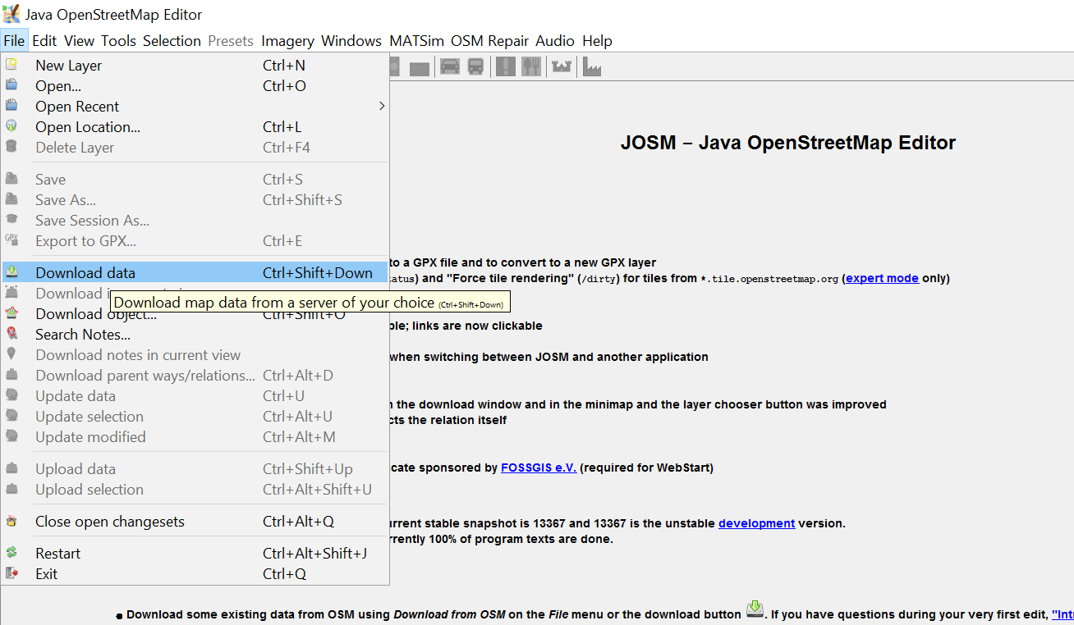

Using the “Download data” option in “File”, search for a proper city boundary (such as New Windsor). Import the data.

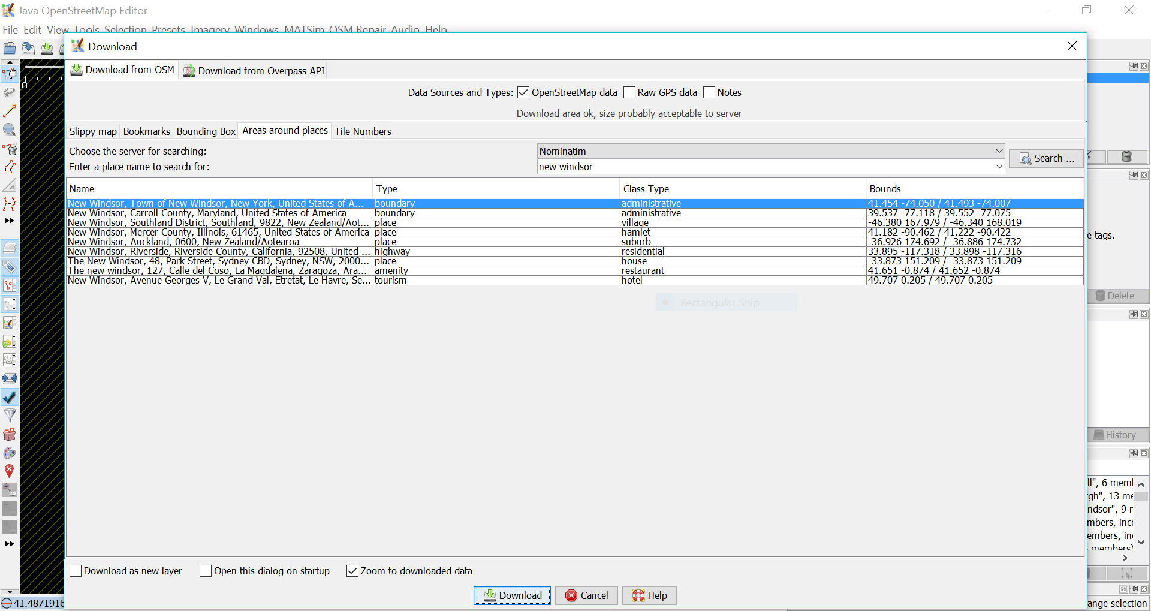

Next, go to the MATSim tab and click “Convert”.

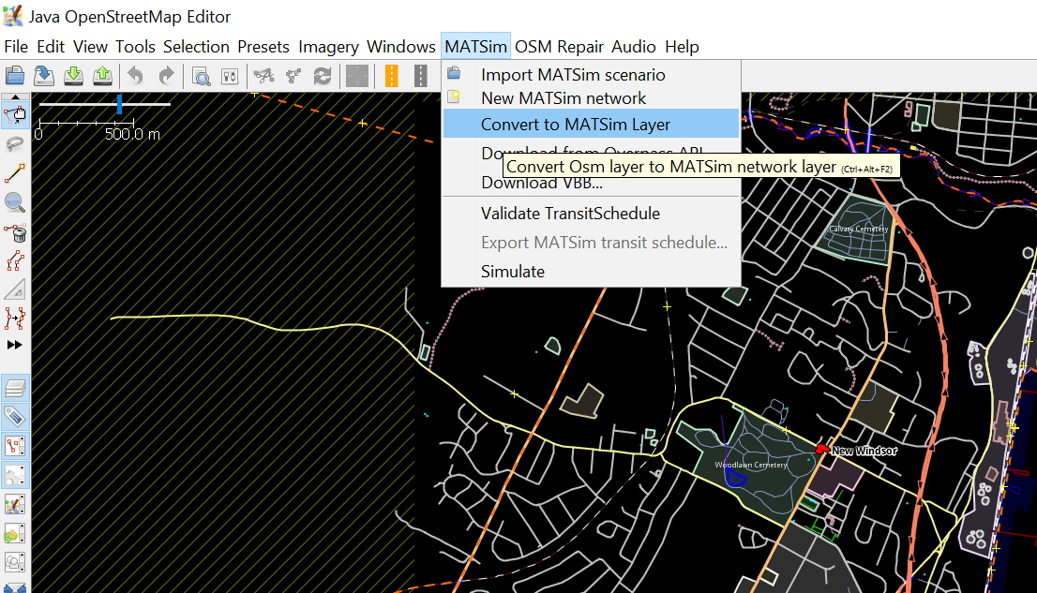

The Network file should be much simpler by now. Click “Save As” and create your .xml file. Open your file in Via, following previous instructions, and you should have your own network in Via!

