WSYZ –LAB3 PD

Mateusz Ostaszewski 325203

# I

## A

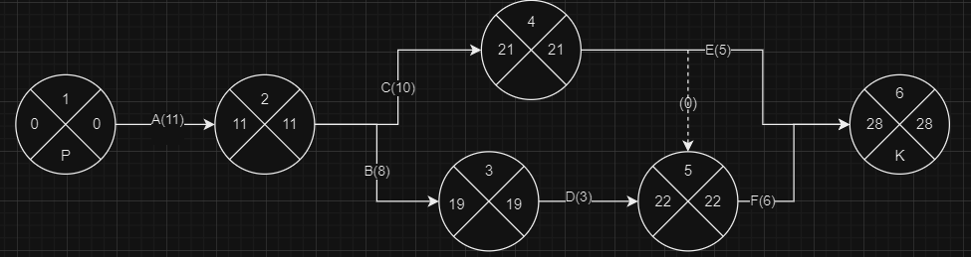

## B

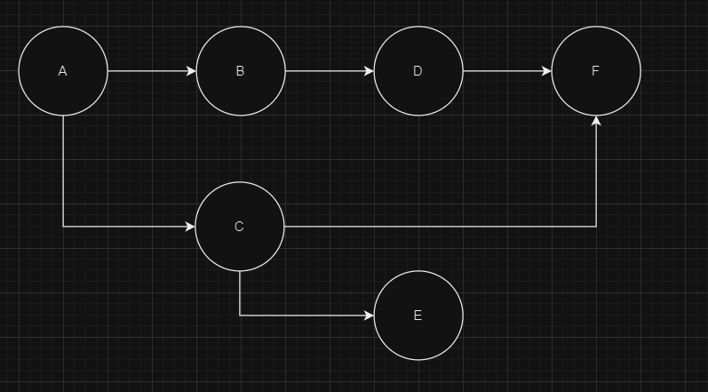

# II

## A

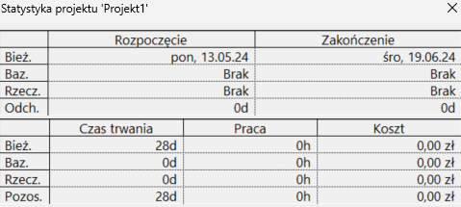

28 Dni

## B

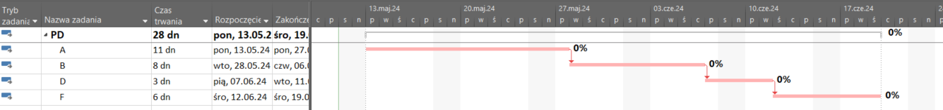

A->B->D->F

## C

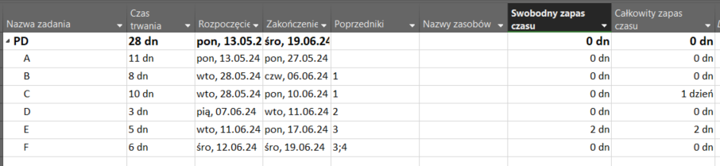

## D

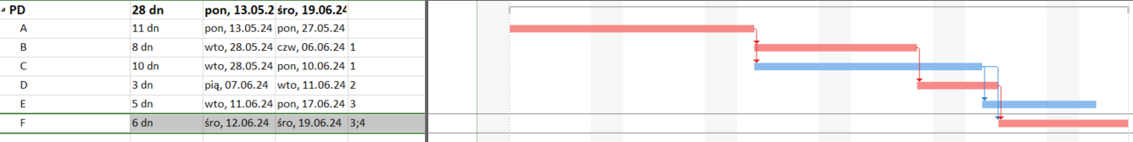

A->C->E: 11 + 10 + 5 = 26

A->C->F: 11 + 10 + 6 = 27

A->B->D->F: 11 + 8 + 3 + 6 = 28

## E

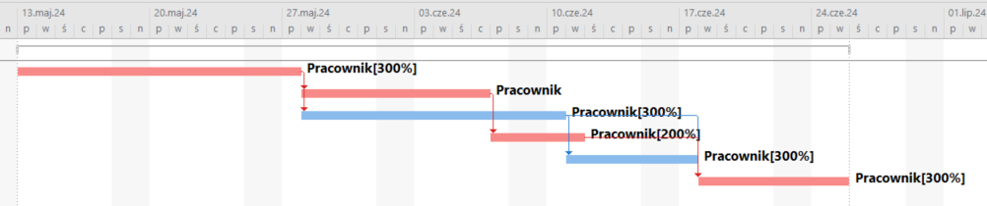

## F

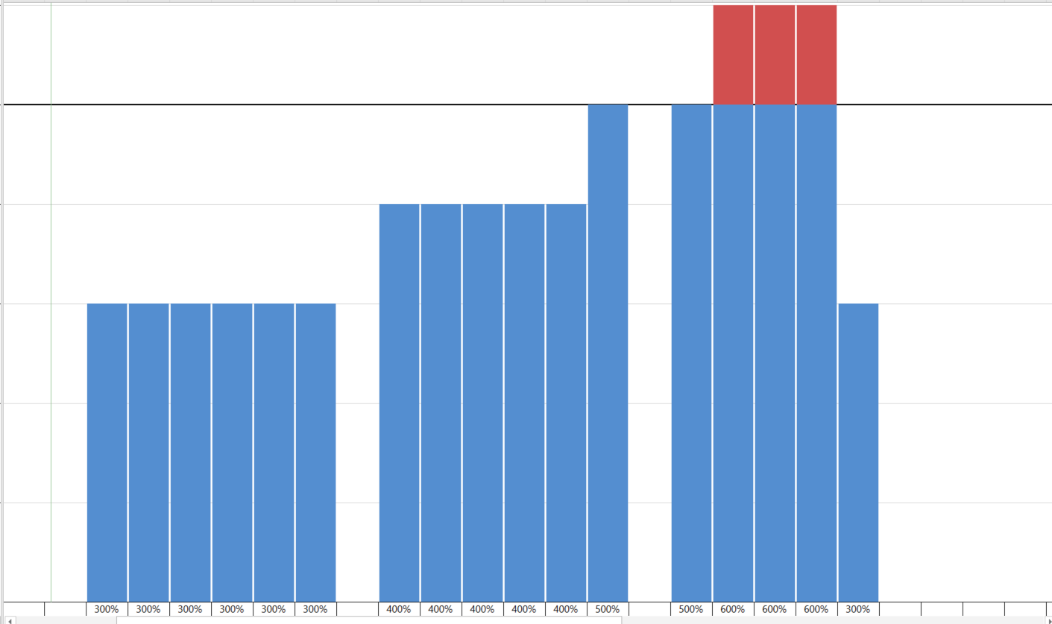

## G

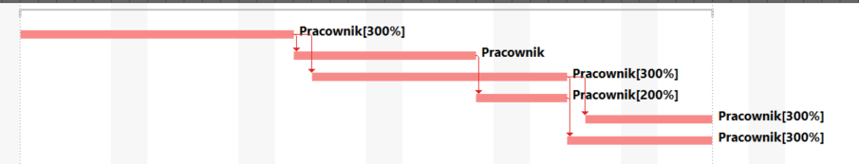

# III

