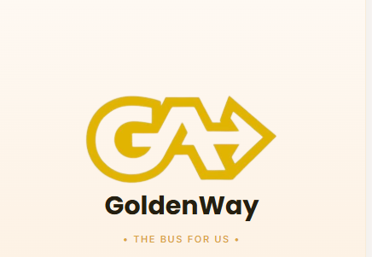
Brand & Design Guide
The Bus For Us
Prepared for academic presentation
GoldenWay Mobile Commuter App

Brand Overview
GoldenWay is a mobile commuter application designed to make daily bus travel simple, transparent, and dignified. The brand identity draws on the visual language of Golden Arrow Bus Services — the gold-and-black palette signals reliability and civic familiarity, while the arrow motif in the logo communicates forward motion and punctuality.
The product spans account creation, live trip tracking, fare/pass management, contactless card use, ride history, and profile management. Across every screen, the interface commits to one consistent set of tokens: colour, type, spacing, and component shape — so the app reads as a single considered system rather than a patchwork of screens.

Brand Attributes
- Reliable — consistent visual patterns build trust the way a punctual bus service does.
- Warm — cream backgrounds and rounded shapes soften what could be a purely transactional utility app.
- Clear — high-contrast ink-on-cream text, generous spacing, and minimal ornamentation prioritise legibility.
- Premium-accessible — gold accents and soft gradients suggest quality without alienating an everyday, mass-transit audience.

Logo & Wordmark
The GoldenWay mark pairs a bold circular “GA” monogram with a forward-pointing arrow, rendered in Gold 400/500. The wordmark uses the display typeface in solid ink, with the tagline “The Bus For Us” set in small gold caps beneath it. The logo should always sit on a light (cream or white) background for full contrast.

Colour System
The palette is built as a small token set rather than a broad swatch library, which keeps every screen visually related. Gold carries primary actions and brand moments; cream carries surfaces and structure; ink and slate carry text; navy is reserved for premium/secure contexts (payment cards, dark banners).
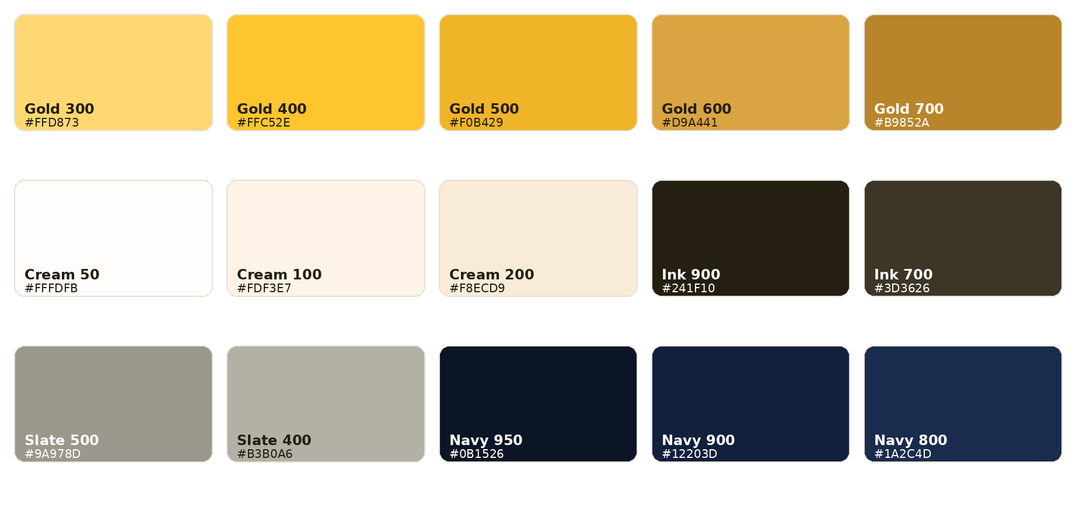

Usage Guidelines
- Gold 400–500: primary buttons, active states, brand highlights, the pass/card surface.
- Gold 600–700: hover/pressed states and small accent text (e.g. “View All” links).
- Cream 50–200: page backgrounds, card surfaces, input fields — never pure white, to keep warmth.
- Ink 900/700: primary and secondary text — never pure black, for a softer contrast with cream.
- Slate 400–500: placeholder text, timestamps, de-emphasised metadata.
- Navy 800–950: the physical card/pass surface and any “secure” or premium banner treatment.
- Semantic colours (emerald for success/verified, red for destructive actions like logout or deactivation) are used sparingly and only for status or risk, never decoratively.

Typography
Two typefaces carry the entire interface. Poppins (display) is used for headings, screen titles, prices, and anything that needs presence. Inter (body) is used for everything read at length — labels, descriptions, form values.

Type Scale
Style | Sample | Size / Weight | Usage
Display XL | Ready for your trip? | 13pt / Bold | Screen headlines
Display L | Your Details | 12pt / Bold | Section / card titles
Body Semibold | John Doe | 11pt / Semibold | Names, key values
Body | Gold Member since 2022 | 10pt / Regular | Descriptions, labels
Caption | PERSONAL IDENTITY | 9pt / Semibold | Eyebrow / section labels

Font Pairing Rule
Poppins never appears in long-form body copy, and Inter never carries a screen title. This split keeps the hierarchy scannable at a glance — a user should be able to tell a heading from a value without reading it.

Core Components
Every screen in GoldenWay is assembled from the same small component vocabulary. Reusing these exact shapes and spacings — rather than styling each screen independently — is what makes the app feel like one product.

Buttons
- Primary: gold gradient (Gold 400 → Gold 500), fully rounded corners, bold ink text, soft gold drop-shadow. Used for the single most important action per screen (Sign Up, Next, Save Card).
- Secondary / Cancel: plain text, slate colour, no fill — always placed below the primary button, never beside it.
- Destructive: outlined in red, red text, no fill — reserved for Logout and account-risk actions.

Cards & Surfaces
- Info cards: Cream 100 fill, no border, generous internal padding (≈16–20px), rounded-2xl corners.
- Feature cards (Pass / GoldenWay Card): gold or navy gradient fill, white or ink text depending on contrast, used only for the one or two “hero” objects per screen (the pass, the payment card).
- Inputs: Cream 200 fill at 70% opacity, a hairline Gold 500 border at low opacity, switching to a solid Gold 500 border on focus — never a harsh black focus ring.

Status & Feedback
- Verified / success: emerald badge, small pill shape, uppercase micro-label.
- Warnings (e.g. Account Deactivation): red-tinted card, red icon and text, kept visually “quiet” relative to gold so it reads as caution, not alarm.
- Progress: a numbered 1–2–3 circle stepper for multi-step flows, with the completed step in dark gold, the active step in bright gold, and future steps in neutral cream-grey.

Motion
Transitions between phases (e.g. moving through the Update Profile steps) use a short opacity cross-fade rather than a slide or bounce — motion is used to smooth continuity, never to draw attention to itself.

Applied Screens
The tokens above are shown here in context, applied consistently from onboarding through to account management.
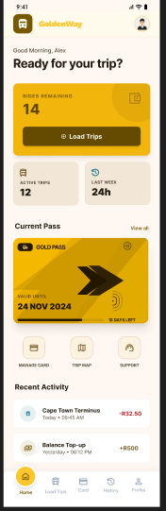
Home — primary dashboard, gold hero card for the active pass
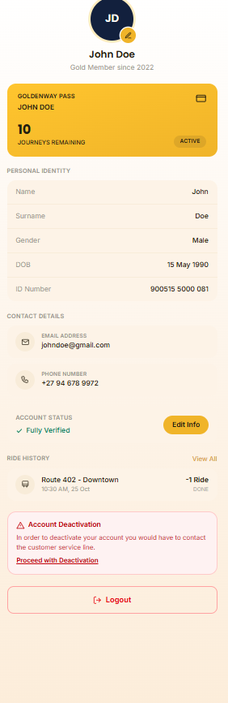
Profile — identity, contact, ride history, and account controls

