Matthew Bastianen
Professor Farah
UP 317
5 May 2026
How Old? The Economic Impacts of Housing Age in Chicago
Introduction
Chicago is a large city. Unlike other large cities, however, it has avoided the worst of the recent rent crisis, with rent only 44% higher than the national average (Cost of Living in Chicago, IL, 2025). Compared to NYC at 411% higher (Cost of Living in New York, NY, 2025) and LA at 135% higher (Cost of Living in Los Angeles, California, 2025), this is remarkably low. So, what is different about Chicago. How does Chicago maintain affordability where other large cities have?
There are many factors that influence affordability. However, popular anecdotes credit this lower rent to the oldest housing in Chicago – 2-3 story stone and brick flats, built primarily in the 1930s. This style of housing has proven to be extremely long-lasting and reliable. It defines the aesthetics of the neighborhoods around Chicago and is an often-cited example of “middle” housing.
“Middle” housing - or sometimes “missing middle” due to its rarity – is housing that lies between the density of single-family homes and apartment units. Conventional American development patterns discouraged this development from the suburban boom of the 1950s and onwards. This housing style shares both the cost of the structure and the land between multiple tenants, like apartments, while retaining the privacy and smaller-scale development of single-family living. This gives it an affordability advantage over single family development. However, nearing a century old, these structures now compete with modern housing on the market, and developers are keen on redeveloping these structures.
This begs the question: has the preservation of older housing really resulted in positive economic effects for the city? Are the flats still valuable nearly a century after they were built? How does the age of housing affect economic factors in Chicago?

Method
5-year ACS estimates from 2020-2024 were used to capture the modern rent hike while avoiding COVID-specific abnormalities and improving reliability of data. The data comes from tables B25034, which counts housing by decade, B25035, which shows the median age of housing, and B25111, which shows the average rent by age of housing, grouped by decade. Cook County data was filtered to Chicago and standardized the weight indices. There are 862 Census tracts in the final dataset. Only 2/3 had marked MOEs for median age, but all listed were reliable.
A major limitation of the data is that the minimum age for ACS data is 1939. This limits complete analysis of the data, as a significant amount of different housing is grouped together in this section. This is most visible on the scatterplots, where the number of observations under 1939 is extremely high compared to any other date.
Queen weights were used for this analysis, with an average of 6.48 neighbors per tract, shown in figure A. Chicago has no spatial islands, so Queen weights are appropriate. Housing age also has localized effects, so prioritizing those closest is advantageous. Testing was completed with Rook, 2-mile distance, and 5-nearest neighbors for robustness where appropriate.
Figure A
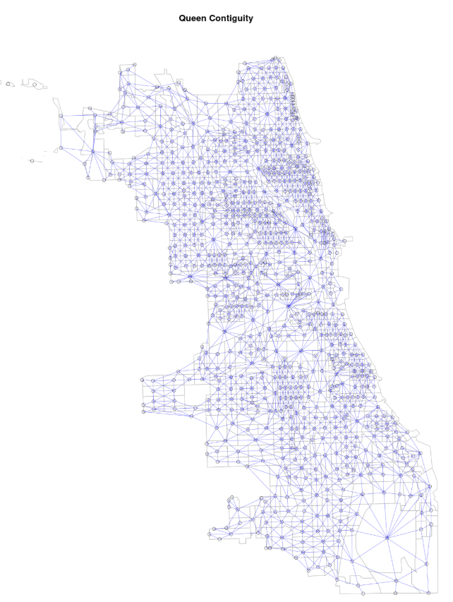

Non-Spatial Analysis
The earliest data analysis revealed that there was something worth researching. Figure B shows that Cook County (which Chicago makes the majority of) has significant amounts of pre-1939 housing. In fact, 28% of all housing in Chicago lies within this category, with a median housing age of 1954 across the whole city, compared to 1971 in Illinois and 1981 in the US. The largest outlier is a tract on the north side with a median age of 2014.
Figure B
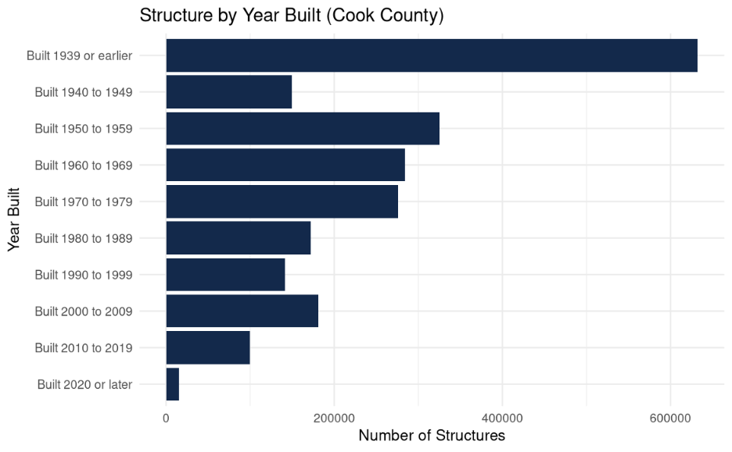 Figure C proves that older housing does have substantially lower rent than modern developments. This disproves a theory that the rent curve would be “U-shaped” - that is, the most expensive housing would be the oldest and the newest. This theory assumes that older housing would feature a combination of somehow being worth preserving or have received extensive renovations. Either factor would drive up the cost of renting in these older apartments, making both ends of the graph most expensive. Instead, the cost of rentals is borderline identical for housing built from pre-1939 until 1999.
Figure C
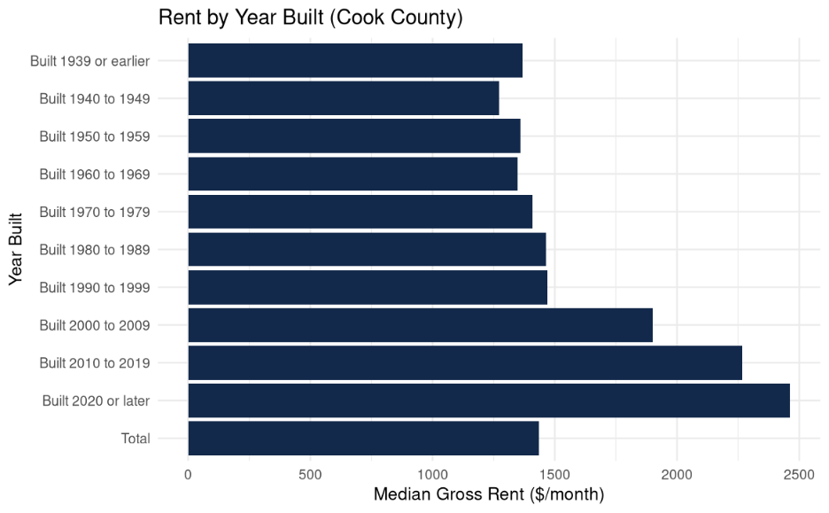
Going beyond reporting on existing data, multiple scatterplots with correlation lines were created. The first, shown in Figure D, compares housing age with poverty. With a p value of ~0 and a correlation value of –0.21, increasing housing age is weakly correlated with increasing poverty, but is statistically significant. This means that the poorest households tend to cluster in areas with old housing. Combining this outcome with Figure C, it is likely that this negative correlation is because of the lower rent.
Figure D
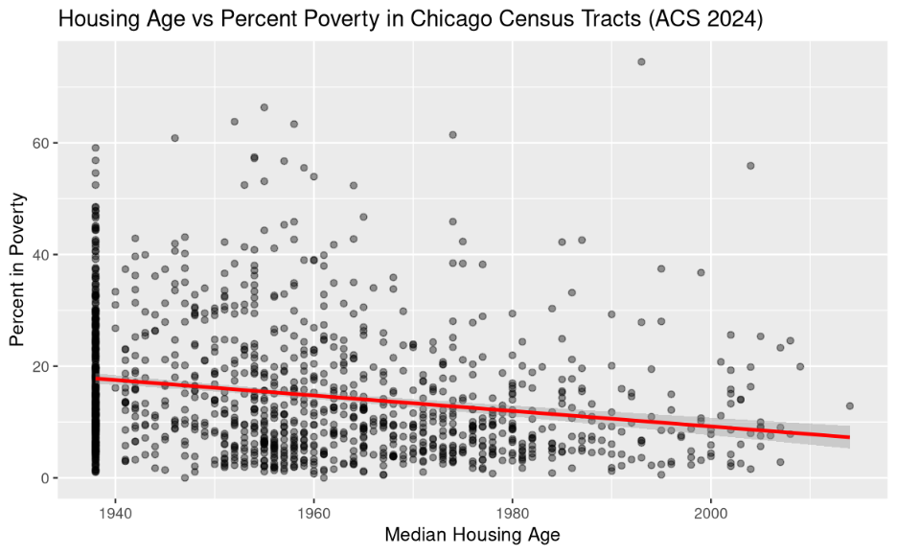 Figure E compares housing age with rates of extreme rent burden, or households spending over 50% of their income on rent. With a p value of ~0 and a correlation of –0.12, these are slightly negatively correlated. This result is unsurprising, as the households that are more impoverished (Figure D) are likely to also suffer from extreme rent burden. It does mean the older housing only provides limited relief from rent when compared to other factors.
Figure E
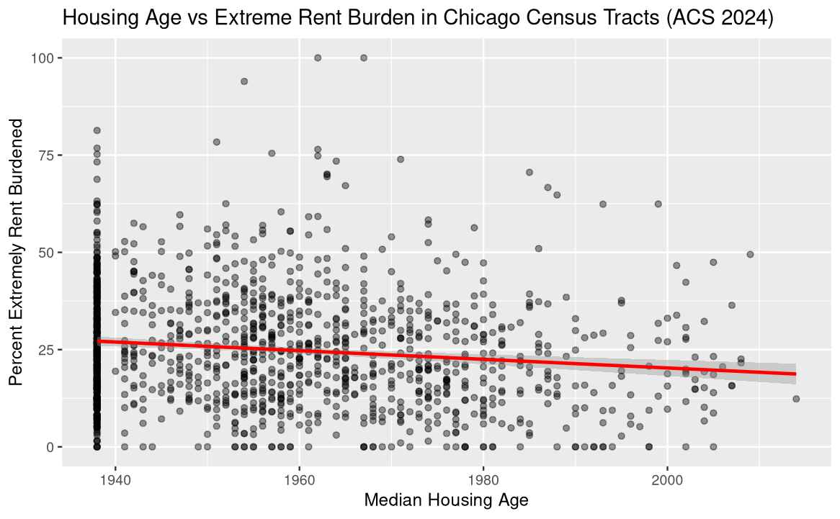
Finally, figure F compares housing age with median home value. With a p value of ~0 and a correlation of 0.11, they are slightly positively correlated, and this result is statistically significant. This result is expected, though perhaps weaker than previously assumed.
Figure F
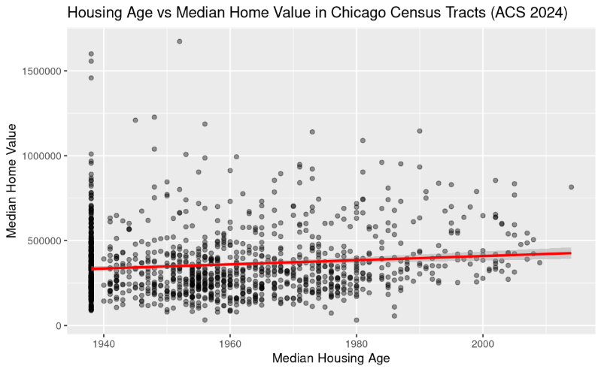
Spatial Analysis
These non-spatial analyses set the stage but cannot tell the full story. For that, spatial analysis is needed. Figure G shows Chicago census tracts by median structure year. From visual observations, a clear “collar” of older housing forms around the downtown but decreases intensity as it approaches the city limits. This visual provides important context for later spatial analysis. Another notable observation is the lack of clear North-South divide seen in so many other economic and social maps. This requires further analysis. Finally, there were 3 tracts that had missing data – likely because they lack significant housing at all, signified by O’Hare’s inclusion in this category.
Figure G
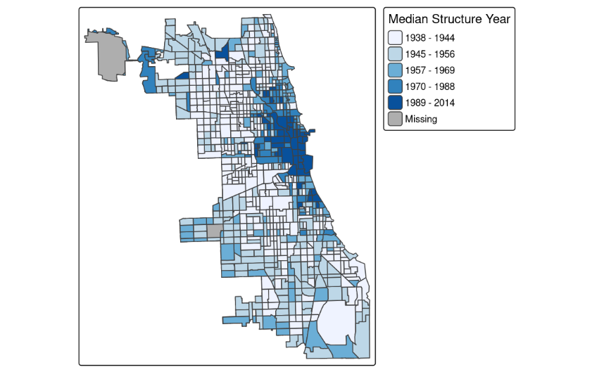
Global Moran’s I, listed in Figure H, provides a clear number showing the strength and statistical significance of spatial autocorrelation. Spatial autocorrelation refers to how clustered the high and low observations are. In this case, a value of 0.59 with the queen contiguity signals a very strong spatial autocorrelation, meaning similarly aged housing clusters together. Multiple weight specifications are listed for redundancy, but all are statistically significant not just at p>0.05, but even at the strict p>0.01. Of the weights tested, the rook was the strongest, while the 2-mile distance was the weakest. This makes sense, as the 2-mile distance was chosen to avoid spatial islands rather than correlation. Other data on the spatial weights is included in figure I.
Figure H
Weight Specification | Moran’s I | P-value | Significant?
Queen Contiguity | 0.5875 | 0 | Yes
Rook Contiguity | 0.5971 | 0 | Yes
2mi Distance | 0.4133 | 0 | Yes
5-Nearest Neighbors | 0.5716 | 0 | Yes

Figure I
Weight Type | Mean Neighbors | Min Neighbors | Max Neighbors | Symmetric | % Nonzero
Queen Contiguity | 6.48 | 1 | 18 | TRUE | 100
Rook Contiguity | 4.65 | 1 | 16 | TRUE | 100
2mi Distance | 46.25 | 1 | 94 | TRUE | 100
5-Nearest Neighbors | 5.00 | 5 | 5 | FALSE | 100

Figure J outlines a Monte Carlo permutation test for Moran’s I. The curve shows the random distribution of Moran’s I assuming the null hypothesis – or true randomness. The vertical line shows where the actual observed Moran’s I appears. Give that it’s so far outside the random curve, it is extremely unlikely to be random.
Figure J
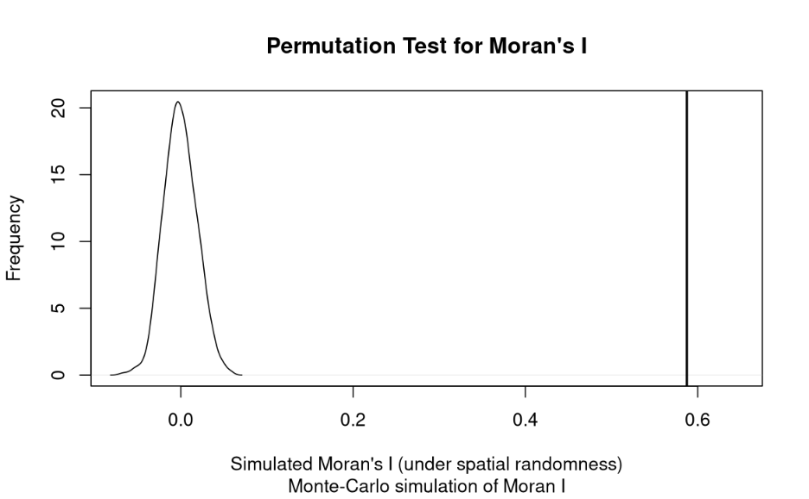

Global Moran’s I proves that there is clustering within housing age in Chicago. In other words, that there are areas of low and high new housing development. However, it doesn’t give any information about where those clusters might be. For that, a local spatial autocorrelation (LISA) is required.
LISA defines tracts into five categories. These are split into two sections, i.e. high-high or low-low. The first factor refers to the observed housing age in the tract – in this case, high means new housing. The second factor refers to the spatial lag, or the expected value of the tract based on its neighbors ages – high means new housing in its neighbors. This defines 4/5 categories on the maps in this section. The fifth category is “not significant”, meaning the clustering wasn’t significant enough at that confidence level, defined by the p value.
Figure K reveals high-high clusters are focused on the immediate urban core, spreading in all directions except the southwest. The low-high outliers also concentrate in this area and exemplify the richer but historically important neighborhoods that have resisted new development.
Figure K also reveals two main low-low clusters – one on the southwest side and another on the northwest side. The Northwest cluster lies roughly between Humbolt Park and Irving Park, while the Southwest cluster centers around Mckinley Park. The high-low outliers exist within and around these two clusters.
This map also reveals the “collar” shape from earlier, with the high-high clusters in downtown and on the fringes, and the low-low clusters circling the downtown. There still is not a significant North South divide, or clusters where expected from other socioeconomic factor maps.
Figure K
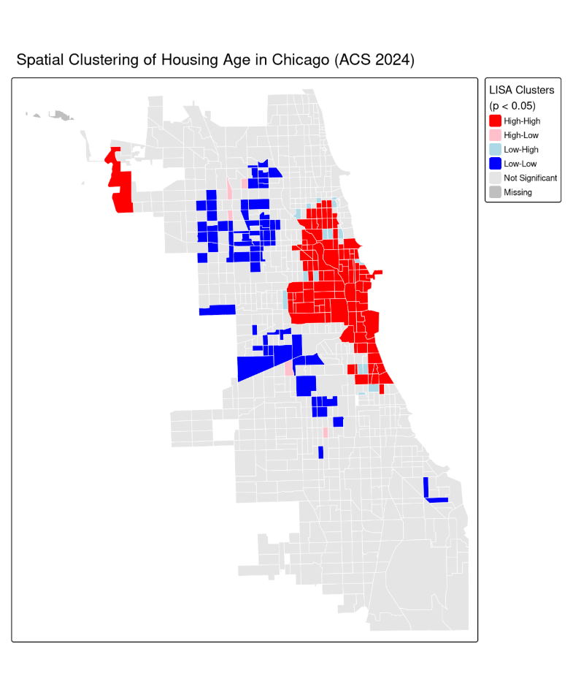
As shown in figure L, restricting the P-value leads to the elimination of the low-low clusters entirely, suggesting they are less significant than the high-high concentration in the urban core. The Southwest low-low cluster (tract 6103) persists at p>0.01, suggesting it is the more significant of the two clusters. Figure M shows how there is a significant drop in the quantity of statistically significant tracts going from 0.05 to 0.01, though somewhat less so from 0.01 to 0.001.
Figure L
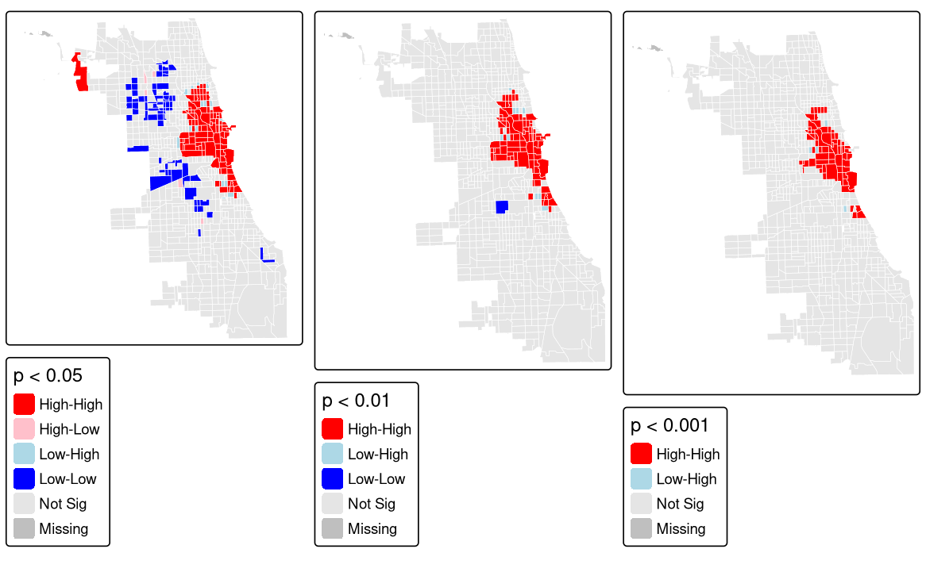
Figure M
Significance Threshold | # Significant | % Significant
p < 0.05 | 194 | 22.6
p < 0.01 | 95 | 11.1
p < 0.001 | 70 | 8.2

For further robustness, the LISA was calculated using different spatial weights as well. At the 0.05 level, 113 tracts were significant with Queen, Rook, and 2-mi distance spatial weights. While this is certainly less than the 194 tracts from just Queen, it still proves that a significant proportion of these tracts maintain their significance across different spatial weights and significance thresholds, making these findings robust.

Discussion
There are many conclusions to be drawn from this analysis. Starting simple, the urban core of Chicago has statistically significant development over a large area. This is because it is the most desirable part of Chicago – being centrally located, close to landmarks and the lake, and flush with offices and businesses. Areas with high desirability have more development turnover, as the land values are high enough to justify redevelopment if a structure no longer makes sense or is as profitable as possible. This also explains why post-2000 housing is more expensive – its built in more expensive areas on top of being more desirable in itself. This also explains why this cluster stretches further North than any other direction – the near north side is extremely affluent.
The edges of Chicago also appear as areas with higher development because they border the affluent and ever-expanding suburbs of Chicago, lessening conventional ties to the urban core. These are also areas that in the Chicago housing of the 1930s were too far away for development. The highways and suburban sprawl of the post 1950s era enabled newer development of these areas.
The “collar” of low development and older housing is also interesting. It’s less robust than the high development areas, suggesting these areas still have some level of new housing development, though still less than the not significant or high clusters. This collar shape also results in significant geographic distribution, from the northwest side to the south side this pattern persists. This is likely responsible for the widespread knowledge and appreciation of the 2-3 story flats described in the anecdotes – they aren’t concentrated in one neighborhood or area.
These low-development areas also defy easy “North-South” distinctions. This is likely because the affordability and density qualities of these units are enjoyed by various income levels, as proven by Figures D and E. Those who are higher income could simply invest more into renovations or other home improvements that are harder to measure. More simply, though, is that the South side’s development is mostly a product of the 1950s, not the 1930s. These developments would be single family or town homes rather than flats. All this complexity removes any clear North-South trends.

Two sample tracts were selected for analysis, a high-high and low-low. The high tract, tract 8391 is in the center of the Loop, encompassing the Sears tower and bordering the Chicago river on the West and North sides. With a density of 19.6k people/mi², and per capita income of $116k, this is a rich and prosperous area. All housing is multi-unit, with a median value of 423k and a vacancy rate of 13%. Its population is 44% White, 9% Black, 28% Asian, and 16% Hispanic. This is very similar to any dense urban core across the US.
The low tract, 6103, was selected because it was the only low-low tract to persist at a higher significance threshold. It lies south of McKinley Park, west of Fuller Park, and east of Brighton Park. With a density of 6.7k people/mi², and per capita income of $14k, this is an area with low income, and with a population that is 36% children. 70% is multi-unit housing, with a median value of 224k and a vacancy rate of 9%. Its population is 4% Black, 8% Asian, and 87% Hispanic.
These sample tracts align very closely with the trends outlined in broader data. 8391 has a much higher income, higher density, higher property values, and skewed towards affluent racial groups. Meanwhile, 6103 has much lower density and a low per capita income, with a quite low median value for Chicago and high minority population. So far, it aligns with expectations of an impoverished community anywhere in America.
Where it deviates - and what makes Chicago special – are the housing characteristics. With 70% of housing being multi-family housing with a majority from the 1930s, it is extremely likely these are flats. This tract also has a shockingly low vacancy rate for such an improvised neighborhood of 9%. This low vacancy rate indicates that despite being old, this more affordable housing still remains valuable to those who need it the most.

Policy Impact

As Chicago’s housing continues to age, there will be renewed and continuous calls from communities, public, and private sectors for redevelopment and new housing. However, as revealed in this report, this existing housing forms the backbone for Chicago’s affordability and neighborhood character. In the worst case, these flats would be replaced by single-family homes. This maximizes the increase in rent by being new housing, which is the most expensive, and by decreasing density thanks to the destruction of an existing multi-family home. Those communities in the “collar” should be wary of any grand promises of redevelopment for this middle housing, as its likely to be replaced by single family or apartment structures. This research should empower community members to protect their existing housing and city councils to ask for a higher standard from developers.
Tools used to fight gentrification – which this type of redevelopment would surely create – are appropriate for use here. Requirements already in place like Chicago’s Affordable Requirements Ordinance (ARO) already help prevent predatory developments. However, communities like Pilsen have even stricter requirements which effectively prevent development (Pupovac, 2017). These strict requirements should be monitored to ensure they don’t result in exclusively downzoned development, which would also reduce affordability.
A more novel tool is the community land trust (CLT). CLT’s operate as nonprofits which are controlled and owned by their communities. They purchase and lease out properties to low-income households for under market-rates. Illinois has invested more into this tool recently. In 2023, the Community Land Trust Task Force Act passed the Illinois Legislature, grouping experts to establish how CLT’s could be leveraged for affordability (Strategies to Support Community Land Trusts in Illinois, 2025). This task force has a full list of recommendations found here.

Future Study

While this report aimed to be comprehensive within Chicago, it remains small in scope. Ultimately, Chicago has so much old housing comparing within itself can be problematic – unreliable data is created when analyzing data on too small a scale. An inter-urban analysis may be more practical and produce more concrete results.
If a dataset is ever compiled that includes the pre-1939 dates for housing, this analysis would be more robust and confident. As it stands, this remains a open question in the analysis.

Conclusion

These results prove that housing age has a small, but consistent and statistically significant impact on economic factors. That Chicago continues to have large swaths of this older housing turns out to be a blessing. The “missing middle” that so many other areas of the country feel the absence of was woven into the fabric of Chicago nearly a century ago. Let’s ensure these structures full of memory are replaced with something worth building and loving for another 100 years.

Works Cited
Cost of Living in Chicago, IL. (2025). PayScale. https://www.payscale.com/cost-of-living-calculator/Illinois-Chicago
Cost of Living in Los Angeles, CA. (2025). PayScale. https://www.payscale.com/cost-of-living-calculator/California-Los-Angeles
Cost of Living in New York, NY. (2025). PayScale. https://www.payscale.com/cost-of-living-calculator/New-York-New-York
Pupovac, J. (2017, April 5). Pilsen Develops New Tools To Fight Gentrification. WTTW Chicago. https://www.wttw.com/my-neighborhood/pilsen/gentrification
Strategies to Support Community Land Trusts in Illinois. (2025, February 12). Institute for Housing Studies - DePaul University. https://www.housingstudies.org/releases/community-land-trust-task-force-report/

