Spiritual Addiction Tracker - Final Project Submission

🧍‍♂️ Student Name

Matthew Bourgeois

📁 Project Title

Spiritual Addiction Tracker

🔗 Links

GitHub Repository: https://github.com/Matthew-Bourgeois/spiritual-addiction-tracker

Live Site: https://matthew-bourgeois.github.io/spiritual-addiction-tracker/

1) 📚 User Stories

1. As a user, I want to log a personal struggle each day so I can track my spiritual battles and growth over time.

2. As a user, I want to receive scripture related to my struggle so I can reflect and find encouragement.

3. As a user, I want to view my history of struggles and victories so I can recognize patterns and celebrate progress.

2) 🖼 Wireframes for Each View

- Home

- SinLog (Daily Tracker)

- Todo (Spiritual Goals)

- Contact (Reflection Request Form)

- Seven Deadly Sins Tracker

[Note: Image version included in Word version; describe or attach separately if needed.]

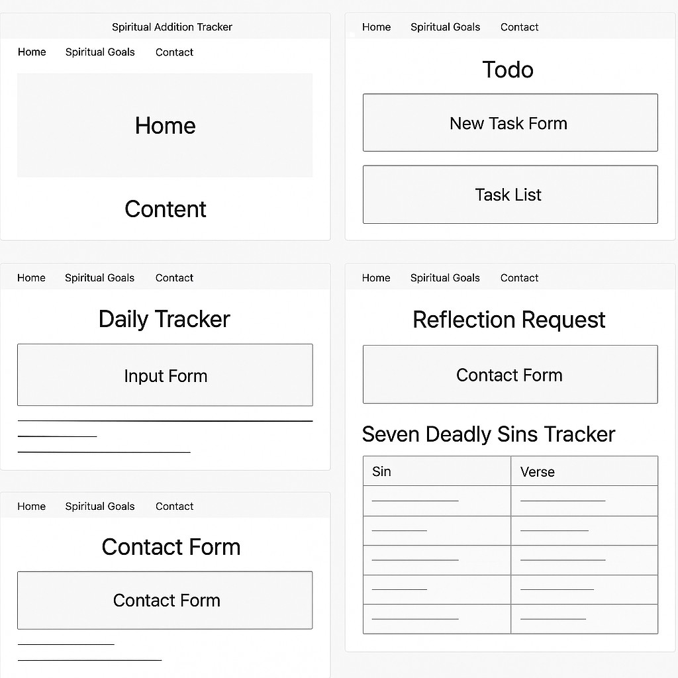

1. 🌳 App State Tree { logs: [ { id: 1, date: "2025-05-09", struggle: "lust", summary: "Struggled with lustful thoughts but overcame by redirecting focus.", overcame: true }, { id: 2, date: "2025-05-08", struggle: "sloth", summary: "Skipped morning prayer. Felt off all day.", overcame: false } ], filter: "all", newLog: { date: "", struggle: "", summary: "", overcame: false }, verseToShow: "", contactForm: { firstName: "", lastName: "", email: "", comments: "" } }
2. 📦 Component List (Container & Presentational) Container Components:

* App
* Todo (Spiritual Goals Tracker)
* SinLog (Daily Tracker)
* Contact (Reflection Request Page)

Presentational Components:

* NewTaskForm
* TaskList
* FilterButtons
* TaskItem
* VerseBox
* ContactForm

1. 🧾 Source Code Location All source code for this application is publicly available in the GitHub repository linked above.