 C:\Users\Tonya\AppData\Local\Microsoft\Windows\INetCacheContent.Word\DurakIcon.png **Durak**

**Creators: Matthew Brennan, Tonya Chung, Michael Sehdev, Wesley Whitmore**

Start off the game with a menu, which allows you to configure your name as well as the deck size you’d like to use, three choices are provided (20 cards, 36 cards and 52 cards).

Offers statistics based off the game as well as a log file for the player to view.

**Rules**

You are either an attacker or a defender. Each bout will be played in the center of the game where a maximum of six cards per player can be used to attack or defend.

**Attacker/Defend**

* Can play a card of higher ranking with the same suits
* Placing any higher trump card is allowed
* Has played less than or equal to six cards

**How to beat off an Attack**

* Defender has beaten all the attack cards
* All six cards have been beaten
* Defender has no more cards left in their hand

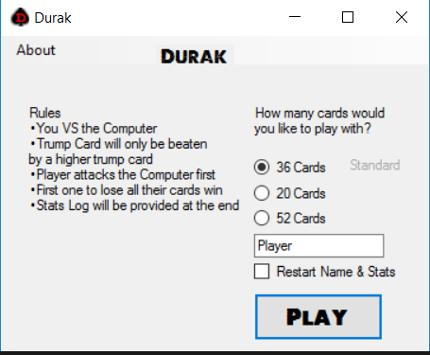

The following is a menu provided which will prompt the user to select the deck of cards they would like to select as well as changing their stat log before playing the game.

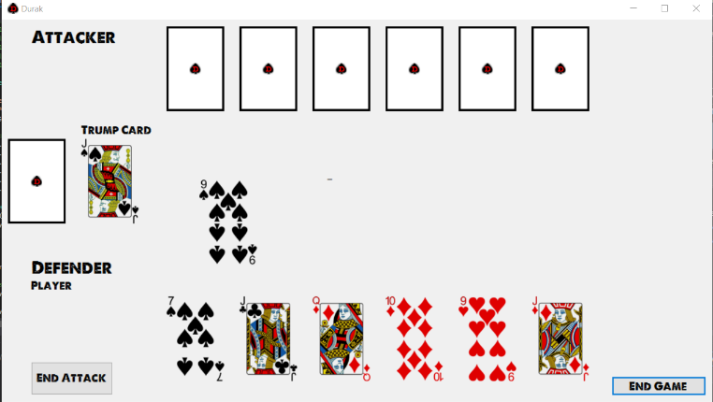The following is the playing field for Durak. The bottom side is the player hand and the top side is the computer’s hand. The game operates by clicking the text boxes.