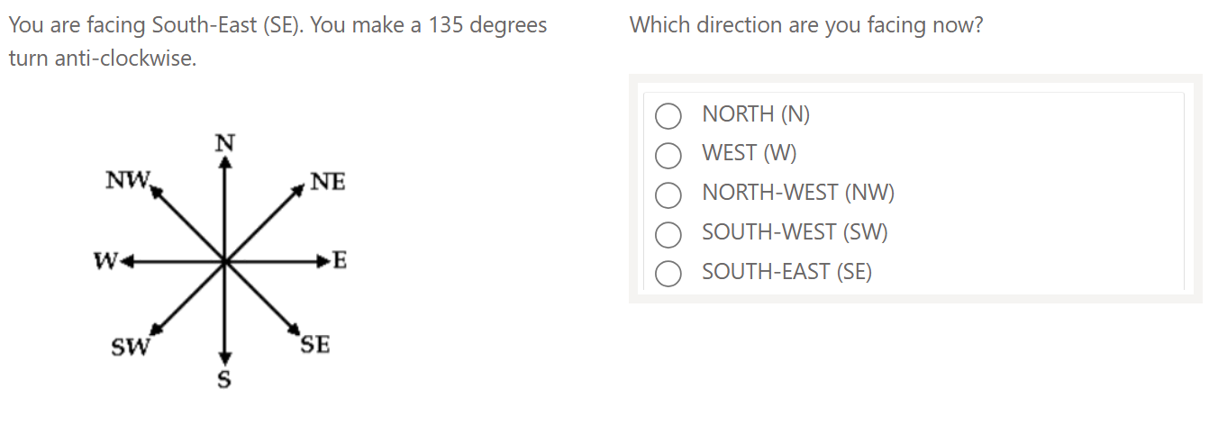  
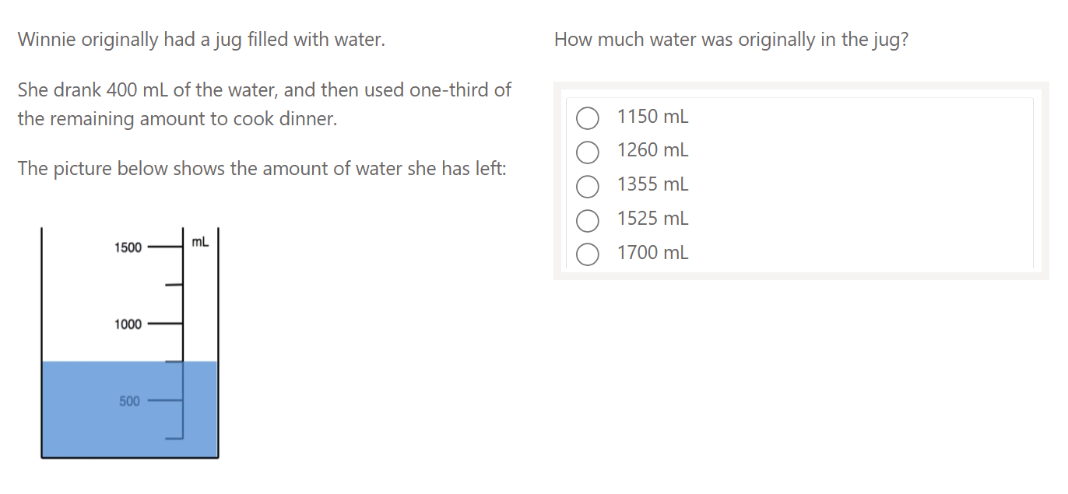  
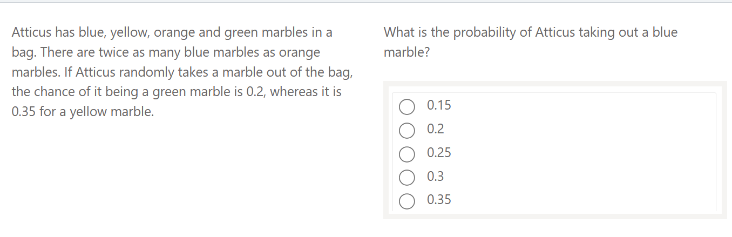

Page 1 / 5

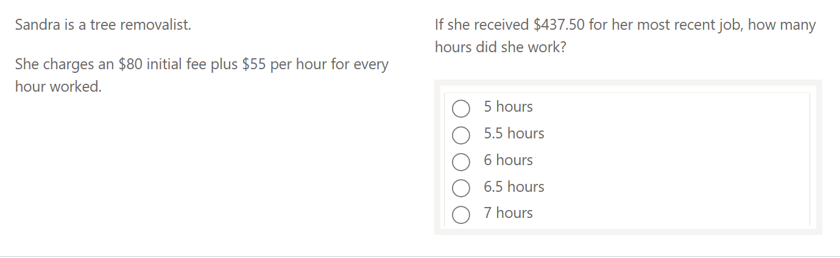  
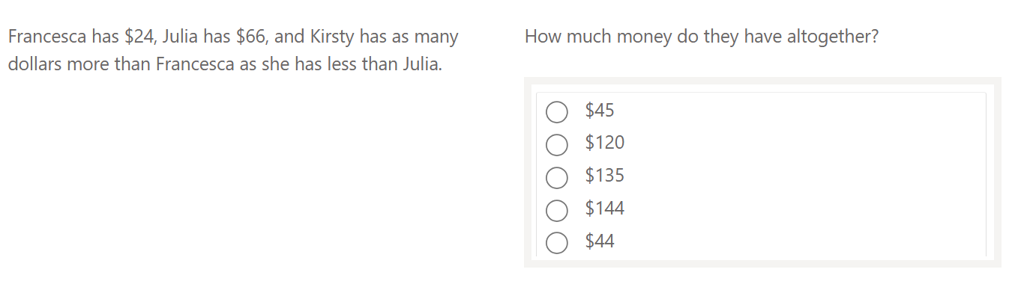  
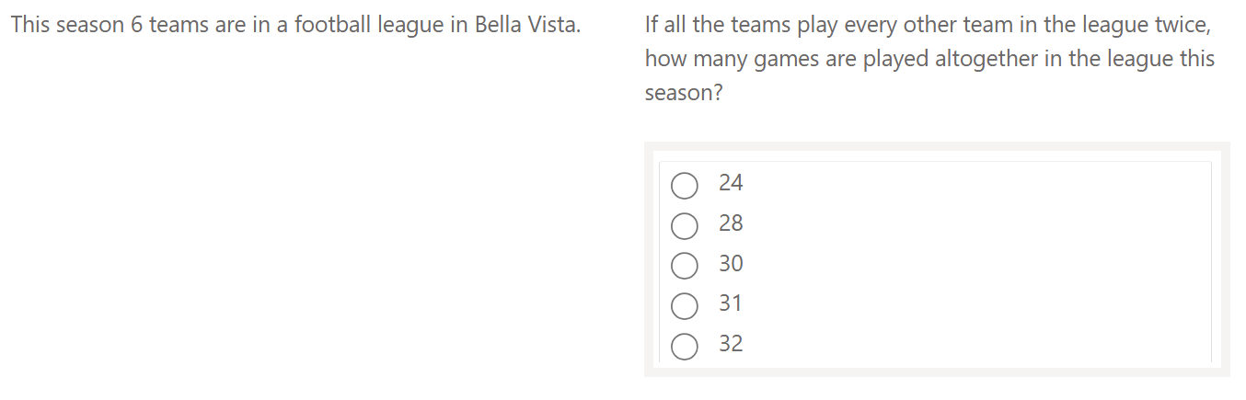

Page 2 / 5

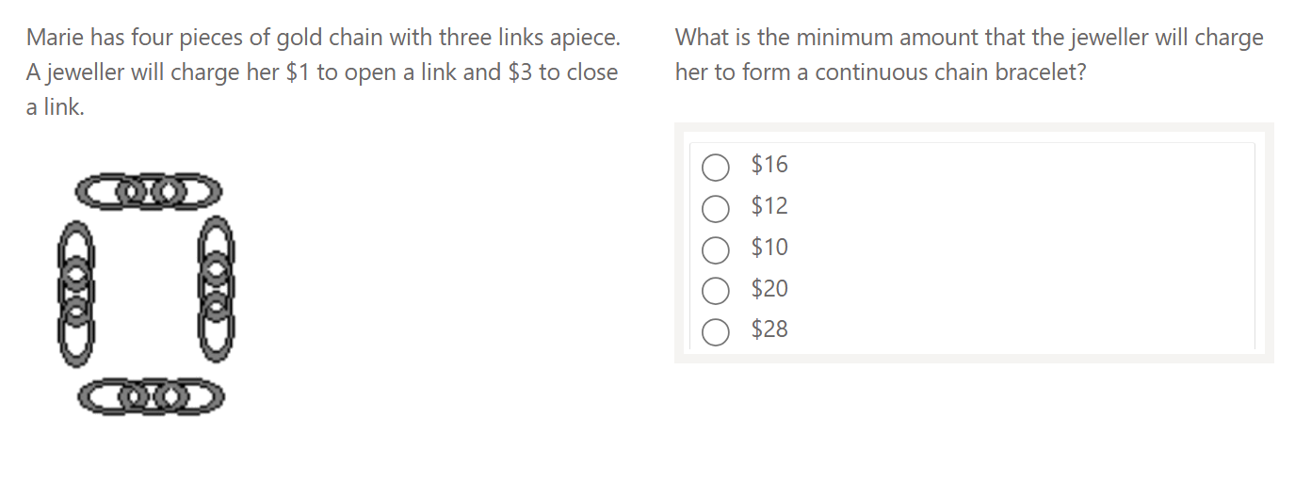  
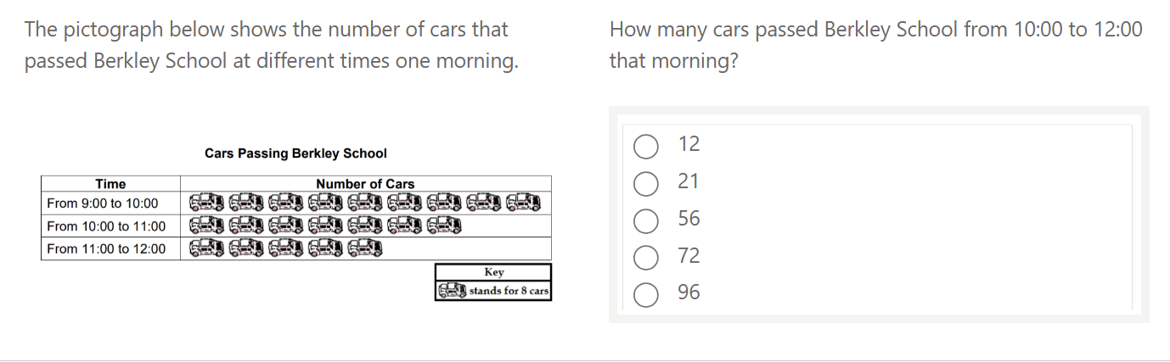  
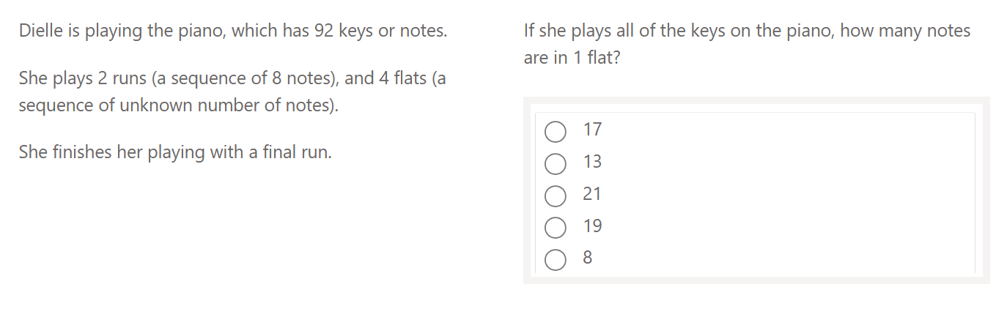

Page 3 / 5

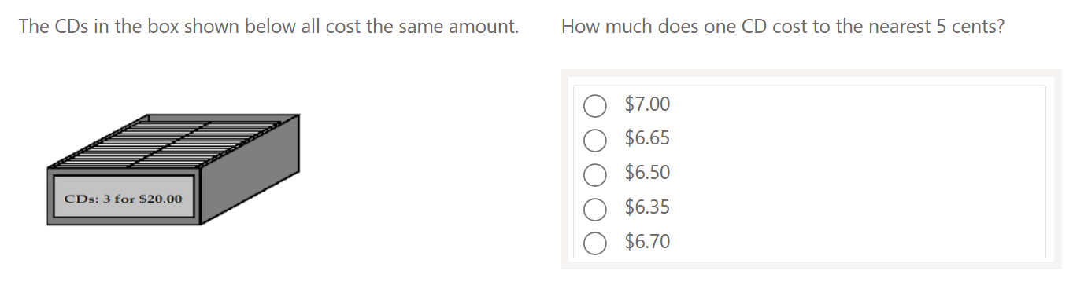  
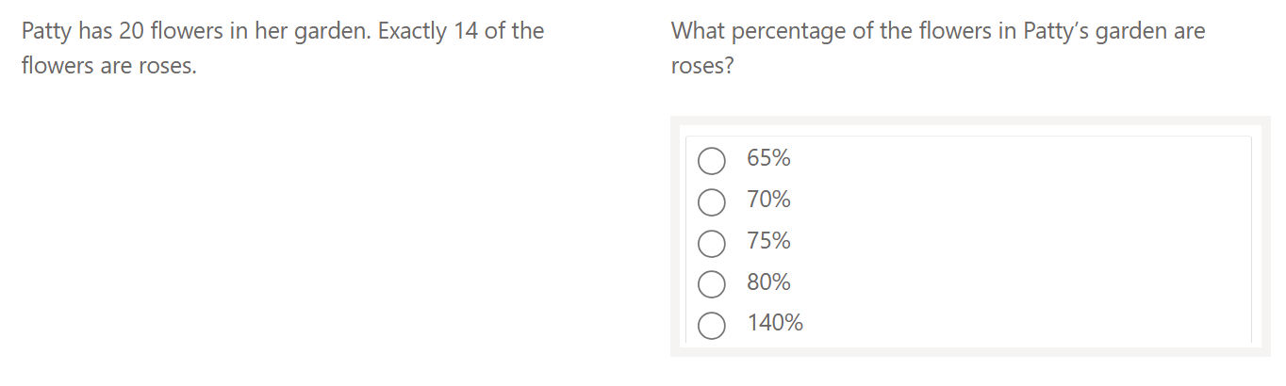  
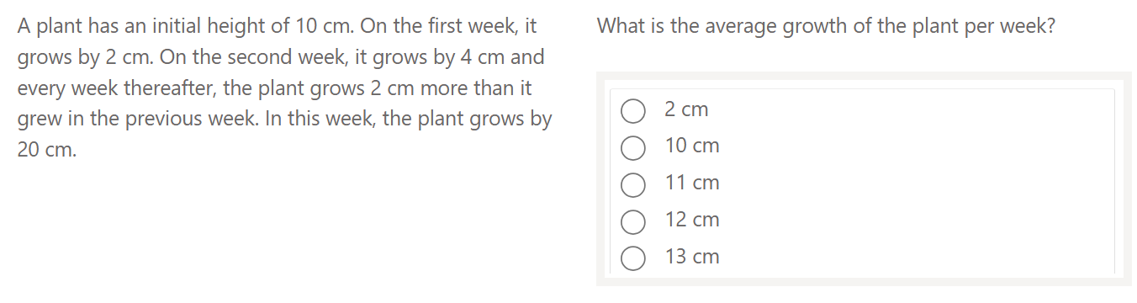

Page 4 / 5

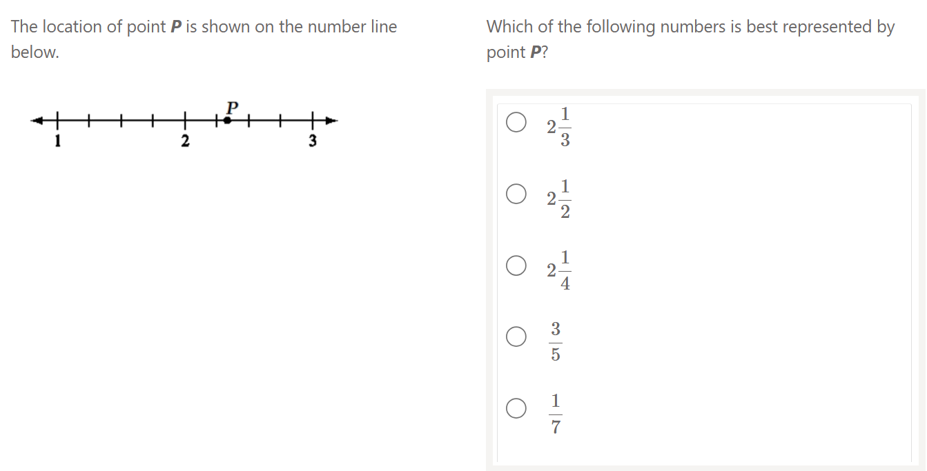

Page 5 / 5