AI Toy Online Retail Store
Database Design and Development | Dominick Spegnolo | CST-339-O500

Purpose and alignment
The ai_toy_store relational database supports the team’s proposed AI toy storefront, including HOME, SHOP, CART, ACCOUNT, ABOUT US, and HELP. MySQL Server 8.0.46 and MySQL Workbench were used to create and verify the database. The initial eight-table schema was expanded by 14 tables, for 22 tables in total. This database work provides a foundation for the Spring Boot N-layer application; frontend and backend functionality remains to be integrated and tested.

Website features and database support
Website area | Schema support
HOME | Featured products and release dates; announcements, store events, polls and voting.
SHOP | Categories, products, inventory, compatibility of accessories/add-ons, product pricing.
CART | Registered-user shopping carts and cart items; guest checkout represented in orders, but guest cart persistence not yet implemented.
ACCOUNT | Registered users, profile fields, customer addresses, purchase history, loyalty accounts and points transactions.
ABOUT US | Static content; no dedicated database table needed at present.
HELP | Static FAQ/contact information and support_messages for submitted inquiries.
CHECKOUT | Orders, order items, shipping methods, billing/shipping address snapshots, promo codes and discounts.

Database design: 22 tables
- Core commerce (8): users, categories, products, inventory, shopping_carts, cart_items, orders, order_items
- Customer and fulfillment (3): customer_addresses, shipping_methods, order_addresses
- Discounts and loyalty (4): promo_codes, order_promotions, loyalty_accounts, loyalty_transactions
- Store engagement (4): announcements, store_events, polls, poll_options
- Engagement and accessories (3): poll_votes, support_messages, product_compatibility

Technical approach and team integration
Presentation (Brittney Seymour) → Spring Boot controllers and services (Dimitri Jimenez) → Spring Data JPA repositories (planned) → MySQL database (Dominick Spegnolo). Matthew Foley coordinates project documentation, testing, and integration. Java entities, repository methods, API endpoints, and business rules must be aligned with the schema before the features are functional.

Key design decisions
- Foreign keys and primary keys link products, users, carts, orders, and the expanded features.
- DECIMAL is used for prices and monetary amounts; stock and cart quantities use integers and validation constraints.
- Orders permit a nullable user reference with guest_email for guest checkout; guest carts still need a separate approach.
- Order addresses retain address snapshots; product compatibility links toys with accessories.
- The database stores password hashes, not plaintext passwords; secure authentication is backend work.
- Payment credentials and raw card numbers must not be stored; use simulated checkout for coursework unless otherwise required.

Implementation evidence
MySQL Workbench returned 22 base tables after the expansion migration. The SQL execution screenshot shows successful creation commands and a 22-row table list. Initial sample products and inventory were queried successfully. This demonstrates schema creation and basic retrieval, not end-to-end checkout or application functionality.
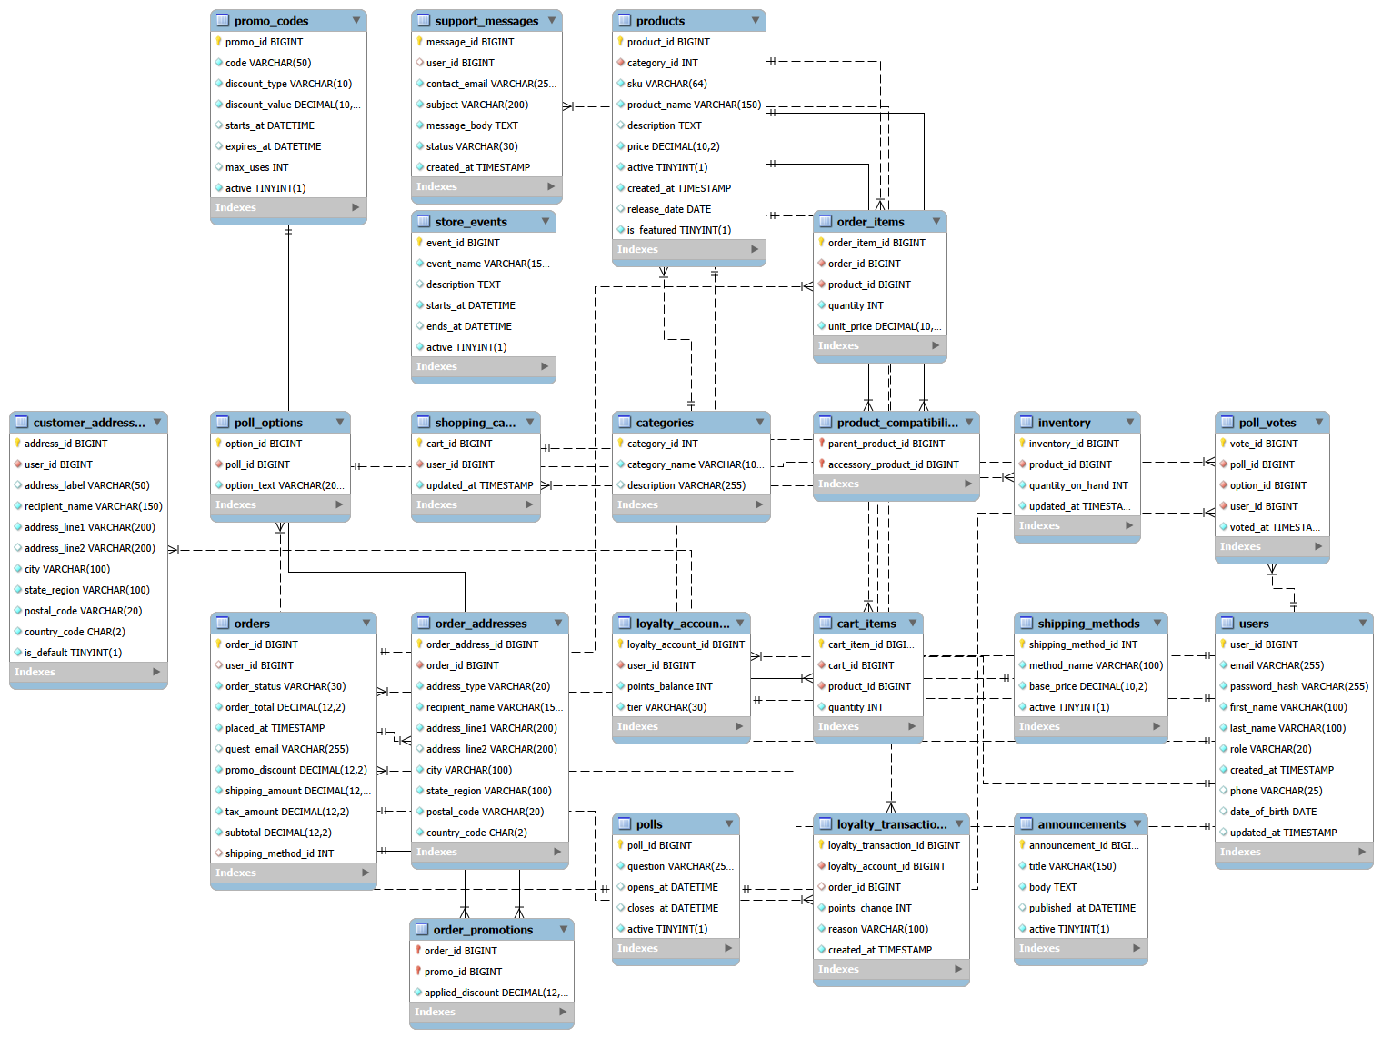
Figure 1. Expanded 22-table Entity Relationship Diagram (MySQL Workbench).

Risks and mitigations
- Scope: 22 tables increase implementation and testing time; prioritize core catalog, account, cart, and order flows.
- Integration: Java entity relationships and foreign keys may mismatch; review mappings jointly with Dimitri.
- Inventory: concurrent orders may oversell; use transactional stock checks and updates.
- Security: protect credentials and customer data; enforce authentication and authorization.
- Promotions and loyalty: enforce eligibility, expiration, redemption limits, and consistent point balances.
- Testing: new tables were created, but feature-level inserts, constraints, and CRUD flows still require verification.

Completed work and next steps
Completed: initial schema, sample catalog and inventory, expansion migration, 22-table verification, ERD export, and SQL documentation. Next: verify new constraints and test data operations; coordinate entity/repository mapping with Dimitri; update GitHub; integrate and test the application; revise the ERD and documentation as requirements evolve.

Repository
https://github.com/Matthew-Foley-Student/JAVA-Year-3-Store/tree/main

