CLC MILESTONE 2
DATABASE DESIGN AND VERIFICATION
ShiftTech Online Retail Store
CST-339-O500 • Programming in Java III
Grand Canyon University
Database Developer: Dominick J. Spegnolo
October 31, 2026
Prepared as the database contribution to the team’s updated Design Report. Application-level requirements and screencast remain team deliverables.

1. Completed Tasks
For this milestone, I reviewed the MySQL database created during Milestone 1 and updated its design to better support the registration and login requirements. I verified the 22-table structure, reviewed 23 foreign key relationships and their referential rules, checked inventory records for missing product references, and saved an updated Workbench model and ER diagram. I also prepared a SQL update script for the username field.

2. Database Overview and Design
Our team is developing ShiftTech, an online retail store using Spring Boot and Spring MVC. The existing database schema is named ai_toy_store because it was created under the original project concept. MySQL Server 8.0.46 and MySQL Workbench are used for the database design. Database integration is not required until Milestone 4, so the database is a prepared design rather than a dependency of the current login demonstration.
Area | Tables
Accounts | users, customer_addresses
Catalog and stock | categories, products, inventory, product_compatibility
Cart | shopping_carts, cart_items
Orders and delivery | orders, order_items, order_addresses, shipping_methods
Discounts | promo_codes, order_promotions
Rewards | loyalty_accounts, loyalty_transactions
Content and engagement | announcements, store_events, polls, poll_options, poll_votes
Support | support_messages
The tables separate different responsibilities. For example, products holds product information while inventory tracks stock. Orders and order_items are separate so one order can contain several products. Primary and foreign keys connect related records and help prevent invalid references.
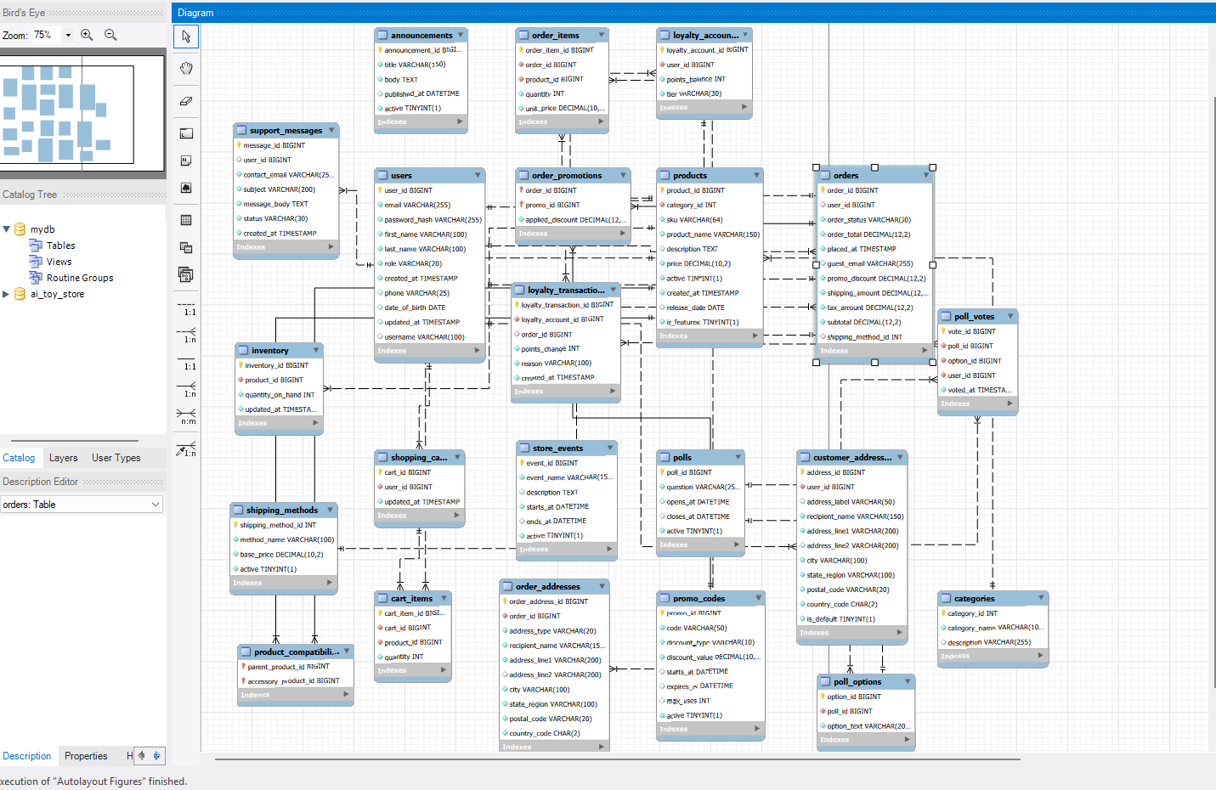
Figure 1. Updated EER diagram. MySQL Workbench diagram showing the expanded 22-table database and its relationships. The exported ShiftTech_Milestone2_ERD.png should replace this working screenshot in the final team report if a clearer export is available.

3. Registration and Login Data Model
The assignment requires first name, last name, email address, phone number, username, and password during registration. I reviewed the users table and confirmed fields that can support this information. The table currently contains 11 columns: user_id, email, password_hash, first_name, last_name, role, created_at, phone, date_of_birth, updated_at, and username.
The email column is unique. The username column is currently nullable and does not yet enforce uniqueness. The backend developer and I need to agree on whether username or email will be used for login before finalizing those rules. The password_hash field is intended for future secure password storage; it does not mean hashing or authentication has been implemented in the current application.
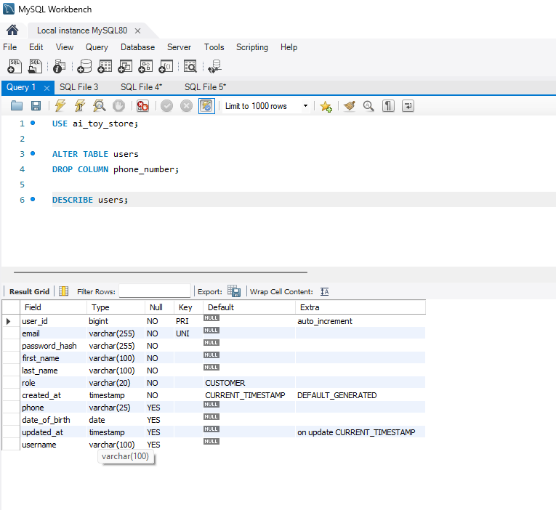
Figure 2. Final users table. Workbench column listing used to confirm that the user model includes the information needed for the future registration database design.

4. General Technical Approach and Decisions
Our application follows an N-Layer approach. Spring MVC handles page requests, the service layer will handle business rules, and the persistence layer will eventually access MySQL through Java entities and repositories. For Milestone 2, registration and login can use simulated authentication without database integration.
I selected a relational design because customer accounts, products, carts, and orders have clear relationships. I used foreign keys to protect those relationships, DECIMAL types for monetary values, and separate tables for inventory and order items. The additional store features are prepared in the schema, but the team should prioritize required features before optional rewards, promotions, and polls.

5. Installation and Configuration
On a fresh MySQL development database, run the SQL scripts in this order: (1) ai_toy_store_schema.sql; (2) ai_toy_store_phase2_expansion.sql; (3) ai_toy_store_milestone2_updates.sql. Refresh the schema and confirm the tables and columns in MySQL Workbench. The third script adds the username column and must not be rerun if that column already exists. The Milestone 2 script has been saved locally and still needs to be included in the GitHub database folder.
The Workbench model is saved as ShiftTech_Milestone2_Database.mwb, and the ER diagram was exported as ShiftTech_Milestone2_ERD.png. The team should keep these files with the SQL scripts and document the execution order in the database README.

6. Testing and Results
Check | Observed result
Database tables | 22 tables
Foreign key relationships | 23
Referential constraints reviewed | 23
Inventory rows without matching products | 0
Users table columns | 11
I used read-only information_schema queries to review relationships and referential rules. I also used a LEFT JOIN from inventory to products to look for records whose product was missing. The result was zero orphaned inventory records in the current dataset. These checks support the database design, but they do not demonstrate working Spring MVC registration, login, or database CRUD integration.
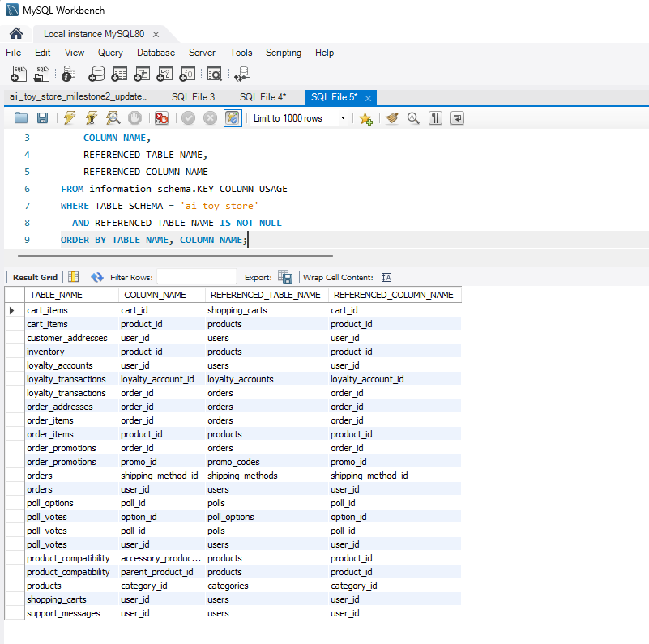
Figure 3. Foreign key relationships. Query results identifying the foreign key relationships defined across the database.
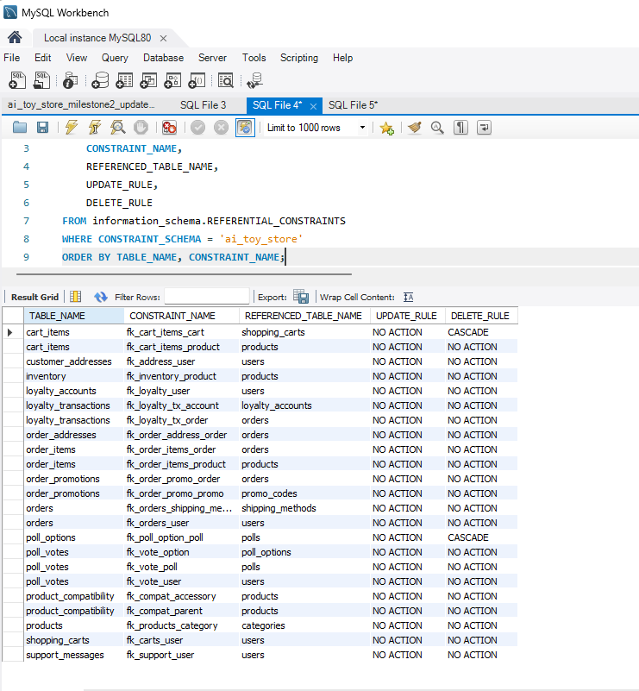
Figure 4. Referential integrity rules. Workbench results used to review delete and update behavior for foreign key constraints. Most relationships use NO ACTION; selected relationships use CASCADE.
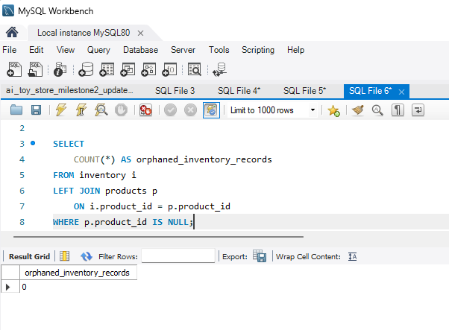
Figure 5. Inventory integrity test. LEFT JOIN query checking for inventory rows with no matching product. The result shows zero orphaned inventory records.

7. Challenges, Known Issues, and Risks
One challenge was updating the users table without leaving duplicate phone-related columns. I checked the structure, removed the unnecessary duplicate field, and kept the existing phone column. I also encountered an ALTER TABLE syntax error when attempting an unsupported IF NOT EXISTS form and corrected the update. Organizing the 22-table diagram required additional layout work.
The main remaining risks are backend-to-database field mapping, deciding how usernames will be validated, protecting passwords and credentials, and maintaining accurate stock during ordering. The schema is designed but has not been verified against the complete Spring Boot application. The team also needs to confirm the final project branding and make sure all required registration fields appear in the application form.

8. What I Learned
This milestone helped me understand how a small registration requirement can affect a database and the Java objects that will eventually use it. I also learned how to check relationships through information_schema instead of relying only on the ER diagram. Testing inventory references showed me another way to look for problems before connecting the database to an application. I am still learning how all the Spring Boot layers work together, but I can see why planning the database early and communicating with the backend developer matters.

9. Next Steps and Conclusion
My database design and verification work for Milestone 2 is ready to be shared with the team. Next I will upload the updated SQL script, model, ERD, screenshots, and README to GitHub; confirm the username requirement with Dimitri; and help Matthew include this section in the final Design Report. The team must still verify its Spring MVC functionality, responsive layouts, code comments, peer reviews, screencast, and ZIP submission. The database will be integrated with the application in a later milestone as required.

