Design and Implementation of a Proof-of-Concept Excavating Rover Platform for Lunar Regolith Collection and Transportation
Luong Nguyen and Matthew Edward Garcia
University of Houston-Clear Lake, Houston, TX 77058, USA
NguyenL@UHCL.edu
This paper presents the design, implementation, and preliminary functional verification of a proof-of-concept excavating rover platform developed as a terrestrial testbed for future lunar regolith collection and transportation research. The platform integrates a four-wheel differential-drive mobility system with additively manufactured grouser wheels, a conveyor-based excavation mechanism, a rear disposal bucket, an NVIDIA Jetson Orin NX, an ESP32 microcontroller, ROS 2, micro-ROS, LiDAR, and camera sensing. The architecture separates high-level computing from low-level actuation and intentionally avoids reliance on wheel-encoder odometry because severe slip is expected on loose granular terrain. A physical prototype was fabricated and integrated. Preliminary testing verified manual forward and reverse motion, turning, conveyor operation, disposal-bucket actuation, ROS 2 and micro-ROS communication, sensor integration, and wireless teleoperation. The prototype is not presented as a lunar-qualified rover: autonomous excavation, quantitative lunar-analog performance, and environmental qualification remain future work. Instead, the contribution is an integrated physical research platform that exposes practical system-level issues and provides a basis for controlled regolith-simulant testing and progressive development of autonomous navigation and excavation capabilities.
Lunar robotics, regolith excavation, proof-of-concept rover, ISRU, ROS 2, micro-ROS, embedded control
- Introduction and Related Work
Sustained lunar exploration and construction will require surface systems that reduce dependence on materials transported from Earth. In-situ resource utilization (ISRU) is therefore a key enabling concept for long-duration lunar activity. Lunar regolith is potentially useful for landing-site preparation, berm generation, habitat shielding, construction feedstock, and resource-processing operations. These applications motivate robotic platforms that can collect, transport, and place granular material while operating with limited human intervention.
The lunar environment imposes coupled mobility and excavation challenges. Regolith is a loose granular medium in which wheel sinkage and slip can substantially reduce tractive efficiency and degrade conventional wheel-encoder odometry. In lunar gravity, the normal load available at the wheel-soil interface is also reduced, which further constrains traction and the reaction forces that an excavation mechanism can generate. Classical terramechanics models developed by Bekker and Wong remain foundational for understanding sinkage, rolling resistance, shear deformation, and traction in deformable terrain [8-10]. For a small excavation rover, wheel geometry, grouser geometry, system mass, center of gravity, and excavation reaction forces must therefore be considered together rather than as independent design problems.
NASA's Regolith Advanced Surface Systems Operations Robot (RASSOR) is an influential example of a lightweight excavation concept intended for low-gravity environments [1]. Counter-rotating excavation drums reduce the net reaction force imposed on the vehicle, illustrating the importance of designing excavation mechanisms around reduced available traction. Other studies have investigated autonomous resource excavation, mission-level task coordination, and robotic construction with raw regolith [2,3,7]. These studies demonstrate the long-term need for excavation, transport, disposal, perception, and mission planning to operate as an integrated system rather than as isolated subsystems.
In parallel, ROS 2 has become an important software framework for distributed robotic systems because it provides standardized communication, modular nodes, and support for sensing and navigation [4]. Nav2 provides reusable components for localization, planning, and obstacle-aware navigation [5], while micro-ROS extends ROS 2 communication to resource-constrained embedded controllers. Work on ROS 2 node composition and distributed architectures has shown the value of separating computationally intensive processes from lower-level hardware interfaces [6].
The practical gap addressed by this work is system integration. Many investigations focus on mobility, excavation, simulation, or autonomy individually; fewer describe a complete physical excavation rover whose mechanical, electrical, embedded, sensing, and software layers must operate together. The contribution is therefore a terrestrial proof-of-concept testbed, not a flight-ready lunar vehicle, intended for subsequent quantitative lunar-analog experiments.
- System Design and Lunar-Relevant Requirements
The intended mission sequence is excavation, material transport, and disposal. In a future autonomous mission, the rover would navigate to a designated excavation area, collect regolith, transport the load to a disposal location, and release the material for berm generation or other construction support. For the current proof-of-concept, this sequence is a design target rather than a demonstrated autonomous lunar capability. The main engineering objective is to integrate all required subsystems in a configuration that can be progressively evaluated and upgraded.
  - Lunar-Relevant Requirements and Current Scope
A central reviewer concern was that requirements for evolving the platform toward lunar use were not sufficiently explicit. Table 1 therefore distinguishes between requirements addressed at the proof-of-concept level and those that remain to be quantified or qualified. This distinction is important because successful terrestrial integration alone does not establish lunar readiness.
Table 1. Lunar-relevant design requirements and current prototype status.
Requirement | Prototype design response | Status / remaining work
Loose-soil mobility | Four-wheel drive; 304.8-mm wheels with 12 grousers | Implemented; quantify slip, drawbar pull, and sinkage in BP-1
Low-mass structure | Modular chassis and additively manufactured components | Prototype implemented; structural and launch-load qualification required
Regolith handling | Front conveyor and rear storage/disposal bucket | Functionally demonstrated; throughput, payload, and energy metrics required
Localization with slip | LiDAR-based localization; wheel encoders omitted for odometry | Integrated; localization error and autonomous performance not yet measured
Distributed control | Jetson/ROS 2 with ESP32/micro-ROS actuation | Communication/manual control verified; autonomous mission tests pending
Power stability | Separate motor and computing power domains | Implemented; endurance and energy-per-task tests pending
Lunar environment | Modular platform supports future hardened redesign | Not qualified; dust, thermal, vacuum, radiation, and launch qualification required
  - Mechanical Architecture
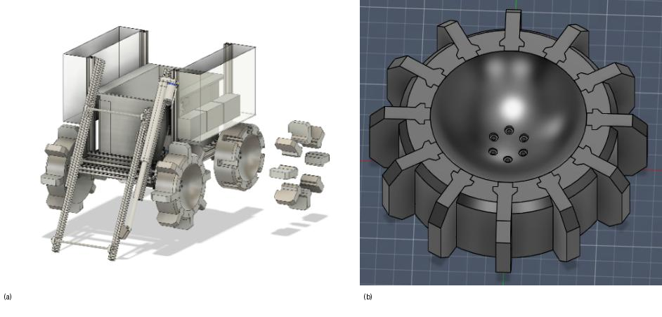
Mechanical CAD arrangement of the rover (a) and grouser wheel CAD model (b).
The mechanical architecture uses a compact four-wheel differential-drive chassis with the excavation conveyor mounted toward the front and the storage/disposal bucket at the rear. This arrangement keeps the material flow path direct and allows mobility, excavation, and disposal functions to be tested on one vehicle. A modular structure was chosen so that the excavation assembly, bucket, wheel modules, sensors, and electronics can be serviced or replaced without a complete chassis redesign.
Weight reduction was pursued through additive manufacturing, particularly for the wheels and excavation components. PETG was selected for the prototype because it is economical, readily printable, and sufficiently robust for iterative terrestrial testing. This material choice is explicitly a prototyping decision; PETG is not proposed as a flight-qualified lunar structural material. The value of additive manufacturing in the present phase is rapid geometry modification and low-cost fabrication, which supports repeated mechanical iteration before more demanding materials and qualification processes are considered.
  - Wheel Design for Granular Terrain
Each wheel has a nominal diameter of 304.8 mm, a width of 100 mm, and twelve evenly spaced grousers. The grousers are intended to increase shear interaction with loose soil and reduce excessive spin relative to a smooth wheel. The wheel geometry also provides a large diameter within the rover packaging constraints, improving obstacle negotiation and reducing the tendency of the vehicle to become trapped in local depressions. The wheel was printed in PETG at 40% infill and has a mass of approximately 1.0 kg.
The current wheel design should be viewed as a test article. No claim is made that the geometry is optimal for lunar regolith. The next design step is controlled comparison in BP-1 simulant using measured slip ratio, sinkage, drawbar pull, turning resistance, and energy consumption. Those measurements will allow grouser height, spacing, wheel width, and vehicle loading to be optimized using data rather than qualitative observation.
  - Excavation, Conveyance, and Disposal
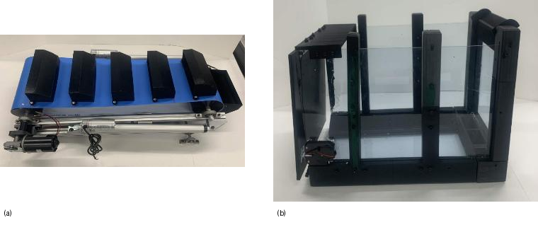
Physical excavation/conveyance subsystem (left) and rear disposal bucket assembly (right).
The excavation subsystem uses a conveyor with multiple bucket-like scoops to collect granular material and move it upward into the rover storage compartment. The design was selected to reduce the mass and mechanical complexity associated with the heavier excavation mechanisms used in earlier rover iterations. The conveyor permits continuous material transfer and allows the excavation subsystem to be tested independently or together with rover motion.
A rear storage bucket receives material from the conveyor. Disposal is achieved using an electronically actuated latch that releases the rear access door. The acrylic storage volume is supported by structural brackets, while a collection scoop beneath the conveyor directs material into the bucket. During preliminary testing, conveyor motion and bucket actuation were demonstrated. Quantitative excavation rate, retained payload, spillage, and material-discharge repeatability have not yet been characterized and are therefore identified as future experimental metrics rather than reported performance results.
  - Embedded Computing, Motor Control, and Power
The embedded architecture separates high-level computation from low-level motor and actuator control. An NVIDIA Jetson Orin NX runs Ubuntu Linux and ROS 2 Humble and is responsible for the software interfaces for sensing, teleoperation, localization and mapping support, navigation software, and mission-level coordination. An ESP32 microcontroller running micro-ROS performs the hardware-facing control functions for the four drive motors, excavation conveyor, and disposal mechanism. The controllers communicate using a UART serial link.
The mobility subsystem uses four brushless DC motors, one per wheel, operated as a four-motor differential drive. Left- and right-side command values are distributed to the corresponding front and rear motors. Separate motor drivers are used for mobility and excavation actuation. Wheel encoder odometry was intentionally removed from the control architecture because severe slip on loose regolith-like material makes encoder-derived vehicle displacement unreliable; future pose estimation is instead intended to rely primarily on LiDAR/inertial sensing and map-based localization.
The rover uses a dual-power architecture. A 24-V battery supplies the higher-current mobility and excavation loads, while a separate V-mount battery supplies the Jetson computing platform. Electrical separation reduces the coupling of motor transients and switching noise into the onboard computer. Fuses, voltage regulation, and modular wiring are used to improve serviceability and fault isolation. The present arrangement is suitable for terrestrial experimentation; lunar flight hardware would require radiation-tolerant electronics, vacuum-compatible thermal design, appropriate battery technology, and more comprehensive fault protection.
Table 2. Key integrated prototype specifications.
Parameter | Value | Parameter | Value
Length | 0.87 m | Width | 0.75 m
Height | 0.75 m | Total mass | 40 kg
Wheel diameter | 304.8 mm | Maximum speed | 0.25 m/s
Battery capacity | 300 Wh | Estimated runtime | 2 h
Excavation motor power | 100 W | High-level computer | Jetson Orin NX
Low-level controller | ESP32 / micro-ROS | Middleware | ROS 2 Humble
- ROS 2 and Embedded Control Architecture
  - Distributed ROS 2 Architecture
The software architecture follows the same separation used in the hardware: high-level robotics processes execute on the Jetson, while low-level actuation executes on the ESP32. ROS 2 provides communication among sensor interfaces, teleoperation, mapping/localization support, navigation components, and mission logic. micro-ROS bridges the ROS 2 environment to the embedded controller. Velocity and subsystem commands are transferred through the UART connection and converted by the ESP32 into motor-driver and actuator commands.
This partition allows perception and navigation software to change without redesigning low-level motor firmware, while the ESP32 retains a compact hardware interface. It also supports progressive testing from manual teleoperation to supervised navigation and, later, autonomous excavation [4,6].
  - Sensing, Localization, and Navigation Framework
The rover integrates a 2D LiDAR and a forward-facing RGB camera. The LiDAR supplies geometric range information for obstacle detection, mapping, and localization experiments, while the camera supplies visual context for monitoring and future terrain-perception algorithms. These sensors are integrated into ROS 2 so that data are available to the same computing framework used for navigation and mission coordination.
The planned autonomy framework uses SLAM Toolbox and Nav2 components for mapping, localization, path planning, and obstacle-aware motion [5]. The software architecture was integrated, but comprehensive closed-loop autonomous navigation was not completed during the prototype development period. Accordingly, this paper reports the architecture and integration status but does not present waypoint-navigation accuracy, obstacle-avoidance success rate, or autonomous excavation-cycle results. This distinction avoids overstating the maturity of the current platform.
  - Node-Level Software Organization and Teleoperation
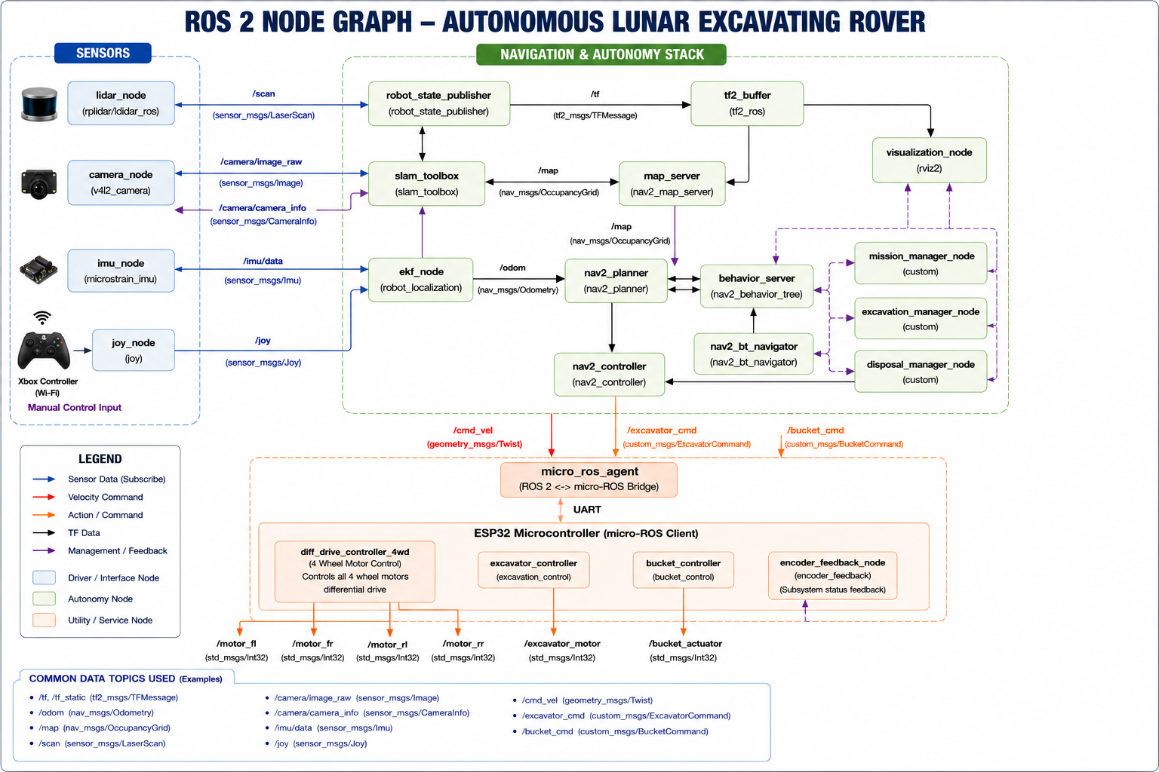
ROS 2 node-level architecture and micro-ROS interface used by the rover platform.
The node graph separates sensor drivers, transform and mapping functions, navigation components, mission-level managers, and the micro-ROS hardware interface. The drive controller produces commands for four wheel motors, while dedicated excavation and bucket controllers manage the material-handling actuators. The graph is intended as a software-development architecture rather than evidence that every autonomous behavior has been experimentally validated.
For functional testing, an Xbox wireless controller communicates with the Jetson over Wi-Fi and provides direct manual control of rover motion and excavation functions. Teleoperation was intentionally retained as a development and safety interface. It enables the mechanical and embedded layers to be verified independently from autonomous navigation and provides a fallback mode during future supervised autonomy experiments.
- Prototype Implementation and Functional Verification
  - Integrated Prototype
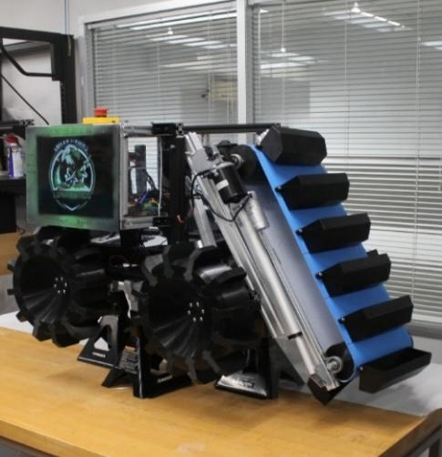
Completed proof-of-concept excavating rover prototype.
A complete physical rover prototype was fabricated, assembled, wired, and integrated. The completed platform combines the four-wheel mobility system, conveyor excavation assembly, disposal bucket, high- and low-level embedded computing, ROS 2 software environment, LiDAR, camera, and dual-power architecture. Functional verification focused on whether these subsystems operated together reliably enough to establish a foundation for subsequent quantitative testing.
  - Verification Procedure and Results
Testing was performed primarily under manual teleoperation so that basic subsystem readiness was not conflated with autonomous-navigation performance. The mobility system was commanded forward, in reverse, and through turning maneuvers. The conveyor was operated to verify continuous mechanical motion and material transfer through the excavation path. The disposal mechanism was actuated to verify release and return operation. At the embedded level, the Jetson executed the ROS 2 environment while the ESP32 handled motor and actuator control through micro-ROS communication.
Sensor integration was checked by launching the LiDAR and camera interfaces and confirming that the corresponding data streams were available within ROS 2. The Xbox teleoperation interface was then used as the operator input for integrated mobility and excavation testing. These checks establish functional integration of the physical platform but do not constitute quantitative validation of lunar excavation performance.
Table 3. Preliminary functional verification results.
Test | Result | Test | Result
Forward motion | Success | Reverse motion | Success
Turning | Success | Conveyor operation/transport | Success
Disposal bucket actuation | Success | Xbox teleoperation | Success
Jetson-ESP32 communication | Success | micro-ROS communication | Success
ROS 2 node communication | Success | LiDAR integration | Success
Camera integration | Success
  - Supplementary Video Evidence
The functional tests were recorded on video, and the reviewers specifically noted that the videos are useful. To avoid redundant still screenshots, the revised manuscript refers directly to the three supplementary multimedia files submitted with the paper: Supplementary Video S1, Rover_motion.mov (forward/reverse motion and turning); Supplementary Video S2, Excavator motion.mov (excavator/conveyor operation); and Supplementary Video S3, Dumping_bucket_motion.mov (disposal-bucket actuation). These videos provide the primary visual evidence of the demonstrated motion and material-handling functions. The files should be uploaded with the revised manuscript in Meteor as supplementary material so that the references remain valid.
The interpretation of the videos is intentionally limited to qualitative functional verification. The videos show that the mechanisms actuate and that the integrated platform can be teleoperated; they are not used to infer excavation efficiency, traction coefficient, navigation accuracy, or lunar environmental suitability. Those quantities require controlled experiments and calibrated measurements.
- Discussion and Future Work
  - Engineering Significance and Limitations
The principal outcome of the project is an integrated physical research platform that combines mobility, excavation, transport, disposal, sensing, distributed embedded computing, and ROS 2 interfaces. This system-level integration is valuable because several design issues become visible only after the subsystems are combined. Wheel slip affects localization strategy; motor-current transients motivate separation of actuation and computing power; mechanical packaging affects sensor placement and material flow; and manual control is necessary as a baseline while autonomous software is progressively introduced.
The present prototype should not be interpreted as a lunar rover in the flight-qualification sense. Its PETG structures, commercial sensors and computers, batteries, wiring, and exposed mechanisms have not been designed or tested for vacuum, extreme lunar thermal cycling, radiation, abrasive dust intrusion, launch vibration, or reduced-gravity excavation. The prototype is therefore best described as a terrestrial proof-of-concept that explores architecture, fabrication, subsystem integration, and functional operation. The revised title and requirements table make this scope explicit.
Similarly, the reported verification is functional rather than performance-based. The tests establish successful motion, mechanism actuation, communication, and sensor integration, but they do not yet provide excavation rate, transported mass, wheel-slip ratio, drawbar pull, sinkage, energy per kilogram of material, localization error, autonomous mission completion rate, or long-duration reliability. These missing metrics define the next experimental phase and provide objective criteria for judging whether design revisions improve performance.
  - Planned Lunar-Analog and Autonomy Evaluation
The next phase will use controlled lunar-analog experiments with BP-1 regolith simulant. Mobility testing will measure slip ratio, sinkage, turning resistance, and drawbar performance under repeatable loading conditions. Excavation testing will measure material throughput, bucket payload, spillage, unloading repeatability, and electrical energy consumption. Together, these measurements will quantify the trade between mobility and excavation reaction forces and will provide data for wheel and conveyor redesign.
Autonomy evaluation will proceed incrementally. LiDAR-based mapping and localization will first be tested independently of excavation. Waypoint navigation and obstacle avoidance will then be evaluated with repeatable position-error and mission-success metrics. After those functions are stable, the rover will be tested in integrated excavation-transport-disposal sequences. This staged process reduces the risk of attributing a failure to autonomy when the underlying mechanical or embedded subsystem is not yet characterized.
Longer-term development toward a lunar-relevant platform will require dust-tolerant mechanisms and enclosures, thermal control appropriate for vacuum, radiation-tolerant computing and power electronics, suitable battery technology, launch-load structural verification, and consideration of reduced-gravity excavation dynamics. The current platform is intentionally modular so that these elements can be replaced or upgraded as experimental results justify more flight-relevant designs.

Acknowledgment
The authors gratefully acknowledge the support of the NASA Lunabotics Program, the University of Houston-Clear Lake (UHCL), the Center for Robotics Software (CRS), and the UHCL Lunabotics Team for their contributions to the design, fabrication, integration, and testing of the rover platform.

References
- Mueller, R.P., Smith, J.D., Schuler, J.M., Nick, A.J., Gelino, N.J., Leucht, K.W., Townsend, I.I., Dokos, A.G.: Design of an Excavation Robot: Regolith Advanced Surface Systems Operations Robot (RASSOR) 2.0. In: ASCE Earth and Space Conference, Orlando, FL, USA (2016).
- Cloud, J.M., Nieves, R.J., Duke, A.K., Muller, T.J., Janmohamed, N.A., Buckles, B.C., DuPuis, M.A.: Towards Autonomous Lunar Resource Excavation via Deep Reinforcement Learning. NASA Kennedy Space Center, KSC, FL, USA.
- Cloud, J.M., Tram, M.Q., Beksi, W.J., DuPuis, M.A.: Lunar Excavator Mission Operations using Dynamic Movement Primitives. In: 2023 IEEE/RSJ International Conference on Intelligent Robots and Systems (IROS), Detroit, MI, USA, pp. 1-8 (2023).
- Macenski, S., Foote, T., Gerkey, B., Lalancette, C., Woodall, W.: Robot Operating System 2: Design, Architecture, and Uses in the Wild. Sci. Robot. 7(66) (2022).
- Macenski, S., Moore, T., Lu, D., Merzlyakov, A., Ferguson, M.: From the Desks of ROS Maintainers: A Survey of Modern and Capable Mobile Robotics Algorithms in the Robot Operating System 2. Robot. Auton. Syst. (2023).
- Macenski, S., Soragna, A., Carroll, M., Ge, Z.: Impact of ROS 2 Node Composition in Robotic Systems. IEEE Robot. Autom. Lett. (2023).
- Vasudeva, K., Emami, M.R.: Lunar Robotic Construction System Using Raw Regolith: Design Conceptualization. Aerospace 12(11), 947 (2025).
- Wong, J.Y.: Terramechanics and Off-Road Vehicle Engineering: Terrain Behaviour, Off-Road Vehicle Performance and Design. Butterworth-Heinemann, Oxford (2009).
- Bekker, M.G.: Introduction to Terrain-Vehicle Systems. University of Michigan Press, Ann Arbor (1969).
- Wong, J.Y.: Theory of Ground Vehicles. 5th edn. Wiley, Hoboken (2021).

