Project01:



Project02:



Project03:



Project04:

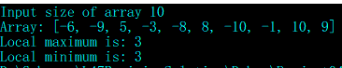

Project05:  
