Matthew Jusino

Lab 6

* **Q1 (3 pts.):** Show the R code you used to define your sse_mean() function. Include the following line before your function definition:

rm(list = ls())

and the following two test lines after your function:

sse_mean(penguins$body_mass_g)

sse_mean(mtcars$mpg)

rm(list = ls())

sse_mean = function(x, n, na.rm = TRUE) {

return(sd(x, na.rm = na.rm)/sqrt(n))

}

sse_mean(penguins$body_mass_g)

sse_mean(mtcars$mpg)

* **Q2 (4 pts.):** Show the code you used to define your two_group_resample_diff() function.

two_group_resample_diff = function(x, n_1, n_2){

dat_1 = sample(x, n_1, replace = TRUE)

dat_2 = sample(x, n_1, replace = TRUE)

diff_simulated = mean(dat_1, na.rm = TRUE) - mean(dat_2, na.rm = TRUE)

print(diff_simulated)

}

* **Q3 (2 pts.):** Does your function perform Monte Carlo or bootstrap resampling, i.e. does it simulate a null or an alternative hypothesis? You may want to review your answer after you complete the rest of the lab questions.

My function performs a Monte Carlo resampling, as it is highly unlikely to reproduce a difference anywhere near the observed difference in bill length between Adelie and Chinstrap penguins.

* **Q4 (1 pt.):** Create a histogram of the resampled differences of means.

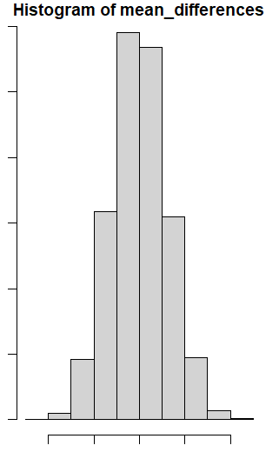

* **Q5 (2 pts.):** How many of your resampled differences of means had a *magnitude* greater than 5.8?
  + Assume that we are doing a 2-sided test: we don’t care which species has longer flippers, we only want to know if they are different.
  + Include the R code you used to check the number of differences greater than 5.8.

None. The greatest magnitude of a resampled mean was 4.74

* **Q6 (2 pts.):** Given a p value of less than 1 per 10 million, how many simulations do you think you would have to do to see a difference in mean flipper length equal to or greater than 5.8 mm?

More than 10 million simulations.

* **Q7 (1 pt.):** Include a boxplot of your chosen variable in your report.

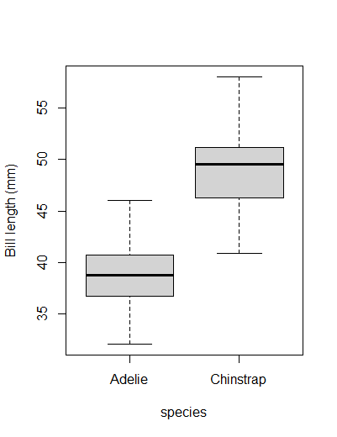

* **Q8 (3 pts.):** Report the group means and difference between the means.

Mean Adelie Bill Length: 38.79 mm

Mean Chinstrap Bill Length: 48.83 mm

Difference Between the Means: 10.04 mm

* **Q9 (4 pts.):** Interpret the p-value from the t-test output in plain, non-technical English that a non-statistician would understand.

The p-value of 2.2e-16 means that I would have about a 1 in 20 million chance of getting results as extreme as these or more so if the null hypothesis were true.

* **Q10 (2 pts.):** How many differences in means were greater than diff_crit?
  + Remember to treat this as a 2-tailed test.

None. The greatest magnitude of differences was 3.38

* **Q11 (1 pt.):** Include a histogram of your simulation results in your report. Make sure it has appropriate title and labels.

