Matthew Jusino

Lab 5

* **Q1 (2 pts.):** Show the R code you used to create exp_fun()

exp_fun = function(x, a, b) {

return(a*exp(-b*x))

}

* **Q2 (4 pts.):** In your lab report, include a single figure containing **four** negative exponential curves with the following parameter values and line colors/textures:
  + curve 1: a = 1.9, b = 0.1, line color = black, line texture = solid
  + curve 2: a = 1.9, b = 0.3, line color = black, line texture = dotted
  + curve 3: a = 1.2, b = 0.2, line color = red, line texture = solid
  + curve 4: a = 1.2, b = 0.4, line color = red, line texture = dotted
  + Hint: check out the from, to, ylim, and add arguments for curve(). Setting appropriate x- and y-limits in your plot will help you see all four curves.

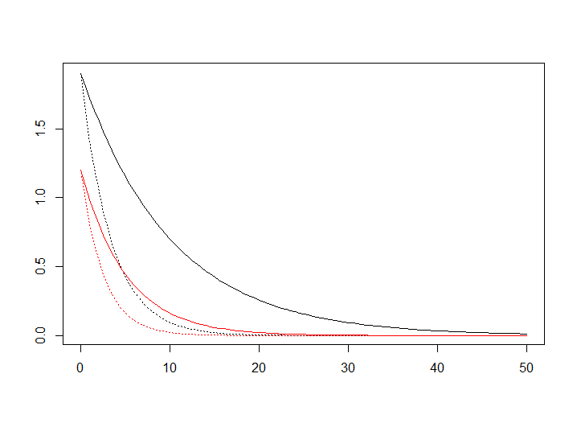

* **Q3 (2 pts.):** Observe how the curves vary as you change the two parameters’ values. Qualitatively describe what happens to the curve as you vary parameter a

The y-intercept changes with changing values of a. Lower values of a mean the curves start lower on the y-axis.

* **Q4 (2 pts.):** Observe how the curves vary as you change the two parameters’ values. Qualitatively describe what happens to the curve as you vary parameter b

The curves get steeper or shallower with changing values of b. As b increases, the curves become more steep.

* **Q5 (6 pts.):** In your lab report, include a single plot containing 6 Ricker curves with these parameter values:
  + curve 1: a = 25, b = 0.2, line color = black, line texture = solid
  + curve 2: a = 20, b = 0.2, line color = black, line texture = dotted
  + curve 3: a = 10, b = 0.2, line color = black, line texture = dotted
  + curve 4: a = 75, b = 0.3, line color = red, line texture = solid
  + curve 5: a = 50, b = 0.3, line color = red, line texture = dotted
  + curve 6: a = 40, b = 0.3, line color = red, line texture = dotted

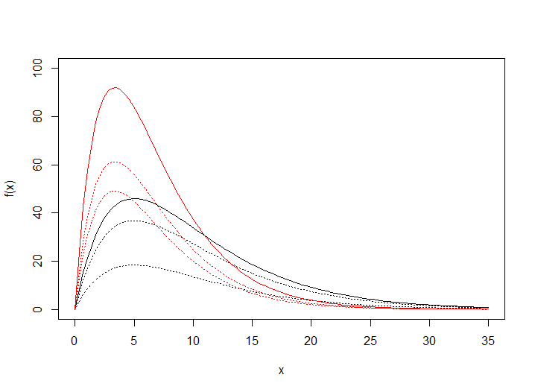

* **Q6 (2 pts.):** Observe how the curves vary as you change the two parameters’ values. Qualitatively describe what happens to the curve as you vary parameter a

Changing the value of a changes the maximum height of the curves.

* **Q7 (2 pts.):** Observe how the curves vary as you change the two parameters’ values. Qualitatively describe what happens to the curve as you vary parameter b

Changing the value of b changes the slope of the curves coming down from the maximum height.

* **Q8 (2 pts.):** Linear Model. Provide the values of the slope, x1, and y1 parameters you chose. Briefly describe how you chose the values.

I chose a slope value of -0.0003, an x1 value of -500, and a y1 value of 0.6. I chose these values by visual trial and error, seeing what values it looked like would approximately fit the data.

* **Q9 (2 pts.):** In your lab report, include a scatterplot of the salamander data with your fitted linear model.

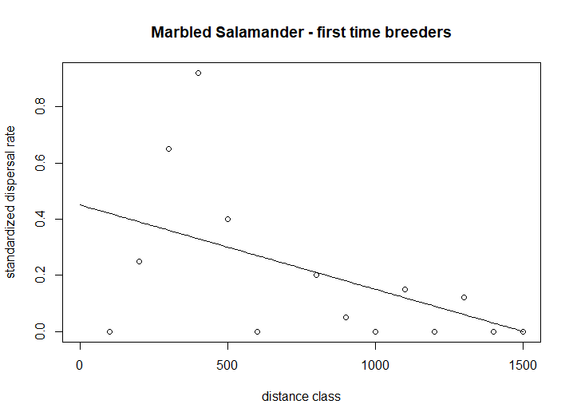

* **Q10 (2 pts.):** Exponential Model. Provide the values of the a and b. Briefly describe how you chose the values.

I chose an a value of 2 and a b value of 0.004. I chose the values by visual trial and error to find what best fit the data.

* **Q11 (2 pts.):** In your lab report, include a scatterplot of the salamander data with your fitted exponential model.

* **Q12 (2 pts.):** Ricker Model Provide the values of the a and b. Briefly describe how you chose the values.

I chose an a value of 0.02 and a b value of 0.008. Again I used a visual method of trial and error to find the values that would best fit to the data.

* **Q13 (2 pts.):** In your lab report, include a scatterplot of the salamander data with your fitted ricker model.

* **Q14 (4 pts.):** Show the R code you used to create your data frame of model residuals.

dispdata$y_pred_lin <- line_point_slope(dispdata$dist.class, -500, 0.6, -0.0003)

dispdata$resids_lin <- dispdata$disp.rate.ftb - dispdata$y_pred_lin

dispdata$y_pred_exp <- exp_fun(dispdata$dist.class, 2, 0.004)

dispdata$resids_exp <- dispdata$disp.rate.ftb - dispdata$y_pred_exp

dispdata$y_pred_rick <- ricker_fun(dispdata$dist.class, 0.02, 0.008)

dispdata$resids_rick <- dispdata$disp.rate.ftb - dispdata$y_pred_rick

resids_dataframe <- data.frame(dispdata$resids_lin, dispdata$resids_exp, dispdata$resids_rick)

* **Q15 (3 pts.):** In your lab report, include histograms of the residuals for each of your three models. You may create a single figure with three panels, or include three separate figures.

