**User Guide**

**The Application side:**

When the user runs the app for the first time they will be prompted to do two things. 1, verify age (Google needs users to be 13+ as the app sends ‘app use’ information to Google) 2, the connection to the database must be set up.

1:

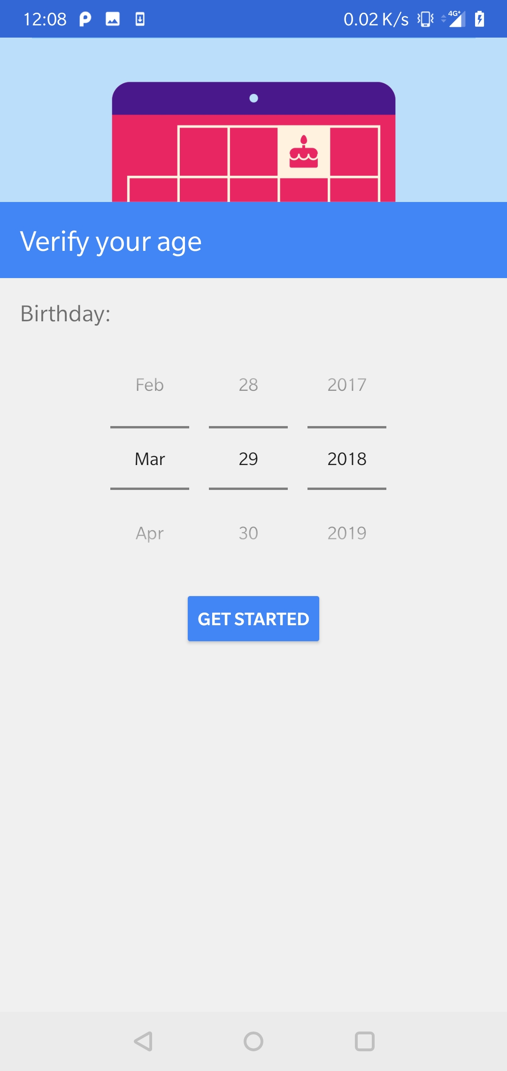

2. If the text boxes are empty there will be a message prompt.

User enters the data and presses enter button.

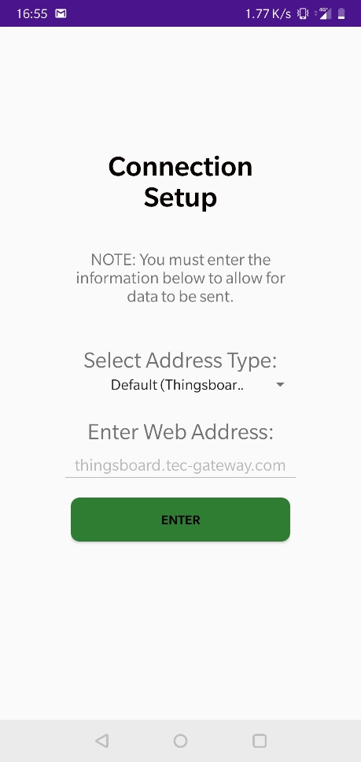

User confirms that the data is correct, or cancels which clears the text fields

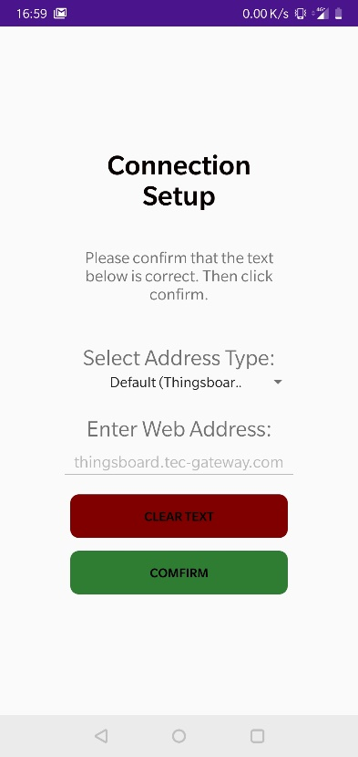

The main body of the app:

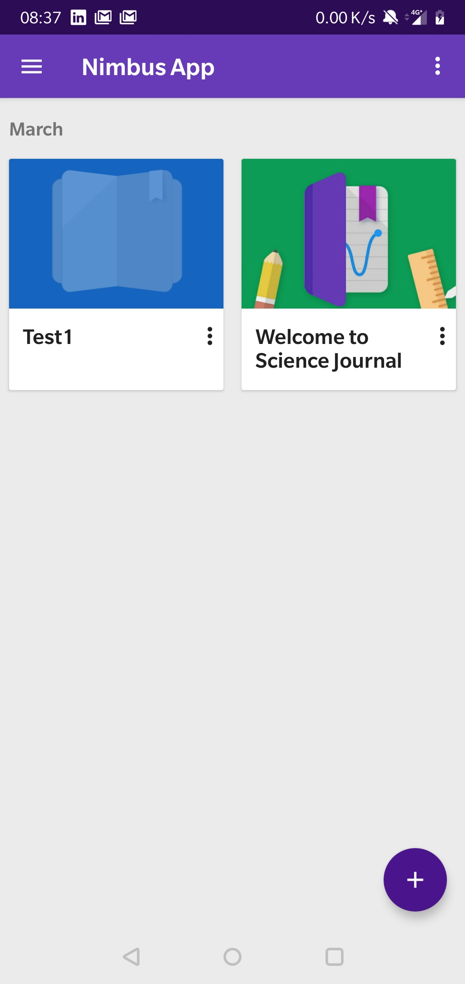

Press the plus button to add a new experiment and then edit the title.

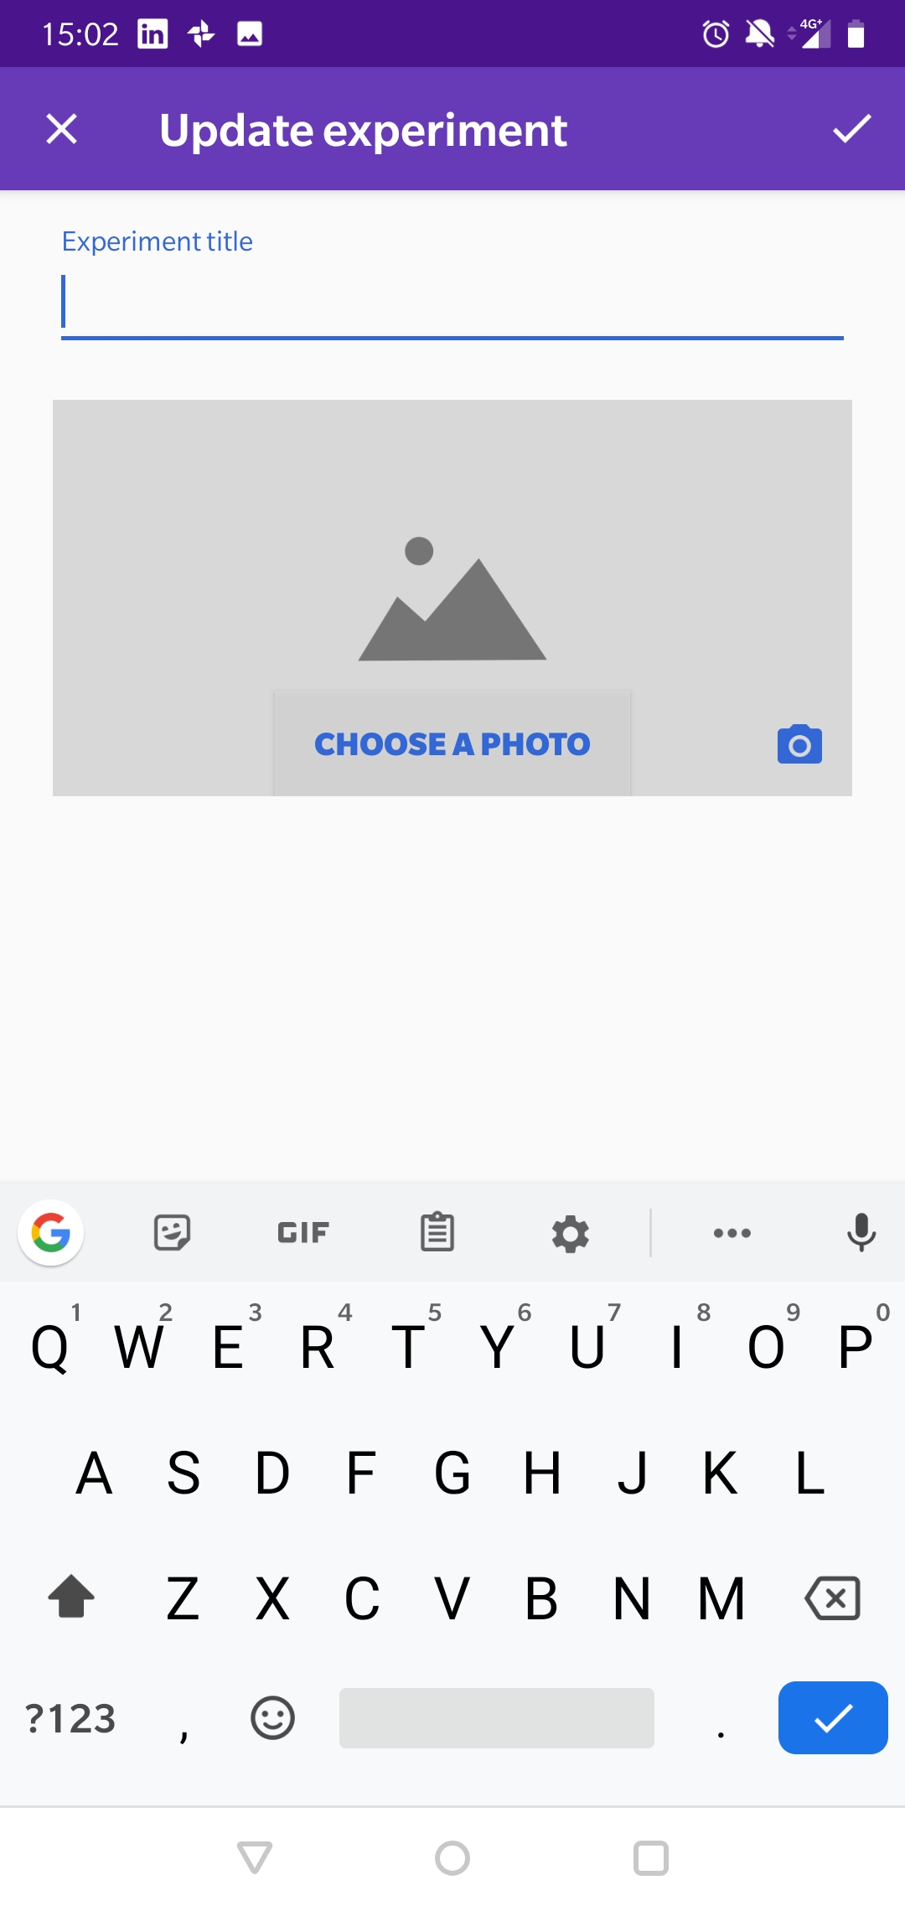

User is prompted for the Access Token for the experiment, this sends the data to the correct Thingsboard tables. This will also have a confirm window.

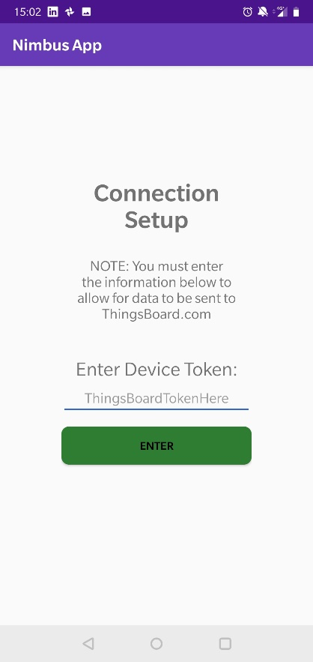

In each experiment you can add Notes, observe the sensors, take pictures (if there is a physical object/device) and add images from the gallery.

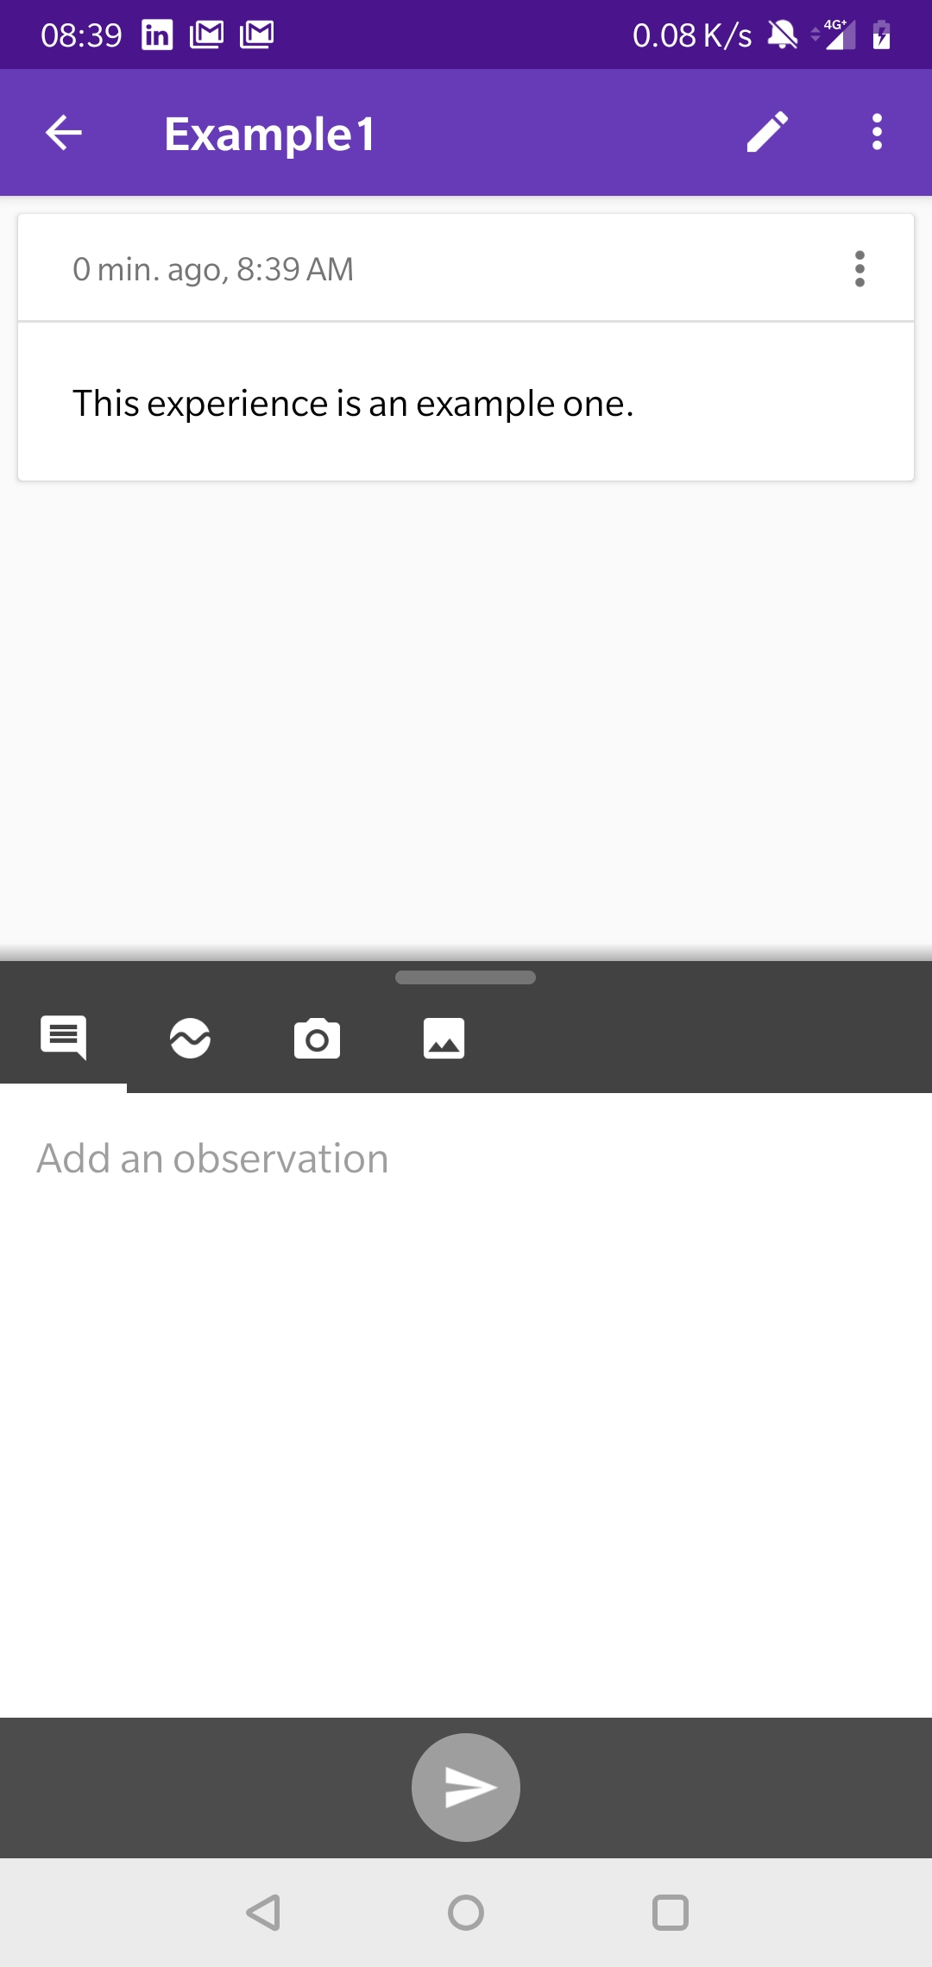

The sensors button (tab 2) has all the sensors with a graphical display.

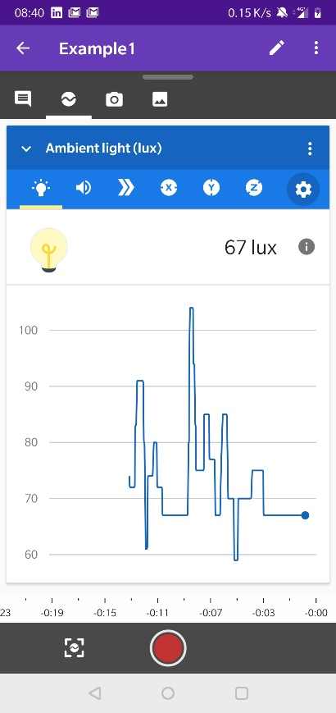

The sensors are: Light, Sound, Motion – Linear acceleration, and x,y,z axis, Compass Degrees and Magnetic field. Just click on the tab you want to view. There is also the capacity to connect via Bluetooth to external sensors and read that data (working on temperature and humidity)

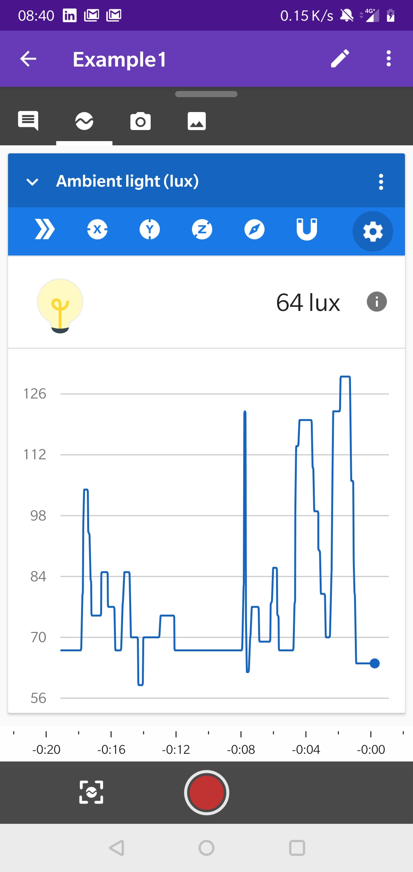

This settings gear leads to BT

Settings button – to set the which sensors you want on/off (see below)

The sensor name will be displayed and the user will be able to select the ‘unit type’.

With the colour picker user can select the chosen time frequency.

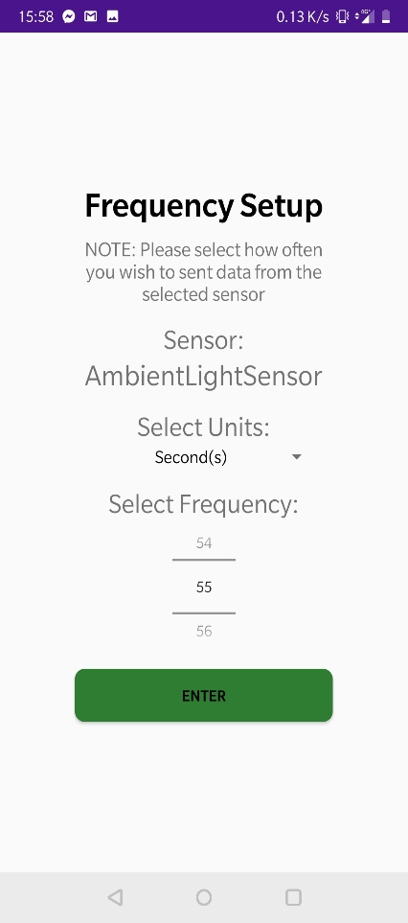

When you select click on the above setting gear this window will appear. Clicking on the button will begin a search

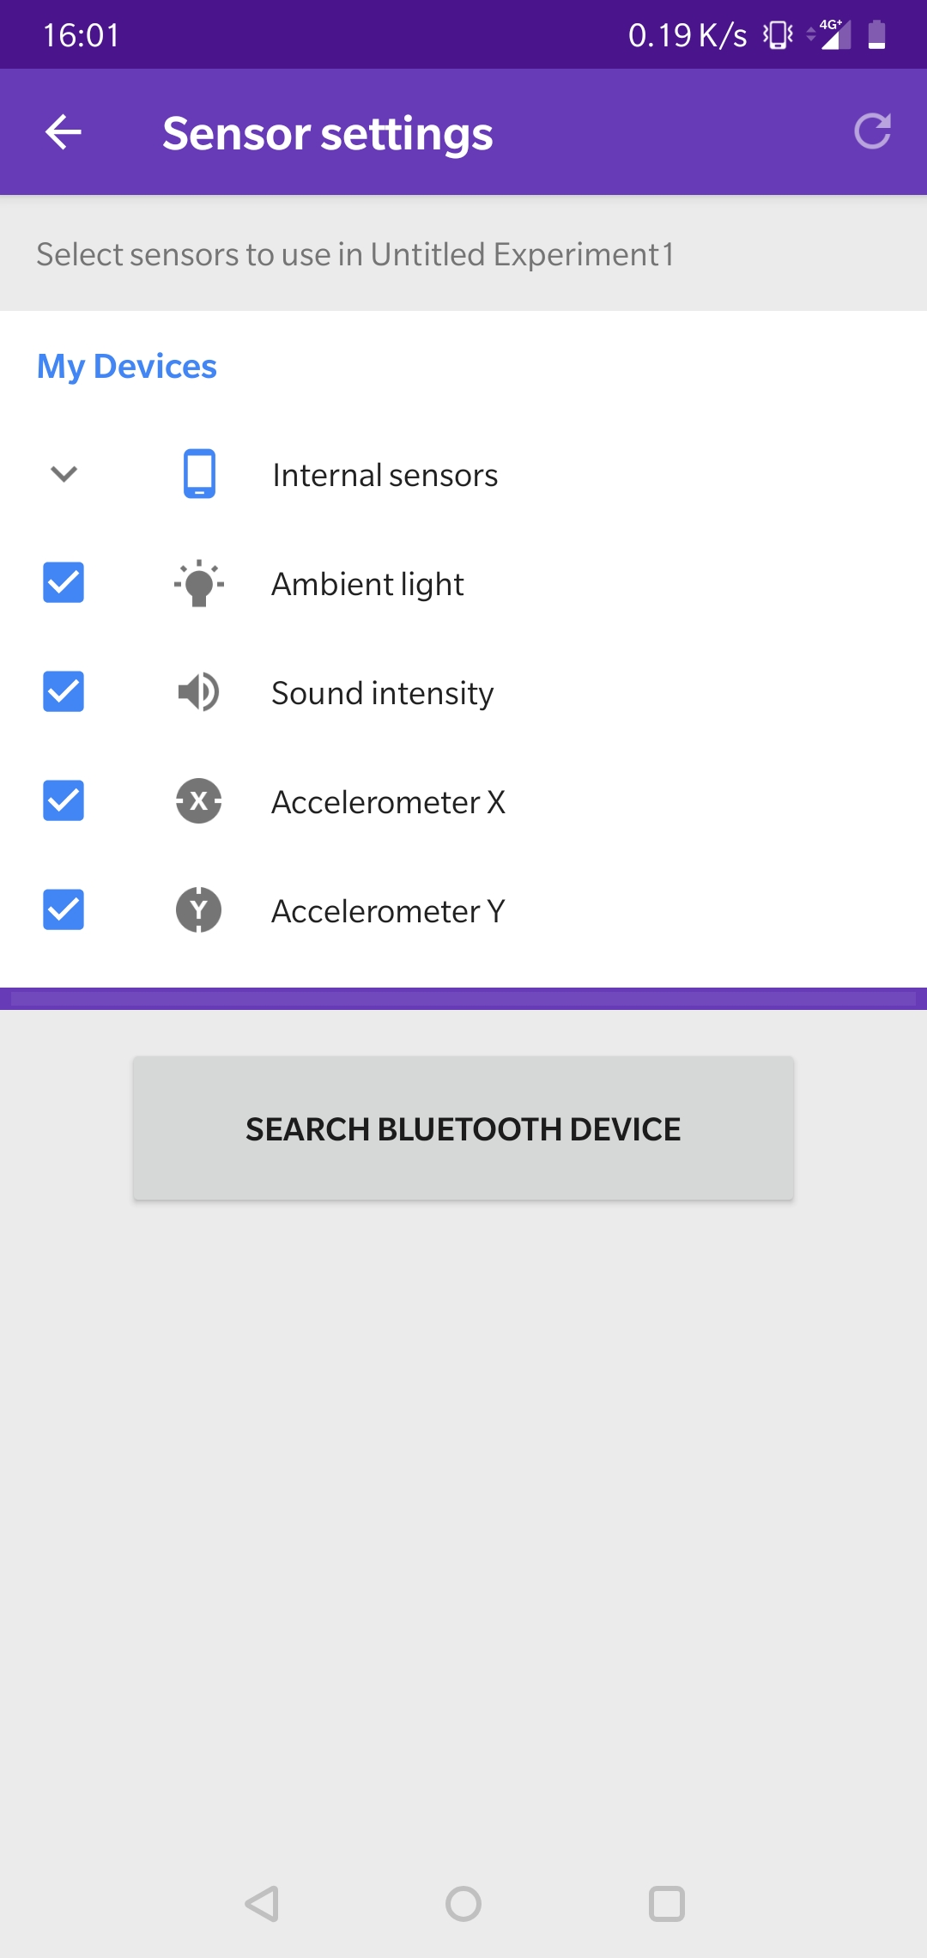

If there are ‘Texas Instrument cc2650 SensorTags’ around, they will be displayed. Connect

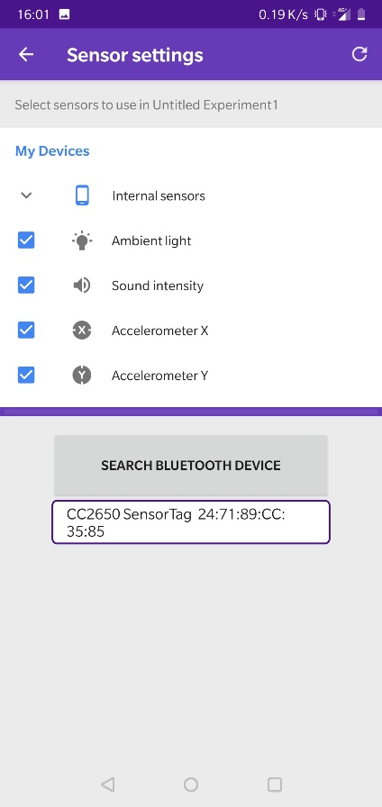

It is possible to take a value reading of the current sensor. This is added to experiment records

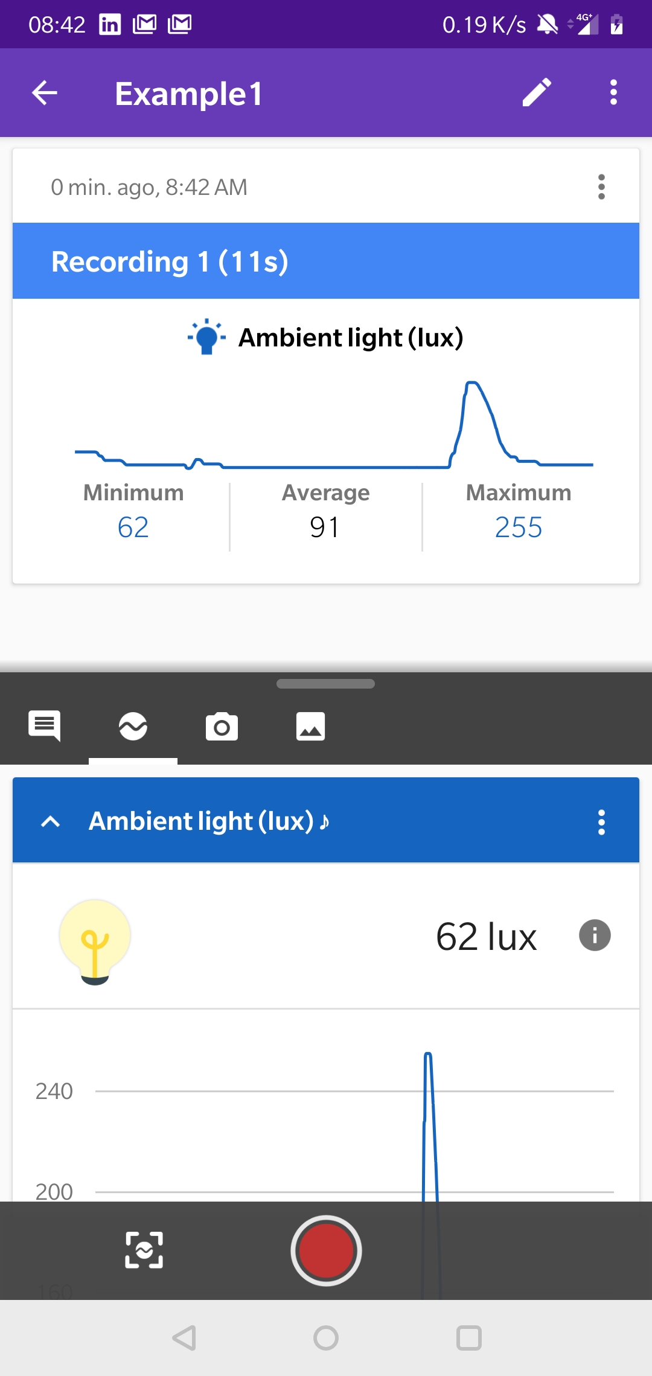

Record current value button

Value noted

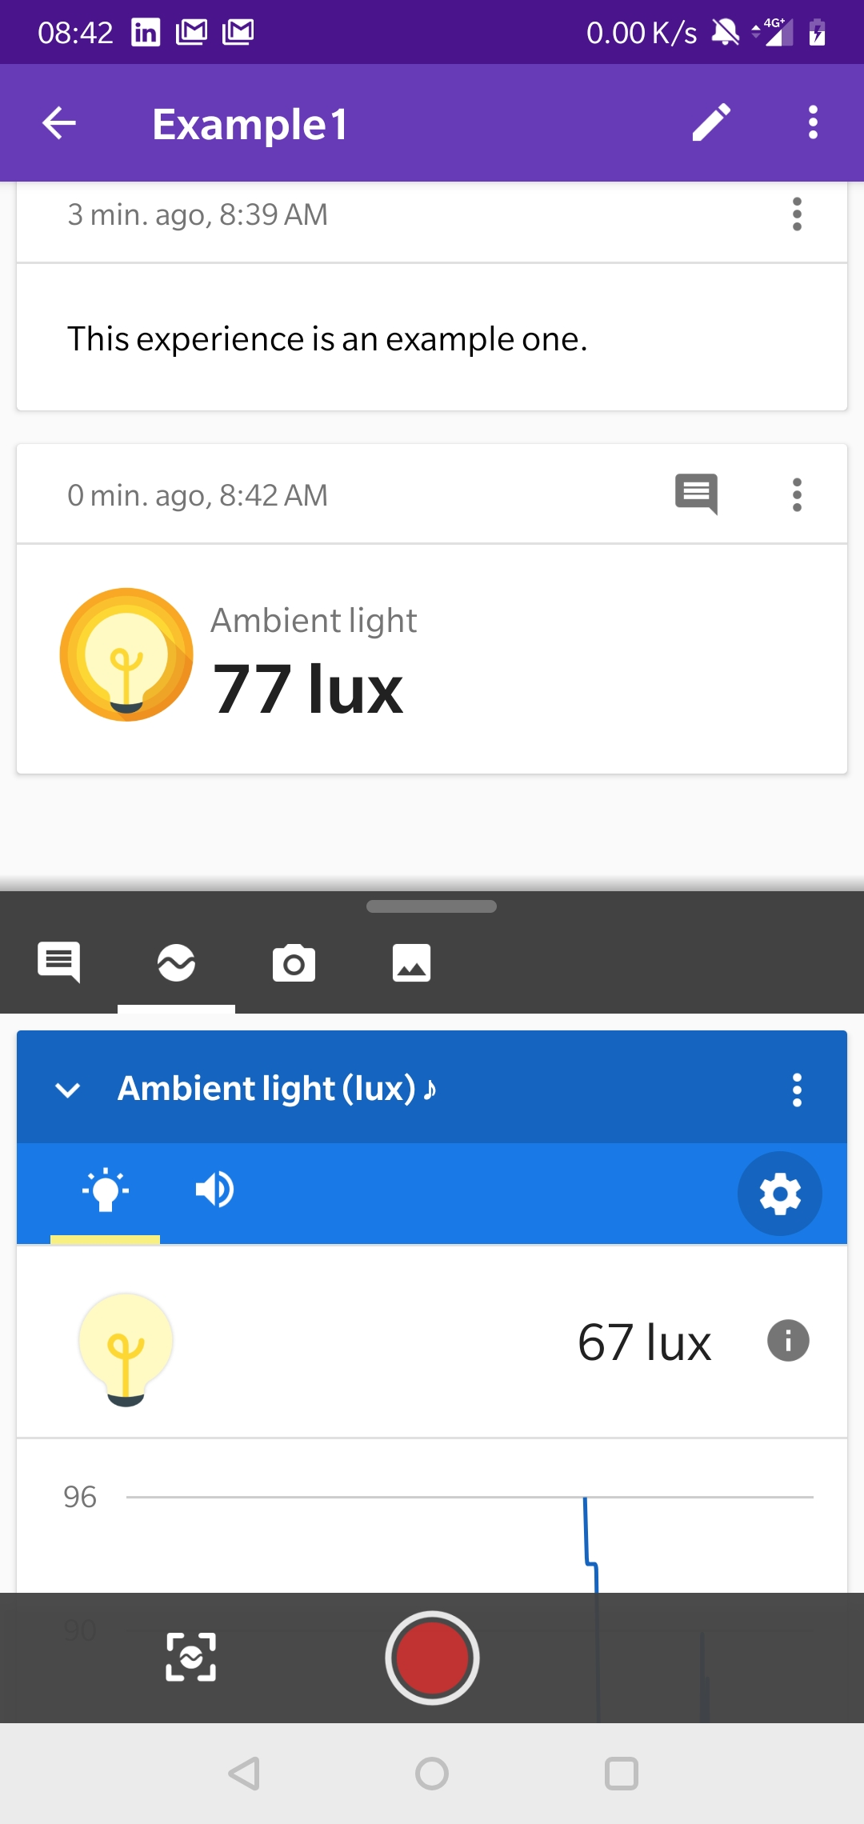

Triggers can be added to each sensor with different trigger points

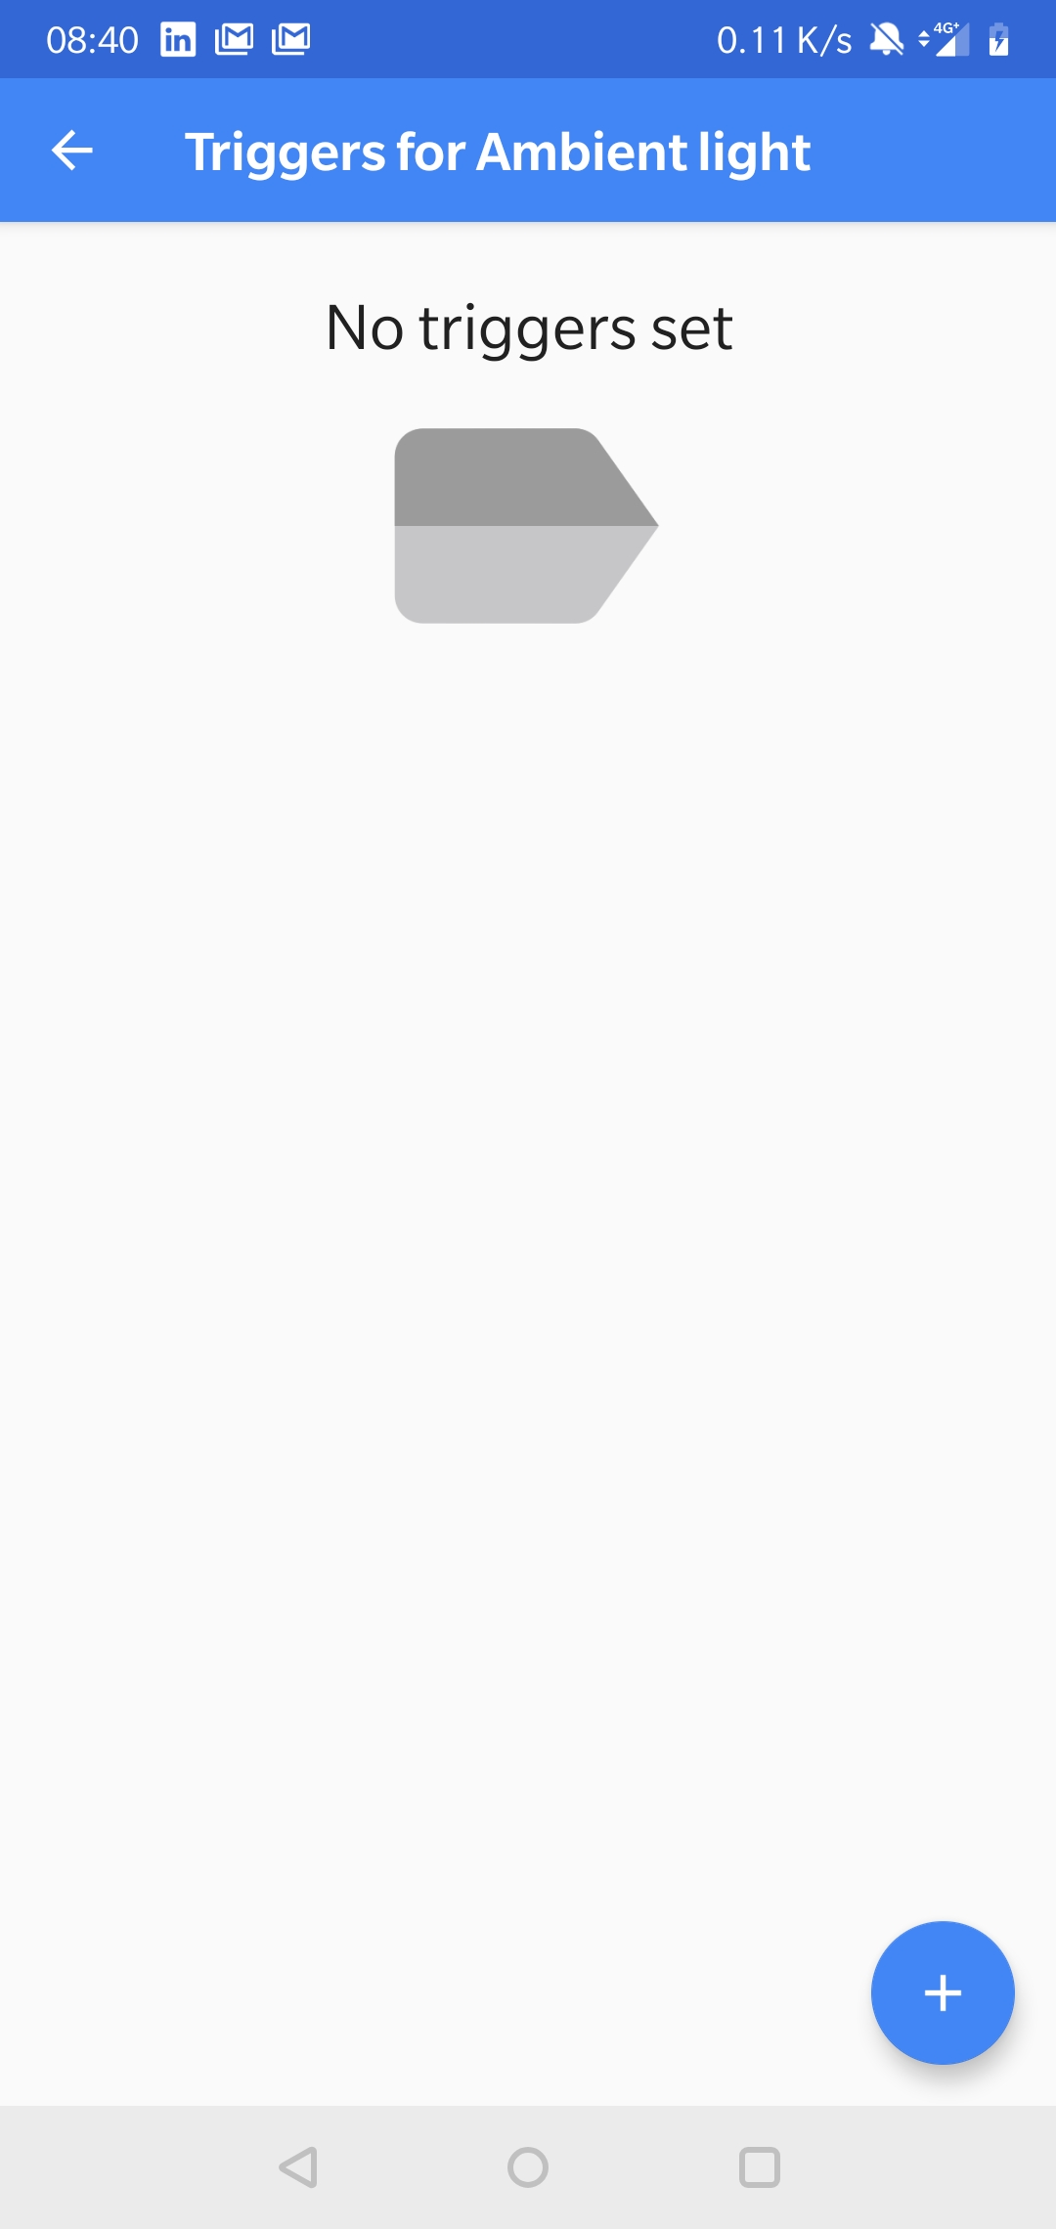

Example, Set to alert with vibration and visual notification when light is raises above 300 LUX

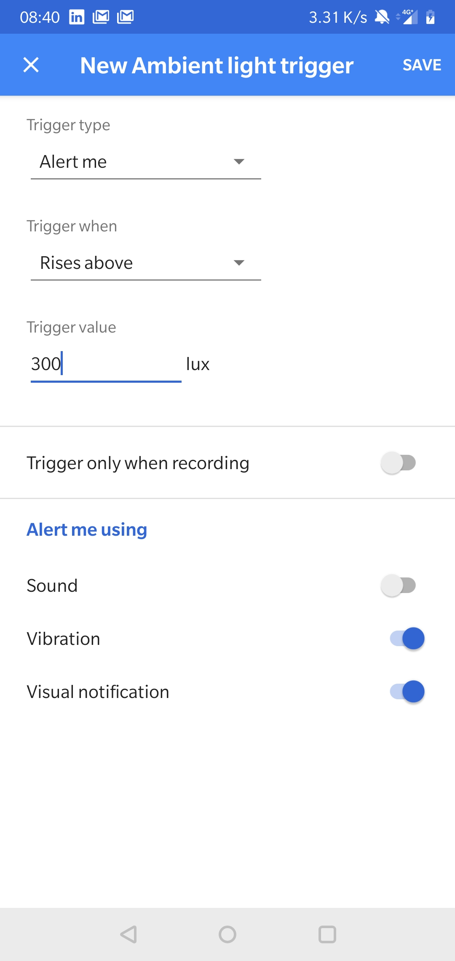

Active trigger

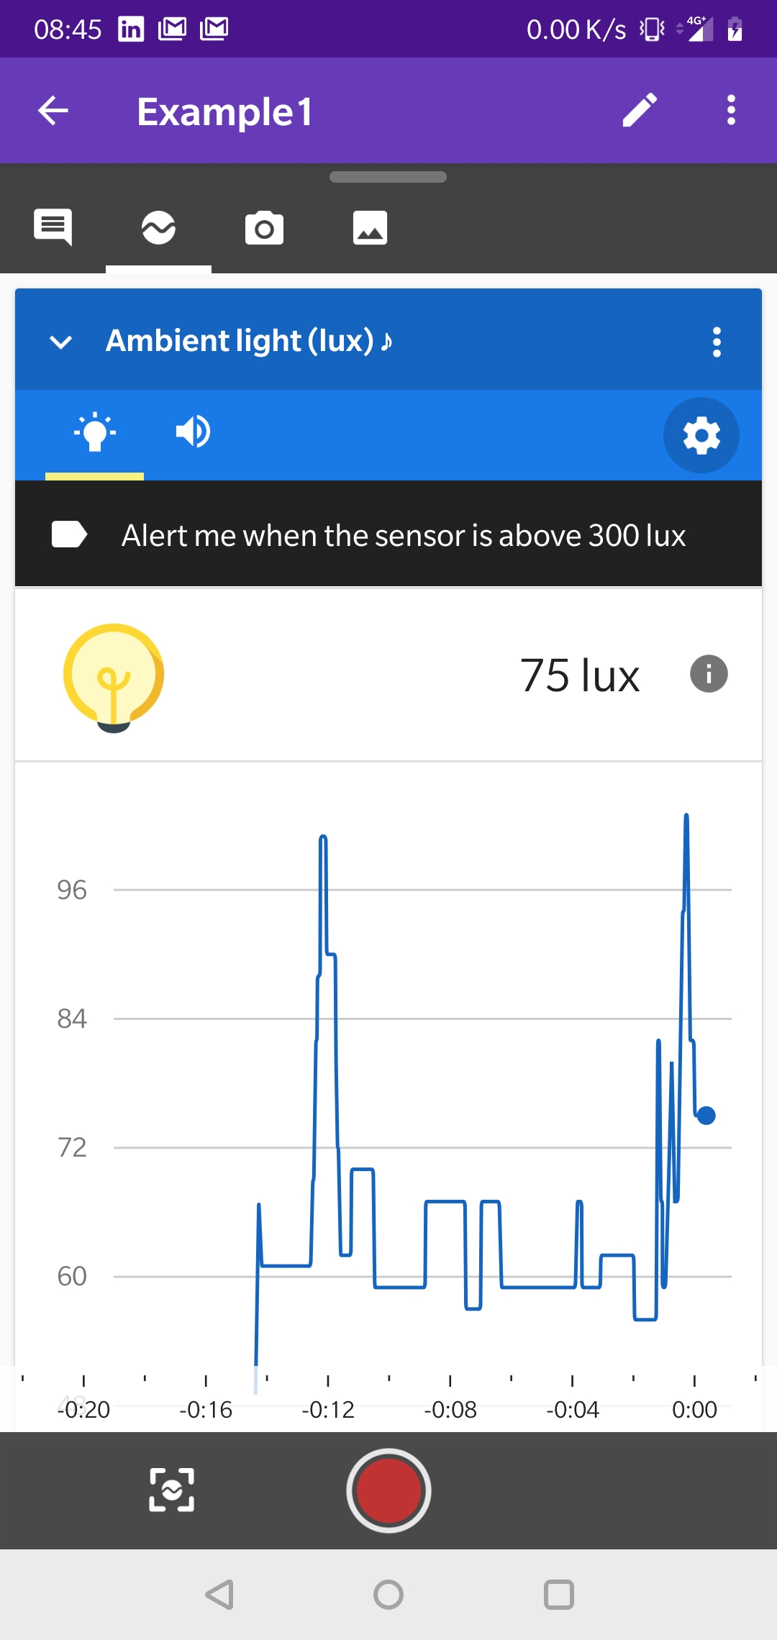

Trigger alert

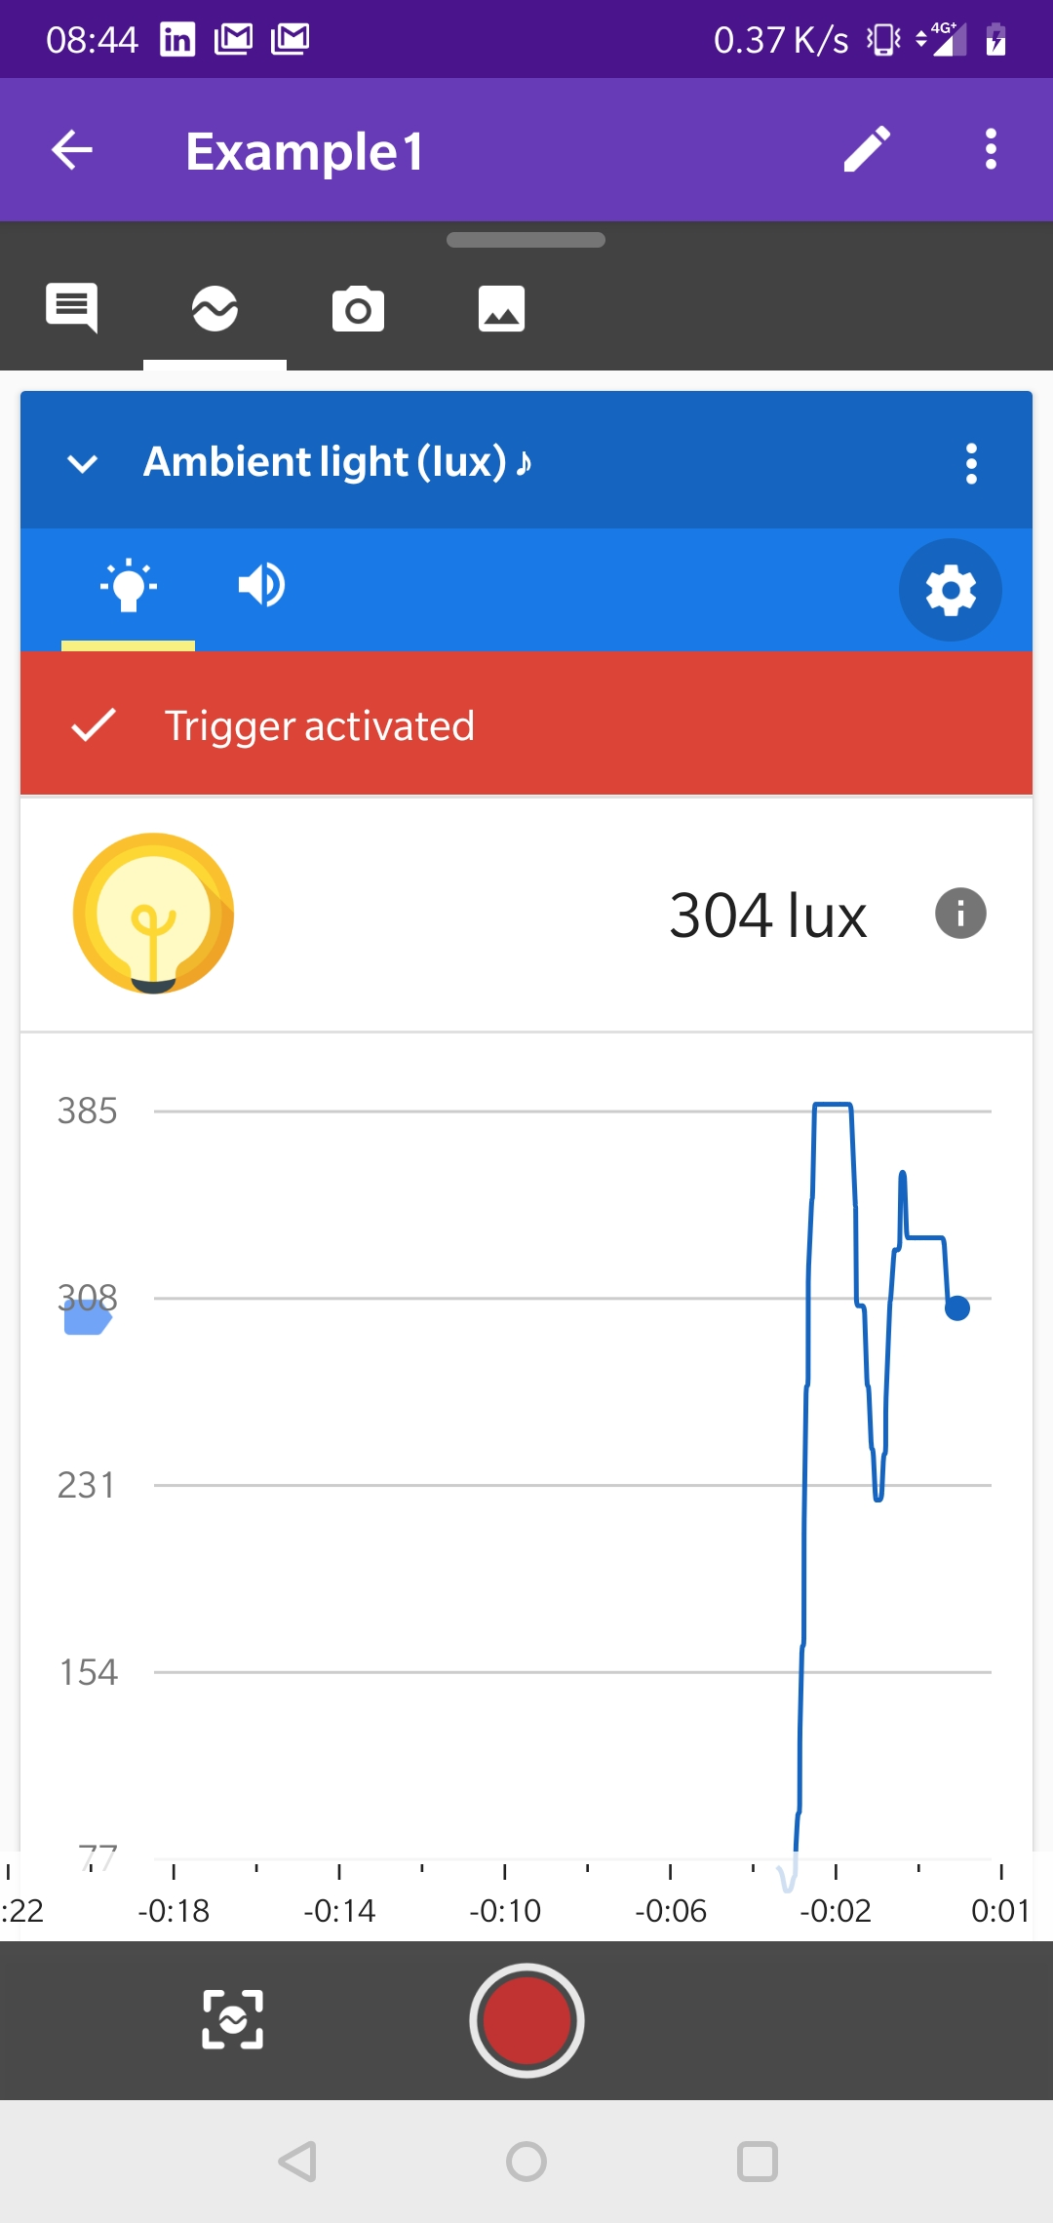

**The Database side:**

Login window

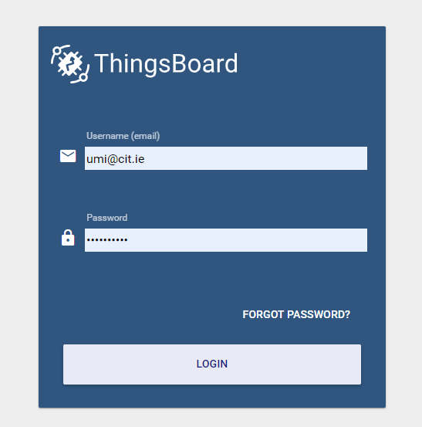

The main window

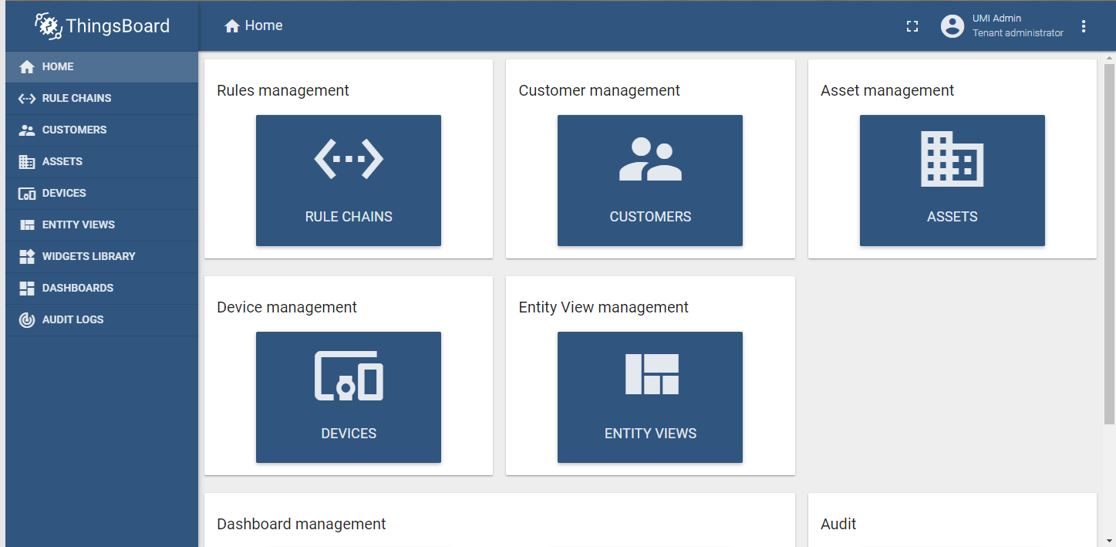

The Customers window, in this case the customer is the school. Click on the plus to add a new school

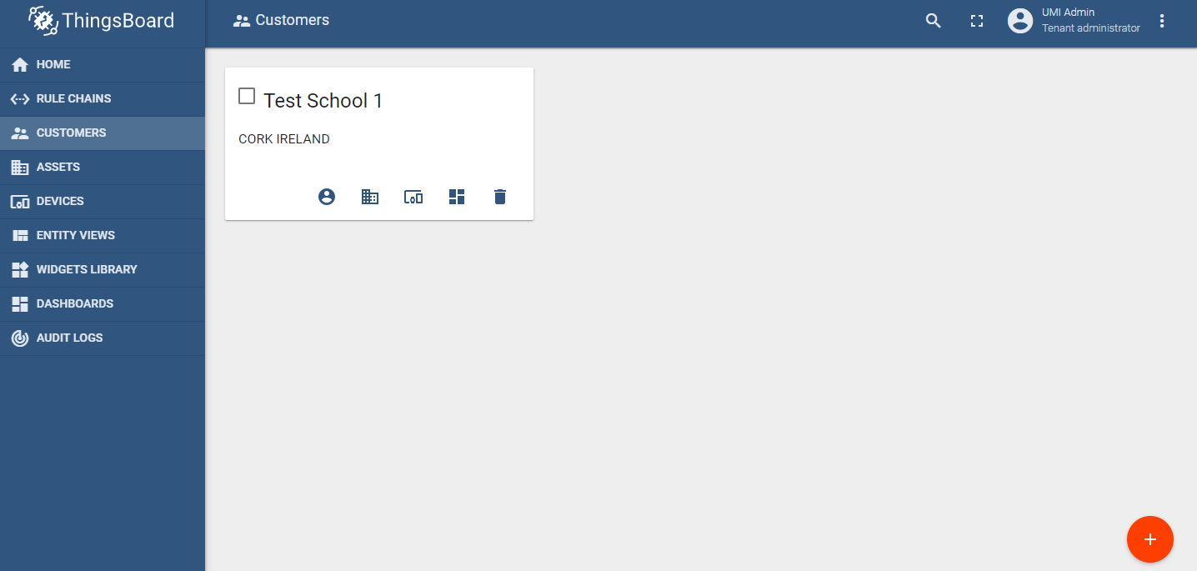

Enter the school details and click add

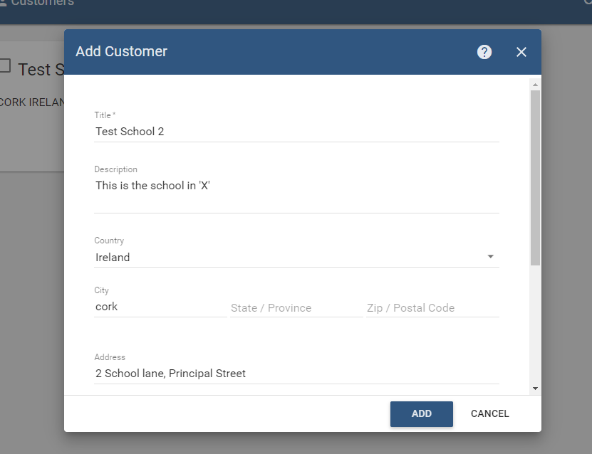

Test School 2 is now there

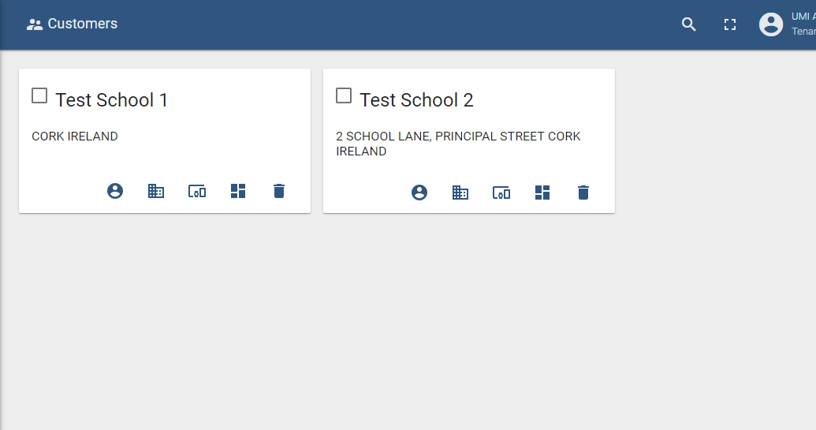

The Devices window is where you register the device, in this case the phone. Like the customers window, click on the plus to add a new device.

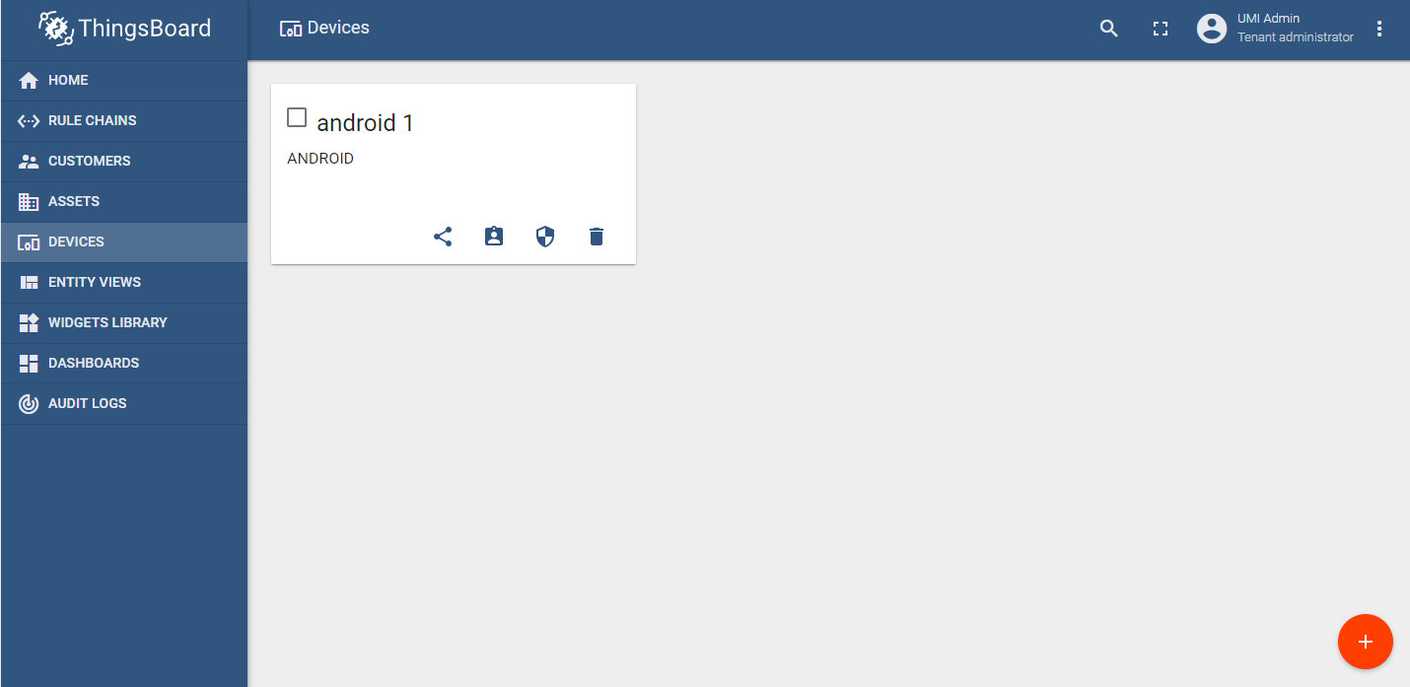

Enter the name and the device type. Click add.

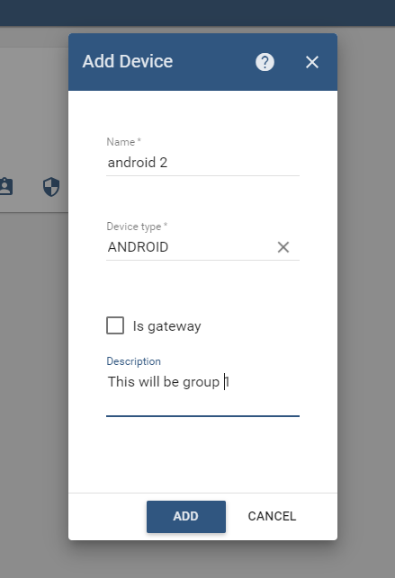

Android 2 is now there

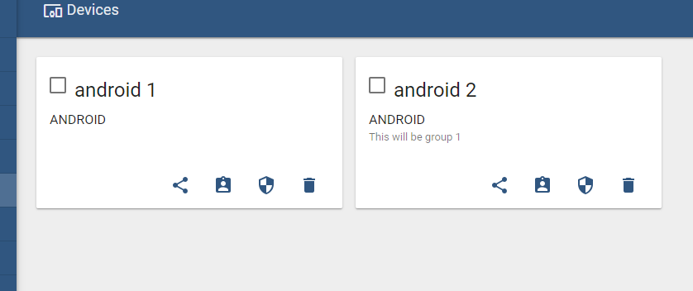

Click on the device and you with see this window. From this window you can manage the device details, see that data as it comes in, set alarms and more.

Click on Manage Credentials to see the access token needed for the phone application.

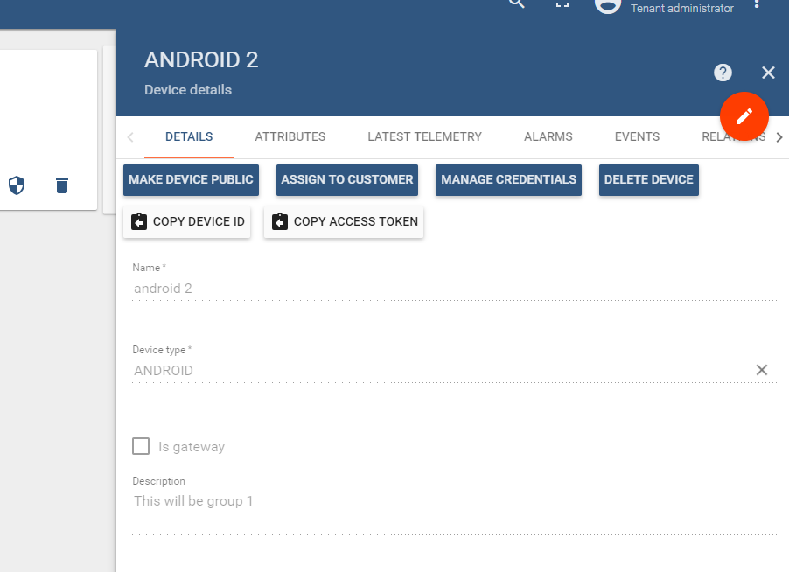

To see the latest data click on Latest Telemetry.

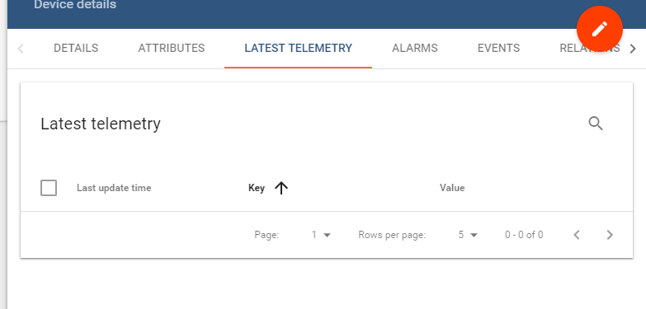

As soon as the device starts to send the data it will start to appear here.

Note: all data from the device will go here, to differentiate the data the name value ‘KEY’ is made up of ‘experiment name_sensorName’.

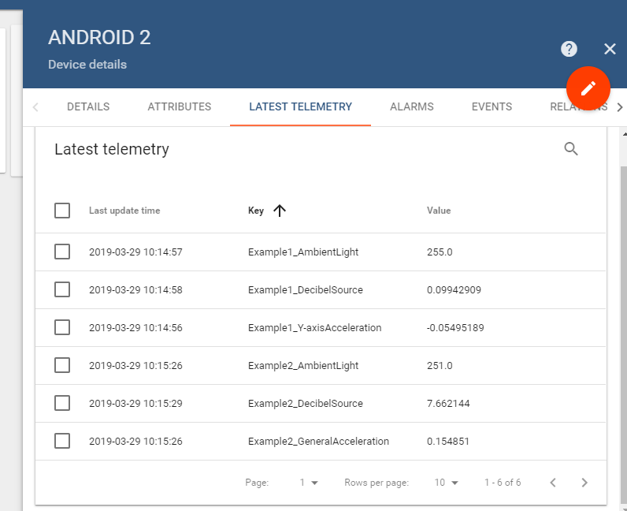

To display the data the user will select the fields and click on the ‘Show on Widget’ button. There are 2/3 different ways to set up the display of the data but this way is simplest.

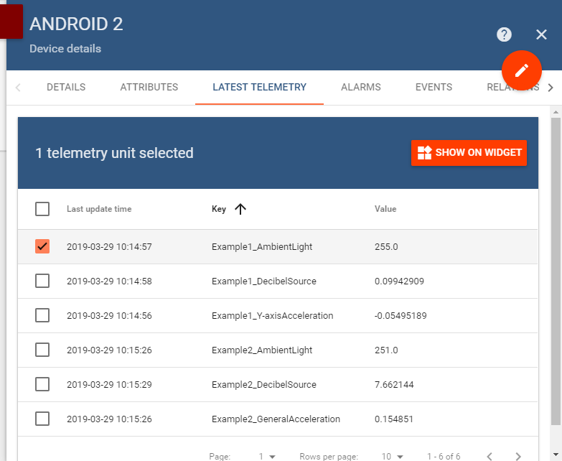

The user will then select the type of display to show the data

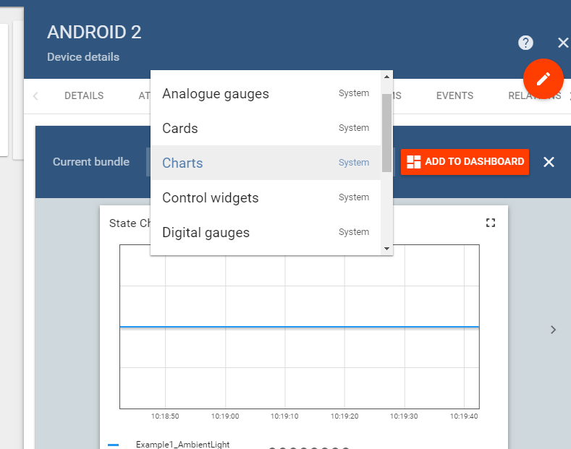

Finally add this to the dashboard that you wish to display it on.

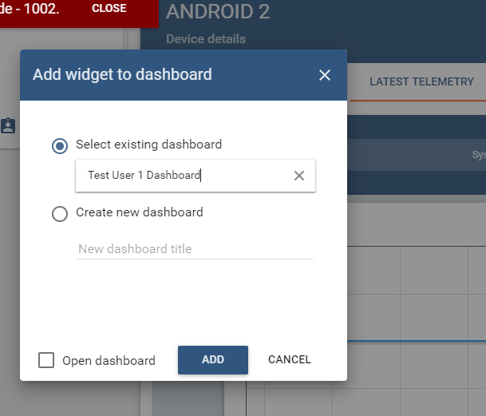

In the Dashboard window, the user can click on the specific dashboard and see the widgets.

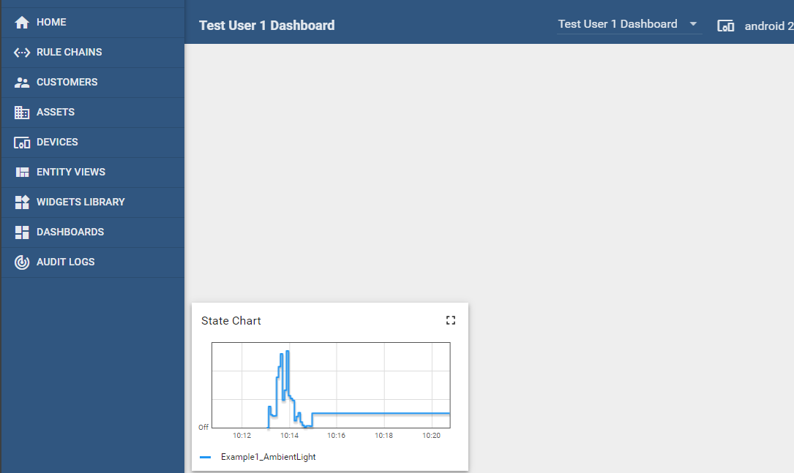

There are many different widgets to choose from and each can then be modified more once on the dashboard.

