WSOA3004

Group 6 Prototype 1

Game Design Document

29 July 2019

# Team Members and Roles:

Matthew Morris – Project Manager

Leoake Nkakala - Designer

Alexandros Flerianos - Programmer

Dhannya Mathew – Visual Artist

Talitha James - Visual Artist

# 1.   Game Name

Eye Spy: Cloud Edition

# 2. Game Overview

This is a game aimed at children aged 7 to 10. It involves image recognition and word typing. Whereby the player must to type out the name of the object that comes to screen. For example; a cloud resembling a baseball bat. The game is aimed to educate the young growing minds with basic word vocabulary as well as increase familiarity with computers and more specifically, typing).

## 2.1. Game Concept

The game is based on a young child who is on a road trip. The trip is lengthy, and the child starts to look for images in the clouds as a form of entertainment. The game involves various animal shaped clouds, which the player must try guess and type in the name of the animal the cloud represents. The game will have a day and night cycle which aims to solidify the length of the road trip. The game ends when the night cycle ends, or the player has attempted to guess all possible clouds. The player is then shown how many they got correct at the end of the game.

## 2.2.   Genre

The game is intended to fall under the educational genre.

## 2.3.   Target Audience

Children between the age 7 and 10.

## 2.4.   Game Flow Summary

The player begins in the main menu. They have the option to play the game or to learn how to play. If the player chooses to learn how to play, they are guided through guessing one of the clouds. This level is described in greater detail in the tutorial level section of this document.

The main game level features a randomly selected cloud from the clouds created. The player then attempts to name the animal which the cloud represents. When correct the cloud will quickly float off the screen and another will follow shortly. If the player is incorrect, they can continue to guess until the cloud has left the screen.

At the end of the game the player is taken to a game over screen where they are shown a short message which tells them how many clouds, they were able to correctly guess.

## 2.5.   Look and Feel

The appearance of the game is based on a crayon style. All assets designed using crayon brushes. The game assets for example; the clouds use a flinch animation style. The game is flat 2D with hand drawn designs to give them a natural feel which young children can easily relate to. The game prioritises the use of bright colours for example; powder blue, yellow and white. These colour choices were chosen specifically for readability choices. The game has day and night time a design choice to assist in imitating the length of the road trip.

# 3.      Gameplay and Mechanics

The use of underscores for input representation for example; hangman style. The player types each character of the word which they think the cloud is representing, using a keyboard as the controller.

The main goal for players is to type in the word that resembles the represented cloud figure. The players have a set time under which they will be allowed to input the word on screen. Upon success the inputted word will be coloured green and remain on screen until the cloud leaves, while incorrect input will change the colour to red.

## 3.1.   Gameplay

The game is text based. The player uses their keyboard to enter their guess. If they are correct the cloud will speed up and move off the screen faster and allow the player to attempt more clouds before the time runs out.

If the player is incorrect, they may continue guessing until the cloud moves off the screen at which time they will not be allowed to input anymore and instead are shown what the correct word was.

## 3.1.1. Game Progression

Different cloud shapes will appear across the screen moving from right to left. Each cloud has a different form and will have a set time for the player to insert the correct word into the placeholder before the cloud moves off the screen.

Ideally the game would progress through harder word progression, such as from something simple like cat, to something more complex such as a rhino. This could also be implemented with different categories. However, for this prototype this is not the case and the game is completely random with which order the clouds appear throughout the game.

## 3.1.2. Mission/challenge Structure

Player must type in the correct letters to create a word that best matches the displayed object. Challenge is presented in the form of stop timer of 10 seconds for each word.

## 3.1.3. Puzzle Structure

Clouds are created to resemble but not completely give away the object presented.

## 3.1.4. Objectives

The objective of the game is to create an enjoyable environment where children can practise their English vocabulary and become more familiar with using a keyboard and computer. The game achieves this by requiring players to guess what shape clouds represent and then correctly spell their answer by typing in the matching word. The art style of the game as well as audio solidify the enjoyment of the experience by using crayon art style and audio, which both feature upbeat qualities.

## 3.1.5. Play Flow

Game flow is completely static across the game. The player has 10 seconds to guess and correctly input the word which is represented by a cloud.

Ideally this would change, and the game would feature clouds which represent words that increase in complexity in a linear fashion. However, this will not be the case as we are heavily influenced by time.

## 3.2.   Mechanics

The game features uniquely shaped clouds which the player must try to guess what they represent. The clouds float across the screen from right to left, the cloud traverses this distance in 10/15 seconds. As soon as the cloud appears on the right side of the screen placeholders appear indicating to the player how long the word which represents the shape of the cloud is. The player then uses the keyboard to type each letter of the word which describes the shape of the cloud.

Upon guessing incorrectly, the players answer is cleared and the player may guess again as many times as they can, before the shape leaves the screen. Upon leaving the screen without the player guessing the word, the correct word will appear, showing the player the correct answer, before the next cloud does.

If the player guesses the word correctly, the word changes colour to green and the players input is no longer registered until the next cloud appears. As soon as the correct word is entered the cloud will also move faster off the screen allowing players to attempt more clouds.

This continues until the player has either guessed all available clouds or they have run out of time (represented by a day and night cycle). In which case the player is shown a game over screen where they are told how many correct answers, they got vs how many clouds they attempted to guess.

## 3.2.1. Physics

There are no physics within Eye Spy - Cloud Edition. The game uses a static car which represents the player on a road trip. Using parallax, the environment scrolls across the screen giving the illusion of the player moving.

## 3.2.2. Movement in the game

Since the player’s input into the game is only typing out words, the only movement is back which is controller through the backspace key. Which allows players to remove letters in scenarios where they have made a mistake.

## 3.2.3. Objects

The game features a few objects, there is a car, a road, background clouds, grass and the animal clouds. These objects are not interactable.

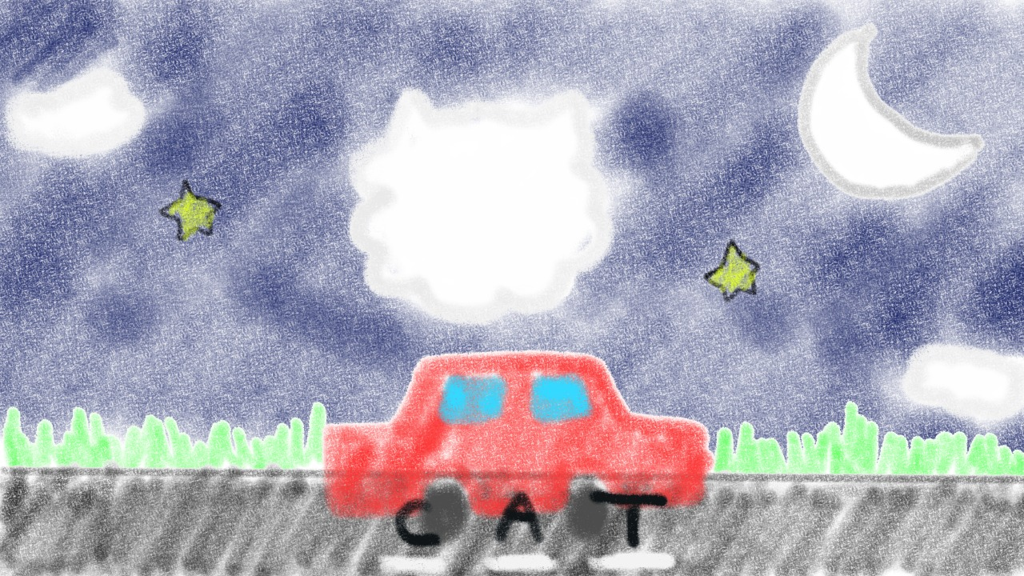

## 3.2.4. Actions

During the main menu (start of the game), players can choose between 4 different menu options these options allow the player to choose between playing the game, learning how to play the game, going to a settings menu, viewing credits and quitting the game.

Both playing the game and learning how to play will take the player to a new scene where they can play the game. The players options are then to type on the keyboard, trying to name the type of animal a cloud represents or opening a pause menu using the escape key on the keyboard.

If the player chooses to go to the settings menu, the player has the option to change the graphics quality, the screen resolution as well as both the music and sound effect volumes. There is also an option to make the game Fullscreen or not.

3.2.5. Screen Flow

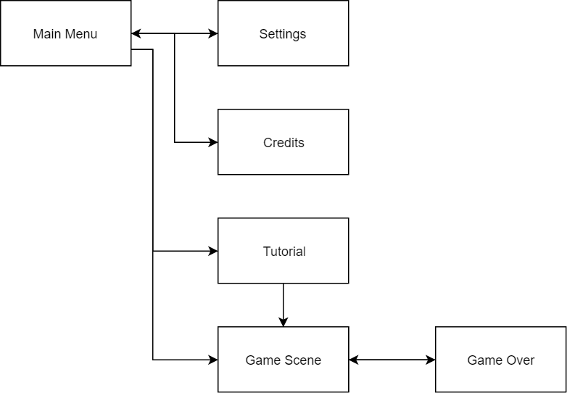

Figure 1 - Flow Diagram Illustrating the Screen Flow

# 4.      Story, Setting and Character

## 4.1.   Story and Narrative

The story behind the game is that the player is a child on a road trip. Sitting in the back seat of a car the player is staring out of the window, gazing at the clouds. The player sees that some clouds have shapes to them which resemble real world animals.

## 4.2.   Game World

## 4.2.1. General look and feel of world

The game world had a crayon coloured in art style. The look and feel is that of a child's colouring in book. Illustrated below,

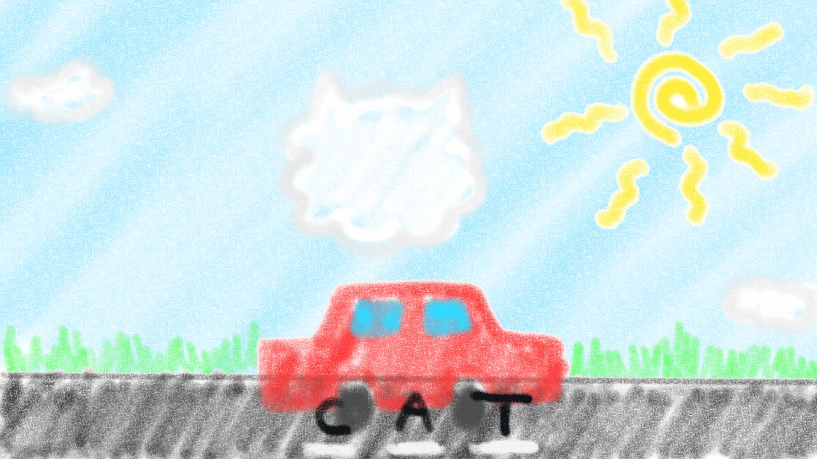

Figure 2 - Game Scene Concept Art

# 5.      Levels

## 5.1.   Levels.

The game features just one level, which has both a day and night cycle. The level is a road which is parallaxed with green grass next to the road and clouds in the sky. Using a day - night cycle and the sun and moon objects, the level aims to portray the length of a long road trip.

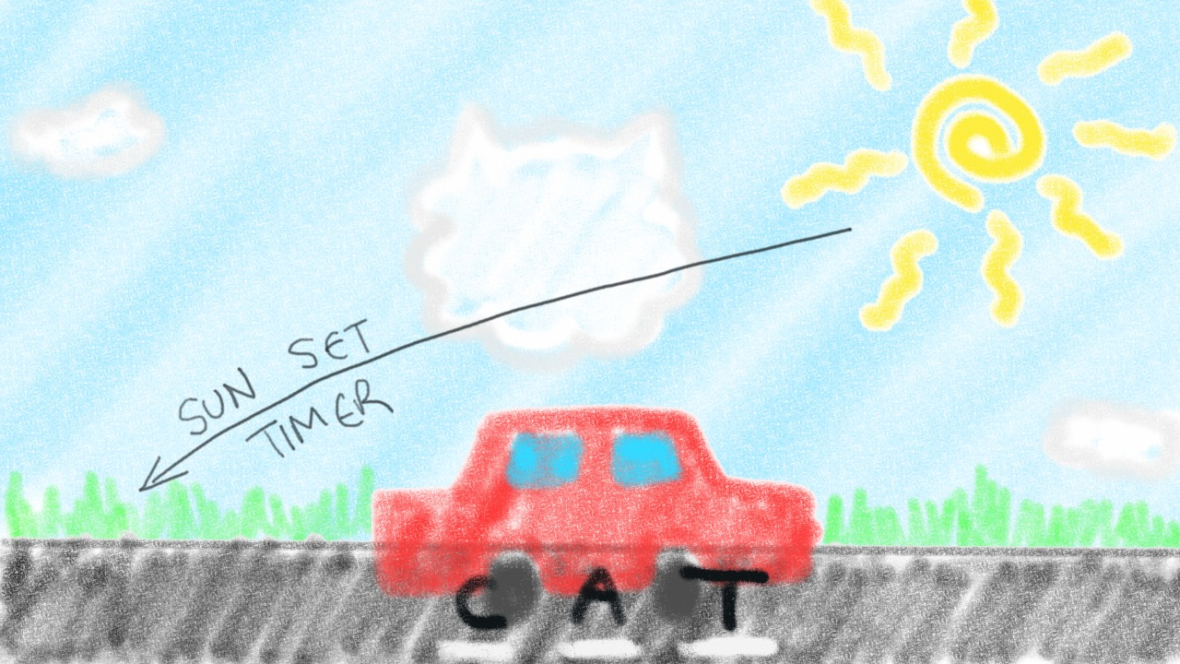

Figure 3 - Concept Art Illustrating Day Timer

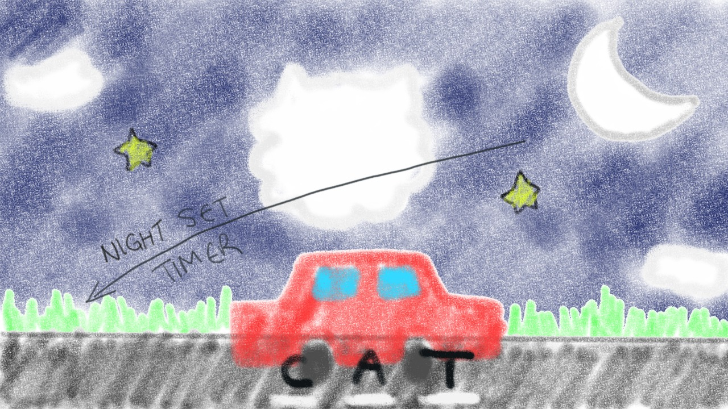

Figure 4 - Concept Art Illustrating Night Timer

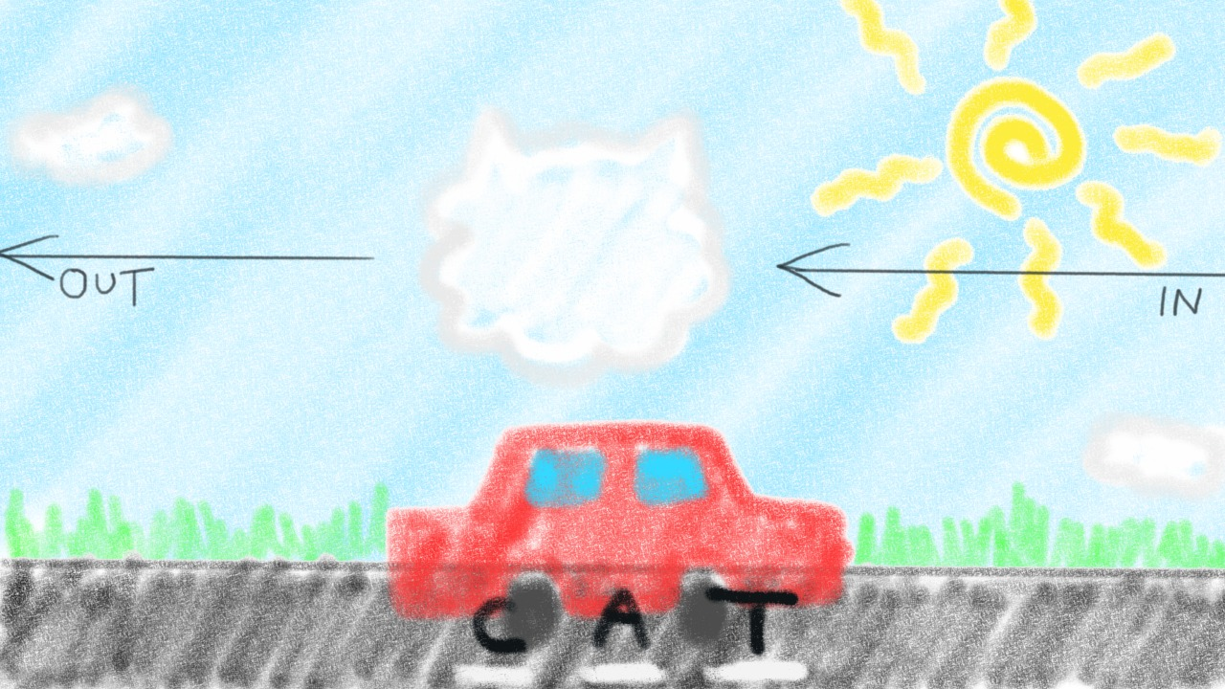

Figure 5 - Concept Art Illustrating Cloud Movement

## 5.2.   Training Level

The game features a training level which is static with a very short word. The player is guided through guessing the cloud’s type of animal, through the use of a keyboard with highlighted keys to illustrate how the player interacts with the game.

# 6.      Interface

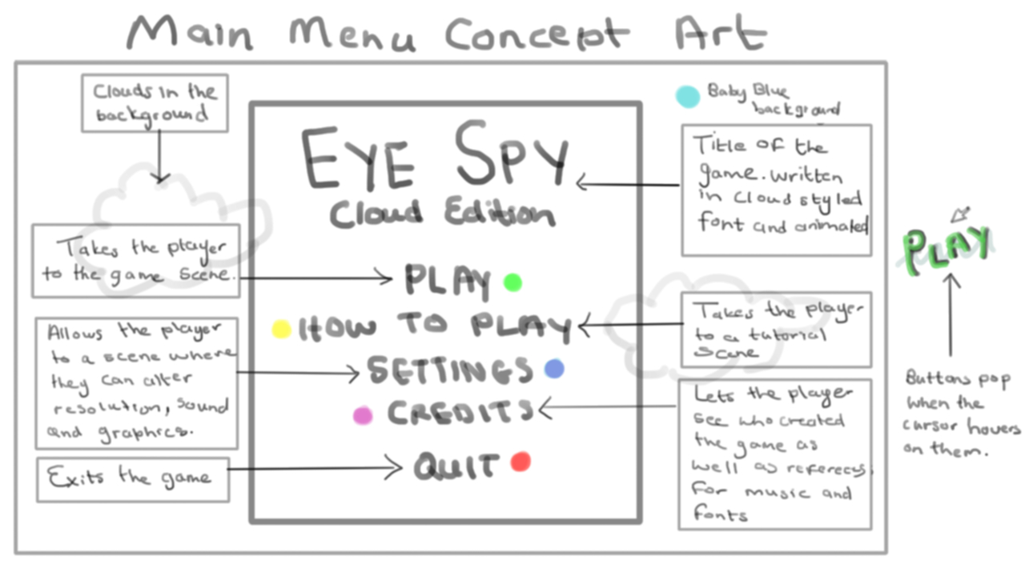

Figure 6 - Concept Art Illustrating the Menu Style

## 6.1.   Visual System

The visual interface which the player has during the game level is simply underscores to denote which letter of the word they are currently implementing. The style is the same as that of hangman. This shows the player the length of the word and their current position within the word.

## 6.2.   Control System

The player uses the mouse or keyboard during the menus, in order to scroll through and click on the buttons. During game play the player uses the keyboard to type out the world they think the cloud is in the shape of, or the escape key in order to bring up the pause menu.

## 6.3.   Audio, music, sound effects

Ambient music for both the menus and during gameplay. This should be uplifting, happy tunes suitable for young audience. Audio for feedback on button hover and click, as well as for correct answers and wrong answers. There also needs to be an ambient sound for the car.

# 7.      Technical

## 7.1.   Target Hardware

This game is designed for computers, either laptops or desktops. The game will be solely available on windows. The reason this is a computer game, is because it requires a keyboard for its current implementation.

## 7.2.   Development hardware and software, including Game Engine

* Krita - used for art assets.
* Unity - Game engine

## 7.3 Code Structure

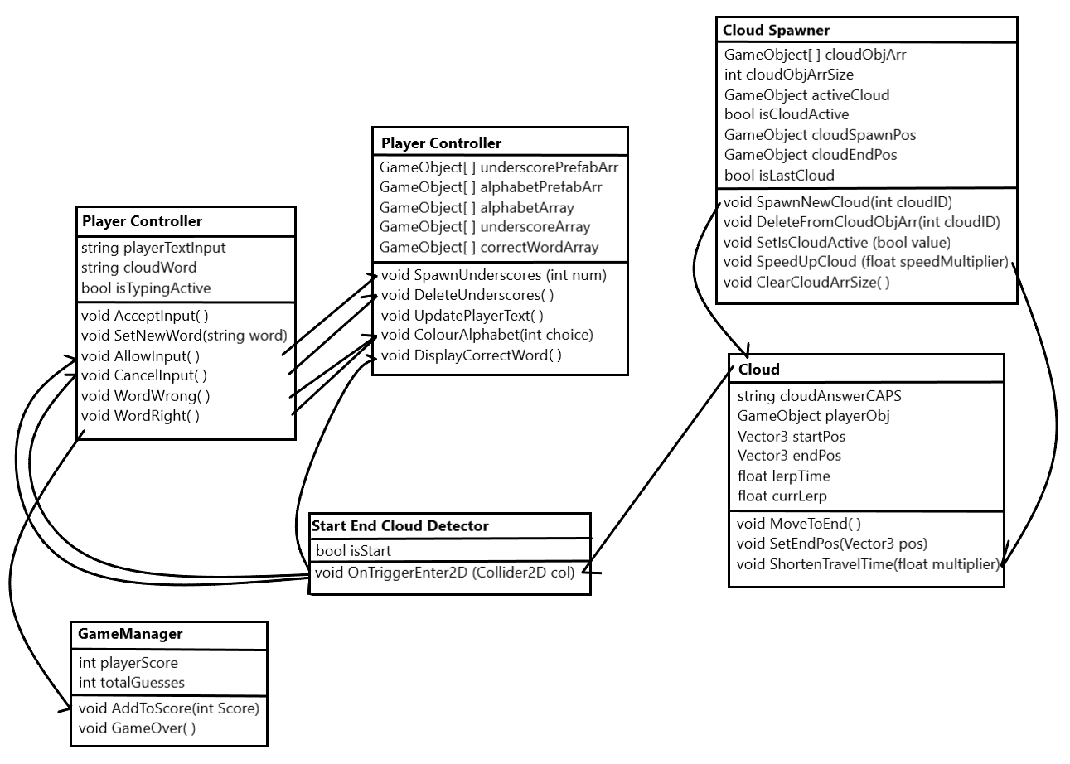

Figure 7 - UML Class Diagram for Eye Spy - Cloud Edition

# 8.      Game Art

List of art assets:

* Road
* Car
* Sun
* Moon
* Day time background
* Night time background
* Grass background
* Keyboard overlay
* Clouds:
  + Cat
  + Bee
  + Bird
  + Bunny
  + Dolphin
  + Elephant
  + Lion
  + Octopus