Stochastic Topographical Mobility Analysis (STMA) in the Copenhagen Metropolitan Area

Matthew Papesh

2025-04-23

#Include needed libraries below:

suppressWarnings({  
 if(!require("ggplot2")) {  
 install.packages("ggplot2", repo="http://cran.us.r-project.org", quite=TRUE, message=FALSE)  
 require("ggplot2")  
 }  
 if(!require("ggtext")) {  
 install.packages("ggtext", repo="http://cran.us.r-project.org", quite=TRUE, message=FALSE)  
 require("ggtext")  
 }  
 if(!require("tidyverse")) {  
 install.packages("tidyverse", repo="http://cran.us.r-project.org", quite=TRUE, message=FALSE)  
 require("tidyverse")  
 }  
 if(!require("dplyr")) {   
 install.packages("dplyr", repo="http://cran.us.r-project.org", quite=TRUE, message=FALSE)  
 require("dplyr")  
 }  
 if(!require("DescTools")) {  
 install.packages("DescTools", repo="http://cran.us.r-project.org", quite=TRUE, message=FALSE)  
 require("DescTools")  
 }  
 if(!require("gridExtra")) {  
 install.packages("gridExtra", repo="http://cran.us.r-project.org", quite=TRUE, message=FALSE)  
 require("gridExtra")  
 }  
 if(!require("knitr")) {  
 install.packages("knitr", repo="http://cran.us.r-project.org", quite=TRUE, message=FALSE)  
 require("knitr")  
 }  
})

## Loading required package: ggplot2

## Loading required package: ggtext

## Loading required package: tidyverse

## ── Attaching core tidyverse packages ──────────────────────── tidyverse 2.0.0 ──  
## ✔ dplyr 1.1.4 ✔ readr 2.1.5  
## ✔ forcats 1.0.0 ✔ stringr 1.5.1  
## ✔ lubridate 1.9.4 ✔ tibble 3.2.1  
## ✔ purrr 1.0.4 ✔ tidyr 1.3.1  
## ── Conflicts ────────────────────────────────────────── tidyverse_conflicts() ──  
## ✖ dplyr::filter() masks stats::filter()  
## ✖ dplyr::lag() masks stats::lag()  
## ℹ Use the conflicted package (<http://conflicted.r-lib.org/>) to force all conflicts to become errors  
## Loading required package: DescTools  
##   
## Loading required package: gridExtra  
##   
##   
## Attaching package: 'gridExtra'  
##   
##   
## The following object is masked from 'package:dplyr':  
##   
## combine  
##   
##   
## Loading required package: knitr

# Import mobility data:

# imported node data by case study area   
nordhavn_nodes = read.csv("./clean_network_mobility_data/nordhavn_nodes.csv")  
mjolnerparken_nodes = read.csv("./clean_network_mobility_data/mjolnerparken_nodes.csv")  
tingbjerg_nodes = read.csv("./clean_network_mobility_data/tingbjerg_nodes.csv")  
taastrupgaard_nodes = read.csv("./clean_network_mobility_data/taastrupgaard_nodes.csv")  
# imported trip data by case study area   
nordhavn_trips = read.csv("./stma_results/nordhavn_results.csv")  
mjolnerparken_trips = read.csv("./stma_results/mjolnerparken_results.csv")  
tingbjerg_trips = read.csv("./stma_results/tingbjerg_results.csv")  
taastrupgaard_trips = read.csv("./stma_results/taastrupgaard_results.csv")

# qaulitative location data:

# count the number of features of a value type in a given vector  
count_feat <- function(vector, type_value) {  
 # vector : vector name   
 # type_value : the value to count inside given vector  
 sum(vector == type_value, na.rm=TRUE)  
}  
  
# vectors of feature types for each case study  
nord_f <- (nordhavn_nodes %>% filter(node_id == "inner" | node_id == "frontier"))$type  
mjol_f <- (mjolnerparken_nodes %>% filter(node_id == "inner" | node_id == "frontier"))$type  
ting_f <- (tingbjerg_nodes %>% filter(node_id == "inner" | node_id == "frontier"))$type  
taast_f <- (taastrupgaard_nodes %>% filter(node_id == "inner" | node_id == "frontier"))$type  
  
data <- data.frame(  
 Case.Study.Area = rep(c("Nordhavn","Mjølnerparken","Tingbjerg","Taastrupgaard"), each = 5),  
 Feature = rep(c("Housing","Necessity","Amenity","Company","Parking"), 4),  
 Count = c(  
 count_feat(nord_f, "house"), count_feat(nord_f, "necessity"),  
 count_feat(nord_f, "amenity"), count_feat(nord_f, "company"),  
 count_feat(nord_f, "parking"),  
  
 count_feat(mjol_f, "house"), count_feat(mjol_f, "necessity"),  
 count_feat(mjol_f, "amenity"), count_feat(mjol_f, "company"),  
 count_feat(mjol_f, "parking"),  
  
 count_feat(ting_f, "house"), count_feat(ting_f, "necessity"),  
 count_feat(ting_f, "amenity"), count_feat(ting_f, "company"),  
 count_feat(ting_f, "parking"),  
  
 count_feat(taast_f, "house"), count_feat(taast_f, "necessity"),  
 count_feat(taast_f, "amenity"), count_feat(taast_f, "company"),  
 count_feat(taast_f, "parking")  
 )  
)  
  
ggplot(data, aes(x = Case.Study.Area, y = Count, fill = Feature)) +  
 labs(title = " Case Study Area Features") +  
 geom_col(position = "dodge", colour = "black", alpha = 0.75) +  
 scale_fill_brewer(palette = "Set2") +   
 scale_color_brewer(palette = "Set2") +   
 theme(  
 plot.title = element_text(size = 20), # Title text size  
 axis.title.x = element_text(size = 16), # X-axis label size  
 axis.title.y = element_text(size = 16), # Y-axis label size  
 axis.text.x = element_text(size = 14), # X-axis tick labels size  
 axis.text.y = element_text(size = 14), # Y-axis tick labels size  
 legend.title = element_text(size = 16), # Legend title size  
 legend.text = element_text(size = 14) # Legend item labels size  
)

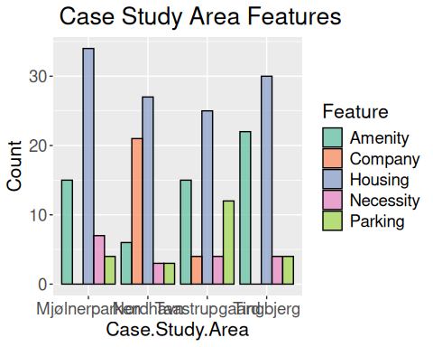 #

# case study area data grouped  
areas <- data_frame(  
 distance_km = c(nordhavn_trips$distance_km, mjolnerparken_trips$distance_km, tingbjerg_trips$distance_km, taastrupgaard_trips$distance_km),  
 time_min = c(nordhavn_trips$time_min, mjolnerparken_trips$time_min, tingbjerg_trips$time_min, taastrupgaard_trips$time_min),  
 trip_speed = c(nordhavn_trips$distance_km/nordhavn_trips$time_min, mjolnerparken_trips$distance_km/mjolnerparken_trips$time_min, tingbjerg_trips$distance_km/tingbjerg_trips$time_min, taastrupgaard_trips$distance_km/taastrupgaard_trips$time_min),  
 trip_type = c(nordhavn_trips$sample_id, mjolnerparken_trips$sample_id, tingbjerg_trips$sample_id, taastrupgaard_trips$sample_id),  
 area_name = c(rep("Nordhavn", nrow(nordhavn_trips)), rep("Mjølnerparken", nrow(mjolnerparken_trips)), rep("Tingbjerg", nrow(tingbjerg_trips)), rep("Taastrupgaard", nrow(taastrupgaard_trips)))  
)

## Warning: `data_frame()` was deprecated in tibble 1.1.0.  
## ℹ Please use `tibble()` instead.  
## This warning is displayed once every 8 hours.  
## Call `lifecycle::last_lifecycle_warnings()` to see where this warning was  
## generated.

# case study area data filtered by trip  
walk_areas <- areas %>% filter(trip_type == "walk")  
bike_areas <- areas %>% filter(trip_type == "bike")  
local_transit_areas <- areas %>% filter(trip_type == "local")  
commute_areas <- areas %>% filter(trip_type == "commute")  
alt_commute_areas <- areas %>% filter(trip_type == "alt_commute")  
# rename area for alternative commute   
alt_commute_areas$area_name = paste0(alt_commute_areas$area_name, rep(" by Train", nrow(alt_commute_areas)))  
# combine alternative commutes back into main list   
commute_areas <- rbind(commute_areas, alt_commute_areas)

# create density charts for test scenarios comparing case study areas

density_chart_walk <- ggplot(data = walk_areas, aes(x = distance_km, fill = area_name, color = area_name)) +  
 geom_density(alpha = 0.15, size = 1) +   
 scale_fill_brewer(palette = "Set2") +   
 scale_color_brewer(palette = "Set2") +   
 theme_minimal() +  
 labs(x = "Distance (km)", y = "Frequency") +  
 theme(  
 plot.title = element_text(size = 20), # Title text size  
 axis.title.x = element_text(size = 16), # X-axis label size  
 axis.title.y = element_text(size = 16), # Y-axis label size  
 axis.text.x = element_text(size = 14), # X-axis tick labels size  
 axis.text.y = element_text(size = 14), # Y-axis tick labels size  
 legend.title = element_text(size = 16), # Legend title size  
 legend.text = element_text(size = 14) # Legend item labels size  
 )

## Warning: Using `size` aesthetic for lines was deprecated in ggplot2 3.4.0.  
## ℹ Please use `linewidth` instead.  
## This warning is displayed once every 8 hours.  
## Call `lifecycle::last_lifecycle_warnings()` to see where this warning was  
## generated.

density_chart_bike <- ggplot(data = bike_areas, aes(x = distance_km, fill = area_name, color = area_name)) +  
 geom_density(alpha = 0.15, size = 1) +   
 scale_fill_brewer(palette = "Set2") +   
 scale_color_brewer(palette = "Set2") +   
 theme_minimal() +  
 labs(x = "Distance (km)", y = "Frequency") +   
 theme(  
 plot.title = element_text(size = 20), # Title text size  
 axis.title.x = element_text(size = 16), # X-axis label size  
 axis.title.y = element_text(size = 16), # Y-axis label size  
 axis.text.x = element_text(size = 14), # X-axis tick labels size  
 axis.text.y = element_text(size = 14), # Y-axis tick labels size  
 legend.title = element_text(size = 16), # Legend title size  
 legend.text = element_text(size = 14) # Legend item labels size  
 )  
  
density_chart_local_transit <- ggplot(data = local_transit_areas, aes(x = distance_km, fill = area_name, color = area_name)) +  
 geom_density(alpha = 0.15, size = 1) +   
 scale_fill_brewer(palette = "Set2") +   
 scale_color_brewer(palette = "Set2") +   
 theme_minimal() +  
 labs(x = "Distance (km)", y = "Frequency") +   
 theme(  
 plot.title = element_text(size = 20), # Title text size  
 axis.title.x = element_text(size = 16), # X-axis label size  
 axis.title.y = element_text(size = 16), # Y-axis label size  
 axis.text.x = element_text(size = 14), # X-axis tick labels size  
 axis.text.y = element_text(size = 14), # Y-axis tick labels size  
 legend.title = element_text(size = 16), # Legend title size  
 legend.text = element_text(size = 14) # Legend item labels size  
 )  
  
density_chart_commute <- ggplot(data = commute_areas, aes(x = distance_km, fill = area_name, color = area_name)) +  
 geom_density(alpha = 0.15, size = 1) +   
 scale_fill_brewer(palette = "Set2") +   
 scale_color_brewer(palette = "Set2") +   
 theme_minimal() +  
 labs(x = "Distance (km)", y = "Frequency") +   
 theme(  
 plot.title = element_text(size = 20), # Title text size  
 axis.title.x = element_text(size = 16), # X-axis label size  
 axis.title.y = element_text(size = 16), # Y-axis label size  
 axis.text.x = element_text(size = 14), # X-axis tick labels size  
 axis.text.y = element_text(size = 14), # Y-axis tick labels size  
 legend.title = element_text(size = 16), # Legend title size  
 legend.text = element_text(size = 14) # Legend item labels size  
 )

# create boxplots for test scenarios comparing case study areas

boxplot_walk <- ggplot(data = walk_areas, aes(x = area_name, y = trip_speed, color = area_name)) +   
 geom_boxplot() +   
 scale_fill_brewer(palette = "Set2") +   
 scale_color_brewer(palette = "Set2") +   
 coord_cartesian(ylim = c(0.05, 0.10)) +  
 xlab("Case Study Area") +   
 ylab("Trip Speed (km/min)") +   
 theme(  
 legend.position = "none",   
 axis.title.x = element_blank(),   
 axis.text.x = element_blank(),   
 axis.ticks.x = element_blank(),  
 axis.title.y = element_text(size = 16), # Y-axis label size  
 axis.text.y = element_text(size = 14), # Y-axis tick labels size  
 legend.title = element_text(size = 16), # Legend title size  
 legend.text = element_text(size = 14) # Legend item labels size  
 )  
  
boxplot_bike <- ggplot(data = bike_areas, aes(x = area_name, y = trip_speed, color = area_name)) +   
 geom_boxplot() +   
 scale_fill_brewer(palette = "Set2") +   
 scale_color_brewer(palette = "Set2") +   
 xlab("Case Study Area") +   
 ylab("Trip Speed (km/min)") +   
 theme(  
 legend.position = "none",   
 axis.title.x = element_blank(),   
 axis.text.x = element_blank(),   
 axis.ticks.x = element_blank(),  
 axis.title.y = element_text(size = 16), # Y-axis label size  
 axis.text.y = element_text(size = 14), # Y-axis tick labels size  
 legend.title = element_text(size = 16), # Legend title size  
 legend.text = element_text(size = 14) # Legend item labels size  
 )  
  
boxplot_local_transit <- ggplot(data = local_transit_areas, aes(x = area_name, y = trip_speed, color = area_name)) +   
 geom_boxplot() +   
 scale_fill_brewer(palette = "Set2") +   
 scale_color_brewer(palette = "Set2") +   
 xlab("Case Study Area") +   
 ylab("Trip Speed (km/min)") +   
 theme(  
 legend.position = "none",   
 axis.title.x = element_blank(),   
 axis.text.x = element_blank(),   
 axis.ticks.x = element_blank(),  
 axis.title.y = element_text(size = 16), # Y-axis label size  
 axis.text.y = element_text(size = 14), # Y-axis tick labels size  
 legend.title = element_text(size = 16), # Legend title size  
 legend.text = element_text(size = 14) # Legend item labels size  
 )  
  
boxplot_commute <- ggplot(data = commute_areas, aes(x = area_name, y = trip_speed, color = area_name)) +   
 geom_boxplot() +   
 scale_fill_brewer(palette = "Set2") +   
 scale_color_brewer(palette = "Set2") +   
 xlab("Case Study Area") +   
 ylab("Trip Speed (km/min)") +   
 theme(legend.position = "none", axis.title.x = element_blank(), axis.text.x = element_blank(), axis.ticks.x = element_blank()) +   
 theme(  
 plot.title = element_text(size = 20), # Title text size  
 axis.title.x = element_text(size = 16), # X-axis label size  
 axis.title.y = element_text(size = 16), # Y-axis label size  
 axis.text.x = element_text(size = 14), # X-axis tick labels size  
 axis.text.y = element_text(size = 14), # Y-axis tick labels size  
 legend.title = element_text(size = 16), # Legend title size  
 legend.text = element_text(size = 14) # Legend item labels size  
 )

# visualize STMA results:

library(grid)  
  
walk_title <- textGrob(  
 "Walkability Across Case Study Areas Analysis",  
 gp = gpar(fontsize = 20)  
)  
bike_title <- textGrob(  
 "Bikeability Across Case Study Areas Analysis",   
 gp = gpar(fontsize = 20)  
)  
local_transit_title <- textGrob(  
 "Local Bus Across Case Study Areas Analysis",  
 gp = gpar(fontsize = 20)  
)  
city_commute_title <- textGrob(  
 "City Commute Across Case Study Areas Analysis",  
 gp = gpar(fontsize = 20)  
)  
  
grid.arrange(boxplot_walk, density_chart_walk, ncol=2, widths=c(6,8), top=walk_title)

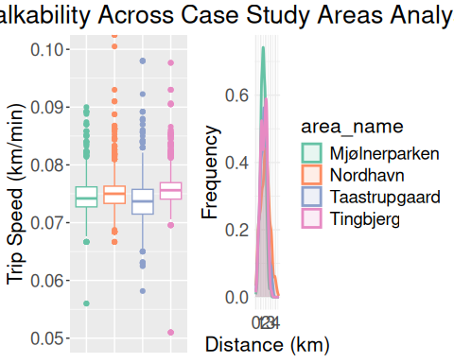

grid.arrange(boxplot_bike, density_chart_bike, ncol=2, widths=c(6,8), top=bike_title)

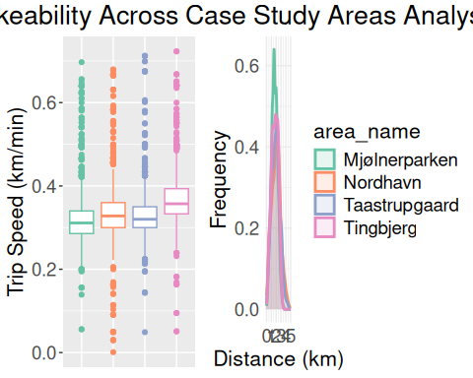

grid.arrange(boxplot_local_transit, density_chart_local_transit, ncol=2, widths=c(6,8), top=local_transit_title)

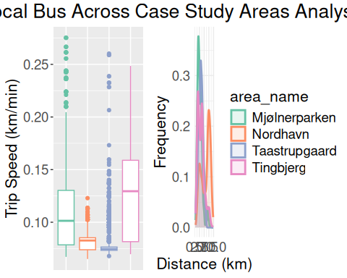

grid.arrange(boxplot_commute, density_chart_commute, nrow=2, widths=c(6,8), top=city_commute_title)

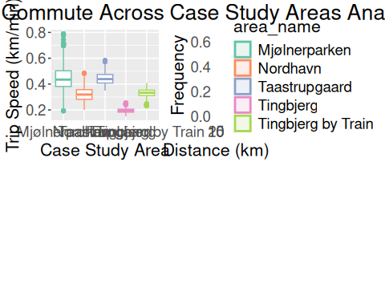 # run kruskal wallis for statistical difference in trip efficiencies across case study areas

kruskal.test(data = walk_areas, trip_speed ~ area_name)

##   
## Kruskal-Wallis rank sum test  
##   
## data: trip_speed by area_name  
## Kruskal-Wallis chi-squared = 545.92, df = 3, p-value < 2.2e-16

kruskal.test(data = bike_areas, trip_speed ~ area_name)

##   
## Kruskal-Wallis rank sum test  
##   
## data: trip_speed by area_name  
## Kruskal-Wallis chi-squared = 1026, df = 3, p-value < 2.2e-16

kruskal.test(data = local_transit_areas, trip_speed ~ area_name)

##   
## Kruskal-Wallis rank sum test  
##   
## data: trip_speed by area_name  
## Kruskal-Wallis chi-squared = 2762.1, df = 3, p-value < 2.2e-16

kruskal.test(data = commute_areas, trip_speed ~ area_name)

##   
## Kruskal-Wallis rank sum test  
##   
## data: trip_speed by area_name  
## Kruskal-Wallis chi-squared = 7659.1, df = 4, p-value < 2.2e-16

# run dunn test for determining rank differences of travel efficiencies across case study areas

NemenyiTest(x=walk_areas$trip_speed, g=walk_areas$area_name)

##   
## Nemenyi's test of multiple comparisons for independent samples (tukey)   
##   
## mean.rank.diff pval   
## Nordhavn-Mjølnerparken 321.6805 6.3e-05 ***  
## Taastrupgaard-Mjølnerparken -615.6737 4.0e-14 ***  
## Tingbjerg-Mjølnerparken 1055.0132 < 2e-16 ***  
## Taastrupgaard-Nordhavn -937.3543 < 2e-16 ***  
## Tingbjerg-Nordhavn 733.3327 4.7e-14 ***  
## Tingbjerg-Taastrupgaard 1670.6870 < 2e-16 ***  
## ---  
## Signif. codes: 0 '***' 0.001 '**' 0.01 '*' 0.05 '.' 0.1 ' ' 1

NemenyiTest(x=bike_areas$trip_speed, g=bike_areas$area_name)

##   
## Nemenyi's test of multiple comparisons for independent samples (tukey)   
##   
## mean.rank.diff pval   
## Nordhavn-Mjølnerparken 790.0047 4.0e-14 ***  
## Taastrupgaard-Mjølnerparken 425.8130 3.3e-08 ***  
## Tingbjerg-Mjølnerparken 2200.6692 < 2e-16 ***  
## Taastrupgaard-Nordhavn -364.1917 3.7e-06 ***  
## Tingbjerg-Nordhavn 1410.6645 < 2e-16 ***  
## Tingbjerg-Taastrupgaard 1774.8562 < 2e-16 ***  
## ---  
## Signif. codes: 0 '***' 0.001 '**' 0.01 '*' 0.05 '.' 0.1 ' ' 1

NemenyiTest(x=local_transit_areas$trip_speed, g=local_transit_areas$area_name)

##   
## Nemenyi's test of multiple comparisons for independent samples (tukey)   
##   
## mean.rank.diff pval   
## Nordhavn-Mjølnerparken -1706.7400 < 2e-16 ***  
## Taastrupgaard-Mjølnerparken -2673.7595 < 2e-16 ***  
## Tingbjerg-Mjølnerparken 761.1745 4.2e-14 ***  
## Taastrupgaard-Nordhavn -967.0195 < 2e-16 ***  
## Tingbjerg-Nordhavn 2467.9145 < 2e-16 ***  
## Tingbjerg-Taastrupgaard 3434.9340 < 2e-16 ***  
## ---  
## Signif. codes: 0 '***' 0.001 '**' 0.01 '*' 0.05 '.' 0.1 ' ' 1

NemenyiTest(x=commute_areas$trip_speed, g=commute_areas$area_name)

##   
## Nemenyi's test of multiple comparisons for independent samples (tukey)   
##   
## mean.rank.diff pval   
## Nordhavn-Mjølnerparken -3360.8360 < 2e-16 ***  
## Taastrupgaard-Mjølnerparken 425.6070 3.1e-05 ***  
## Tingbjerg-Mjølnerparken -6494.8865 < 2e-16 ***  
## Tingbjerg by Train-Mjølnerparken -3138.4932 < 2e-16 ***  
## Taastrupgaard-Nordhavn 3786.4430 < 2e-16 ***  
## Tingbjerg-Nordhavn -3134.0505 < 2e-16 ***  
## Tingbjerg by Train-Nordhavn 222.3427 0.1059   
## Tingbjerg-Taastrupgaard -6920.4935 < 2e-16 ***  
## Tingbjerg by Train-Taastrupgaard -3564.1002 < 2e-16 ***  
## Tingbjerg by Train-Tingbjerg 3356.3933 < 2e-16 ***  
## ---  
## Signif. codes: 0 '***' 0.001 '**' 0.01 '*' 0.05 '.' 0.1 ' ' 1

ggplot(data = walk_areas, aes(x = trip_speed, fill = area_name, color = area_name)) +   
 geom_histogram(bins = 100) +   
 xlab("Case Study Area") +   
 ylab("Trip Efficiency (km/min)") +   
 labs(title = "Walkability Trip Speed Efficiency Across Case Study Areas")

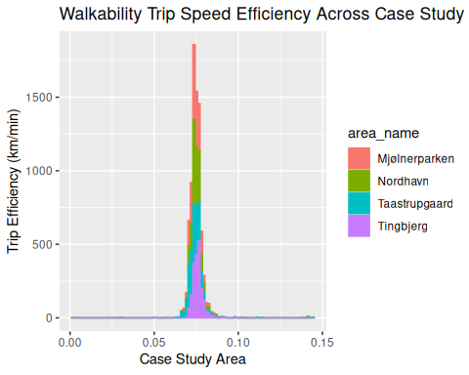

ggplot(data = bike_areas, aes(x = trip_speed, fill = area_name, color = area_name)) +   
 geom_histogram(bins = 100) +   
 xlab("Case Study Area") +   
 ylab("Trip Efficiency (km/min)") +   
 labs(title = "Bikeability Trip Speed Efficiency Across Case Study Areas")

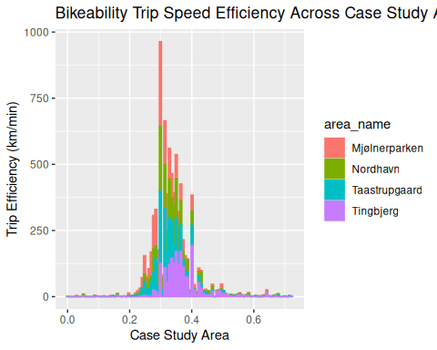

ggplot(data = local_transit_areas, aes(x = trip_speed, fill = area_name, color = area_name)) +   
 geom_histogram(bins = 100) +   
 xlab("Case Study Area") +   
 ylab("Trip Efficiency (km/min)") +   
 labs(title = "Local Transit Trip Speed Efficiency Across Case Study Areas")

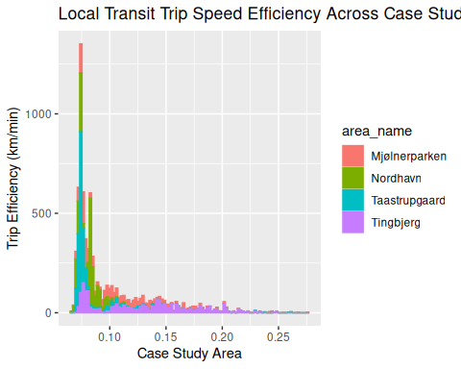

ggplot(data = commute_areas, aes(x = trip_speed, fill = area_name, color = area_name)) +   
 geom_histogram(bins = 100) +   
 xlab("Case Study Area") +   
 ylab("Trip Efficiency (km/min)") +   
 labs(title = "City Commute Trip Speed Efficiency Across Case Study Areas")

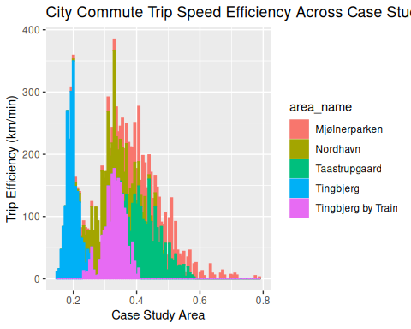

ggplot(data = alt_commute_areas, aes(x = trip_speed, fill = area_name, color = area_name)) +   
 geom_histogram(bins = 100) +   
 xlab("Case Study Area") +   
 ylab("Trip Efficiency (km/min)") +   
 labs(title = "Alt City Commute Trip Speed Efficiency Across Case Study Areas")

