How Much Do Markets Respond to Noise? Evidence from Oil
Exposure Around the Venezuela Shock (January 2026)
An event-window analysis using the United States Oil Fund (USO)
January 2026
Matthew Tembo (Economist and Data Scientist)

Abstract
This event study evaluates whether a salient geopolitical announcement is associated with a statistically unusual price discontinuity or with a response characterised mainly by transitory price movements and elevated uncertainty. Using daily data for the United States Oil Fund (USO) around the January 2026 Venezuela-related event, in which U.S. forces reportedly captured President Nicolás Maduro and subsequent reporting discussed potential changes in Venezuelan oil flows to the United States, the analysis evaluates price dynamics in an event window, applies a jump diagnostic based on pre-event return variability, and tracks changes in rolling volatility. Across the window, the reaction-day return remains within the pre-event jump band, while prices exhibit rapid reversal and recovery. Rolling volatility stays elevated after the event, indicating that the market response is expressed more through uncertainty than through an immediate and persistent repricing of near-term supply expectations.

Background and Rationale
In early January 2026, international attention focused on Venezuela following reports that a United States operation resulted in the capture of President Nicolás Maduro. The development was quickly interpreted through an oil-market lens because Venezuela’s export capacity and the prevailing sanctions environment are closely linked to expectations about global crude supply, trade flows to specific refinery configurations, and the geopolitical risk premium embedded in prices. As reporting evolved, discussion also extended to United States leverage over Venezuelan oil revenues and the possibility of changes in Venezuelan crude flows toward United States buyers. These developments heightened uncertainty regarding the extent to which the episode would translate into near-term supply effects as opposed to reflecting predominantly informational salience within the news cycle.
Such settings present two empirically distinguishable channels of market adjustment. First, prices may incorporate new information through a sharp and persistent revaluation when market participants infer an immediate and durable shock to physical supply conditions. Second, prices may display a response dominated by heightened uncertainty and short-horizon rebalancing, producing transitory fluctuations and increased variability when the mapping from political developments to realised production, exports, and shipping outcomes is unclear. Contemporary reporting during 5 to 7 January 2026 characterised oil pricing as responsive but not disorderly, with subsequent sessions emphasising broader supply conditions and uncertainty about the speed with which political changes could be reflected in production and export volumes.
To examine whether the observed behaviour is more consistent with a statistically unusual price discontinuity or with a primarily uncertainty-driven response, this study uses daily market data for the United States Oil Fund (USO) as a liquid proxy for tradable oil exposure. USO is constructed to track daily movements in light, sweet crude oil primarily through futures-based positioning. This feature makes USO suitable for measuring the response of exchange-traded oil exposure to geopolitical headlines, while acknowledging that futures roll mechanics and term-structure conditions may influence realised ETF returns.

Scope of Study and Methodology

Asset selection and data
The analysis focuses on the United States Oil Fund (USO), a liquid and widely traded oil-linked exchange-traded product intended to reflect daily movements in light, sweet crude oil through futures-based exposures.
The empirical analysis uses daily closing prices, which are transformed into daily log returns for estimation and inference.
Because the information arrival date may coincide with a non-trading day, the event is operationalised using a reaction-day convention. Specifically, the reaction day is defined as the first trading day on or after the headline date that appears in the price series. This convention ensures that the measured event-day response corresponds to the earliest opportunity for market participants to incorporate the information into traded prices.
USO returns may deviate from spot crude oil returns because the fund primarily holds and rolls futures positions. Consequently, term-structure conditions and roll mechanics, including contango or backwardation and associated roll yield effects, can influence realised USO performance and should be considered when interpreting event-window results.
The headline date is set to 3 January 2026, and the reaction day is the next trading day in the dataset. The event window is defined as ±20 trading days around the reaction day. The pre-event estimation window used to compute μ and σ contains 180 trading days ending one day before the reaction day. The jump threshold is z∗=2.5. Rolling volatility is computed using a 10-day window.

Notation
Let ​$P_{t}$ denote the USO closing price on trading day $t$ , and let $r_{t}$ denote the corresponding log return. The reaction day is denoted by $t_{0}$ , defined as the first trading day on or after the headline date. The event window is $W = \left[t_{0}- K, …, t_{0}+ K\right]$, and $E$ denotes the pre-event estimation window used to characterise baseline return behaviour.

Log returns
We compute daily log returns:
$$r_{t}=\ln\left(P_{t}\right)-\ln\left(P_{t-1}\right)$$
Log returns are additive over time, which is useful for cumulative return plots.

Reaction Day alignment
If the headline occurs on a weekend/holiday, the reaction day is:
$$t_{0}=\min\left\{ t ∈ TradingDays : t ≥ EventDate \right\}$$
This ensures the event is evaluated when the market first has a chance to trade.

Jump diagnostic (event-day “unusualness”)
Define the pre-event mean and standard deviation from the estimation window $E$:
$μ = \left(\frac{1}{\left|E\right|}\right)Σ_{\left\{t∈E\right\}r_{t}}$ , $σ = sqrt\left( \left(\frac{1}{\left|E\right|-1}\right)Σ_{\left\{t∈E\right\}\left(r_{t}- μ\right)}^{2}\right)$
Compute the event-day z-score:
$$z_{\left\{t_{0}\right\}}=\frac{\left(r_{\left\{t_{0}\right\}}- μ\right)}{σ}$$
A “jump” is flagged when: $Jump = 1\left\{ \left|z_{\left\{t_{0}\right\}}\right|≥ z* \right\}$
where z∗ = 2.5 in this study.
If the event-day return is inside the ±2.5σ band, the move is not statistically extreme relative to typical pre-event fluctuations.

Rolling volatility (uncertainty response)
To capture changes in uncertainty, compute rolling volatility over a window of m days:
$${\hat{σ}}_{t}^{\left\{\left(m\right)\right\}}= sqrt\left( \left(\frac{1}{m-1}\right)Σ_{\left\{i=0\right\}}^{\left\{m-1\right\}{\left(r_{\left\{t-i\right\}}- {\bar{r}}_{t}^{\left\{\left(m\right)\right\}}\right)}^{2}}\right)$$

where ${\bar{r}}_{t}^{\left\{\left(m\right)\right\}}= \left(\frac{1}{m}\right)\sum_{i=0}^{m-1}{r_{t-i}}$ is the rolling mean over the same m days. If volatility rises around $t_{0}$ without a corresponding tail jump in returns, that pattern often fits a noise/uncertainty shock more than a clean fundamental repricing

Results

Price behaviour around the event (USO)

Figure 1. USO price around the event window; dashed line indicates the reaction day
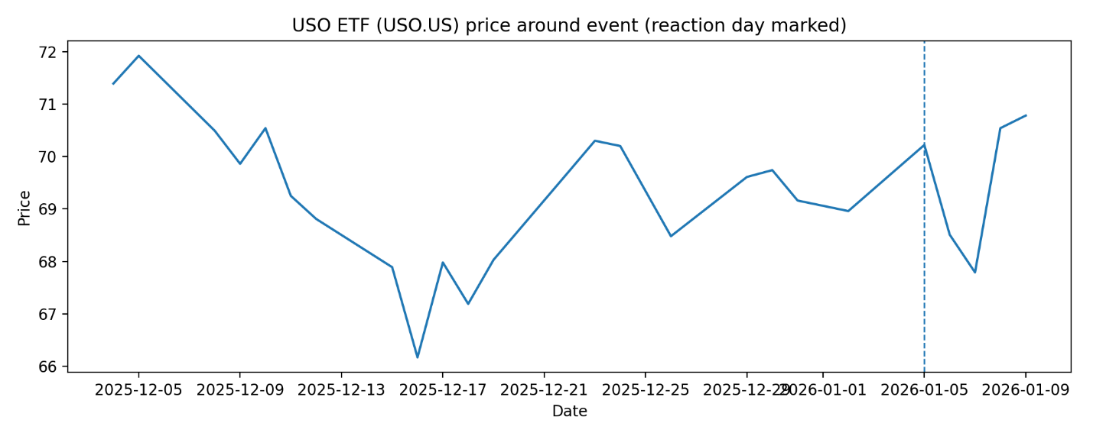
USO rises into the reaction day and then reverses sharply, followed by a rapid rebound. The absence of a persistent level shift is consistent with a transitory adjustment rather than sustained repricing.

Returns and jump bands (±2.5σ from pre-event)

Figure 2. USO log returns with jump band ±2.5σ computed from the pre-event estimation window
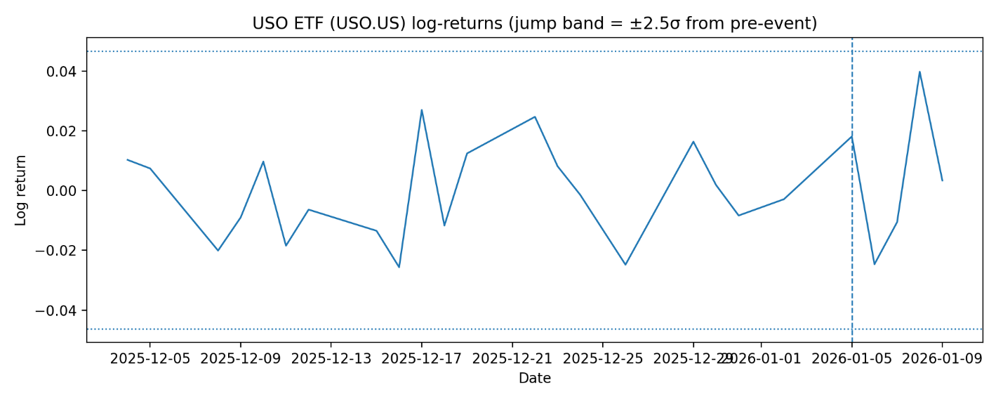
The reaction-day return is positive but remains within the ±2.5σ band derived from pre-event returns. Under the adopted rule, the event does not meet the threshold for a statistically unusual jump.

Rolling volatility around the event

Figure 3. USO rolling 10-day volatility around the event window; dashed line indicates the reaction day
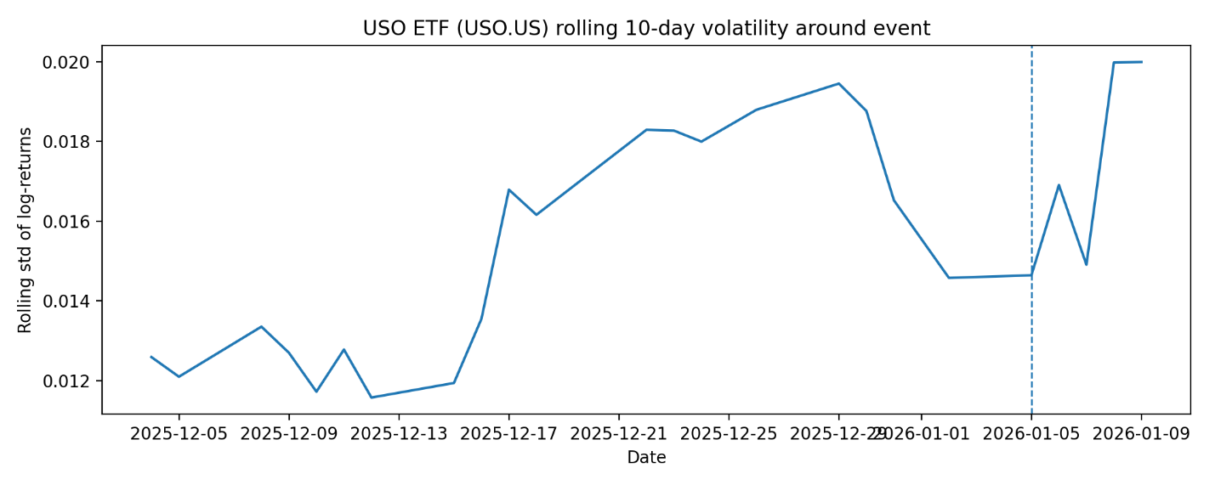
Rolling volatility is elevated around the event window and does not revert immediately after the reaction day. This indicates a stronger uncertainty response than a single large return shock.
Overall, the event appears to have increased uncertainty and short-horizon reversals more than it produced a discontinuous repricing.

Conclusion
The USO evidence indicates an uncertainty-dominant response rather than a discontinuous jump. The reaction-day return remains within the ±2.5σ pre-event band, and the price path shows a rapid reversal and rebound, which is consistent with short-horizon reassessment rather than a persistent repricing. The concurrent elevation in rolling volatility suggests that the headline affected perceived uncertainty more than it altered near-term supply expectations. The main implication is that when the link between geopolitical news and near-term physical flows is ambiguous, markets tend to reprice uncertainty before they reprice levels.

References
- Reuters (January 2026). Reporting on the capture of Venezuelan President Nicolás Maduro and subsequent oil-market reaction. https://www.reuters.com/world/americas/view-investors-economists-react-us-capture-venezuelas-maduro-2026-01-03/ (Accessed: 11 January 2026).
- Reuters (January 2026). Reporting on discussions regarding Venezuelan oil flows and market supply expectations. https://www.reuters.com/business/energy/venezuela-us-talks-export-venezuelan-oil-us-sources-say-2026-01-06/ (Accessed: 11 January 2026).
- USCF Investments. United States Oil Fund (USO): fund objective and methodology. https://www.uscfinvestments.com/uso
- Stooq (n.d.) Historical data download for USO.US. Available at: https://stooq.com/q/d/l/?s=uso.us&i=d (Accessed: 11 January 2026).

