Student ID: 103219809

Name: Matthew Jester

# Setup Screenshot

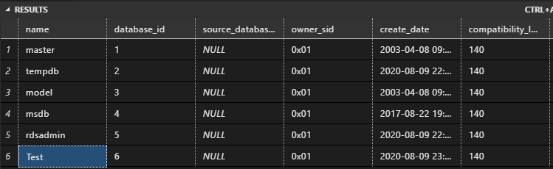

# Task 2 Screenshot

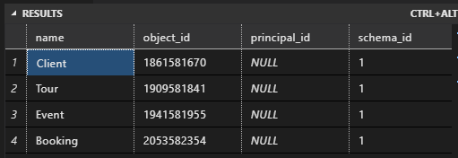

# Task 3 Screenshot

