The Grinch – Unity Mulitplayer Game
Contents
Introduction 2
Networking Setup 2
Implementation Details 5
Movement 5
Pickups 6
Score 7
Camera 7
Networking Architecture and Authority Model 8
Challenges and Solutions 9
Testing 10
Optimisation 10
Conclusion 11

Introduction
For my Network Programming module, I was required to complete a Unity multiplayer game that showcased a multiplayer game with a theme.
For my project I decided to make a game called ‘The Grinch’ and in this game you play as the grinch going around picking up presents. You compete against other players to collect a certain amount of presents before the other players. The winner is decided by who reaches the target number of presents first, I have it set to 10 presents as the goal.
The game was completed in Unity 2022.3 using NetCode.
The multiplayer functionality of this game was based around clients connecting to a server and synchronizing player movements, presents spawning, scores and win conditions at the same time across all client screens. It uses things like NetworkManager, NetworkObject, ServerRPC and ClientRPC to complete the in sync multiplayer functions.
In this report I will be going into detail about the network setup, implementation details, authority model, challenges I faced, testing methodology and some changes for optimisation.

Networking Setup
The network setup in my project uses netcode in Unity. NetCode is a networking library in Unity that uses networking logic and helps you to setup data packets to be transferred to multiple players at once.
The first thing I did was set up my NetworkManager in the hierarchy of Unity. This is an integral part of the networking setup as it manages the server including clients connecting, game objects spawning and is responsible for syncing up progress across the game for every player.
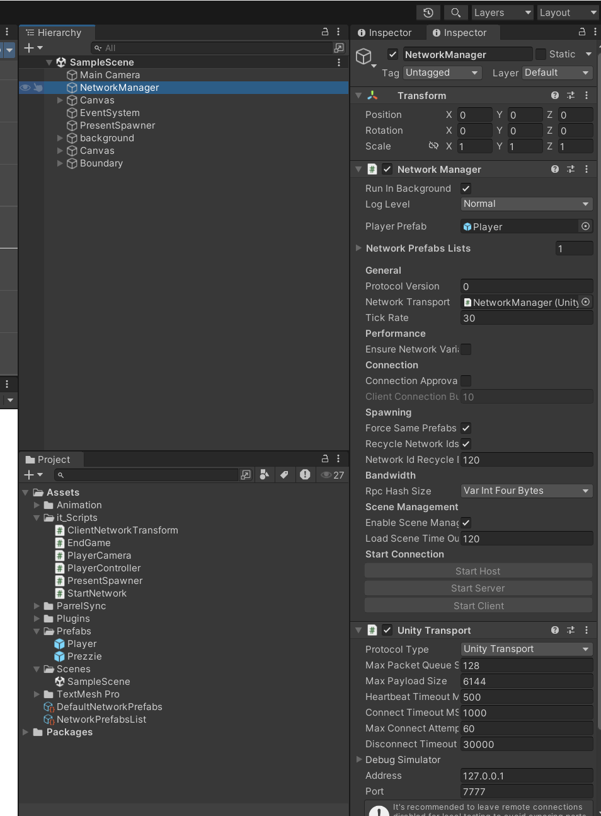
Figure 1 NetworkManager in hierarchy and inspector
I used unity transport as the transport protocol for this game. It’s a very easy to use method of transferring packets between clients. It also allowed for me to use a server, host and client in the game. You can see this in StartNetwork script. It takes in input from the user and triggers a connection based on what you picked to either start the server, start the host which is server and client at once or start the client to connect to the server.
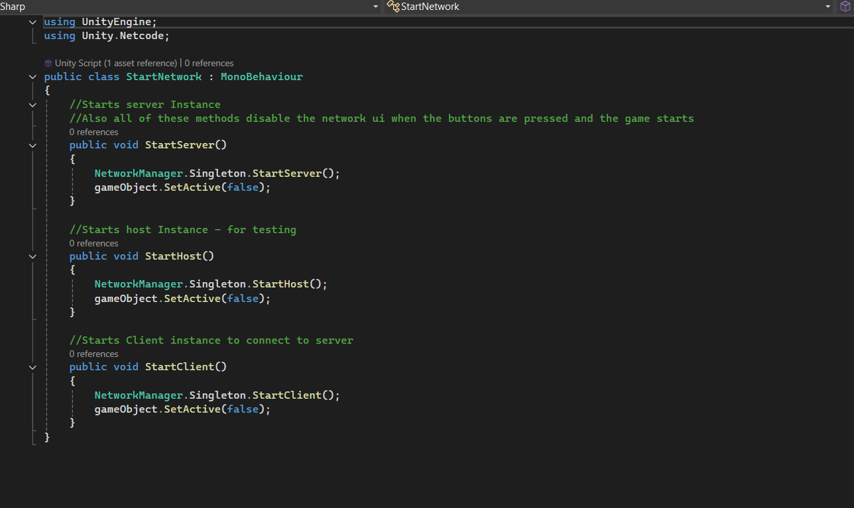
Figure 2 StartNetwork.cs
My server in this game uses a client-server type architecture. This means that the server is mostly authoritative but it does some client authoritative things as well like movement. The server validates the clients’ requests like picking up a present and broadcasts that to every client connected on the server. I like this architecture as it is consistent across the board with every client and keeps everything nicely in sync.
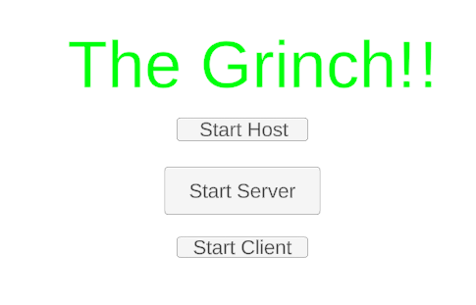
Figure 3 Example of the buttons I implemented

Implementation Details

Movement
The movement for the client is controlled by the WASD keys. When the client makes a movement input it sends that signal to the server and it sends that information across to all the other clients to update the players position on the map. Each player that’s spawned in is a network object. This is what allows the server to broadcast the players movement to other players, while still allowing for movement to be controlled locally.
ClientNetworkTransform is used to transform the updates in player’s position. It acts in a way that overrides the server authoritative behaviours of NetworkTransform which allows the local user to make their own movements. I found that this made the game more responsive and reduced latency which is very important in a competitive environment. My only issue with this method is it could potentially be a security risk if it was implemented in a proper scenario where other players are connecting to the game as it allows for the client to have some form of control. It could introduce hackers to the game.
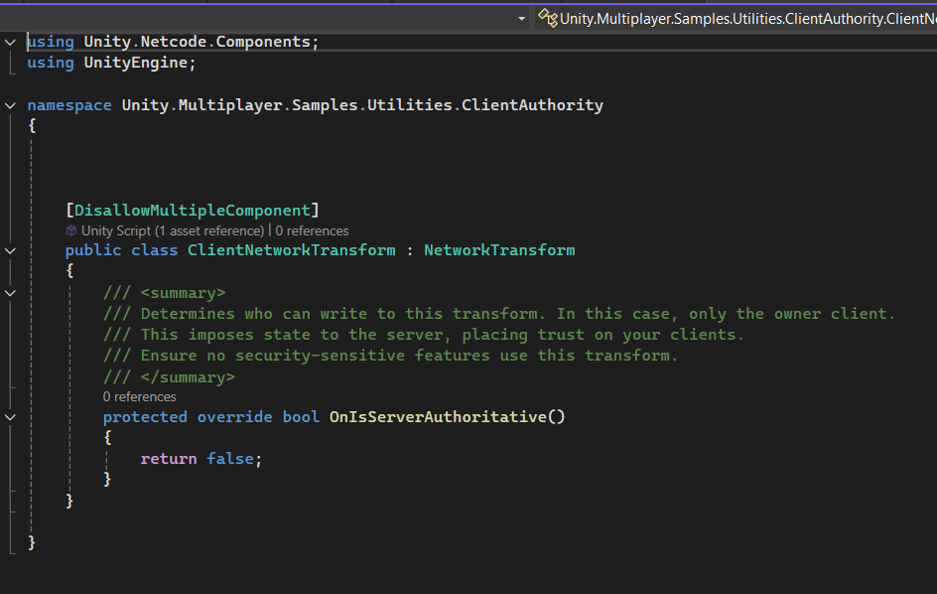
Figure 4 ClientNetworkTransform.cs

Pickups
The spawning of the pickups(presents) is server authoritative. This means the server has full control of where the pickups spawn and is only allowed to be controlled by the server.
It done in the PlayerSpawner.cs that inherits from NetworkBehaviour
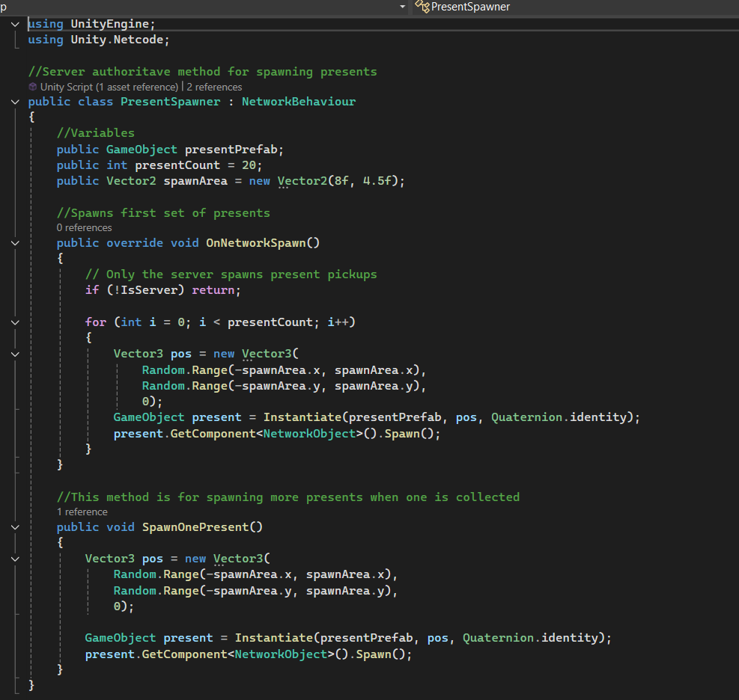
Figure 5 PresentSpawner.cs
When the game is started (the user picked server, host or client) the OnNetworkSpawn() method is ran which then spawns the first set of presents at random positions. The presents are created as NetworkObjects as I attached this to the present prefab and they are then shown to everyone connected to the server.
When the present is picked up by a user the present despawns and score is added to the users score that picked it up and another present is spawned at a random location.

Score
The score system is server authoritative and is controlled mostly in the PlayerController script. The client sends a ServerRPC request to pickup the present, then the server approves the rpc and the player collects the present and in turn adds to their own score.
The UI for score however is handled on a client authoritative behaviour as the score is updated locally and displays to that client on screen.
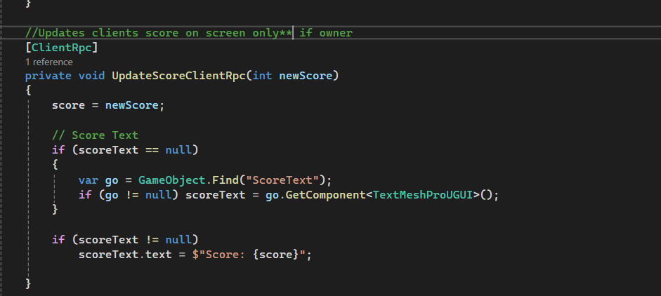
Figure 6 Client Score rpc method

Camera
The camera system is an unnetworked system in the game. It is handled in a script called PlayerCamera and makes sure the camera only follows the local user’s player object. This prevents issues like following other players positions on screen.
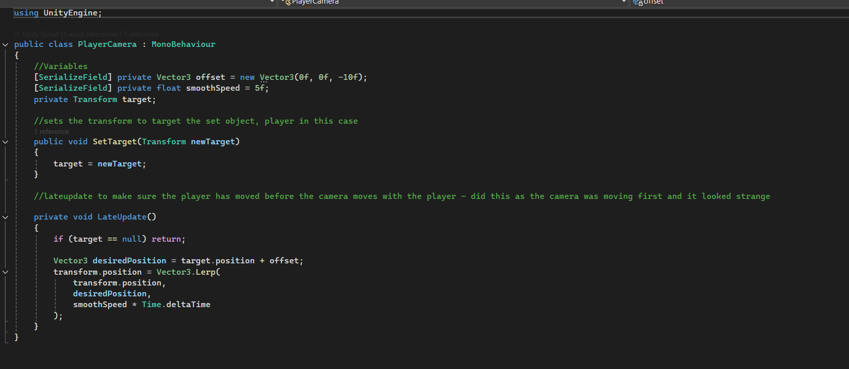
Figure 7 PlayerCamera.cs

Networking Architecture and Authority Model
My project, The Grinch, is a hybrid system in terms of network authority.
This is because the player movement, input and camera are client authoritative. Every other feature in the game is server authoritative including the spawning of presents, score, win checks etc.
I feel this authority model offers the best of both worlds as you have less delay in things like player inputs or camera updates but keeps server authority over the most important features like score and presents. Meaning while the player itself could be used for cheating potentially, there is much less of a risk of cheating to instantly win the game or cheat score etc.
You can see this in PlayerController.cs where the server authoritative behaviours are called in a serverRPC and client authoritative behaviours are called in a clientRPC.
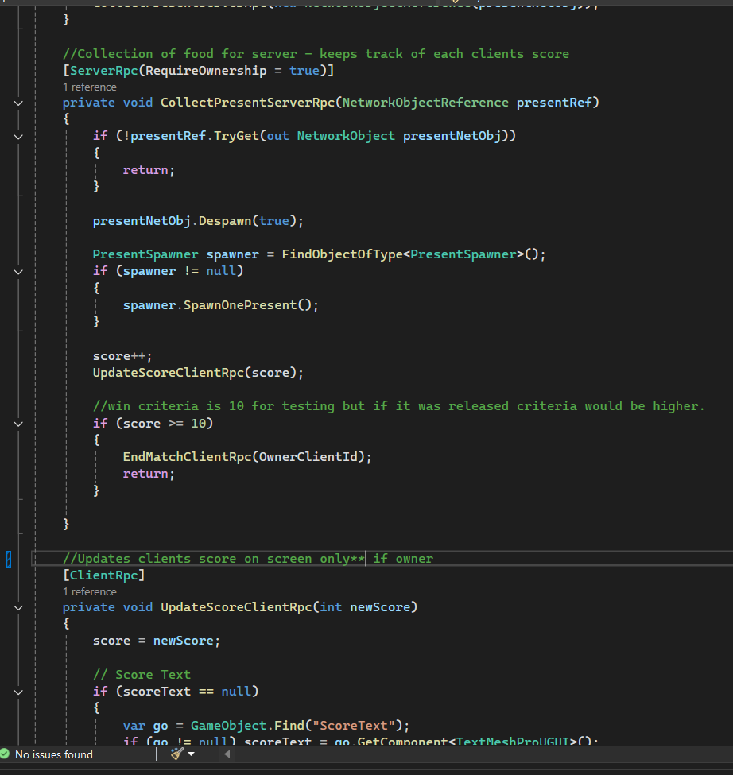
Figure 8 Example of client and server RPC

Challenges and Solutions
I faced a number of challenges while making this game.
The first one I will speak about is setting up the win conditions. The issue I had on this was getting the game to freeze for more than one player when the win condition was met. I realised I had to send a freeze to all clients connected to the server when a certain score threshold was met.
The next issue was displaying the win text. I couldn’t get the text to set to active after the win was triggered in spite of having the setactive(true) code in place. I realised I could just set to active from the beginning and simply had the text object set to empty while the game was playing.
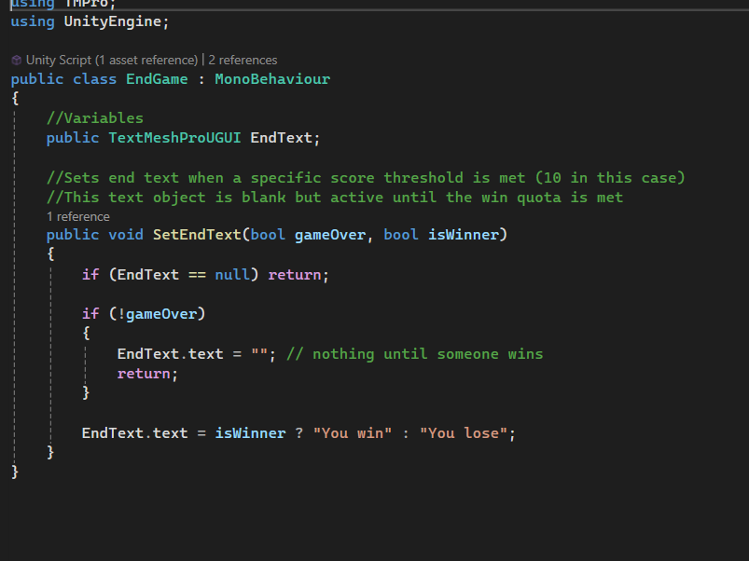
Figure 9 EndGame.cs
I also had issues with displaying score to only the local player. I found the score was only updating for the most recent player that collected a present so it was only displaying the most recently updated score on all clients screens. I fixed this by making it a clientRPC method and adding a score update in the Update() method in playercontroller.cs
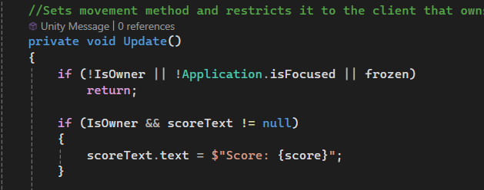
Figure 10 score in update()

Testing
The game was tested on my own machine using parrelsync. This is a tool that allows you to clone the unity editor you have open. This meant that I could have 3 copies of the project open at once: the server and then two clients.
Initially, I only used 2 instances of the project open as I was mainly using the host feature which acts as the server and client as one. This helped me a lot as I didn’t overload my computer as much while I was developing the game.
As the project was closer to completion then I used three copies open at once and ran the server on one and client on the other two to make sure everything was working as intended.
I also made use of debug logs during development as I ran into various issues to do with spawning presents, text etc. I have outlined those issues above.

Optimisation
There are a few ways I could make changes to optimise this game.
The first one would be to make use of NetworkVariables which was something I only came across on research but wasn’t sure on how to implement them. They would take up less traffic than rpc calls for small data variables. This could reduce server lag and increase latency.
Another optimisation could be to ‘cull’ network updates happening off-screen like presents being picked up. This would certainly reduce server lag.

Conclusion
During my time developing this project, The Grinch, I learned quite a bit about networking in Unity and netcode itself. I learned about the different authority models for networking like client authoritative, server authoritative and the hybrid system which I used which actually had me learn about both. I also learned about how important it was to have gameplay synced for multiple players at once in a competitive setting. I learned about RPC communication in a server also.
Overall, I would say my development skills have greatly benefited from this project as it opened my eyes to developing in a multiplayer context.

