Hangman

Matthew O’Rourke Bourke – K00287407

Network Programming
Contents
Background 3
Research 3
a. Addressing 3
b. Fork Server 4
c. Select Server 4
d. Dual Stack 5
e. Modulization 6
Implementation 6
a. Fixing Code 6
b. Modulization 7
c. Dual Stack 9
d. Fork Server 10
e. Select Server 11
Conclusion 11
References 13
Appendix 14

Background
For Network programming we are required to complete a project working on a game based on hangman using C code and using the Linux Ubuntu virtual Environment. This code uses sockets through TCP connections. The point of this is to allow multiple clients to connect at once using two methods: fork and select methods.
Hangman is also good for testing network concurrency because it involves a small amount of state data and turn-based input from multiple clients. The server randomly selects a word and communicates with clients through the TCP sockets, it then updates the word after each guess.
My objectives on this project were:
- To fix the existing code base
- Make the code better using getaddrinfo()
- Implement dual stack, fork and select methods
- Implement IPV4 and IPV6 connections through dual TCP stack
- To make the system more modular and comment
The final multiplayer game allows several players to connect at the same time and play separate games of Hangman. The server randomly selects words from the words file, manages guesses, and shows progress and results back to the clients.

Research

a. Addressing
Originally networking programs in C used functions like gethostbyname() like the original one in the code base that I altered. Functions like this do not allow for dual stack connection between ipv4 and ipv6. Instead, they only allow for ipv4 connections. This reason makes this method of connection outdated as ipv6 is a more modern way of connecting to a network as it is more flexible and stable.
When the getaddrinfo() function was created it modernized the call used for returning addresses for network connection. Getaddrinfo() essentially creates a linked list of addresses sent to it to call from instead of the single ipv4 address that gethostbyname() uses. This allows for more than one client to connect to a server and also allows for ipv6 addresses to connect as well.
From my research on this I found that getaddrinfo() is a safer and better method. You no longer need to convert the address strings to binary using inet and it has better error communication support through gai_strerror().
Beej(2023) provided a lot of contexts between the differences of these functions for my research.

b. Fork Server
The fork server uses a method in which each connection is done client by client. It creates a new child process every time a client connects. Essentially what this does is it creates independent environments for each client that connects. It has its preset parameters to give the clients connected and if one were to disconnect or crash it would not affect the others connected on the server.
There are however issues with fork servers. One of the issues is that it uses a lot of memory. Each client has its own address space, which means with each new connected user memory consumption is growing a lot. Another issue is zombies. According to Stevens et al, (2011) A zombie is when a client disconnects but in such a way as that the child process created when joined stays connected to the server. This is bad because it’s using up more memory on the server.

c. Select Server
Select servers uses a call – select() – that allows for a single thread to monitor multiple sockets at once. It is able to work out if a socket is ready to be read or to write and doesn’t block the other connected sockets.
I would consider the select server from my research to be quite an efficient method of socket connection. As it allows for multiple connections on one thread. It also works that the select process only runs when a socket is ready for reading or writing. This saves memory from build up of waiting processes.
However, it is only really efficient to be used on smaller scale servers as it has to read through a list the FD_SET to see which sockets are available. This makes it not very useful when dealing with a server with high traffic.
In my research I found Stevens et al(2011) to be quite informative as he gave clear definitions for the select server and brought the point of select only being useful in a smaller-scale server.
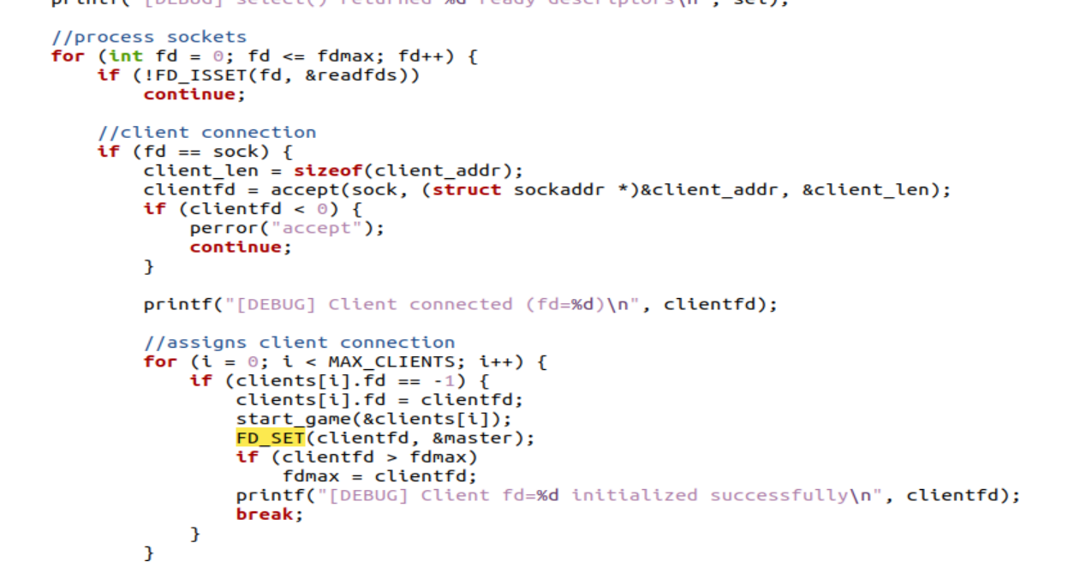
Figure 1 select loop

d. Dual Stack
TCP Dual Stack allows for both IPV4 and IPV6 support at the same time on the same server. It has been implemented as there are many sockets still using IPV4 so it acts as almost a transition to IPV6 for those still using that connection.(Kerrisk, 2010)
IPV4 uses 32 bit addresses such as 192.x.x.x.x and IPV6 uses 128 bit addresses like 2001::db8::1. These differences in addresses make it so IPV6 does not work backwards with IPV4 making the Dual Stack method necessary for cross compatibility.
As you can see below is the option to enable both ipv4 and ipv6 support we can see this in the setsockopt function and then as you set IPV6ONLY to <0 this enables dual stack support. If you were to set this to 1 however it would only allow for IPV6 socket connections.
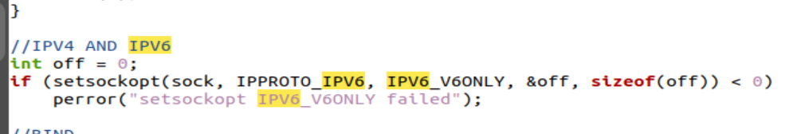
Figure 2 example of Dual Stack

e. Modulization
Modulization of code is essentially creating reusable code to pull from. This can take many forms such as making functions to call from, putting functions in header files. Modulization also allows code to read much easier for anyone else to read or work on existing code. Or it is even easier for the creator to come back and forth too. It can also cut down on development time as you have functions to pull from cutting out having to rewrite code repeatedly. It’s also quite good for file size as it cuts out a lot of the storage needed for reused code.(Kerrisk,2010)
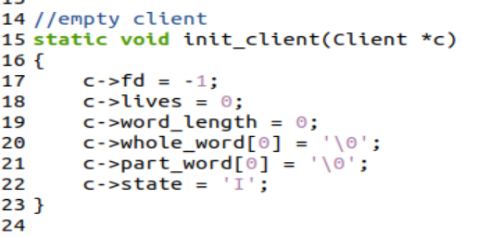
Figure 3 Example of reusable function

Implementation

a. Fixing Code
The first change I made in the hangman code was that I replaced the gethostbyname() function with the getaddrinfo() function. This change was needed to allow for dual stack. Dual stack allows the game to have both IPv4 and IPv6 connections at the same time.
The gethostbyname() function is now considered outdated because it only supports IPv4 addresses and is not thread safe. getaddrinfo() is more flexible and more utilized interface for network address resolution, that returns results that can be used for socket creation and connections.
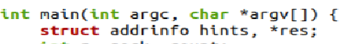
Figure 4 calling getaddrinfo()
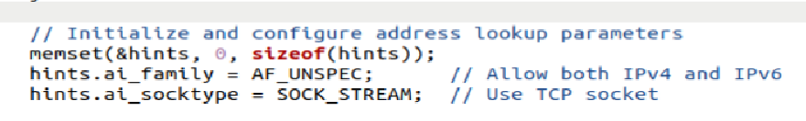
Figure 5 code for getaddrinfo()
The getaddrinfo() function returns a list of addresses containing hostnames and addresses like 192.168.0.0 or some https etc.
By iterating through the list, the application can connect using the address given.

b. Modulization
Description:
Modulization in this project meant breaking up code into functions to call from. Here are the functions used in the select server:
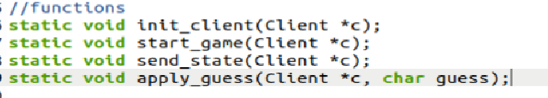
Figure 6 functions in select server
I think the start_game functions is a good example of modularization:
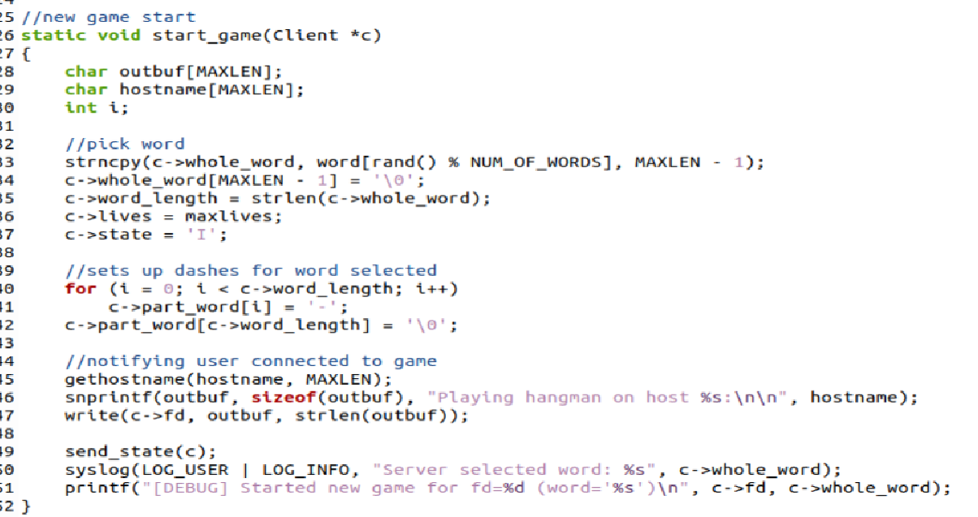
Figure 7 example of start_game function
In this you can see I created a function to set the game up and be called from.
In here it initializes variables for name and buffer. It also creates code to pick the work from the word file. It sets up the visuals for the game – the dashes displayed on screen for letters not guessed correctly yet. It also sends out communications notifying about connected users and server.
I also included a few header files to enable me to use pre made functions that I could pull from a library rather than having to define it and take up more space in my own code. For example the signal header enabled me to add the signal function to the fork server to end zombie processes.
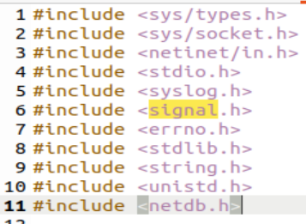
Figure 8 header files included in fork
Issues:
Some issues I had here were trying to find the headers to be included for certain functions like signal. This just took some time to research using the references included and some quick google searching.
I also had some issues trying to get some of the functions to work but they were only grammar errors in terms of coding.

c. Dual Stack
TCP Dual Stack was easy enough to implement. First I started by configuring an IPV6 structure using AF_INET6.
Figure 9 IPV6 structure
Then I made a line of code to create a socket from the address info read from the client. Next was the code that enabled Dual Stack connection it was as seen in figure 3. I used the setsockopt function and set IPV6_V6ONLY to < 0. This value enabled the socket to work with both IPV4 and IPV6 sockets. If the value was set to 1 it would only allow for IPV6 connections
Then in the client folder I added this line:
Figure 10 client dual stack support
This makes the getaddrinfo() return both types of addresses and picks the one most suited.

d. Fork Server
The fork server was one of the first changes I made. Instead of having only one client at a time, the server now creates a child process for each new client connecting using fork. Each client runs their own hangman game.
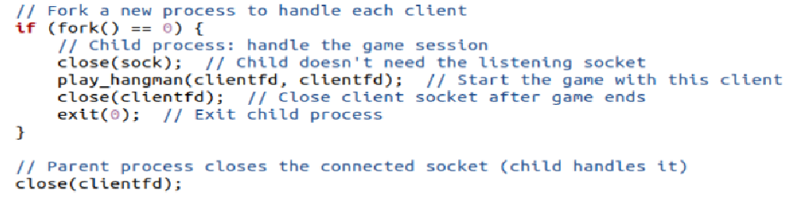
Figure 11 how fork works
This approach allowed multiple clients to play Hangman simultaneously, each in its own isolated process.
I also added a line using the function freeaddrinfo. This clears up memory used by the getaddrinfo() function that gathers the addresses from clients. This helps the project run better.
Figure 12 freeing memory
However, spawning new processes introduces the issue of zombie processes (terminated children that remain at the process table). To prevent this, I used the signal function:
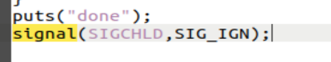
Figure 13 deleting zombies
What this does is frees the memory that’s allocated to the server from getaddrinfo()

e. Select Server
I also implemented a select server in a separate file basing off changed code from the fork server file. The select server I implemented allows for multiple clients to be handled on a single thread. The clients sockets are stored in an array based on parameters I fed in:
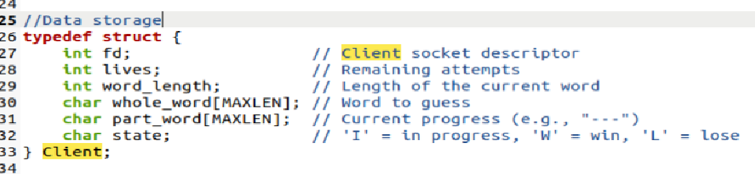
Figure 14 client array
This also handles the dual stacking in the same way as the fork server did as I talked about in the Dual Stack section above.
The select itself is done in a repeating loop. In this loop it takes in if the sockets are trying to read or write, takes in clients guessing one of the letters, then processes the letter and sends it to the game to update lives, correct guesses etc.
This implementation allowed for a more fluid handling of multiple clients at one given time, handling it all on a single thread.

Conclusion
In conclusion, this project helped me understand how socket coding works. Be it from the point of view of analyzing the existing gethostbyname() method and implementing the more modern getaddrinfo() method.
I also learned a great deal about dual stack, fork servers and select server. How important it is to implement dual stack in a multiplayer or just a general network server connection environment at all. I learned about the uses of a fork and select, where their strengths lie for select in a smaller scale server for example.
In the fork server I learned about zombie child processes and why it is important to get rid of them, using the signal function.
The modularisation of the code allowed me to learn a lot about breaking code into functions. I also learned why this is vital to coding as it improves the efficiency of running code and reduces the file size. It also increases the readability of the code.
Overall, I feel this project very beneficial to learning about socket programming.

References
Beej, B. (2023) Beej’s Guide to Network Programming Using Internet Sockets. Available at: https://beej.us/guide/bgnet/ (Accessed: 11 November 2025)
Comer, D.E. (2019) Internetworking with TCP/IP, Volume 1: Principles, Protocols, and Architecture. 7th ed. Pearson. Available at: https://lit-main-mdl-euwest1.s3.eu-west-1.amazonaws.com/ce/cf/cecf7c282a87d23febe559ea9893c3d575e7432e (Accessed: 11 November 2025)
Beej, B. (2023) Beej’s Guide to Network Programming (PDF version). Available at: https://lit-main-mdl-euwest-1.amazonaws.com/de/52/de526640f53f4d5c049d55474e5f69e107524ef0 (Accessed: 11 November 2025)
Donahoo, M.J. and Calvert, K.L. (2009) TCP/IP Sockets in C: Practical Guide for Programmers. 2nd ed. Morgan Kaufmann. Available at: https://lit-main-mdl-euwest1.s3.eu-west-1.amazonaws.com/85/de/85dee996b03a36a08c91522ce8893e0e9af5f24b (Accessed: 11 November 2025)

Appendix

Figure 15 select loop

Figure 16 example of Dual Stack

Figure 17 Example of reusable function

Figure 18 calling getaddrinfo()

Figure 19 code for getaddrinfo()

Figure 20 functions in select server
Figure 21 IPV6 structure
Figure 22 client dual stack support


Figure 23 header files included in fork


Figure 24 example of start_game function

Figure 25 how fork works
Figure 26 freeing memory

Figure 27 deleting zombies

Figure 14 client array

