Software Security Assessment

Part 1: C Code (Memory Safety)
Vulnerable Snippet:
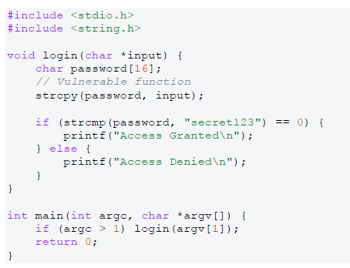
• Vulnerability: The vulnerability here is a Buffer Overflow This is seen in the strcpy(password, input). This function on its own is vulnerable as it doesn’t allow for limitations to be set in the function to the limit on the input, allowing for attackers to overflow the buffer array with their input and potentially corrupt memory.
• Impact: The password is only 16 bytes long, but strcpy(password, input) copies the entire input with no length check. If the attacker passes more than 15 characters plus the null terminator, it writes past the end of the array. That can corrupt stack memory, crash the program and allow code execution.
• Solution: My solution was to code an if statement that checks the size of the input the user enters in the field and if it goes past size of the password array it will return an error warning the user and it will not take the input therefore not overflowing the buffer. An alternative solution to this could be using:
snprintf(password, sizeof(password), "%s", input);
This is a shorter method to fix the vulnerability and a safer function than strcpy.
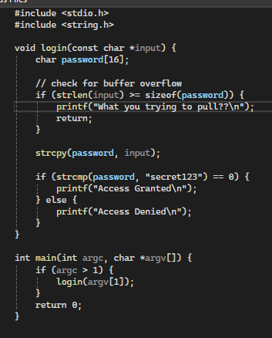
Figure 1 Solution to Buffer Overflow

Part 2: C# Code (Injection)
Vulnerable Snippet:
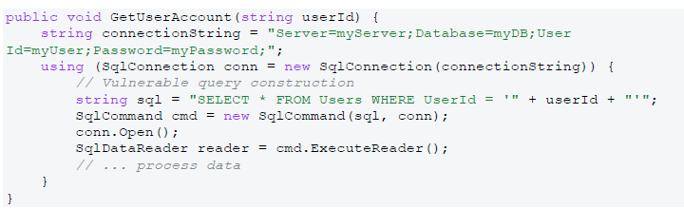
• Vulnerability: The vulnerability here is SQL Injection. This is seen in the line:
string sql = "SELECT * FROM Users WHERE UserId = '" + userId + "'";
This allows the users input to concatenate into SQL. If they were to use OR ‘1’ = ‘1’ it would make the condition true.
• Impact: The impact of the vulnerability in this case is it allows attackers to retrieve sensitive database information about users’ information stored on the database or company information stored on the database. It also allows for modification of existing data or possibly a full compromise of the database
• Solution: My solution to this is to input a paramaterised query where the select statement is programmed to treat the input more as data and not as executable sql code. You can see this as the input is now all a string input whereas before the userID was taken in as a value.
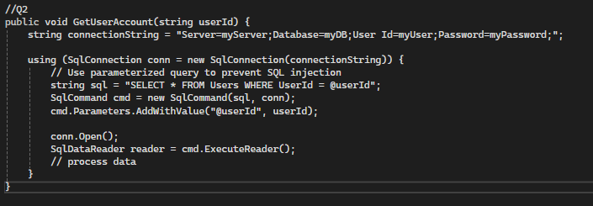
Figure 2 SQL injection solution

Part 3: Python Code (OS Command Injection) [11, 12]
Vulnerable Snippet:
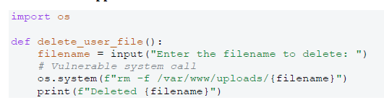
• Vulnerability: The vulnerability here is OS Command Injection. This occurs in the line:
os.system(f"rm -f /var/www/uploads/{filename}")
This is because it allows for the user to input special characters like ; or & which allows for execution of malicious code directly to the shell.
• Impact: The impact of this is the attacker could potentially input commands to delete files or even take control of the operating system and execute commands remotely.
• Solution: My solution to this is to avoid using the shell to execute the user input altogether. It no longer uses os.system as this is the vulnerable part and now it checks for special characters like / or .. and will return invalid if they are inputted in where the filename should be. It also takes the input and joins to make the full path to the file to be accessed and checks if the file exists before it deletes it.
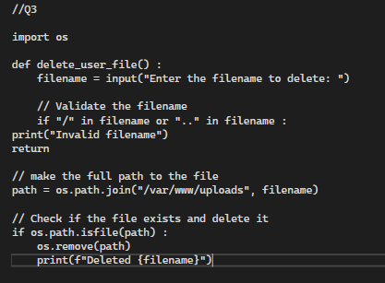
Figure 3 OS Command Injection

Part 4: C# (Insecure Deserialization)
Vulnerable Snippet:
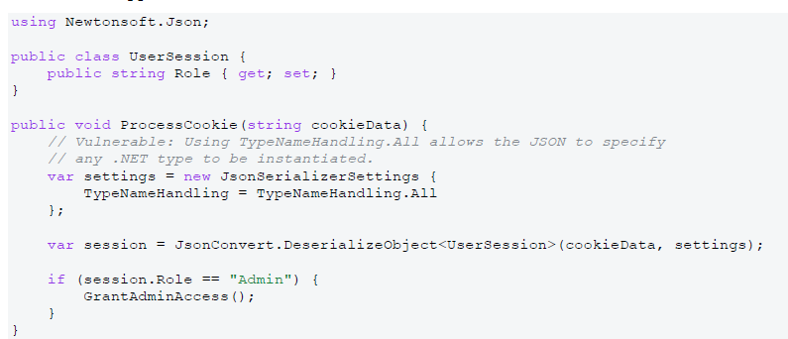
• Vulnerability: The vulnerability here is Insecure Deserialization. This occurs here in the line:
TypeNameHandling = TypeNameHandling.All
This is because it allows the JSON to to specify any .NET type. Which allows the attacker to create malicious objects. The cookies are also controlled by the user which makes for an untrusted input.
• Impact: The impact of this is that it allows the attacker to execute code remotely, it also allows for privilege escalation which means the attacker could give themselves the role of admin potentially. They could also manipulate the app such as the date or other information.
• Solution: My solution to this is quite simple as all that was changes was in the line:
var settings = new JsonSerializerSettings {
TypeNameHandling = TypeNameHandling.None
};
I set the TypeNameHandling to .None instead of .All. This now stops unexpected objects from being created from allowing the attacker to specify any .NET type and only allows for expected UserSession objects to be created.
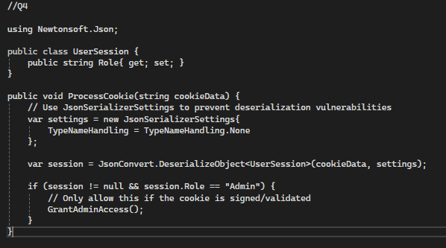
Figure 4 Insecure Deserialisation solution

Part 5: Python (Server-Side Request Forgery - SSRF)
Vulnerable Snippet:
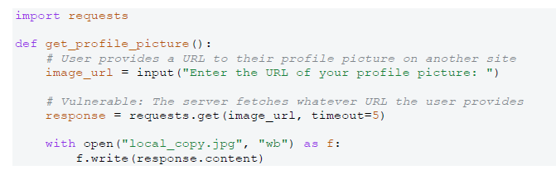
• Vulnerability: The vulnerability here is Server-side request forgery or SSRF. This occurs in the line: response = requests.get(image_url, timeout=5)
This means that the server will take in any url that is submitted to it meaning the attacker could enter a url like http://local host giving direct access to the internal systems.
• Impact: The impact of this vulnerability being exploited is that the attacker could access the internal system through inputting the localhost url. This gives them access to the database allowing for data exfiltration, network scanning and credential leaks.
• Solution: My solution to this was to change the code so that the program has a variable to set the allowed hosts for the inputted url, it then validates that the inputted url matches the host parameters it will return as invalid. It also checks if the host is in the whitelist for hosts and if that criteria is all met it will return the image and save it to a local file.
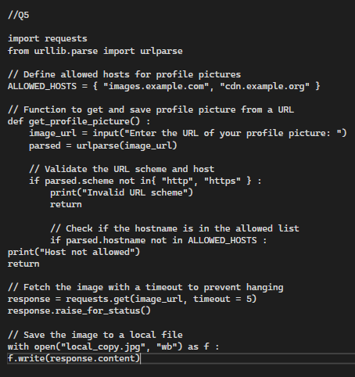
Figure 5 ssrf solution

Part 6: C (Format String Vulnerability)
Vulnerable Snippet:
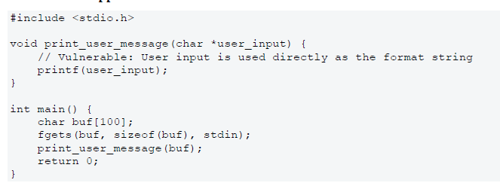
• Vulnerability: This is an example Format String Vulnerability. This is seen in the line:
printf(user_input);
This allows for the user input to be taken into the program directly with no validation which allows the attacker to use specifiers to read or write memory to the system.
• Impact: The impact of this is it allows attackers to read or write to the memory of a system which in turn allows for leaking of private information, code execution or even modification of existing memory.
• Solution: My solution to this was simple as it was just changing the printf statement to:
printf("%s", user_input);
This checks for format specifiers and only allow the input to be read as a data string as to not allow for attackers to infiltrate through this vulnerability.
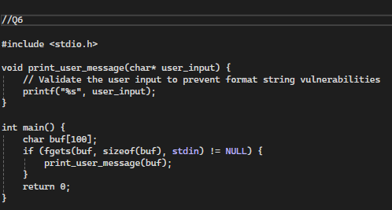
Figure 6 Solution to the Format String Vulnerability

