Title of Project | Gravity System Library
Name of Student | Matthew O’Rourke Bourke
Student Number | K00287407
Date | 08/04/2026
Word Count | 10,212

I declare that no element of this assignment has been plagiarised:
Student Signature



Contents
1. Introduction 5
1.1 Problem Definition and Background 5
1.1.1 Aim 5
1.1.2 Objective 6
1.1.3 Research Question 6
1.1.4 Intended Audience 6
1.1.5 Problem Definition 6
1.1.6Scope 7
1.1.7 Approach 7
1.1.8 Project Plan 7
1.1.9 Outcomes 8
2. Literature Review and Research 9
2.1 Introduction 9
2.2 Theoretical Foundations of Celestial Mechanics 10
2.2.1 Newtonian Mechanics 10
2.2.2 Kepler’s Laws of Planetary Motion 11
2.3 The N-Body Problem and Computational Challenges 11
2.4 Numerical Integration Methods 12
2.4.1 Euler Method 12
2.4.2 Unity Rigid Body Physics 12
2.5 Building a reusable Unity Library 13
2.6Emerging Systems and Research Directions 14
2.7 Summary 14
3. System Design and Configuration 16
3.1 System Overview 16
3.2 System Architecture 17
3.3 Design Methodology 17
3.4 User Story Maps 18
3.5 Class Design 20
3.6 Use Case 22
3.7 Sequence Diagrams 22
3.8 Design Behaviour 24
3.9 Design Application 24
4. Implementation and Testing 25
4.1 Core Implementation 25
4.1.1 Gravity Manager 25
4.1.2 Gravity Body 27
4.1.3 Gravity Attraction 28
4.1.4 Orbit Initializer and Orbit Math 28
4.1.5 Scriptable Objects 30
4.2 Challenges 31
4.3 Testing Methodology 31
4.4 Functional Testing 32
4.5 Performance Testing 32
4.6 Usability Testing 32
4.7 Bug Tracking and Fixes 33
4.8 Results evaluation 33
5. User manual 34
Introduction 34
Installation and Setup 34
Overview 34
How to use the library 34
Troubleshooting and FAQs 36
6. Critical analysis and Conclusions 37
6.1 Overview 37
6.2 Evaluation of Success 37
6.2.1 Achievement of Objectives 37
6.2.2 Technical Contribution 37
6.2.3 Demonstration Through Simulation 38
6.3 Challenges encountered and Lessons learned 38
6.3.1 Technical Challenges 38
6.3.2 Research Hurdles 39
6.3.3 Project Management 39
6.4 Key Conclusions 39
6.4.1 Effectiveness of Contribution 39
6.4.2 Personal and Professional Growth 40
6.5 Future Work 40
6.5.1 Potential Enhancements 40
6.5.2 Broader Applications 40
6.6 Final Summary 41
7. Bibliography 42
8.Appendix 43
API Document 43

Introduction
My name is Matthew O’Rourke Bourke, my K number is K00287407. This thesis will be conducted on my final year project – ‘Gravity System Library’.
My project Gravity System Library is a library built with the intention of simulating realistic space physics, such as gravity, collisions, spacecraft piloting.
The project makes use of Newtonians law of gravitation to apply these physics in the library and to show how motion is applied using these physics, it also includes collision detection which affects the gravity on existing objects, so it is a fully functional gravity and orbit system with realistic collision checks.
It features three demo scenes one completed solar system, one simulation of an aspect of gravity and a demo scene to demonstrate how the library may be applied to an existing project with game objects in scene already. As part of the demo side of the library, it also includes an asteroid spawner to view how asteroids orbit planets in space. It is there to show the potential user of the library how they could apply them in their own game.
This project was completed using Unity game engine and coding in C#.

1.1 Problem Definition and Background
To give some background on the motivation for this project, I have always been interested in the laws that govern space and want to learn more about how physics affects the way that it works, from the forces that shape celestial bodies to the principles that define motion and interactions beyond Earth. I think it would be very interesting to demonstrate all these things in the setting of a game and to give developers a tool that will help them to develop their own games based in space.

1.1.1 Aim
The aim of the project is to create as realistic of a simulation of gravity as possible in the allotted time I was given and to convert this into a reusable library for developers intending on applying these physics in their own projects.

1.1.2 Objective
The objectives of this project are as follows:
To create a simulation of as close to realistic Newtonian gravitational physics as possible.
To create a reusable library that contains code to apply gravitational physics in the Unity game engine environment.
To allow for collisions that affect the gravity works in the simulation without compromising the gravity system working.
To create a fully pilotable spacecraft that allows the user to explore how the gravity system affects players in game.

1.1.3 Research Question
In order to demonstrate the aim of this project the research questions I propose are:
To implement Newtons gravitational law in a real time physics simulation.
To decipher how to create a reusable library for other developers in the unity environment and structure it as such as to be user friendly.

1.1.4 Intended Audience
The intended audience for this project would range from students, professors and game developers that are looking to create a game that includes any kind of celestial gravity or orbital mechanics system.
This project is also intended towards space enthusiasts who might like to understand the workings of celestial mechanics and provides access to that in the form of a game simulation.
It also includes people with an interest in mathematics and want to see how newtons laws can be applied in a game scenario.

1.1.5 Problem Definition
The problem definition of this project is as follows:
To introduce Newtonian laws of gravity and to use as little computing power as possible in the Unity Game Engine using C# code. Unity has a built in gravity system that is acceptable for planetary gravity, but I would like to push this built in gravity system aside and create my own to overwrite this and apply Newtonian physics on the scale of a fully functional space based gravity system that allows for developers to apply this in any way they deem necessary in their own game projects. I attempted to make this as realistic as possible and as user friendly as possible.

1.1.6Scope
The scope of the project is as follows:
To add a fully functional gravity system to the Unity game engine.
To create a quick user-friendly way of creating orbits in a solar system like environment.
To allow for collisions between celestial bodies in this simulation.
To feature a system that allows for as close to N-Body mechanisms as possible.
To implement a spacecraft for users to experiment with in the demo simulation.
To create a reusable structured and user-friendly library in the Unity environment.

1.1.7 Approach
The approach I took to complete this project were as follows:
I created a High-Level User Story map and a detailed user story map. I followed this as a guide on the features I wanted to implement and how important they were to the overall project ranking them on a make it work, make it better and make it best system.
I also took on an agile based methodology for this project, I set myself weekly goals and took count of what I had completed at the end of the week. This helped with the overall focus of the project and allowed me to complete things in a reasonable amount of time. It was a vital approach for keeping the project on track at all times.

1.1.8 Project Plan
My plan for this project is as follows:
I carried out the project in multiple phases.
The first phase was the research and concept phase where I brainstormed ideas for the project and researched how they could be implemented or how difficult it could be to implement in my short timeframe. This was a very important part as it was the first step in planning out the project as a whole and considering if it was a viable project to take on or not.
The second phase was researching literature papers on the topic of the project such as scientific papers written on various aspects of space laws of physics. This phase also included me creating the initial project in unity and starting work on prototyping the project itself.
The third phase was where I fully engaged in the development of the project having completed all prior necessary research.
The fourth phase was upon completion of my features. I looked at improving performances and fixing as many existing issues with the library as possible.
The fifth and final phase included me completing necessary documentation including my thesis, screencast and final presentation of the project.

Explain how you understand the project objective(s), what is to be solved or done, your perception of what has to be accomplished including the scope. Provide a plan for the project timeline implementation including key tasks, deadlines and outputs.
The purpose of the Background section is to provide the typical reader with information that they cannot be expected to know, but which they will need to know in order to fully understand and appreciate the rest of the report

1.1.9 Outcomes
My expected outcome for this project was to have a completed and working gravity system that uses Newtonian physics applied in the Unity game engine and C# code, also to have a complete and structured reusable library for future developers to make use of in their own projects.

Literature Review and Research

2.1 Introduction
The simulation of space physics in video games is a complex problem that combines principles from physics, maths, and computer science. Unlike normal game physics, which prioritises simplicity and responsiveness over realism to add to the fun aspect, space-based simulations need a more accurate representation of physical laws in order to model celestial motion, orbital systems, and gravity accurately. This shows to me that there is quite a challenge ahead of me: achieving a balance between computational efficiency and physical accuracy.
The purpose of this literature review is to examine the theoretical foundations and computational methods important to the development of a gravity system library. The research focuses on key areas including Newtonian mechanics, Kepler’s laws of planetary motion, the N-body problem, and numerical integration techniques like Eulers and Unity’s Rigid Body physics. Additionally, it explores how these concepts are implemented in modern game development and simulation systems.
It also includes research conducted on making a reusable library for the Unity game engine for future developers to make use of.
Understanding these concepts is key to the success of my project, as the aim is to replicate realistic gravitational behaviour in the Unity game engine using C# code. The research I will conduct informs both the design decisions and the limitations of the system, especially in relation to performance constraints and real-time simulation requirements.

2.2 Theoretical Foundations of Celestial Mechanics

2.2.1 Newtonian Mechanics
Newtons Mechanics is the basis for many implementations of gravity.
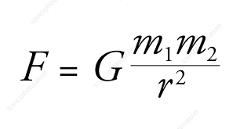
Figure 1 Newton Gravity Formula - https://www.sciencephoto.com/media/594575/view/newton-s-law-of-universal-gravitation
To explain the formula, F describes the gravitational force of two masses. M1 and m2 represent these two masses and r is the distances between the masses. G represents the gravitational constant.
The reason this formula is the most applied formula in simulations is due to its own simplicity. Another reason is due to its low use of computational resources, meaning it has a broader use for lower end computers.
The reason this is so simple is because it is so accurate in trajectory calculations. To give an example imagine you’re performing a jump in a game. Your character must come down to the ground. This requires trajectory calculations to pull you down in the right direction. This formula takes in two masses it takes the distance from the two masses and for G it takes the force of how fast the masses are pulled too each other. (Zhu, 2024)
For my project, Newtonian gravity is especially suitable because the target application is gaming software rather than astrophysical research. The purpose of my project is not to model relativistic effects near something like black holes, but instead to create a convincing and reusable system for planets, asteroids, spacecraft, and collisions in Unity. Zhu (2024) also discusses Newtonian gravitation in relation to motion and rotation, reinforcing its continued importance as a model for understanding large-scale gravitational interaction. This means that Newtonian gravity is accurate enough for most orbital game scenarios while remaining far cheaper to compute than more advanced models. This makes it the most appropriate choice for a reusable library intended for real-time use.

2.2.2 Kepler’s Laws of Planetary Motion
Kepler’s Law defines how orbital mechanics work, including how planets move or how spaceships move. (Saari, 1976)
Law of Ellipses - This law dictates that all planets orbit the sun in the shape of an ellipse.
Law of equal areas - This law dictates that a radius vector that connects a planet to the sun completes its cycle in equal areas in equal amounts of time. This means that when the planet is further away from the object its orbiting, it will move slower and as it gets closer, it gets faster.
Law of Harmonies - This law states that the square of a planets orbital period is proportional to cube of its average distance from the object its orbiting. This means the further away the planet is from the orbit object, the longer it will take to orbit said object.
Kepler’s laws are also helpful from a testing perspective. Because a reusable library needs to be validated, these laws offer observable expectations: stable ellipses, variable orbital speed, and sensible period-distance relationships.

2.3 The N-Body Problem and Computational Challenges
The N-Body Problem discusses the issue of predicting the movement of multiple gravitational bodies all interacting with each other at once, like a cluster of asteroids. A big step up from just the two masses we were dealing with earlier. The issue with this is the N-Body problem is very unpredictable.
The N-Body Problem is an extremely rare mechanic applied to games as it takes an excessive amount of power to simulate this. Even when it is simulated it can never be a true version of it as it is currently analytically unsolvable. For games, the main lesson from N-body research is that full physical accuracy is usually sacrificed in favour of useful approximation. This is not necessarily a weakness. It is often better to simulate the most noticeable effects reliably than to pursue exactness that damages performance. Oberdorfer and Latoschik’s discussion of game-based orbital mechanics learning, including Kerbal Space Program, shows how simplified models can still teach meaningful orbital intuition. In practice, many interactive systems use dominant-body assumptions, patched-conic style simplifications, local influence zones, or approximation trees instead of direct all-to-all gravitation across every celestial body in the scene.
There is one game that does a good job on implementing it and that is Universe Sandbox. Universe Sandbox gives every celestial body a force of gravity. This allows for the player to play around with how planetary collisions may work or simulating realistic asteroid clusters. (Oberdorfer and Latoschik, 2018)

2.4 Numerical Integration Methods

2.4.1 Euler Method
Easily the most common and simplest method of time stepped integration, Eulers method is done by getting an initial position, velocity then calculating the position and velocity after a specified period. This can then be iterated by using increments of time so, for example where will the object be in 1 second, 2 seconds etc. (Zhu, 2024)
There are upsides and downsides to this method. An upside being it’s very easy on resources so a relatively low-end computer can use this method largely with little performance issues. The downside is that it is not 100% accurate. The reason for this inaccuracy is because it gives a margin of error upon completing the calculation. The error refers to the difference between the solution and the estimation of the calculation. As the method is carried out, the bigger the error margin gets so to fix this I might decrease the increment of time between calculations.
To put it as an example in a game, an asteroid could be used to simulate its movement in space. Though instead of moving at a constant speed it will increase slightly as time goes on, so it won’t simulate realism.

2.4.2 Unity Rigid Body Physics
In addition to explicitly implemented numerical integration methods, it is important to consider the role of built-in physics systems within game engines. In Unity, motion and force-based interactions are typically handled through the Rigidbody component. This engine is responsible for updating object motion over time based on applied forces, collisions, and constraints.
Unity’s physics system does not use the basic explicit Euler method due to its instability in dynamic simulations. Instead, it uses a semi-implicit Euler integration method, which improves numerical stability and energy conservation compared to standard Euler integration. In this approach, velocity is updated before position, resulting in more stable motion over time, particularly in systems where forces are continuously applied such as gravitational simulations.
Once forces are applied, Unity internally updates velocity and position during the FixedUpdate cycle. According to Unity’s official documentation, Rigidbody components respond to forces, gravity, and collisions automatically, allowing developers to focus on force calculation rather than low-level motion integration.
The use of Unity’s built-in physics system offers me several advantages. It reduces implementation complexity, ensures stable and optimised simulation behaviour, and integrates seamlessly with other engine systems such as collision detection. However, it also introduces limitations, as I have less control over the exact numerical method and simulation precision.
In the context of this project, using Unity’s Rigidbody system seems to be a practical design decision. Leveraging Unity’s internal semi-implicit integration allows for stable real-time simulation while maintaining performance and simplicity. This makes sense in the context of my objective of creating a reusable and user-friendly gravity library in Unity.

2.5 Building a reusable Unity Library
Software architecture is as important as physics in my project as my aim is to create a reusable library for future developers to use. Unity’s official documentation on custom packages explains that reusable systems should be structured as packages, with clear folder layout, assembly definitions, changelogs, and documentation. This is relevant to my Gravity System Library because the reusability depends on whether another developer can import, understand, and extend it without disturbing their existing project.
One concept here is the use of assembly definition files. Unity states that these are the equivalent of C# projects in unity and that package code should be organised into one or more explicit assemblies. From a reusable-library standpoint, this is important as it reduces unnecessary script compiling, makes dependencies explicit, and helps separate runtime code from everything else. For a gravity library, that means the runtime gravitational engine and demo code can be kept modular instead of being mixed together in one large scripts folder.
Another important Unity pattern is the use of ScriptableObjects as data containers. Unity documents ScriptableObjects as a way to store shared data independently of scene instances, which can reduce duplication and improve organisation. In my project, that gives it a strong design pattern: masses, gravitational constants, orbital presets, time warp or system configuration variables can be put into ScriptableObject assets rather than being hard coded into scene objects. This makes the library easier to configure and more reusable across projects. A developer could modify variables without rewriting my code.
It was also made clear to me that including demo scenes to showcase the working library in some kind of context is vital to the developer picking up and using this library as it can show them various uses of it.

2.6Emerging Systems and Research Directions
There haven’t been any physic related breakthroughs in many years, leading back towards the 1970s so there is not in the way of emerging systems here. There have however been talks on the use of AI to further help prove some physic related questions that have gone unanswered for decades. This however is quite far off from what I can tell so as a research direction the use of artificial intelligence in physics seems to be the way to go moving forward. There has been a focus on improving existing physics like better handling the number of objects on screen in the context of a simulation. They are using things like tree-based approximations, gpu acceleration to better optimize performance here. This would be for quite large-scale simulations.
These seem to me to be beyond the scope of my project but not only are they interesting to me to research but I feel they are important to consider for future work beyond the scope currently laid out and that time has allowed for.

2.7 Summary
In my literature review I completed here, I have learned that the gravity system has plenty of avenues to go down. These include research into celestial mechanics and simulations and also the research of reusable library designs. Newtons mechanics could provide the basis for the calculations I will do for my gravity system, Kepler’s laws can provide a basis for the gravity attraction how orbits can form and behave. However, my research on the N-Body problem has shown me that it’s unrealistic to pursue implementing this fully in my library. This is due how expensive these calculations are to perform on most computers. It would tank the game performance and is unrealistic to create a close model to it as the majority of computers will struggle running it. Also, as there is no truly accurate way of representing the N-Body problem currently and would take a significant amount of time and computational power to accurately represent it. As for the Numerical Integration after studying Eulers method ology and Unitys built in rigid body physics I believe that the existing physics will be the most realistic way for me to model in my project.
As for the reusable library aspect. Unity provides more than enough guidance on how one can and should be structured, separated and modularised to fit into a reusable, user friendly library. Also gives me a reason to model a good demo scene to fit into my project to showcase how these physics work beyond the scope of just meeting project requirements to have one, it is key in any good library to have a demonstration scene.
Overall, I have concluded that Newtonian gravity will be the best way to go for the gravity system, using unity’s Rigid body physics as the numerical integration. Also to build this around a stable, structured reusable project and a demonstration to make this understandable for future developers.

System Design and Configuration
This chapter focuses on the system design and configuration of my project Gravity System Library. It will discuss how my system is structures and how all the components interact with each other and how my architecture can support the aims and objectives of the project I outlined earlier on in my report. The purpose of this chapter is to show a clear understanding of what the system is required to do and how it achieves this in its design.
The system has been designed to simulate realistic Newtonian gravity within the Unity game engine while managing performance and reusability. As I said in Chapter 2, achieving a balance between realism and performance is a challenge in real-time simulations. Therefore, the design decisions made in this chapter reflect the compromises between accuracy, usability, and performance.
This chapter also makes use of a few UML diagrams, including user story maps, a class diagram, a use case diagram, and sequence diagrams, which further show the design of the system.

3.1 System Overview
My Gravity System Library is a reusable library developed in Unity using C# code. Its most important part is to simulate gravity interactions between objects such as planets, asteroids, and spacecrafts using Newton’s law of universal gravitation.
The system includes:
- Real-time simulation of gravitational forces between multiple bodies
- Quick creation of stable orbital systems
- Interactions between objects through gravity and collisions
- Allows for integration into existing Unity projects as a reusable package
Unity’s existing gravity system applies a constant downward force as if you were living on earth, this system calculates gravitational attraction between objects in the sense that you are in space. This allows for more complex simulations, such as orbital motion and multiple body interactions.
My system is designed to be modular allowing developers to integrate what they need from this library into their existing projects as easily as possible.

3.2 System Architecture
The architecture of the library is a modular design, where the functionality is divided into different components each with their own responsibilities. This separation of responsibilities improves the maintainability and makes the system easier to understand and build upon.
The most important part of the library is the manager component responsible for coordinating gravitational calculations this is the gravity manager. This component ensures that all objects in the simulation are updated constantly and that global variables, such as the gravitational constant, are applied. Along with this core are the components that represent the individual objects for the simulation, and they store properties like mass and velocity.
Another important part of the system architecture is the differences described between objects that are affected by gravity and those that give gravitational force. This allows for better calculations, as not all of the objects in the scene need to influence every other object. By introducing the spheres of influence, the system only allows for interactions between relevant objects, improving on the performance.
The architecture also allows for configuration through the ScriptableObjects, which allows the system parameters to be defined outside of the code. This design choice improves on the usability, as developers can change the settings without altering the actual code. It also supports reusability, as configurations can be shared across multiple projects or scenes.
Overall, the architecture shows a balance between simplicity and functionality. It is structured to support complicated calculations and simulations while remaining accessible to developers who may not have much experience with physics systems.

3.3 Design Methodology
My design methodology was like an agile methodology, as I said in chapter 1. Instead of trying to design the entire system straightaway, the system changed over time through small changes and refinements.
Initially, I made a high-level user story map to identify the main features required for the system. These features were prioritised using three different tiers:
- Make it Work - the essential foundation
- Make it Better - improve upon the foundation
- Make it Best - to make the foundation the best it can be
This method of prioritisation made sure that the essential foundation was implemented first, reducing the risk of me failing to create what was necessary to the library.
I then expanded on the user story map into a detailed user story map, breaking down the features into smaller tasks. This approach helped guide my development process and ensured that all aspects of the library aligned with my project objectives.

3.4 User Story Maps
User story mapping was something I used as a vital design tool to understand how the system would be used after completion. It provided a user-centred perspective, ensuring that the system was intuitive and practical for developers. It also helped tremendously in the development process itself of the library as these all broke down how important each feature was and the exact steps to do them and when.
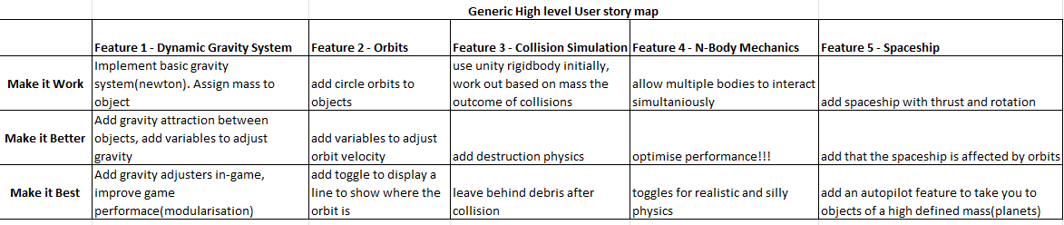
Figure 2 High Level User Story Map
From the high-level user story map, the features were:
- Creating a dynamic gravity system using newtons mechanics
- Allowing for orbital motion in the simulation
- Allowing for collisions affected by gravity
- Attempting to include some form of N-Body mechanics
- Creating a spacecraft that shows the gravity system in the game format

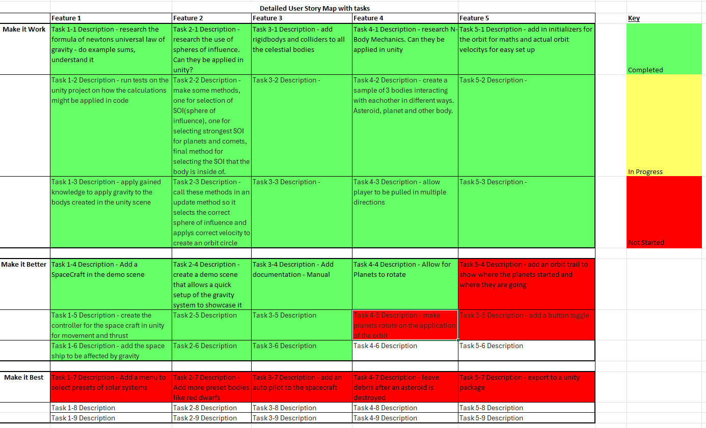
Figure 3 Detailed User Story Map
The detailed user story map expands these goals into specific tasks, such as:
- Creating a Gravity Manager
- Conducting research on the implementation of newtons laws
- Add in the rigid body collision physics
- Initialising orbital velocity
- Adding documentation like a manual to configure the library
The use of these story maps has helped tremendously in the prioritisation of the work to be done and also to design all of the key features of the project and how they will be designed and used.

3.5 Class Design
I have also completed a class diagram for my library project to illustrate the library and the relationships between the components of my project. It really showcases the fact that it is designed in an object-oriented sense and includes encapsulation and also modularity here.
Each class on this diagram here is showing that they all have their own reason and function for being implemented. Like the Gravity manager showing that it is the key controller or manager of the entire system and all of the runtime classes have a relationship with it and even one of the demo files AsteroidSpawner has a relationship with Gravity Manager. Classes like OrbitMath perform the orbit calculations and GravityBody defines things like the collision mass. This means that the separation helps define that they have different responsibilities and they have a specific role in the library.
The relationship in the library is also there to improve the risk of one file controlling all and therefore it minimizes the dependencies placed on them which improves the developer flexibility of it. The components interact through interfaces which means they don’t have direct access to the internal variables which allows the system to be more easily modified without breaking the code.
Overall, the classes further help implement the objective of a reusable library meaning future developers don’t necessarily need to implement the entire library of code and can take only what they need to implement in their own project making it more user-friendly.
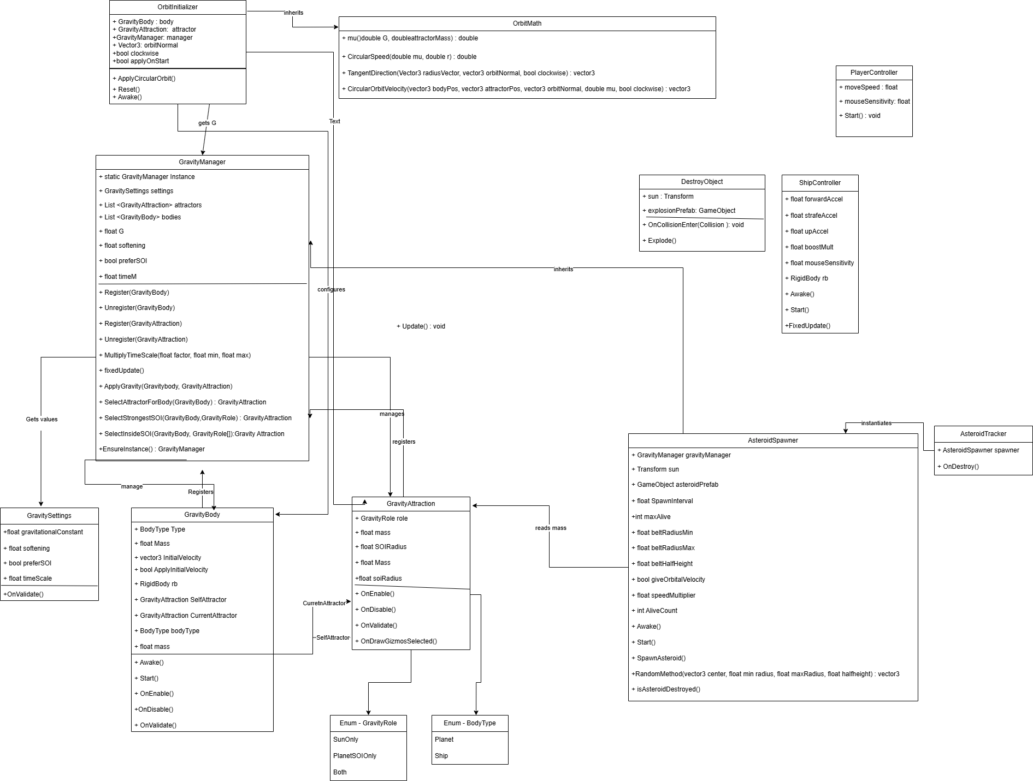
Figure 4 Class Diagram

3.6 Use Case
I also made a use case diagram for my design part of my project. The one below demonstrates how I envisioned the project to work initially. It highlights still the key features of the simulation. The player presses start and this starts the game which triggers the gravity system to create the spheres of influence and apply gravity and orbits to the objects in the scene. This is an example of the demo scene which is key to demonstrating how the library functions as its own complete entity to future developers using the library.
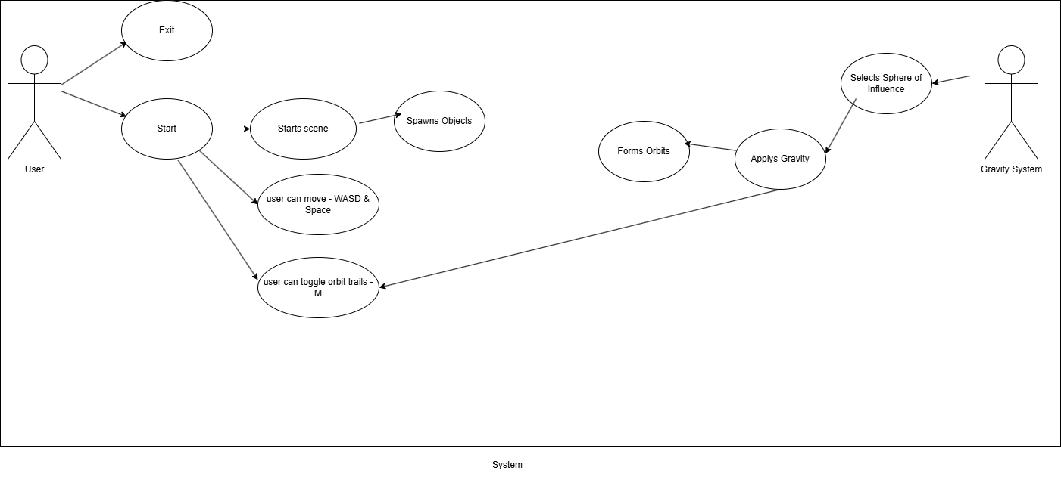
Figure 5 Early System Use Case Diagram
Use case diagrams provide a clear visualization of what the project accomplishes through the visualizing of the steps the user takes and even the gravity system and orders them in the events of which they occur.

3.7 Sequence Diagrams
I also made use of sequence diagrams in the design process of this project. I found that they provide a dynamic view of the library showcasing how the components work and how they interact with each other in the library.
The diagram below for the orbit initialization shows how a selected object is assigned its initial velocity and allows it to orbit another object in scene. It includes calculating the correct velocity based on mass and distance, much like Newtonian gravity, between the objects. When this sequence is completed it results in the creation of a stable orbital motion in the game scene.
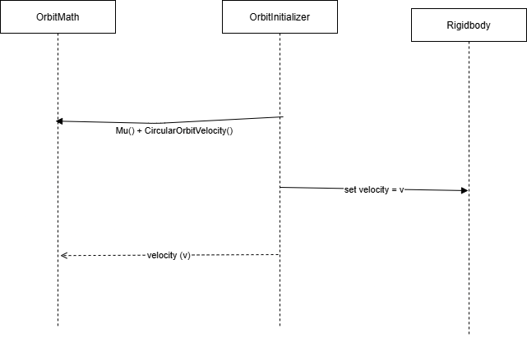
Figure 6 Sequence Diagram for orbit
The next sequence diagram is the runtime gravity sequence. This is the actual gravity system I implemented without the preset parameters of orbit initializer. The manager iterates through the nearby objects, calculates the gravity forces and applies force using the unity rigid body system as the numerical integrator. This process runs constantly in fixed update, so it is simulating motion in real time.
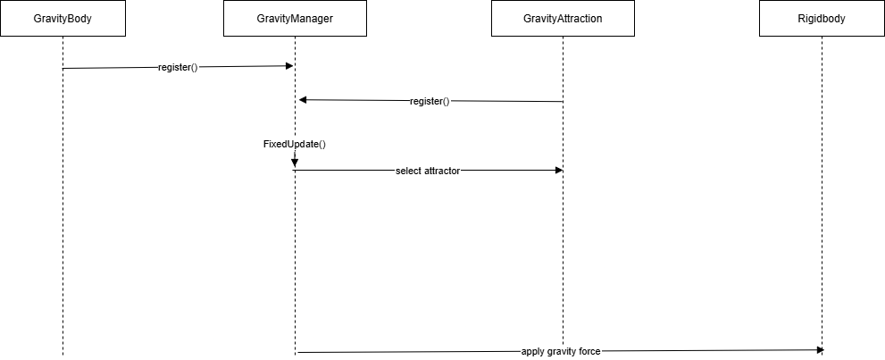
Figure 7 Runtime Gravity Sequence Diagram
The sequence diagrams were important in the design process as they highlight interactions between systems in my library and demonstrate it.

3.8 Design Behaviour
The behaviour of this library is completed by a continuous data loop, driven at each update cycle. The system gets information about the objects inside the simulation and completes calculations to apply gravity forces and performs update to the motion of the objects.
This is completed in the FixedUpdate() section of the game manager which is a unity function that allows for physics calculations to be completed at constant intervals in real time. This helps reduce the risk of errors and improves the numerical stability of the library.
It is also useful in a debugging sense as it makes the library predictable. It will all be labelled clearly and structured as to provide the user with an easier time to debug should the need arise.

3.9 Design Application
Overall, the library is designed to be applied in the most straightforward way possible, with the creation of an empty object that acts as the gravity manager and the ability to configure the variables all on the inspector in unity through use of scriptable objects and serialized fields in the code.
The inclusion of the orbit initialiser allows for developers to simply create stable orbits without any physics related calculations necessary. This is all key to the accessibility of the library.
I believe the design of this project shows the effectiveness of the reusability and the structure of the code shows how easy it is to troubleshoot and implement.

Implementation and Testing
In this chapter I will be discussing the implementation and testing that I undertook during the development of my Gravity System Library. The library was created in the Unity Game Engine using C# as the code. This chapter is about the more practical side of what was actually implemented in this project rather than the design like the last chapter. I will be discussing the implementation of the different components of the library and what problems I ran into during the development of this project. I will also be discussing how I tested the project after I felt the implementation was sufficient for what I had done.

4.1 Core Implementation
The core system includes a collection of files in the runtime folder that are responsible solely for the gravity system itself. These include GravityManager, GravityBody, GravityAttraction, OrbitInitializer and OribitMath. The scriptable objects also make up part of the core system as they are core to changing essential variables for the gravity simulation.

4.1.1 Gravity Manager
GravityManager is the most important and central part of the gravity system and is responsible for controlling all gravitational interactions. It was implemented as a singleton, making sure that only one instance exists while the simulation is running. This was achieved as a static instance and validation in the Awake() function, which destroys any duplicate instances and keeps one instance across all scenes using the DontDestroyOnLoad unity function. This is a function I learned about while coding my most recent cross platform game.
The design lets the gravity system work as a constant global manager rather than being kept to a single scene. It also makes accessing the other scripts easier, which uses a getter method to get the manager through GravityManager.Instance.
The manager takes care of two lists, one for bodies and one for attractors. These lists are populated through registration of the objects in the simulation. The GravityBody and GravityAttraction scripts call Register() and Unregister() methods when enabled or disabled. This approach helps improve the performance and avoids repeated calls to functions like FindObjectsOfType which can bog the system down.
The core game logic is completed in the FixedUpdate() method. During each update, the manager iterates through all of the registered bodies, removes invalid references, selects the appropriate attractor, and applies gravitational force. This use of FixedUpdate() makes sure that calculations are synced with Unity’s physics engine, which is important to maintaining constant motion.
The gravitational force is calculated using Newton’s law:
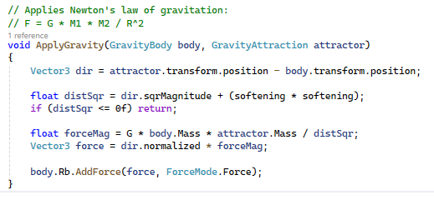
Figure 8 ApplyGravity Method in Gravity Manager
This is seen in the ApplyGravity() method in gravity manager using vector function. The direction of the objects is calculated, the squared distance is adjusted using softening, and the force vector is applied using Rigidbody.AddForce(). The reason I included softening was because softening helped prevent extreme forces at very small distances, which made it impossible for me as the tester to move around the scene without getting stuck to a planet or other object like the sun body.
Another important feature of the manager and the library overall is the attractor selection logic. Rather than applying forces from all attractors, the system determines which attractor makes the most sense for the relevant body. This is handled in the methods: SelectAttractorForBody(), SelectStrongestSOI(), and SelectInsideSOI().
Planets have a central body for the scene to orbit while using orbit initializer, otherwise they will use relevant spheres of influence to select attractors, while ships can move between attractors based on the sphere of influence conditions. I made use of roles as enum lists like SunOnly, PlanetSOIOnly, and Both. These for simple configuration and more realistic behaviour in simulations that include more than one celestial body.
This implementation also shows my attempt at implementing the N-body problem. Instead of calculating all interactions, the manager selects the most relevant attractor based on mass and distance, significantly improving performance while keeping it looking realistic.

4.1.2 Gravity Body
My GravityBody script defines variables for the objects in scene that are affected by the gravity system. It stores properties like the mass and type and keeps a reference for the Rigidbody.
When it is initialized, the script makes sure that a Rigidbody component is on the object on scene, and it also adds one if it doesn’t already have one. It unchecks the gravity component check box to stop Unity from overwriting my gravity system and sets the sleep component to false to make sure that the objects stay active even in slow moving moments. The reason I added these checks in the script was I had issues with objects stopping motion in scene and it also adds to the function of the library to have safeguards like this in place if someone unfamiliar with the code picks up the library and uses it.
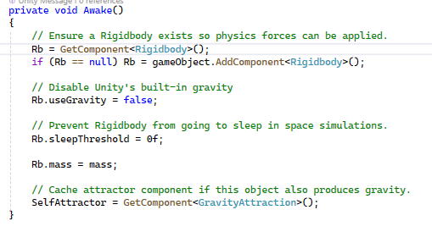
Figure 9 Awake method in GravityBody
GravityBody also includes a BodyType enum list. This lets the system distinguish between different types of objects like planets and ships. This role is used by the GravityManager to decide which sphere of influence method to use.
The script also allows for an initial velocity to be set in the initialVelocity and applyInitialVelocity fields. This allows objects to begin with defined motion, which is useful for testing and for integration with the orbit system. It does require some calculations worked out on the user’s part which is why I went on to create orbit initializer.
Another important feature of the implementation is the SelfAttractor role, which stops objects from applying the gravitational force to themselves. This is important to the stability of the simulation. This links back to the gravity manager in the sphere of influence selection once this role is on a body it prevents this.

4.1.3 Gravity Attraction
The GravityAttraction script defines the objects that give off gravitational force. It stores mass, radius for its sphere of influence, and roles that decide how the object acts in the attractor selection.
Figure 10 ENUM list in GravityAttraction
The role system is quite important, as it allows the simulation to distinguish between global attractors (such as the sun) and the local attractors (like the planets). This enables gravity to act on sort of a hierarchy, where objects can switch between the different attractor influences depending on where they are in relation to the objects in the simulation.
The sphere of influence radius is used to decide whether an object is in the range of the attractor. It’s also important to note that it uses the unity gizmos as a visual aid for anyone defining the radius. It draws a wireframe sphere around the attractor.
Like in the GravityBody script, the GravityAttraction script registers and unregisters itself with the manager. This ensures that the manager always has a constantly updating list of active attractors.

4.1.4 Orbit Initializer and Orbit Math
The orbit initializer system is implemented in two of my scripts: OrbitInitializer and OrbitMath. One script (OrbitInitializer) is for the scene behaviour and OrbitMath is for the calculations performed to get the orbit. OrbitInitializer is the script that gets attached to the relevant scene objects, whereas OrbitMath is the helper class that gets used for the orbital calculations.
OrbitInitializer starts by getting references to GravityBody, GravityAttraction, and GravityManager, along with the orbit parameters like orbitNormal, clockwise, and applyOnStart. In Reset(), the script fills in references where possible, which helps with usability when the script is first added so developers don’t have to manually set up everything. In Awake() then, it calls ApplyCircularOrbit() if applyOnStart is enabled, making sure that orbit velocity is assigned before the simulation starts. This just makes sure that the orbit initializes immediately when the scene starts.
The ApplyCircularOrbit() method has a few layers of setup. It attempts to find missing references if the developer didn’t assign them manually. It makes sure a rigidbody exists, adding one if necessary, much like in GravityBody. It also provides error messages if the body, attractor, or manager are missing. These checks are important because orbit initializer depends on all three of these parts being active. Without these messages and checks, the script could fail without notifying the developer and it just helps identify what the issue is.
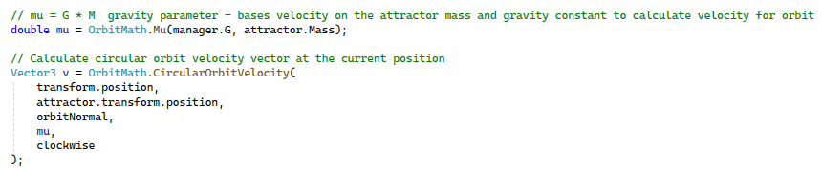
Figure 11 ApplyCircularOrbit - applying calculations to create orbit in OrbitIntializer
The script then calculates the standard gravitaty parameter mu by calling OrbitMath.Mu(manager.G, attractor.Mass). The orbit velocity vector is then done using OrbitMath.CircularOrbitVelocity(transform.position, attractor.transform.position, orbitNormal, mu, clockwise), which takes the body position, attractor position, orbit normal, gravitational parameter, and orbit direction. The vector then is assigned to rb.velocity to give its initial velocity number. Then the script sets body.initialVelocity = v and body.applyInitialVelocity = false, ensuring that the orbit velocity just assigned will not later be overwritten by the body’s own startup logic. This was done so the scripts gravity body and orbit initializer could live together in the game.
The OrbitMath class implements the equations for creating the orbit like the speed of the orbit and the direction.
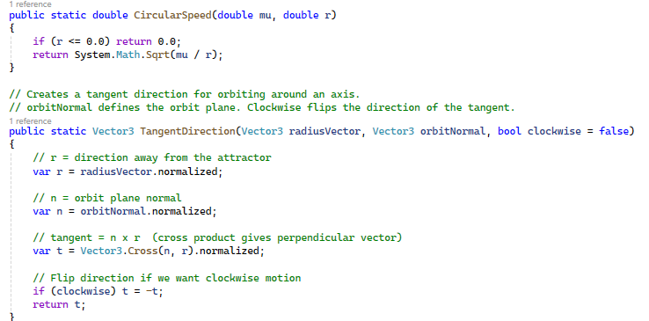
Figure 12 CircularSpeed and TangentDirection in Orbit Math
TangentDirection() uses the result of the orbit normal and radius to make a perpendicualar direction that is suitable for the orbital motion. It also allows the developer to switch the orbit to work clockwise or anticlockwise essentially just inverting the direction. Finally, CircularOrbitVelocity() combines the magnitude, the orbit speed and tangent direction into the final velocity.

4.1.5 Scriptable Objects
The GravitySettings script is made as a ScriptableObject, which allows the configurable variables to be stored separately from the scene objects. This has gravitational constant, softening factor, and simulation preferences which aren’t in use in the final product. They included a time warp feature which would have sped up the simulation speed, but I could not successfully implement it correctly in time without causing instability in the gravity system.
Using the ScriptableObject for configuration is an important design decision, as it improves the reusability aspect. Developers can simply change the simulation parameters in the inspector without changing any of the code, making the system more accessible for those unfamiliar with the code.

4.2 Challenges
During my time implementing these features I came upon many many a challenge.
The first and largest one being the change of my project from what was initially supposed to be a game on its to a library. This happened in January which was two months after coding had already begun. Now, at this time it didn’t necessarily mean that code had to be re-written, but the focus did change. Where I didn’t have error messages and safeguards before, I now added them to make it feel more like a professionally made library that anyone could pick up and use easily. I did this as in this context, it wouldn’t just be me as the developer using it, it would mean other people would have to be able to pick up the library and be able to use all of it and debug it.
This also led to the introduction of scriptable objects and making references private.
One issue I had that went unsolved was the issue of the ship controller. I could not get the movement correct on this script, and I couldn’t get it to truly simulate the gravity effecting the player’s ship. Now this wasn’t a key issue as it was only a part of the demo scripts and not important to any of the library code, but it does raise flags for me as to how hard it is to integrate a ship into this gravity system and it would be something I would have liked to investigate further given the time.
Another challenge I had was the setting up of realistic orbits. I had to perform quite a bit of my own calculations to get planets to make an orbit formation in scene, I resolved this issue by creating the orbit initializer script which I discussed above.

4.3 Testing Methodology
Testing was an important part of the project because the success of a physics-based library requires quite a lot of testing to check if the physics are acting as intended. The testing methodology used in this project was mostly based on manual testing (brute force) and the use of debug.log functions that are provided in unity.
Manual testing was what I mainly used because the project is mostly visual. The movement of celestial bodies, stability of orbits, the effect of gravity on the spacecraft, and the collisions are all easier to judge through me observing them in real time than through separate tests done individually.
The features were tested as they were developed, then tested again when new features were created. This was important because modifications to the gravity calculations or settings usually affected existing logic in different ways. Testing helped to see whether fixes actually improved the system or created new issues in the library.
The testing environment was made up of the demo scenes I created for the project. These scenes were useful as scenarios to test different parts of the system.

4.4 Functional Testing
Functional testing mainly focused on whether or not the system could do what I designed it for. The requirement was that a gravity source should be able to attract another object according to the distance and mass. This was tested mostly in one scene with a single central body as the sun and multiple other bodies in scene.
More testing included the existence of more than one object in scene without upsetting the gravity system. This part was mostly about making sure the sphere of influence system was done correctly. That all the objects selected the right attractors at the right time. I made great use of debug.log here to show what object was in what sphere of influence.

4.5 Performance Testing
Performance testing aimed to say whether the library could work efficiently enough for practical use on regular hardware. The most important factor affecting performance was the number of active gravitational interactions in the scene as this meant there was more and more calculations being done at once. The more objects on scene, the less smooth the operation ran.
The asteroid spawner was useful for checking this. It showed that the system could support a significant number of objects. As stated before though the more objects on scene meant the simulation did not run as smoothly which was my first realisation of why it is so hard to get a true N-Body system working.

4.6 Usability Testing
A major objective of this project was reusability. So naturally the usability testing was especially important. A fully functioning gravity system would still fall short if it happened to be confusing or difficult for another developer to use. Testing here included the process of setting up the system from the perspective of another developer rather than just me making it as a once off game.
This mostly involved creating things like scriptable objects, serialized fields which could be edited in the unity inspector and not make the developer go into the code. It also included a lot of built in debugging to say whether or not the developer has selected bodies or objects and put them into the right containers for specific scripts, telling them that they aren’t assigned.

4.7 Bug Tracking and Fixes
While I was undergoing development of this project, many bugs were identified and addressed. One issue included bodies accelerating too aggressively at close range. This meant that objects got close and could get stuck to other objects and it didn’t look natural. This led to the introduction of softening as I discussed above.
Another issue that I had to address was the issue of setting up orbits as simply as possible. This meant not having to perform calculations each time to define orbits as it was near impossible to get right. This led to the introduction of the orbit initializer and orbit math scripts that helped me successfully set up orbits without having to do calculations manually.
There are also a lot of built in debugs that help if objects aren’t assigned correctly to components in the inspector. I did this as it is easy to forget to do these things and as a library context it helps future developers.

4.8 Results evaluation
My evaluation of the results I received were that I successfully implemented a working gravity library in unity. It was successfully implemented using Newtonian gravity as I had set out to do and also implemented unity’s rigid body system as the collision detection. I also successfully implemented a reusable library and of that part I am particularly proud because there is so many safeguards and error messages and parts that make this library user friendly like the scriptable objects for example. This to me meant that the core objectives of the project were met.
However, the library does not do everything perfectly as my implementation of the N-Body problem is not a true implementation though as discussed would be impossible to do with this hardware and allotted time. The spacecraft also did not end up working properly as part of the demo section of the library.
I do believe overall, as solely a reusable gravity library it does succeed in what I set out to do and shows a result of the research I carried out and the design methods I put in place before starting the implementation.

User manual

Introduction
This user manual contains information on how to setup a working scene in Unity that has a central body of gravity, an object that orbits it and how to setup scriptable objects and define variables in the project.

Installation and Setup
To install the library, you must download the folder that contains the code. These should include a root folder called SpaceSim. This should then contain three more folders: Demo, Documentation and Runtime. These folders all contain scripts, but the runtime folder is the only one necessary to have to run the core functionality of the library.
The setup of these runtime scripts is defined below in the How to use the library section.

Overview
This library contains scripts that apply a different gravity system to unity, allowing the developer to set up a space like simulation that includes orbits and allows for gravity in a celestial form using spheres of influence to define attractors and using Newtons law of gravitation.

How to use the library
1. Create the Gravity Manager
Steps:
In the Hierarchy, create an empty GameObject
Rename it GravityManager
Add the component:
GravityManager
Create settings:
Right-click in Project
Create - SpaceSim - Gravity Settings
Name it SpaceSimGravitySettings or something similar
Assign it:
Drag the settings asset into the GravityManager - Settings field or select it in the inspector

Recommended settings:
Gravitational Constant: 1
Softening: 0.1

2. Create the Sun (Gravity Source)
Steps:
Create a sphere:
Right-click - 3D Object - Sphere
Rename to Sun
Scale it up to your preferred size (1000). for realism make if significantly larger than the planet you will create
Add components:
GravityAttraction
Configure the Sun:
Mass: 100000 (or higher)
SOI Radius: make sure it is sized up to include all the planets (you will see the white gizmo to guide you when you click on the soi size)
Role: SunOnly

Optional:
The Sun does NOT need a Rigidbody unless you want it to move
It does NOT need GravityBody unless it should orbit something else

3. Create the Planet
Steps:
Create another sphere
Rename to Planet
Scale (100) and Position it a good distance away from the sun
Add components:
GravityBody
GravityAttraction - unless you want the planet to only be affected by the sun and not affect other bodies (like asteroids)
OrbitInitializer
Configure GravityBody:
Mass: 1000
Type: Planet
Configure GravityAttraction (for planet SOI):
Mass: 5000 (smaller than sun)
SOI Radius: 100–300
Role: PlanetSOIOnly

4. Set Up the Orbit
On OrbitInitializer:
Body: drag the Planet
Attractor: drag the Sun
Manager: drag the GravityManager
Orbit settings:
Orbit Normal: (0,1,0) (horizontal orbit)
Clockwise: optional
Apply On Start: enabled

Now run the scene, and the planet should orbit the sun under the influence of gravity. Adjust masses and distances to see different orbital behaviors.

Troubleshooting and FAQs
Some issues the user may run into is not assigning correct objects to the script components. To fix these issues look at the debugs that appear at the bottom of the unity editor in the logs which will tell you what is missing from the component. Another good way of avoiding issues is to follow the above How to use the library section. Follow that checklist which contains all the information required to set up a simulation of a solar system which is what this library’s intended usage is.

Critical analysis and Conclusions

Overview
The critical analysis and Conclusions chapter here will cover how I feel I have successfully or unsuccessfully met the objectives and aims of my project the Gravity Library System. In this chapter I will be talking about the challenges I faced during implementation of the project and the design, discussing whether the project was successful or not.

Evaluation of Success

Achievement of Objectives
The most important objective of this project was to create a reusable gravity library to be used by future developers in Unity. To that extent, I believe I have been successful. I successfully implemented Newtonian gravity in my library system, and I feel I have done a good job on making the library reusable in the sense that there quite a few safeguards put in place to assist in debugging if necessary and clear demo scenes and documentation to describe how the project works. I feel I have learned quite a bit about making a reusable library through the creation of the documentation, scriptable object components and the use of the debugs to notify users if something isn’t working correctly and how to fix it.
I will say that the objective of implementing a working space craft in the demo scene was not met and I would have liked to have had more time to remedy this. I believe this could have been done with looking at the speed at which the ship moves and how the movement forces are applied could have fixed this.
I also could not achieve a true N-Body simulation but as I stated it was not a realistic goal and the N-Body mechanics I allowed for are acceptable currently.
Overall, I believe the project was successful in the objective sense.

Technical Contribution
The technical contribution of this project is that it contributes a tool for developers to use in game development or simulations to implement a working solar system or celestial mechanics in general. Unity’s existing gravity system is somewhat limited, and I feel I have contributed a more refined system of defining gravity in space like scenarios in Unity.
I feel it integrated quite well in the Unity Game engine as the performance was good in the end and I could also make use of existing unity components like the rigid bodies to enhance my project through collisions and such.
I also believe it further raises the question of the difficulty of implementing a true N-Body system on modern hardware in games. I saw this question raised during my research and experienced it myself when developing the library.

Demonstration Through Simulation
I created three demo scenes to showcase my project. The first scene being a solar system example of three body’s orbiting one central body. This particular demo scene also included the unfinished spacecraft in scene. I believe this scene does a good job of showing what the library is capable of doing in development if the developer wanted to make a simulation or a game based in space.
I also had another demo scene that showcases a body being pulled toward a central body. I feel that this shows another use of the library, it shows the collision system in action and the attractors working.
I had one final demo scene that acted as a setup scene. This scene allows developers to go through my manual and set up a successful orbit including a central body and an orbiting body. The manual does a good job of making use of all the runtime scripts that are part of the core library and should provide them with an understanding of how to implement the library in their own projects.

Challenges encountered and Lessons learned

Technical Challenges
I had some technical challenges while developing this project. One being achieving a stable orbital motion. This was because it required equations to define correct initial velocity to be put on each body. This led me to the creation of a script that does this for you in orbit initializer.
Another challenge was the force of gravity pulling objects together rapidly. I remedied this issue with the introduction of softening in my project to stop this from happening and show a more stable gravity system.

Research Hurdles
I did not encounter much in the way of hurdles during the research phase. I found there to be plenty of papers written on Newtonian mechanics and plenty of documentation for creating reusable libraries in Unity.
However, I did not find any papers relating to integrating Newtonian mechanics in the Unity game engine. This leaves an opening to write a paper like that to assist in future development for other people.
In existing games there were also conflicting methods of implementation of gravity to this made it difficult to narrow down exactly how I should go about doing it in my library.

Project Management
I structured the project using an agile approach which I learned a lot about during my time at college. This included weekly sprints, prototyping, idea generation, documentation like uml diagrams and bug fixing. I found this style of project management to be key to the project’s success.
Some phases of the project took longer than others, for example the design phase took the longest as it consisted of me thinking about how I was going to undertake this project and implement it as it seemed very daunting at the time. The testing phase also took quite a while as there are a lot of checks to do in physics-based libraries.

Key Conclusions

Effectiveness of Contribution
I feel my Gravity System Library adds a good contribution to game development and simulations in general. It addresses what I see as a limitation in Unity’s existing gravity system and goes to improve upon it making future developers lives easier as this part can be time consuming and very low level and requires a good knowledge of physics to undertake.
While I do feel some improvements are most certainly possible I do feel that the system achieves the objectives it set out to do and provides a valuable tool for future developers hoping to make a space game or simulation.

Personal and Professional Growth
This project has improved my knowledge of physics and mathematics drastically, I knew beginning this project would challenge me to my full extent of mathematical and physics knowledge as neither of which have ever been my strong point in academics. I feel coming out of this project that I have improved my knowledge base on both topics a good amount and I am very happy with that.
I also feel I have improved overall as a game developer as developing a library has thought me the skill of working on something keeping in mind that someone else will one day have to work with this code base. It taught me more about keeping code modular and reusable, making use of things like scriptable objects to make developers lives easier and of course the use of commenting and debug statements for those unfamiliar with the code.
Professionally, I would say my problem solving, planning and critical thinking skills have all improved dramatically.

Future Work

Potential Enhancements
There are some avenues I could take this project down for improvements.
As a standalone library I could introduce a new numerical integration method like Runge Kutta or Verlet. This would be a significant undertaking but one that would be worth exploring to further build on this base I have created.
Other work could include a more advanced collision detection system, or user interfaces for including things like preset celestial bodies for developers to drag and drop.
I also would like to finish the spacecraft as I think it would be beneficial to future developers to see how a spacecraft might be implemented using this library.

Broader Applications
The broader application of this library could be applied in places like game development. It could also be applied as an educational tool to understand Newtonian mechanics with a visual simulation as an aid making it more interesting to learn about.
This project could also be packaged and shipped in the Unity Asset store to be downloaded by anyone and worked on to integrate it in large scale projects.

Final Summary
The aim of this project was to create a gravity system using Newtonian mechanics improving upon the existing Unity gravity system. It was also a core aim to build a reusable library for future developers to make use of. These aims have been successfully met through a modular and configurable library based on Newtonian gravitation.
I have demonstrated in this project that a balance of realism and good performance can be achieved when implementing a complex gravity system that performs many calculations. I have also proved this through testing.
I have also demonstrated as a result that a good reusable and modular library on its own was built through things like scriptable objects, commenting and debugs to allow for others to work on this library also.
The impact of this contribution to game development has I hoped benefitted those looking to create a space-based game or simply those wishing to improve upon unity’s existing gravity system and makes their lives as developers easier going forward.
Overall, my project shows that it has succeeded as a physics based reusable library and has provided a useful tool for developers going forward.

7. Bibliography
Zhu, H. Scientific Research Publishing (2024) ‘The Newtonian Problem and Gravitational Rotation’ Available at: https://www.scirp.org/journal/paperinformation?paperid=128759

Saari, D.G. (1976) ‘The N-body problem of celestial mechanics’ Available at: https://link.springer.com/article/10.1007/BF01247127

Oberdorfer, S and Latoschik, M.E. (2018) ‘Effective Orbital Mechanics Knowledge Training Using Game Mechanics’ Available at: https://downloads.hci.informatik.uni-wuerzburg.de/2018-vsgames-ksp-preprint.pdf

Hairer, E. (2011) ‘Euler Methods: Explicit, Implicit, Symplectic’ Available at: https://www.researchgate.net/profile/Ernst-Hairer/publication/302468139_Euler_Methods_Explicit_Implicit_Symplectic/links/57c84db408aefc4af34ec417/Euler-Methods-Explicit-Implicit-Symplectic.pdf

NASA (2018) ‘Newton’s Law of Gravitation’ Available at: https://imagine.gsfc.nasa.gov/educators/programs/swift/classroom/law_grav_guide.html

Unity Technologies (2023) ‘Rigidbody Physics’ Available at:
https://docs.unity3d.com/Manual/class-Rigidbody.html

Unity Technologies (2023) ‘Creating custom packages’ Available at: https://docs.unity3d.com/2022.2/Documentation/Manual/CustomPackages.html

Unity Technologies (2023) ‘Assembly definition and package’ Available at: https://docs.unity3d.com/2022.2/Documentation/Manual/cus-asmdef.html

Unity Technologies (2023) ‘ScriptableObject’ Available at: https://docs.unity3d.com/2022.3/Documentation/Manual/class-ScriptableObject.html

8.Appendix

API Document
Package | SpaceSim
Primary namespaces | SpaceSim.Gravity, SpaceSim.Orbits
Purpose | Custom gravity, sphere-of-influence selection, and orbit initialization for Unity scenes.
Included runtime types | GravitySettings, GravityAttraction, GravityBody, GravityManager, OrbitInitializer, OrbitMath

Scope: This document describes the public runtime API present in the uploaded package. Demo scripts are not treated as part of the core of the API.
1. Architecture overview
GravitySettings stores global simulation values such as gravitational constant and softening.
GravityManager is the central coordinator. It registers bodies and attractors, chooses the active attractor for each body, and applies Newtonian force in FixedUpdate.
GravityAttraction marks an object as a gravity source with a mass, sphere-of-influence radius, and role.
GravityBody marks an object as affected by the gravity system and exposes the current attractor and rigidbody.
OrbitInitializer computes and applies a circular starting velocity.
OrbitMath provides reusable orbital math helpers.

2. Namespaces
Namespace | Contents
SpaceSim.Gravity | GravitySettings, GravityAttraction, GravityBody, GravityManager
SpaceSim.Orbits | OrbitInitializer, OrbitMath

2.1 GravitySettings
ScriptableObject that stores global gravity configuration and can be created from the Unity Create menu.
Member | Type / Signature | Description
gravitationalConstant | float | Scaled gravitational constant used in force calculations.
softening | float | Softening term added to distance calculations to prevent extreme forces at very small separations.
preferSOI | bool | When true, a ship inside a valid sphere of influence prefers that attractor over the global fallback.
timeScale | float | Global simulation time multiplier. Marked in code comments as not currently in use.

Notes: CreateAssetMenu is configured with menuName = "SpaceSim/Gravity Settings" and fileName = "GravitySettings". OnValidate clamps all numeric values to non-negative ranges.

2.2 GravityAttraction
represents an object that produces gravity.
Member | Type / Signature | Description
GravityRole | enum { SunOnly, PlanetSOIOnly, Both } | Controls how the attractor participates in selection logic.
Mass | float (read-only) | Mass used in gravitational force and attractor scoring.
SoiRadius | float (read-only) | Sphere-of-influence radius checked during local attractor selection.
role | GravityRole | Role assigned to the attractor for selection filtering.

Notes: OnEnable automatically registers the component with GravityManager.EnsureInstance(). OnDisable unregisters it. OnDrawGizmosSelected renders the SOI wire sphere in the editor.

2.3 GravityBody
For an object affected by the custom gravity system.
Member | Type / Signature | Description
BodyType | enum { Planet, Ship } | Determines how attractor selection behaves.
Type | BodyType (read-only) | Configured body category.
Mass | float (read-only) | Body mass used in gravity calculations.
initialVelocity | Vector3 | Optional startup velocity.
applyInitialVelocity | bool | When true, initialVelocity is applied in Start().
Rb | Rigidbody (read-only) | Cached rigidbody used by the simulation.
SelfAttractor | GravityAttraction (read-only) | Reference to the body's own attractor, if present, to avoid self-attraction.
CurrentAttractor | GravityAttraction | The attractor selected for the body in the current physics step.

Notes: Awake ensures a Rigidbody exists, disables Unity gravity, sets the mass, and caches an optional local GravityAttraction. OnEnable and OnDisable handle manager registration.

2.4 GravityManager
Singleton that tracks all registered bodies and attractors and applies gravitational forces in FixedUpdate.
Member | Type / Signature | Description
Instance | static GravityManager | Global singleton instance.
G | float (read-only) | Resolved gravitational constant from the assigned settings asset.
softening | float (read-only) | Resolved softening value from the settings asset.
preferSOI | bool (read-only) | Resolved SOI selection preference.
timeM | float (read-only) | Resolved timeScale value from the settings asset.
Register | void Register(GravityBody body) | Adds a gravity body to the simulation list.
Unregister | void Unregister(GravityBody body) | Removes a gravity body from the simulation list.
Register | void Register(GravityAttraction attractor) | Adds an attractor to the manager list.
Unregister | void Unregister(GravityAttraction attractor) | Removes an attractor from the manager list.
MultiplyTimeScale | void MultiplyTimeScale(float factor, float min = 0f, float max = 50f) | Scales the settings timeScale within the supplied clamp range.
EnsureInstance | static GravityManager EnsureInstance() | Finds or creates a manager automatically.

Notes: At startup, the manager loads Resources/SpaceSimGravitySettings if no settings asset is assigned. Planet bodies always seek a SunOnly attractor. Ship bodies first look for PlanetSOIOnly or Both attractors whose SOI contains the ship, then fall back to a SunOnly attractor.

2.5 OrbitInitializer
MonoBehaviour that computes and applies a circular orbit velocity to a GravityBody.
Member | Type / Signature | Description
body | GravityBody | The body that will be given orbital velocity.
attractor | GravityAttraction | The object being orbited.
manager | GravityManager | Used to read the gravity constant G.
orbitNormal | Vector3 | Normal vector of the orbit plane.
clockwise | bool | Flips the tangential direction when true.
applyOnStart | bool | When true, orbit velocity is applied during Awake().
ApplyCircularOrbit | void ApplyCircularOrbit() | Computes circular velocity from the current body and attractor positions and applies it to the Rigidbody.

Notes: Reset auto-fills body and manager when the component is added in the editor. ApplyCircularOrbit also disables GravityBody.applyInitialVelocity after writing the computed velocity to avoid it being overwritten later.

2.6 OrbitMath
Static utility class with reusable orbit-related calculations.
Member | Type / Signature | Description
Mu | static double Mu(double G, double attractorMass) | Returns the standard gravitational parameter G × M.
CircularSpeed | static double CircularSpeed(double mu, double r) | Returns sqrt(mu / r), or 0 when the radius is invalid.
TangentDirection | static Vector3 TangentDirection(Vector3 radiusVector, Vector3 orbitNormal, bool clockwise = false) | Returns a normalized tangential direction using the cross product of orbit normal and radius vector.
CircularOrbitVelocity | static Vector3 CircularOrbitVelocity(Vector3 bodyPos, Vector3 attractorPos, Vector3 orbitNormal, double mu, bool clockwise = false) | Combines tangent direction with circular speed to produce a velocity vector.

3. Typical setup flow
Create a GravityManager object in the scene and assign a GravitySettings scriptable object.
Create a central body such as a sun and add GravityAttraction. Use a large mass and role = SunOnly.
Create an orbiting body and add GravityBody. If the object should also attract others, add GravityAttraction as well.
Add OrbitInitializer to the orbiting body, assign the body, attractor, and manager, then enable applyOnStart.
Run the scene and adjust masses, distances, and SOI radius as required.

