Cross Platform Development Design Doc for CA1 – Space Soldier

Contents
Introduction 3
Architecture 3
Diagrams 4
C# coding examples 6
PlayerBullet.cs 6
GameManager – Update and Start 7
Playerhealth – health(), AddShield(), RefreshHUD() and Die() 9
Part 2 – Game Design 10
What is the game? 10
What’s different about my game? 11
Features 11
Gameplay 11
Conclusion 11

Introduction
For my first Cross Platform continuous assessment I was required to complete a side scrolling 2D space shoot completed in Unity 2022.3 LTS. The goal of this project was to develop a game that can be deployed and played across different platforms, android, webGL (Itch.io) and includes an executable that can be played on windows.
This documentation will contain sections going through the system architecture, some diagrams, code examples, critical analysis of developing in the unity environment and finally an overview of what the is and some of the features and gameplay.

Architecture
For the architecture, my game has a component-based architecture which is the standard for most unity projects. Game objects have some C# scripts which are attached to them that provide them with their behaviours.
The architecture contains some files that are reusable such as DestroyOffScreen. Files like these I attached to multiple game objects like enemies and bullet prefabs, it cuts down on reused code and makes it work better in a modular sense. I also used some encapsulation like for the shield and health pickups
For the component-based side the main components consist of:
- GameManager - responsible for starting the game time and victory conditions, also for playing music. This also calls boss spawns
- PlayerController – used for player movement for WASD and the joystick.
- EnemySpawner – Randomly spawn’s enemies and has the spawn logic for the bosses. Keeps track of enemies alive on screen.
- Playershoot and Enemyshoot – has the methods for shoot() and shootInterval().
- SoundManager – creates the objects for sounds and has the play() method.

Diagrams
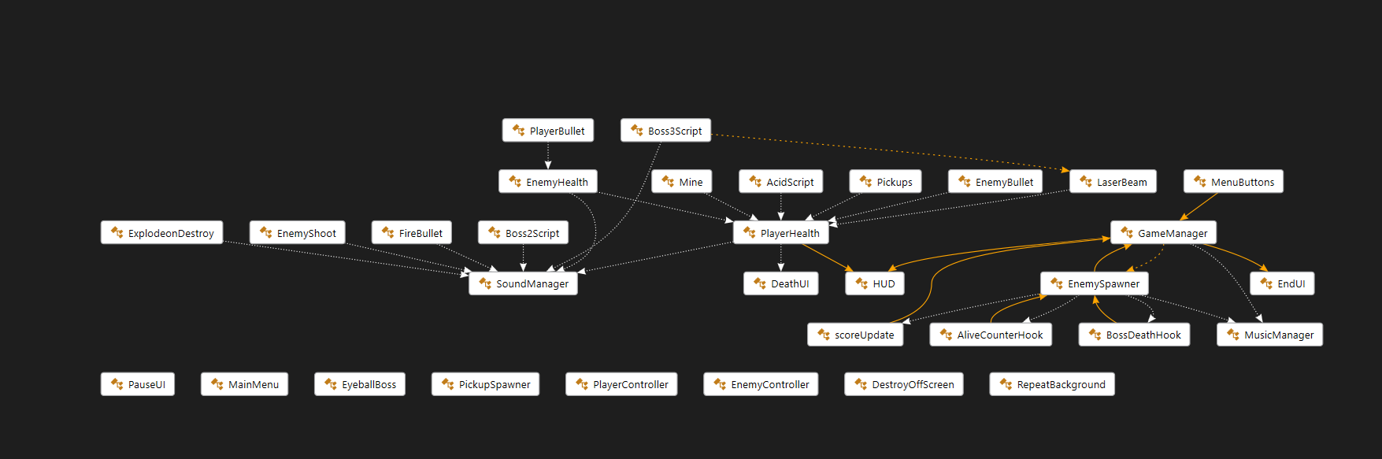
Figure 1 Class Diagram
In figure one here it displays a class diagram. This shows all of the classes and files that are used in this project.
As you can there are files that call from other classes like GameManager acting as a central piller and calls from classes like enemy spawner and sound manager to utilise their methods.
Code being structured like this helps to keep it modular and reusable. I also find a visual like this helps to put in perspective what classes inherit from others and how it all works together.
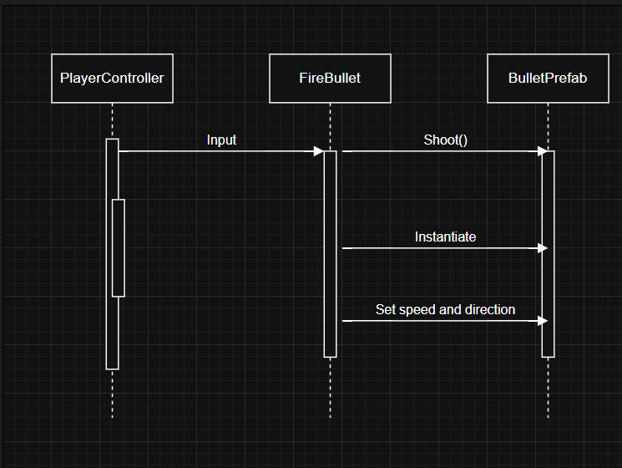
Figure 2 Shoot Sequence Diagram
In figure two you can see the sequence of events that happens when the player goes to fire a bullet.
The player makes there input so they either click or touch the shoot button on screen, and this calls the firebullet class to call shoot from playerShoot that then instantiates the bullet prefab that spawns on screen.
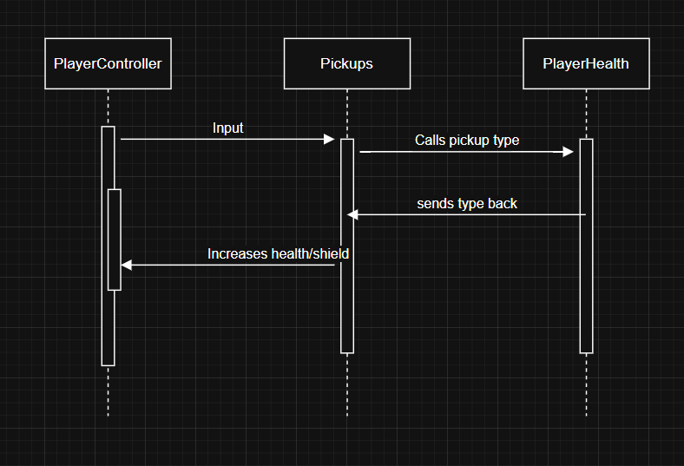
Figure 3 Pickup Sequence Diagram
In figure three, this shows the events that occur when the player collides with a pickup.
So, the player is moving to collide with one of the pickups using WASD or the joystick and upon collision the pickup class decides which pickup has been collected and applies the pickup logic to the player health based on that pickup type so either shield or health.

C# coding examples
In this section I’ll be going through some of the code that is crucial to the workings of the project.

PlayerBullet.cs
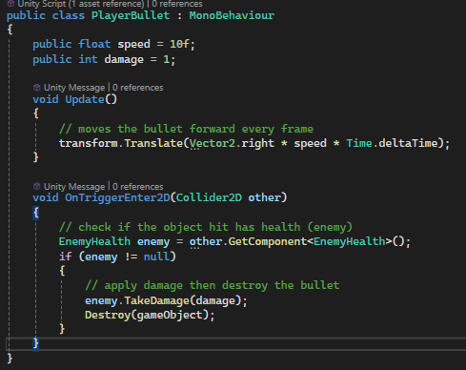
Figure 4 PlayerBullet.cs
Playerbullet.cs is responsible for controlling the player bullet prefabs behaviour. As you can see in the code snippet above there are variables that can be redefined in the editor to control how fast the bullet is (float speed) and how much damage the bullet inflicts on enemies (int damage).
In the update method it controls where the bullet moves. In that single line of code it moves the bullet using a transform containing a vector of the direction and speed and moving it every frame.
In the OnTrigger method, it checks if the bullet has intersected with an enemy and it will then call the TakeDamage method to damage the enemy and then finally destroy the bullet prefab itself.

GameManager – Update and Start
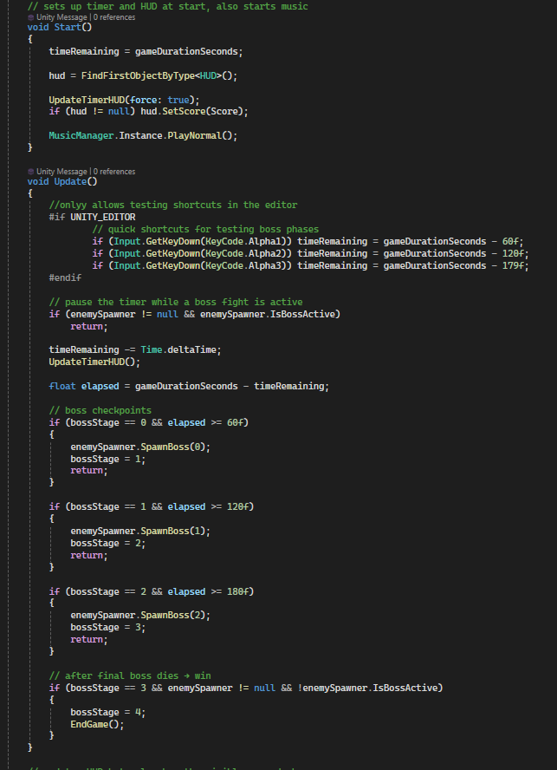
Figure 5 GameManagers Start and Update Method
In figure five it shows how the methods for Start and Update. These methods are responsible for setting up the hud, timer and music in start. In update then it sets up updating the timer and boss checkpoints and the win conditions
In Start(), it creates an instance of the MusicManager.cs that plays the ‘normal’ music from start of gameplay. It also sets up the score hud item that displays score: 0 on start and assigns the timeRemaining variable to the games duration which is three minutes.
In update() the first thing it does is set up shortcuts for testing in the editor. This allowed me to cut straight to the boss fights by subtracting time from gameDurationSeconds. This also only works in the unity editor using #if Unity_Editor which I thought was interesting and very useful as I have never done it before. After this it sets up the logic to pause the time if there is a boss active on screen. It also decreases the time using Time.deltaTime and then decreases game duration every frame using the timeRemaining.
The boss logic is then done here too checking the elapsed time and does a boss fight at 60 second intervals.
The win conditions set here are if the boss stage is 3, the enemyspawner is inactive and boss three is defeated it will the trigger end game.

Playerhealth – health(), AddShield(), RefreshHUD() and Die()
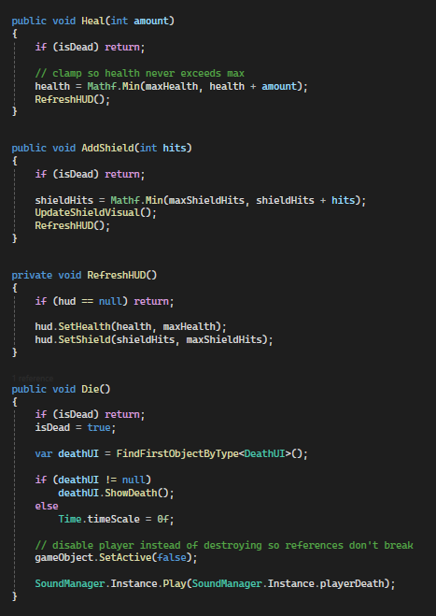
Figure 6 Playerhealth.cs – health(), AddShield(), RefreshHUD() and Die()
In figure six here I have some key methods for the pickup’s applications to the player and the hud and also the die method
The heal and add shield methods both control what the pickups do to the player. The Heal method adds the amount defined in the pickup.cs to the players health and makes sure it doesn’t exceed max health using the clamp. It the refreshes the hud to display this. The AddShield does the same logic as the health with the clamp to not exceed max shield hits and updates the hud. It also calls the method to display the shield fx on screen.
RefreshHUD calls the setHealth method and then the setShield method to define the shield hits you get and the max shield hits.
Die controls what happens the the players health hits 0 this is called. It finds the deathUI class and calls the showdeath() method which pauses the game and shows the death screen. This also sets the player object to inactive and plays a death sound to indicate the player has died.
2 -Provide appropriate critical analysis and conclusions about developing this 2D game in Unity. Think about and discuss how developing in Unity is similar or different to developing in C++
Unity allows for much swifter development times than other ways of development. Comparing to my time developing with c++ or java this all had to be hard coded and written. Whereas in Unity you can do quite a bit of the development visually in the unity editor and using C# scripts to define the already created game objects behaviour.
I also like the component-based methods that Unity goes by. I find this to be easy to follow and easier to develop in.
In this context also making separate builds for different platforms is a breeze as you can just pick which platform you wish to build for and in the case of this project, I didn’t have to make many changes outside of resolution to allow for play on different platforms.

Part 2 – Game Design
1- Provide an overview of the game use appropriate screen shot

What is the game?
My game is a 2D side scrolling game. It is called ‘Space Soldier’ It takes place in space where the player controls one spaceship. There is only one character for the player to control, and it is that of the spaceship. The focus of the game is the player must progress through the game with a boss spawning each minute until the final boss appears at minute three. Once the last boss is defeated the victory criteria is met and the player will have completed the game. It is made in Unity 2022.3 LTS and can be played in three ways – on a mobile phone, in the web browser on Itch.io or on windows through an executable.
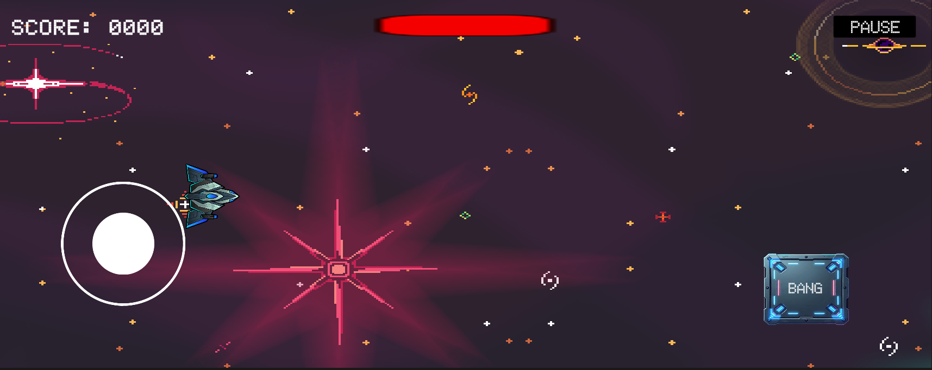
Figure 7 Screenshot Space Soldier

What’s different about my game?

Features
- A shield system – The shield can be filled by collecting blue balloons with a maximum of three charges. The shield when active displays a blue particle system that spawns in a ring around the player. The shield replaces the health system while active negating loss of actual health.
- A health system – Health starts at three and every time the player is damaged it loses either one or two health depending on the enemy. The health can be refilled by collecting red balloons which refills the health by one.
- An enemy spawner – this iterates randomly through an array of six enemy prefabs and has parameters on when the enemy is allowed to be spawned and from the allowed enemies it selects a random one and spawns in a random position off screen to look as if they are spawning in naturally.
The game also has many other features like a pause menu, main menu, victory screen and a death screen. These menus provide the player with options such as play game with changes the scene from main menu to game, quit game which closes the application or resume which will un-pauses the game. The game also has three unique bosses with unique attack patterns and movements; the bosses also act as an interval into next sections of the game providing the player with a natural sense of progression in terms of difficulty increasing as they play. The game can also be controlled via a touch joystick or on keyboard with the WASD keys and the player may shoot by either clicking or tapping the ‘BANG’ button.

Gameplay
The game provides a challenging but engaging side scrolling experience with omni-directional movement. It contains natural difficulty progression with a boss to separate each section. It also contains randomly spawning pickups to add depth to the games systems and further engage the player in the experience.

Conclusion
In conclusion, I had a lot of fun developing this project. Mobile game development wasn’t something that was on my radar previous to this, but I found the process to be quite enjoyable, and I learned a lot about developing for multiple platforms like changing resolutions and touch controls.
I also enjoyed making a 2D game in Unity as this was also something that I hadn’t experimented much with previous to this project. It was interesting looking at different 2D games and taking inspiration from them.

