

# BlogX Readme & Documentation

Table of Contents

BlogX Readme & Documentation 1

License 3

Installation 6

Installation Requirements 6

Installation Instructions 6

Known Issues 7

Help/Questions 7

Suggestions 7

BlogX Feature Configuration 8

Administrative Features 8

Admin Panel Configurable Features 8

Includes/Config.asp Configurable Features 9

E-mail Setup 9

Legacy Mode 10

Update Information 11

New Version Notification 11

How To Update 11

Credits 12

License

'*********************************************************************

'** Copyright (C) 2008 Matthew Roberts, Chris Anderson

'**

'** This free software; you can modify under the terms

'** of the GNU General Public License as published by the

'** Free Software Foundation; either version 2 of the License, or any

'** later version.

'**

'** All copyright notices regarding Matthew1471's BlogX

'** must remain intact in the scripts and in the outputted HTML

'** The "Powered By" text/logo with a link back to Matthew1471

'** (or "About.asp" provided the About.asp file isn't modified or deleted)

'** in the footer of the pages MUST remain visible when the pages

'** are viewed on the internet or intranet.

'**

'** This program is distributed in the hope that it will be useful,

'** but WITHOUT ANY WARRANTY; without even the implied warranty of

'** MERCHANTABILITY or FITNESS FOR A PARTICULAR PURPOSE. See the

'** GNU General Public License for more details.

'**

'** You MUST NOT use this in a commercial environment without my explicit

'** permission.

'**

'** In no event will the authors be held liable for any damages

'** arising from the use of this software.

'**

'** This notice may not be removed or altered from any source distribution.

'**********************************************************************

License Last modified: 12 August 2008

Copyright 2008 Matthew Roberts All Rights Reserved.

This license grants you the right to install, view and run one or multiple instance of this for private, public, non-commercial use.

You may modify source code (at your own risk), but the software (altered or otherwise) may not be distributed to entities beyond the license holder without the explicit written permission of the copyright holder.

You may use parts of this program including source code and images in your own private work, but you may NOT redistribute, repackage, sublicense, copy, or sell the whole or any part of this program even if it is modified or reverse engineered in whole or in part without the explicit written permission of the copyright holder.

Copyright notices must be transferred to any file that any source code from this program in whole or in part used within.

It is forbidden to repackage in full or any part of this software including source code and images as your own work and redistribute for profit or for free without the explicit written permission of the copyright holder.

You may not pass off the whole or any part of this software as your own work.

Any attempt otherwise to copy, modify, sublicense, reverse engineer or distribute any part of this work is void, and will automatically terminate your rights under this License.

You may not deactivate, hide, change, remove, all or any hyper links or links to Matthew1471 and the powered by logo's, text, or images. All must remain visible when the pages are viewed unless you first obtain explicit written permission from Matthew1471.

Permission can be obtained from Matthew1471 to remove the powered by logo's, text or, images by making a donation to Matthew1471 to help support the development and update of this and future software.

You will keep all copyright notices intact, including the notices embedded in all parts of the software.

The license holder is the legal owner of the magnetic medium on which the software is recorded. However, the software itself is not sold : the copyright holder retains the property rights on the software itself, whichever medium is used to store it upon and at any moment in time : original disks, plus any and all copies of the same which may have been produced subsequently.

Material from Matthew1471 including programs, applications, tutorials, scripts, may not be used for anything that would represent or is associated with an Intellectual Property Violation, including, but not limited to, engaging in any activity that infringes or misappropriates the intellectual property rights of others, including copyrights, trademarks, service marks, trade secrets, software piracy, and patents held by individuals, corporations, or other entities.

You are not required to accept this License, since you have not signed it.

However, nothing else grants you permission to download, install, run, use, view, modify, the Program or its derivative works. These actions are prohibited by law if you do not accept this License. Therefore, by downloading, installing, using, viewing, modifying the Program (or any work based on the Program), you indicate your acceptance of this License to do so, and all its terms and conditions for using, copying, or modifying the Program or works based on it.

Any disagreement which may arise between the parties with regard to the interpretation and/or execution of the present contract shall by default come under the jurisdiction of the United Kingdom Courts.

NO WARRANTY

-----------

THERE IS NO WARRANTY FOR THE PROGRAM, TO THE EXTENT PERMITTED BY APPLICABLE LAW. EXCEPT WHEN OTHERWISE STATED IN WRITING THE COPYRIGHT HOLDERS AND/OR OTHER PARTIES PROVIDE THE PROGRAM "AS IS" WITHOUT WARRANTY OF ANY KIND, EITHER EXPRESSED OR IMPLIED, INCLUDING, BUT NOT LIMITED TO, THE IMPLIED WARRANTIES OF MERCHANTABILITY AND FITNESS FOR A PARTICULAR PURPOSE. THE ENTIRE RISK AS TO THE QUALITY AND PERFORMANCE OF THE PROGRAM IS WITH YOU. SHOULD THE PROGRAM PROVE DEFECTIVE, YOU ASSUME THE COST OF ALL NECESSARY SERVICING, REPAIR OR CORRECTION.

IN NO EVENT UNLESS REQUIRED BY APPLICABLE LAW OR AGREED TO IN WRITING WILL ANY COPYRIGHT HOLDER, BE LIABLE TO YOU FOR DAMAGES, INCLUDING ANY GENERAL, SPECIAL, INCIDENTAL OR CONSEQUENTIAL DAMAGES ARISING OUT OF THE USE OR INABILITY TO USE THE PROGRAM (INCLUDING BUT NOT LIMITED TO LOSS OF DATA OR DATA BEING RENDERED INACCURATE OR LOSSES SUSTAINED BY YOU OR THIRD PARTIES OR A FAILURE OF THE PROGRAM TO OPERATE WITH ANY OTHER PROGRAMS), EVEN IF SUCH HOLDER OR OTHER PARTY HAS BEEN ADVISED OF THE POSSIBILITY OF SUCH DAMAGES.

If any terms are violated, Matthew1471 reserves the right to revoke the license at any time. No refunds will be granted for revoked licenses. Matthew1471 reserves the right to modify these terms at any time without prior notice.

This license is governed by the laws of the United Kingdom.

For correspondence : <http://matthew1471.co.uk/Contact.asp>.

Installation

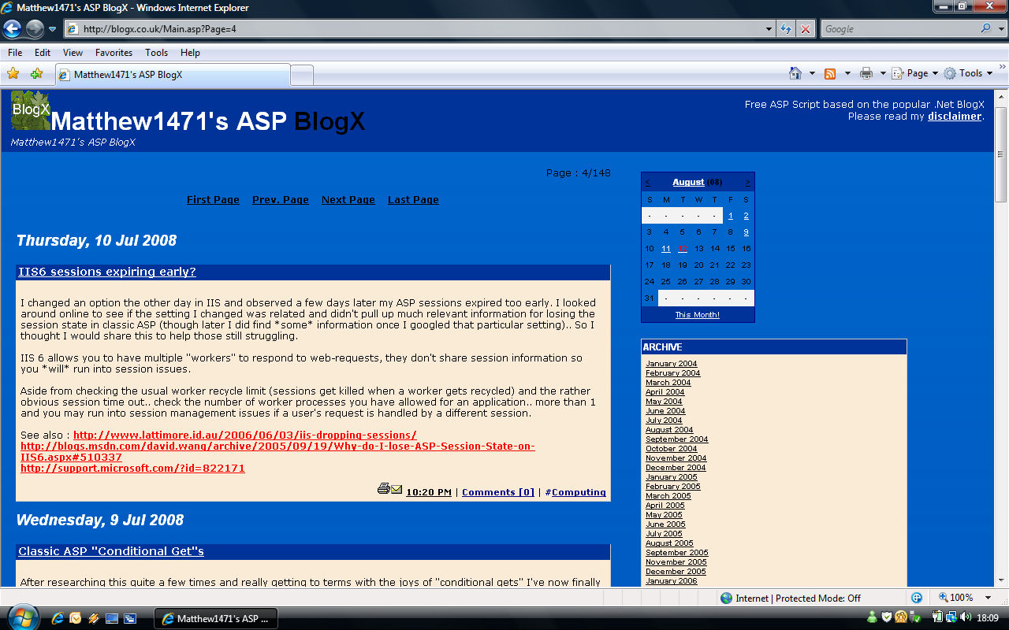

Thanks your interest in Matthew1471's Blogging solution. This file should give you the quickest guide to installing and using BlogX in a few quick steps.

## Installation Requirements

* Internet Information Services (preferably running on Windows Server 2003)
* Microsoft Access Driver version 2000 or later.

## Installation Instructions

Step 1. - Extract all the files in the zip's "WWWroot" directory to your web server's content directory. e.g. C:\Inetpub\wwwroot\BlogX\

Step 2. - Extract all the files in the zip's "Database" folder to a non-public database directory.  
e.g. C:\Inetpub\Database\

Step 3. - Edit "Includes\Config.asp" (e.g. from the following folder "C:\Inetpub\wwwroot\BlogX\Includes\Config.asp") edit the path to your "SiteURL" and additionally "DataFile" & "SharedFilesPath" (if different from the examples).

Step 4. - Ensure the database folder can be written to by the user that your web server runs under (i.e. IUSER_ServerName must have write privileges for this folder). Ensure the Images folder can also be written to by this user (for pingback and image upload..etc).

Now load up your blogging page e.g. http://yourdomain.com/BlogX/ and login using the username **admin** and the password **letmein**.

## Known Issues

Q: I get a blank white screen.  
  
A: If you are running NAV (Norton Anti Virus) on your server, Turn off "Script blocking". Norton script blocking is renowned for interfering with ASP scripts.

Q: I receive an error about a “Disallowed Parent Path” (Active Server Pages error "ASP 0131", “Disallowed Parent Path “,“The Include file "../Includes/Header.asp" cannot contain ".." to indicate the parent directory”).  
  
A: In order to avoid this problem please do the following:  
  
1. Go to your IIS Manger  
2. Right click the default web site  
3. Choose Properties >   
4. Select Home Directory Tab  
5. Click ‘Configuration’ button  
6. Select App Options Tab  
7. Check the Enable Parent Paths  
8. Click OK and your new configuration will be saved.

Q: I receive an error about “File is in use” (Active Server Pages error, “File is in use.”)

A: The IUSER account cannot remove the database temp file, make sure the IUSER can write to the entire database folder.

## Help/Questions

Do not be afraid to ask questions, even simple ones. Help is available by visiting <http://matthew1471.co.uk/Support.asp>.

## Suggestions

You may submit your suggestions to me at <http://matthew1471.co.uk/Contact.asp>.

# BlogX Feature Configuration

There are many features to BlogX. Most do not require setting up, however system administrators may wish to amend or alter some of the functionality.

## Administrative Features

There are 2 main places to customise your BlogX’s configuration. Online at the “Config” section of the admin panel and offline in the Includes/Config.asp file.

If you are a hosting provider you may not want a blog owner to change certain configuration options which is why some settings are only accessible by editing the Includes/Config.asp file. There are many reasons a server administrator may wish to disable certain features (decrease processor utilisation, reduce site bandwidth, enhance security).

### Admin Panel Configurable Features

SiteName - What The Site Is Called (Shows Up At The Top)  
CookieName - Random Text Value Which Is Stored On Clients Computer & Verified To See If They Have Logged In.  
Copyright - Shows Up In Each Pages' Footer.  
Description - Shown Just Underneath The Site Name (and as the RSS title).  
Comments - If ticked, Will allow users to comment on entries.  
EntriesPerPage - How Many Entries To Show On One Page (and in the RSS).  
ReaderPassword - (If not empty) Restrict your blog to only allow in users who know this password.  
SiteSubTitle - Shown On The Top-Right  
Polls - If ticked allows polls in the navigation  
Show Categories - If ticked allows categories in the navigation (and entry footers)  
SortByDay - Make The Calendar Clickable.  
BackgroundColor - The Background Colour In The Body Tags (should the style sheet fail).  
12HourTimes - AM/PM or 24Hour Clock Times.  
Logging - Save Where People Are Coming From In The "Referrers" Table.

### Includes/Config.asp Configurable Features

CommentNotification - Sends a subscribed commenter an e-mail **every** time a user comment is made.  
SiteURL - Used to help the site to refer to itself and prevent others from accessing via other addresses (i.e. <http://blogx.co.uk> <http://www.blogx.co.uk/>).  
AboutPage – Link to the local About.asp file or, if false, link to the one on blogX.co.uk instead.  
AllowEditingLinks - Setting to 1 allows a logged in user to edit the links file online.  
ArgoSoftMailServer - If your server is running "Argosoft Mail Server" allows posting from e-mail.  
CalendarCheck - Checks whether all calendar dates have entries, if they do it will provide a link in the calendar (Changing this to 0 increases BlogX's speed).  
CommentNotify – Sends the blog owner an e-mail **every** time a user comment is made.  
MailingList - Allows you to run a mailing list and displays the link at the bottom.  
LegacyMode - This will remove all functionality that wasn't in the original BlogX (see section below).  
NotifyPingOMatic - Lists your blog on the PingOMatic.com website whenever you make a post.  
NoDate - Stops separating entries by day.  
OtherLinks - Display the section "Other Links" from the OtherLinks table.  
Register - Notifies BlogX.co.uk that you want your site to be linked to from the “Who Uses” page.  
RSS - Lets people access a small RSS feed.  
RSSImage - Displays an image in your RSS feed (The image in the RSS folder).  
TimeOffset - Change the time by this many MINUTES e.g. "60" adds 1 hour to the server's time  
UseImagesInEditor - If 0 buttons are used in the editor, otherwise if 1, images are used in the editor (e.g. for bold, centre, underline).  
UseExternalPlugin - If 1 will dynamically include the "Plugin.asp" file to the navigation.  
XMLTimeZone - The times specified in the RSS are "GMT", "UT", "EST", "EDT", "CST", "CDT", "MST", "MDT", "PST", "PDT" see RFC822.

## E-mail Setup

BlogX can send comment notification e-mails, mailing list e-mails and even allow your users to e-mail you by clicking the mail icon next to an entry. Each e-mail allows the recipient to opt-out of receiving e-mails that they had previously subscribed to and e-mails to the administrator feature a convenient ban button to prevent certain senders from e-mailing.

To correctly set up and use e-mails one must perform the following. Once logged in click "Email Settings" in the admin panel. The page will then attempt to use various components and list the components it detects. Once the page has loaded, you will see a checkbox "Enable Email" the first step is to tick this box. Select the E-mail component that you want BlogX to use from the drop down box. Next enter in the mail server address that you wish the site to connect to and the administrative e-mail address that you want comments and messages to be sent to. Click save and users can now send you comments. In future toggling "Enable Email" allows you to globally turn on and off e-mail functionality.

Note: If your server’s e-mail component is not shown here and it is definitely installed, please contact me and I will add it.

## Legacy Mode

As mentioned in the “Includes/Config.asp Configurable Features” there is the option to turn on “legacy mode”.

In 2003 a Microsoft employee Chris Anderson created a blogging script that ran on ASP.Net. It was programmed in C#. Chris publicly shared the code without any license requirements, warranty or support.

In 2004 I discovered his blog code and could think of many additional features and improvements to make (this was also at a time when the ASP .Net runtime was extremely slow and not very reliable). I also did not believe that many webhosts supported ASP.Net at that time and that excluded a lot of people from running it. I also could not program in C# at that time.

BlogX was therefore completely re-programmed from scratch in classic visual basic code and additional features and bug fixes were added. For those looking to emulate the original ASP.Net BlogX blog I have included a “LegacyMode” which is useful for speed comparisons and for those who would prefer to keep their blog simple.

Below is a screenshot of a BlogX blog website running in legacy mode:

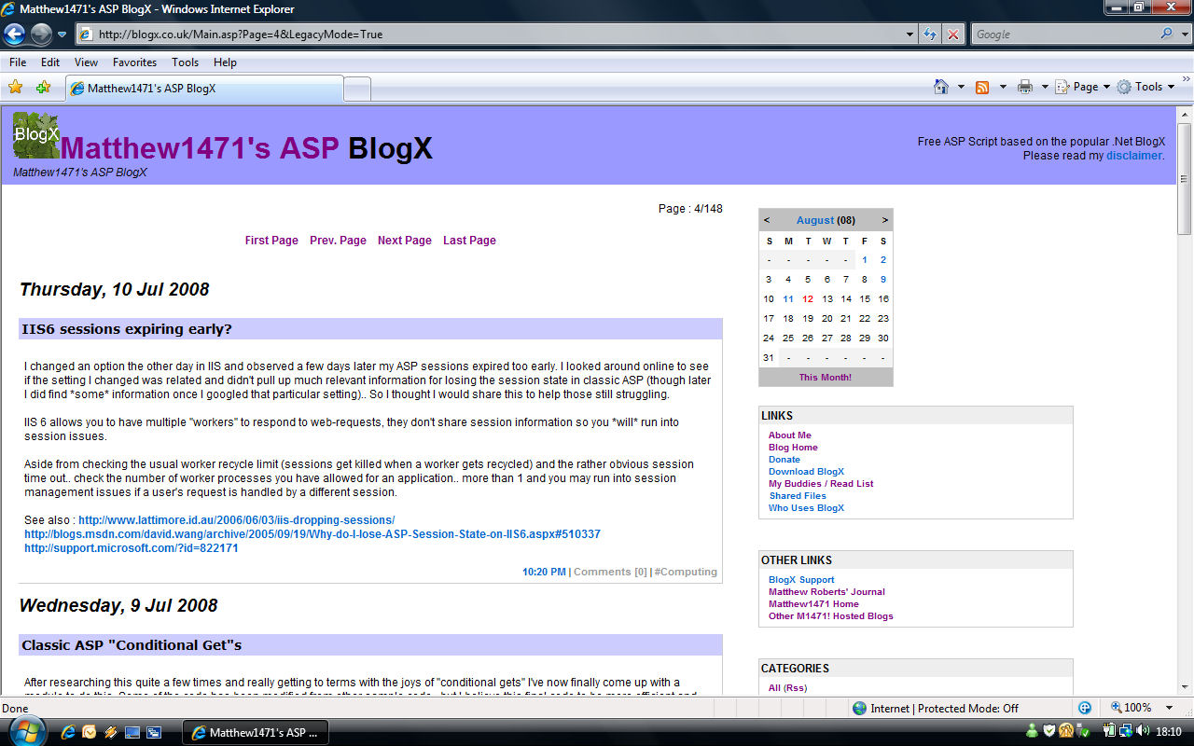

As you can see the archive and many other features have been turned off as well as the new style sheets.

# Update Information

BlogX has been actively and continuously developed from the beginning of 2004. Consequently it is very difficult to ensure that all upgrade paths are supported. Sometimes after observing various parts of the database could be further optimised or new features can be added the structure of the database has had to be changed. Database changes are often documented in the BlogX change log (<http://blogx.co.uk/About.asp>). The following information will more than likely require knowledge of databases, Microsoft Access table editing and fields.

## New Version Notification

To discover if a new version is available you can click “Check For Update” in the admin panel of your blog when logged in.

## How To Update

The easiest way to update is to first create a backup copy of your website’s files (and the database) so that you can recover your website if the upgrade does not run smoothly.

Some versions of BlogX have a Setup.asp which will check that all of the expected tables and fields are present in a database file. I would recommend running this against the old database file and copying the fields or missing tables from the new database to the old database. Knowledge of table editing in Microsoft Access is required for this part. Re-running Setup.asp after making changes will give you a clear indication as to whether BlogX should run smoothly with that database file.

Now extract the new “WWWroot” from the latest ZIP archive available on my website.

Your BlogX should now be up to date. If you struggle to follow these instructions, change your password (for security reasons) and contact me asking for my e-mail address and I may offer (depending on my schedule) for you to send your database to me and I will update it for you.

# Credits

BlogX uses the following public domain code snippets:

* “inc_mail.asp” from "Max Web Portal" (<http://www.maxwebportal.com>)  
  Why: Handles a range of mail server components.  
  Modifications: Wording & variables modified.
* "CharCount" for Visual Basic (<http://www.freevbcode.com/ShowCode.asp?ID=1025>)  
  Why: Counts the number of times a search query comes up in a post.  
  Modifications: Converted to ASP.
* "IIF" for ASP (<http://www.developerfusion.com/show/1606>)  
  Why: Was used in the port of CharCount to ASP.  
  Modifications: Unmodified.
* XML-RPC for ASP (<http://aspxmlrpc.sourceforge.net/>)  
  Why: Runs the XML-RPC engine for "Pingback".  
  Modifications: Filters "." to allow new method names.
* ASP PoorMan's Spell Check (<http://www.kirchmeier.org/code/pmsc/>)  
  Why: Runs the dictionary component.  
  Modifications: Handled by the BlogX GUI, has a "User Dictionary".
* Firefox JavaScript compatibility update was a user submission from IndaUK.  
  Why: Makes the IE specific JS run on Firefox.
* a simple AS2 Flash MP3 Player (<http://www.skylab.ws/?p=116>)  
  Why: Provides our podcast player.  
  Modifications: Unmodified.