1.public IP address is as shown underlined in red
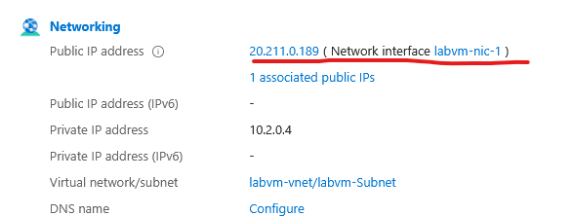
2.Logged in using the credentials provided
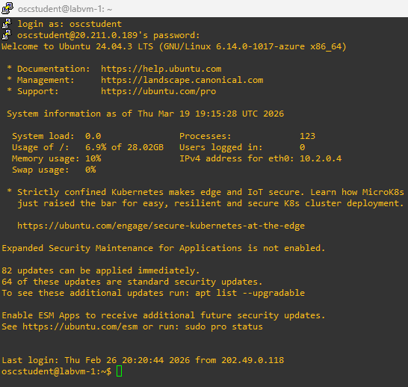
3. Logged in as another admin account and changed the name of osc student, the group and directory

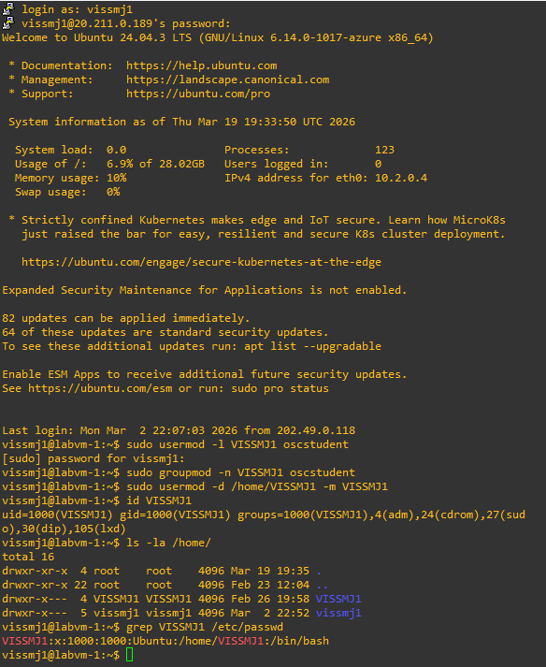
4. on the same admin account I used to change the account name I changed the account password(Account usernames are case sensitive so the username in all caps was oscstudent) I then tried logging into oscstudent using the old login credentials and it didn’t work and then logging in with the new credentials did just to double make sure it works
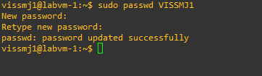
5.Completed bash script file
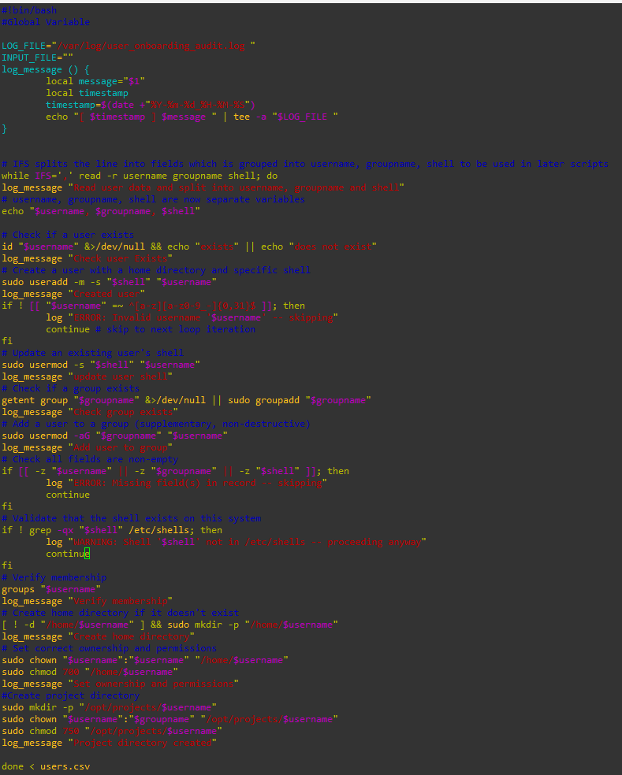
6.Script running
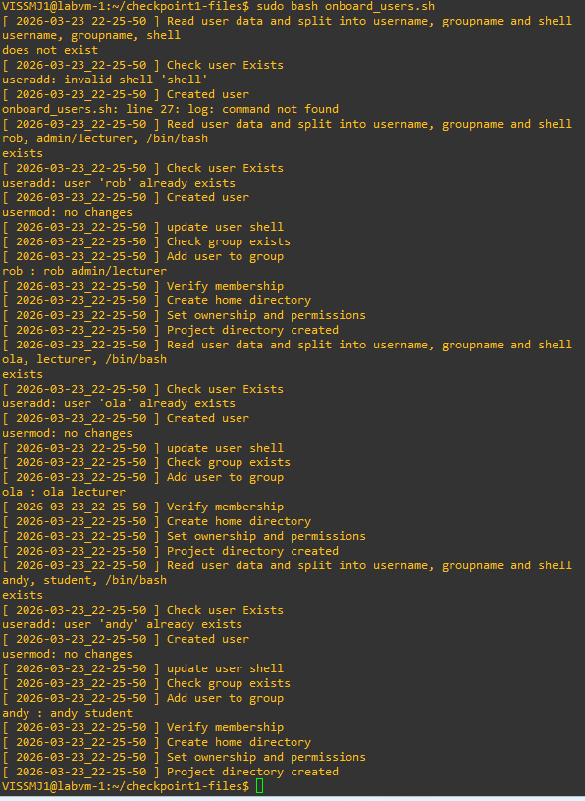

7.WinSCP viewing of the output of the log file
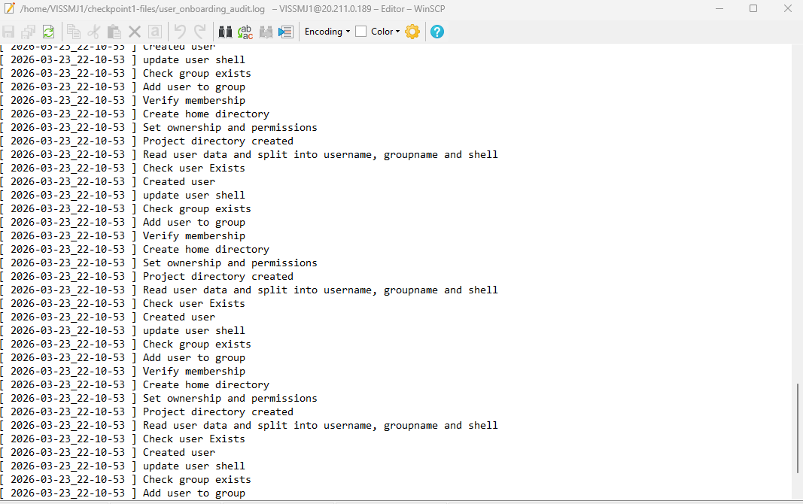
8. all users created properly
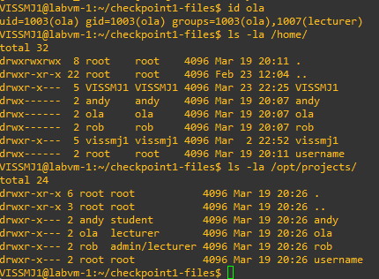

9.Critical log analysis script
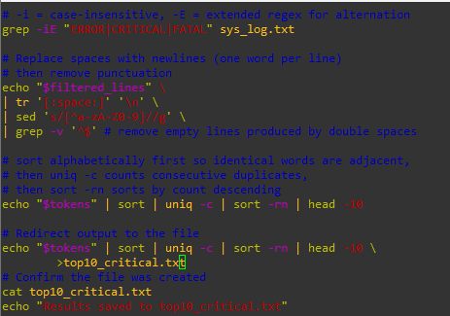
10.top10_critical.txt
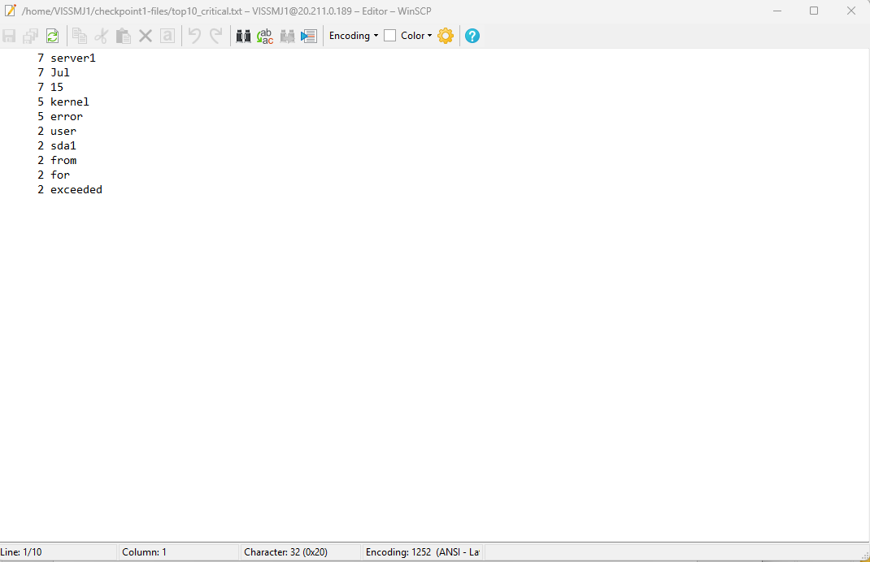

11. results when the script runs
