**Interface Description**

We will be creating a web application to simulate physics used in a specific game (Planetside 2) to visually display to the users of the web app. The specific physics simulate would be effects of gravity (bullet-drop), travel time (bullet velocity) and may include inertia (shooting while moving).

This app will include a selection of objects that the user chooses which would correspond to a specific item in the game represented as a list. There will be a graph along side with the list and the graph will display distances as its axes and a silhouette of the object selected by the users. It will support having multiple objects, within the graph, up to a reasonable limit.

Each of these objects would have their own velocity and additional modification to that object which would change the velocity value. The graph will then be able to display the object’s trajectory based on where the object is aiming at.

**Interface Requirements**

Users

* able to see and pick from a list an object they want to use
* will include filters to allow them to quickly found what they need
* able to change the angle, distance and time
* angle; by moving a crosshair to represent where they aim
* distance; the size of the graph width wise
* time; time given for the object to fly along its trajectory
* allow to toggle between two different modes
  + one dynamically updates the line representing the objects' trajectory instantaneously
  + one will slowly draw to represent an object's trajectory
* allow for drag and drop of more than 1 objects into the graph

**User-Centered Design Choices**

Visibility of system status

* app will be able to dynamically redrawn to reflect the user action of moving the aiming line
* provide visual feedback whenever an object is selected to be used in the graph

User control and freedom

* will contain a history of points where the crosshair is moved by the user and allow them to cycle through
* will allow the user set the dimension of the graph

Aesthetic and minimalist design

* Will be using simplified drawings to represent complex graphics of the objects used in game
* Color coded lines to differentiate between multiple objects on screen

Error prevention

* Will be checking user input to see if they are the correct data type needed

Help and documentation

* may include a button that toggles an overlay to display tooltips for the available functionality

Things done more often should be assigned a larger area of the screen

* The interactive crosshair should be large because it is a key component
* each object in the list will large enough for easier selection while be small enough to not take too much space

Things done more often should be closer to the average position of the user’s cursor

* the web app will focus on placing the elements at the center of the screen where users will have access to the list of objects and the graph itself

Strive for consistency

* Consistent styling, uniform color coding

Recognition rather than recall

* A list of all previous target positions will be clearly visible, plus all calculations will be mapped on to the graph.

Risks and Issues

* Computer’s crashing and losing all the data for the application
* Procrastination and neglection of the project could lead to missing deadlines
* jQuery and Javascript needed for graphic component
* Multi-Browser compatibility
* Scope of project may be too small
* Physics equations may not be properly implemented giving unpredictable results.
* Graph display may be difficult to implement
* PHP calls to database may not be OS portable, double check that they are not Windows specific.
* Loss of internet connection at BCIT may slow down progress

Early Prototype

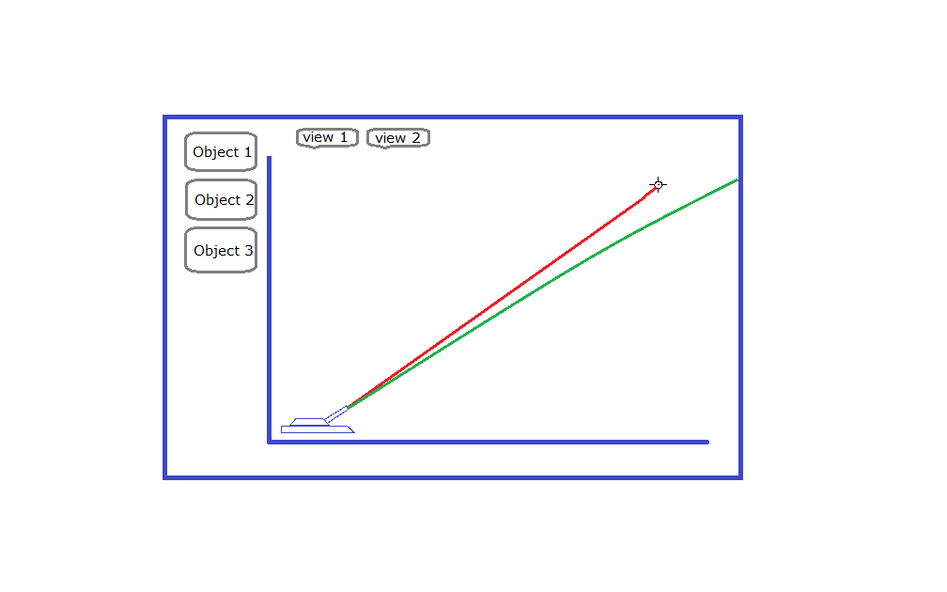

Task Analysis

User Task Analysis

* I want to be able to select an object
* I want to be able to change between a graph view and an animation view
* I want to be able to compare 2+ different objects
* I want to be able to change the line of aim
* I want to be able to manually change the time of flight or distance that the projectile travels
* I want all my previous calculations to be saved in a list where I can view them again later

**Summary**

The purpose of study is to determine the usefulness of the application that we are conceiving and creating.

Tests were conducted during the week of sept 14 - 21 with 3 participants. Tests were typically only about 10-15 minutes long, and they were done over the internet using chat clients and google docs.

The most significant findings are that the design needs work but that the idea of what is trying to be accomplished is well received and that there could be some interest for the type of product we are making.

**Table of Contents**

**Summary**

**Table of Contents**

**Purpose**

**Participants**

**Method**

**Findings/Recommendations**

**Discussion**

**Appendices**

**Purpose**

The principle reasons for conducting this study is to determine whether or not the application we are creating is a tool that people would actually use to decide what equipment they would use in the video game Planetside2

The product is a web application that graphs the trajectories of projectiles over time to represent their characteristics within the game and to more easily test a weapons effectiveness without actually having to go into the game first.

The usability goals for this application is that players of Planetside2 will use this as a means to calculate weapon statistics. As opposed to crunching the numbers and seeing which ones are bigger, users we be able to use visual context to make their decisions and what all those numbers actually translate to.

**Participants**

|  |  |  |  |  |
| --- | --- | --- | --- | --- |
| **Participant number** | **Method of Contact** | **Age** | **Computer/Web Experience** | **Occupation/Major** |
| 1. | Steam Chat | 20 | Avid computer user, uses web applications similar to ours. Some programming experience | Warehouse worker |
| 2. | Steam Chat | 20 | Computer Programmer attending BCIT, lots of experience with computers and the web | CST student |
| 3. | Steam Chat | 27 | Lots of experience with web applications, Router programmer | Network Administrator |

**Method**

Due to the simplicity of our application as it is a one page application, the best way to conduct the study was to get the users to just start using the prototype. The only testing that was able to be conducted was the aesthetic UI as we currently do not have a function ready prototype. How we conducted the study was we simply gave users access to our prototype and asked them to experiment with it and tell us what they thought.

Users commented that the initial prompting screen was mildly confusing as they were faced with photos and check boxes with no explanation as to what they were actually clicking them for. Only after had they finished did they understand, but if it were a website prototype they would have ended up refreshing the page to change their selection.

The UI design of the graph was also too ambiguous, they felt that more description was needed or possibly even a type of tutorial to show users what they can do with the tool.

**Findings/Recommendations**

As it currently stands the prototype is pretty far off from what has been envisioned for the final product. Further user studies will need to be conducted in order to test the actual interactive graph once that stage of the project is reached. We will need to improve on recruiting users but using the actual prototypes will be much easier once an actual web based application has been established. Overall users found the product to be useful and could imagine the possibilities for its purpose but turned out not to be the demographic that we had hoped would be interested in such a thing.

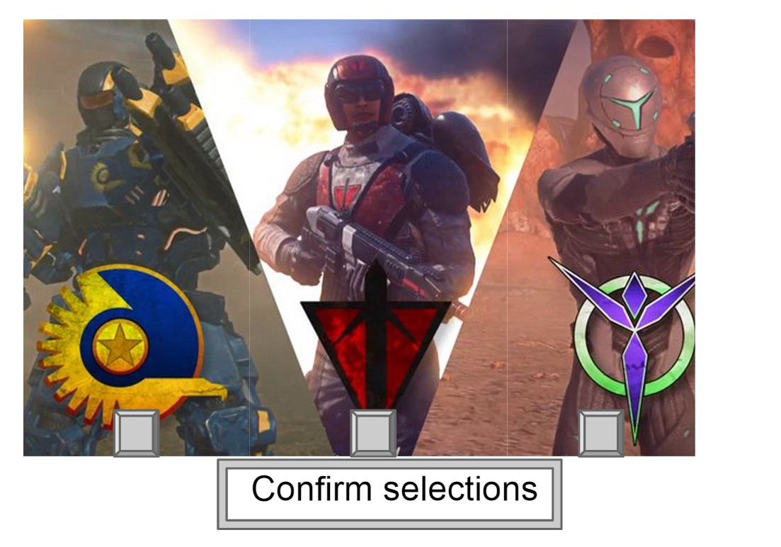

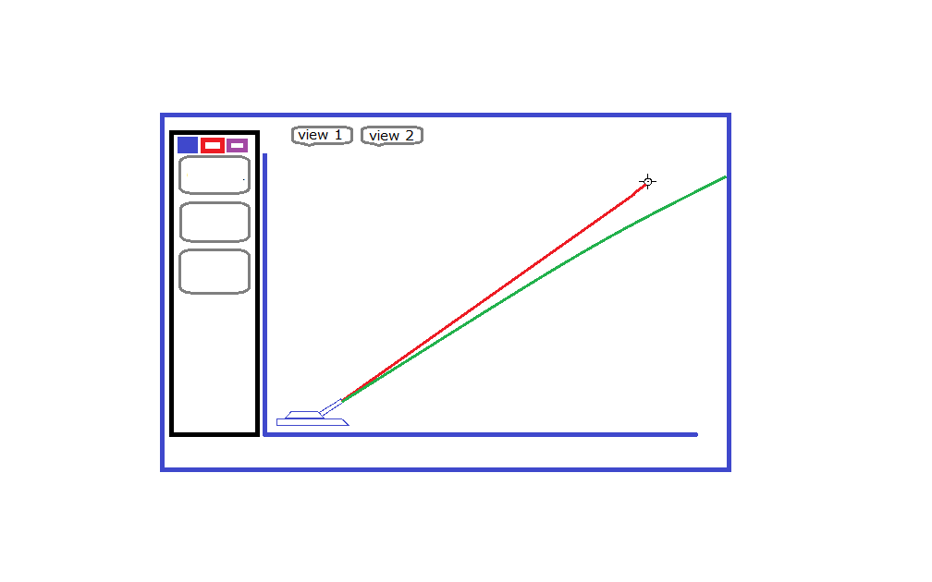

A more streamlined and matching UI will be designed for further stages, but despite the design currently, the product was well received with the user testers.

**Discussion**

The Interactive Physics Simulator is still very much in its infant stages of planning and design. Without and current functionality the user studies proved less than spectacular but also each case included a silver lining with every result.

The ideas for the UI are not all ideal but with a few tweaks here and there the application with vastly improve in making users easily understand what it is they’re looking at and how they can use the tools we’ve given them.

The next steps will including a minor overhaul to the graph interface to make it more stylish and functional.

**Appendices**

Comments made:

Tester 1: “I could see how that would be useful, it’s a great idea”

Tester 2: “I personally wouldn’t use it but I know some people who would”

Tester 3: “That sounds really cool, I would love to check it out when it’s done”