B11 arrives at the Library, the place where the Demogorgon lives. As she enters, she finds herself into the hall. The place is dark and all covered in black vines. In front of the entrance there is a desk with some lamps spreading a feeble light nearby. On her left the space is filled with shelves of books. When she looks closely she realizes that she can open and read some of them (easter eggs, foreshadowings and tributes to the other children):

# - *The Little Prince* by Antoine de Saint-Exupéry:

# «“I am looking for friends. What does that mean -- tame?"

# "It is an act too often neglected," said the fox. "It means to establish ties."

# "To establish ties?"

# "Just that," said the fox. "To me, you are still nothing more than a little boy who is just like a hundred thousand other little boys. And I have no need of you. And you, on your part, have no need of me. To you I am nothing more than a fox like a hundred thousand other foxes. But if you tame me, then we shall need each other. To me, you will be unique in all the world. To you, I shall be unique in all the world.”

# “People have forgotten this truth," the fox said. "But you mustn’t forget it. You become responsible forever for what you’ve tamed. You’re responsible for your rose.”»

# - *To the lighthouse* by Virginia Wolf:

# « “At home the mountains are so beautiful,” and there was no hope, no hope whatever»

# - *Indigenous races of the earth* by Josiah C. Nott:

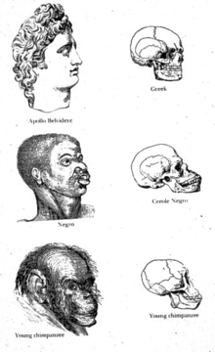

# - An Orienteering Manual

# - *Treasure Island* by Robert Louis Stevenson:

# «We must go on, because we can’t turn back»

# - *The Overcoat*, by Nikolai Gogol:

# «And Petersburg was left without Akakii Akakievich, as though he had never lived there. A being disappeared, and was hidden, who was protected by none, dear to none, interesting to none, who never even attracted to himself the attention of an observer of nature, who omits no opportunity of thrusting a pin through a common fly, and examining it under the microscope. »

# - *Dracula* by Bram Stoker:

# «Do you not think that there are things which you cannot understand, and yet which are; that some people see things that others cannot? But there are things old and new which must not be contemplate by men´s eyes, because they know -or think they know- some things which other men have told them. Ah, it is the fault of our science that it wants to explain all; and if it explain not, then it says there is nothing to explain.»

# - *Oroonoko* by Aphra Ben:

# «And ’tis most evident and plain that simple Nature is the most harmless, inoffensive, and virtuous mistress. ’Tis she alone, if she were permitted, that better instructs the world than all the inventions of man. Religion would here but destroy that tranquillity they possess by ignorance; and laws would but teach ’em to know offense, of which now they have no notion.»

- Poetry by Fernando Pessoa:

«I am the escaped one,

After I was born

They locked me up inside me

But I left.

My soul seeks me,

Through hills and valley,

I hope my soul

Never finds me.»

- *Hagakure* by Yamamoto Tsunetomo:

«There is something to be learned from a rainstorm. When meeting with a sudden shower, you try not to get wet and run quickly along the road. But doing such things as passing under the eaves of houses, you still get wet. When you are resolved from the beginning, you will not be perplexed, though you will still get the same soaking. This understanding extends to everything.»

On the other side of the room the roof is collapsed and hides some tables. There is a door, covered in vines but B11 can’t open it. Behind the desk are the stairs to the upper floor. While she explores the other children start talking to her.

Abazu: “I don’t like it in here”

Guil: “You’ll get used to it, shut up”

Abazu: “So you plan on killing a little girl?”

Catinca: “Like she killed everyone else, if only I had seen her coming..”

On the second floor there is a room with the door covered with a knot of three vines, which covers the roots of a fourth one; the roots of these vines are scattered, respectively, in one of the three other rooms of the floor. B11 will have to find them and burn them in order to free the way. The floor of the room on the right is collapsed, so she will have to use the super speed to reach the roots and burn them. In the second room the roots are hidden behind some heavy objects, so she will use her power and lift them. In the last room the vines are above a high shelf of books, so she will levitate to reach them. Now the way to the other room is almost free, after having burned the last vine effortlessly she will be able to enter.

Cati: “Go on with the last step of this madness now”

Abazu: “You still have a choice, just go back and try to live your life like we all did”

Cati: “Yeah, and just wait for the next child to come and murder you like you did with us”

This room is again full of bookshelves. In a corner Zasha is sitting, terrified when she sees B11 approach.

Z: “How you find me? Who you? What you want from me?”

B11 uses Abazu’s power to calm Zasha before answering.

B11: “I am a friend. I don’t want to hurt you. I arrived at the Laboratory and found out that I wasn’t alone, I saw you. It is my power, to have visions, don’t be afraid. I came here looking for you, as a friend. I will help you now, will you let me?”

Z: “Why we here? I no like it here. Want go home.”

B11 (again using Abazu’s powers): “I can help you go home, but you need to trust me. I might know a way to get out, but I need to know more about you and your powers. What can you do?”

Z: “Mind. I control it. I control monster lives here. He no hurts me, he hurts who I want.”

B11: “That is good, we can escape. Is there anything you want to take with you?”

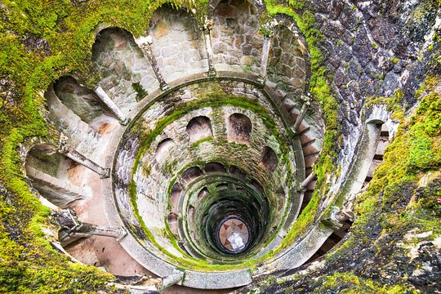Z: “My book. And necklace, with mom photo on it. But I lose it underground and am afraid to go back and take it. Can you?”

Guil: “That must be her object, we need to find it before killing her”

B11: “Yes, tell me where to go”

Z: “There is a door down. You go down and down and down and find it. But monster is down too, I no control it, too far”

B11: “Don’t worry, I’ll be back”

B11 leaves Zasha alone and goes back. Now the door on the ground floor is free from the vines because Zasha removed them with her mind control. On the other side of the doors there is a staircase that leads to the lower floor, in which B11 finds the archives of the Library. She can explore but she will find nothing interesting. On the side opposite to the door there is a hole in the wall, probably dug by the Demogorgon. B11 enters it and finds herself in a labyrinth.

Here she will have to try to find the way to the other exit and at the same time she will have to run from the monster, which has found her. To help her, she will have small rooms in which she can hide without being seen by the Demogorgon.

At the center of the maze there is a staircase, similar to the one in the picture but carved by the Demogorgon. As Eleven descends it she sees the Demogorgon following her on the other side. Towards the end a part of it is missing and she falls into a gigantic cave, the lair of the monster.

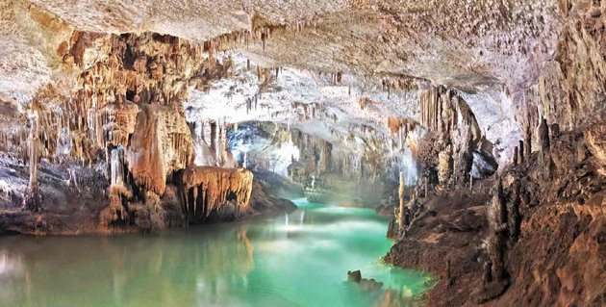

The first room is the biggest, but it is also flooded. Eleven has to be careful not to make too much sound. As she proceeds, she hears the Demogorgon around her, but they can’t see each other.

Guil: “We are close, we can do it”

B11: “I don’t want to do it”

Guil: “What?”

B11: “I don’t want her to die. She is too little”

Abazu: “You don’t have to do it, you could help her”

Cati: “She must do it. She’s come too far to stop now”

Abazu: “But what if we all tried to get out without killing someone else? As a family”

Cati: “I don’t need a family”

Guil: “I want to kill my family too, now shut up before the Demogorgon finds us or I swear I’ll find a way to leave you with it for the rest of your days”

In the second room some Demodogs are sleeping pe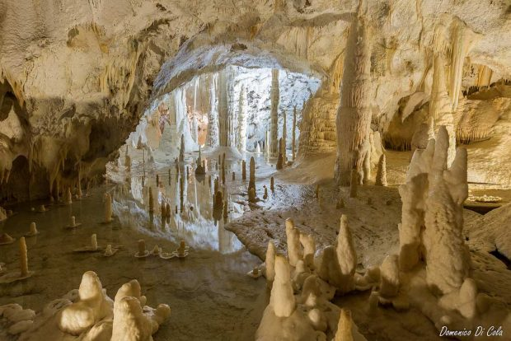acefully. It is here that they grow and rest, while the Demogorgon takes care of them and feeds them. Eleven will have to be extremely quiet If she wants to get out alive.

B11: “A little girl like she is..all alone..down here..”

Guil: “She will soon be dead and no longer alone”

Raiden: “I wonder how these monsters see or feel the world around them. Maybe we could find a way to defeat them”

Cati: “Or maybe we could use the power of the little girl to make them do what we want. Take back our lives in the real world”

As she enters the last room, Eleven notices the pendant on a pinnacle. The whole cave seems very unstable and silent, except for the sound of drops of water falling. As she approaches the other children start talking to her.

Raiden: “Be careful, don’t make a sound. Even a whisper could make it all fall”

Guil: “Oh yeah, and how do you know?”

Raiden: “I liked to read remember? Papa always gave me books”

Cati: “Spare us the part where you tell us how much Papa loved you, you poor thing. You ended up here like the rest of us”

Abazu: “Maybe we should stop it and concentrate on what we need to do?”

Cati: “Says the one sold like a slave. Family really loved you uh?”

Abazu: “How do you know?”

Cati: “I remember Papa talking ab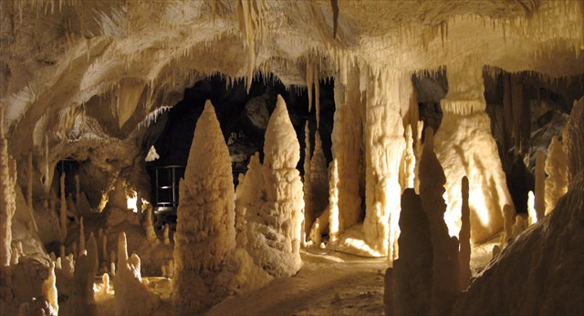out someone they *bought*. With actual money. He used to joke about it a lot with the other scientists”

Abazu: “They didn’t sell me. I sold myself. For them. I don’t believe you, Papa was a good man, he wouldn’t..”

Guil: “Was he? Why don’t you tell him about all the times he put you into confinement cells Eleven?”

B11: “Please just shut up”

Eleven manages to take hold of the necklace, but the other children won’t let her alone.

Guil: “Maybe some memories will help you remember why you want to kill that little girl and go back to the real world”

B11: “Papa is dead”

Cati: “But the others aren’t”

B11: “Stop it”

Guil: “They beat me and kept me in chains”

Cati: “They locked me in my room for days, just like you”

B11: “STOP!”

As she screams, she hears a rumble coming from the ceiling. The whole cave starts collapsing, the stalactites start falling all over the place.

Raiden: “There! A squeeze!”

Eleven rushes towards it and enters it. The tunnel is dark and narrow, but she manages to crawl until the end of it. She finds herself under a bookshelf in the archives under the Library, so she pushes it away and goes back to Zasha.

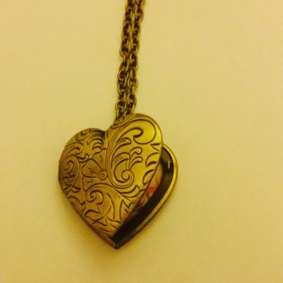

As she arrives in the room where Zasha is, she finds her sleeping on the floor, curled under a dirty blanket. She could wake her up and give her the necklace back, or just stab her and take her soul and powers. Without conferring with the other children, Eleven wakes Zasha up and hands her the necklace. The little girl opens it, stares at the picture hidden inside it and starts crying.

B11: “What? What happened?”

Zasha: “This my mother. Never see her, just this. But I know this my mother”

B11: “You have never seen her? Why?”

Zasha: “She leave me. Orphanage? In Russia, cold, alone, afraid”

B11: “And then? What happened? Why did you end up here?”

Zasha: “Doctors came. Said I dangerous. Took me away and studied. Then they hurt me, really bad and tell me things. America bad, America hurt me. And then took me to America, leave me like mother”

B11: “And Papa found you? He saved you?”

Zasha: “He no Papa, he no save. He put me in cage, use electricity on me. Hurt me like doctors in Russia. I always sleep, they fear me. On day I try to run and arrive here. I no like it here, but library is safe, monster keep me safe”

B11: “Don’t worry, I am here now. You’re safe with me. I won’t hurt you. Now try to sleep, before we escape from this place”

Zasha smiles and returns to the place where she was sleeping. She closes her eyes, her cheeks still wet. While she waits for Zasha to fall asleep Eleven is tortured by doubt. She really wants to go back to the real world, but she doesn’t want to kill an innocent child.

B11: “I won’t do it. I will tell her the truth, make her trust me, make her use her powers and get out”

Abazu: “She is way stronger than I was, I’m not sure you could make her trust you again, if you told her that you killed us”

Guil: “And you’d always have someone you must rely on. Someone who could just want to go back to Russia and look for her damned mother. You need to take her powers”

Cati: “Or just kill her for the sake of killing her. You killed us all, why should you stop now?”

B11: “She doesn’t deserve the pain”

Cati: “Oh did we? If only I was still alive I swear I would..”

Guil: “We help you come this far, kill her. And once you did you can go back to the real world and avenge us all. Destroy everything you want. You would be the most powerful being ever existed, no one could stop you. Us”

Abazu: “Or maybe you could make something up. The real Eleven is your twin, she sent you here, hurt you like they hurt her and you need help to kill her”

Guil: “She is way too powerful to let her live. She could stop us all. Do you want to be stopped? Again?”

With her hands shaking, Eleven draws the knife she stole from Will’s house. She is as close to Zasha as she can get, holding her breath in fear of waking her up, but she hesitates. This murder would take her too far, she doesn’t want to hurt Zasha, but at the same time this seems her only choice to regain her freedom. With closed eyes she stabs Zasha multiple times. The last thing the little girl says before dying is “you hurt me”. After this her soul enters the necklace and Eleven takes hold of it. Her vision is blurred with tears.

Attracted by the smell of blood, the Demogorgon comes running. The children hear it coming up the stairs.

Raiden: “Use her power, now. Control it.”

Eleven does it and the Demogorgon stops on the threshold. It worked. Guilherme and Catinca laugh happily, whereas the other remain silent.

Guil: “Let’s go back to the Lab. With its strength we can open a passage to the Portal and finally go back”