**Data Management Document**

**THE ELEVENTH DICE**

<GAME NAME>: <The Demogorgon’s Lair>

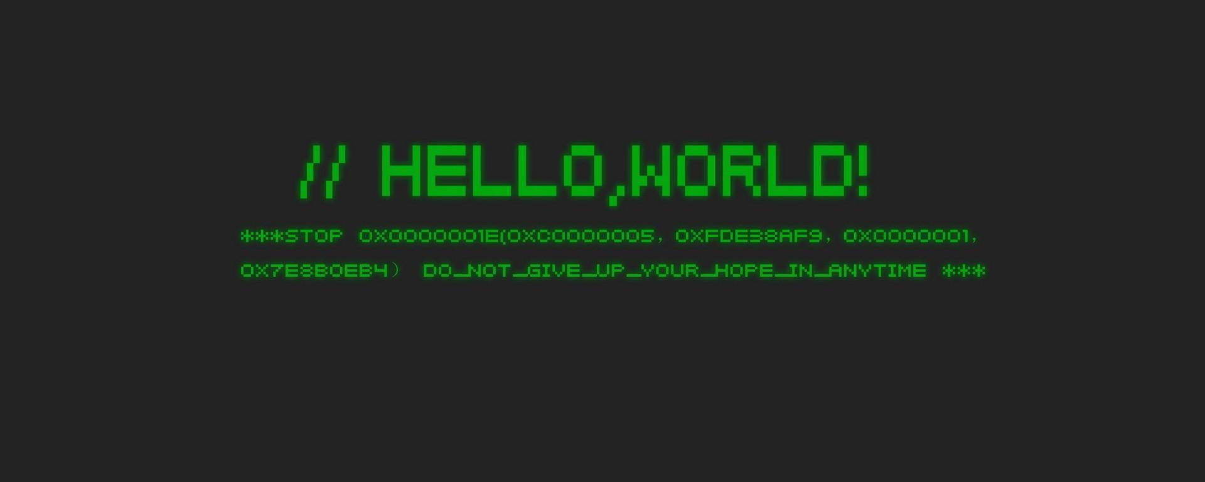

Maurizio Lu - 943827

maurizio.lu@studenti.unimi.it

Nicolò Buganza - 961149

nicolo.buganza@studenti.unimi.it

Matteo Malorgio - 931487

matteo.malorgio@studenti.unimi.it

Alessandro Compagnoni - 111111

alessandro.compagnoni@studenti.unimi.it

Deborah Leonardi - 935754

deborah.leonardi@studenti.unimi.it**The Eleventh Dice DMD**

|  |  |
| --- | --- |
| **Purpose** | This document provides information about the data used in the implementation of the project and the related management policies applied in their manipulation. |
| **Creation date** | 19/11/2019 |
| **Current owner** | Maurizio Lu |
| **Last modification** | 28/11/2019 |

|  |  |  |
| --- | --- | --- |
| **Revision History** | | |
| Who | **When** | **What** |
| **Maurizio** | 19/11/2019 | Created this Document |
| **Maurizio** | 20/11/2019 | Set the structure of the document |
| **Maurizio, Matteo, Nicolò** | 21/11/2019 | Added Software List Chapter |
| **Nicolò** | 24/11/2019 | Added Data Type and Format Chapter |
| **Matteo** | 24/11/2019 | Added Software versions |
| **Maurizio** | 27/11/2019 | Added Data Storage and Access & File Naming Convention Chapters |
| **Nicolò, Matteo** | 28/11/2019 | Minor revisions for the second milestone |

1. **Software List**

This is the software list used by the “The Eleventh Dice” team for this project, which also includes the version and the platform adopted.

* 1. ***Asset Editing Software***

|  |  |  |
| --- | --- | --- |
| **Name** | Version | Platform |
|  |  |  |
|  |  |  |
|  |  |  |

* 1. ***Development Software***

|  |  |  |
| --- | --- | --- |
| **Name** | Version | Platform |
| **Git** | 4.4.2 | Windows |

* 1. ***Organization Software***

|  |  |  |
| --- | --- | --- |
| **Name** | Version | Platform |
| **Microsoft Office** | 16.0.11328.20438 | Windows |
| **GitHub** | TBD | Web/Windows |
| **Google Drive** | NA | Web |
| **Google Docs** | NA | Web |
| **Pages** | 8.2.1 | Mac |

* 1. ***Environments***

|  |  |  |
| --- | --- | --- |
| **Name** | Version | Platform |
| **Windows** | 10 | Windows |
| **Mac OS** | 10.14.5 | Mac OS |

1. **Data Types and Format**
   1. ***Text***

All the documents related with **Game Design, Level Design** and game’s story must be saved using **.gdoc** or **.docx** extension. The final files must be sent in **.pdf** format.

As far as font type and dimension are concerned, we will follow the undergoing specifications:

1. Document title in Arial, 26
2. Chapter titles in Arial, 20
3. Index titles and secondary titles in Arial, 16
4. Normal text in Arial, 11

Using **bold,** *Italic* and underlined text is allowed and left free to the user, within the limits of legibility. Common sense is advised.

* 1. ***Pictures***

Two formats are allowed. PSD files are used in the production process but eventually all the images will be delivered in the PNG format.

Size in XxY pixel may be not specified in some cases.

|  |  |  |
| --- | --- | --- |
| **Description** | Format | Size |
| **Template Images** | PSD | TBD |
| **Final Images** | PNG | TBD |

* 1. ***Audio & Video***

Sounds format allowed: **WAV, MP4**

1. **Data Storage and Access**

All the data regarding the project are stored on the “Google Drive” online platform in order to provide easy access for the team members and automatic synchronization.

Due to the “Google Drive” 30 days versioning limitation, a GIT repository is also adopted to keep track of the older version.

* 1. ***Backup & Policies***

**Shared Data Manager**: Matteo Malorgio

Every monday and thursday at 17:30 CET a push of the whole project is performed by the Data Manager to the remote repository.

Each 1st of the month all the members will fetch the remote repository, guaranteeing multiple backups equal to the number of the collaborators.

* 1. ***Data Access***

This is the link to the **Google Drive Folder**:

<https://drive.google.com/drive/folders/1U-WBH1YysxJNJr3Sj5C41ktVeG_ZO83Z>

Inside you can find a README file where you can get more internal information. (Eg. about the GIT repository)

To get the permissions send an email to the **Data Manager**:

matteo.malorgio@studenti.unimi.it

1. **Directory Structure**

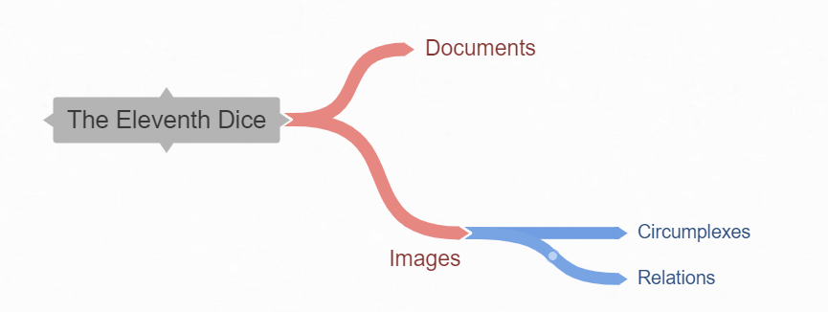

We used different colors to identify the different layer of the file system.

1. **File Naming Convention**

Every file must be named following the camel case convention.

Additional properties can be specified in the file name, in this case remove the extension from the original name and then append the “_Property1_Property2_ … .[extension]” string.

All the pdf documents that will be delivered must be preceded by the “TED_” prefix.

|  |  |
| --- | --- |
| **Type of file** | **Example** |
| Text document | TED_FirstMileStone.pdf |
| Image | Circumplex1_1920x1080.png |
| Audio | RainSound.mp4 |