Instructor: Dr. Craig W. Slinkman

Office: COBA 532

|  |  |
| --- | --- |
| My office hours will be held in the Central Library on the second floor of the library. Mu location will be on the south side of the library. This is the side of the library that is closest to Mitchel Street.  In addition, office hours are available by appointment. | |
| Days and Time  Monday: 19:00 – 21:30 Hours  Tuesday: 19:00 – 21:30 Hours |  |

**Course description**

**Section Information:** BSTAT 5301-Section 001

**Time and Place of Class Meetings:**

|  |  |  |  |  |  |
| --- | --- | --- | --- | --- | --- |
| Class | Class Title | Enrolled | Days & Times | Room | Class Dates |
| [BSTAT 5301-001 (80843)](javascript:submitAction_win0(document.win0,'CLASS_TITLE$1');) | INTRODUCTION TO STATISTICS (Lecture) | 23 | Th 7:00PM - 9:50PM | COBA241 | Aug 27, 2015- Dec 9, 2015 |

**Description of Course Content: BSTAT 5301 BUSINESS STATISTICS I** (3-0)

This course covers the application of statistical techniques to business and economic data. Topics include descriptive statistics, probability distributions, estimation, inference, regression, correlation, and time series.

**Prerequisite: INSY 2303 and MATH 1315.**

**COURSE OBJECTIVE:** The course introduces the student to the basic principles and applications of descriptive and inferential statistics. The course assists students to become knowledgeable consumers of statistical analysis, its applications and limitations.

**Class requirements and grades**

1. To learn data analysis and applied statistics you must do applied statistics.
2. There are five homework assignments.
3. The homework with the minimum grade will be dropped.
4. The final homework which will be collected during final week counts twice.
5. A homework may have a potential bonus question which will add points to your homework score.
6. Since there are 5 homework assignments and one will be dropped and the final homework counts twice, then there are 4 possible grades. Each homework counts 100 points so there are 500 possible homework points. The homework counts 10% of your grade.
7. Class attendance will be taken and constitutes 10% of your grade. One unexcused absence is allowed. Anyone who arrives after the first 10 minutes will be given an unexcused absence. The US Department of Education now requires this because of fraudulent student loans. So if I have to carry out this task I might as well count it in your grade. If you must miss a class you need to tell me prior to missing the class.
8. If you come to class and get up and leave and do not return this counts a missed class.
9. There are three two exam plus a final exam. The exams are count 80% of your grade. The exams during the semester are worth 25% of your grade and the final exam is worth 30% of the grade.

## Letter grades



**Textbook**

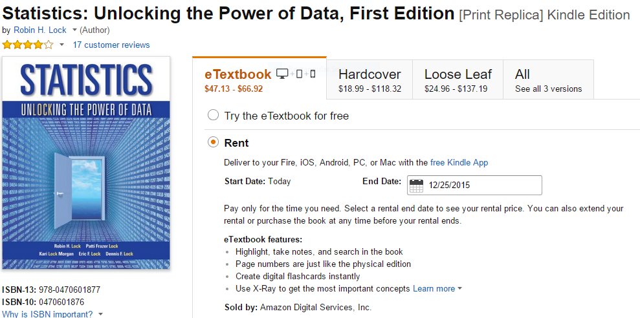

You can purchase the book [here](http://www.amazon.com/Statistics-Unlocking-Power-Data-First-ebook/dp/B00AZP83CC/ref=sr_1_1?s=books&ie=UTF8&qid=1440694506&sr=1-1&keywords=statistics+unlocking+the+power+of+data+kindle). I would recommend the Kindle edition.**Web Resources**

|  |  |
| --- | --- |
| **Resource** | **Html** |
| Basic statistics notes | <https://github.com/utaSlinkman/BusinessStatistics> |
| Homework | <https://github.com/utaSlinkman/utaBSTAT5301> |
| Data | <https://github.com/utaSlinkman/utaStatisticsData> |

**Tentative class schedule**

|  |  |  |  |
| --- | --- | --- | --- |
| 27-Aug-2015 | 01-Getting data | 01-Statistics and data |  |
| 3-Sep-2015 | 02-Sumerizing data | 02-Sumerizing data |  |
| 10-Sep-2015 | 03=2-Sumerizing data | 02-Sumerizing data | Assignment H1 due |
| 17-Sep-2015 | Data collection and summarization | 03-Data Collection and summarization |  |
| 24-Sep-2015 | **Exam 1** |  |  |
| 1-Oct-2015 | 05-confidence intervals | 04-Confidence intervals | Assignment H2 due |
| 8-Oct-2015 | 05-Hypothesis testing | 05-Hypothesis testing | Assignment H3 due |
| 15-Oct-2015 | 06-Summary of statistical inference | 06-Summary of statistical inference |  |
| 22-Oct-2015 | **Exam 2** |  |  |
| 29-Oct-2015 | 07- Using theoretical reference distributions | 07- Using theoretical reference distributions |  |
| 5-Nov-2015 | 08-Classical Statistical inference | 08-Classical Statistical inference | Assignment H4 due |
| 12-Nov-2015 | 08-Classical Statistical inference | 08-Classical Statistical inference |  |
| 19-Nov-2015 | 08-Classical Statistical inference | 08-Classical Statistical inference |  |
| 26-Nov-2015 | **Thanksgiving Holiday** |  |  |
| 3-Dec-2015 | 09-Reducing your confusion | 09-Reducing your confusion | Assignment H5 due |
| 15-Dec-2015 | Final Exam 20:15-22:45 |  |  |