PKI-TLS Project CS-GY 6903
mb9661@nyu.edu

Setup:
- Creating a client and server
For this step, I set up two containers, a client and a server. The server is running a nginx image, and the client is running a lightweight Debian image. They are set up in a docker compose file with a custom network to reach each other.
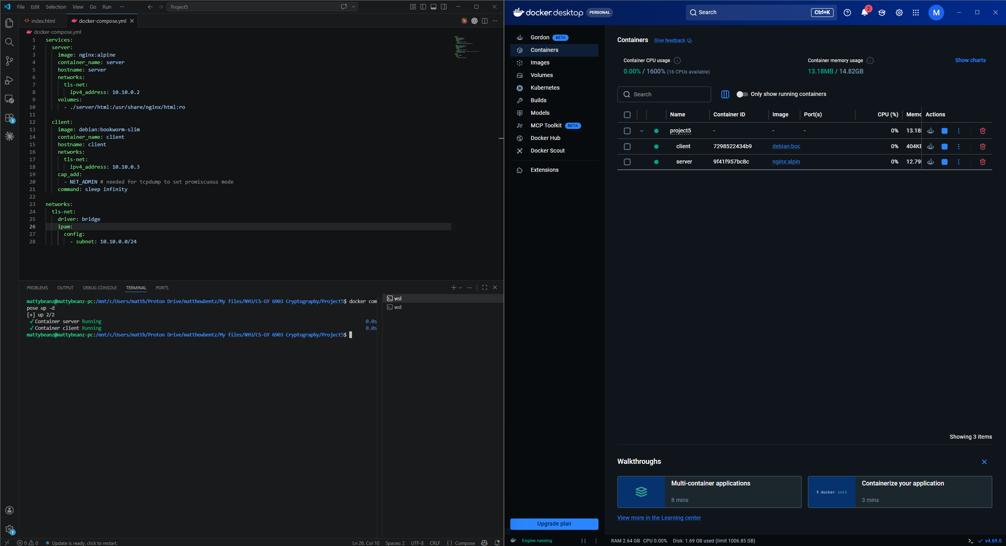
- Installing tools on the server
a/b.) The server already has nginx pre-installed. We install easy-rsa and openssl as well through the package manager.
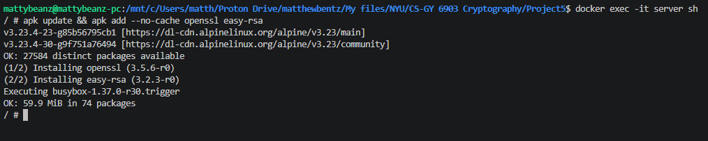
- Installing tools on the client
a/b.) The client will also install cURL and tcpdump.
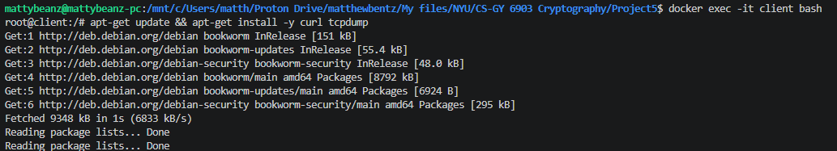

TLS Configuration:
- Configuring the server
- The server is already set up to run nginx with a basic http server that returns the index.html file I created within my project folder.
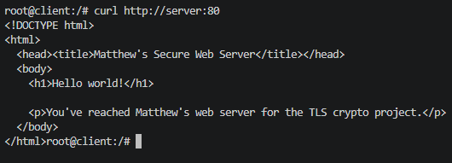
b/c.) Now, I will configure it to use HTTPS with a self-signed ECC certificate. OpenSSL is used to generate the ECC key and sign the certificate with it.
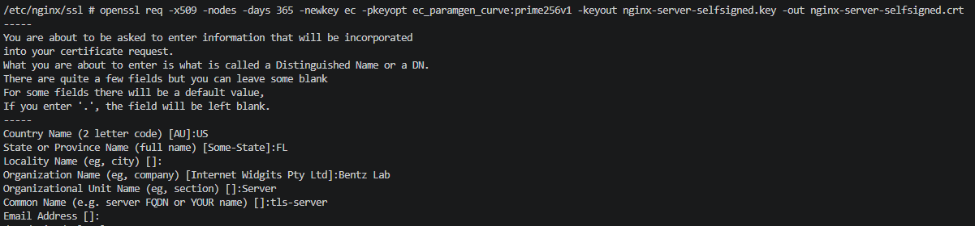
The resulting private key and certificate:
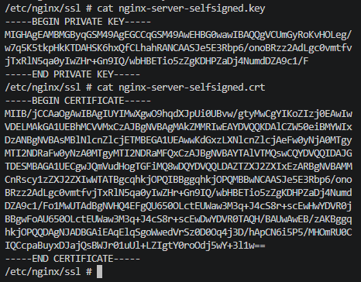
Then the nginx configuration needs to be updated to use the HTTPS config. To do this, we modify the default config:
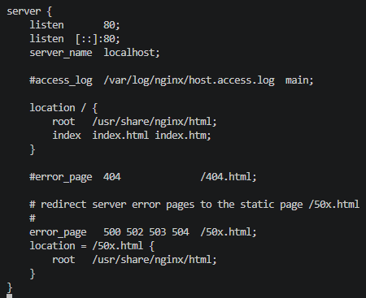
To the new, TLS v1.3 only, self-signed certificate serving config:
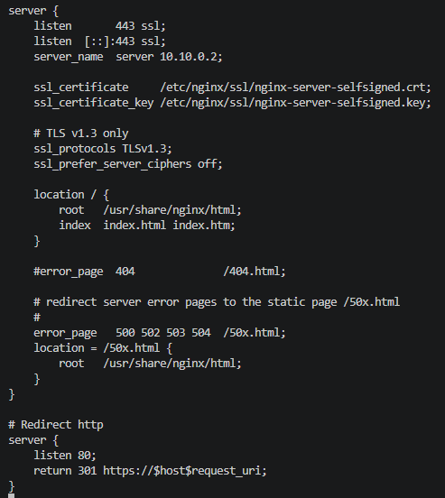
After reloading nginx to pull the new configuration, we can verify that we are serving the new self-signed certificate. We use -k to skip certificate validation, but we will do this from the client on the next step.
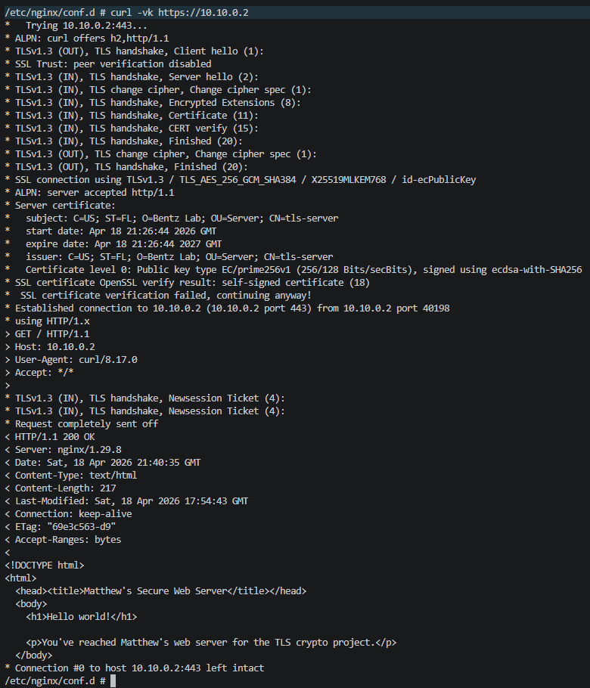
- Configuring the client
As a pre-requisite, we’ll trust the server’s self-signed certificate. To do this, we’ll copy the server’s generated certificate and add it to our trusted certificate store.
First, I copy the `nginx-server-selfsigned.crt` from the server container to the client container:
Then, I update the trusted certificates:
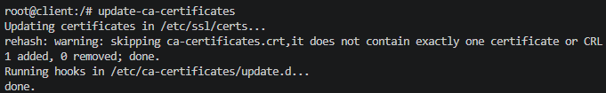
Now I can validate the server’s certificate from the client when I establish a connection:
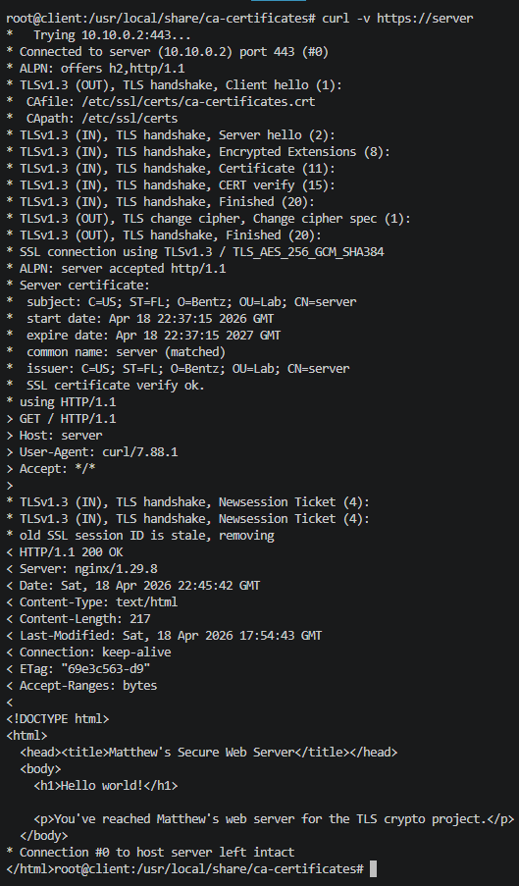
Additionally, we need to set the SSLKEYLOGFILE environment variable to obtain the (pre)-master-secret according to https://wiki.wireshark.org/TLS. This is a simple command:
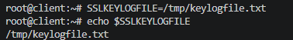
- Start tcpdump to start capturing traffic
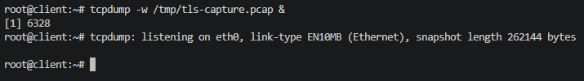
- Use cURL to make a secure request to the server
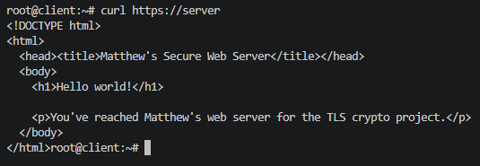
- Stop tcpdump
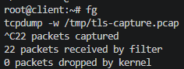
- Analyze the captured traffic
Opening the pcap file in Wireshark, we can see that (as the rubric hint suggests) traffic is encrypted before the certificate exchange. The server hello is encrypted.
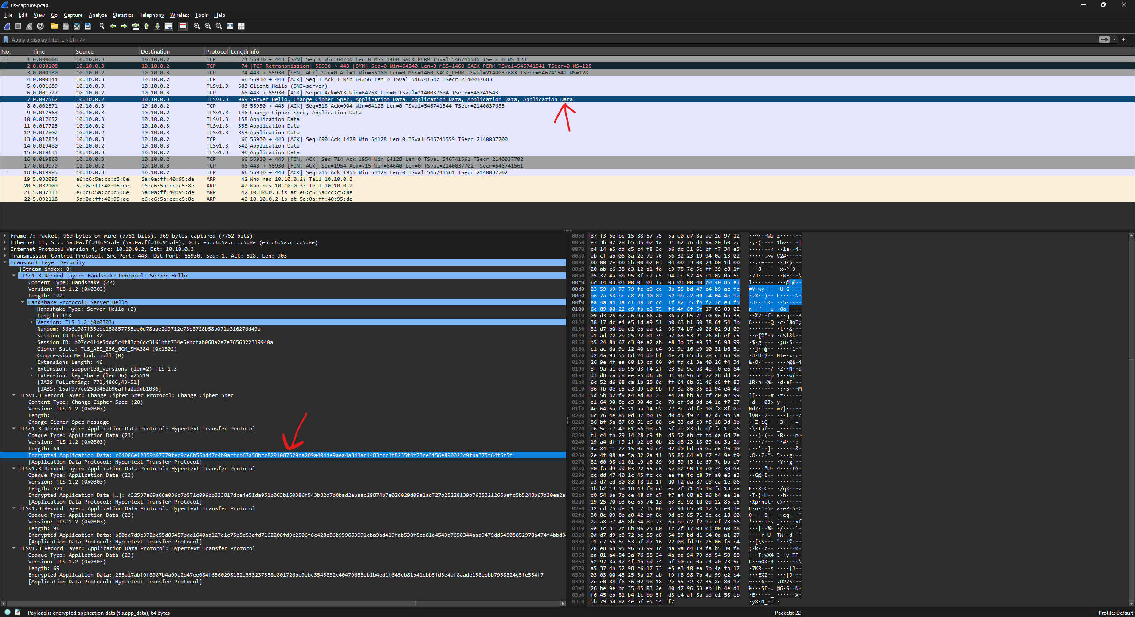
We add the (pre)-master-secret to the TLS preferences within Wireshark:
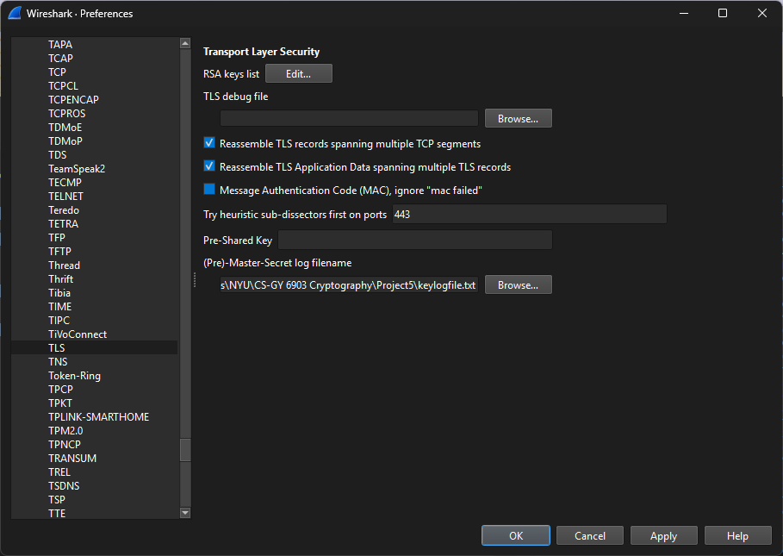
Now we can decrypt the traffic and validate that the certificate being provided by the server is correct, as well as show TLSv1.3 is being used. You can see in the screenshot that the certificate sent by the server is the same one we generated earlier, with ‘Bentz’ as the organizationName.
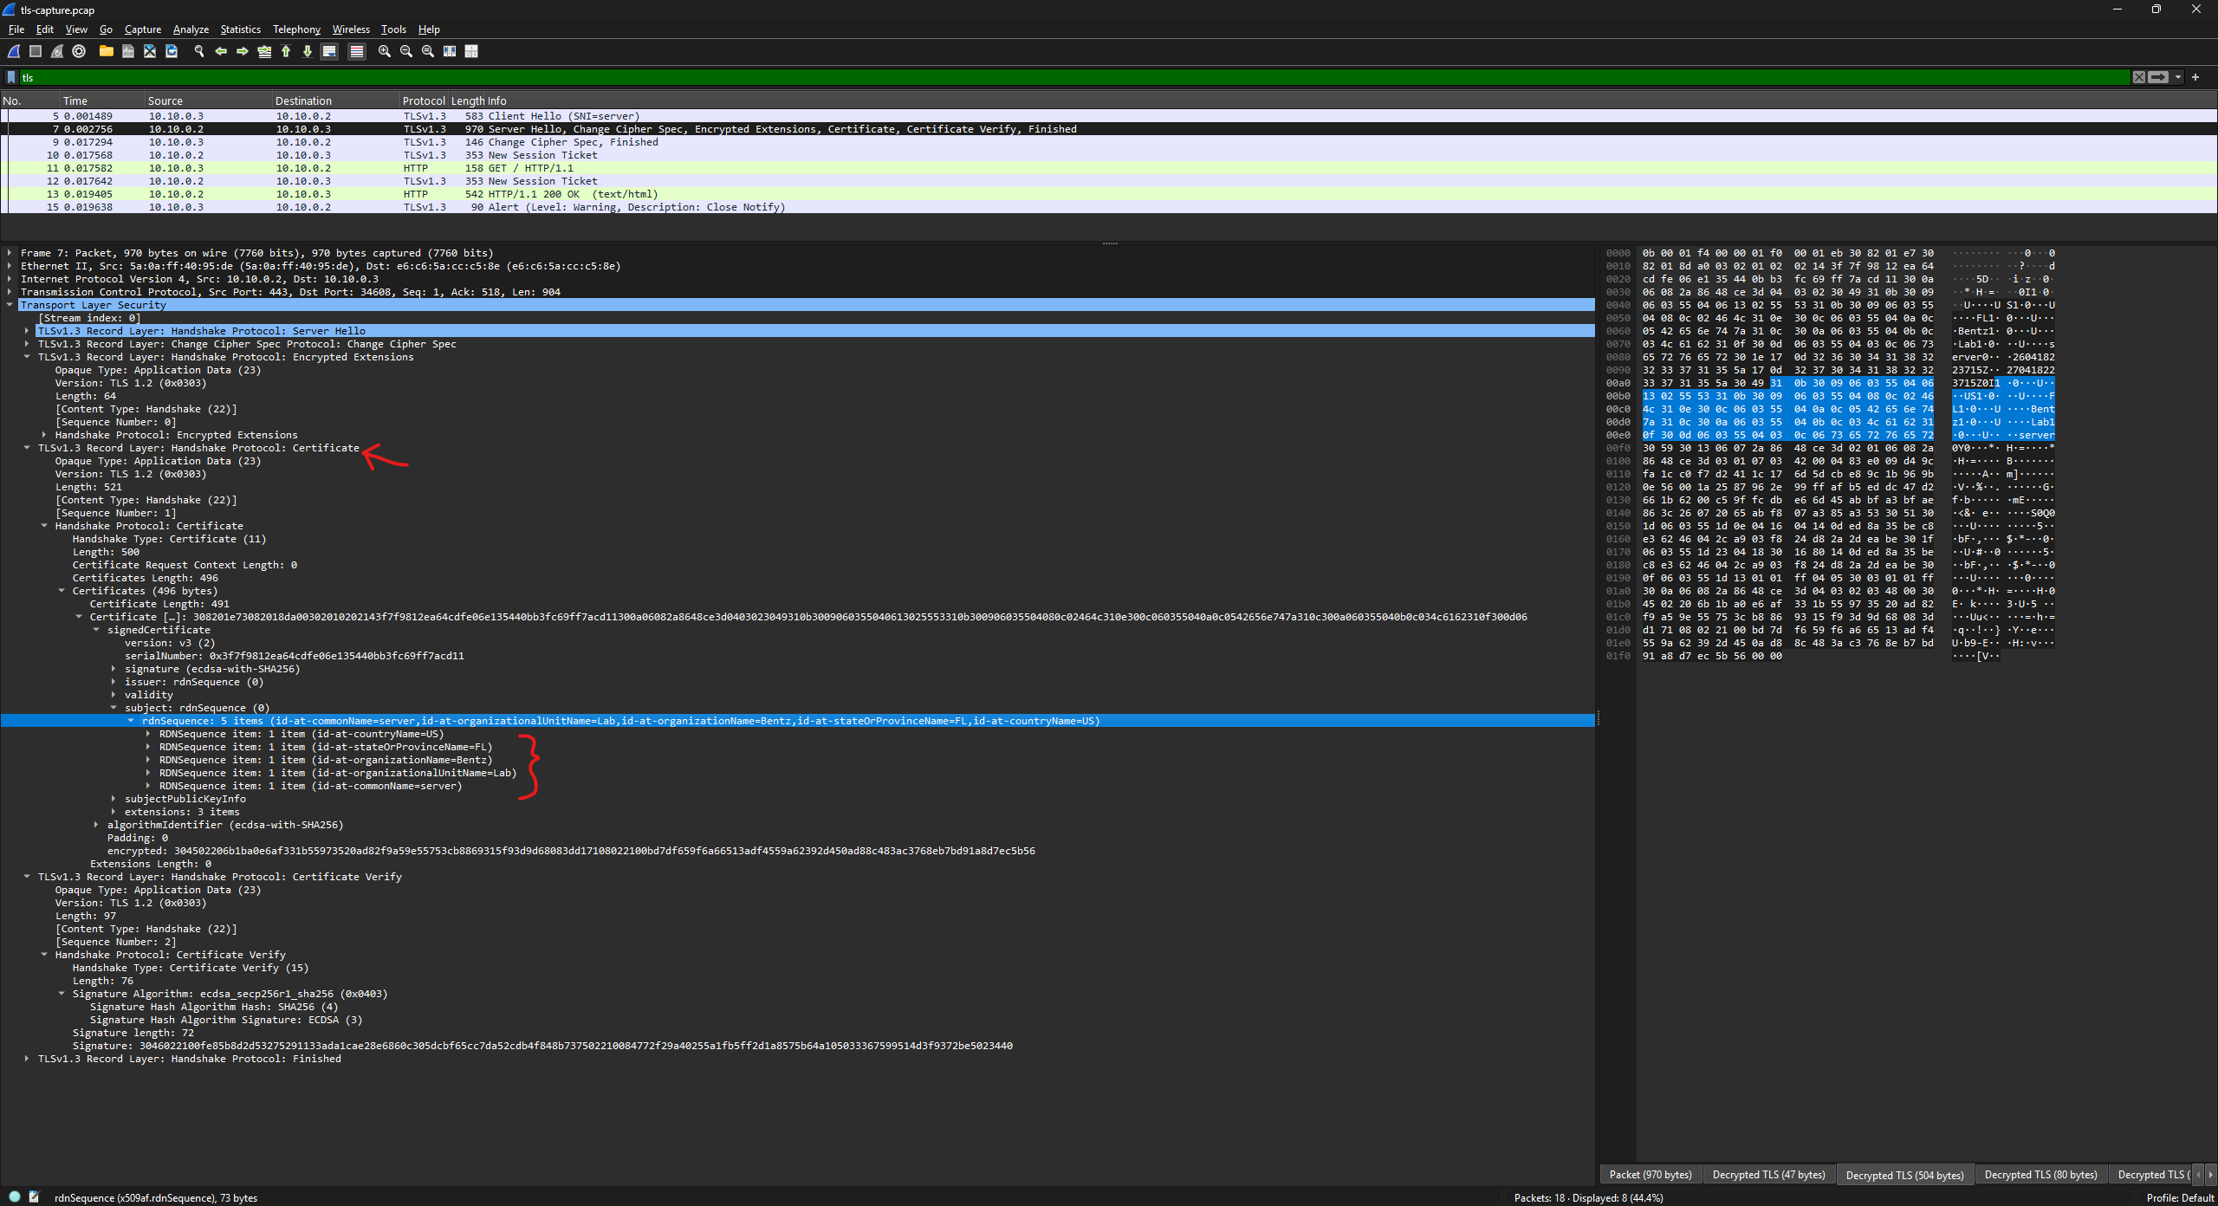
mTLS Configuration:
- Configuring the server
  - Creating a CA using easy-rsa with ECC for the certificate type
First, we use easy-rsa to initialize the PKI directory to hold the keys, certs, and requests.
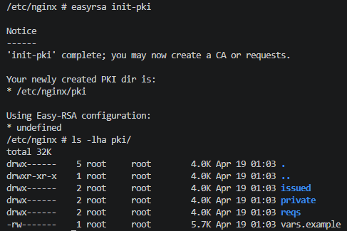
Then, we’ll update the configuration to opt for ECC instead of RSA. The three variables we need to update from default are:
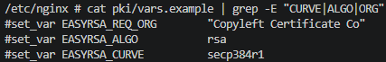
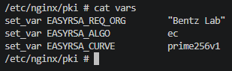
And we can build the CA:
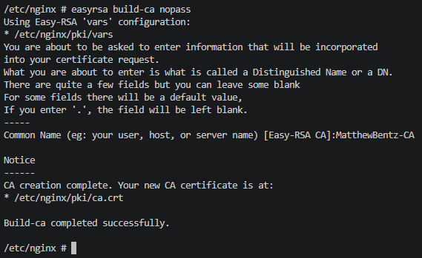
- Generating and signing certificates for the Client/Server
Now that our CA is ready, we begin by generating certificate requests for both the client and server.
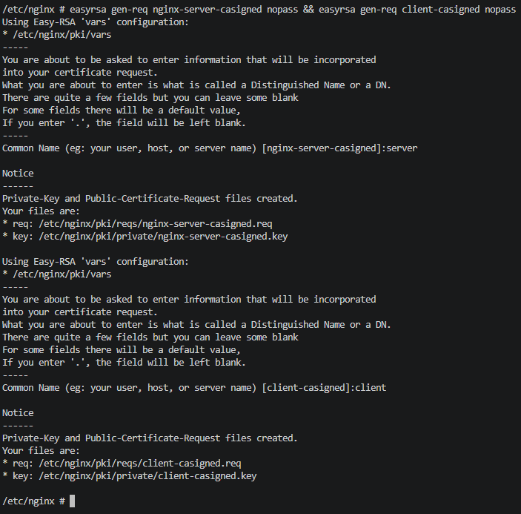
After we have the requests, we sign them to generate the issues certificates.
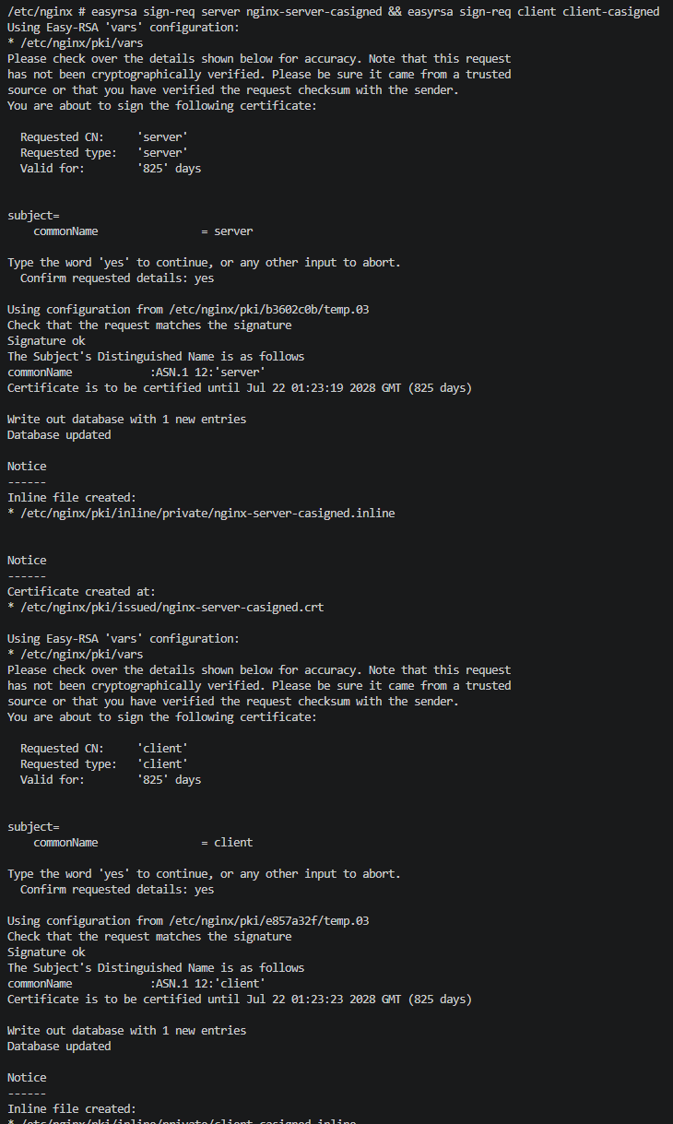
- Configure nginx
Now that we have the CA-signed certificates, we must move the new private key and certificate to the nginx configuration.
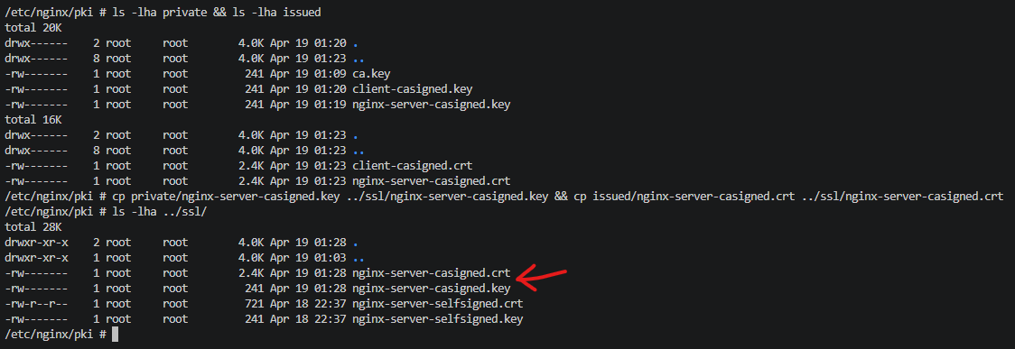
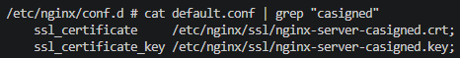
Then, I added the requirement for client certificate validation and reloaded nginx.
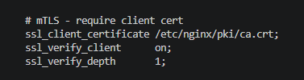
- On the client
Before sending requests from the client to the server, we must take some preliminary steps. First, I copied over the server-casigned.crt to the client and updated its trusted certificates. I could have also trusted the ‘MatthewBentz-CA’ ca.crt, and invoked the chain-of-trust, but I decided to do the server’s directly for simplicity.
The necessary files moved on the client:
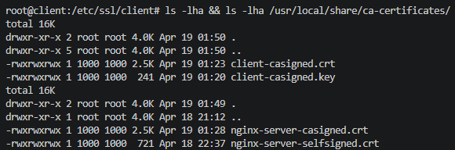
- Sending a request without presenting the client certificate
Starting tcpdump, sending a request to the server, and observing the resulting failure. Captured the pcap to clientcert-tls-capture.pcap and the key log to clientcert-keylogfile.txt
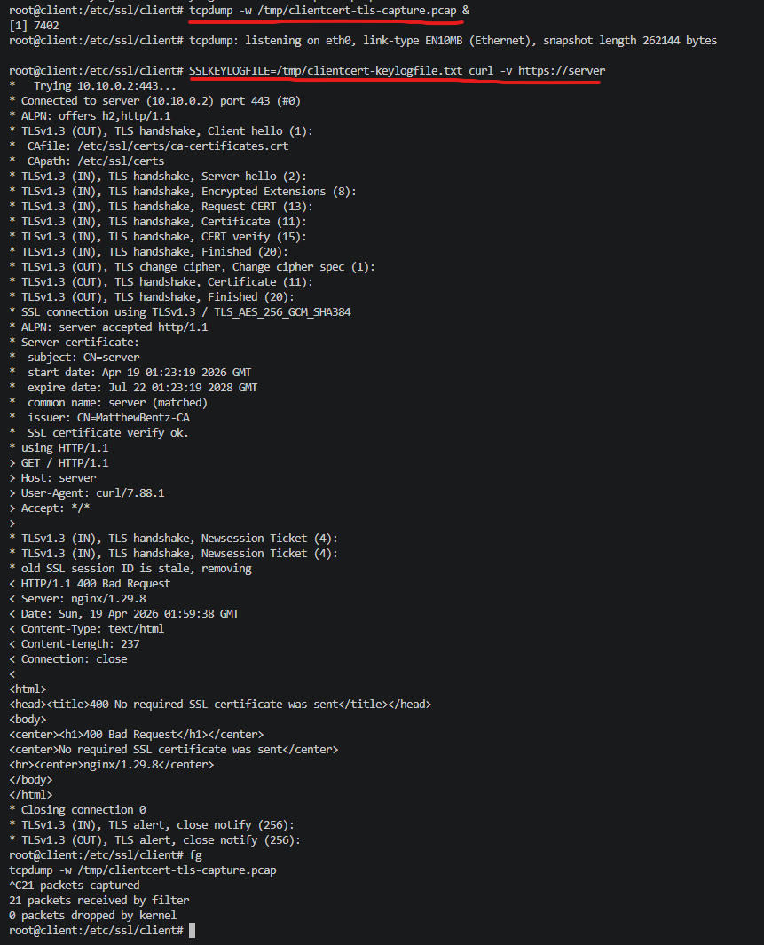
- Analyzing the pcap w/o client certificate in Wireshark + nginx logs
Section 1 shows us that the Server Hello is requesting a client certificate that is signed by the MatthewBentz-CA certificate authority. In section 2, we see the new CA-signed certificate being sent back to the client for verification.
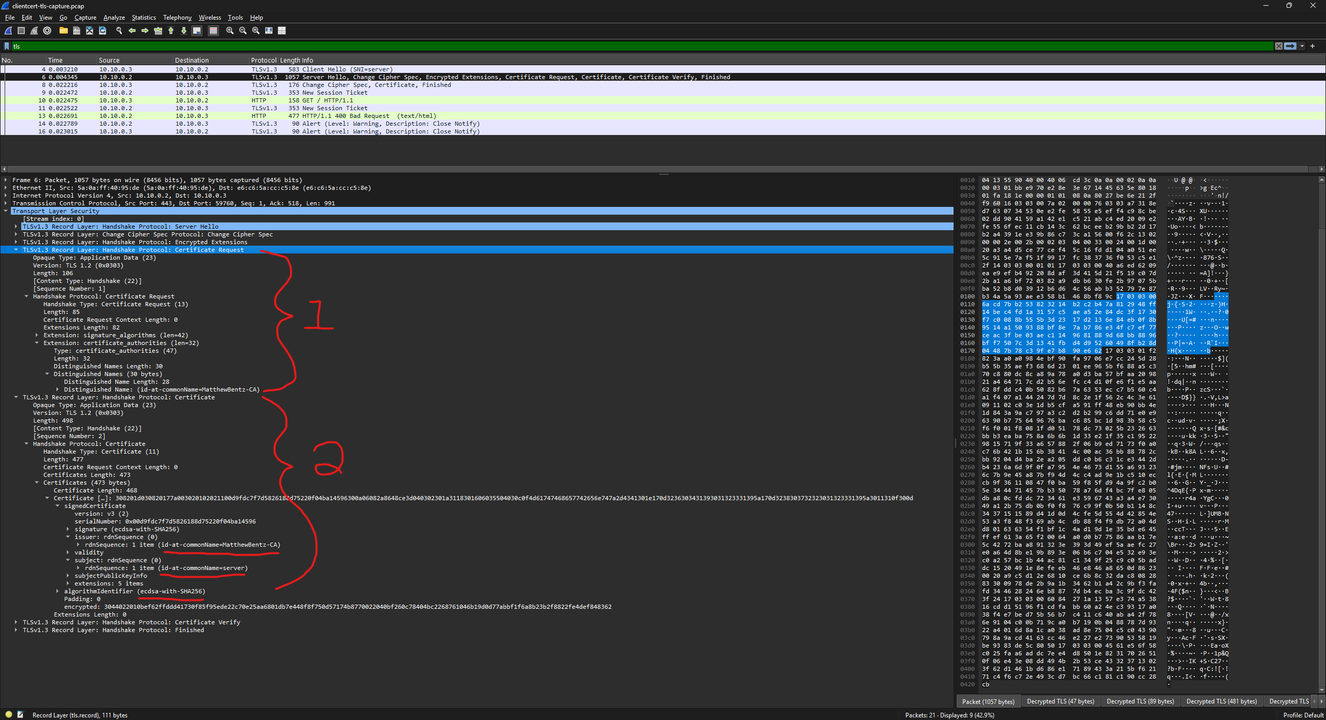
Additionally, we can see that the client responds but has no certificate to include.
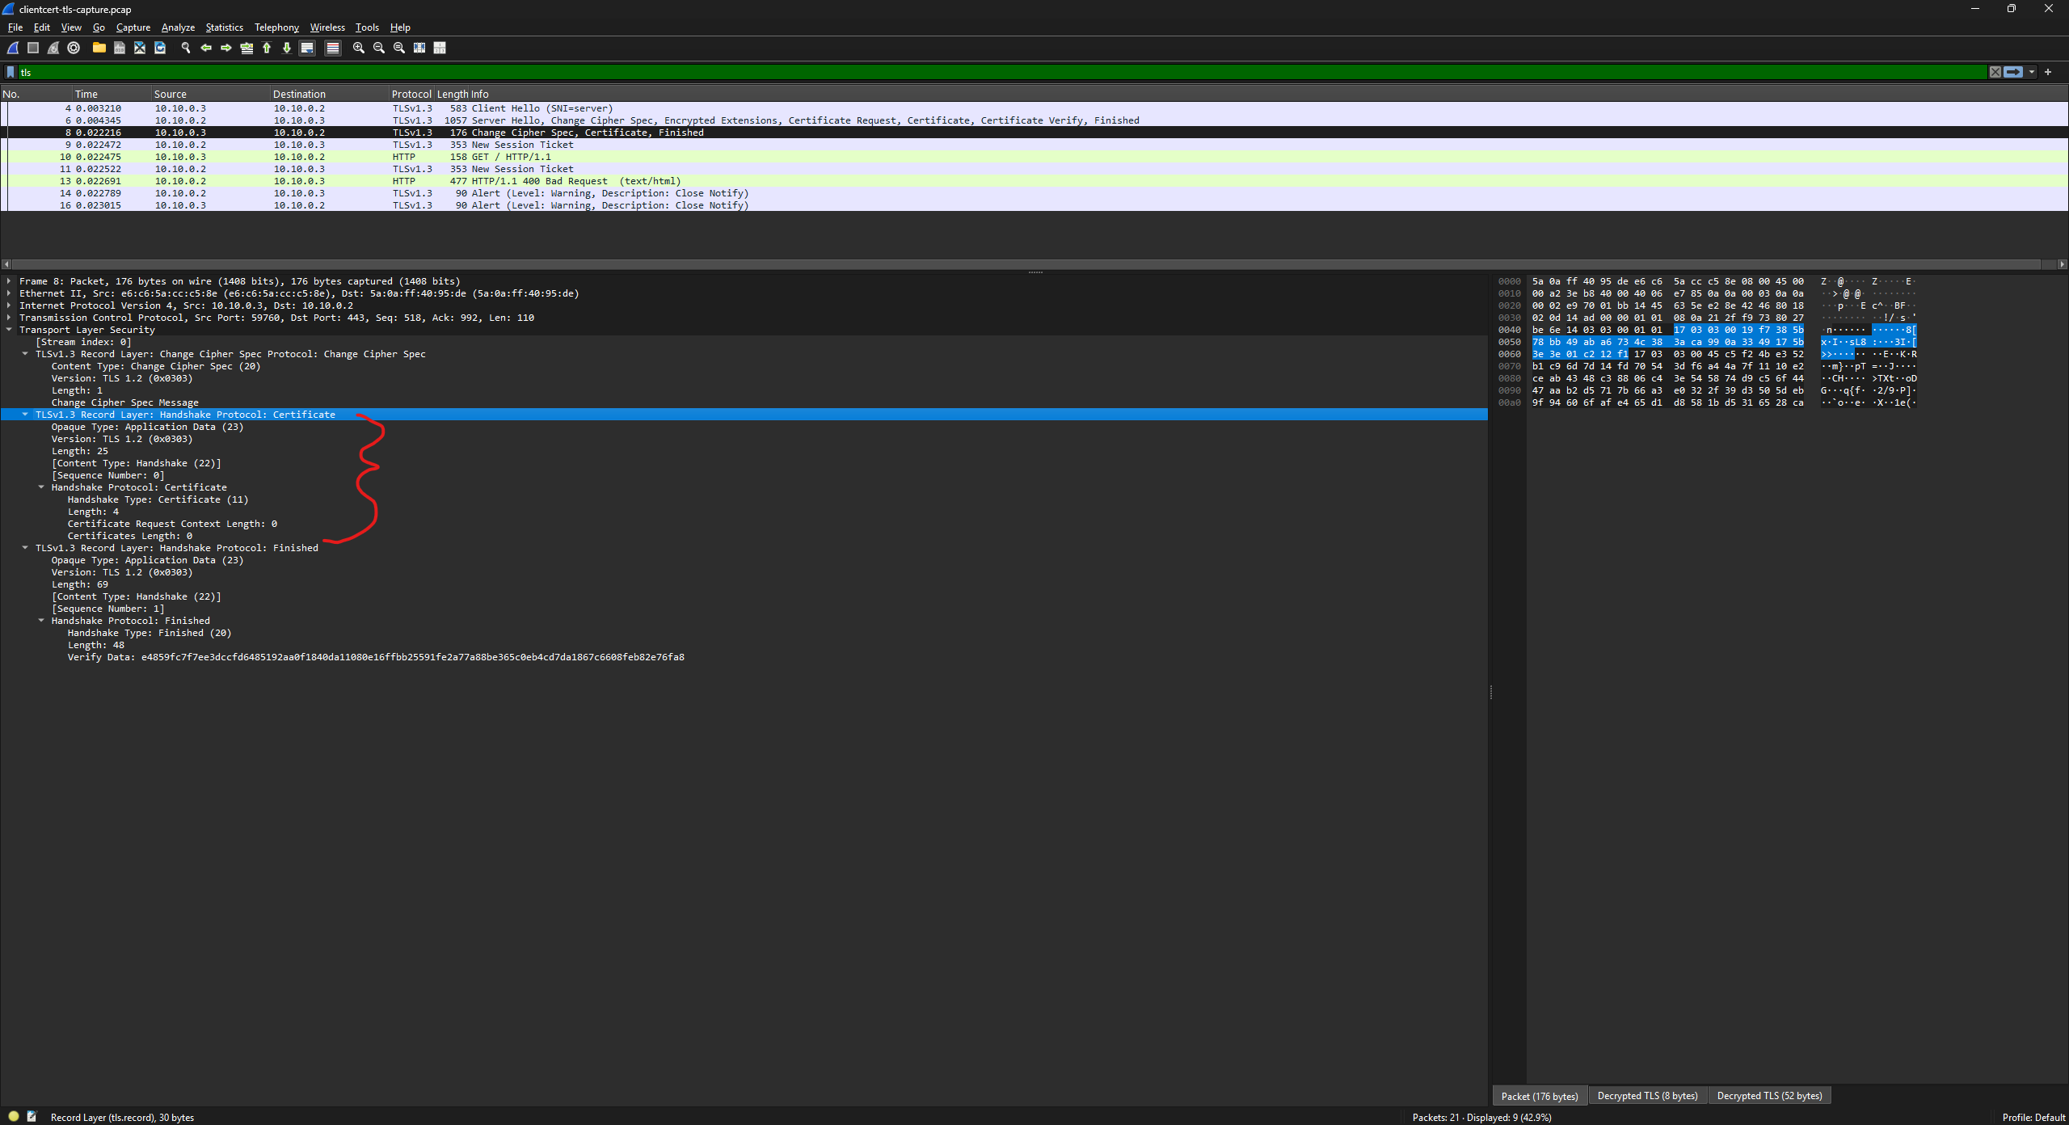
Since I’m running this on a docker container, nginx defaults logs to stdout. I did not set up nginx logs to write a file. However, we can see that nginx returned a bad request with the message ‘No required SSL certificate was sent’
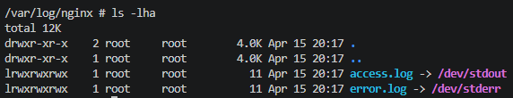
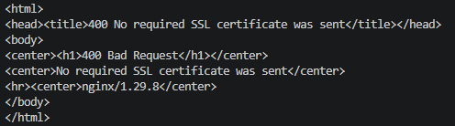
- Sending the request with the client’s certificate
We take the same steps as before, except this time passing in the certificate and key in curl arguments. This time, our request is successful.
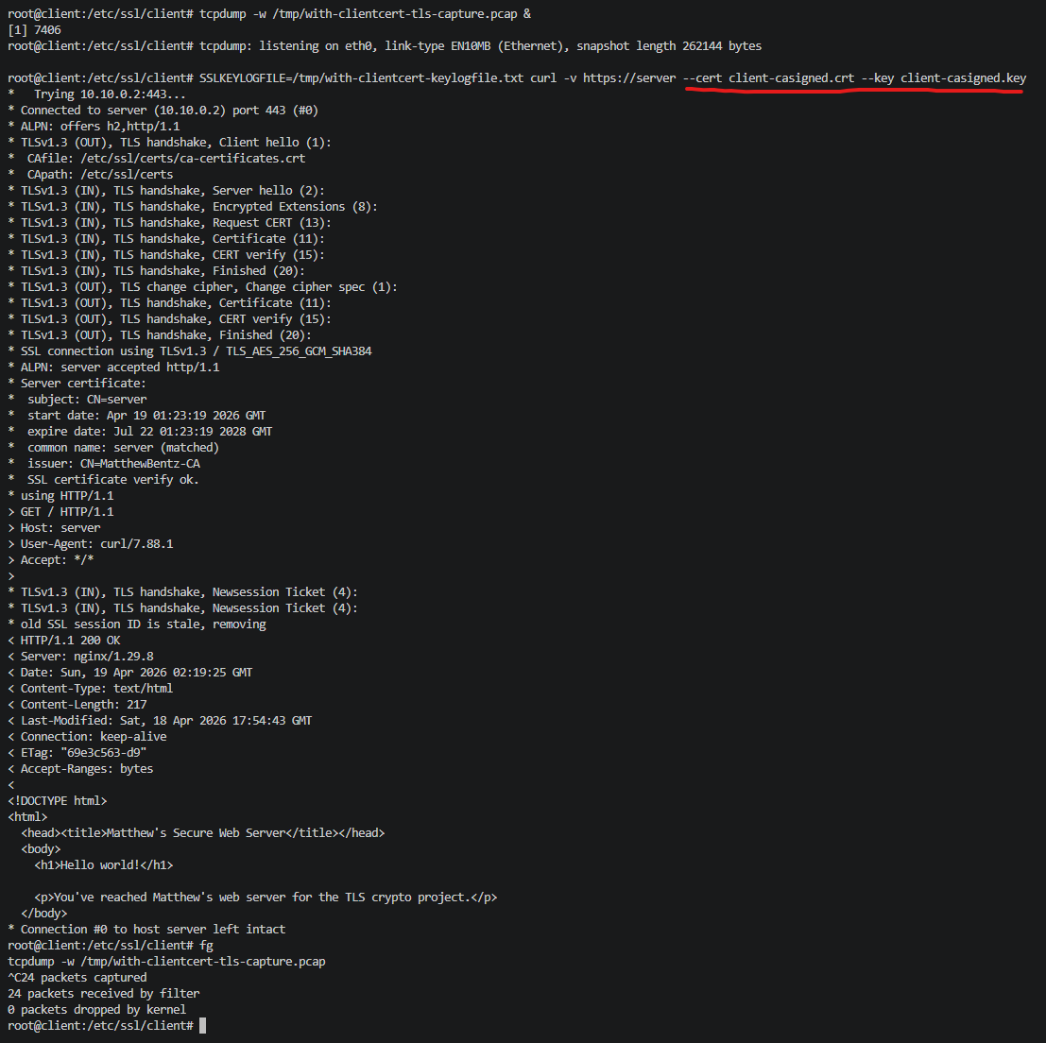
- Analyzing the pcap with client certificate in Wireshark (nginx response above)
The Server Hello is the same as the previously analyzed request, except this time the client’s response includes the certificate I supplied in the command line arguments. You can see from the screenshot that this section is now filled, and the CA specifies MatthewBentz-CA with the CN=client.
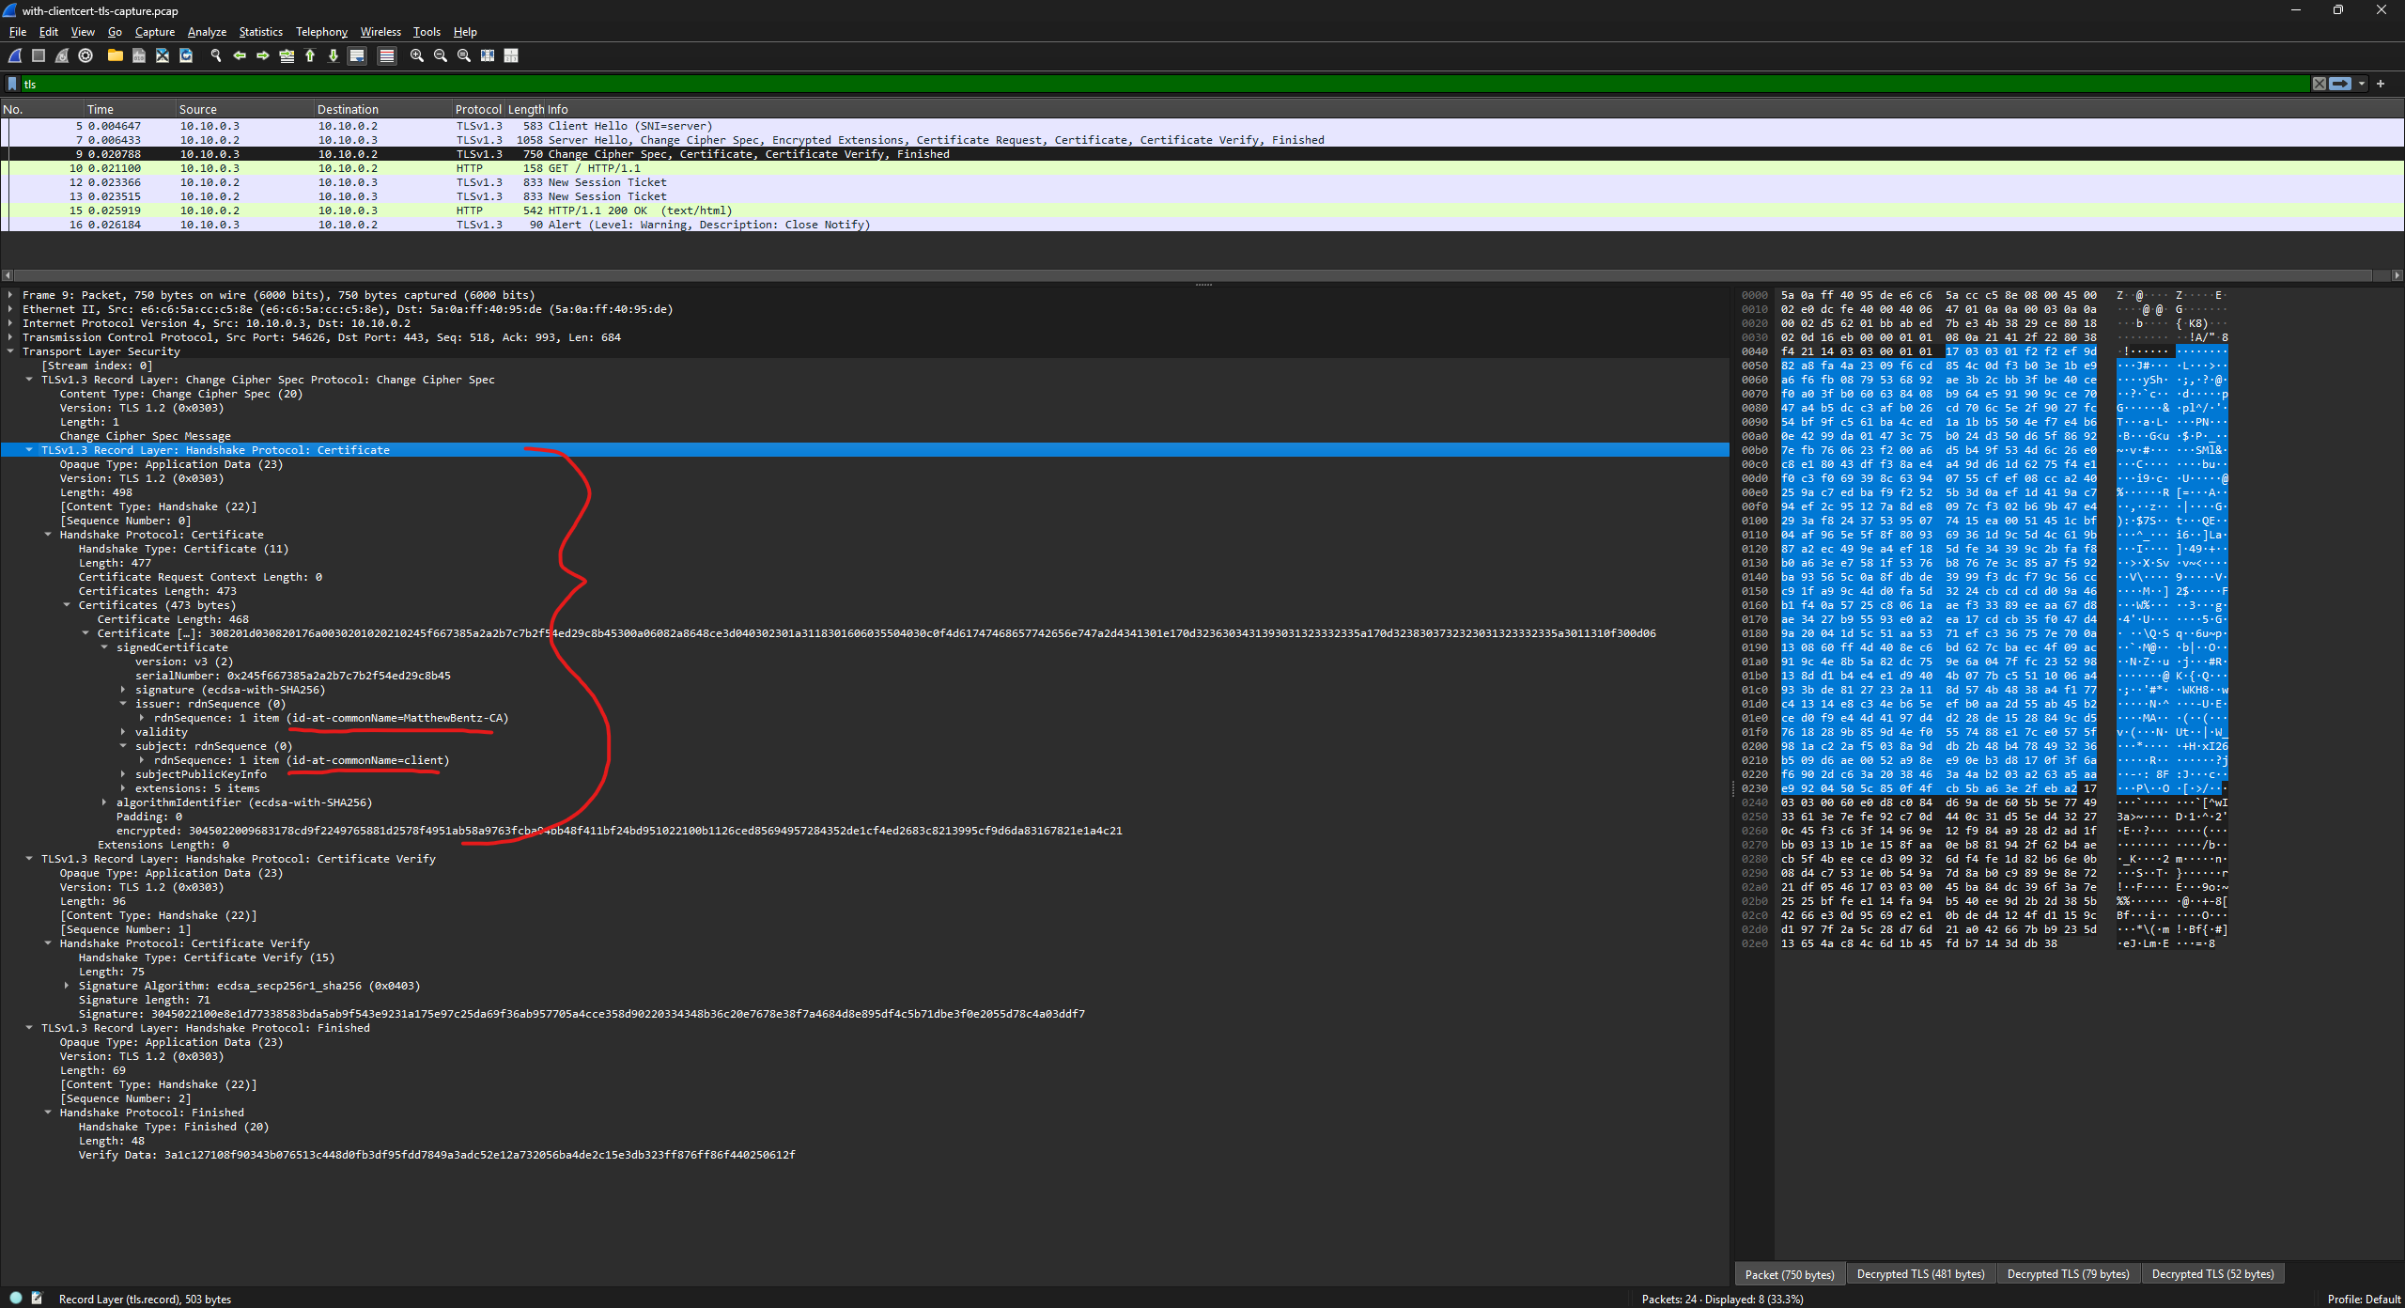
- On the Server
- Revoke the existing client certificate
Running `easyrsa revoke`, we can revoke the existing client certificate.
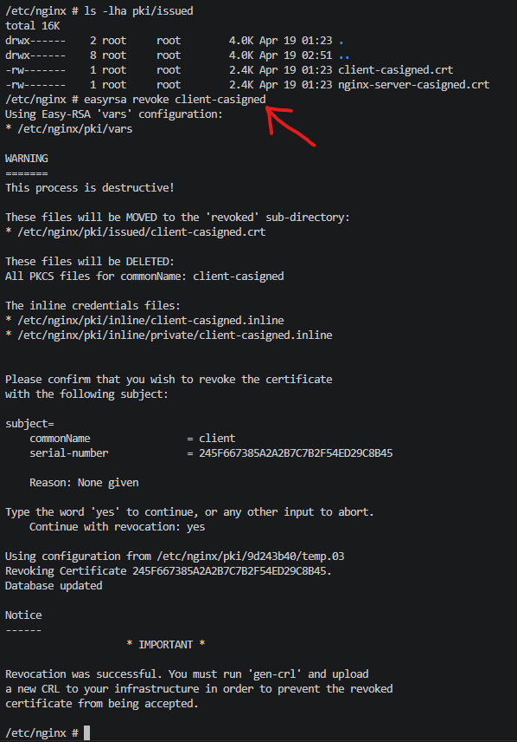
- Issue a new client certificate
Using easyrsa, we can issue a new certificate with gen-req and sign-req as done previously.
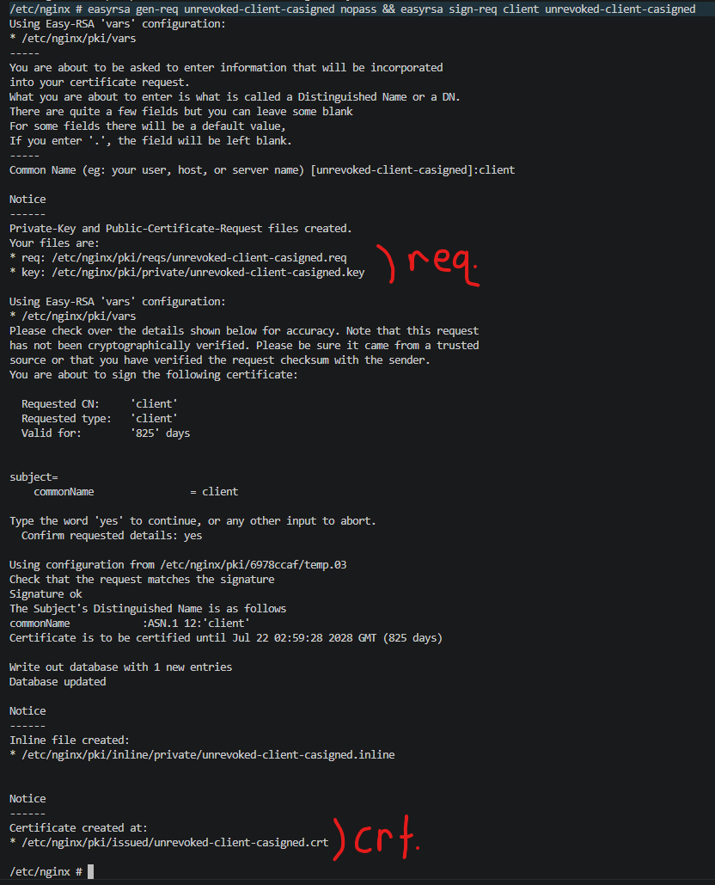
- How do you inform the server that the client’s old certificate should be rejected?
As shown in the warning from the revocation:
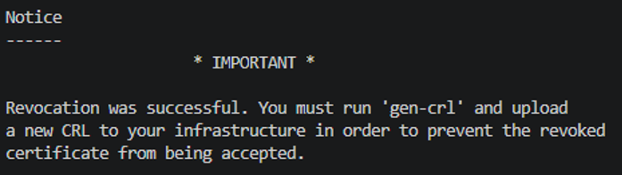
We must inform the server that the client’s old certificate is invalid based on the certificate revocation list (CRL). To do this through easyrsa, we can use the ‘gen-crl’ command as shown above.
These commands generate the revocation list and show the single ‘client-casigned.crt’ certificate in the list since we just revoked it.
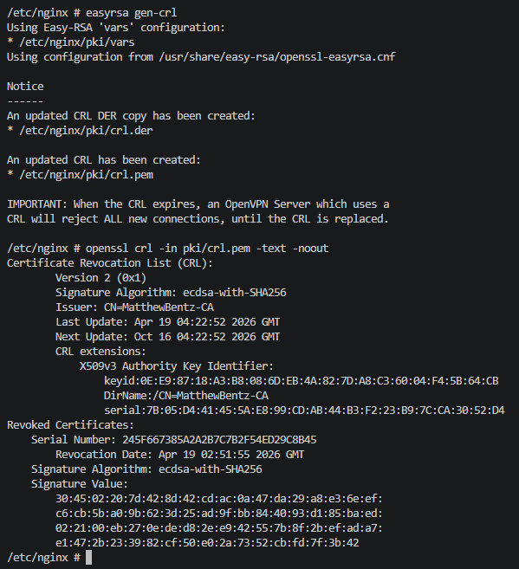
After the CRL is generated, we can add it to the nginx configuration with the following line:
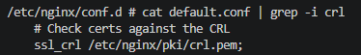
Now, when we send the request from the client with the previously valid certificate, we get a certificate error since nginx finds it within the CRL.
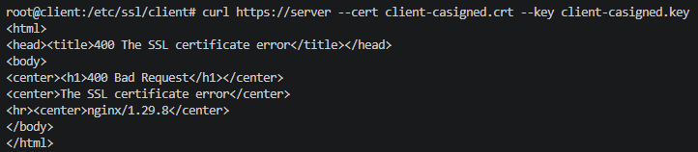
But we can use the newly issued, unrevoked certificate.
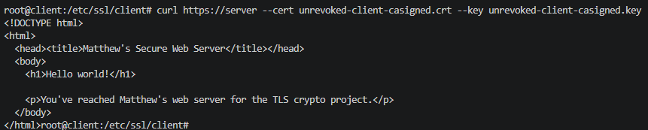
Discussions:
- PKI Security: How should you protect the PKI setup on the server?
The PKI setup would not be like our setup on the server. A public server that serves traffic should never host a root certificate authority. They are typically offline or in a highly constrained environment, and certificate signing requests come from intermediaries and implement a chain-of-trust model.
If we were to keep the root CA on the web server, it should be protected in multiple ways. First, the certificates that were issued as well as the CA’s certificate were stored without encryption. This was simplicity for the project, but it could be improved by protecting the certs with passphrases as suggested by easyrsa when generating them. Additionally, all sensitive information could be controlled with limited user permissions.
Another thing that could help protect the setup is automating or validating the revocation list often. In our example, we manually revoked a client certificate and specified that the nginx server should check the list we generated. For security (and sys-admin headache) reasons, this should be automated and as current as possible.
- TLS vs. mTLS: What differences do you observe in the TLS handshake process between standard TLS and mTLS?
There were two main differences between TLS and mTLS that were observed from the handshake process, as evident by the Wireshark screenshots. Without mutual authentication, the Server Hello does not specify a ‘Certificate Request’. Also, the client does not send any certificates. When mutual TLS is used, Server Hello specifies that it requires the client’s certificate to establish a connection, and the client responds to this request by sending its available certificate. The certificate verification process happens on the client for both (validating it trusts the server cert) but on the server only for mutual TLS, since it needs to do the same process as the client.
- Cipher Suites: What might happen if a client configured only to use RSA cipher suites tries to connect?
If a client is configured to only use RSA cipher suites, the connection will fail. This is because we explicitly specify that TLSv1.3 should be used, and we also signed the certificates with EC ciphers. If the client cannot use elliptic curve ciphers, then it cannot participate in the key exchange or validate certificates.
We can prove this by specifying within curl which cipher suite should be used. TLSv1.3 supports three cipher suites: TLS_AES_128_GCM_SHA256, TLS_AES_256_GCM_SHA384, and TLS_CHACHA_POLY1305_SHA256
Ref: https://www.ibm.com/docs/en/zos/2.5.0?topic=security-using-tlsv13-protocol-support
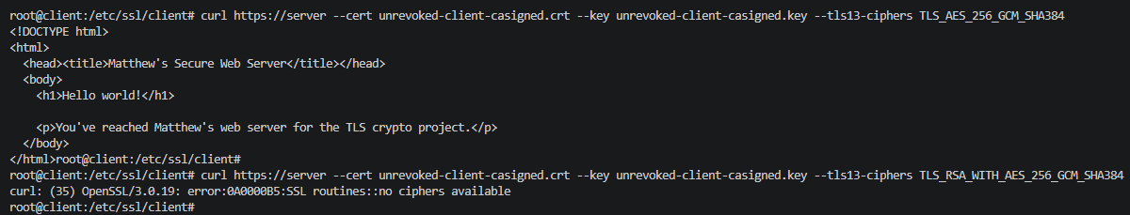
By advertising the client only supports TLS_RSA, we receive a ‘no ciphers available’ error. This is technically due to the difference in TLSv1.2 vs. TLSv1.3 specification, but I think it highlights the plausibility of a client trying to connect to a server supporting TLSv1.2 without any RSA cipher suites available.

