**Javadoc**

The Javadoc tool is a documentation generator that is used to generate documentation in a HTML format. Javadoc comments start with /** and end with */ and the tool looks for these patterns to extract the data. The Javadoc tool is integrated into different development environments for example eclipse and jgrasp and it can be used in eclipse by clicking “Generate JavaDoc” in the project menu. Figure 1 shows an example of Javadoc comments in the code and Figure 2 shows what the javadoc generates on the browser. Tags are also useful to define the information shown and these tags can include @author, @version, @param and @return. These tags can be seen in Figure 3 where they are decribing the parameters and the return.

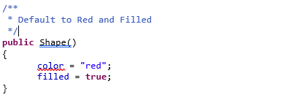

Figure - Javadoc Implementation

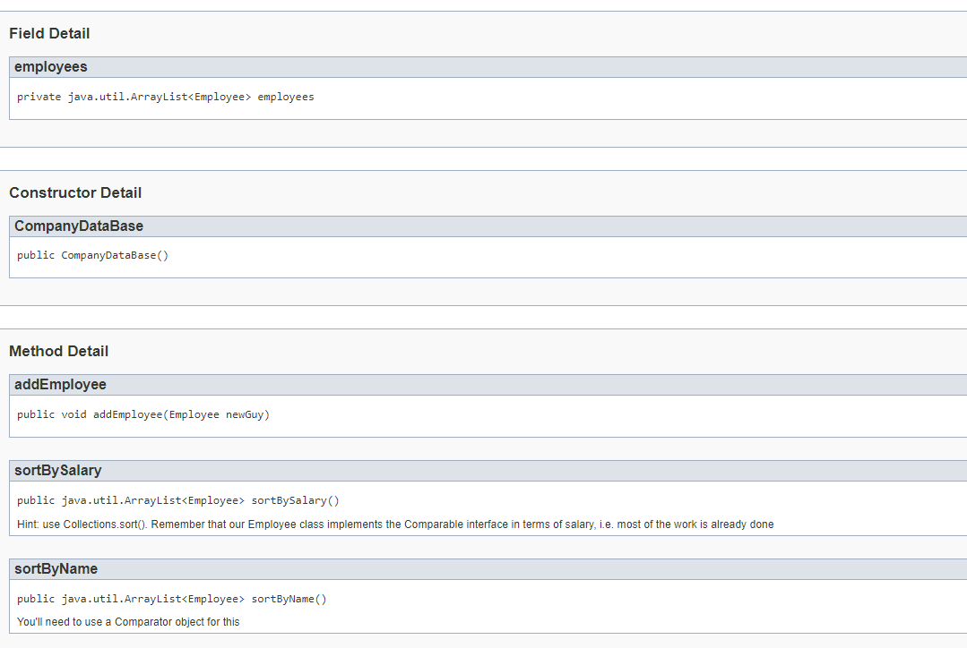

Figure - Javadoc Example

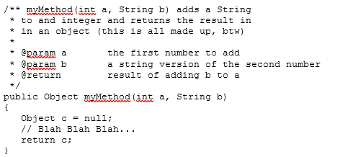

Figure - Javadoc Tags