--Total Revenue

SELECT SUM(total_price) AS Total_Revenue

FROM pizza_sales

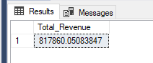

--Average order value

SELECT (SUM(total_price)/COUNT(DISTINCT(order_id))) as AVG_Order_Value

FROM pizza_sales

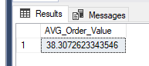

--Total Pizzas Sold

SELECT SUM(quantity) as Total_Pizzas_Sold

FROM pizza_sales

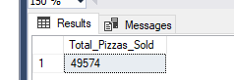

--Total Orders

SELECT COUNT(DISTINCT order_id) AS Total_Orders

FROM pizza_sales

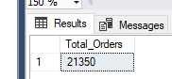

--Average Pizzas Per Order

SELECT CAST(CAST(SUM(quantity) AS DECIMAL (10,2))/CAST(COUNT(DISTINCT order_id) AS DECIMAL (10,2))AS DECIMAL (10,2)) AS Average_Pizza_per_Order

FROM pizza_sales

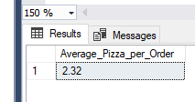

--Hourly Trend for Total Pizzas Sold

SELECT DATEPART(HOUR, order_time) AS SeparateTIME, SUM(quantity) AS Total_Pizzas

FROM pizza_sales

GROUP BY DATEPART(HOUR, order_time)

ORDER BY SeparateTIME

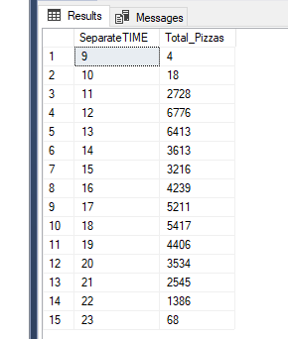

--DAYNAME Trend for Total Pizzas Sold

SELECT DATENAME(DW, order_date) AS Day_of_the_Week, COUNT(DISTINCT order_id) AS Total_Orders

FROM pizza_sales

GROUP BY DATENAME(DW, order_date)

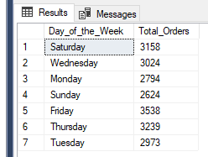

--Weekly Trend for Total Orders

SELECT DATEPART(ISO_WEEK, order_date) AS WEEKDATE, COUNT(DISTINCT order_id) AS TotalOrders, YEAR(order_date) AS Year

FROM pizza_sales

GROUP BY DATEPART(ISO_WEEK, order_date), YEAR(order_date)

ORDER BY WEEKDATE, Year

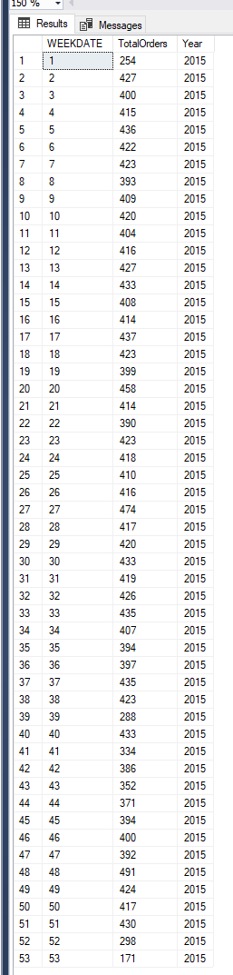

--Daily Trend for Total Orders

SELECT DATEPART(HOUR, order_time) AS HOURDATE, COUNT(DISTINCT order_id) AS TotalOrders

FROM pizza_sales

GROUP BY DATEPART(HOUR, order_time)

ORDER BY HOURDATE

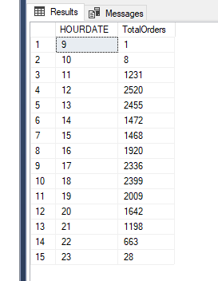

--Percentage of Sales by Pizza Category

SELECT pizza_category, CAST(SUM(total_price) AS DECIMAL(10,2)) AS Total_Sales, CAST(SUM(total_price)/

(SELECT SUM(total_price) FROM pizza_sales)*100 AS DECIMAL(10,2)) AS Precentage_by_Pizza_Category

FROM pizza_sales

GROUP BY pizza_category

ORDER BY Precentage_by_Pizza_Category DESC

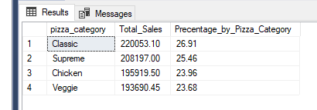

--Precentage of Sales by Pizza Size

SELECT pizza_size, CAST(SUM(total_price) AS DECIMAL(10,2)) AS Total_Sales, CAST(SUM(total_price)/

(SELECT SUM(total_price) FROM pizza_sales)*100 AS DECIMAL(10,2)) AS Precentage_by_Pizza_Category

FROM pizza_sales

GROUP BY pizza_size

ORDER BY Precentage_by_Pizza_Category DESC

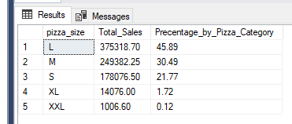

--Total Pizzas Sold by Pizza Category

SELECT pizza_category, SUM(quantity) AS Total_Pizzas_Sold_Category

FROM pizza_sales

--WHERE MONTH(order_date) = 2

GROUP BY pizza_category

ORDER BY Total_Pizzas_Sold_Category DESC

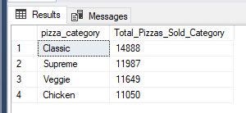

--Total Orders by Pizza Category

SELECT pizza_category, COUNT(DISTINCT order_id) AS Total_Orders_by_Category

FROM pizza_sales

GROUP BY pizza_category

ORDER BY Total_Orders_by_Category DESC

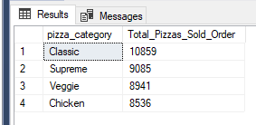

--Top 5 Best Sellers by Revenue

SELECT TOP 5 pizza_name, CAST(SUM(total_price) AS DECIMAL (10,2)) AS Revenue

FROM pizza_sales

GROUP BY pizza_name

ORDER BY Revenue DESC

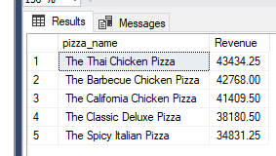

--Bottom 5 Best Sellers by Revenue

SELECT TOP 5 pizza_name, CAST(SUM(total_price) AS DECIMAL (10,2)) AS Revenue

FROM pizza_sales

GROUP BY pizza_name

ORDER BY Revenue

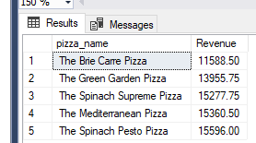

--Top 5 Best Sellers by Total Quantity

SELECT TOP 5 pizza_name, SUM(quantity) AS Quantity

FROM pizza_sales

GROUP BY pizza_name

ORDER BY Quantity DESC

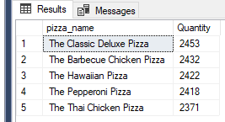

--Bottom 5 Best Sellers by Total Quantity

SELECT TOP 5 pizza_name, SUM(quantity) AS Quantity

FROM pizza_sales

GROUP BY pizza_name

ORDER BY Quantity

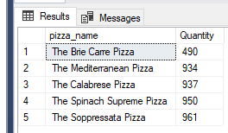

--Top 5 Best Sellers by Total Orders

SELECT TOP 5 pizza_name, COUNT(DISTINCT order_id) AS OrderT

FROM pizza_sales

GROUP BY pizza_name

ORDER BY OrderT DESC

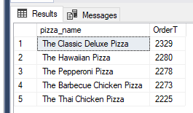

--Bottom 5 Best Sellers by Total Orders

SELECT TOP 5 pizza_name, COUNT(DISTINCT order_id) AS OrderT

FROM pizza_sales

GROUP BY pizza_name

ORDER BY OrderT

