# ISTM 209

# *HTML Assignment*

Due Date: February 11

Due Time: 5:00 p.m. (Central)

Points: 100

Location: eCampus

# Objective

The overall objective is to create a website that you can use to market yourself while seeking a job. In other words, your target audience is a future employer. This assignment will allow you to build a basic understanding of creating and publishing a web page.

***Important***: This will be a public web site. Anyone in the world can see the contents of your website. Part of designing and implementing a personal website is making decisions about what content you want to publish.

# Assignment Overview

1. Create and publish a space for your website on the <http://people.tamu.edu> web server.
2. You must use Notepad or Notepad ++. Notepad and Notepad ++ are on the computers on campus in any open lab.
3. You can use the voal.tamu.edu or on campus computer. There are limited licenses for the voal.tamu.edu. Licenses will most likely be taken if you wait until the last minute to complete this assignment.
4. Submit the URL and webpage files in a zipped folder for your homepage for grading on the course website.

# Resource Materials

TAMU TechDocs: u.tamu.edu/html

Tutorial Points https://www.tutorialspoint.com/html/index.htm

Code Academy: <http://www.codeacademy.com>

Creating a Web Page: <http://people.tamu.edu/Getting_Started/Creating_a_Web_Page.php>

W3Schools: <http://w3schools.com>. Select “Learn HTML” from the menu options at left.

You must use each of the following tags at least once somewhere in your website.

<h#></h#> -- heading

<p></p> -- paragraph

<ul></ul> -- bullet list

<li></li> -- list item used for ordered and unordered items.

<hr /> --- horizontal rule

<b></b> -- boldface

<i></i> -- italics

<u></u> -- underline

<ol> </ol> - ordered list

<a></a> -- anchor

<table></table> -- table

<tr></tr> -- table row

<td></td> -- table data (cell)

<head></head> -- defines document head and beginning of the page.

<title></title> -- title of webpage

<body></body> -- defines document body and designates the beginning of the viewable page.

<html></html> -- defines HTML document

<img /> -- image

<br> - creates a line break

# Instructions

# Step One: Activating Your Website Account

1. You must be logged into the voal.tamu.edu or on a campus computer to activate your URL for this assignment.
2. Go to: people.tamu.edu
3. Click: Getting Started Link
4. Click: Setting Up a TAMU Personal Website link
5. Click: Manage OAL Account link (sign in with your TAMU ID/password).
6. Click: Activate my account - Click: Activate Account
7. Click: Set up my webpage link - Click: Enable
8. Write or copy your link into a document. This link will be submitted with your assignment. Ex. - http://people.tamu.edu/~wndxxxxx
9. Copy and paste your link into a browser. A page will display with this message (Under Construction- This page is under construction). This means your account has been activated. If you don’t see this, you will need to contact the student help desk on campus.
10. You have activated your account and completed step one.

Every student has a public_html folder. This folder will be used to place all of your pages, documents, and pictures. You will use a Texas A&M computer or access the voal.tamu.edu (from your computer) to complete this assignment. The IT student help desk will help you if have problems with the voal.tamu.edu. The website is <https://helpdesk.tamu.edu/> or call 979-845-8300. The GA’s and I can’t help you fix it.

# Step Two: Creating Your Pages, Gathering Documents and Pictures

To locate the public_html folder using the voal.tamu.edu (you must login to the VOAL) or campus computer (if using campus computer, you don’t use the voal.tamu.edu) and follow the steps below:

1. After you login to the voal.tamu.edu or login into a campus computer, you will click on File Explorer (folder usually located on the task bar) to display the drives.
2. Locate the public_html folder on the Unix Drive (U:).

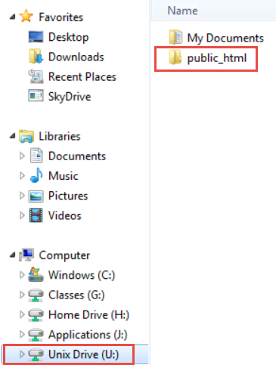

1. Below are the items you will create in your public_html folder:
   1. index.html
   2. workhistory.html
   3. mylife.html
   4. resume word document
   5. resume pdf document (if you don’t have a resume, you will need to create one and save it as word and pdf version.)
   6. six pictures (use short names such as: tamu.jpg)
2. There is an index file already in the public_html folder. You will need to delete that file.

# Page Creation:

1. Open Notepad or Notepad++.
2. You will have created three pages in your folder after this step.
3. Click File, Save as, Unix Drive (U:), public_html folder, and type index.html (The very first page of any website is called index).
4. Repeat steps above to create the workhistory.html page.
5. Repeat steps above to create the mylife.html page.
6. Below are the steps to reopen your pages if you close your pages to take a break:
   1. Open Notepad
   2. Click File
   3. Click Open
   4. Change the drop-down box Text Documents (*.txt) to all files. You will click on the page you want to work on.

# Gathering Your Pictures

1. Find six pictures. Pictures must not be copyrighted and belong to you. Pictures can be of yourself, goals, family, pets, hobbies or so forth. You need to use pictures grandma will approve of.
   1. Two pictures for the Home Page (index.html).
   2. One pictures for the Work History (workhistory.html).
   3. Three pictures for the My Life Page (mylife.html).
2. Use simple names when saving the pictures. Examples: me.jpg. File extensions usually include: .jpg, .jpeg, .png, or .bmp. If you use the incorrect file extension in the HTML code, the picture will not appear in the web browser. You can right click the pictures to check the image extensions.
3. Place your pictures in the public_html folder.

# Resumes

1. You will need a word version and pdf version of your resume. Place the word and pdf resume in the public_html folder. You can save the word version to pdf by clicking on File, Save As, click on Save as Type drop down, click on PDF and then click Publish. Save your resumes as your first letter of first name and full last name – wcurtsinger.docx or wcurtisnger.pdf. Replace your wcurtsinger with your name.

# Public_html Files

You should have the following in your public_html folder:

* 1. Three html pages. (index.html, workhistory.html, and mylife.html)
  2. Word and PDF resumes.
  3. Six pictures.

If you have the above files, you are ready to move on.

# Step Three: Creating Common Content for All Pages

Your website should have a common “look and feel” for all of the pages on your website. You will create the common content on the index page (Home Page) that includes all of the following elements and test it in your browser. After you confirm this page works correctly, then copy the code into the other pages (workhistory.html, and mylife.html) for your site.

Open your index.html page in notepad.

If you have an opening tag, you will need a closing tag with the majority tags used. A tag is written like that <html>.

The first tag required on the page is the html tag. This tag will always be the “first and last tag” on every webpage.

1. Type html in your index page. You need to add < > before after html like in the example picture below.
2. Hit enter about 20 times.
3. Type the closing tag html. All closing html tags will have / like in the example below. There are only few closing tags that don’t a closing tag.

All other code will be placed between the opening html and closing html like in the picture below.

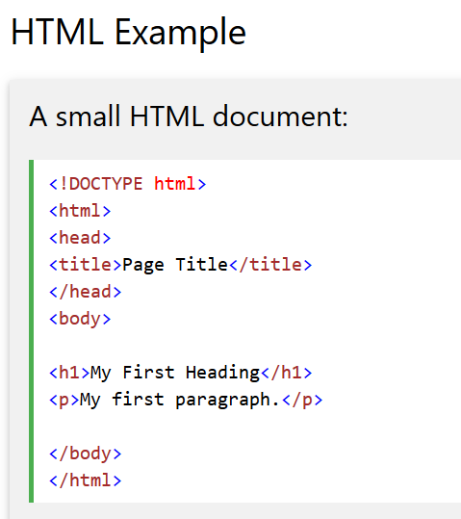

1. You can copy/paste or type the code below after the opening html tag.

<head>

<title>Last Name, First Name: Homepage Name</title>

<!—Designed By: Last Name, First Name: Semester (fall, spring or summer) and Class Section ###-->

</head>

1. You will replace “Last Name, First Name: Homepage Name” with your Last Name, First Name and name of your Homepage Name (could be any name) in the code you copied.
2. You will replace “Last Name First Name, Semester and Class Section ###” with your Last Name and First Name, your Semester, and your Section Number, in the code you copied. (*The <head> tag displays information about your webpage but it is not viewable on the page when displayed in a browser.)*

Click Save.

# Body Section:

1. The body section is where the viewable part of your webpage begins and is viewable by your viewers. The body section should include the following minimal code.
2. Copy/paste the code below and place under the closing </head> tag in the index.html page.
3. **You will alter this code to include a “background color” for the body background and a background color for the table cell td tags. You will have two different colors. You can use the resources listed at the top or PowerPoint to find the code for adding background color and table color.

Resources: <http://www.w3schools.com/tags/tag_table.asp>

<http://www.w3schools.com/tags/tag_tr.asp>

**<body>**

**<table align="center" width = "800px" cellpadding="15px">**

**<tr>**

**<td>**

**The information listed below in the directions for the index, work history, and my life will go here. The information for each page will be different. You will delete this paragraph and place your information here eventually.**

**</td>**

**</tr>**

**</table>**

**</body>**

Click Save.

Place your webpage URL (the one you activated earlier) into a browser (Google, Firefox, IE, or Safari) and press Enter. You should see the paragraph up above if you have followed the directions correctly.

# Body Section Continued:

The bgcolor attribute will add a background color and table color on your webpage.

1. You will add a bgcolor attribute to the following tags that you copied in the steps above:
   1. <body> bgcolor resource:
   2. <td>

You can use Google to search for background and table color for HTML.

Click save, refresh the browser, and view your changes.

1. The next tag after the <td> tag is the heading tag. There are six types of heading tags h1 through h6. The largest is h1 while h6 is the smallest.

Resource:

<https://www.tutorialspoint.com/html/html_quick_guide.htm>

<https://www.w3schools.com/tags/att_hn_align.asp>

Type the following code:

* 1. University Name – Replace University Name with the name of the university
  2. First Name, Last Name - Replace with your actual name
  3. Today’s Date – Replace with the today’s date. (You will type in today’s date that you are working on this assignment).

You will need a center align tag to center the heading tags. You can use Google to search for the center tag.

Example picture layout will be different.



Click save, refresh the browser, and view your changes.

1. The next tag is a horizontal rule hr tag used before and after your navigational links to set them apart from the other content on your page. Both hr tags will go below the heading tag you created in the step above.

Resource: <http://www.w3schools.com/tags/att_hr_width.asp> ** (*You can’t use 50% for the width, use some other percentage value*).

* 1. You will have **two** horizontal tags.
  2. The horizontal rule dividers **should be centered** on the page.
  3. The horizontal rule dividers should not be the full width of the page. (**HINT**: use the width attribute) Look at the example pictures below to see the hr lines.

Click save, refresh the browser, and view your changes.

1. The navigation menu will be located between the hr tags created in the above step. The nav menu will be the same on all pages.
   1. Your navigational links **should be centered** on the page.

<https://www.w3schools.com/tags/tag_nav.asp>

<https://www.w3schools.com/tags/att_a_name.asp>

Your code should look like below but you add different brackets or so forth around the page names . This is an example picture. Your page names will be different.



* 1. The navigation links in your code must match the names of your saved notepad file names or the links will not work.
  2. The active page will not have an active link. Home Pagewill be an inactive link when on the Home Page because it does not have an <a> tag associated with it, whereas the other two pages will be marked in different colors.
  3. Important. You will need to change the active links after you copy the common code into the other pages to make the page you are on with an inactive link.

1. A “footer” section will offset the other content of your page using a horizontal rule. You will add one more hr tag above the </td> tag on the page. All three horizontal lines must be the same length.
2. The footer code will go below the hr tag you just created and should be “centered” on the page.

The footer code section should contain text something like “Contact Me”. This is a link to your email address. You can make up an email address. **(You must use some other words beside “Contact Me”). Your words will display for the link.

Resource: <http://www.w3schools.com/tags/tag_p.asp>

<http://www.w3schools.com/tags/att_p_align.asp>

<http://www.w3schools.com/tags/tag_address.asp>

Click save, refresh the browser, and view your changes.

It should look similar to the below picture.



# Step Four: Copy the Code to Other Pages.

1. Select and copy all your code on your index page. You will open your Work History and My Life Notepad pages and paste the code.
2. You need to make the necessary changes to the navigation links to reflect that code on each page so the nav link is inactive when on the page.



Click save, refresh the browser, and view your changes.

Test the links to make sure they are working. You are ready to start on the individual pages.

# Step Five: Adding Info to Pages.

## Home Page (index.html)

The information for the Home Page will be placed between the second and third hr tags.

The Home page will describe what your website is about on each page:

1. Add two images at the top of the page below your navigational links. A personal image is an image that you own.
   1. The picture should be **centered** on the page.

<http://www.w3schools.com/html/html_images.asp>

Adjust the width and/or height of the picture as necessary.

* 1. You must use the **ALT** attribute for your image. The alt attribute provides additional information about the picture if the picture doesn’t appear.

The image code must match the saved picture. If your picture is saved as tamu.jpg it must appear in the code as tamu.jpg. You can right click on the picture and view properties to see the file extension.

1. You will write two paragraphs describing your website, goals, or any other thing. Paragraphs must have at least eight sentences in each. You will lose points if you have less than eight sentences are in each paragraph. <p> tags are used for the paragraphs.
2. Include at least four links to external websites in your two paragraphs. For example, if you mention that you are a student at Texas A&M University, you might link to the TAMU website.

Resource: <http://www.w3schools.com/HTML/html_links.asp>

Click save, refresh the browser, and view your changes. Your page will be a little but different but same setup.

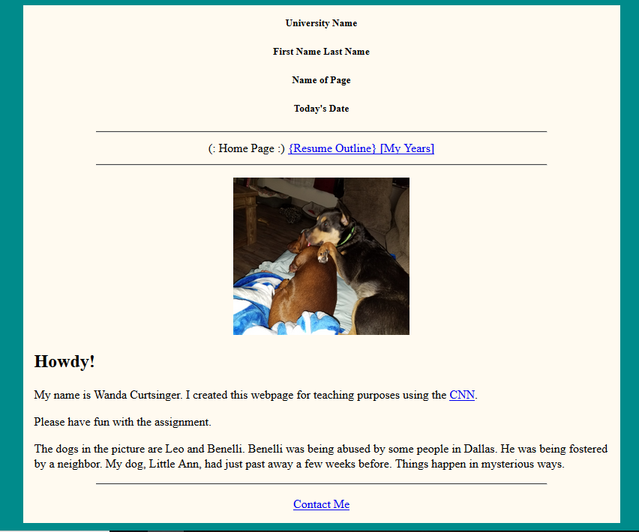

## Work History Page (workhistory.html)

1. The first several lines will have your contact information. It will be **centered** on the page. You will type the following but replacing with your information. You can use fake email address and phone number.

**Contact Information:**

First Name Last Name

Email Address

Phone Number

1. You will create a copy of your resume (it doesn’t have to match your resume exactly) below contact information in text (see screenshot below). You will create five headers. You must list at least four items under each header. Ex. If Volunteering is a header, you will need to have four items listed under the Volunteering header. Underline each header.

Resource:

<http://www.w3schools.com/tags/tag_u.asp>

You will need to create one of the following under a header. You can choose where you want to use each requirement under each header. Refer to example on how to setup your headers. The header names will only have the name (no formatting). The items under headers will have the following:

1. First header must be a bullet list.
2. Second header must be a number list and bold items.
3. Third header must be square bullet and italic items list.
4. Forth header must be a Roman numerals list.
5. Fifth header must be a square bullet and bold items list.

Resource:

https://www.tutorialspoint.com/html/html_lists.htm

<http://www.w3schools.com/html/html_formatting.asp>

<http://www.w3schools.com/html/html_links.asp>

1. Add one image below the fix headers.
   1. The picture should be **centered** on the page.

<http://www.w3schools.com/html/html_images.asp>

Adjust the width and/or height of the picture as necessary.

* 1. You must use the **ALT** attribute for your image. The alt attribute provides additional information about the picture if the picture doesn’t appear.

1. Type two sentences that contain the link to your resume in pdf and word format. One sentence will be for the word resume link. One sentence will be for the pdf resume link. The sentences will be placed above the footer and hr line. The sentences should be **centered**. You will need a period at the end of the sentence.

Example: The picture below is an example of the Work History. Example picture layout will be somewhat different than your layout.

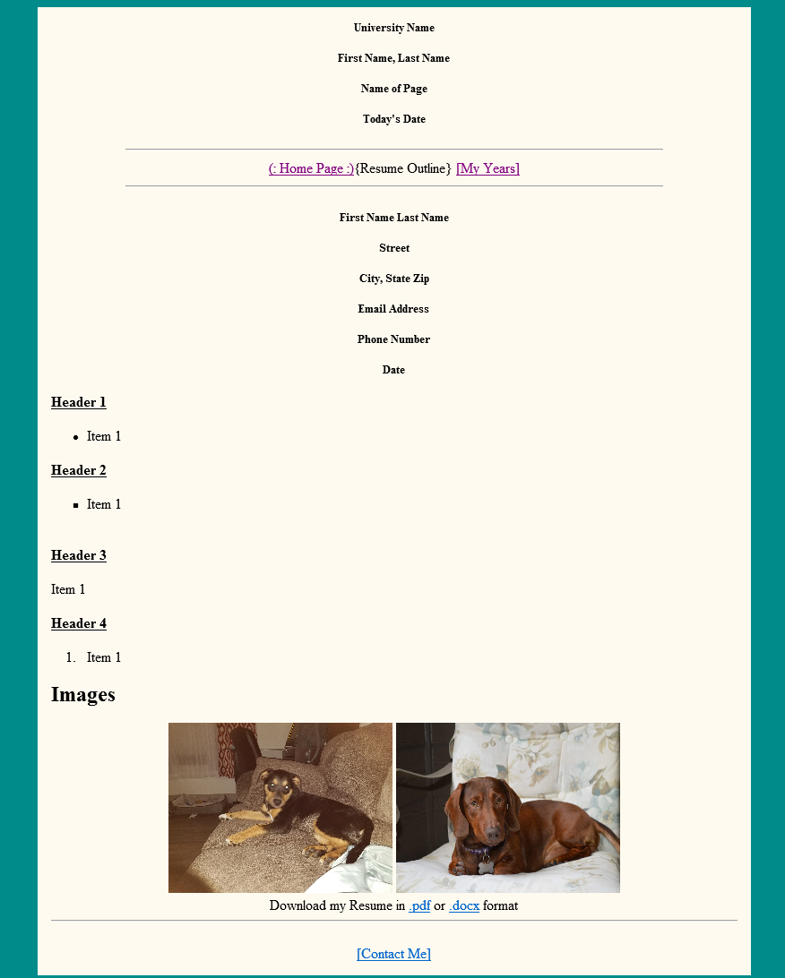

Click save, refresh the browser, and view your changes.

## My Life Page (mylife.html)

The My Life page will provide additional information about your likes, goals, and so forth.

1. You will type two paragraphs. Each paragraph needs to have at least six sentences in each paragraph. You can list your goals, career, past, present or future (where you see yourself), hobbies, and so forth. You can use false information if you want.
   1. Bold the second word of the second sentence.
   2. Italicize the third word of the third sentence in second paragraph.
   3. Underline any word of your choice in any paragraph.

Resource: Resource: <http://www.w3schools.com/html/html_formatting.asp>

1. You will create a table of four columns and three rows plus header row = four rows. The first row will be your header row. The header row will have the headers listed below. You can list different books, article, magazine, journal, or anything you are interested in the other three rows.

Resource: https://www.tutorialspoint.com/html/html_table_tag.htm

Example:

| Name | Published Date | Written By | Recommend |
| --- | --- | --- | --- |
| Lord of the Rings | January 1, 2019 | J R Tolkien | Yes or No |

1. List four hyperlinks to external websites.
2. Insert three pictures.
   * Adjust the width and/or height of the picture as necessary.
   * Must use the **ALT** attribute for your image.
   * Center the pictures.

Example picture layout will be different than your layout.

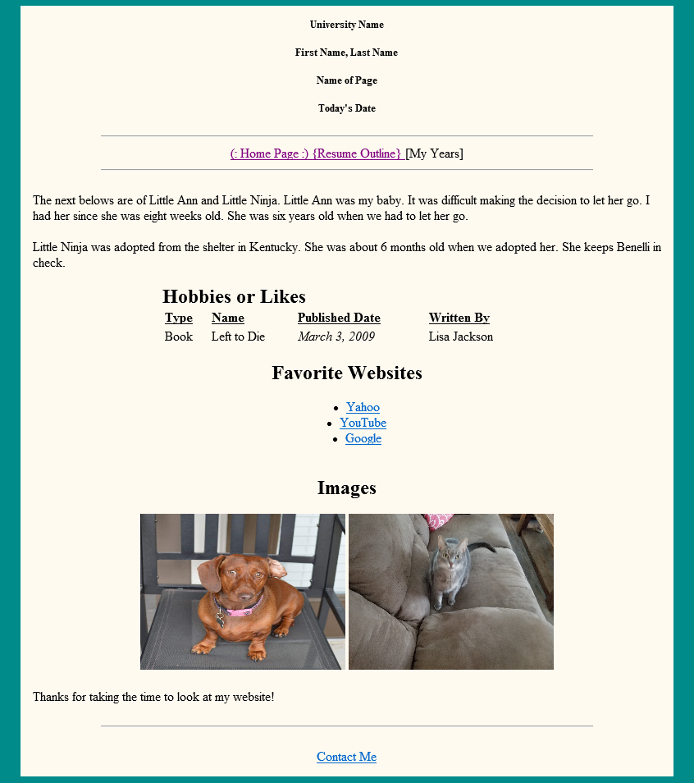

Click save, refresh the browser, and view your changes.

## Deliverables

Submit your completed work on the course website. To submit a deliverable on the course website, you must do the following:

1. You will need to zip the folder. You will right click on the folder, click Send To, and click Compressed (zipped folder). The files in the folder are in the zipped folder. You don’t have to open it and check.
2. Click the “Browse My Computer” button and upload the following zipped file: public_html.zip for the assignment. (Don’t click submit yet.)
3. Enter the URL for your website in the “Submission:” textbox. The URL for your website is <http://people.tamu.edu/~NetID> (replace NetID with your actual NetID). It is not your UIN.
4. After you have uploaded the attachment ***AND*** entered the URL for your website, click the “Submit” button.
5. Important: Check your My Grades for the yellow icon under the HTML assignment. The yellow icon is great.
6. READ ME: This happens every semester to at least 3 – 5 students. If you attach the assignment and don’t submit it, you get a zero. If you see blue icon, you must check your assignment and make sure you submitted and not attached or saved it. Once the GA’s start grading and you didn’t submit or attach, you will get a zero. It only takes a second to check for the yellow icon.