**RISK ASSESSMENT**

**MATRIX:LIKELIHOOD**

|  |  |  |  |  |
| --- | --- | --- | --- | --- |
| RARE (1) | UNLIKELY(2) | MODERATE (3) | PROBABLE(4) | CERTAIN(5) |

**MATRIX: IMPACT**

|  |  |  |  |  |
| --- | --- | --- | --- | --- |
| NEGLIGABLE (1) | MINOR(2) | MODERATE(3) | MAJOR(4) | EXTREME/DEVASTATING(5) |

**MATRIX: Risk Rate x:x=likelihood, y:y=impact, RR:x*y**

|  |  |  |  |
| --- | --- | --- | --- |
| 1 -3  Low | 4-6  Moderate | 8-12  Major | 15+  EXTREME/DEVASTATING(5) |

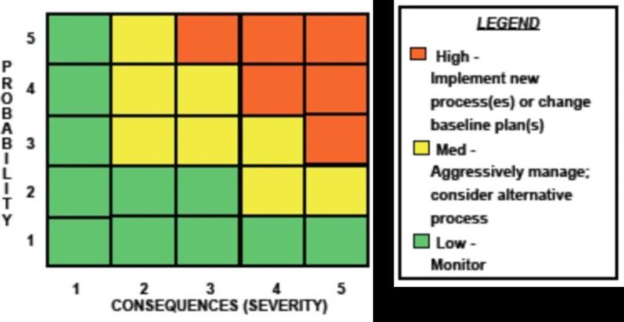

New Or Primary:

Due to the nature of software projects, risk assessments are ongoing at all times, as new risks may appear and old risks may decrease in threat as time goes on. Check the final column of the table to find which risks were added primarily, and which risks are classified as “new”. “new” classification means that the risk was not identified in the primary risk assessment phase, but rather was added afterwards. The table is split in order of primary, then new, making it easier to comprehend.

|  |  |  |  |  |  |
| --- | --- | --- | --- | --- | --- |
| Risk | Response strategy | Likelihood | Impact | RR | New or primary |
| Loss of relevant data | Keep backups and take fresh back ups regularly | Moderate | Moderate | 9 | Primary |
| SQL Injection | User inputting SQL into the system. An issue will become more likely when user input is added to the table. | Moderate | Extreme | 15 | Primary |
| User data theft | All data holding personal information on users should be hashed when entered into the table to ensure privacy from both hackers and staff accessing the database. | Moderate | Extreme | 15 | Primary |
| User damaging database structure with invalid inputs | All input points should have the adequate protections and validation to keep the database structure and set up functioning as intended (inputting negative numbers when not applicable, entering a string of a vast length in string columns) | Rare | Moderate | 3 | Primary |
| Repo mismanagement and automated update failures | Keeping multiple back ups to negate any erroneous updates sabotaging progress on the construction/update of the end system | Rare | Extreme | 3 | New |
| Illness | Plan to make up time around the illness, where time has been lost. | Moderate | Extreme | 15 | New |
| Database net connectivity failure/Run out of Google dollars (credit) | Focus on constructing the database connection first, iron out problems for project moving forwards. | Possible | Major | 9 | New |
| Database hack/hijack/ransom | Employ industry practice standards of security, not just a good password, but keeping it protected from prying eyes. Currently hack rates have increased globally due to more remote work being conducted leading to less secure packet transfer and less secure system set ups. | High | Major | 15+ | New |
| Back End Blocker | Rally as many compatriots as possible to relentlessly assault the issue into nonexistence. If Backend dev stalls, front end is near impossible to implement so this is a high priority issue | moderate | EXTREME | 15 | New |
| Front End UI does not meet accessibility standards | Constantly consult those who know how to meet those standards, and adhere to them 100% | Unlikely | Major | 8 | New |
| Front end not connecting to back end | Rigorously test and check the Jscript aspects until flaw is found, consult back end testing to ensure methods actually work | moderate | Major | 12 | New |