Physical Activity for Health / School of Psychological Sciences and Health
Electronic Submission Cover Sheet

This page must be included at the start of any electronic document submitted for assessment to Myplace, Turnitin, or via email.

Class Code (e.g. B1701): | B1705
Student Registration Number: | 202473668
Tutor/Lecturer: | Allan Hewitt
Supervisor:
(Yr 4 Dissertation only)
Title of Assignment: | Patterns Behind the Scoreline: Expected Goals (xG) - Driven Profiling of Football Teams
Title of Project or Topic Area:
(Dissertation only)
Date: | 25/4/2025
Word Count: | 3998

Plagiarism is defined as the submission or presentation of work in any form which is not one's own, without acknowledgement of the sources. Plagiarism includes inappropriate collaboration with others. Special cases of plagiarism can arise from a student using their own previous work (termed auto-plagiarism or self-plagiarism). Auto-plagiarism includes using work that has already been submitted for assessment at this University or for any other academic award.

In submitting this electronic assignment, I confirm that:
- It represents my own original work and that, where the work of others or my own previous work is used, this is clearly indicated to the reader and is referenced accurately;
- I have read and understood the guidance on plagiarism in the Course Handbook and in the University of Strathclyde’s guidance on plagiarism for students (link);
- I have clearly referenced, in both the assignment text and the bibliography and/or references section, all sources used in the assignment (including my own previous work). Note: the course referencing style is APA6;
- I have fully and accurately referenced (including page numbers), and used inverted commas for, all text directly quoted from books, journals, web pages etc.;
- I have provided sources for, and accurately referenced, all tables, figures, numerical data etc. that are not my own work (i.e. which I have not produced or collected myself);
- I have not made use of the work of any other student(s) past or present without acknowledgement. This includes any of my own work that has previously, or concurrently, been submitted for assessment, at this or any other educational institution;
- I have not sought or used the services of any professional agencies to produce this work;
- I understand that any false claim in respect of this work will result in disciplinary action in accordance with University regulations.

Patterns Behind the Scoreline: Expected Goals (xG) - Driven Profiling of Football Teams

Introduction

An in-depth understanding of team performance is critical for strategic decisions, from recruitment to long-term planning, to gain a competitive advantage within elite European football leagues. While traditional metrics such as shot counts offer an overview, Expected Goals (xG) [1] provides a far more insightful and objective way of quantifying the quality of scoring opportunities by evaluating the probability of a shot resulting in a goal based on factors such as shot location, body part used, assist type, and defensive pressure [2]. This report presents a statistical profiling framework applied across the Premier League (England), La Liga (Spain), Bundesliga (Germany), Serie A (Italy), and Ligue One (France) (Top 5 European Leagues), utilising xG and associated engineered metrics.

Through the application of Principal Component Analysis (PCA) to reduce the dimensionality of these xG features and identify key underlying performance dimensions, coupled with advanced clustering techniques (K-Means, Louvain algorithm, and Bayesian Dirichlet Process Mixture modelling), the aim was to identify a distinct performance profile for each club based on their attacking and defensive characteristics, as well as home and away dynamics. The resulting team profiles, along with insights from a linear regression model predicting league points from the principal components, offer actionable knowledge for cross-league benchmarking, targeted player acquisition, and informed strategic evaluation, moving beyond simple league standings to reveal patterns behind the scoreline.

The Dataset

This analysis utilises match-level data from the top five European Leagues across the 2024/2025 season (15/8/2024 to 7/4/2025). The dataset was sourced via the worldfootballR package in R, which scraped structured data from FBRef. This ensured consistency and comparability of xG metrics across leagues and matches.

Each match entry includes key variables such as:
- Team names (Home and Away)
- Final score
- xG values for both sides
- Match date and season year

Following collection, the data was cleaned for missing values and games which had not been played yet. The dataset could then be manipulated, and engineered key performance indicators could be added to capture an overall picture of each team’s profile for the season. This structure allowed for both descriptive and unsupervised learning techniques to be applied.

Research Question

The aim of this analysis is to provide a structured, data-driven understanding of how teams are performing relative to the quality of chances they create and concede. In an environment where marginal gains can determine season outcomes, clubs and analysts increasingly turn to xG-based metrics. This report explores how those metrics can be used to classify and benchmark team performance profiles at scale.

Rather than offering a tactical breakdown or match-by-match review, this work focuses on answering the following key question:
- How do teams compare in terms of underlying attacking and defensive performance?
Using xG and related engineered features, explore how teams are performing behind the scoreline and identify patterns that would not be obvious from the league table alone [3].

- Can we identify distinct performance ‘types’ among teams using clustering techniques?
Through dimensionality reduction (PCA) and clustering, the analysis aims to segment teams into meaningful groups based on performance characteristics, for example, high xG dominance with poor finishing, or teams that outperform their xG consistently via low-volume, high-efficiency strategies.

- How can this profiling approach support practical decision-making?
The insights generated from this process are designed to support multiple use cases:
- Recruitment and Scouting: Identifying clubs with similar profiles to target players better suited to a certain style or system.
- Loan strategy: Aligning player development pathways with teams that play in comparable environments or demand similar tactical roles.
- Performance Benchmarking: Comparing clubs across leagues in a more objective way than wins or points alone can allow
- Strategic Planning: Informing internal reviews of team strengths/weaknesses based on sustainable metrics rather than short-term results.

The report ultimately asks: What can we learn when we profile clubs by what they’re trying to do on the pitch, not just what the scoreboard says? By leveraging advanced metrics and unsupervised learning, the aim is to provide actionable insights into how teams perform and how this information can be used to support strategic football operations.

Methods

This section outlines the analytical workflow used to transform match-level data into actionable insights about team performance. The process consisted of four phases: data transformation, principal component analysis, clustering analysis, and linear regression modelling.

Data Transformation

Following initial cleaning and standardisation, raw match data was manipulated to produce team summaries of the current season. The aim was to construct features that capture the underlying performance quality rather than the outcome of matches.

Key engineered metrics included:
- xG differential per match (xG – xGA): to capture the balance of attacking and defensive threat.
- Finishing Efficiency (Goals/xG): to assess a team’s ability to convert chances.
- Defensive Efficiency (Goals conceded/xGA): to evaluate how well a team prevents chances from becoming goals
- xG Ratio (xG/xGA): provides a relative measure of overall dominance in terms of expected goals.
- Home/away splits: to reflect consistency or volatility across different game locations.

These features, as well as the others created, provided a multi-dimensional view of how teams approach matches, whether by creating volume, being ruthless in front of goal, or over/under performing expectations.

Principal Component Analysis (PCA)

To identify the fundamental patterns underpinning team performance and to manage the size of the xG-related dataset, Principal Component Analysis (PCA) was used [4]. This statistical technique transforms the original correlated variables into a smaller set of uncorrelated principal components, ordered by the amount of variance they explain. By focusing on these key components, the most significant aspects of how teams differ in their performance can be captured, which provides a more interpretable basis for cluster analysis. The resulting principal components were then examined based on their loadings to understand the underlying performance dimensions they represent.

Cluster Analysis

Following PCA, unsupervised clustering techniques were used to group teams based on their performance profiles. These methods allowed for identifying distinct performance patterns within the dataset, with each cluster representing a group of teams exhibiting similar playing styles or performance characteristics [5].

Various clustering algorithms were tested to explore different clustering structures, including K-Means [6], Hierarchical Clustering [7], and Density-Based Spatial Clustering of Applications with Noise (DBSCAN) [8]. These algorithms were applied to the PCA-transformed data to ensure that teams were similar underlying performance metrics were grouped together. The optimal number of clusters was determined through methods such as the elbow method or silhouette analysis, depending on the chosen algorithm.

Each cluster was analysed to interpret the common performance traits of teams within it, offering insights into the specific strategic or tactical approaches shared by teams in the same group. This phase of the analysis provided a clearer understanding of how teams perform in comparison to each other and helped identify trends and outliers in team strategies.

League Prediction Model

To investigate the predictive relationship between the principal components and team performance, a linear regression was used. The dependent variable in this model was the total points by each team so far in the 2024/2025 season, with the scores of the first five principal components serving as the independent variables.

The model was trained on the complete dataset of teams to establish the linear coefficients linking the principal component scores to league points. The trained model was used to generate the predicted points total for each team based on their PCA scores. These predicted values were then compared against the actual current points total to quantify the correlation between the underlying xG performance characteristics.
Results

Principal Component Analysis

The Principal Component Analysis (PCA) was conducted on the xG-related features. The loadings, indicating the contribution and direction of each original feature to the principal components (PC1 through PC5), are presented in the subsequent subsections and visualised. Appendix includes each team’s score on each principal component.

Principal Component 1 (PC1): Overall xG Performance

PC1 accounted for 58.88% of the variance. The loadings for PC1 are shown in Figure 1. The highest positive loadings were on total xG (0.22) and average xG difference per game (0.24). The highest negative loadings were on total xGA (0.22) and average xGA per game (-0.2). The top and bottom 10 clubs based on their PC1 scores are illustrated in Figure 2.
Figure 1: Loadings on Principal Component 1

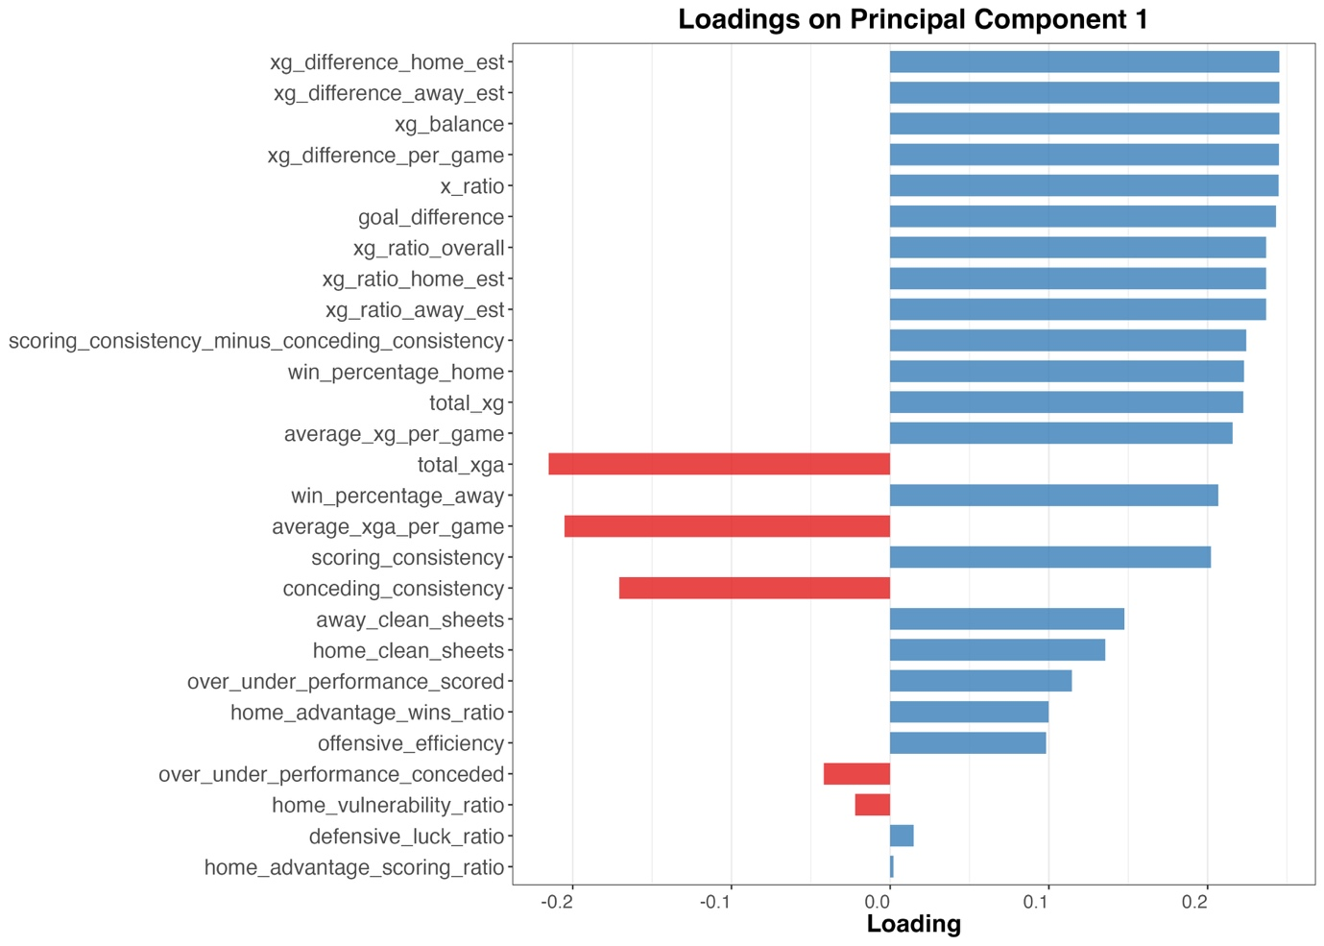

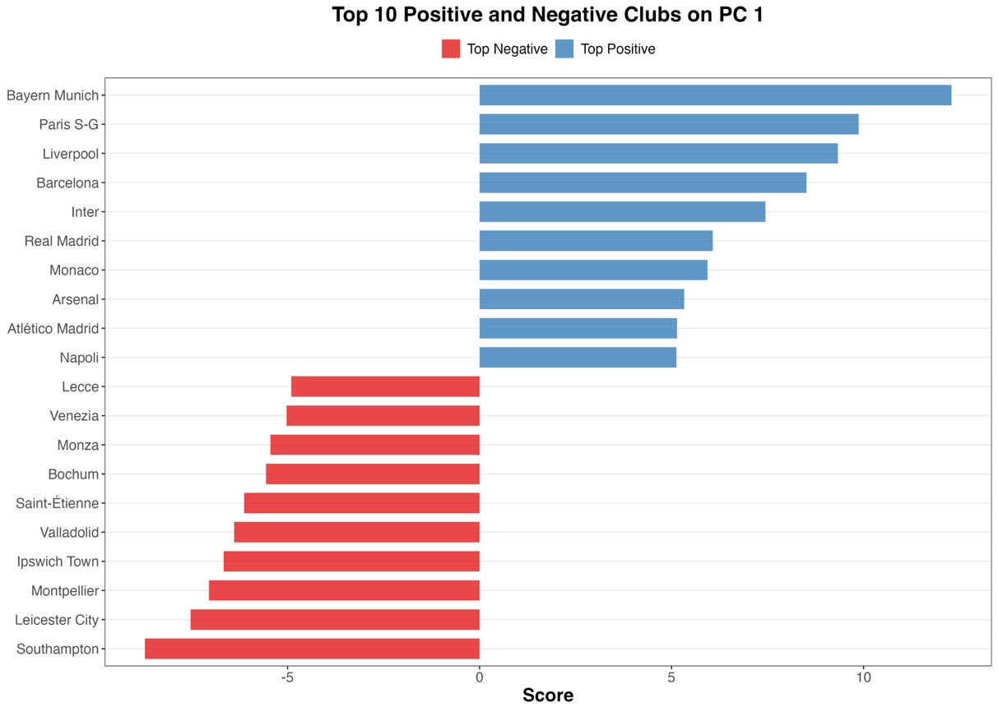
Figure 2: Top and Bottom 10 Clubs on PC1

Principal Component 2 (PC2): Defensive Efficiency and Conceding Patterns

PC2 accounted for 10.53% of the variance. The loadings for PC2 are shown in Figure 3. The strongest negative loadings were on defensive luck ration (-0.484), home clean sheets (-0.317), and away clean sheets (-0.23). The strongest positive loadings were on over/under performance conceded (0.472) and conceding consistency (0.338). The loadings on win percentage home was -0.111. The top and bottom 10 clubs based on their PC2 scores are illustrated in Figure 4.
Figure 3: Loadings for PC2
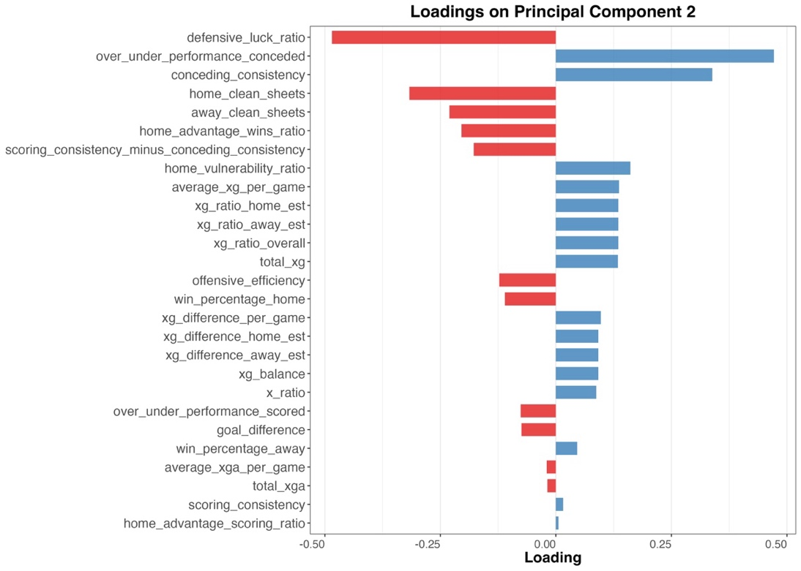

Figure 4: Top and Bottom 10 Clubs on PC2
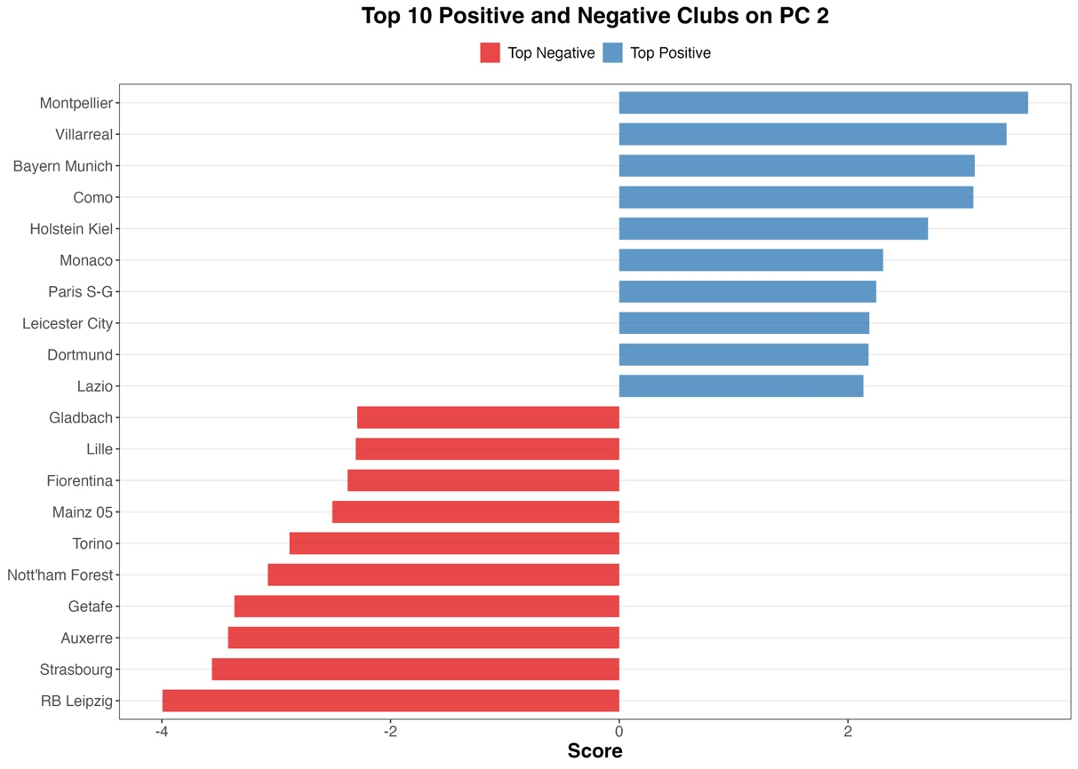

Principal Component 3 (PC3): Scoring Efficiency and Home Vulnerability

PC3 contributes to a cumulative variance of 76.74%. The loadings for PC3 are visualised in Figure 5. The strongest negative loadings were on offensive efficiency (-0.581) and over/under performance scored (-0.549). A positive loading was observed for home vulnerability ratio (0.291), and a negative loading for scoring consistency (-0.227). Clubs with the highest and lowest PC3 scores are highlighted in Figure 6.
Figure 5: Loadings on PC3
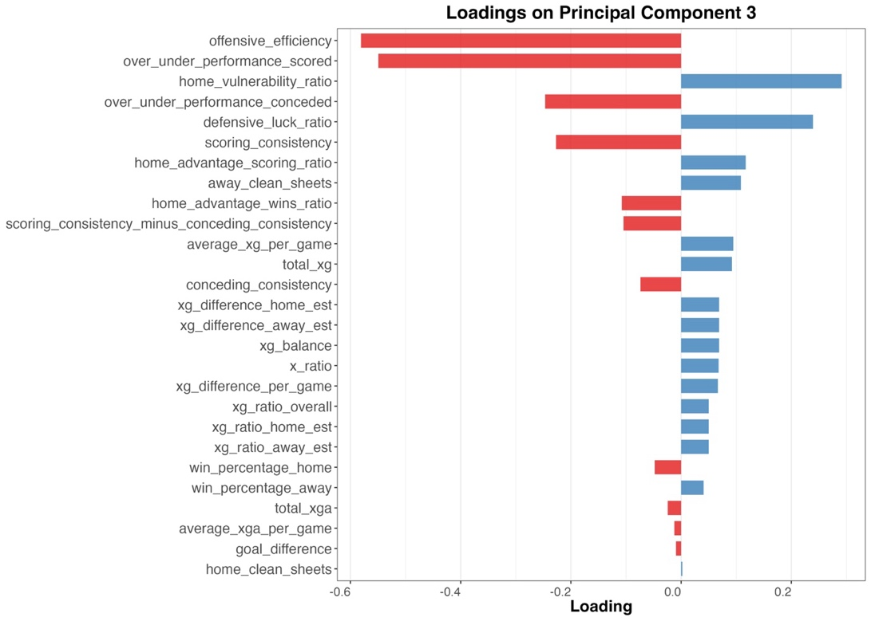

Figure 6: Top and Bottom 10 Clubs on PC3
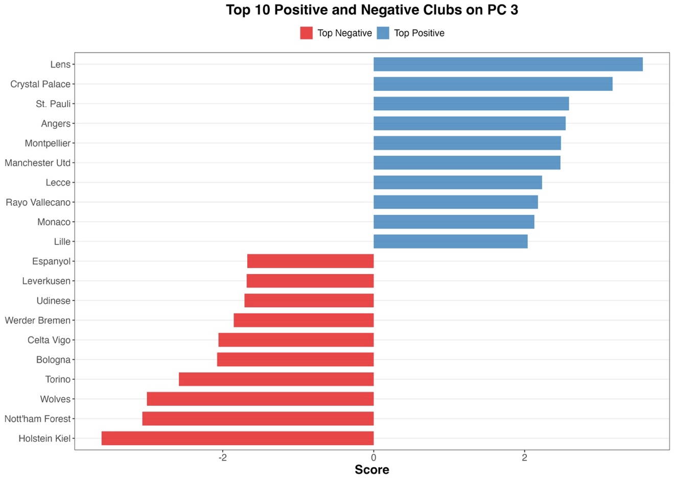

Principal Component 4 (PC4) : Home vs Away Contrast

PC4 accounts for 6.37% of the variance. The loadings for PC4 are shown in Figure 7. The strongest positive loading was on home vulnerability ratio (0.429). Strong negative loadings were observed for home advantage wins ration (-0.527) and home advantage scoring ratio (-0.368). A positive loading was also seen for away clean sheets (0.215). The top and bottom 10 clubs based on their PC4 scores are illustrated in Figure 9.
Figure 7: Loadings on Principal Component 4

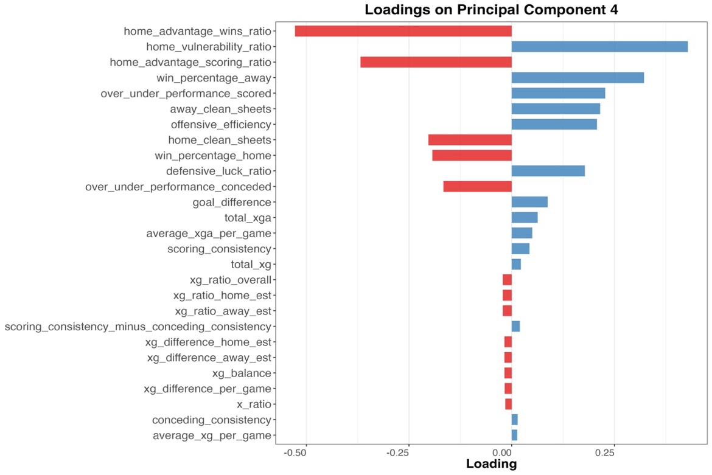

Figure 8: Top and Bottom 10 Clubs on PC4

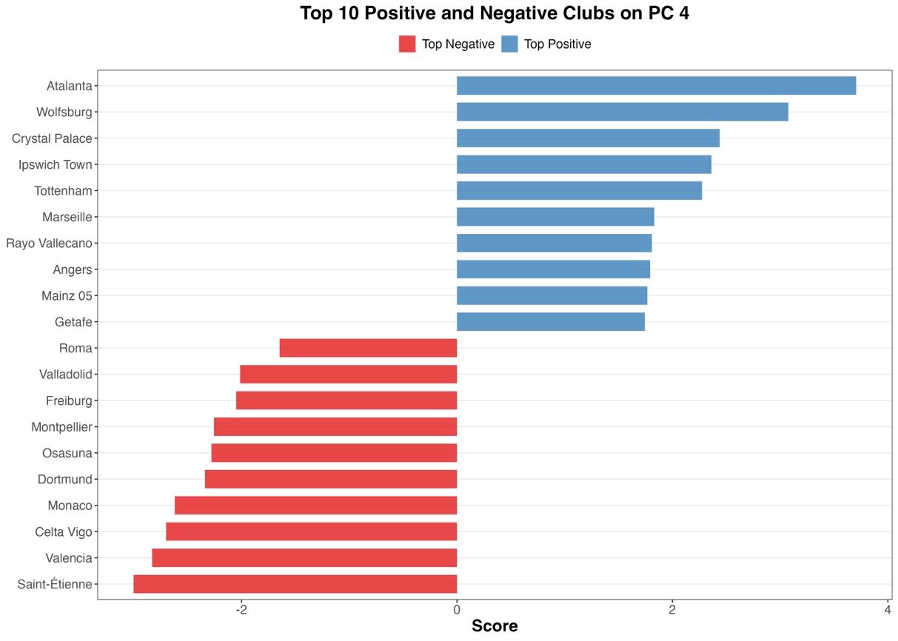

Principal Component 5 (PC5): Home Attacking and Conceding Consistency

PC5 showed the loadings presented in Figure 9. The strongest positive loadings were on home advantage scoring ratio (0.393) and average xGA per game (0.334), followed by conceding consistency (0.273) and home advantage wins ratio (0.277). A negative loading was present for home clean sheets (-0.372). The top and bottom 10 clubs based on their PC5 scores are illustrated in Figure 10.
Figure 9: Loadings on PC5
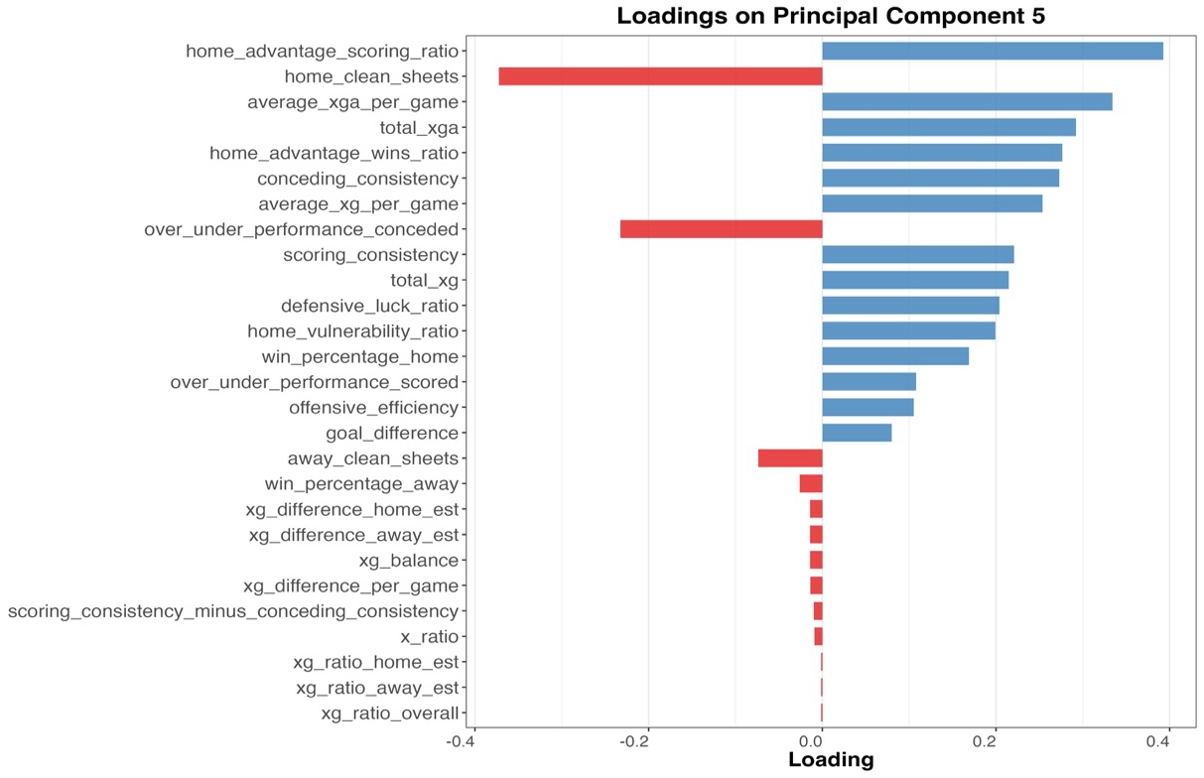

Figure 10: Top and Bottom 10 Clubs on PC5
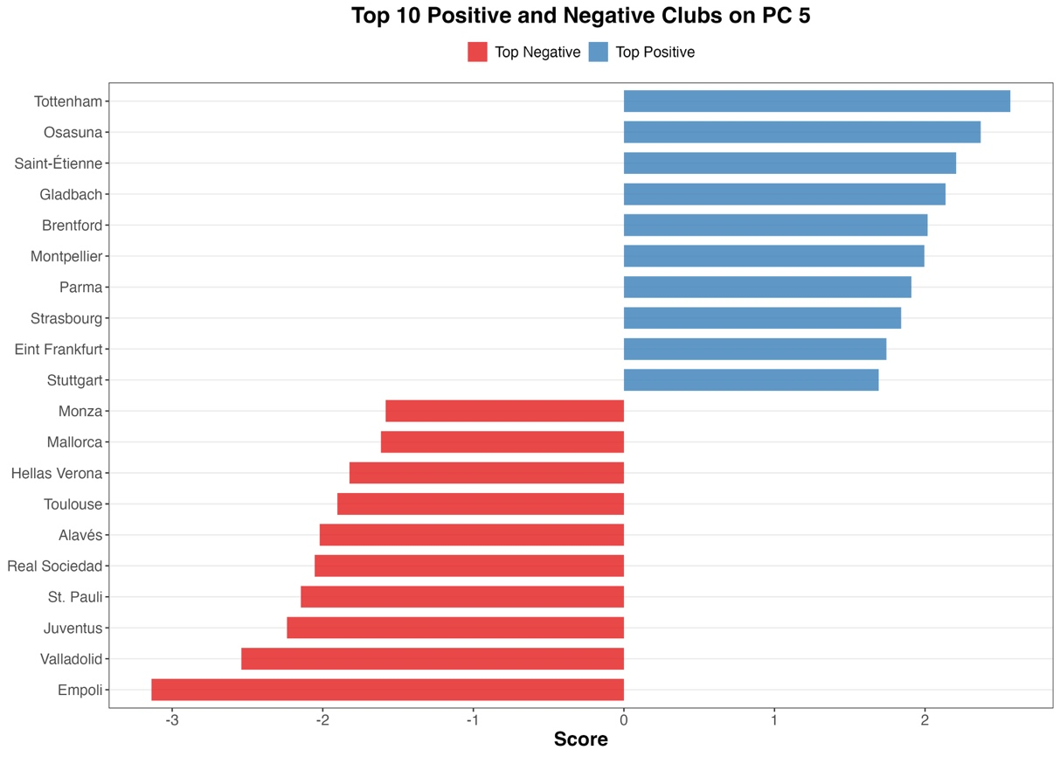

Cluster Analysis

Following PCA, several clustering algorithms were applied to the principal component scores. The methods investigated included K-Means, K-Medoids, Hierarchical Clustering, DBSCAN, HDBSCAN, Gaussian Mixture Models (GMM), Spectral Clustering, OPTICS, the Louvain Algorithm, Fuzzy C-Means, Bayesian Dirichlet Process Mixture modelling, and Self-Organising Maps (SOMs). The clearest cluster structures were obtained from K-Means, the Louvain algorithm, and Bayesian DPM. Other methods tried can be found in the R script.

K-Means Clustering

K-Means analysis resulted in three clusters with the following sizes:
- Cluster 1: 53 teams
- Cluster 2: 31 teams
- Cluster 3: 12 teams

The mean scores for each cluster across the first five principal components, providing insights into their distinct performance profiles, are visualised in Figure 11 below:

Figure 11: Table of Average Principal Component Scores across K-Means Clusters

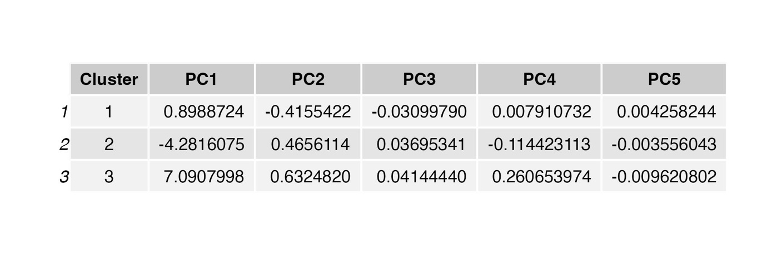

The distribution of these clusters and the teams included in each cluster are shown below in Figure 12. Clusters have been plotted on PC1 (overall xG performance) and PC2 (attacking vs defensive balance) as these components capture the majority of variance in the data. This visual consistency will be maintained across the plots for all clustering methods to allow direct comparison.

Figure 12: Scatter Plot of K-Means Clusters on PC1 and PC2
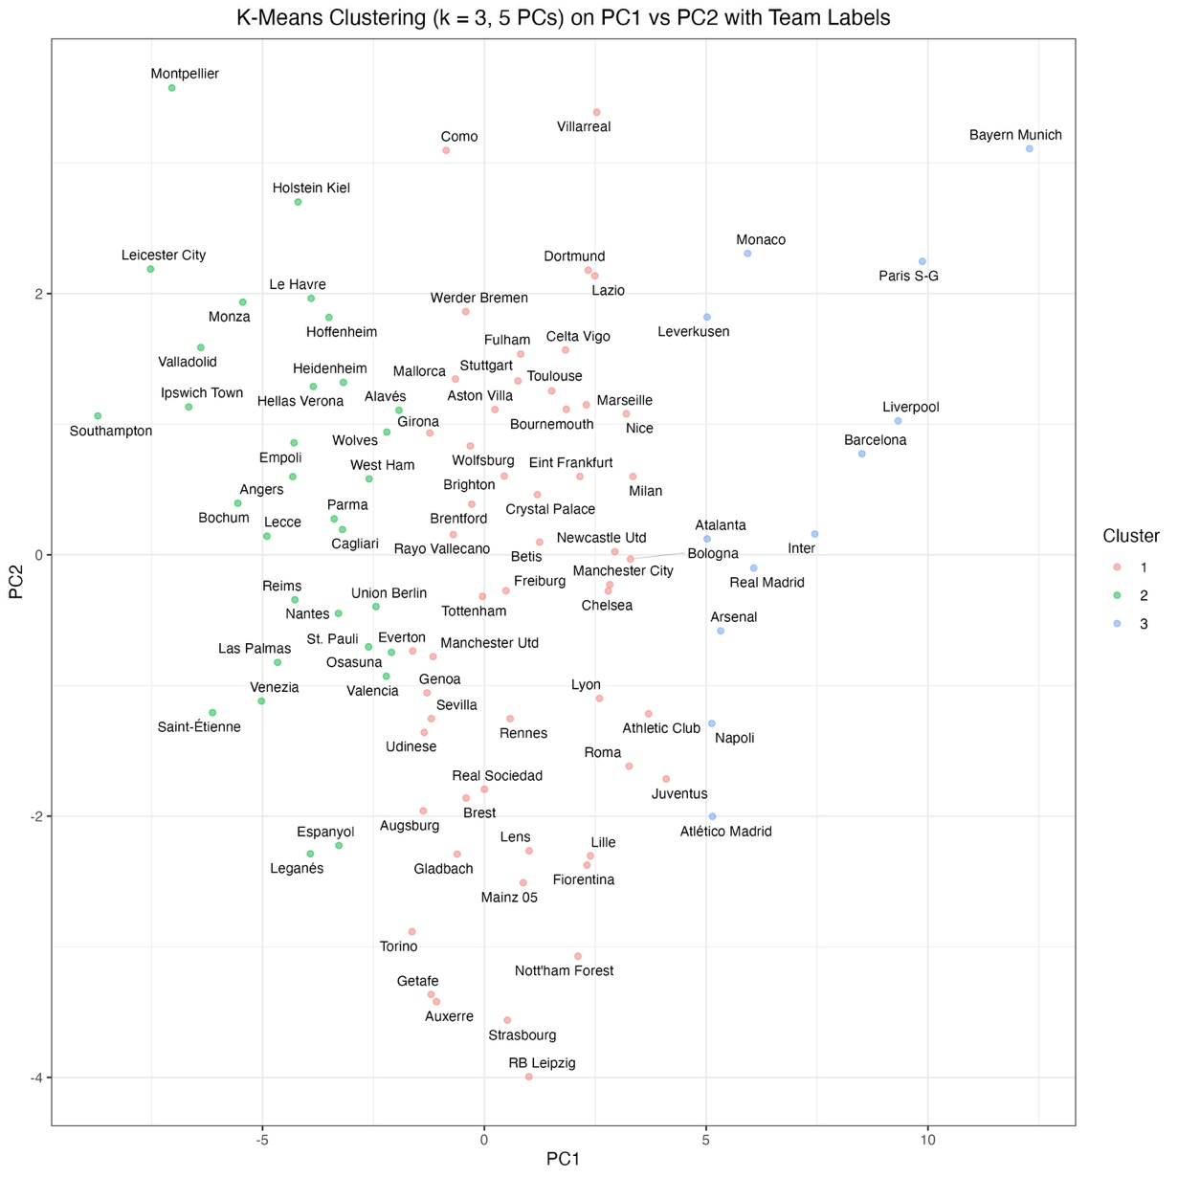

Louvain Algorithm

The Louvain algorithm identified two distinct communities within the team network:
- Community 1: 49 teams
- Community 2: 47 teams

The mean scores for each community across the five principal components are presented in Figure 13 below:

Figure 13: Average Principal Component Scores across Louvain Communities
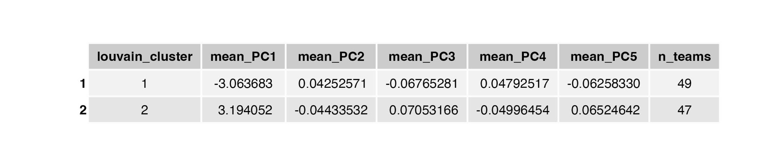

The distribution of these Louvain communities and the teams included are visualised in Figure 14 below.

Figure 14: Scatter Plot of Louvain Algorithm Communities on PC1 and PC2

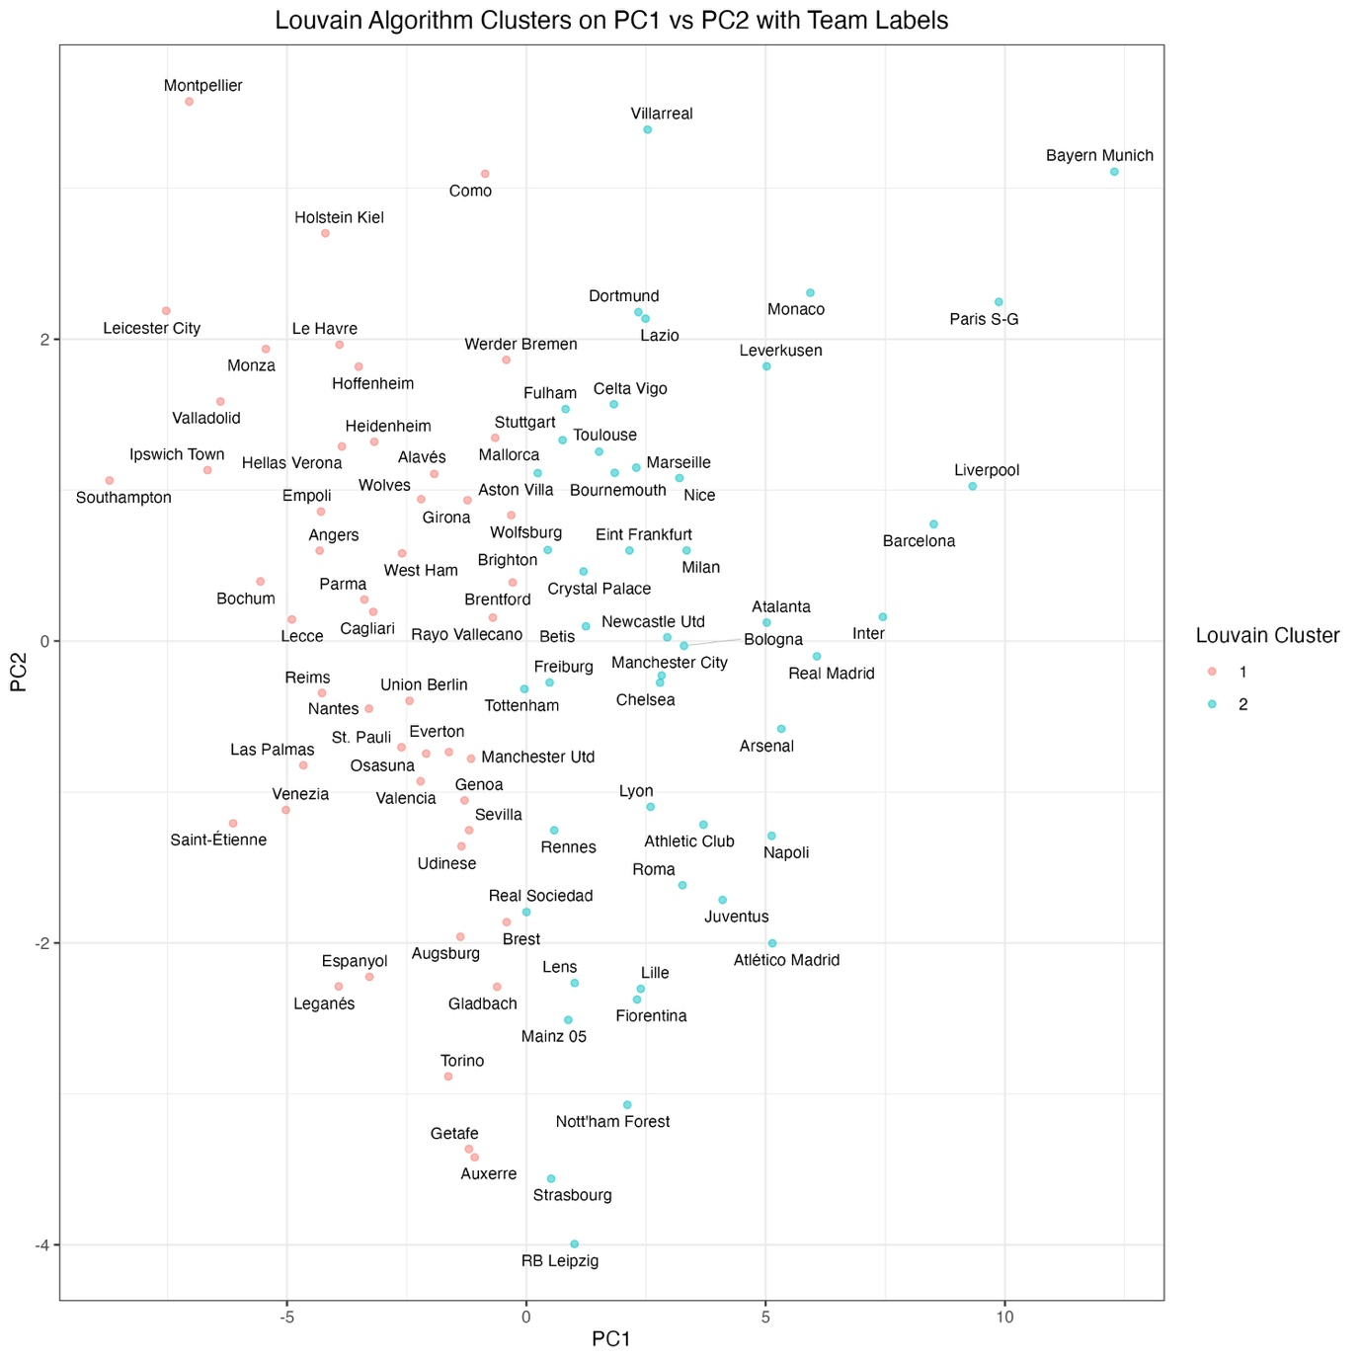

Bayesian Dirichlet Process Mixture Model (EEE)

The Bayesian DPM identified two clusters with the following sizes:
- Cluster 1: 34 teams
- Cluster 2: 62 teams

The mean scores for each cluster are represented in Figure 15 are shown below.

Figure 15: Average Principal Component Scores across Bayesian DPM (EEE) Clusters
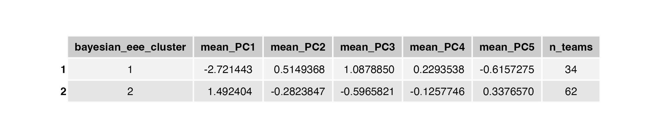

The distribution of these clusters are visualised below on Figure 16:

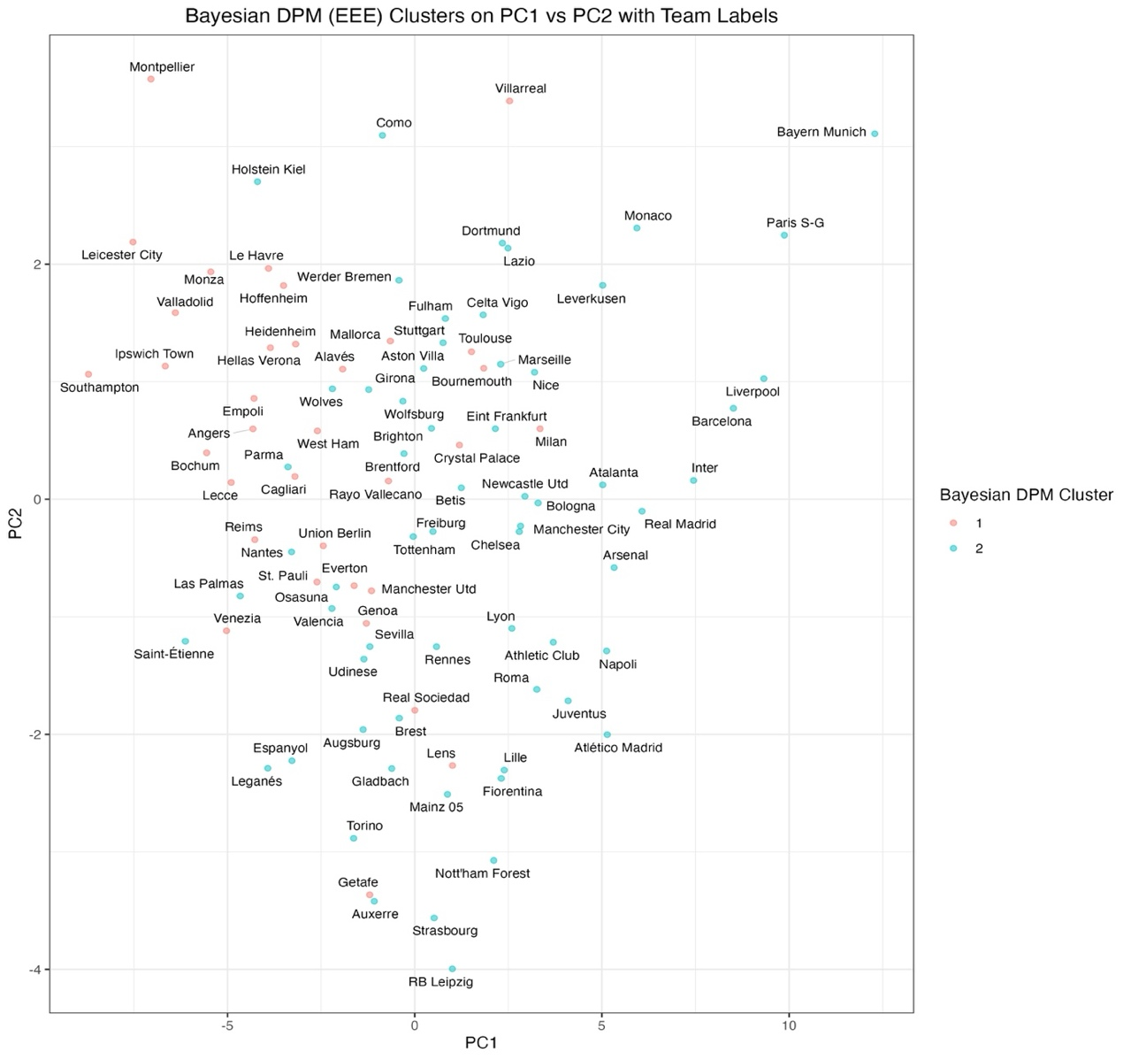
Figure 16: Scatter Plot of Bayesian Dirichlet Process Mixture Model (EEE) on PC1 and PC2

Summary

K-Means, the Louvain Algorithm, and Bayesian DPM showed the most interpretable cluster structures. Other algorithms (K-Medoids, Hierarchical, Spectral Clustering, SOMs [9]) provided similar groupings. DBSCAN, OPTICS [10], GMM [11], Affinity Propagation [12], and Fuzzy C-Means [13] did not produce meaningful clusters for this dataset, as the majority of data points were being identified as noise.

Linear Regression Model

A linear regression model was developed to predict the current total points of teams based on their principal component scores. The model used the first five principal components as predictor variables and the current total points accumulated by each team as the dependent variable.

The summary of the fitted model revealed an adjusted R-squared value of 0.9315, indicating that approximately 93.2% of the variance in current points is explained by the five principal components. The F-statistic of 259.5 with a p-value of less than 2.2e-16 suggests that the overall model is highly statistically significant.

The coefficients of the individual principal components showed varying degrees of influence on the predicted points:
- PC1: 3.37 (p <2e-16)
- PC2: -1.06 (p = 0.00012)
- PC3: 0.21 (p = 0.431)
- PC4: 0.69 (p = 0.013)
- PC5: -0.15 (p = 0.582)

Figure 17 displays a plot of the actual current points versus the points predicted by the model for each team. The close clustering of points around the dashed red line (representing perfect prediction) visually indicates a strong predictive accuracy of the model.

Figure 17: Scatter Plot of Actual vs Predicted League Points
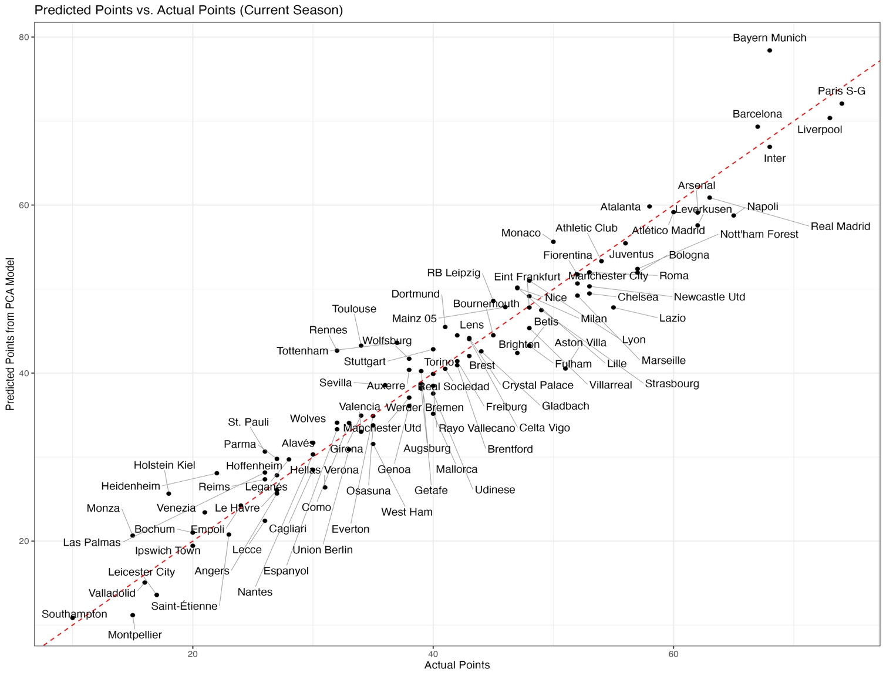

Discussion

Principal Component Analysis

This study aimed to profile elite European football teams based on their underlying xG characteristics and to explore the relationship between these profiles and league performance. The results of the Principal Component Analysis, cluster analysis, and linear regression model offer several insights into these objectives.

The PCA identified five key dimensions of xG-related performance, accounting for a cumulative 88.7% of the variance in the dataset. PC1, explaining the largest proportion of variance (58.88%), exhibited high positive loadings on total xG and average xG difference, and high negative loadings on total xGA and average xGA per game. This suggests that PC1 represents a fundamental measure of overall team quality in terms of both attacking threat and defensive solidity. Teams with high PC1 scores are likely those consistently creating higher quality chances and limiting their opponents to fewer dangerous opportunities.

PC2 (10.53% variance) showed strong negative loadings on defensive luck ratio and clean sheets (home and away), and positive loadings on over/under performance conceded and conceding consistency. This component may reflect aspects of defensive efficiency beyond just the quality of chances conceded, potentially capturing goalkeeping efficiency or the consistency of defensive errors.

PC3 (7.33% variance) was characterised by negative loadings on offensive efficiency and over/under performance scored, and a positive loading on home vulnerability ratio, potentially indicating a dimension related to scoring proficiency relative to chances and defensive weaknesses at home.

PC4 (6.37% variance) highlighted a contrast between home and away performance, with a positive loading on home vulnerability ratio and negative loadings on home win and scoring ratios, alongside a positive loading on away clean sheets.

Finally, PC5 (5.60% variance) appeared to capture aspects of home advantage in attack and conceding consistency.

Cluster Analysis

Applying K-Means, the Louvain algorithm [14], and Bayesian DPM [15] revealed distinct groupings of teams based on their scores across these principal components. While algorithms varied in the number and size of clusters identified, a consistent pattern emerged, particularly with the Louvain algorithm and Bayesian DPM, of a primary division driven largely by overall xG performance (PC1). This split suggests a separation between teams with strong underlying attacking and defensive capabilities and those with weaker metrics.

The three-cluster solution from K-Means offered a more nuanced perspective. Cluster 1 (53 teams), characterised by a slightly positive mean PC1 (0.11) and a negative mean PC2 (-0.21), appears to represent teams with marginally better than average overall xG performance and a tendency towards conceding fewer goals than expected relative to their xG. Cluster 2 (31 teams), with a strongly negative mean PC1 (-0.68) and a slightly negative mean PC2 (-0.13), likely comprises teams with considerably worse than average overall xG performance who also tend to concede slightly more goals than expected. Cluster 3 (12 teams), exhibiting a very positive mean PC1 (1.53) and a slightly positive mean PC2 (0.18), seems to represent high-performing teams with significantly better than average overall xG, who may also have a slight tendency to concede more goals than expected relative to their xG.

The Louvain algorithm identified two communities, primarily separated by overall xG performance. Community 1 (49 teams), with a strongly negative mean PC1 (-0.57) and a slightly positive mean PC2 (0.06), likely represents teams with considerably lower than average overall xG performance but a potential tendency to concede fewer goals than expected. Community 2 (47 teams), showing a strong positive mean PC1 (0.59) and a slightly negative mean PC2 (-0.06), appears to consist of teams with significantly higher than average overall xG performance, who may also have a slight inclination to concede more goals than expected.

The Bayesian DPM also identified two clusters with a strong split based on overall xG performance. Cluster 1 (34 teams), with a strongly negative mean PC1 (-0.89), a positive mean PC2 (0.31), a positive mean PC3 (0.25), a positive mean PC4 (0.19), and a negative mean PC5 (-0.22), suggests teams with lower than average overall xG who tend to concede fewer goals than expected, outperform their xG in scoring, have more away clean sheets and home vulnerability, and lower overall xGA with less consistent conceding. Cluster 2 (62 teams), with a positive mean PC1 (0.49), a negative mean PC2 (-0.17), a negative mean PC3 (-0.14), a negative mean PC4 (-0.11), and a positive mean PC5 (0.12), appears to represent teams with higher than average overall xG who tend to concede more goals than expected, underperform their xG in scoring, have fewer away clean sheets but better home performance, and higher overall xGA with more consistent conceding.
The consistency of a primary division based on overall xG performance (PC1) across these different clustering methods underscores its fundamental importance in differentiating team profiles. However, the clusters identified by K-Means and the secondary characteristics highlighted by the Louvain and Bayesian DPM (related to defensive efficiency, scoring efficiency, home/away contrasts, and conceding consistency) suggest that team performance is multi-faceted and that different groups of teams exhibit distinct combinations of these underlying xG characteristics.

Linear Regression Model

The linear regression model demonstrated a strong predictive relationship (adjusted R-squared = 0.9315) between the five principal components and current league points. The highly significant positive coefficient for PC1 (3.37, p < 2e-16) underscores the critical importance of overall xG performance in determining league success. Teams that consistently generate better chances and concede fewer tend to accumulate significantly more points. The significant negative coefficient for PC2 (-1.06, p = 0.00012) suggests that teams exhibiting characteristics of lower defensive luck and fewer clean sheets, even after accounting for the quality of chances conceded, tend to have fewer points. The positive coefficient for PC4 (0.69, p = 0.013) indicates a modest positive association between the home vs away contrast captured by this component and league points, suggesting that teams with relatively better away form compared to their home form may have a slight advantage in overall points accumulation. The non-significant coefficients for PC3 and PC5 suggest that the aspects of scoring efficiency/home vulnerability and home attacking/conceding consistency, as captured by these components, did not have a statistically significant independent linear relationship with current league points in this model.

These findings align with the general understanding in football analytics that underlying xG metrics are strong indicators of team performance [16]. The dominance of PC1 in both the clustering and regression analysis highlights the fundamental importance of creating high-quality chances and limiting the opponent’s opportunities. The significant, albeit smaller, influence of PC2 suggests that factors beyond just the quality of conceded chances play a role in league outcomes.
One potential limitation of this study is its cross-sectional nature, examining team performance at a single point in time. Future research could explore the temporal evolution of these xG profiles and their predictive stability across multiple seasons. Additionally, incorporating other potentially relevant factors such as player quality, tactical approaches, and contextual variables could further enhance the predictive power of such models.

Conclusion

This study has provided a comprehensive analysis of elite European football teams based on their underlying expected goals (xG) characteristics, revealing key dimensions of performance and distinct groupings of teams. The application of Principal Component Analysis (PCA) successfully reduced the dimensionality of the xG dataset, identifying five principal components that capture the majority of the variance in team performance. These components represent overall xG quality, defensive efficiency and conceding patterns, scoring efficiency and home vulnerability, home vs away contrast, and home attacking and conceding consistency.

The cluster analysis, employing K-Means, the Louvain algorithm, and Bayesian Dirichlet Process Mixture modelling, identified distinct groups of teams with differing profiles across these performance dimensions. A consistent finding across methods was the primary importance of overall xG performance (PC1) in differentiating teams. However, clustering solutions also highlighted variations in secondary characteristics such as defensive and scoring efficiency as well as home and away performance dynamics.

The linear regression model demonstrated a strong predictive relationship between the derived principal components and current league points, with overall xG performance (PC1) emerging as the most significant positive predictor of success. This reinforces the widely held belief in football analytics that a team’s underlying xG metrics are a robust indicator of their league performance [16].

Ultimately, by profiling clubs based on their xG characteristics, this study reveals the fundamental performance drivers that underpin success beyond simple match outcomes, allowing for a more objective understanding of teams strengths, weaknesses, and strategic approaches.

Recommendations

Based on these findings, several recommendations can be made to practitioners in the field:
- Focus on xG Quality: Clubs should prioritise strategies that aim to improve their overall XG, both in terms of increasing their own high-quality scoring opportunities and limiting those of their opponents. The strong correlation with league points suggests this is a fundamental driver of success.
- Consider Multi-Dimensional Performance: While overall xG is crucial, the identification of other significant performance dimensions (e.g. defensive efficiency) highlights the need for a more nuanced approach to team evaluation. Clubs should analyse their performance across these multiple facets to identify specific areas for improvement.
- Utilise Clustering for Benchmarking: The identified team clusters can serve as a valuable tool for benchmarking. Clubs can compare their performance profile to those of teams in aspirational clusters or analyse the characteristics of clusters that consistently achieve higher league positions.
- Home vs Away Dynamics: The significance of the home vs away performance component suggests that clubs should pay specific attention to optimising their strategies for both home and away fixtures.
- Integrate xG into Scouting and Recruitment: The underling xG profiles of potential signings could provide valuable insights itno their likely future performance and fit within a team’s tactical approach.

Future Research

To build upon this study, future research could explore:
- Temporal Analysis: Examining how these xG profiles evolve across multiple seasons and managers.
- Impact of Contextual Factors: Incorporating variables such as player quality, tactical styles, and strengths of schedule into the analysis.
- Predicting Future Performance: Developing more sophisticated predictive models for future match outcomes and league standings based on these xG-features.
- Qualitative Analysis of Clusters: Conducting qualitative analysis (e.g. examining tactical approaches) of the teams within the identified clusters to gain a deeper understanding of the characteristics that underpin these statistical groupings.
- League by League Analysis: Analysing each league separately could reveal further insights to performance patterns and relationships between each league, which may be hidden when compared to all European leagues. Every European league has variations in playing styles, tactical trends, competitive balance, and refereeing standards.

References

[1] ‘(PDF) Beyond Expected Goals’. Accessed: Apr. 09, 2025. [Online]. Available: https://www.researchgate.net/publication/327139841_Beyond_Expected_Goals
[2] J. Mead, A. O’Hare, and P. McMenemy, ‘Expected goals in football: Improving model performance and demonstrating value’, PLOS ONE, vol. 18, no. 4, p. e0282295, Apr. 2023, doi: 10.1371/journal.pone.0282295.
[3] ‘(PDF) Increasing offensive or defensive efficiency? An analysis of Italian and Spanish football’, ResearchGate, doi: 10.1016/j.omega.2006.08.002.
[4] I. T. Jolliffe and J. Cadima, ‘Principal component analysis: a review and recent developments’, Philos. Trans. R. Soc. Math. Phys. Eng. Sci., vol. 374, no. 2065, p. 20150202, Apr. 2016, doi: 10.1098/rsta.2015.0202.
[5] L. Kaufman, Finding groups in data: an introduction to cluster analysis. in Wiley series in probability and mathematical statistics. Hoboken, N.J: Wiley, 2005.
[6] D. Arthur and S. Vassilvitskii, ‘k-means++: the advantages of careful seeding’, in Proceedings of the eighteenth annual ACM-SIAM symposium on Discrete algorithms, in SODA ’07. USA: Society for Industrial and Applied Mathematics, Jan. 2007, pp. 1027–1035.
[7] F. Murtagh and P. Legendre, ‘Ward’s Hierarchical Agglomerative Clustering Method: Which Algorithms Implement Ward’s Criterion?’, J Classif, vol. 31, no. 3, pp. 274–295, Oct. 2014, doi: 10.1007/s00357-014-9161-z.
[8] R. J. G. B. Campello, D. Moulavi, and J. Sander, ‘Density-Based Clustering Based on Hierarchical Density Estimates’, in Advances in Knowledge Discovery and Data Mining, vol. 7819, J. Pei, V. S. Tseng, L. Cao, H. Motoda, and G. Xu, Eds., in Lecture Notes in Computer Science, vol. 7819. , Berlin, Heidelberg: Springer Berlin Heidelberg, 2013, pp. 160–172. doi: 10.1007/978-3-642-37456-2_14.
[9] ‘(PDF) An Introduction to Self-Organizing Maps’, in ResearchGate, 2024. doi: 10.2991/978-94-91216-77-0_14.
[10] M. Ankerst, M. M. Breunig, and H.-P. Kriegel, ‘OPTICS: Ordering Points To Identify the Clustering Structure’.
[11] G. McLachlan and D. Peel, Finite Mixture Models, 1st ed. in Wiley Series in Probability and Statistics. Wiley, 2000. doi: 10.1002/0471721182.
[12] M. J. Brusco, D. Steinley, J. Stevens, and J. D. Cradit, ‘Affinity propagation: An exemplar-based tool for clustering in psychological research’, Br. J. Math. Stat. Psychol., vol. 72, no. 1, pp. 155–182, 2019, doi: 10.1111/bmsp.12136.
[13] ‘(PDF) Fuzzy C-means++: Fuzzy C-means with Effective Seeding Initialization’. Accessed: Apr. 24, 2025. [Online]. Available: https://www.researchgate.net/publication/277253640_Fuzzy_C-means_Fuzzy_C-means_with_Effective_Seeding_Initialization
[14] Z. Zhang, P. Pu, D. Han, and M. Tang, ‘Self-adaptive Louvain algorithm: Fast and stable community detection algorithm based on the principle of small probability event’, Phys. Stat. Mech. Its Appl., vol. 506, no. C, pp. 975–986, 2018.
[15] E. Paul and S. Basu, ‘Bayesian Computation in Dirichlet Process Mixture Models’, 2016.
[16] G. Anzer and P. Bauer, ‘A Goal Scoring Probability Model for Shots Based on Synchronized Positional and Event Data in Football (Soccer)’, Front. Sports Act. Living, vol. 3, Mar. 2021, doi: 10.3389/fspor.2021.624475.

Appendix

 | team | PC1 | PC2 | PC3 | PC4 | PC5
1 | Alavés | -1.92421408058939 | 1.10710537138922 | -0.421952652305435 | -0.930105222300538 | -2.02052024103554
2 | Angers | -4.32057769235877 | 0.598640195746739 | 2.54399173813571 | 1.79359993719213 | 0.528461483063448
3 | Arsenal | 5.32738257342295 | -0.581689115845272 | -0.576456483933688 | -0.205787705327126 | -0.575270201478017
4 | Aston Villa | 0.239087781515328 | 1.11245564412781 | -0.373056729514711 | -0.436719430190589 | 0.86860131046081
5 | Atalanta | 5.02208742119694 | 0.122531167130274 | 0.152455278321272 | 3.70717026093175 | -0.197008342276362
6 | Athletic Club | 3.70072296607723 | -1.2165852510963 | 0.628142222216928 | -0.538926262385721 | -0.907536788422111
7 | Atlético Madrid | 5.1418443185402 | -2.00219787803076 | 0.953815581224987 | -0.0868906533330862 | -0.914939594495412
8 | Augsburg | -1.37698185802808 | -1.95919439825105 | -1.52302430873979 | -0.228058709904904 | -1.31341884101209
9 | Auxerre | -1.07989266311361 | -3.41987956084839 | -0.803560941127914 | -1.39680634004852 | 0.646328162304096
10 | Barcelona | 8.5115326010907 | 0.773906722958223 | -0.324097347813926 | 0.555890692251675 | 0.698321829798593
11 | Bayern Munich | 12.2883677899366 | 3.10933834484785 | -0.444429497051752 | -0.554006340921928 | -0.324291585916918
12 | Betis | 1.24505165934224 | 0.0973484950735572 | 1.01797458260454 | -1.33203933731187 | -0.0634540242780103
13 | Bochum | -5.55695600415829 | 0.395298868889655 | 0.799302678996549 | -0.408880294079695 | 0.389300453763468
14 | Bologna | 3.29454668974354 | -0.0318210358545391 | -2.0741773574819 | -0.687811473887257 | -0.956333464371385
15 | Bournemouth | 1.84518957838725 | 1.11430410424801 | 1.30458829850321 | -0.581038342558724 | -0.277199495077175
16 | Brentford | -0.285605140761624 | 0.387915007780386 | 0.217191828247151 | 1.28705587958715 | 2.01731077578139
17 | Brest | -0.411625727472877 | -1.8620859382384 | -1.1350904170462 | -0.544641398767024 | 1.34963503546025
18 | Brighton | 0.447445016748248 | 0.603049141961749 | -1.12390003224646 | 0.533742099054182 | -0.15809868915952
19 | Cagliari | -3.19948594832388 | 0.193894897137012 | 1.85909366289007 | -0.741246708927157 | 0.599045605383366
20 | Celta Vigo | 1.82884870902498 | 1.5682476631305 | -2.05698025521738 | -2.699962316225 | -0.618202913422622
21 | Chelsea | 2.79316796786435 | -0.276091516049259 | 1.62100479441258 | -0.749106184084145 | 1.05900015892866
22 | Como | -0.860733829565999 | 3.0958437868277 | -1.44308156993574 | -1.36415313468424 | -0.43121360091247
23 | Crystal Palace | 1.19447511852796 | 0.460919021501175 | 3.16566961903258 | 2.43970199075205 | -0.259929077955761
24 | Dortmund | 2.34210264904231 | 2.17889623236085 | -0.834079416558575 | -2.3388935908825 | 1.08677139448853
25 | Eint Frankfurt | 2.15459424578377 | 0.599834928936133 | -0.0214436415079108 | -0.324750341408869 | 1.74312654398089
26 | Empoli | -4.29194928537278 | 0.857840456418098 | 0.114721507927558 | 0.498554419949142 | -3.13644750087379
27 | Espanyol | -3.27952326151267 | -2.22441806495861 | -1.67419434026842 | 0.124214258587488 | 0.904450796326595
28 | Everton | -1.61716270517355 | -0.73540067837759 | 1.07959535700799 | -0.386045537062068 | -0.665982499328531
29 | Fiorentina | 2.3117645279971 | -2.37501942096323 | -1.48473627959775 | -0.0249658768635756 | 0.103929641035353
30 | Freiburg | 0.487177634587042 | -0.27494463837768 | -0.485077329544817 | -2.05004312904607 | 0.0108876766030684
31 | Fulham | 0.819715294213605 | 1.53685410112607 | -1.2206111828374 | 0.948047874078127 | 0.455410937380716
32 | Genoa | -1.29190759125094 | -1.05539253371414 | 1.11999583044862 | -0.379403083132592 | -1.16361739025764
33 | Getafe | -1.20038002323449 | -3.36486722972784 | 1.03160049701184 | 1.74359193640431 | -1.50616052424599
34 | Girona | -1.228603649903 | 0.932794071695768 | -0.665841977446455 | -1.34797392621108 | 0.0150039706041696
35 | Gladbach | -0.612460526712347 | -2.29074516959915 | 0.125078146105218 | 1.00005639944395 | 2.13702916500217
36 | Heidenheim | -3.17788366801611 | 1.31996701045196 | 0.146100989899776 | 0.238415646436506 | -1.31001957666144
37 | Hellas Verona | -3.85526632921392 | 1.28906701116923 | -0.903477789003623 | 0.591635006519183 | -1.82363920542058
38 | Hoffenheim | -3.5027341276085 | 1.81787029720619 | 0.196116615696785 | 0.673129524174434 | 1.23844577927825
39 | Holstein Kiel | -4.19984836275538 | 2.70143815000434 | -3.60523530395647 | -0.0048496201367508 | 0.430068641989558
40 | Inter | 7.44830875534837 | 0.159678465059509 | -0.839583475363475 | 1.44519305494216 | -0.125323463144536
41 | Ipswich Town | -6.66237903580989 | 1.13228380850012 | -0.981174262602381 | 2.36246607969446 | 0.650590172542358
42 | Juventus | 4.09901339582432 | -1.71470049864059 | -0.322775525775179 | -0.0316330568673245 | -2.23708354881411
43 | Las Palmas | -4.65986418639181 | -0.823157542573621 | -1.57779916348556 | 1.45271905143712 | 1.18792636077892
44 | Lazio | 2.49027181550475 | 2.13583075993349 | -1.0069036729921 | 0.976422693382302 | -0.312701342896077
45 | Le Havre | -3.90439525672633 | 1.96357660228946 | 0.704747256688809 | 1.50135395431292 | -0.104582331203937
46 | Lecce | -4.90182748442158 | 0.142789175354989 | 2.23154001350701 | 0.103052318472182 | -1.23164107799421
47 | Leganés | -3.92223983863104 | -2.28846996147607 | -0.417982897027026 | -0.569564719149523 | 0.0256337228388103
48 | Leicester City | -7.52468182365304 | 2.18776149947433 | -0.883904304591407 | 0.394190261299117 | -0.301722238224411
49 | Lens | 1.00790049150052 | -2.26546471484228 | 3.56486241658328 | 0.424939496685966 | -1.07948489208583
50 | Leverkusen | 5.02141946648204 | 1.82012246787927 | -1.68170129230631 | 1.37963656364488 | 0.363658969442813
51 | Lille | 2.39131853161031 | -2.30386867295349 | 2.03929244409517 | -0.909849912100821 | 1.57487722775223
52 | Liverpool | 9.32607476660186 | 1.025767898027 | 0.161865706983676 | -0.254485309617291 | -0.779184371974566
53 | Lyon | 2.59613034826899 | -1.09851918441945 | -0.378771214275485 | -0.4542310250438 | 1.29838149050575
54 | Mainz 05 | 0.875878225178858 | -2.51008946322984 | -0.653618323004393 | 1.7679476533905 | 0.0449784901153002
55 | Mallorca | -0.652224512319149 | 1.34600897749949 | 1.26829272487449 | -0.771230091065605 | -1.61446652315573
56 | Manchester City | 2.82738344864733 | -0.227660944768128 | 0.0815163936460867 | -0.212959673256502 | 1.01760113822044
57 | Manchester Utd | -1.15458743911955 | -0.779278315348524 | 2.47360806431377 | 0.781702060749724 | 0.42471981361169
58 | Marseille | 2.29693299648369 | 1.14866464139404 | -0.540518822918003 | 1.83198934576794 | 1.20263410199305
59 | Milan | 3.34810547874866 | 0.599693118605477 | 1.53360657440471 | -1.22587898713184 | -1.18369381961142
60 | Monaco | 5.9338553394548 | 2.30714944869306 | 2.12950995475233 | -2.62104457521171 | 0.807111330679062
61 | Montpellier | -7.04550627063824 | 3.57460777037828 | 2.48210915798094 | -2.25512395132081 | 1.99567454406224
62 | Monza | -5.44555962892146 | 1.93454853195585 | -1.40864065732524 | 0.517909140064181 | -1.58202856999087
63 | Nantes | -3.2891497428874 | -0.447881125878099 | -0.811237398233182 | -0.579915951627535 | 0.571632673207711
64 | Napoli | 5.12544258325293 | -1.2903781431145 | -0.290280989880188 | -0.0673403986917514 | -1.44689282567905
65 | Newcastle Utd | 2.94318261309367 | 0.0246076632392662 | 0.318132654519533 | 0.309760333301194 | -0.60808058049598
66 | Nice | 3.1995705657647 | 1.07984213955515 | -0.772442252981909 | -1.13985232976931 | 0.529778218223098
67 | Nott'ham Forest | 2.1112897075025 | -3.07254750883666 | -3.0651167651971 | 0.472378731318306 | -1.17615579893668
68 | Osasuna | -2.09342046962948 | -0.746186644570812 | 0.152053174297393 | -2.2804582490225 | 2.36838154561898
69 | Paris S-G | 9.8719570686189 | 2.24670074351948 | 0.749602721974429 | 0.419668862731508 | 1.5680391579136
70 | Parma | -3.38548134152038 | 0.27494112611426 | -0.187095036048885 | -0.141123994197121 | 1.90946170843156
71 | RB Leipzig | 1.00474467327158 | -3.99464035977498 | -0.165461792398359 | -0.204511775068057 | 0.810622437953341
72 | Rayo Vallecano | -0.700714935746846 | 0.155167517802686 | 2.17543513608434 | 1.80872917868928 | 0.450005623288364
73 | Real Madrid | 6.07132504446855 | -0.101145559070095 | 0.506632685154338 | -0.590156765213751 | 0.810329474155751
74 | Real Sociedad | 0.00286529662313062 | -1.79487051940405 | 1.69791179117303 | -0.474550803773109 | -2.05286095224506
75 | Reims | -4.27009136185105 | -0.343642221272336 | 1.5915226455862 | 1.54820566730937 | 1.00535012816896
76 | Rennes | 0.581849537050102 | -1.25385217410384 | -0.0858587540891839 | -1.3989420746798 | -0.825017096648629
77 | Roma | 3.26250177078741 | -1.61779278085894 | 0.80284851259017 | -1.6478317351382 | 0.425555655585931
78 | Saint-Étienne | -6.12688163061912 | -1.20746172303805 | -1.16073152107947 | -3.00263736165165 | 2.20571238396813
79 | Sevilla | -1.19620420723619 | -1.25344842915471 | -1.14695875367075 | 0.925828613027206 | -1.43804711470099
80 | Southampton | -8.71286584995387 | 1.06353036343352 | 0.767490561175501 | 0.890471825697822 | 1.00323136830794
81 | St. Pauli | -2.60952862579177 | -0.703723084813247 | 2.58886281602312 | 0.386053710891289 | -2.14531724141998
82 | Strasbourg | 0.51883096476849 | -3.56162896849132 | -0.261529667860685 | 0.52510525008009 | 1.84010304591311
83 | Stuttgart | 0.757634618826144 | 1.33108872760269 | 0.0925961880136749 | 0.516737100114305 | 1.69301032809742
84 | Torino | -1.63135506477607 | -2.8843841906887 | -2.58142863036104 | 1.07987268892716 | -0.915186883054196
85 | Tottenham | -0.0404156482899362 | -0.317597441428197 | -0.12366639158671 | 2.27437156302829 | 2.56732227757343
86 | Toulouse | 1.51825432970486 | 1.25462819878447 | 1.25742649363388 | 0.41412159040802 | -1.90269850973226
87 | Udinese | -1.35548975336121 | -1.35939976967544 | -1.71152851361915 | -0.87424821812104 | -0.551565434295641
88 | Union Berlin | -2.44165115888775 | -0.395922055128136 | 1.45543281100477 | -0.916152507848782 | -1.35248648152368
89 | Valencia | -2.2117374744743 | -0.929163370001099 | -1.13896014207669 | -2.83133230247335 | 0.459282729353049
90 | Valladolid | -6.39198319507075 | 1.58675362986393 | -0.198053769439611 | -2.01224376575784 | -2.54079214364604
91 | Venezia | -5.0255550995361 | -1.11904982338703 | 0.704563456591555 | -1.49147007105967 | -0.297138176706093
92 | Villarreal | 2.53371776160794 | 3.38788611262229 | 0.742807452196684 | 0.553051091090674 | -0.532029802915506
93 | Werder Bremen | -0.419353859488076 | 1.86250721648146 | -1.85225534795846 | 1.48580808131449 | -1.1290345509895
94 | West Ham | -2.59749247741138 | 0.581319706092527 | 1.18429611643389 | 0.706522714204299 | 0.864897740298334
95 | Wolfsburg | -0.315331027984499 | 0.833647028942208 | -1.08857071991674 | 3.07536526799224 | 0.73231649230792
96 | Wolves | -2.19910326176341 | 0.939793589657593 | -3.00595024176521 | 0.835494695208693 | -0.601450383856343

