Synthetic Benchmark School Model Shiny Application Proposal
Office | DDOE Analytics
Prepared by | Matt Faiello, PhD
Date | 03/27/2026

Purpose
This proposal recommends developing an interactive Shiny application to operationalize the proposed Synthetic Benchmark School Model as a structured, user-facing tool. The goal is to make an advanced benchmarking workflow usable in a no-code environment. Instead of requiring users to work directly in code, the application would allow them to define a benchmark, run the model, and interpret results through a guided interface with built-in guardrails.
The value of the proposed application is that it would make an advanced machine learning workflow more accessible, more transparent, and easier to use responsibly. The current proof of concept already demonstrates the method. What is missing is a practical way for users to engage it without having to build, validate, or interpret the workflow on their own.

Why This Is Needed
School performance is often discussed through direct comparisons of average test scores. Those comparisons are sometimes useful, but they can also be misleading because they do not account for meaningful differences in school context. The Synthetic Benchmark School Model addresses that problem by estimating an expected score for a school based on a selected set of characteristics, then comparing observed performance to that expected benchmark. That produces a more contextual comparison than raw score comparisons alone.
This answers the question, "What score would we expect for a school with this profile, under this benchmark definition?" The proposed application would make that question operational for users in a way that is structured and repeatable.

What the Application Would Do
The proposed Shiny application would bring the demonstrated workflow into an interactive, user-facing environment that is designed for responsible use and convenience. It would package it in a way that allows users to interact with a complex analytic process while keeping key modeling choices, validation logic, and interpretive boundaries governed by the established framework. In practice, users would be able to define the benchmark, run the model, generate an expected score, compare that expected score to a school’s observed performance, and interpret the result within a guided framework.

Analytic Framework
The model always includes SchoolYear and then adds benchmark groups as selected by the user. Those benchmark groups can include characteristics such as county, low income, race, SPED, and ELL. Selected benchmark features are modeled in interaction with school year so that relationships are allowed to vary over time rather than being treated as fixed across years.
The current workflow uses ridge regression to generate expected scores, applies square-root weighting based on sample size, and evaluates performance using school-grouped cross-validation. For observed schools, the comparison is based on the cross-validated predicted score, not a simple in-sample fit. Performance is then interpreted through the difference between the observed score and the predicted benchmark score. That residual is translated into a practical performance classification such as above expected, near expected, or below expected using a neutral-band threshold.

Core Application Components
The proposed application would include four core components. Together, these components would create a structured, no-code environment for using an advanced modeling workflow while maintaining transparency, consistency, and methodological discipline.
Component | Primary function
Benchmark definition | Lets users choose which characteristics define the comparison school.
Model execution | Runs the established ridge-regression workflow within a governed interface.
Results | Displays observed score, expected score, residual, and performance classification.
Diagnostics and guidance | Explains assumptions, benchmark choices, and interpretation boundaries.

Proof of Concept and Scalability
At present, the model exists as a worked example in the 3rd grade DeSSA ELA case study. The proposed application would take that demonstrated framework and scale it into a more usable tool without changing the underlying logic.
In practical terms, this would move the model from a scripted analytic workflow into a governed application environment, expanding access without loosening rigor. This modeling structure can support synthetic benchmarking across Delaware’s major statewide summative assessments, including additional DeSSA content areas and tested grades, as well as the 11th-grade SAT.

Limits and Interpretation

This tool is designed to support analysis and interpretation, not causal explanation. It can show whether a school performed above or below what the model would expect for a school with a given profile, but it does not explain why that difference occurred. The results should be read as benchmark-adjusted comparisons, not as evidence of cause and effect.

It is also important to be clear that the benchmark depends on how the comparison is defined. Different benchmark definitions may produce different expected scores. One of the main values of the application is that it makes those definitional choices visible. The benchmark is not intended to serve as a fixed truth or a final judgment on school quality. It is a structured comparison that should be interpreted in the context of the selected benchmark and the application’s methodological guardrails.

Deliverables
The main deliverable would be an interactive Shiny application built around the demonstrated Synthetic Benchmark School Model. Supporting deliverables would include the underlying R workflow, documentation explaining how the benchmark is defined and how the model operates, and user guidance to support appropriate interpretation of outputs. Together, these deliverables would create a scalable, no-code application environment through which users can engage an advanced machine learning workflow with greater consistency, transparency, and methodological support.

Appendix I. Supplemental Walkthrough Demonstration
Demonstration scope | 2025 grade 3 DeSSA ELA
To illustrate how the workflow performs in practice, I include a focused walkthrough using 2025 grade 3 DeSSA ELA (SBAC). For demonstration purposes, I limit the comparison set to schools with at least 30 available test scores contributing to the school mean, which helps reduce sampling variability and makes the school-level averages more stable.
For the walkthrough, I start with a baseline benchmark of school year + low income. I then compare that baseline to several alternative benchmark definitions by adding one group at a time, including gender, race, SPED, ELL, and county, along with a fuller benchmark that combines the major groups together. I focus on the top 10 and bottom 10 schools under the baseline model in 2025 and then track those same schools across the alternative benchmark definitions. Holding the school set fixed makes it easier to see how much movement is coming from the benchmark definition itself rather than from switching schools in and out of the display.
Term | Definition
Observed score | The school’s actual average score for the selected assessment, grade, and year.
Predicted benchmark score | The score the model would expect for a school with the selected benchmark characteristics in that year.
Residual | The difference between the observed score and the predicted benchmark score. This shows whether a school performed above or below what the benchmark model would expect.
Performance z-score | The residual expressed in standardized units. This makes it easier to compare how far above or below benchmark a school is across schools and model specifications.
Performance rank | A school’s relative standing based on its benchmark-adjusted performance. Smaller rank numbers indicate stronger performance relative to the benchmark.
Benchmark definition | The set of characteristics used to define the comparison school, such as low income, race, SPED, ELL, county, or other school-level characteristics.
Baseline model | The starting benchmark definition used for comparison in this walkthrough. In this demonstration, the baseline model is school year + low income.
Alternative benchmark definitions | The other model specifications used to compare results against the baseline model.
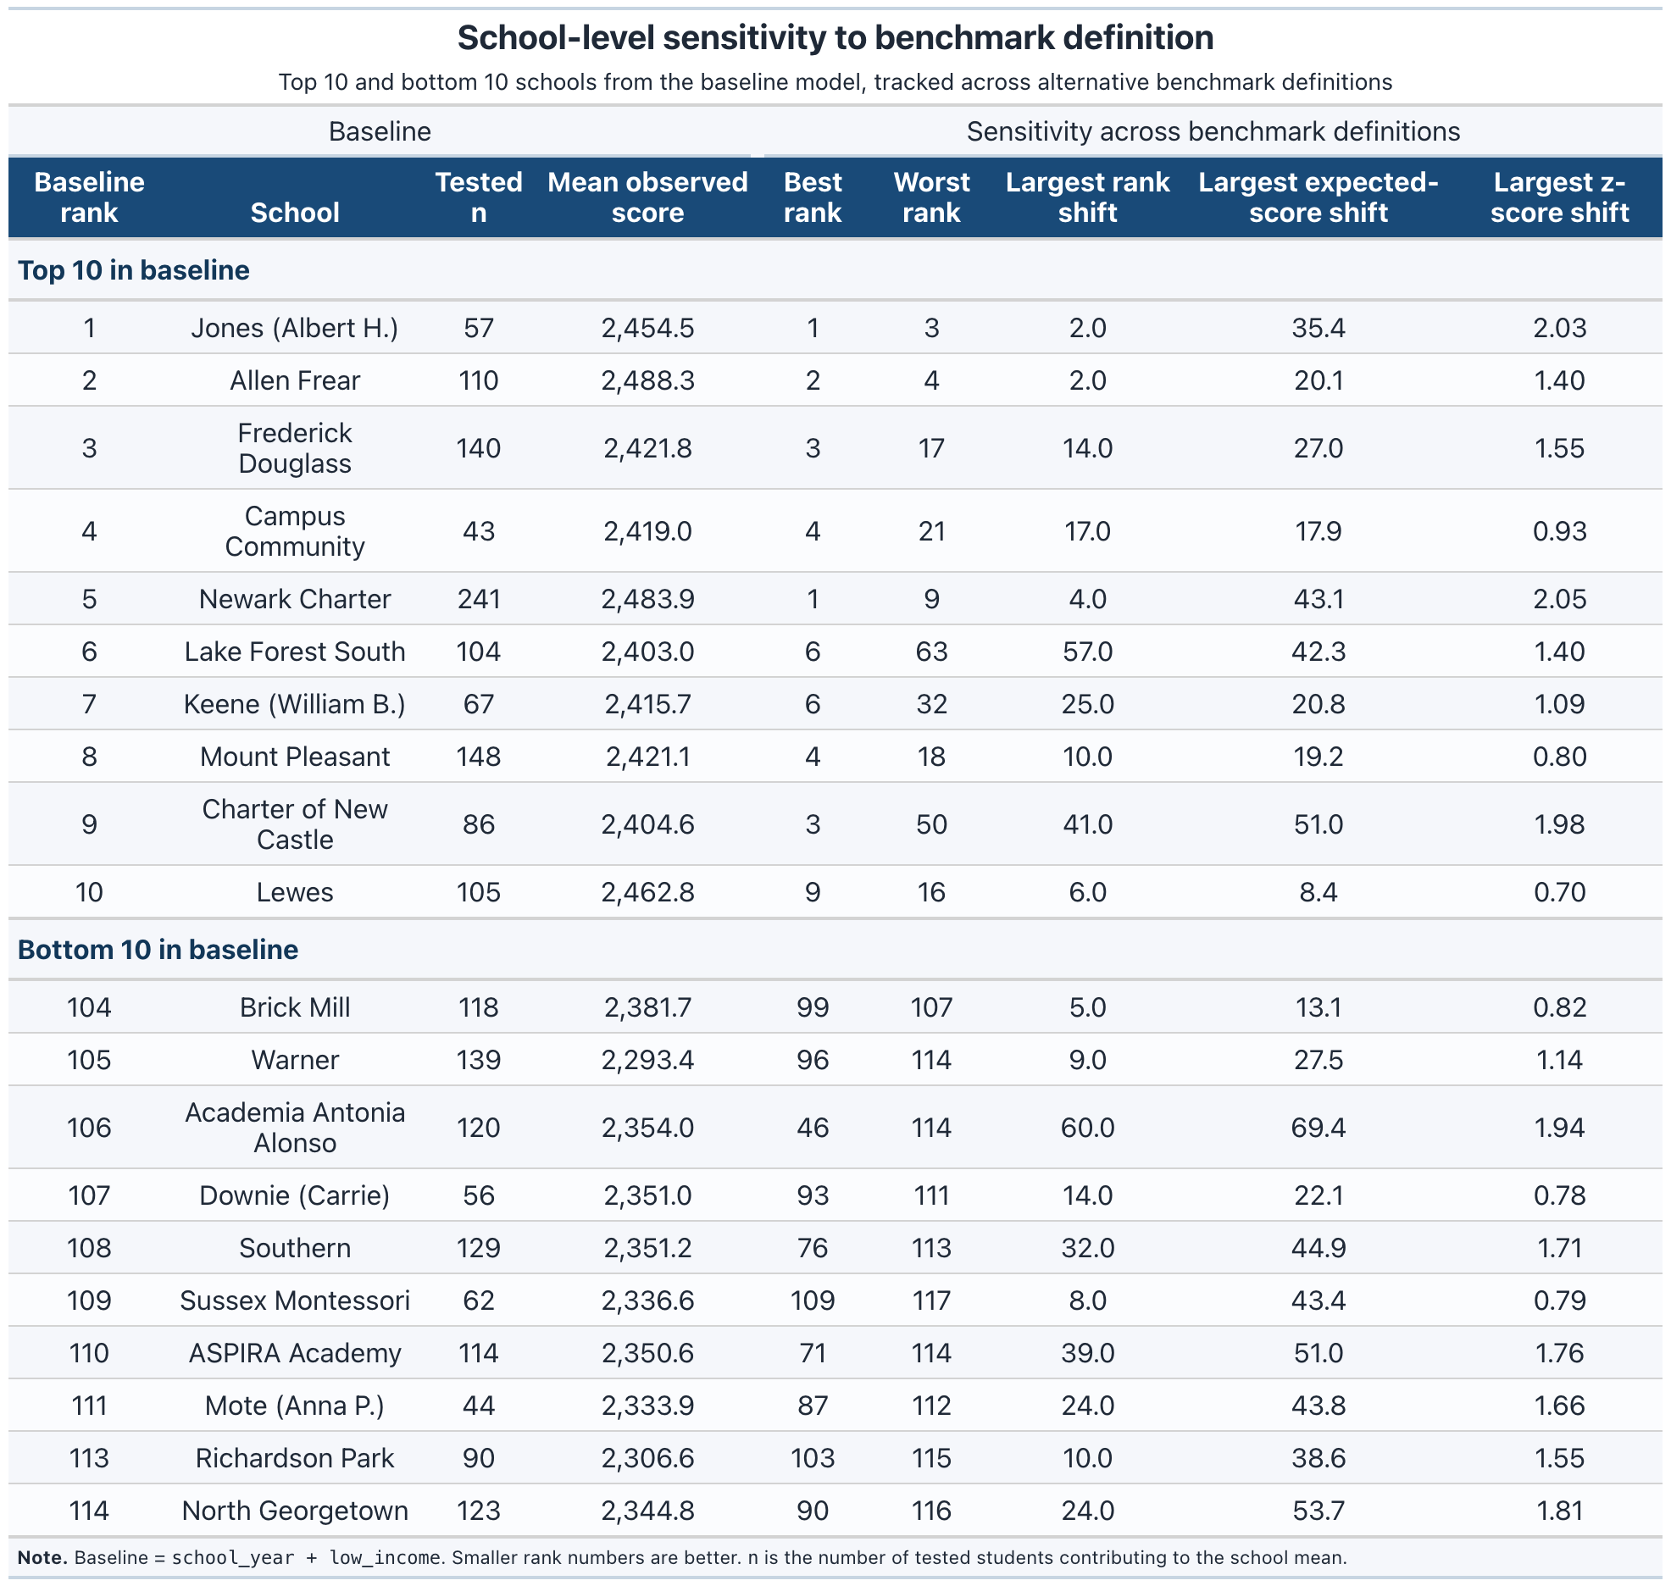
The summary table lists each school’s baseline rank and shows how far that school moves across alternative benchmark definitions, including its best and worst rank, total rank range, and the largest shifts in expected score and performance signal.
Inference: The table suggests that benchmark sensitivity is uneven across schools. Some schools stay in nearly the same position regardless of benchmark definition, while others shift substantially, which means the choice of benchmark can materially affect how results are interpreted.

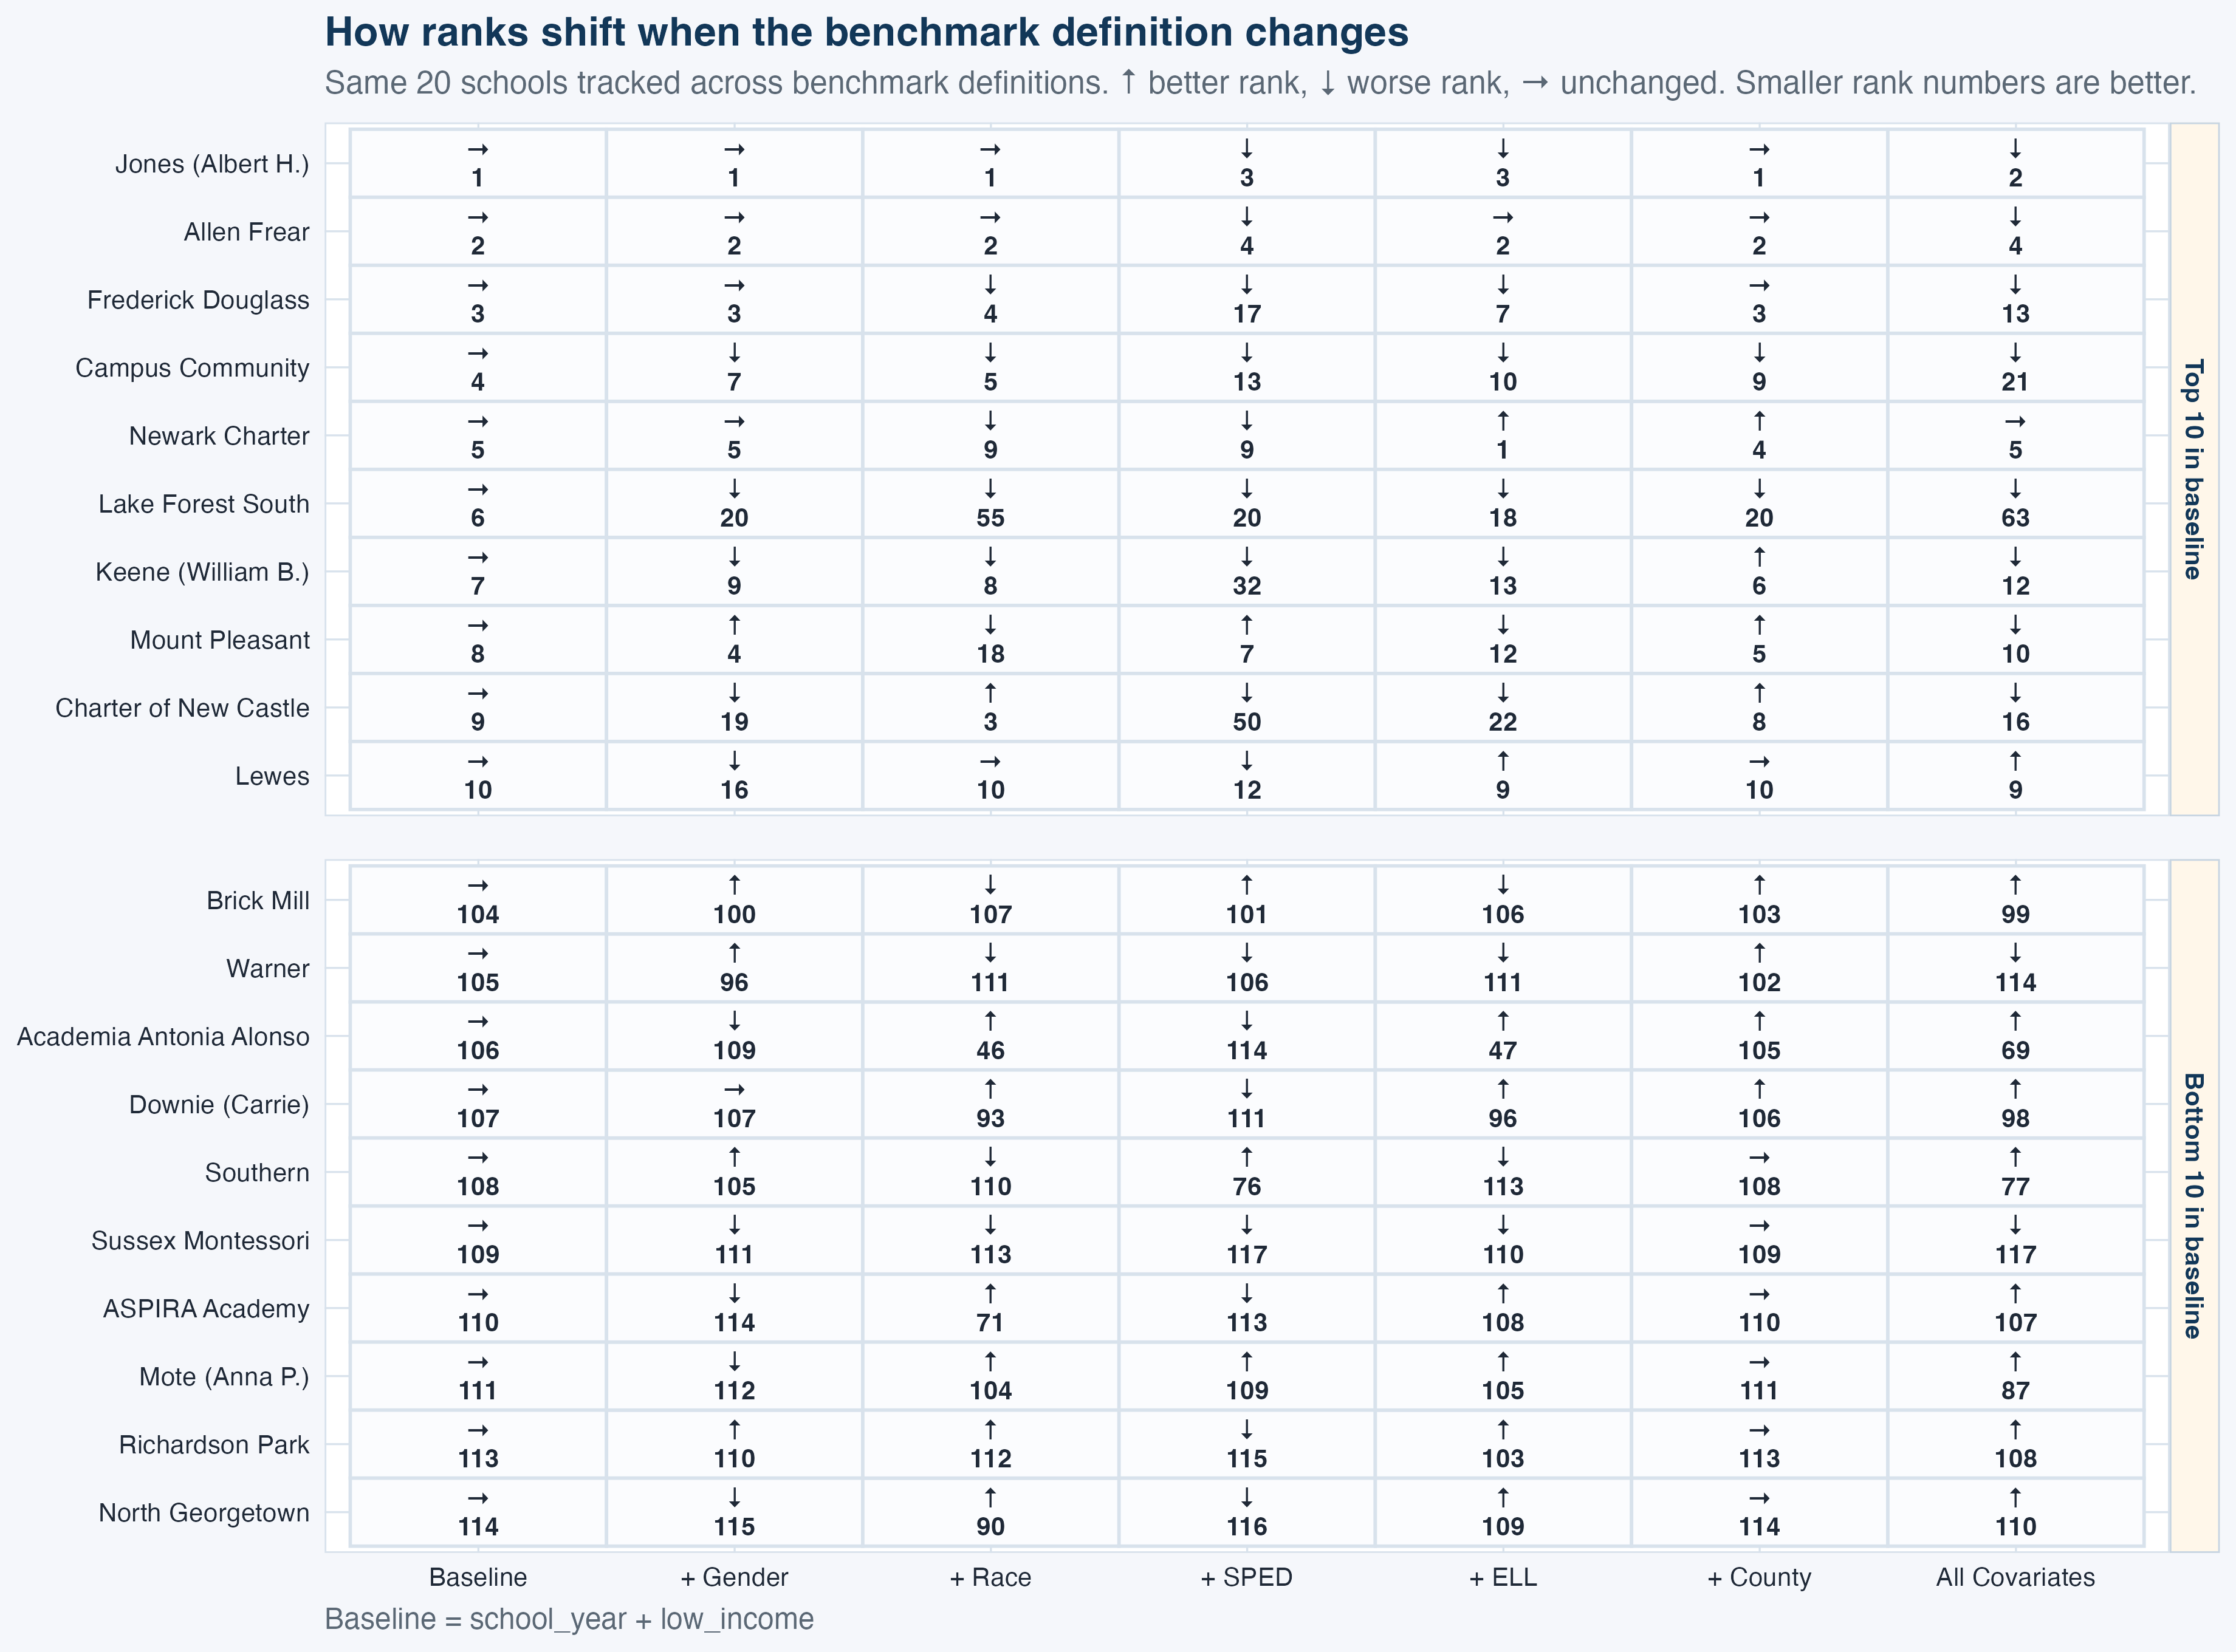
The rank heatmap tracks the same schools across benchmark definitions and makes the direction of movement easy to see. It gives a quick visual answer to a practical question: when the benchmark changes, do schools stay in roughly the same place, or do they move?
Inference: The heatmap shows that rank movement is not uniform across schools or benchmark definitions. Some schools stay in nearly the same position across models, while others move noticeably, suggesting that certain benchmark choices have a larger effect on relative standing than others.
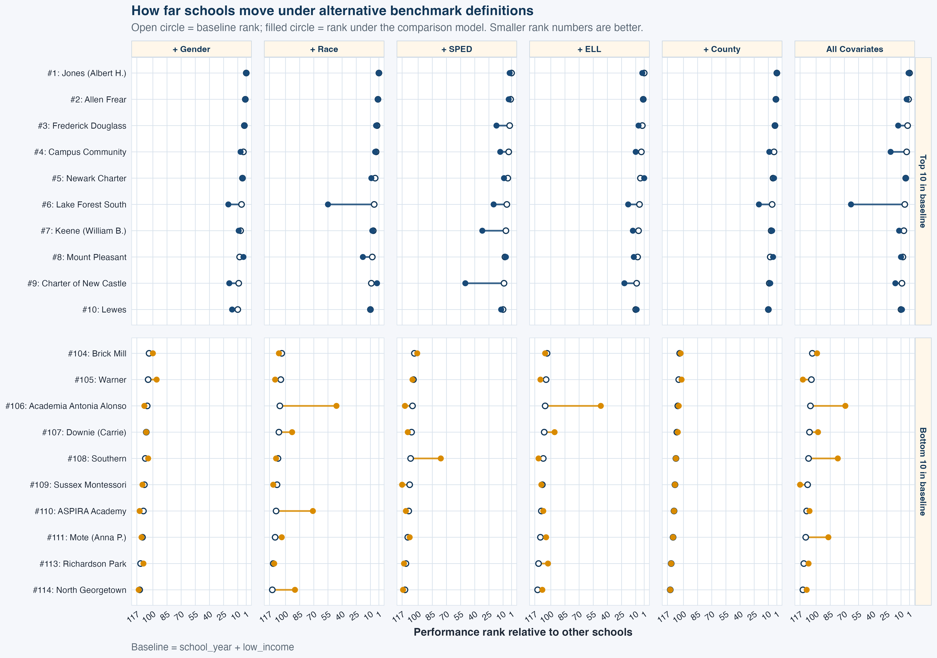
The dumbbell plot gives a clearer view of the size of those rank changes. It places each school’s baseline rank next to its rank under each alternative benchmark definition, making it easier to distinguish minor movement from more substantial shifts.
Inference: The dumbbell plot suggests that benchmark sensitivity varies not just in direction, but in magnitude. Many schools move only slightly across benchmark definitions, but a smaller number experience larger shifts that could meaningfully change how their benchmark-adjusted standing is understood.
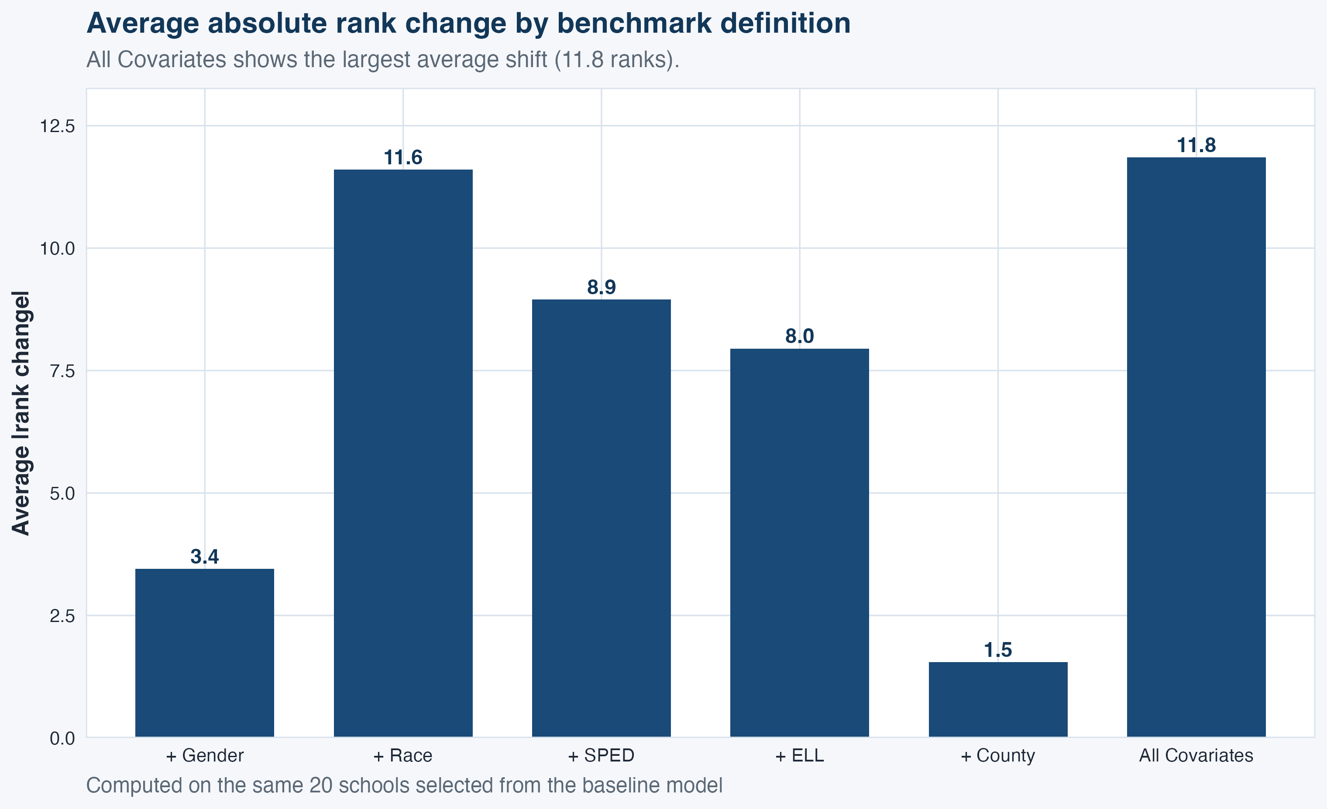
The summary figure condenses the school-level comparisons into a single view by showing the average absolute rank change under each benchmark definition. It provides a quick way to see which benchmark additions are associated with the most overall movement.
Inference: The summary figure suggests that benchmark additions do not contribute equally to rank movement. In this demonstration, county and gender produce relatively small average shifts, while race, SPED, ELL, and especially the full covariate specification produce larger changes in school standing.
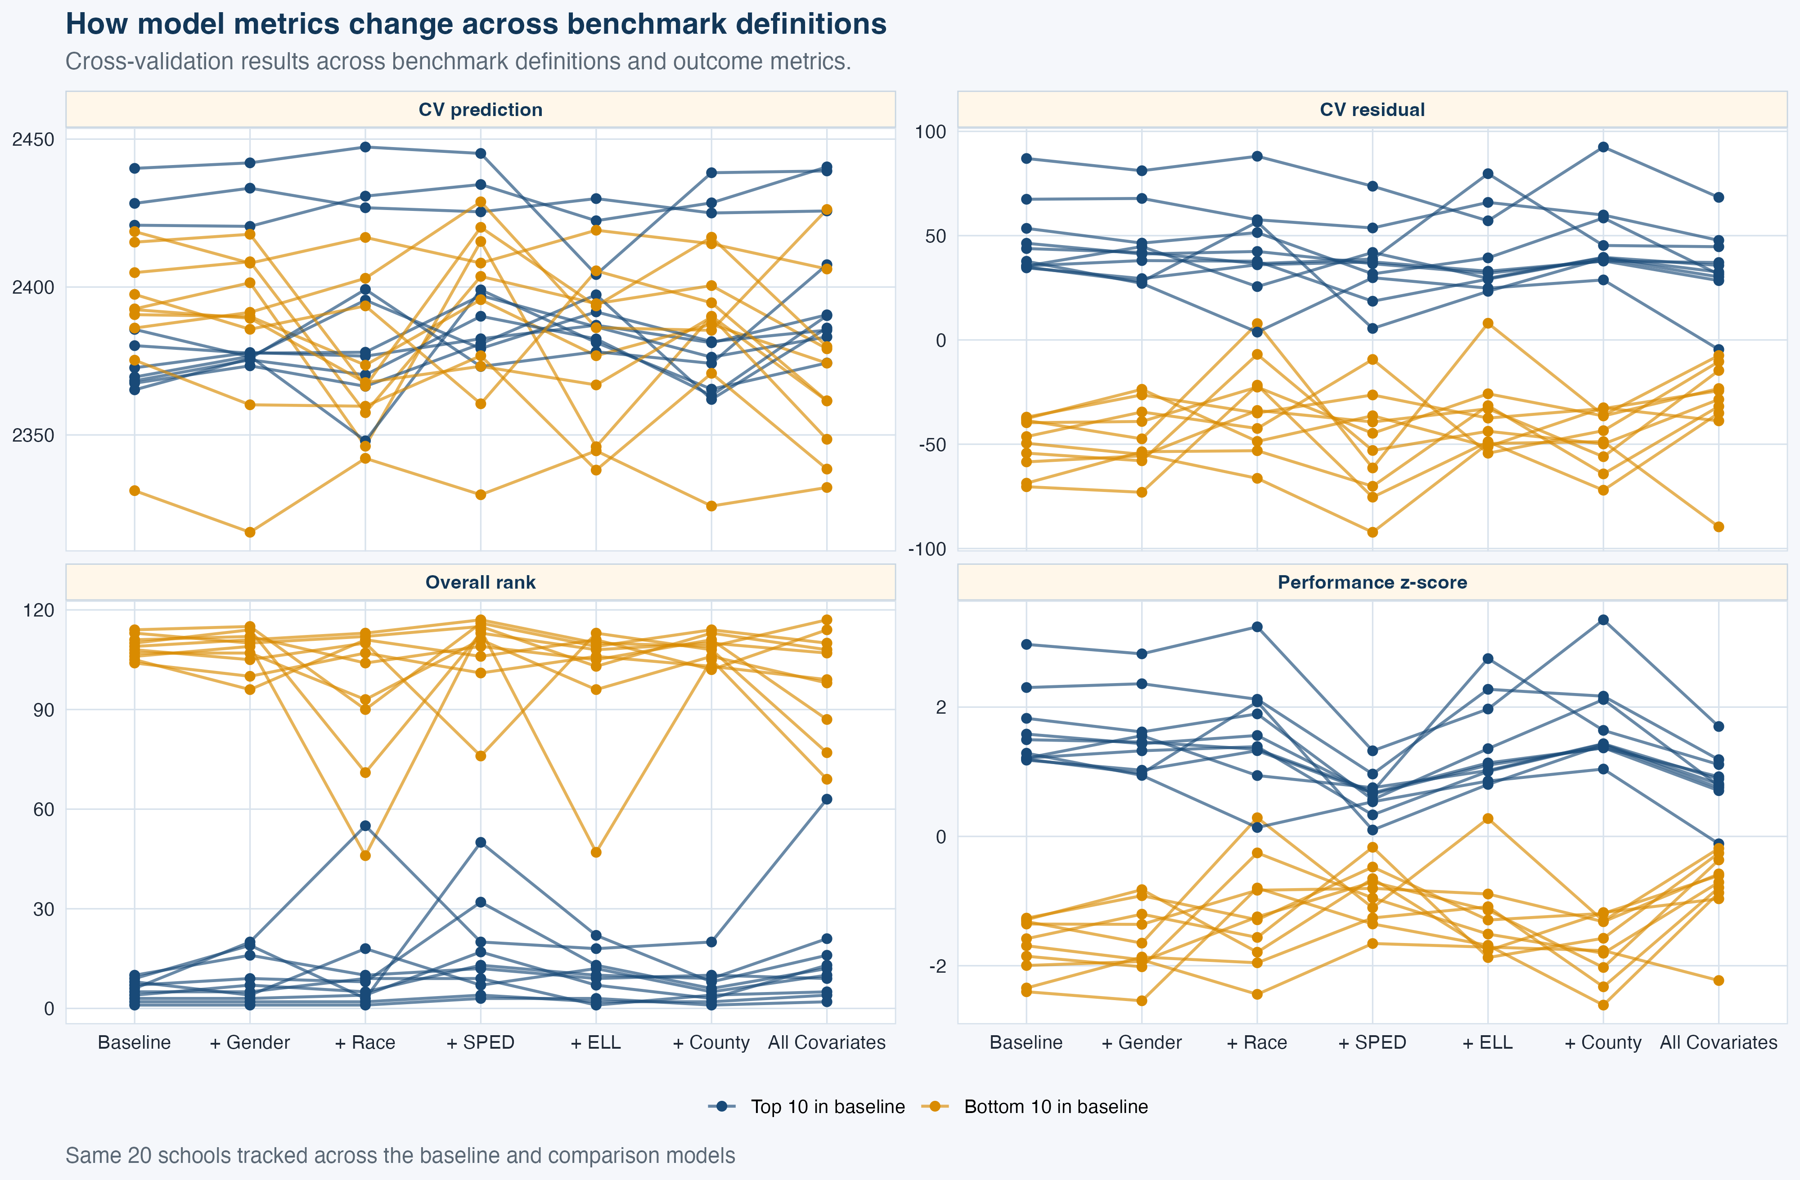
This figure is more technical, but it helps show what is happening underneath the rank comparisons. It tracks the same schools across benchmark definitions and shows how the model’s core outputs change across specifications, including the predicted benchmark score, the residual-based performance signal, the standardized performance z-score, and the resulting overall rank. Its main value is that it ties the visible rank movement back to the mechanics of the model rather than treating rank as a stand-alone result.
Inference: The appendix figure suggests that changes in school rank are being driven by underlying changes in the model outputs themselves. As the benchmark definition changes, the predicted score, residual-based performance signal, and standardized performance measure also shift, which helps explain why some schools move more than others in rank.

Appendix II. Technical Overview

Modeling Overview

The model predicts a school’s average scale score using school year together with a user-selected set of benchmark characteristics. School year is always included so that comparisons stay anchored to when performance was observed. The other benchmark dimensions are selected by the user and combined to define the comparison school.
Benchmark Feature Group | Definition
School year | The year in which performance was observed.
County | The county where the school is located.
English learner status | The share or composition of students identified as English learners.
Foster care status | The share or composition of students identified as being in foster care.
Gender | The gender composition of the tested student group.
Geography | The school’s geographic setting or location type.
Homelessness | The share or composition of students identified as experiencing homelessness.
Immersion participation | The share or composition of students participating in immersion programs.
Economic disadvantage | The share or composition of students identified as low income or economically disadvantaged.
Migrant status | The share or composition of students identified as migrant.
Military-connected status | The share or composition of students connected to military service.
Racial composition | The racial and ethnic composition of the tested student group.
Special education status | The share or composition, by special education code, of students receiving special education services.
Missing-score count | The number of eligible students who do not have a test score available.
Grade-band distribution | The mix of grade levels represented within the school.
School size proxy | A measure intended to capture the approximate size of the school, based on unit count.

Model structure
At its core, the workflow uses a ridge regression model. In this setting, ridge is a practical choice because the benchmark can include many related predictors, including dummy-encoded categories and year-by-feature interaction terms. The script fits the model with glmnet, sets alpha = 0 to specify ridge regression, and selects the tuning parameter through cross-validation (Hoerl & Kennard, 1970a, 1970b; Friedman, Hastie, & Tibshirani, 2010).
The model is specified as a linear function of year indicators, benchmark features, and year-by-feature interactions, with coefficients estimated using ridge regularization:
yi=β0+t∈T​βt Yearit+j∈S​γjXij+t∈T​j∈S​δtjYearit×Xij+εi
where:
- $y_{i}$ is the school’s average score, ScaleScore.mean
- ${Year}_{it}$ represents the school-year indicators
- $X_{ij}$ represents the user-selected benchmark features
- ${Year}_{it}×X_{ij}$ are interaction terms that allow feature effects to differ by year
- $ε_{i}$ is the remaining unexplained difference

Ridge regularization objective
Given this model specification, coefficients are estimated using ridge regression, which minimizes a weighted penalized loss function that balances predictive fit against coefficient shrinkage (Hoerl & Kennard, 1970a, 1970b).
$$\min_{β}\left[\sum_{i=1}^{N}{w_{i}}{\left(y_{i}-{\hat{y}}_{i}\right)}^{2}+λ\sum_{k=1}^{p}{β_{k}^{2}}\right]$$
where:
- $w_{i}=\sqrt{n_{i}}$, where $n_{i}$ is the number of eligible tested students for that school in a given year (school-year)
- $λ$ is the penalty strength chosen by cross-validation
- the $∑β_{k}^{2}$ term is the ridge penalty, which pulls coefficients toward zero but usually does not force them all the way to zero
The first part of the objective function emphasizes fitting the data well through weighted least squares, while the second part discourages coefficients from becoming overly large, which helps keep the model more stable. This balance is one reason ridge is a sensible choice for this problem, because it allows the model to capture meaningful patterns in the benchmark data while reducing the risk that estimates become overly sensitive to noise, small sample differences, or correlation among predictors.

Why the benchmark features are user-selected
The benchmark school is meant to be flexible rather than fixed. Users can decide which characteristics should define the comparison school. This makes the benchmark more transparent: users are not comparing a school to a hidden model, but to an explicitly defined synthetic profile based on the features they chose.
This also means the benchmark can support different questions in different contexts. A more minimal benchmark might condition only on year. A richer benchmark might condition on year, missing test counts, poverty, county, and race. Both can be reasonable, but they answer slightly different versions of the same underlying question: what would we expect for a school like this?

Why school year is always included
A central design choice is that school year is always part of the model. This keeps the benchmark explicitly year-specific. That matters because average test performance can shift over time for reasons that are broader than any one school, including policy changes, assessment conditions, or wider educational disruptions. Keeping year mandatory helps avoid comparisons that treat all years as though they were interchangeable. This is also consistent with the broader modeling principle that temporal structure should be represented directly when it is substantively important (James, Witten, Hastie, & Tibshirani, 2021).

Why the model includes year interactions
The script does not assume that a feature has the same relationship with scores every year. Instead, it allows selected features to interact with each school year. In practical terms, that means the association between a feature like low income or race and the expected score can change across years making the benchmark more responsive to historical context (James et al., 2021). Without those interactions, the model would assume a single fixed effect over time, which is often too rigid for education data.

Why the square root of n is used as the weight
Rather than weighting each school-year equally, the script uses observation weights to reflect differing precision across aggregated outcomes (Carroll & Ruppert, 1988). However, it does not weight fully by raw n. Instead, it uses the square root of n, so school-years with more tested students have somewhat more influence without dominating the model in direct proportion to their size. Square-root sample-size weights are a practical compromise between treating all school-years identically and allowing the largest schools to drive the benchmark. From a representation standpoint, this approach gives somewhat more weight to more stable averages while still keeping smaller schools meaningfully represented.

How the model is validated
The model uses cross-validation grouped by school. Instead of splitting rows completely at random, it assigns whole schools to folds. This reduces leakage: the model is less likely to appear artificially strong simply because it saw the same school during training. That makes the cross-validated predictions a more credible basis for judging whether a school-year performed above or below expectation. This choice is consistent with recommendations for cross-validation under hierarchical or grouped dependence structures (Roberts et al., 2017).

How predictions are used
For an observed school-year already in the training (historical) data, the script uses the out-of-fold cross-validated prediction. This is the more careful benchmark for evaluation because it is based on predictions made when that school was held out from training. Once the model has generated an expected score, it calculates the residual:
Residualᵢ = Observedᵢ − Predictedᵢ
A positive residual means the school scored above its benchmark, while a negative residual means it scored below.

References
- Friedman, J., Hastie, T., & Tibshirani, R. (2010). Regularization paths for generalized linear models via coordinate descent. Journal of Statistical Software, 33(1), 1-22. https://doi.org/10.18637/jss.v033.i01
- Hoerl, A. E., & Kennard, R. W. (1970a). Ridge regression: Biased estimation for nonorthogonal problems. Technometrics, 12(1), 55-67.
- Hoerl, A. E., & Kennard, R. W. (1970b). Ridge regression: Applications to nonorthogonal problems. Technometrics, 12(1), 69-82.
- James, G., Witten, D., Hastie, T., & Tibshirani, R. (2021). An introduction to statistical learning: With applications in R (2nd ed.). Springer.
- R Core Team. (2025). R: A language and environment for statistical computing. R Foundation for Statistical Computing. https://www.R-project.org/
- Roberts, D. R., Bahn, V., Ciuti, S., Boyce, M. S., Elith, J., Guillera-Arroita, G., Hauenstein, S., Lahoz-Monfort, J. J., Schroder, B., Thuiller, W., Warton, D. I., Wintle, B. A., Hartig, F., & Dormann, C. F. (2017). Cross-validation strategies for data with temporal, spatial, hierarchical, or phylogenetic structure. Ecography, 40(8), 913-929. https://doi.org/10.1111/ecog.02881
- Carroll, R. J., & Ruppert, D. (1988). Transformation and weighting in regression. Chapman and Hall.
- Shmueli, G. (2010). To explain or to predict? Statistical Science, 25(3), 289-310. https://doi.org/10.1214/10-STS330

