Delaware School Funding Model
Independent Verification and Validation Technical Analysis Summary
School Year 2025–26
━━━━━━━━━━━━━━━━━━━━━━━━━━━━━━━━━━
August 13, 2026

Analytical status
The staffing analysis remains partly provisional, and confirmed current-model analogues for Opportunity and Operational Funding are not yet available. This report presents the IV&V findings to date and should not be read as a final determination of net fiscal impact.
The analysis outputs, scripts, and supporting technical documentation are maintained in the School Funding Models GitHub repository. Together, these materials provide the reproducible technical record underlying the findings presented in this report.

How to read the report
The report is organized around the guiding questions of the IV&V process:
- Which current funding rules are confirmed, provisional, or unresolved?
- What changes under the proposed staffing rules?
- How do the proposed weighted funding streams operate?
- How the independent implementation compares with the PEFC workbook?
- What still requires confirmation?
Rounding
Dollar amounts in the narrative are generally rounded to the nearest $0.1 million. Position quantities are rounded for display where doing so improves readability. Pipeline calculations and technical reconciliation files retain full precision.

Table of Contents
Executive Summary 5
Staffing funding increases but core teaching is essentially unchanged 5
The proposal separately distributes $442.0 million through weighted funding 6
The IV&V independently reproduces the PEFC proposed model 7
What is still needed before a final fiscal impact can be estimated? 7
1. Current Funding Rules, Proposed Treatments, and Evidence Status 9
1.1 How to interpret the rule inventory 9
1.2 Division I teaching units 9
1.3 School-level staffing positions 10
1.4 LEA and Central Office positions 10
1.5 Opportunity and Operational Funding: proposed rules and missing current analogues 11
1.6 Evidence-status summary 12
1.7 What remains unknown 13
2. What the IV&V Examined and Why 14
2.1 Scope and interpretation 14
2.2 Official school codes and funding calculation units 15
3. What Changes Under the Staffing Rules? 16
3.1 Two views of the statewide staffing comparison 16
3.2 Core teaching quantities are nearly unchanged 17
3.3 The largest differences occur outside core teaching 18
3.4 Principals illustrate why calculation units matter 20
3.5 District and charter patterns 20
4. How Do Opportunity and Operational Funding Work? 22
4.1 Opportunity Funding 22
4.2 Operational Funding 22
4.3 Fixed pools and recalculated rates 22
4.4 Proposed allocation and current comparison status 23
4.5 LEA-level composition of proposed weighted funding 23
4.6 Current model Opportunity and Operational Funding analogues 26
5. How Does the IV&V Proposed Model Compare with the PEFC Workbook? 27
5.1 Principal positions show the effect of calculation-unit implementation 27
5.2 Staffing-rule interpretations produce practical differences 28
5.3 DAFB creates a scope difference 29
5.4 Overall assessment 29
6. What Remains to Be Confirmed? 30
7. How Was the Analysis Built and Validated? 31
7.1 Technical documentation and audit trail 31
7.2 HFM Calculator: Interactive Implementation of the Technical Reference 31
7.3 Conclusion 32
Technical Appendices 34
Appendix A. Selected staffing rules 34
Appendix B. Report exhibit traceability 35
Appendix C. Interpretation guardrails 35

Executive Summary
What the analysis found
The proposed Hybrid Funding Model changes how Delaware calculates and distributes school funding, including the staffing positions generated through the formula and two proposed weighted funding streams for student and operational needs.
The IV&V examined the proposal in three ways: it recreated the current staffing model for comparison, independently implemented the proposed model, and compared that independent implementation with the PEFC workbook used to present the proposal.
The analysis covers 43 LEAs for SY 2025–26: 19 districts and 24 charter schools. BASSE is included; Delaware Air Force Base is excluded.
Key takeaway: The proposed model produces approximately $47.1 million more in comparable staffing funding and that increase is not being driven by core classroom teaching positions. Core teaching is essentially unchanged statewide, while other comparable administrative and support staffing increases by approximately 421 modeled positions. The IV&V also independently reproduces the overall PEFC proposed model within 0.18%.
Four numbers to know
+$47.1M  Comparable staffing funding  $1.564B current vs. $1.611B proposed  3.0% more modeled staffing funding | +0.26 positions  Core Division I teaching positions  11,754.38 current vs. 11,754.64 proposed  Regular education, special education, and net vocational teaching positions are essentially unchanged statewide | +421 positions  School administration, support & Central Office positions  Approximately +421 positions on net  Net modeled increase across comparable staffing categories outside core Division I teaching | 0.18%  PEFC vs. IV&V  $2.054B PEFC vs. $2.058B IV&V on the same 43-LEA scope  Shows the independent IV&V closely reproduces the proposed PEFC model
Note: The +421 figure is a net modeled change across comparable staffing categories outside core Division I teaching. Some current and proposed support categories are functional mappings rather than identical positions, and the current Food Services Supervisor quantity remains provisional.
Together, the first three numbers tell the staffing story. Comparable staffing funding increases by $47.1 million, while core teaching changes by only 0.26 positions statewide. The additional modeled staffing is instead concentrated in school administration, support functions, and Central Office positions, which increase by approximately 421 positions on net across the other comparable categories. The 0.18% answers a separate validation question: it shows how closely the IV&V independently reproduces PEFC’s proposed model.

Staffing funding increases but core teaching is essentially unchanged
For staffing categories that can be compared under both models, modeled funding increases from approximately $1.564 billion under the recreated current model to $1.611 billion under the proposed model, an increase of $47.1 million, or 3.0%. This is the best available statewide comparison because it includes only categories with funding amounts available on both sides; Buildings and Grounds Supervisor is excluded because the current quantity cannot yet be estimated. Food Services Supervisor remains provisional because current LEA-level quantities are incomplete.
The increase is not being driven by the basic classroom teaching formulas. Across K–3 regular education, grades 4–12 regular education, Basic, Intensive, and Complex special education, and net vocational Division I positions, the recreated current model generates 11,754.38 positions and the proposed model generates 11,754.64 positions. The statewide difference is just +0.26 positions.
Instead, the net increase occurs almost entirely in other school administration, support, and Central Office staffing. Across those other comparable categories, the proposed model generates approximately 421 additional modeled positions on net.
Largest modeled staffing drivers
Category | Position difference | Funding difference
Assistant Principals | +132.85 | +$17.8M
Administrative Support Professionals | +239.00 | +$17.7M
Instructional Supports | −114.88 | −$11.0M
Principals | +30.00 | +$4.6M
Superintendents | +24.00 | +$4.5M
The three largest differences alone illustrate the pattern. Assistant Principals and Administrative Support Professionals increase substantially, while the proposed consolidated Instructional Supports formula offsets part of those increases.
These changes result primarily from differences in how schools and LEAs generate administrative and support positions, rather than from changes in teacher-to-student ratios. The proposed model:
- uses additional charter building calculation units for school-based formulas;
- removes the current 15-Division-I-unit minimum for Principals;
- extends eligibility for some LEA-level positions to charter schools; and
- uses a broader staffing base for selected Central Office formulas.
For example, Principal positions increase from 223 to 253. Twenty-four of the additional positions result from using 48 charter building calculation units rather than 24 charter organization codes, while six result from removing the current 15-unit minimum.
The overall staffing result is therefore a structural shift in where formula-generated positions occur, even though statewide core teaching quantities remain essentially unchanged.

The proposal separately distributes $442.0 million through weighted funding
In addition to staffing-based funding, the proposed model creates two weighted funding streams that are not tied to staffing positions:
- Opportunity Funding: $163.0 million distributed based on low-income and active multilingual learner enrollment.
- Operational Funding: $279.0268 million distributed based on total enrollment, low-income and multilingual learner enrollment, special education, and vocational enrollment.
Together, these formulas distribute approximately $442.0 million across the 43-LEA scope. Districts receive approximately $392.0 million, or 88.7%, while charters receive approximately $50.1 million, or 11.3%.
Important: The $442.0 million should not be read as $442.0 million in new state spending. Existing Delaware funding already supports many of the needs represented by the proposed Opportunity and Operational formulas. However, an authoritative mapping of existing funding streams into these two proposed categories has not yet been established. Until that crosswalk is established, the IV&V can show how the proposed $442.0 million would be distributed but cannot determine how much more or less Delaware would spend compared with the current system

The IV&V independently reproduces the PEFC proposed model
The IV&V also addressed a separate question: Can the proposed model be independently rebuilt and produce results consistent with the PEFC workbook?
When the two implementations are placed on the same 43-LEA scope:
PEFC proposed model | IV&V proposed model | Difference
$2.054B | $2.058B | +$3.72M / +0.18%
A difference of 0.18% indicates that the IV&V independently reproduces the overall proposed funding structure very closely.
The remaining differences are traceable to specific implementation choices, including Principal treatment for five district calculation units, fractional Assistant Principal awards, Assistant Superintendent thresholds, Instructional Supports calculations for some multi-building charters, and the treatment of Delaware Air Force Base.
These differences are important for final implementation, but they do not materially change the broader conclusion that the proposed model can be independently reproduced.

What is still needed before a final fiscal impact can be estimated?
Several outstanding items prevent the IV&V from presenting a complete current-versus-proposed fiscal estimate:
Outstanding item | Why it matters
Opportunity & Operational Funding crosswalk | Needed to determine how the proposed $442.0M compares with existing funding
Buildings & Grounds Supervisor data | Current custodial-unit counts are needed to calculate current eligibility
Food Services Supervisor allocations | Current LEA-level awards remain incomplete
Vocational enrollment | The Operational Funding input is retained from PEFC but has not been independently validated
The IV&V currently recreates nine Food Services Supervisor positions across the 19 eligible districts. Because the remaining LEA-level awards have not yet been confirmed, the primary analysis retains these nine independently recreated positions as an incomplete minimum estimate.
Overall assessment
The IV&V establishes a reproducible technical foundation for evaluating Delaware’s proposed Hybrid Funding Model. The independently implemented proposed model is within 0.18% of the aligned PEFC implementation.
The analysis also provides a clear picture of where the proposed staffing model changes. Comparable staffing funding increases by approximately $47.1 million, but statewide core teaching positions remain essentially unchanged. The modeled increase is instead concentrated in administrative and support staffing generated through changes in calculation units, eligibility rules, staffing bases, and position formulas.
The proposed Opportunity and Operational Funding formulas can also be independently reproduced, and their $442.0 million in proposed allocations can be examined by LEA and funding component. However, their relationship to existing funding must still be established before those allocations can be translated into a net fiscal change.
Accordingly, the analysis is ready to support technical and policy discussion, but it should not yet be interpreted as a final estimate of increased state spending or confirmed LEA gains and losses.

1. Current Funding Rules, Proposed Treatments, and Evidence Status

1.1 How to interpret the rule inventory
Delaware's school funding framework is not represented by a single, fully documented source. The available record includes statutory provisions, annual appropriations, operational practices, PEFC recommendations, IV&V implementation interpretations, and formulas or precomputed values contained in the FY2025-26 reference workbook.
This report therefore distinguishes among three analytical contexts:
- Recreated Current Staffing Rules: the documented current rules, reported quantities, maintained comparison mappings, and available supplemental inputs used to recreate current staffing quantities and available modeled funding amounts. This serves as a comparison baseline rather than a complete estimate of Delaware's current funding system.
- IV&V Proposed Model: the proposed Base, Central Office, Opportunity, and Operational Funding rules independently implemented by the IV&V using common inputs and explicit interpretation rules where needed.
- PEFC Workbook as Presented: the supplied workbook treated as a separate reference implementation of the proposed model, including its inputs, calculation units, formulas or precomputed values, and scope treatment.
Evidence status is reported separately from analytical context. A rule may be supported by current statute, documented as a PEFC recommendation requiring governing action, reproduced from the workbook, or remain unresolved where available sources conflict or are incomplete. Reproducing a proposed or workbook treatment does not imply that it has been enacted, funded, approved, or independently established as current policy.
In the staffing comparison, Confirmed has a narrower analytical meaning: the comparison mapping, quantity, and common rate are established for the IV&V analysis. It does not mean that every underlying policy or implementation question has been resolved.
These distinctions are maintained in the Delaware School Funding Formula Technical Reference and operationalized in the companion HFM Calculator described in Section 7.2.

1.2 Division I teaching units
The most clearly established portion of the funding model is the calculation of Division I teaching units. The Technical Reference identifies five continuous student-to-position ratios that apply to districts and charter schools.
Student category | Established ratio
K–3 regular education | 1 position per 16.2 students
Grades 4–12 regular education | 1 position per 20 students
Basic special education, Pre-K–12 | 1 position per 8.4 students
Intensive special education, Pre-K–12 | 1 position per 6 students
Complex special education, Pre-K–12 | 1 position per 2.6 students
These ratios are supported by the supplied text of 14 Del. C. §1703(a) and reconcile to the corresponding reference-workbook values. Basic special education includes eligible preschool and K–12 students because both populations use the same 8.4 divisor. The current statutory baseline does not contain a separate general-education Pre-K unit.
For the IV&V comparison, the recreated current model carries forward the Division I teaching quantities reported in the SY 2025–26 Unit Count data, while the proposed model independently recalculates the corresponding quantities from student counts using the ratios above. The resulting statewide teaching quantities are nearly identical, as shown later in Section 3.2.
The statutory framework for occupational-vocational units and the associated regular-unit deduction is documented, but the implementation chain from school-level CTE participation and pupil-minute data to the reported values has not been independently reconstructed. The reported vocational positions and deductions are therefore retained unchanged in both models and combined as net vocational Division I positions for the comparison.
Source: Delaware School Funding Formula Technical Reference.xlsx, Rule Register BR2-001–BR2-006.

1.3 School-level staffing positions
School-level staffing must be interpreted separately across the recreated current, IV&V proposed, and PEFC workbook contexts.
Under the recreated current model, a Principal is generated for an official coded school when reported Division I units reach 15. The IV&V proposed model removes that threshold and provides one Principal for each included school calculation unit. The PEFC workbook stores Principal quantities as precomputed values rather than exposing the generating formula, and five district calculation units receive zero positions despite the literal one-per-unit interpretation. The calculation-unit universe and treatment of those units therefore remain important to the workbook comparison.
The current Assistant Principal schedule provides 0.65 of a position at 25 units, one position at 30 units, 1.65 positions at 50 units, two positions at 55 units, and one additional position for every completed 20 units thereafter. The recreated current model applies those thresholds to reported Division I units. The IV&V proposed model applies the same schedule to a broader school-level base consisting of Base Division I positions, Administrative Support Professionals, and Instructional Supports, while retaining the documented fractional awards. The PEFC workbook uses the same schedule but rounds the final result down, creating a difference in the treatment of the 0.65 and 1.65 awards.
The current Secretary comparison provides one position per 10 Division I units through 100 and one additional position per completed 12 units thereafter. The IV&V proposed model applies the same tiered schedule to a broader base consisting of Base Division I positions, Principals, and Instructional Supports to calculate Administrative Support Professionals. The Secretary-to-Administrative Support Professionals mapping is confirmed for this functional comparison, but the categories are not treated as identical positions. The PEFC workbook stores Administrative Support Professional quantities as precomputed values, so its original generating logic cannot be independently inspected.
Instructional Supports are calculated in the IV&V proposed model as 20% of Base Division I positions. The recreated current comparison instead combines several separately funded support functions through a maintained functional crosswalk. The mapping supports a common-rate comparison but should not be interpreted as a one-to-one match of positions or services. The PEFC workbook also uses a 20% factor, although its building-level calculation base differs for some multi-building charters, as discussed in Section 5.2.
Source: Delaware School Funding Formula Technical Reference.xlsx, Rule Register BR2-007–BR2-010.

1.4 LEA and Central Office positions
LEA and Central Office positions differ materially across the recreated current, IV&V proposed, and PEFC workbook contexts.
The recreated current model provides one Superintendent per district and excludes charter schools. The IV&V proposed model provides one Superintendent for every included district or charter LEA, producing 43 positions. Administrative Assistants are modeled as one per included LEA under both the recreated current and IV&V proposed models. These treatments are confirmed for the staffing comparison, although underlying authority or implementation questions documented in the Technical Reference remain separate from that analytical status.
The current Buildings and Grounds Supervisor rule provides one position when a district reaches 95 custodial units. The proposed model instead provides one position per included LEA. Because the custodial-unit data needed to apply the current threshold are unavailable, a comparable current statewide amount cannot yet be estimated and Buildings and Grounds Supervisor remains outside the comparable-amount staffing subtotal.
The current Food Services Supervisor rule provides one position for a district with at least 500 Division I units or, below that threshold, at least four lunch-program buildings. The IV&V independently recreates nine current positions from the 500-unit threshold. School Finance indicated that all 19 districts currently receive at least one unit, but the additional LEA-level awards and supporting lunch-program building counts have not yet been confirmed. The proposed model provides one position per LEA plus one additional position for each completed 500 Base Division I positions beyond the first 500, producing 46 positions. The current-versus-proposed comparison therefore remains provisional.
Assistant Superintendents, Directors, and 11-Month Supervisors illustrate the importance of the staffing base used in Central Office formulas. The recreated current model applies these rules to reported Division I units, while the IV&V proposed model applies them to the broader Total Base position count. Assistant Superintendents are awarded for each completed 300 positions, capped at two; Directors use the applicable 200-position and additional 100-position thresholds; and 11-Month Supervisors are calculated by dividing the staffing base by 150. The broader proposed base increases modeled quantities in all three categories. The PEFC workbook differs from the IV&V interpretation for Assistant Superintendents by allowing a proportional second position between the 300- and 600-position thresholds.
Transportation Supervisors are calculated from enrollment divided by 7,500 under both the recreated current and IV&V proposed models, with fractional positions retained for the staffing comparison. Reading Cadre increases from one position per district under the recreated current model to one position per included LEA under the proposed model, expanding the modeled allocation from 19 to 43 positions. The Technical Reference separately identifies unresolved authority or appropriation questions for these treatments; those issues do not change their confirmed status within the staffing comparison.
Source: Delaware School Funding Formula Technical Reference.xlsx, Rule Register BR2-011–BR2-018 and BR-CO-009.

1.5 Opportunity and Operational Funding: proposed rules and missing current analogues
Opportunity and Operational Funding are components of PEFC's proposed Hybrid Funding Model. They are presented separately because an authoritative mapping of existing current funding streams to these proposed categories has not yet been established.
- Opportunity Funding distributes a fixed $163.0 million statewide pool using low-income enrollment weighted at 0.675 and active multilingual learner enrollment weighted at 0.470.
- Operational Funding distributes a fixed $279.0268 million statewide pool using total enrollment weighted at 0.200; low-income enrollment at 0.675; active multilingual learner enrollment at 0.470; Basic special education at 0.480; Intensive special education at 0.670; Complex special education at 1.540; and vocational enrollment at 0.200.
The IV&V independently reproduces these formulas, weights, and fixed statewide pools as proposed-model calculations. The resulting Opportunity and Operational allocations can therefore be analyzed by LEA, sector, and formula component. Their treatment as fixed pools means that the per-weighted-unit rates are recalculated when the eligible weighted counts or reporting scope changes.
These proposed calculations should not be interpreted as current law, enacted funding authority, or entirely new spending. DOE, OMB, and CGO are still determining how existing funding streams should map into the proposed structure, and an authoritative current analogue or LEA-level crosswalk has not yet been established for the IV&V. A net current-versus-proposed fiscal difference for Opportunity and Operational Funding is therefore not yet estimable.
Source: Delaware School Funding Formula Technical Reference.xlsx, Rule Register BR2-PEFC-001–BR2-PEFC-003.

1.6 Evidence-status summary
The table below separates recreated current, IV&V proposed, and PEFC workbook treatments. Status language distinguishes what is established for the IV&V staffing comparison from remaining workbook, policy, or implementation questions. A category may therefore be confirmed for analytical comparison even when an underlying policy interpretation or workbook treatment remains open.
Rule area | Recreated current | IV&V proposed / PEFC workbook | Principal limitation or status
Core Division I | Reported Unit Count teaching quantities | IV&V recalculates the same five teaching categories using established ratios | Confirmed for comparison; statewide quantities are nearly identical
Vocational units | Reported vocational positions and deduction retained | Same reported net vocational quantity retained | Confirmed for comparison; underlying generating chain remains open
Principal | One at 15 qualifying Division I units | IV&V: one per included calculation unit; PEFC: precomputed quantities | Confirmed for comparison; PEFC differs for five district calculation units
Assistant Principal | Current fractional threshold schedule applied to Division I units | IV&V applies same schedule to proposed school-level base; PEFC rounds fractional awards down | Confirmed for comparison; PEFC fractional treatment differs
Administrative support | Current Secretary tier schedule | IV&V applies same tiered structure to the proposed ASP base; PEFC quantities are precomputed | Functional mapping and common rate confirmed; PEFC generating logic remains open
Instructional Supports | Current support functions combined through a maintained crosswalk | IV&V: 20% of Base Division I; PEFC also uses 20% with some base differences | Confirmed functional comparison; not a one-to-one position match
Superintendent | One per district; charters ineligible | One per included district or charter LEA | Confirmed for staffing comparison; expands modeled charter eligibility
Administrative Assistant | One per included LEA in the working comparison | One per included LEA | Confirmed for staffing comparison; quantity unchanged
Assistant Superintendent / Director / 11-Month Supervisor | Current Division I base | IV&V uses Total Base positions; PEFC uses a broader workbook base and differs for Assistant Superintendent fractional treatment | Confirmed for current-versus-proposed comparison; PEFC interpretation differences remain
Buildings and Grounds Supervisor | One at 95 custodial units | One per included LEA | Current quantity not yet estimable because custodial-unit inputs are unavailable
Food Services Supervisor | Nine positions independently recreated from the 500-unit threshold; School Finance indicates all 19 districts receive at least one unit | One per LEA plus additional positions at completed 500 Base Division I thresholds | Provisional; current LEA-level awards are incomplete
Transportation Supervisor | Enrollment divided by 7,500; fractions retained | Same treatment | Confirmed for staffing comparison; underlying eligibility/fractional interpretation remains documented separately
Reading Cadre | One per district; charters ineligible | One per included LEA | Confirmed for staffing comparison; appropriation treatment remains to be reconciled
Opportunity and Operational Funding | Authoritative current analogues have not yet been established | Proposed fixed weighted pools are independently reproduced | Proposed allocations are estimable; net current-versus-proposed fiscal change is not yet estimable
Source: Delaware School Funding Formula Technical Reference.xlsx; IV&V pipeline outputs and maintained comparison crosswalks.

1.7 What remains unknown
The current rule inventory supports a reproducible comparison baseline, but several material uncertainties remain:
- Vocational Division I: The reported vocational positions and associated deduction are retained consistently in both staffing models, but the underlying calculation chain from school-level CTE participation and pupil-minute data to those reported quantities has not been independently reconstructed.
- PEFC school-level treatments: The PEFC workbook stores Principal, Assistant Principal, and Administrative Support Professional quantities as precomputed values rather than transparent formulas. The IV&V independently applies the documented rules, but the workbook's treatment of five district Principal calculation units, fractional Assistant Principal awards, and Administrative Support Professional generating logic remains distinct from the IV&V implementation.
- Selected Central Office interpretations: The current-versus-proposed staffing comparison applies documented rules consistently, but some underlying policy interpretations remain open. In particular, confirmation is still needed on whether the proposed Assistant Superintendent rule should retain completed 300-position thresholds or allow proportional positions between thresholds.
- Current operations inputs: Buildings and Grounds Supervisor quantities cannot be completed without current custodial-unit data. Food Services Supervisor quantities also remain provisional: nine positions are independently recreated, while School Finance has indicated that all 19 districts receive at least one unit but the additional LEA-level awards and supporting lunch-program building counts have not yet been confirmed.
- Other current-rule interpretations: The current nurse fractional rule remains unresolved, and the Technical Reference identifies outstanding authority or appropriation questions for selected Administrative Assistant, Transportation Supervisor, and Reading Cadre treatments. These issues do not prevent their use in the working staffing comparison where the analytical treatment is established.
- Opportunity and Operational Funding: An authoritative mapping of existing current funding streams to the proposed Opportunity and Operational Funding categories has not yet been established. The proposed allocations can be reproduced, but their net fiscal change relative to current funding remains not yet estimable.
- Operational vocational enrollment: The vocational-enrollment input used for Operational Funding was retained from the PEFC workbook because its business rules, operational definition, and underlying source were not sufficiently documented for independent validation.
These limitations do not prevent analysis of the proposed funding structure, the staffing comparison, or reproduction of the PEFC workbook treatment. They do limit how confidently the results can be characterized as final current-versus-proposed fiscal changes. Missing current values remain missing rather than being treated as zero.

2. What the IV&V Examined and Why
The IV&V analysis was designed to provide an independent and reproducible assessment of the proposed funding model while also creating a consistent basis for comparing it with the current model. The work had three closely related goals:
- Develop a common, independently verifiable set of inputs. The analysis assembled student counts, reported units, school and LEA records, and other required model inputs from sources obtained independently of the PEFC workbook. These inputs were not necessarily different from those used in the workbook, but they were retrieved, reconciled, and validated through separate processes. Vocational student enrollment under Operational Funding is the one exception. Because the applicable business rules were insufficiently specific and the underlying input source could not be clearly identified, the IV&V retained the count reported in the PEFC workbook to preserve a consistent analytical foundation for the proposed-model reproduction and workbook comparison. This input is therefore not considered independently validated.
- Compare the current and proposed models on a common analytical foundation. The analysis applied the same independently verifiable inputs across both models, as closely as their structures allowed. For comparable staffing categories, it also applied PEFC’s recommended current dollar rates to both the recreated current and IV&V proposed staffing quantities through maintained component mappings. This approach helps isolate differences attributable to staffing formulas, thresholds, eligibility rules, position bases, and calculation units rather than differences in source inputs or dollar-rate assumptions. Where no defensible rate or mapping was available, the amount remains missing rather than being treated as zero.
- Compare the independently implemented proposed model with the PEFC workbook. The analysis reproduced the proposed formulas and eligibility rules in a transparent pipeline and compared the resulting estimates with the workbook as presented. This comparison evaluates how closely the proposed model can be independently reproduced and identifies differences related to inputs, scope, calculation units, formula interpretation, or workbook mechanics.
Together, these goals distinguish the substantive current-versus-proposed comparison from the validation of the proposed model as represented in the PEFC workbook, while grounding both in a consistent and independently reviewed analytical framework. The resulting common-rate estimates support a consistent comparison but should not be interpreted as independently verified actual expenditures or complete costs under the current funding system.
Exhibit 1. The three analytical objects
Analytical object | Role in the analysis
Recreated current staffing model | Recreates current staffing quantities and available modeled funding estimates using Unit Count, independently obtained student counts, documented rules, maintained rate mappings, and available supplemental inputs.
IV&V proposed model | Independently implements the proposed Base, Opportunity, Operational, and Central Office formulas using common, independently sourced and reconciled inputs, along with explicit interpretation rules.
PEFC workbook as presented | Serves as the reference implementation for validating the proposed model. It is evaluated at face value, including its source inputs, calculation units, formulas, displayed totals, and scope treatment.
Source: README.md; scripts 02–11; maintained model labels in 00_settings.R.

2.1 Scope and interpretation
The primary comparison uses School Year 2025–26 data and a September 30, 2025 count date. It includes 43 LEAs: 19 districts and 24 charters. Bryan Allen Stevenson School of Excellence (BASSE) remains included. Delaware Air Force Base (DAFB) is excluded because it does not receive state funding; source-level DAFB records are retained only where needed to audit the PEFC workbook.
Exhibit 2. IV&V analysis at a glance
Measure | Current IV&V status
Primary scope | 43 LEAs: 19 districts and 24 charters
Students | 140,829
Official coded schools | 229: 205 district schools and 24 charter organization records
Proposed school calculation units | 253: 205 district school codes and 48 charter building units
Weighted funding pools | $163.0M Opportunity + $279.0268M Operational
Source: 00_run_settings.csv; 11_final_qc.csv; Step 02 and Step 06 validated outputs.
The report uses several evidence labels. “Confirmed” means the comparison mapping, quantity, and common rate are established in the maintained project files. “Provisional” means a working treatment is implemented but still requires confirmation. “Not yet estimable” means a required current input, rate, or allocation is unavailable. Missing values are left missing rather than being converted to zero.

2.2 Official school codes and funding calculation units
A school code is an official administrative identifier. A calculation unit is the school or building row to which a funding formula is applied. Under the current administrative structure used in this analysis, each recognized district school is represented by an official school code, while each charter organization is assigned one official school code even when it operates multiple buildings or grade-span programs.
The PEFC workbook uses a different proposed representation for certain charter organizations. It identifies separate charter buildings as calculation units for school-based Base formulas. This makes the charter funding structure more similar to the district structure for formulas such as one principal per school.
Exhibit 3. Current administrative representation and proposed funding representation
Entity | Current administrative representation | Proposed funding-model representation
Districts | One official school code per recognized school building | Official school code used as proposed calculation unit
Charters | One official school code per charter organization | PEFC building rows used as proposed calculation units for school-based Base formulas
Source: 00_settings.R; 02_shared_model_input.csv; 06_proposed_school_calculation_units.csv; 11_charter_building_treatment.csv.
Key implications
- Primary impacts: Principals, Administrative Support Professionals, and Assistant Principals because these formulas are applied separately to each school or building unit.
- Downstream effects: Assistant Superintendents, Directors, and 11-Month Supervisors because changes in school-based positions flow into Total Base positions.

3. What Changes Under the Staffing Rules?
For comparable staffing categories, the analysis applies a common, independently verified set of staffing inputs and holds the dollar rate constant within each category, as closely as the models’ structures allow. The common rates are drawn from the PEFC workbook and represent PEFC’s recommended current dollar rates for the relevant position categories. These rates are applied to both the recreated current and IV&V proposed staffing quantities through maintained component mappings. Where no defensible rate or mapping was available, the amount remains missing rather than being treated as zero.
This approach helps isolate differences attributable to the models’ staffing formulas, thresholds, eligibility rules, position bases, and calculation units rather than differences in source inputs or dollar-rate assumptions. The resulting estimates support a consistent comparison but should not be interpreted as independently verified actual expenditures or complete costs under the current funding system.

3.1 Two views of the statewide staffing comparison
The working staffing difference is $52.5 million. Removing the proposed Buildings and Grounds amount, for which a comparable current amount is unavailable, produces a $47.1 million comparable-amount subtotal. This subtotal includes only categories with funding amounts available on both sides, although the Food Services Supervisor comparison remains provisional because current quantities are incomplete. The difference between the two views reflects completeness of the current baseline, not different versions of the proposed model.
Exhibit 4. Statewide staffing comparison
View | Recreated current | IV&V proposed | Difference | Categories included | How to use it
Working estimate | $1.564B | $1.616B | $52.5M | All 19 modeled staffing categories, including Buildings and Grounds Supervisor and Food Services Supervisor. | Broadest view. Includes proposed Buildings and Grounds funding without a comparable current amount and a provisional Food Services Supervisor comparison based on incomplete current quantities.
Comparable-amount subtotal | $1.564B | $1.611B | $47.1M | The 18 categories with funding amounts available on both sides. Buildings and Grounds Supervisor is excluded. | Best available statewide comparison of modeled staffing amounts. Food Services Supervisor remains provisional because current quantities are incomplete.
Source: 11_staffing_statewide_comparison.csv. Values rounded; detailed outputs retain full precision.
Category status
Of the 18 categories included in the comparable-amount subtotal, 17 have confirmed mappings, quantities, and common rates: the six Base Division I categories; Principals; Assistant Principals; Administrative Support Professionals; Instructional Supports; Superintendents; Administrative Assistants; Assistant Superintendents; Directors; 11-Month Supervisors; Transportation Supervisors; and Reading Cadre.
Food Services Supervisor is the only provisional category included in the subtotal. The recreated current model independently identifies nine positions, valued at approximately $1.11 million, for districts meeting the 500-Division I-unit threshold. School Finance indicated that all 19 districts currently receive at least one unit, but LEA-level allocations and the lunch-program building counts needed to fully reproduce those awards have not yet been confirmed. The primary estimate therefore retains the nine independently recreated positions as an incomplete minimum.
Buildings and Grounds Supervisor is excluded from the comparable-amount subtotal because current custodial-unit data are not yet available.

Note
School Finance indicated that all 19 districts currently receive at least one Food Services Supervisor unit. If confirmed at the LEA level, the current estimate would increase from 9 to 19 positions and from approximately $1.11 million to $2.35 million. This sensitivity is not incorporated into the primary estimate.

3.2 Core teaching quantities are nearly unchanged
The recreated current model carries forward the Division I teaching quantities reported in the SY 2025–26 Unit Count file produced by the Data Service Center. The IV&V proposed model uses the corresponding student enrollment categories from that same file and applies the proposed staffing ratios to recalculate the teaching quantities. For these categories, the proposed ratios are the same as the Division I staffing ratios reflected in the current Unit Count quantities.
For charters, the official Unit Count totals are allocated across the building-level calculation units identified in the PEFC workbook while preserving each charter organization’s statewide total. Whole-student categories are split across the charter’s buildings in proportion to the workbook’s building-level shares. Vocational quantities are not rounded and retain their full decimal values.
Because the two models use the same underlying Unit Count enrollment categories and equivalent staffing ratios for these teaching categories, the statewide Base Division I totals are nearly identical. The IV&V proposed model produces only 0.26 more positions statewide. The small remaining differences are consistent with differences in calculation precision and aggregation rather than meaningful changes in statewide teaching levels.
Exhibit 5. Core teaching and vocational quantities
Category | Recreated current | IV&V proposed | Position difference
K–3 Regular Education Teachers | 2,090.01 | 2,090.06 | +0.05
Grades 4–12 Regular Education Teachers | 3,989.70 | 3,989.70 | 0.00
Basic Special Education Teachers | 1,653.86 | 1,653.93 | +0.07
Intensive Special Education Teachers | 1,152.47 | 1,152.50 | +0.03
Complex Special Education Teachers | 2,449.12 | 2,449.23 | +0.11
Net Vocational Division I Positions | 419.22 | 419.22 | 0.00
Total Base Division I Positions | 11,754.38 | 11,754.64 | +0.26
Source: 11_staffing_component_comparison.csv. Net vocational positions combine the reported vocational positions and vocational deduction, both of which are retained unchanged in the two models.
Taken together, these results show that core teaching quantities are not the main source of the statewide staffing difference. The larger differences emerge in school administration, support positions, Central Office eligibility, position bases, and school calculation units.
Note
The report uses three related but distinct staffing measures. In the recreated current model, Division I units are the reported funding units used to determine staffing eligibility. In the proposed model, Base Division I positions are the teaching and net vocational positions generated by the proposed formulas. Total Base positions are a broader measure that adds Principals, Assistant Principals, Administrative Support Professionals, and Instructional Supports to Base Division I positions. These categories are calculated first and then included once in Total Base. For example, Instructional Supports are calculated as 20% of Base Division I positions and then included in Total Base for selected Central Office formulas.

3.3 The largest differences occur outside core teaching
Figure 1. Largest working staffing differences by category
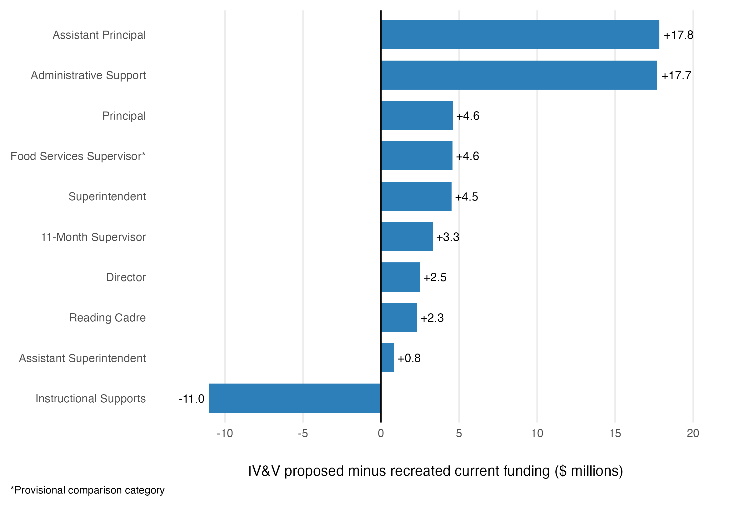Source: 11_staffing_component_comparison.csv. Asterisks identify provisional comparison categories.
Exhibit 6. Major staffing-rule drivers
Category | Current | Proposed | Position difference | Funding difference | Status
Assistant Principal | 361.75 | 494.60 | +132.85 | $17.8M | Confirmed
Administrative Support Professionals | 1,053 | 1,292 | +239.00 | $17.7M | Confirmed
Instructional Supports | 2,465.81 | 2,350.93 | -114.88 | $-11.0M | Confirmed
Principal | 223 | 253 | +30.00 | $4.6M | Confirmed
Superintendent | 19 | 43 | +24.00 | $4.5M | Confirmed
Food Services Supervisor | 9 | 46 | +37.00 | $4.6M | Provisional
11-Month Supervisor | 78.36 | 107.63 | +29.27 | $3.3M | Confirmed
Director | 60 | 75 | +15.00 | $2.5M | Confirmed
Reading Cadre | 19 | 43 | +24.00 | $2.3M | Confirmed
Assistant Superintendent | 19 | 24 | +5.00 | $839,290 | Confirmed
Source: 11_staffing_component_comparison.csv.
The three largest working modeled funding differences are Assistant Principals, Administrative Support Professionals, and Instructional Supports. Together, they produce a net increase of approximately $24.5 million. All three are confirmed comparison categories, although Administrative Support Professionals and Instructional Supports are broad functional crosswalks rather than one-to-one position matches.
- Assistant Principals increase by 132.85 positions and $17.8 million. Both models use the same threshold schedule but apply it to different staffing bases. The recreated current model uses reported Division I units, while the proposed model uses Base Division I positions plus Administrative Support Professionals and Instructional Supports. For districts, where school calculation units remain unchanged, this broader base allows more schools to cross higher staffing thresholds. For some charters, dividing an organization into multiple building-level calculation units slightly reduces the proposed total.
- Administrative Support Professionals increase by 239 positions and $17.7 million. The recreated current model calculates Secretary positions from reported Division I units, while the proposed model applies the same tiered schedule to Base Division I positions, Principals, and Instructional Supports. The Secretary-to-Administrative Support Professionals mapping and the $74,017 common rate are externally confirmed for this functional comparison.
- Instructional Supports decrease by 114.88 positions and $11.0 million, offsetting part of the increases above. The proposed model provides a consolidated allocation equal to 20% of Base Division I positions. The recreated current comparison instead combines several separately funded functions, including counselors and social workers, psychologists, nurses, Academic Excellence, driver education, related services, and visiting teachers. The functional crosswalk and $96,155 common rate are confirmed, but the result should be interpreted as a broad comparison of support functions rather than a direct reduction in identical positions or services.
Beyond these three categories, most of the remaining differences reflect four features of the proposed model: additional building-level calculation units for some charter organizations, expanded charter eligibility for certain LEA-level positions, a broader staffing base for selected Central Office formulas, and a revised Food Services Supervisor rule.
- Principals increase by 30 positions and $4.6 million. The recreated current model provides one Principal only when an official coded school has at least 15 Division I units. The proposed model provides one Principal for every district school code and charter building calculation unit. Of the 30-position increase, 24 result from using additional charter building units beyond the 24 official charter organization codes, and six result from removing the 15-unit threshold for five district schools and one charter.
- Superintendents and Reading Cadre each increase by 24 positions, adding $4.5 million and $2.3 million, respectively. The current model provides one of each position per district and excludes charters. The proposed model provides one per LEA, leaving the 19 district totals unchanged while adding one position for each of the 24 charter LEAs.
- Assistant Superintendents, Directors, and 11-Month Supervisors increase because the proposed model applies their formulas to a broader staffing base. The recreated current model uses reported Division I units, while the proposed model uses Total Base positions. Because Total Base adds Principals, Assistant Principals, Administrative Support Professionals, and Instructional Supports to Base Division I positions, some LEAs cross additional Assistant Superintendent and Director thresholds. The proportional 11-Month Supervisor allocation also increases as the staffing base grows.
- Food Services Supervisors show a working increase of 37 positions and $4.6 million, but the comparison remains provisional. The recreated current model identifies nine known positions, valued at approximately $1.11 million, for districts that meet the 500-Division I-unit threshold. Districts below that threshold may also qualify if they operate at least four lunch-program buildings, but those building counts remain unavailable for ten districts. The current estimate is therefore an incomplete minimum. The proposed model provides one position per LEA, including charters, plus one additional position for each completed 500 Base Division I positions beyond the first 500. This produces 46 positions: one for each of the 43 LEAs and a second position for three large districts.

3.4 Principals illustrate why calculation units matter
An official coded school is a school represented by a distinct school code in DDOE systems. Under the DDOE interpretation reflected in the 2023 correspondence, each charter organization is treated as one coded school, regardless of the number of buildings it operates. A calculation unit, by contrast, is the school or building row to which a funding formula is applied. Principals provide the clearest example, but calculation-unit structure also affects Administrative Support Professionals and Assistant Principals because those formulas are applied separately to each calculation unit. Changes in these school-level positions can then flow into Total Base positions and affect selected Central Office calculations.
The recreated current model provides one Principal only when an official coded school has at least 15 reported Division I units. The proposed model provides one Principal for every school calculation unit, including the separate building-level units proposed for some charter organizations in the PEFC workbook. The resulting increase therefore reflects both the removal of the 15-unit threshold and the use of additional charter building units.
Exhibit 7. Bridge from 223 current principals to 253 proposed principals
Bridge element | Positions | Explanation
Recreated current principal positions | 223 | Current rule: one Principal for a school building or combination of school buildings once it reaches at least 15 Division I units.
Effect of additional charter building calculation units | +24 | The proposed model uses 48 charter building-level calculation units rather than 24 official charter organization codes, adding 24 units eligible for a Principal.
Effect of replacing the current 15-unit minimum | +6 | Five district coded schools and BASSE have fewer than 15 Division I units and therefore receive no Principal under the recreated current rule, but each receives one under the proposed rule.
IV&V proposed principal positions | 253 | Proposed rule: one Principal for every school calculation unit.
Source: 04_current_model_quantities.csv; 07_proposed_model_quantities.csv; 11_charter_building_treatment.csv.
The bridge shows that 24 of the 30 additional positions result from using 48 charter building-level calculation units rather than 24 official charter organization codes. The remaining six result from removing the current 15-unit minimum, which allows Capital Early Childhood Center, Pulaski Early Education Center, Stubbs Early Education Center, DelCastle ILC, First State School, and BASSE to receive Principal positions.
Interpretation
The additional charter building rows are funding calculation units used to apply school-based formulas under the proposed model. Based on the building structure presented in the PEFC workbook, they allow certain staffing rules to be applied separately to distinct charter buildings.
Charter totals are allocated across building units only for Base staffing formulas. Opportunity and Operational Funding retain each charter organization’s students and weighted counts at the organization level. The building rows therefore affect how certain school-based positions are calculated, not the number of students funded statewide.

3.5 District and charter patterns
Exhibit 8. LEA distribution of comparable staffing amounts
LEA type | LEAs | Current | Proposed | Aggregate change | Median LEA change | Direction
Districts | 19 | $1.393B | $1.423B | +2.2% | 2.6% | 18 increase; 1 decrease
Charters | 24 | $170.7M | $187.7M | +9.9% | 12.6% | 24 increase
All LEAs | 43 | $1.564B | $1.611B | +3.0% | 8.4% | 42 increase; 1 decrease
Source: IV&V pipeline outputs. Comparable amounts include the 18 staffing categories with funding amounts available under both models. The current Food Services Supervisor quantity remains provisional.
Christina remains the only LEA with a comparable decrease, at approximately 0.5%. The result is driven primarily by Instructional Supports. The recreated current comparison includes 330.07 positions across several separately funded support functions, valued at approximately $31.74 million, while the proposed model provides 266.39 consolidated Instructional Supports positions, valued at approximately $25.61 million. This decrease of 63.67 positions and $6.12 million exceeds Christina’s increases in other comparable staffing categories. Because the current and proposed estimates represent different groupings of positions and formulas, the result should be interpreted as a broad functional comparison rather than the loss of 63.67 identical positions or services.
Figure 2. Distribution of comparable staffing funding
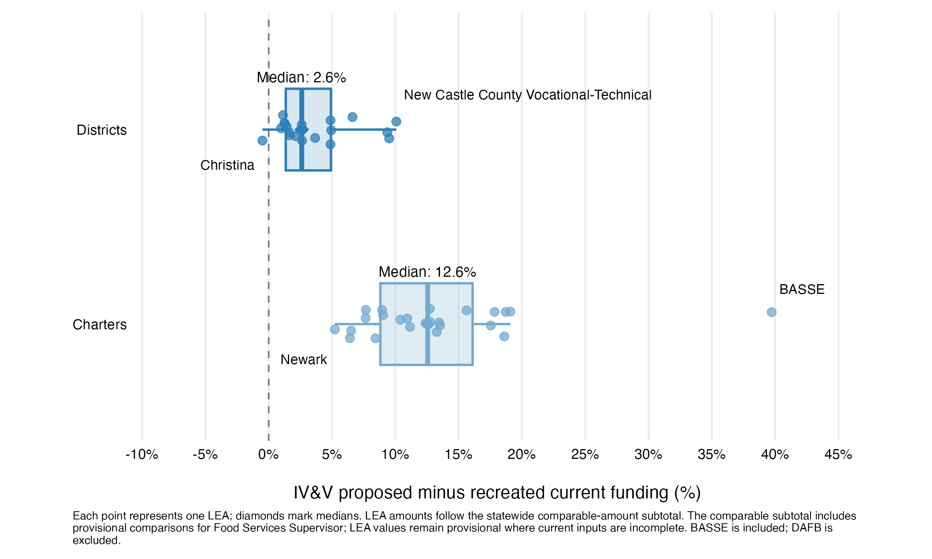
Source: IV&V analysis of SY 2025–26 staffing quantities and PEFC-recommended rates; calculations from 11_staffing_lea_comparison.csv and 08_proposed_model_funding_detail.csv.
Figure 2 shows that district percentage changes are generally clustered closer to zero, while charter percentage increases are larger. The median comparable increase is 2.6% for districts and 12.6% for charters. Christina is the only LEA with a negative percentage difference, while BASSE is a notable charter outlier, with an estimated 40% increase in comparable staffing funding under the proposed model.
Note
BASSE contributes approximately $1.4 million to the recreated current total and $2.0 million to the proposed comparable total, a net increase of about $561,000. It is included because the analysis reflects the SY 2025–26 model scope, but BASSE will not operate in SY 2026–27.

4. How Do Opportunity and Operational Funding Work?
The proposed model adds two funding streams that are not tied to staffing positions: Opportunity Funding and Operational Funding. Each distributes a fixed statewide pool using weighted student counts. Eligible student counts are multiplied by category weights to create weighted units, and the statewide pool is divided by the total weighted units to calculate a statewide per-weighted-student rate. Each LEA’s allocation equals that rate multiplied by its weighted units.

4.1 Opportunity Funding
Opportunity Funding is distributed using low-income and active multilingual learner counts, weighted according to their respective formula weights. Within the 43-LEA primary scope, these counts produce 32,939.54 weighted units. Dividing the fixed $163.0 million pool by those units yields a rate of approximately $4,948.46 per weighted unit.

4.2 Operational Funding
Operational Funding is distributed using total enrollment and counts of low-income students, active multilingual learners, Basic special education students, Intensive special education students, Complex special education students, and vocational students, each weighted according to the formula. Within the 43-LEA primary scope, these counts produce 85,860.95 weighted units. Dividing the fixed $279.0268 million statewide pool by those units yields a rate of approximately $3,249.75 per weighted unit.
Exhibit 9. Proposed weighted funding inputs, weights, and statewide amounts
Funding stream | Input | Raw count | Weight | Weighted count
Opportunity | Low income | 36,713 | 0.675 | 24,781.275
Opportunity | Active multilingual learner | 17,358 | 0.47 | 8,158.260
Operational | Total enrollment | 140,829 | 0.20 | 28,165.800
Operational | Low income | 36,713 | 0.675 | 24,781.275
Operational | Active multilingual learner | 17,358 | 0.47 | 8,158.260
Operational | Basic special education | 13,893 | 0.48 | 6,668.640
Operational | Intensive special education | 6,915 | 0.67 | 4,633.050
Operational | Complex special education | 6,368 | 1.54 | 9,806.720
Operational | Vocational enrollment* | 18,236 | 0.20 | 3,647.200
Source: 08_proposed_weighted_component_summary.csv; 08_proposed_weighted_rate_summary.csv.
*Vocational enrollment. Vocational student enrollment is the one weighted student input that was not independently validated. Available documentation did not provide sufficiently specific business rules or a clear operational definition of which students should be included, and the underlying source of the count could not be clearly identified. The IV&V therefore retained the count reported in the PEFC workbook to preserve a consistent analytical foundation for the proposed-model reproduction and workbook comparison. The resulting vocational weighted count should be interpreted with additional caution until the applicable inclusion rules and source-system logic are confirmed.

4.3 Fixed pools and recalculated rates
The PEFC calculator provides the statewide pool amounts for Opportunity Funding and Operational Funding. Following implementation guidance, the IV&V treats these amounts as fixed statewide pools rather than fixed per-student rates. The per-weighted-unit rates are therefore recalculated whenever the eligible weighted counts or reporting scope changes. This treatment reflects externally provided implementation guidance, not an assumption introduced solely for the IV&V analysis.
Rate calculation
- Opportunity rate: $163,000,000 ÷ 32,939.535 weighted units = $4,948.460869 per weighted unit
- Operational rate: $279,026,800 ÷ 85,860.945 weighted units = $3,249.752259 per weighted unit

4.4 Proposed allocation and current comparison status
Exhibit 10. Distribution of the proposed weighted funding pools
Funding stream | Statewide pool | District allocation | Charter allocation | Current comparison
Opportunity Funding | $163.0M | $143.7M (88.2%) | $19.3M (11.8%) | Current analogue not yet defined/confirmed
Operational Funding | $279.0268M | $248.3M (89.0%) | $30.8M (11.0%) | Current analogue not yet defined/confirmed
Source: IV&V pipeline output, 11_opportunity_operational_lea_comparison.csv. Primary scope includes BASSE and excludes DAFB.
The proposed allocations can be calculated and analyzed by LEA and sector. A current-versus-proposed difference cannot yet be estimated because an authoritative mapping of existing funding streams to the proposed Opportunity and Operational Funding categories has not yet been established. Missing current amounts remain blank and are not treated as zero.
Interpretation guardrail
The combined $442.0268 million proposed allocation should not be described as entirely new spending. Estimating the net fiscal change requires a crosswalk identifying which current programs or appropriations would continue, change, be consolidated, or be replaced under the proposed model.

4.5 LEA-level composition of proposed weighted funding
Proposed weighted funding varies according to each LEA’s eligible student counts and the weights assigned to each formula component. Across the combined Opportunity and Operational Funding pools, districts receive approximately $392.0 million, or 88.7%, while charters receive approximately $50.1 million, or 11.3%. Exhibit 11 shows how each formula component is divided between districts and charters, while Figures 3 and 4 show how those allocations are distributed across individual LEAs within each sector.
Across the 43-LEA primary scope, the two low-income components together account for approximately $203.2 million, or 46.0% of the combined weighted funding pools. Operational total enrollment contributes $91.5 million; the two active multilingual learner components contribute $66.9 million; the three Operational special education components contribute $68.6 million; and vocational enrollment contributes $11.9 million. Median combined allocations are $16.3 million among districts and $1.6 million among charters, reflecting differences in enrollment scale and weighted student composition.
Exhibit 11. Proposed Opportunity and Operational Funding by sector and formula component
Funding stream | Formula component | District allocation | Charter allocation | Statewide total
Opportunity | Low income | $107.4M | $15.2M | $122.6M
Opportunity | Active multilingual learner | $36.3M | $4.1M | $40.4M
Opportunity total |  | $143.7M | $19.3M | $163.0M
Operational | Total enrollment | $79.2M | $12.4M | $91.5M
Operational | Low income | $70.5M | $10.0M | $80.5M
Operational | Active multilingual learner | $23.8M | $2.7M | $26.5M
Operational | Basic special education | $19.1M | $2.6M | $21.7M
Operational | Intensive special education | $13.7M | $1.4M | $15.1M
Operational | Complex special education | $30.6M | $1.3M | $31.9M
Operational | Vocational enrollment | $11.4M | $0.5M | $11.9M
Operational total |  | $248.3M | $30.8M | $279.0268M
Combined total |  | $392.0M | $50.1M | $442.0268M
Source: 08_proposed_model_funding_detail.csv; sector totals reconcile to 11_opportunity_operational_lea_comparison.csv.
Figure 3. Composition of proposed weighted funding by district LEA
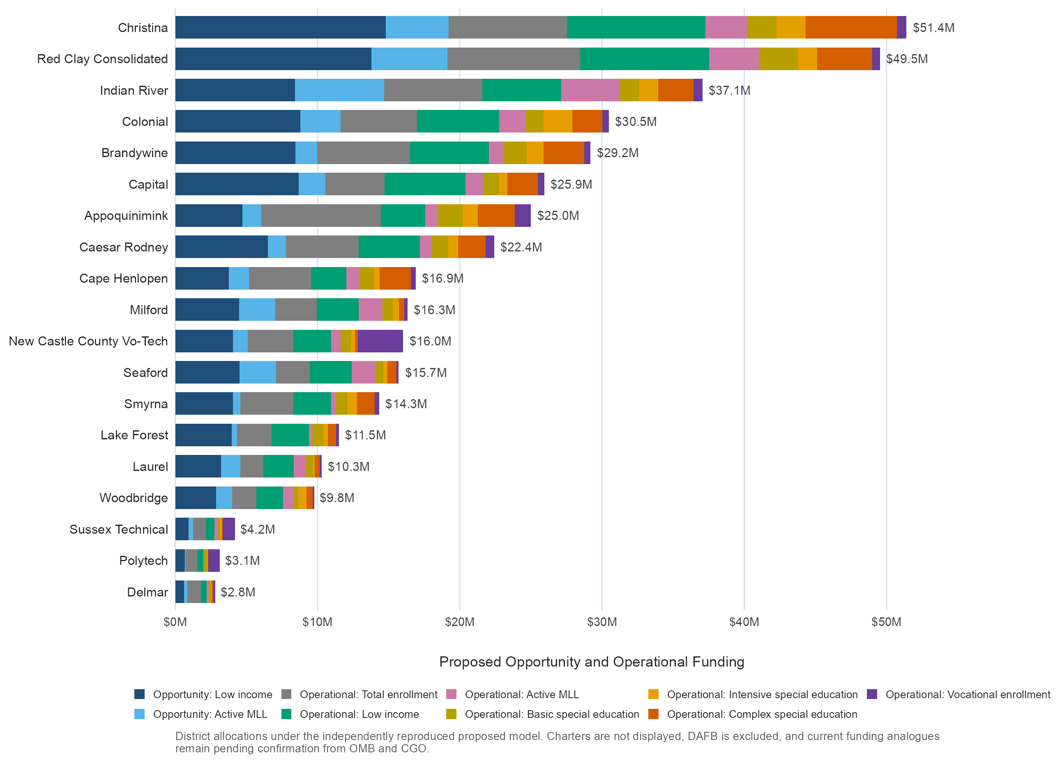
Source: IV&V pipeline output, 08_proposed_model_funding_detail.csv. Ordered by combined Opportunity and Operational Funding.
Figure 4. Composition of proposed weighted funding by charter LEA
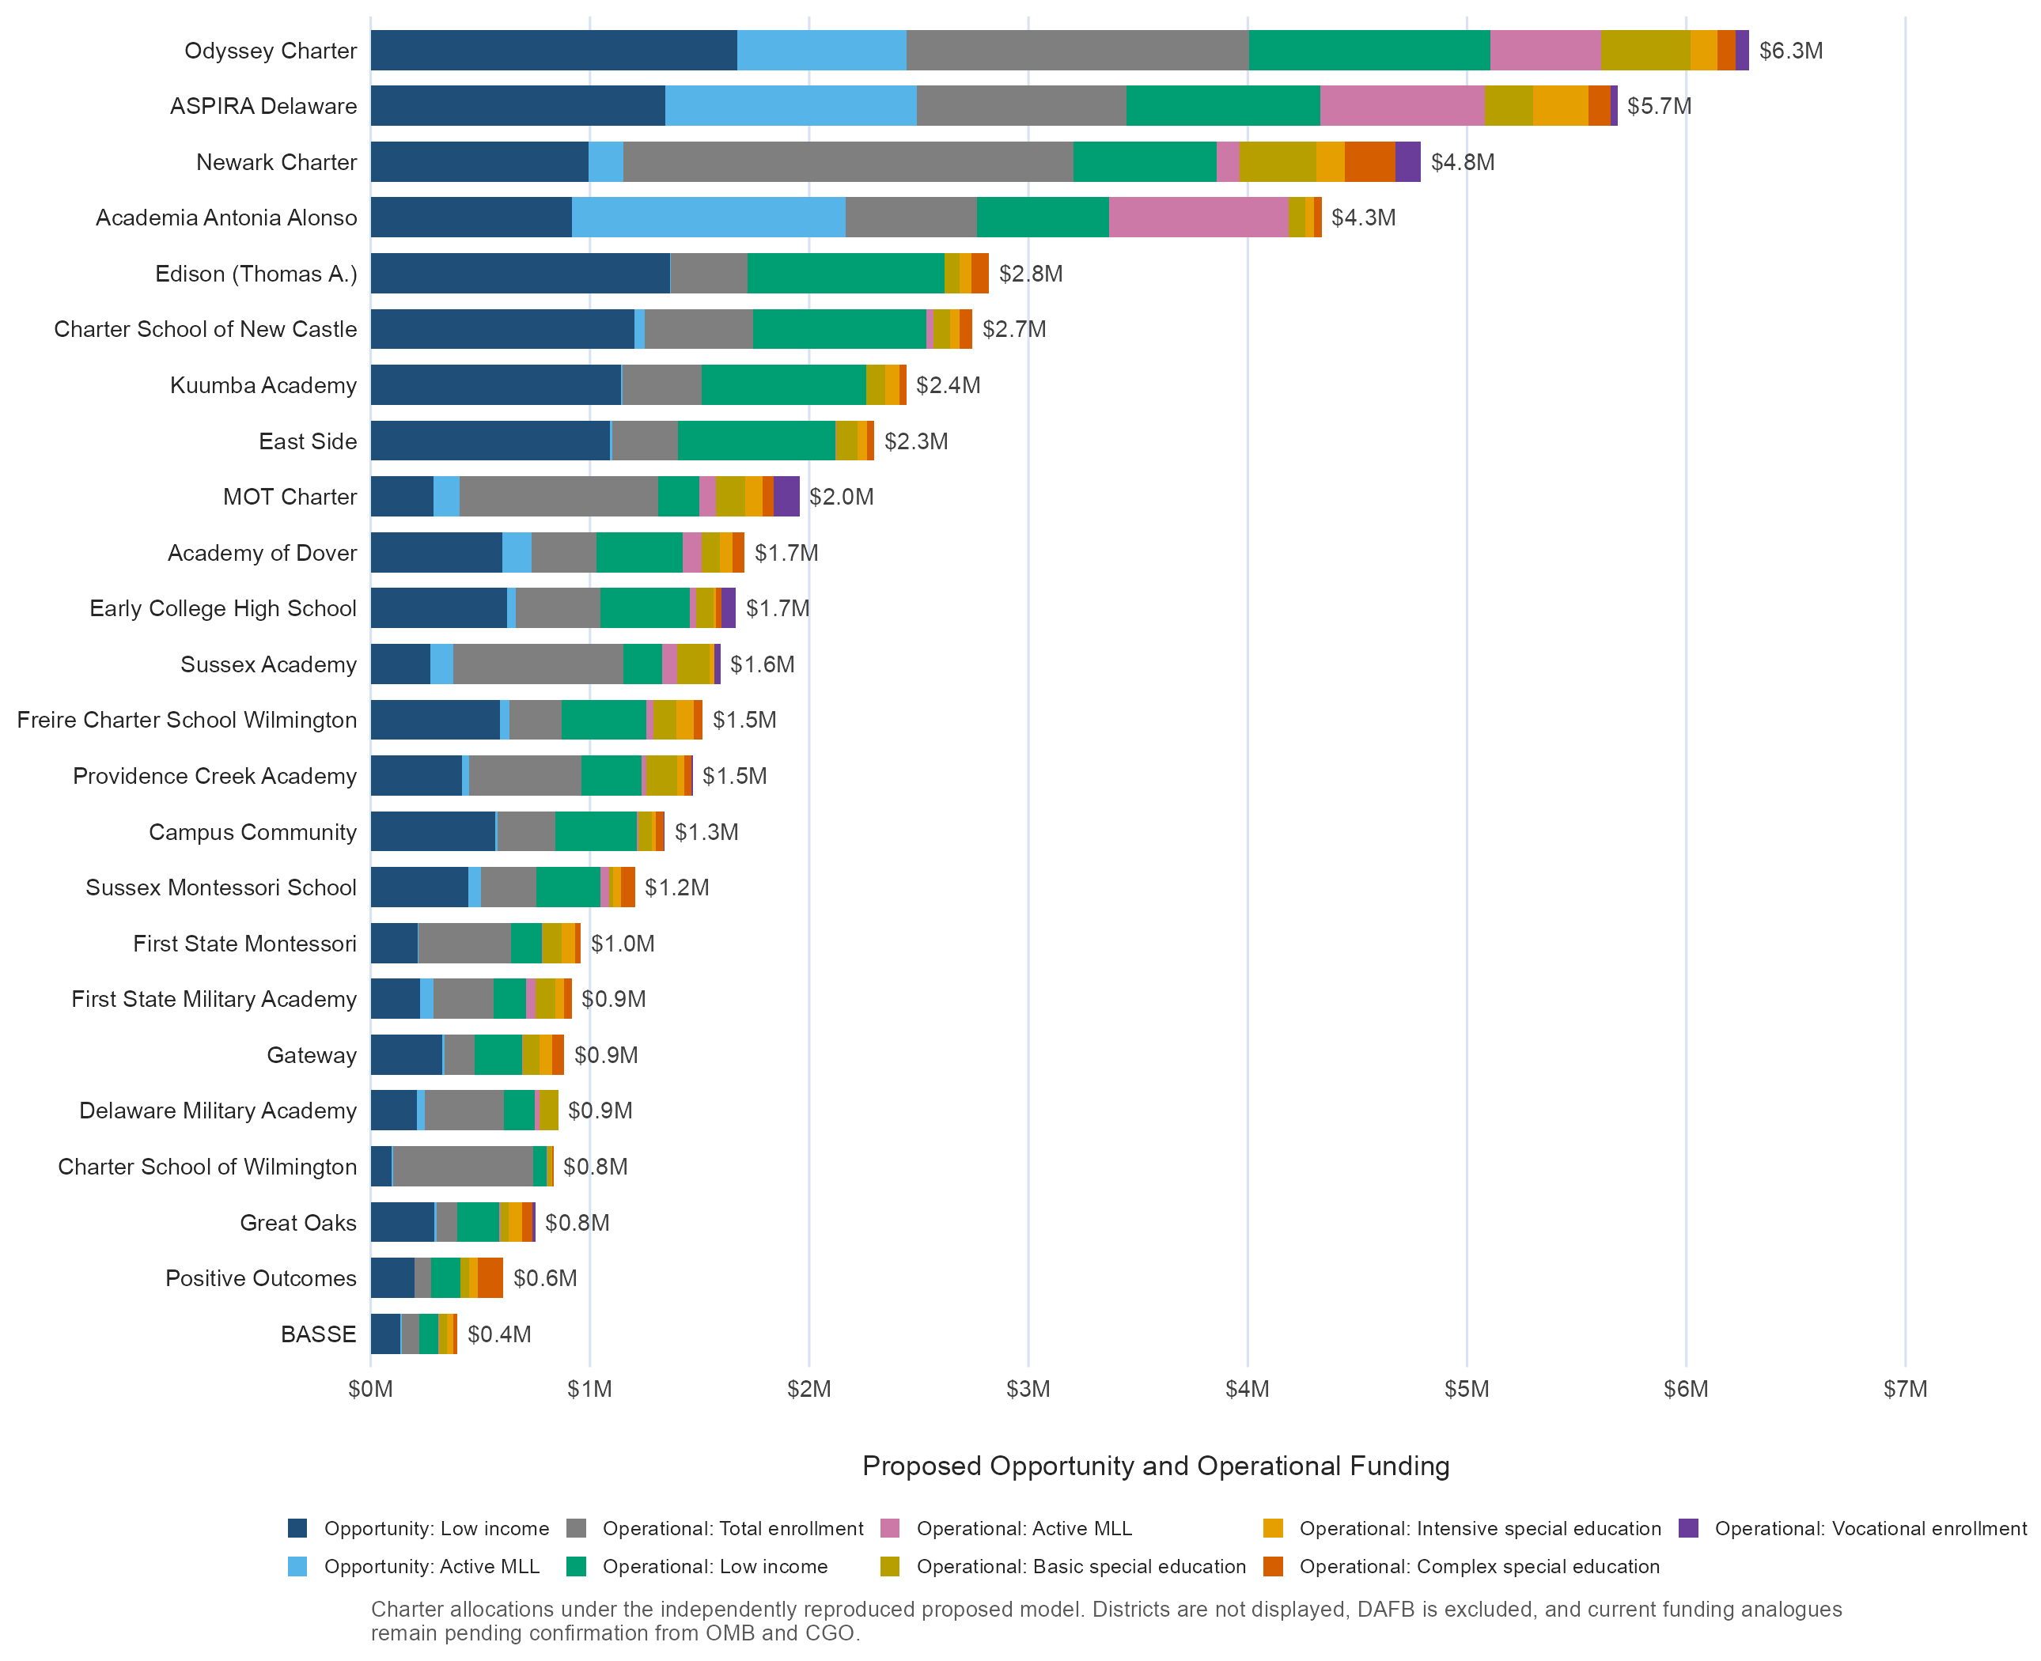
Source: IV&V pipeline output, 08_proposed_model_funding_detail.csv. LEAs are ordered by combined Opportunity and Operational Funding. BASSE is included and DAFB is excluded.
Note
BASSE receives approximately $0.4 million in proposed Opportunity and Operational Funding, or 0.8% of charter allocations. It is included in the SY 2025–26 scope but will not operate in SY 2026–27, so this amount should not be interpreted as a future allocation. Excluding BASSE in a later year would redistribute the fixed statewide pools among the remaining eligible LEAs through recalculated weighted rates.
The charts show that allocation size generally tracks enrollment scale across the 43 LEAs (Spearman’s ρ = 0.93). Differences in weighted student composition, however, can move an LEA’s funding rank above or below what its enrollment size alone would suggest.
Among districts, the relationship is especially strong (ρ = 0.94). Red Clay ranks first in enrollment and second in weighted funding, and Christina ranks third in enrollment but first in funding. Appoquinimink is the clearest exception: it ranks second in enrollment but seventh in funding, indicating that its weighted student composition produces a smaller allocation than its enrollment rank alone would suggest. Conversely, Capital ranks ninth in enrollment but sixth in funding.
Among charters, the relationship is also positive but less consistent (ρ = 0.69). Newark ranks first in enrollment and third in weighted funding, and Odyssey and ASPIRA rank second and third in enrollment but first and second in funding. Charter School of Wilmington is the clearest exception: it ranks sixth in enrollment but 21st in funding. Conversely, Edison ranks 14th in enrollment but fifth in funding.
Interpretation guardrail
The component counts are not mutually exclusive. A student may contribute to more than one weighted category, and low-income and active multilingual learner counts generate separate components within both Opportunity and Operational Funding. The chart segments therefore represent formula components, not distinct student groups or separate funding pools. These figures describe proposed allocations only. They do not show a current-versus-proposed change because no confirmed current analogues were identified in or provided to the IV&V process.

4.6 Current model Opportunity and Operational Funding analogues
A complete current-versus-proposed comparison of Opportunity and Operational Funding requires identifying which existing funding streams are intended to serve as their current-model analogues. The IV&V requested this mapping, including any available LEA-level allocations, through written correspondence and subsequent in-person discussions with the DOE School Finance Office and other involved parties.
DOE indicated that this crosswalk was not established when the proposed formula was developed and that DOE, OMB, and CGO are still determining how the existing 32 funding streams should map into the proposed funding structure. As of this analysis, that work remains in progress, and an authoritative mapping or LEA-level allocation has not yet been identified for use in the IV&V.
The IV&V therefore does not construct its own analogue or treat unavailable current amounts as zero. Current-versus-proposed Opportunity and Operational Funding differences remain not yet estimable pending an authoritative crosswalk. The proposed $163.0 million Opportunity Funding and $279.0 million Operational Funding pools can be reproduced and analyzed independently, but they should not be interpreted as increases over current funding until the corresponding current funding sources are defined.

5. How Does the IV&V Proposed Model Compare with the PEFC Workbook?
This section compares two implementations of the proposed model: the PEFC workbook as presented and the independently reproduced IV&V model. The recreated current model is not part of this validation comparison. The workbook is not treated as an unquestioned target, and differences are not automatically assumed to be errors. Instead, the comparison identifies where the implementations diverge, explains the practical effects, and isolates rules or scope decisions requiring confirmation.
The proposed model’s overall structure can be reproduced, but the implementations are not identical. The most meaningful differences involve which school calculation units receive positions, how selected thresholds and fractional awards are applied, and which organizations are included in each funding section.
Overall, the two implementations produce closely aligned totals when restricted to the same 43-LEA scope. The aligned PEFC implementation totals approximately $2.054 billion, compared with $2.058 billion under the IV&V model, a difference of approximately $3.72 million, or 0.18%. On the PEFC side, DAFB’s approximately $5.12 million displayed workbook allocation is removed from the aligned comparison. On the IV&V side, DAFB is excluded from scope and the Opportunity and Operational rates are recalculated so the full fixed statewide pools are redistributed across the remaining 43 LEAs. Most of the remaining difference occurs in Base Funding.

5.1 Principal positions show the effect of calculation-unit implementation
Both implementations describe the proposed principal rule as one position per school calculation unit. Principal counts therefore provide a direct test of whether the workbook and IV&V model identify and treat the same school and building universe.
Exhibit 12. Principal positions in the primary 43-LEA scope
PEFC principals | IV&V principals | Difference | Funding effect
248 | 253 | +5 | +$0.765M
Source: 10_pefc_component_comparison.csv; PEFC Summary school rows; 07_proposed_model_quantities.csv.
All 24 charter LEAs and all 48 charter building calculation units match between the PEFC workbook and the IV&V model. Charter building treatment is therefore an important driver of the current-versus-proposed principal increase described in Section 3, but it does not explain the difference between the two proposed-model implementations.
Exhibit 13. Primary-scope LEAs with different principal counts
LEA | PEFC | IV&V | Difference | Explanation
Capital | 13 | 14 | +1 | Capital Early Childhood Center receives zero in the workbook and one under the IV&V one-per-unit rule.
Christina | 27 | 29 | +2 | Pulaski and Stubbs Early Education Centers receive zero in the workbook.
New Castle County Vo-Tech | 4 | 5 | +1 | DelCastle ILC receives zero in the workbook.
Red Clay | 26 | 27 | +1 | First State School receives zero in the workbook.
Primary scope | 248 | 253 | +5 | Five district calculation units explain the primary-scope difference.
Source: PEFC Summary sheet and IV&V school calculation-unit output.
The primary-scope difference instead comes from five district school-code units for which the workbook carries zero principal positions. The IV&V applies the proposed rule literally by assigning one principal to each included school calculation unit.

5.2 Staffing-rule interpretations produce practical differences
Several additional differences arise because the workbook and IV&V implementation interpret selected staffing rules or construct their calculation bases differently.
Exhibit 14. Selected staffing-rule differences between the PEFC workbook and IV&V model
Area | IV&V minus PEFC | Practical explanation
Assistant Principals | +18.25 positions; +$2.45M | The IV&V retains the written 0.65 and 1.65 fractional awards, while the workbook formula rounds those awards down.
Assistant Superintendents | -1.97 positions; -$0.33M | The IV&V applies completed 300-position thresholds, capped at two positions, while the workbook produces a proportional second position.
Instructional Supports | +3.43 positions; +$0.33M | Both implementations use a 20% factor, but some charter-wide vocational positions and deductions are not carried into the workbook’s building-level calculation bases. The IV&V applies the factor to the complete Base Division I position total.
Source: 10_pefc_component_comparison.csv; 11_open_items_and_assumptions.csv.
Note: Exhibit 14 uses the PEFC workbook-as-presented diagnostic scope. DAFB is retained only where needed to reproduce and audit the workbook; the aligned 43-LEA comparison excludes DAFB.
The Assistant Principal difference is the largest of these examples. The calculator states,
“1 Position per 30 or more Division I, Administrative Support Professional, and Instructional Support Positions or 65% of a Position for schools which earn 25 Positions, but less than 30; and a second Position when the school earns 55 Positions or 65% of a Position when earning 50 Positions, but less than 55; subsequent Positions are earned on the basis of 1 Position per 20 Positions beyond the first 55.”
The IV&V applies the written schedule as 0.65 position from 25 to fewer than 30 positions, one position from 30 to fewer than 50, 1.65 positions from 50 to fewer than 55, and two positions at 55, followed by one additional position for each completed 20-position increment. The PEFC workbook uses the same values but applies ROUNDDOWN to the final result, converting 0.65 to zero and 1.65 to one. For example, Hartly Elementary falls within the 25-to-fewer-than-30 tier and receives 0.65 under the IV&V but zero in the workbook. East Dover Early Childhood Center falls within the 50-to-fewer-than-55 tier and receives 1.65 under the IV&V but one in the workbook. Across the workbook-as-presented diagnostic scope, this produces 18.25 fewer Assistant Principal positions in the workbook.
The Assistant Superintendent difference reflects whether the current whole-position rule should continue under the proposed model. The calculator states,
“1 Position per 300 Division I Positions (max of 2).”
The recreated current model awards one Assistant Superintendent for each completed 300 Division I units, capped at two, and does not provide fractional positions. Because the proposed materials do not explicitly authorize a change to that treatment, the IV&V applies the same completed-threshold approach to Total Base positions. Milford illustrates the difference: its 454.97 Total Base positions produce one Assistant Superintendent under the IV&V interpretation but 1.52 in the PEFC workbook. Similarly, New Castle County Vocational-Technical has 538.20 Total Base positions under the IV&V and receives one Assistant Superintendent, while the workbook uses a 537.21-position base and produces 1.79 positions. Across all LEAs, this treatment results in 1.97 more Assistant Superintendent positions in the workbook than in the IV&V implementation. Confirmation is therefore needed on whether the proposed model is intended to retain the current whole-position rule or introduce fractional eligibility.
The Instructional Supports difference does not reflect a different percentage: both implementations use 20%. For some multi-building charters, the workbook’s building-level bases exclude net vocational positions recorded only at the charter level. For example, Newark Charter’s building bases total 205.87 positions and produce 41.17 Instructional Supports positions. Including its 4.04 net vocational positions raises the IV&V base to 209.91 and the allocation to 41.98, a difference of 0.81 position. Across the workbook-as-presented diagnostic scope, these differences produce 3.43 additional positions, or approximately $0.33 million, in the IV&V implementation.

5.3 DAFB creates a scope difference
DAFB is included in the PEFC workbook’s Base, Opportunity, and Operational Funding calculations but excluded from Central Office Funding. Its displayed allocation totals approximately $5.12 million: $4.59 million in Base Funding, $0.01 million in Opportunity Funding, and $0.51 million in Operational Funding. The IV&V excludes DAFB from all four sections because it does not receive state funding.
The Opportunity and Operational amounts are portions of fixed statewide pools, so they are redistributed among the remaining 43 LEAs rather than removed from statewide funding. DAFB’s exclusion therefore reduces the modeled statewide total by its approximately $4.59 million Base allocation, while leaving the two weighted funding pools unchanged.
Source: 11_pefc_dafb_scope_discrepancy.csv; 11_pefc_reconciliation_summary.csv.

5.4 Overall assessment
The PEFC workbook’s overall proposed-model architecture can be independently reproduced. Within the same 43-LEA scope, the two implementations differ by approximately 0.18% in total modeled funding. The most salient differences involve principal treatment for five district calculation units, fractional Assistant Principal awards, Assistant Superintendent thresholds, the Base Division I position total used for Instructional Supports, and DAFB’s inclusion in the workbook scope. Smaller differences reflect inputs, aggregation, calculation precision, rounding, and minor gaps between displayed statewide summaries and summed LEA-level results. Taken together, these differences are limited and do not materially change the conclusion that the two implementations are closely aligned overall.

6. What Remains to Be Confirmed?
The pipeline has a stable technical foundation, but several current-model inputs, formula interpretations, and fiscal crosswalks remain unresolved. These issues define the boundary of the current findings and the additional work required before a final net fiscal analysis can be completed.
Open items are maintained explicitly in source inputs, crosswalks, settings, and the final assumptions output. The pipeline does not fill missing quantities or rates with assumed values, and provisional quantities and implementation choices remain labeled as such. When an authoritative source or policy decision becomes available, the maintained input should be updated and the full pipeline rerun rather than adjusting report totals manually.
Exhibit 15. Material outstanding confirmations
Area | Issue | Current status | Why it matters
Current operations | Custodial units for Buildings and Grounds Supervisor | Missing | Needed to apply the 95-custodial-unit eligibility threshold for 19 districts.
Food services | Lunch-program building counts | Incomplete | Needed to complete current Food Services Supervisor eligibility for 10 districts.
Weighted funding input | Vocational-enrollment definition, business rules, and source | Not independently validated | Needed to confirm that the Operational Funding vocational count consistently identifies the intended student population.
Weighted funding | Current Opportunity allocations | Not yet defined/confirmed | Needed for a current-versus-proposed Opportunity Funding comparison.
Weighted funding | Current Operational allocations | Not yet defined/confirmed | Needed for a current-versus-proposed Operational Funding comparison.
Formula interpretation | Current nurse fractional rule | Unresolved | Confirm whether the fractional unit earns 30% of a nurse position, as implemented in the IV&V.
Formula interpretation | Assistant Superintendent thresholds | Provisional | Confirm whether positions are awarded only at completed 300-position thresholds or proportionally between thresholds.
Fiscal interpretation | Current-to-proposed appropriation crosswalk | Not complete | Needed before any gross modeled difference can be interpreted as a net fiscal effect.
Source: 11_open_items_and_assumptions.csv; 11_final_readiness.csv.
Readiness status
The working staffing comparison and PEFC workbook reconciliation are available and reproducible. Within the comparable-amount staffing subtotal, 17 of 18 categories have confirmed mappings, quantities, and common rates. Food Services Supervisor remains provisional because current quantities are incomplete, while Buildings and Grounds Supervisor remains excluded because the required current custodial-unit data are unavailable. Current-versus-proposed comparisons for Opportunity and Operational Funding remain not yet estimable because an authoritative mapping of existing funding streams to the proposed categories has not yet been established. The project is ready to support technical and policy discussion, but not a final determination of net fiscal impact.

7. How Was the Analysis Built and Validated?
The project uses a linear, auditable pipeline that separates source preparation, current-model calculations, proposed-model calculations, model comparison, workbook validation, and final reporting. Quantities are calculated and reviewed before rates are applied, and detailed school-, calculation-unit-, and LEA-level outputs remain available behind the statewide summaries.
Validation is built into each stage through input reconciliation, maintained scope and entity crosswalks, formula and component comparisons, detailed audit outputs, and final integrity and readiness checks.
Exhibit 16. Pipeline from source data to final IV&V outputs
Step | Purpose | Validation role
01 | Student-count SQL export | Creates enrollment, low-income, active multilingual learner, K–8, and Grade 10 counts.
02 | Shared validated input | Reconciles student counts to Unit Count and establishes a common school, LEA, and statewide universe.
03–05 | Recreated current staffing rules | Prepares current inputs, calculates positions, applies comparison rates, and records missing or provisional items.
06–08 | IV&V proposed model | Creates calculation units, allocates charter counts, calculates staffing and weighted units, and applies rates.
09 | Current-versus-proposed comparison | Produces staffing comparisons and separate Opportunity and Operational comparison files.
10 | PEFC workbook comparison | Compares the workbook as presented with the independently implemented proposed model.
11 | Final outputs and readiness | Packages report-ready comparisons, assumptions, technical QC, reconciliation results, and readiness status.
Source: README.md; RUN_PIPELINE.R; scripts 00–11.

7.1 Technical documentation and audit trail
The analysis scripts, maintained inputs, generated outputs, and technical documentation are available in the School Funding Models GitHub repository. The Delaware School Funding Model Pipeline Definitions document provides the detailed source lineage, implemented calculation rules, comparison mappings, open items, and PEFC reconciliation framework underlying this report. The Delaware School Funding Formula Technical Reference is the governed rule record for the companion calculator: its Rule Context Matrix separates current, proposed, and locked treatments; its Rule Register records formulas and evidence status; and its recommendation tracker identifies the governing action required for PEFC proposals.

7.2 HFM Calculator: Interactive Implementation of the Technical Reference
The HFM Calculator is a point-in-time analytical implementation of the Delaware School Funding Formula Technical Reference. It documents the established statutory and operational rules used to recreate the current staffing baseline, reproduces the available FY2025–26 reference-workbook treatment, and provides an interactive environment for examining documented PEFC recommendations and alternative funding assumptions.
The calculator carries forward the Technical Reference’s model contexts and evidence/adoption statuses. Users can distinguish a verified current statutory rule from a reproduced workbook treatment, a value reconciled with its formula still open, a documented PEFC recommendation requiring governing action, or an unresolved discrepancy. Inclusion of a rule or formula does not mean that the treatment has been enacted, funded, approved, or independently established as current policy.
The calculator separates into four related functions:
- Current Law/Operations. Documents the statutory and operational rules used to recreate the current staffing baseline, along with their citations, current-law evidence status, crosswalk limitations, missing inputs, and unresolved interpretations. This function provides context for evaluating proposed changes; it is not a separate, complete current-law funding calculator.
- Locked FY2025–26 Workbook. Reproduces the available FY2025–26 reference-workbook treatment using the supplied school- and LEA-level data. It shows what the reference workbook calculates and labels that treatment as workbook reproduction, without assuming that it represents current law or approved policy.
- Proposed/What-If Model. Tests documented PEFC recommendations, alternative interpretations, and user-defined enrollment, rate, and funding-pool assumptions without changing the locked workbook baseline. Recommended formulas remain labeled as requiring governing action, and pattern-derived or unresolved formulas remain identified as analytical estimates rather than established rules.
- Plan Forward. Identifies the statutory, appropriation, regulatory, policy, data, and implementation actions needed to reconcile open treatments, adopt or revise recommendations, and prepare the model for future validation and use.
Because the calculator is downstream of the Technical Reference, it should be reviewed whenever the governing rule record changes. Clarifications to citations, source documentation, model context, or evidence/adoption status may require only documentation or labeling updates. Computational logic should be revised only when an established or reconciled decision changes a formula, eligibility rule, calculation base, threshold, rate, or calculation unit.
The calculator should therefore be understood as a point-in-time product of the laws, appropriations, documented PEFC recommendations, reference-workbook calculations, operational practices, and evidence available when it was built. Its principal purpose is to make the proposed funding structure and its assumptions transparent and testable while preserving the recreated current staffing rules as a comparison baseline.
The calculator can be used by DDOE, districts, charter schools, policymakers, analysts, and the public to review assumptions and test scenarios. It does not resolve conflicts among sources, convert a recommendation into law or approved policy, calculate a complete current-law fiscal baseline, or function as an official DDOE Hybrid Funding Formula calculator.
Access the interactive HFM Calculator

7.3 Conclusion
The IV&V establishes a reproducible basis for understanding the proposed funding structure and comparing it with the recreated current staffing rules. It identifies where the largest modeled staffing changes occur, clarifies the importance of school calculation units, reproduces the proposed weighted funding pools, and documents differences among established current rules, documented PEFC recommendations, and the FY2025–26 reference-workbook implementation.
The Technical Reference and HFM Calculator extend this work by creating a transparent and maintainable record of the available laws, appropriations, recommendations, business rules, formulas, interpretations, model contexts, and evidence/adoption statuses. The calculator documents the current statutory and operational comparison baseline, reproduces the locked reference-workbook treatment, and demonstrates how proposed changes and alternative assumptions can be operationalized and tested without presenting them as enacted policy.
The analysis is technically ready to support review and policy discussion, but it is not a final net fiscal assessment. Current Opportunity and Operational allocations or defensible program crosswalks remain unavailable, and several formula interpretations, eligibility decisions, calculation-unit definitions, and appropriation relationships still require confirmation. Missing current amounts should therefore remain unidentified rather than being treated as zero.
As recommendations are adopted, revised, or reconciled, the Technical Reference should be updated first to record the governing authority, effective date, and approved rule. The calculator’s labels, documentation, logic, and data should then be adjusted as necessary, and its outputs revalidated against approved sources and expected reconciliation totals. Once the proposed rules are approved and the remaining inputs are resolved, the calculator can provide DDOE, school districts, charter schools, policymakers, analysts, and the public with a consistent and accessible tool for applying the approved funding structure and evaluating future scenarios.

Technical Appendices
The appendices provide concise technical support for the narrative. The complete project retains more detailed school-, calculation-unit-, LEA-, component-, audit-, and QC-level files than are reproduced here. The full analysis scripts, outputs, and supporting documentation are available in the School Funding Models GitHub repository. The Delaware School Funding Model Pipeline Definitions document provides the complete source lineage, implemented rules, comparison mappings, evidence labels, and readiness framework.

Appendix A. Selected staffing rules
Category | Recreated current rule | IV&V proposed rule | Comparison note
Core teaching | Uses reported Unit Count Division I teaching quantities. | Divides enrollment by the proposed staffing ratios for each student category. | Statewide current and proposed quantities are closely aligned.
Principal | One position when a coded school has at least 15 current Division I units. | One position per school calculation unit. | The proposed result depends on the calculation-unit universe and removes the current 15-unit threshold.
Assistant Principal | Applies the current 25-, 30-, 50-, 55-, and additional 20-unit thresholds. | Applies the proposed thresholds to the school-level calculation base and retains the documented 0.65 and 1.65 fractional awards. | Produces one of the larger confirmed staffing differences. The PEFC workbook rounds the fractional awards down.
Administrative support | Secretary formula: one per 10 positions through 100, then one per completed 12 positions. | Administrative Support Professionals formula using the same tiered structure. | The Secretary-to-Administrative Support Professionals functional mapping and $74,017 common rate are externally confirmed; the categories are not identical.
Instructional supports | Models separate counselors, psychologists, nurses, Academic Excellence positions, driver education teachers, related-services specialists, and visiting teachers. | Provides Instructional Supports equal to 20% of Base Division I positions. | The functional mapping and $96,155 common rate are confirmed, but this remains a broad comparison rather than a one-to-one position match.
Superintendent | One per district; charters are ineligible. | One per included LEA. | Expands eligibility to charter LEAs.
Administrative Assistant | One per included LEA. | One per included LEA. | The quantity is unchanged between models.
Assistant Superintendent | One per completed 300 current Division I units, capped at two; districts only. | One per completed 300 Total Base positions, capped at two. | The IV&V applies completed whole-position thresholds pending confirmation that proportional fractions are not intended.
Director | One at 200 current Division I units, plus one per completed additional 100 units, capped at six. | Applies the same thresholds to Total Base positions. | The proposed rule uses a broader position base.
11-Month Supervisor | Current Division I units divided by 150. | Total Base positions divided by 150. | Fractions are retained under both implementations, but the proposed calculation uses a broader base.
Transportation Supervisor | Enrollment divided by 7,500; fractions retained. | Enrollment divided by 7,500; fractions retained. | The formula is unchanged between models.
Reading Cadre | One per district; charters are ineligible. | One per included LEA. | Expands eligibility to charter LEAs.
Food Services Supervisor | One per district at 500 Division I units or at least four lunch-program buildings. | One per LEA, plus one per completed 500 Base Division I positions beyond the first 500. | The current quantity remains incomplete for 10 districts because lunch-program building counts are unavailable.
Buildings and Grounds Supervisor | One position when current custodial units reach 95. | One position per included LEA. | The current quantity is not yet estimable because custodial-unit inputs are missing.
Source: 04_current_model_rules.csv; 07_proposed_model_rules.csv; model_comparison_crosswalk.csv; Delaware School Funding Model Pipeline Definitions.

Appendix B. Report exhibit traceability
Report topic | Primary project output
Staffing statewide views | 11_staffing_statewide_comparison.csv
Staffing categories and drivers | 11_staffing_component_comparison.csv
LEA staffing distribution | 11_staffing_lea_comparison.csv
Opportunity and Operational comparison status | 11_opportunity_operational_comparison.csv
Weighted-funding component, sector, and LEA allocations | 08_proposed_model_funding_detail.csv; 11_opportunity_operational_comparison.csv; 11_opportunity_operational_lea_comparison.csv
PEFC statewide reconciliation | 11_pefc_reconciliation_summary.csv; 11_pefc_dafb_scope_discrepancy.csv
Detailed PEFC component comparison | 10_pefc_component_comparison.csv
Charter building treatment | 11_charter_building_treatment.csv
Open items, assumptions, and outside-formula current funding | 11_open_items_and_assumptions.csv; 11_current_outside_formula_components.csv; 11_current_district_cafeteria_allocation.csv
Final technical QC | 11_final_qc.csv
Analytical readiness | 11_final_readiness.csv
Run settings and manifest | 00_run_settings.csv; 00_run_manifest.csv
Full implementation definitions and source lineage | Delaware School Funding Model Pipeline Definitions; README.md
Interactive rule review, locked-model reproduction, scenario testing, and plan-forward decisions | HFM Calculator interactive implementation
Source: final reporting outputs, audit files, project README, and the Delaware School Funding Model Pipeline Definitions.

Appendix C. Interpretation guardrails
The results should be interpreted as modeled comparisons rather than complete estimates of Delaware’s current funding system or future state spending. Missing current values are not treated as zero and remain outside confirmed comparisons. Broad functional mappings allow current and proposed staffing categories to be compared, but they do not imply that the underlying positions or services are identical. Accordingly, gross modeled differences and preliminary LEA-level results should not be interpreted as confirmed net fiscal impacts, gains, or losses.
The PEFC workbook comparison and the current-versus-proposed analysis address different questions. The former assesses whether the proposed model can be independently reproduced, while the latter compares that proposed model with the recreated current staffing rules.

