Delaware School Funding Model Analysis
Current Model, PEFC Proposed Model, and Independent Technical Reproduction
FIRST FULL DRAFT FOR REVIEW
Report detail | Value
Model year | School Year 2025–26
Count date | September 30, 2025
Final reporting scope | 42 LEAs: 19 districts and 23 charters
Analysis run | July 23, 2026; Step 11 version 2026-07-23-v3
Status | Working draft; technical appendices will be delivered separately

Important interpretation note
The modeled differences in this report are not confirmed net fiscal impacts. The recreated current baseline is incomplete, and current appropriations that may continue, be consolidated, or be replaced by proposed weighted funding have not been fully netted.

Contents
Executive Summary
1. Purpose, Scope, and Methods
2. The Current Funding Model as Recreated in the Analysis
3. The PEFC Proposed Model as Presented
4. Independent Technical Review and Reproduction of the Proposed Model
5. Three-Way Model Comparison
6. Key Findings
7. Limitations, Unresolved Questions, and Next Steps
Companion Technical Appendices
How this report uses model names
The report distinguishes three separate analytical objects throughout: the Recreated Current Model, the PEFC Proposed Model as Presented, and the Independent Technical Review and Reproduction of the Proposed Model. The shorter term “independent reproduction” is used only after the full name has been introduced.

Executive Summary
Delaware’s current funding model and the proposed hybrid funding model are not simple variations of the same formula. The current model assigns many teaching, support, administrative, and operating positions through separate unit, threshold, and eligibility rules. The Public Education Funding Commission (PEFC) proposal retains position-based funding, reorganizes it into Base and Central Office sections, and adds two weighted-student funding pools: Opportunity Funding and Operational Funding.
This report compares three distinct versions of that work. The Recreated Current Model is a reproducible, but partial, reconstruction of the current position-based system. The PEFC Proposed Model as Presented reports the calculator exactly as supplied, including its own inputs, formulas, and scope. The Independent Technical Review and Reproduction of the Proposed Model uses reconciled Unit Count inputs, documented implementation guidance, explicit interpretation rules, and reproducible quality-control checks.
Key measure | Statewide result
Partial recreated current funding | $1,562.2M
Independent position-based funding | $1,614.0M
Position-based modeled difference | $51.8M (+3.3%)
Proposed weighted funding | $442.0M
Independent total modeled funding | $2,056.1M
Gross modeled difference | $493.8M (+31.6%)

The closest available like-for-like comparison is position based. In the final 42-LEA scope, proposed Base and Central Office Funding total $1.614 billion. That is $51.8 million, or 3.3%, above the $1.562 billion captured in the partial Recreated Current Model. The comparison is still preliminary because the current baseline does not yet include all custodial, cafeteria, and facilities quantities or rates.
The complete independent reproduction totals $2.056 billion after adding the fixed $163.0 million Opportunity pool and $279.0268 million Operational pool. Compared with the partial current baseline, the gross modeled difference is $493.8 million, or 31.6%. This is not a confirmed increase in state spending. It does not subtract current appropriations that may continue, change form, or be replaced under the proposed model.
Scope changes the PEFC comparison
The PEFC calculator displays $2.0596 billion statewide, about $3.51 million above the independent reproduction. When the PEFC LEA rows are restricted to the same final 42-LEA scope, the PEFC amount is $2.0519 billion, about $4.13 million below the independent reproduction. The direction of the difference therefore changes after scope alignment.

Exhibit 1. Statewide funding summary across the three model versions
Funding measure | Recreated Current Model | PEFC as presented | Independent reproduction | Comparability
Base Funding | $1,526.7M | $1,558.1M | $1,555.6M | Partial
Central Office Funding | $35.6M | $59.4M | $58.4M | Partial
Position-based Funding | $1,562.2M | $1,617.5M | $1,614.0M | Closest available comparison
Opportunity Funding | — | $163.0M | $163.0M | No direct current equivalent
Operational Funding | — | $279.0M | $279.0M | No direct current equivalent
Total modeled funding | $1,562.2M | $2,059.6M | $2,056.1M | Gross comparison only

Source: 11_three_way_funding_comparison.csv. Values rounded to the nearest $0.1 million. PEFC values use the calculator scope as presented; current and independent values use the final 42-LEA scope.

Principal findings
- Teaching-position totals are relatively close after the independent reproduction uses the final source inputs and reporting scope. Larger changes occur in principals, assistant principals, administrative support, and Central Office eligibility and formulas.
- Charter calculation units matter. The current model treats each charter organization as one coded school, while the proposed Base formulas use calculator building rows. The independent reproduction applies school-based formulas to 252 calculation units: 205 district school codes and 47 charter building units.
- The proposed model consolidates several separately identified current support functions into one Instructional Supports quantity equal to 20% of all Base Division I positions.
- The independent reproduction recalculates Opportunity and Operational rates so that the fixed pools are fully distributed in the final reporting scope. The final rates are $4,952.73 per Opportunity weighted student and $3,252.72 per Operational weighted student.
- All 42 included LEAs increase under the gross full-model comparison. Under the preliminary position-based comparison, 41 increase and one district decreases slightly.
The independent review found that the proposed model can be reproduced, but not without documented choices. The most important choices involve charter building allocations, the position base used for selected Central Office formulas, the treatment of fractional assistant-principal positions, the use of completed thresholds for Assistant Superintendents, and the fixed-pool weighted-rate method. All 18 Step 11 reporting checks passed, and the report outputs reconcile to the validated pipeline.
The main conclusion is therefore twofold. First, the proposed hybrid model represents a meaningful structural change, not just a new set of rates. Second, the statewide differences are interpretable only when model scope, source inputs, calculation units, and unresolved current-model gaps are kept visible.

1. Purpose, Scope, and Methods
The purpose of this review is practical: document how the current and proposed funding structures operate, reproduce the PEFC calculator with traceable data and formulas, identify material ambiguities, and create a reproducible basis for statewide and LEA-level comparison. The work is a model implementation and reconciliation exercise. It is not a legal interpretation of Delaware’s funding statutes, a policy approval, or a complete forecast of future LEA budgets.

1.1 Three model versions
Exhibit 2A. Definitions of the three model versions
Model version | Definition | Primary source
Recreated Current Model | The current Delaware funding model as reconstructed in the pipeline, including reported Unit Count quantities, calculated staffing, available rates, documented crosswalks, analytical assumptions, and missing inputs. | Steps 02-05 and adjusted Step 10 outputs
PEFC Proposed Model as Presented | The proposed hybrid model exactly as displayed in Copy of Calculator for 25-26 w Charter (003).xlsm, without silently applying pipeline corrections. | PEFC calculator workbook
Independent Technical Review and Reproduction of the Proposed Model | The proposed model independently reviewed and reproduced with reconciled source data, documented guidance, explicit interpretation rules, and QC. | Steps 06-10 and Step 11 reporting outputs

Source: 11_model_version_definitions.csv.
These distinctions are central to the report. PEFC results are first described on the calculator’s own terms. The independent review is discussed separately so that source corrections and implementation choices are not presented as though they were part of the original workbook. Comparisons with the current model use the final pipeline scope unless a table explicitly says otherwise.

1.2 Reporting scope
The analysis uses School Year 2025–26 data and a September 30, 2025 count date. The final reporting scope includes 140,706 students across 42 local education agencies (LEAs): 19 districts and 23 charters. It contains 228 coded school records and five vocational or program records without school codes. For proposed school-based formulas, those records become 252 calculation units: 205 district school-code units and 47 charter building units.
Dover Air Force Base (DAFB) is calculated in the detailed pipeline but excluded from statewide reporting. Bryan Allen Stevenson School of Excellence is removed in Step 10 because 2025–26 was its final operating year. The fixed Opportunity and Operational pools are retained and redistributed across the remaining eligible weighted units. The PEFC-as-presented section, by contrast, preserves the calculator’s source scope unless a specific workbook formula excludes an organization.
Scope item | Implemented value
School year / count date | 2025–26 / September 30, 2025
Final reporting scope | 42 LEAs: 19 districts and 23 charters
Students | 140,706
Coded school records | 228
Vocational/program records without school codes | 5
Proposed school calculation units | 252
Reporting exclusions | DAFB and Bryan Allen Stevenson School of Excellence

1.3 Source hierarchy
The analysis uses a clear source hierarchy to avoid silently blending different versions of the model. Current code and generated outputs define the models as implemented in the pipeline. Maintained inputs and SQL exports define the values that enter the calculations. The supplied PEFC workbook defines the proposed model as presented. Supporting workbooks, presentations, and question lists help explain intent and identify discrepancies, but they do not override implemented code or literal workbook formulas without a documented decision.
Externally provided implementation guidance is labeled separately. In particular, the calculator supplies the $163.0 million Opportunity pool and $279.0268 million Operational pool. Guidance from Nick Johnson of POLYTECH School District is the basis for treating those amounts as fixed statewide pools and recalculating per-weighted-student rates when the eligible weighted counts or reporting scope change.

1.4 Reproducible pipeline
The pipeline separates source preparation, current-model calculations, proposed-model calculations, comparison, exclusions, and reporting. This separation makes it possible to review a quantity before a rate is applied, trace statewide totals to LEA and school outputs, and rerun the report after a source or policy decision changes. Step 11 is a reporting layer. It does not change the model logic established in Steps 01–10.
Exhibit 2B. Analysis pipeline through report outputs
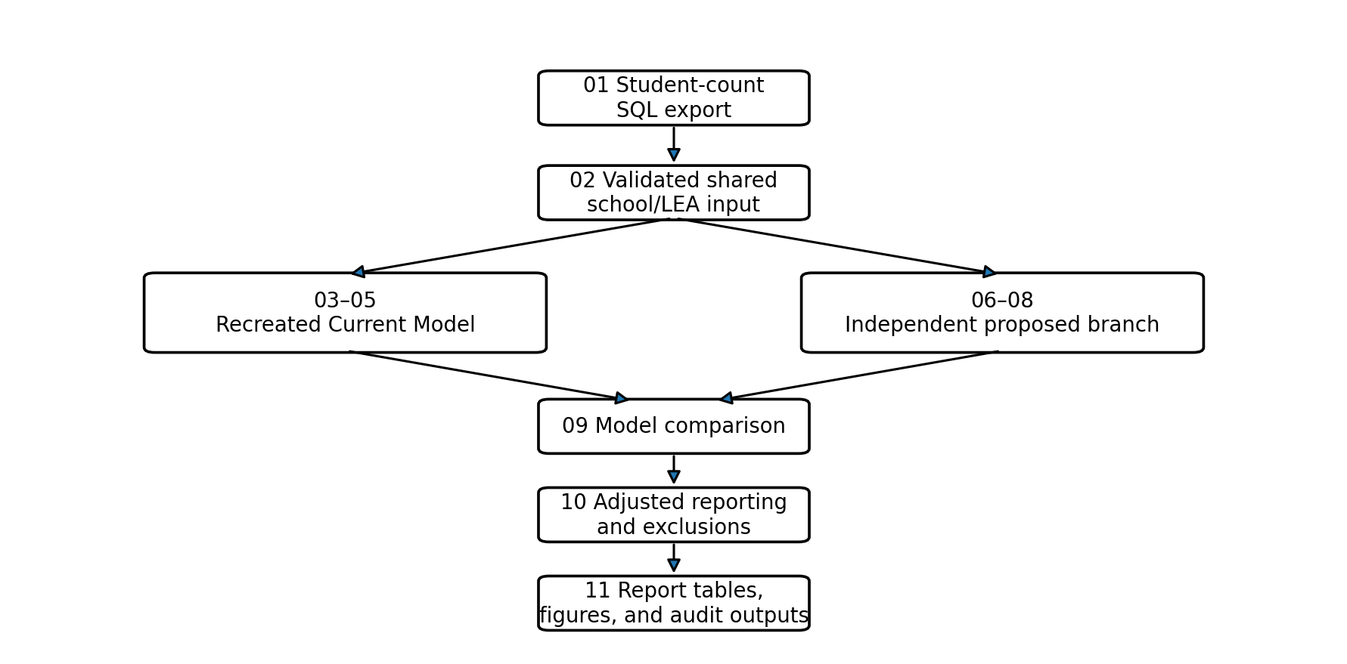
Source: Project scripts 00–11 and 11_analysis_version.csv.

1.5 Rounding and interpretation
The calculation files retain full precision. Main-report dollars are generally shown to the nearest $0.1 million, positions to two decimals, weighted rates to the nearest cent, and percentages to one decimal. Rounding occurs only for presentation and does not feed back into model calculations.
Interpretation guardrail
“Position-based difference” compares the partial Recreated Current Model with proposed Base plus Central Office Funding. “Gross difference” compares that same partial current baseline with all four proposed funding sections. Neither measure is a confirmed net fiscal impact.

2. The Current Funding Model as Recreated in the Analysis
The current model is best understood as a collection of separate allocation rules rather than one statewide weighted formula. Teaching units are largely reported through Unit Count. Other positions are generated from school enrollment, Division I units, grade-specific counts, LEA type, and eligibility thresholds. The pipeline recreates most of these quantities, but the resulting funding total remains partial because several operations and food-service inputs or rates are unavailable.

2.1 How the recreated current model is organized
For readability, the 32 recreated current components can be grouped into five broad areas:
1. Division I teaching and vocational positions, including regular education, special education, vocational positions, and the vocational deduction.
2. School administration and administrative support, including principals, assistant principals, and secretaries.
3. Instructional, student, and related-service supports, including counselors or social workers, psychologists, nurses, Academic Excellence, driver education, related services, and visiting teachers.
4. Central administration, including Superintendent, Assistant Superintendent, Director, Administrative Assistant, 11-Month Supervisor, Transportation Supervisor, and Reading Cadre.
5. Operations and food services, including custodians, Buildings and Grounds Supervisor, Food Services Supervisor, and charter cafeteria positions.
The proposed model does not preserve a separate line for every current component. Several current support functions are therefore grouped into broader comparison categories later in the report. Those groupings improve comparability but should not be read as a claim that the functions are identical.

2.2 Inputs and calculation units
Unit Count is the primary source for reported Division I units. The current model recognizes an officially coded Unit Count school as the school-building calculation unit. Multiple physical sites under one school code are treated as one current calculation unit. In the final reporting scope, that produces 228 coded school records: 205 district schools and 23 charter organization records.
Five additional vocational or program records do not have school codes. They retain their vocational positions or deductions, but they do not generate principals or other school-based positions. LEA-level formulas use source-reported LEA totals and validated student counts where required.
The current Pre-K special education quantity is a source limitation. Unit Count supplies the reported Pre-K units but not the corresponding student headcount needed to independently reconstruct the 1:8.4 ratio. The pipeline therefore passes through the reported UnitsPreK value instead of recalculating it.

2.3 Representative quantity rules
Representative component | Implemented current-model rule
Division I teachers | Use source-reported Unit Count positions; Pre-K is passed through because headcount is unavailable.
Principal | One position when total Division I units are at least 15.
Assistant Principal | Apply thresholds at 25, 30, 50, 55, and each additional 20 units.
Counselor / Social Worker | K–8 enrollment divided by 250.
School Psychologist | K–8 enrollment divided by 700.
Nurse | One per 40 units; the implemented fractional portion is funded at 30% and still needs confirmation.
Secretary | One per 10 units through 100; one per completed 12 units thereafter.
Assistant Superintendent | One per completed 300 Division I units, capped at two, for eligible districts.
Director | One at 200 units plus one per completed additional 100, capped at six.
11-Month Supervisor | Division I units divided by 150; fractions retained.

Source: 04_current_model_rules.csv. The full rule inventory will be provided in the companion technical appendices.

2.4 Rate evidence and modeled funding
The available project materials do not provide an authoritative current rate for every recreated component. To create a consistent modeled comparison, the pipeline classifies each rate as calculator-supplied, documented crosswalk, analytical assumption, or not available. A calculator-supplied rate is explicitly listed in the proposed calculator. A documented crosswalk links a current component to a broader calculator category. An analytical assumption uses the closest reasonable calculator rate without an explicit crosswalk. Not available means no defensible rate was identified.
These classifications are evidence labels, not statements of policy authority. They allow the comparison to be reproduced, but they do not establish the complete official cost of the current funding system. Missing rates and missing quantities remain blank rather than being converted to zero.
Exhibit 3. Recreated Current Model: major quantities and completeness
Component or group | Statewide quantity | Completeness | Main note
Base Division I and net vocational positions | 11,743.85 | Complete | Uses source-reported current units.
Principal | 223.00 | Complete | One only when the current unit threshold is met.
Assistant Principal | 361.75 | Complete | Current unit thresholds.
Secretary / mapped administrative support | 1,052.00 | Complete | Current secretary formula.
Mapped instructional and student supports | 2,463.68 | Complete | Combines several separately named current functions for comparison only.
Superintendent | 19.00 | Complete | District-only in final scope.
Assistant Superintendent | 19.00 | Complete | Completed 300-unit thresholds.
Director | 60.00 | Complete | Current unit thresholds.
11-Month Supervisor | 78.29 | Complete | Current LEA-level Division I units divided by 150.
Buildings and Grounds Supervisor | — | Incomplete | Custodial-unit input is missing.
Food Services Supervisor | 9.00 known | Incomplete | Required lunch-building inputs are missing for some LEAs.
Custodians | — | Incomplete | Site-evaluated positions and rate are unavailable.
Charter cafeteria positions | 17.52 managers; 118.10 workers | Incomplete | Satellite counts and/or rates are unavailable.

Source: 11_current_vs_reproduction_position_crosswalk.csv; 04_current_model_issues.csv; 05_current_model_rate_issues.csv. Final scope excludes DAFB and Bryan Allen Stevenson School of Excellence.

2.5 Statewide recreated current-model results
The partial Recreated Current Model totals $1.562 billion in the final reporting scope. Of that amount, $1.5267 billion is grouped as current Base Funding and $35.6 million as current Central Office Funding for comparison purposes. The grouping is analytical: the current system does not formally use the proposed model’s four-section architecture.
The pipeline identifies four current components with missing inputs and two components with unavailable rates. The missing information affects custodians, Buildings and Grounds supervision, Food Services supervision, and charter cafeteria positions. The separate district cafeteria process is also outside the recreation. As a result, the current total is a reproducible partial baseline rather than a complete current-system cost.
What readers should keep in mind: The current amount should never be described as the full cost of Delaware’s existing funding system. It is the portion that could be recreated from the available inputs, formulas, crosswalks, and rates in this analysis.

3. The PEFC Proposed Model as Presented
The PEFC calculator presents a hybrid funding model with four sections: Base Funding, Opportunity Funding, Operational Funding, and Central Office Funding. This section describes the workbook faithfully, using its displayed statewide values and its source scope. Differences identified by the independent review are addressed in the next section rather than being silently corrected here.

3.1 Four-part architecture
Section | What it funds | Funding basis
Base Funding | Position-based teaching, school administration, Administrative Support Professionals, and Instructional Supports. | Positions × calculator-supplied rates
Opportunity Funding | Low-income and active multilingual learner weighted counts. | Fixed statewide pool of $163.0M
Operational Funding | Enrollment, low income, active MLL, special education, and vocational weighted counts. | Fixed statewide pool of $279.0268M
Central Office Funding | Nine LEA-level administrative and operational position categories. | Positions × calculator-supplied rates

3.2 Base Funding
Base Funding begins with five enrollment-driven teaching categories: regular K–3, regular Grades 4–12, Basic special education Pre-K–12, Intensive special education, and Complex special education. The workbook divides those enrollments by fixed staffing ratios of 16.2, 20, 8.4, 6, and 2.6, respectively. Vocational Division I positions and the vocational deduction are then added to create Base Division I positions.
Additional Base positions include one principal per school calculation unit, Instructional Supports, Administrative Support Professionals, and Assistant Principals. The calculator defines Instructional Supports as 20% of Base Division I positions. Administrative Support uses a tiered formula, and Assistant Principals use position thresholds. Total Base positions equal Base Division I plus all four additional Base categories.
The calculator reports 11,791.23 Base Division I positions, 249 principals, 477 assistant principals, 1,294 Administrative Support Professionals, and 2,354.73 Instructional Supports. Its displayed Total Base is 16,165.964 positions, producing $1.5581 billion in Base Funding.

3.3 Opportunity and Operational Funding
Opportunity Funding uses two weights: 0.675 for low-income students and 0.47 for active multilingual learners. The calculator reports 32,909.32 Opportunity weighted students and a rate of $4,953.00 per weighted student, producing the fixed $163.0 million pool.
Operational Funding applies a 0.20 weight to total enrollment, repeats the low-income and multilingual learner weights, and adds weights of 0.48 for Basic special education, 0.67 for Intensive special education, 1.54 for Complex special education, and 0.20 for vocational enrollment. The calculator reports 85,986.89 Operational weighted students and a rate of $3,244.99, producing the fixed $279.0268 million pool.
The weights determine each LEA’s share of a pool. The rate converts weighted units into dollars. Because the calculator’s displayed pool amounts are fixed, the implied rate depends on the eligible weighted count used in the denominator.

3.4 Central Office Funding
The calculator includes nine Central Office categories: Superintendent, Administrative Assistant, Assistant Superintendent, Director, 11-Month Supervisor, Buildings and Grounds Supervisor, Food Services Supervisor, Transportation Supervisor, and Reading Cadre. Unlike the recreated current model, major Central Office formulas generally apply to charter LEAs as well as districts.
The PEFC calculator reports 43 organizations receiving at least one Central Office position. DAFB is present in the workbook source scope but excluded from those Central Office formulas. The displayed total is 445.585 Central Office positions and $59.4 million in Central Office Funding.

3.5 Calculation and reporting levels
Districts are generally represented through school-code rows. Several charter organizations are divided into multiple building rows for school-based Base formulas, while the calculator also reports charter organization totals. This distinction matters because a formula such as one principal per school produces different results depending on whether a charter is treated as one organization or several buildings.
The workbook displays 44 organization rows and 249 school calculation units or principal positions. The final independent pipeline later reconciles those organization and building structures to validated source totals.
Exhibit 4. PEFC Proposed Model as Presented: statewide architecture and estimates
PEFC section | Displayed quantity | Displayed funding | Interpretation
Base Funding | 16,165.96 positions | $1,558.1M | Includes teaching and additional Base positions.
Opportunity Funding | 32,909.32 weighted students | $163.0M | Low income and active MLL.
Operational Funding | 85,986.89 weighted students | $279.0M | Enrollment, LI, MLL, special education, and vocational.
Central Office Funding | 445.58 positions | $59.4M | Nine LEA-level position categories.
Total modeled funding | 16,611.55 position-based positions | $2,059.6M | Workbook displayed statewide total.

Source: 11_pefc_statewide_as_presented.csv. Scope is the PEFC calculator as presented.

3.6 Internal workbook reconciliation
The workbook’s displayed statewide values do not exactly match the sum of its Summary LEA rows for five measures. The differences are small relative to the statewide totals: Base Funding differs by $24,039, Central Office Funding by $43,788, total modeled funding by $19,749, Total Base positions by 0.25, and Total Central Office positions by 0.381. The PEFC-as-presented results retain the displayed statewide values and preserve the differences for technical review.
These reconciliation items should be confirmed, but they do not by themselves imply that the full calculator is unusable. They are treated as visible workbook discrepancies rather than silently adjusted values.

4. Independent Technical Review and Reproduction of the Proposed Model
The independent review tested whether the proposed model could be reproduced from reconciled source data and explicit calculation rules. The answer is yes, but the exercise required several decisions that are easy to miss in a spreadsheet-only review. The pipeline keeps those decisions visible so that they can be revised if a source owner or policy decision changes.

4.1 What was reviewed
The review covered input totals and entity crosswalks, school and charter calculation units, workbook formulas and written notes, staffing ratios, position bases, eligibility rules, rates and fixed pools, reporting exclusions, output reconciliation, and file integrity. It also tested whether school-level, LEA-level, and statewide totals agreed after each stage.
The reporting layer extracted 29 PEFC components and 44 PEFC organization rows, aligned 42 PEFC rows to the final pipeline scope, verified the component crosswalk, and reconciled Base, Central Office, weighted, and total funding. All 18 Step 11 checks passed, and no upstream Step 10 QC failures remained.

4.2 Input reconciliation
The independent reproduction uses the validated shared pipeline input as its source of student counts and reported current units. That choice keeps the current and independent models on one common input base. The PEFC workbook is retained as the source of proposed structure, charter building patterns, weights, position rates, vocational enrollment, and fixed pool amounts.
The largest visible source discrepancy is ASPIRA. The PEFC calculator and source PDF show 815 students in Grades 4–12 and 1,476 total students, while unit_count.xlsx and the SQL student count show 814 and 1,475. The pipeline uses 814 and 1,475. For the three ASPIRA building rows, the 814 Grades 4–12 students are allocated as 178, 345, and 291, preserving the shared total while keeping the calculator’s building pattern as closely as possible.

4.3 Charter building allocation
Official charter organization totals remain authoritative in the independent reproduction. Calculator building rows are used only to distribute those totals for school-based Base formulas. For whole-student categories, the pipeline first applies the calculator shares, takes the integer floor, and assigns remaining students to the largest remainders. Ties are resolved by calculation-unit sequence. Vocational positions and deductions retain full precision.
This design serves two purposes. It preserves the source-reported charter total, and it avoids counting weighted inputs more than once. Low income, active multilingual learners, total enrollment, special education, and vocational weighted inputs are counted once at the charter-organization level, even when a charter has several building rows for Base calculations.
Plain-language example: A charter may receive more than one principal because its Base formulas are applied to multiple calculator buildings. The same charter’s students are still counted once for Opportunity and Operational funding at the organization level.

4.4 Formula interpretation decisions
Most proposed rules can be implemented directly from the calculator. A smaller set required an explicit interpretation. The most consequential decisions are summarized below.
Exhibit 5. Key review findings and implemented treatments
Issue | Independent treatment | Why it matters
Charter calculation units | District school codes; charter calculator building rows. | Changes principals and other school-based thresholds without duplicating weighted enrollment.
Instructional Supports | 20% of all Base Division I positions, including vocational/program adjustment rows. | Produces 2,348.82 positions in the final scope.
Administrative Support base | Base Division I + Principal + Instructional Supports. | Uses a broader constructed base than the current secretary formula.
Assistant Principal base | Base Division I + Administrative Support + Instructional Supports; principals excluded. | Written 0.65 and 1.65 awards are retained even though the literal workbook formula rounds them down.
Selected Central Office base | Assistant Superintendent, Director, and 11-Month Supervisor use Total Base positions. | Makes school-level support positions part of the selected LEA thresholds or ratios.
Assistant Superintendent fractions | Completed 300-position thresholds, capped at two. | Retains the current whole-position default because proposed materials do not clearly authorize fractions.
Food Services Supervisor base | Base Division I positions. | Uses the narrower subtotal specified by the calculator.
Additional State Funding | Excluded. | The optional calculator mechanism lacks a supporting written rule.

Source: 11_decision_discrepancy_log.csv and 07_proposed_model_rules.csv. The full decision log will be included in the companion technical appendices.

4.5 Weighted-rate method
The calculator is the source of the two fixed pool amounts. Based on implementation guidance from Nick Johnson of POLYTECH School District, the pipeline divides each pool by the eligible weighted units in the applicable scope. The Step 08 rates use the full pipeline universe. Step 10 then recalculates the rates after final exclusions while retaining the full pools.
Section | PEFC calculator rate | Step 08 rate | Final Step 10 rate | Fixed pool
Opportunity | $4,953.004947 | $4,948.460869 | $4,952.732549 | $163.0M
Operational | $3,244.992536 | $3,249.752259 | $3,252.723851 | $279.0268M

Source: 11_three_way_rate_comparison.csv and 10_adjusted_weighted_rate_summary.csv.

4.6 Final independent results
The independent reproduction contains 11,744.12 Base Division I positions. It adds 252 principals, 494.60 assistant principals, 1,291 Administrative Support Professionals, and 2,348.82 Instructional Supports, producing 16,130.54 Total Base positions. Central Office formulas produce 438.30 positions.
The resulting funding is $1.5556 billion in Base Funding and $58.4 million in Central Office Funding, or $1.6140 billion position based. Opportunity Funding remains $163.0 million and Operational Funding remains $279.0268 million. Total modeled funding is $2.0561 billion.
The final weighted counts are 32,911.125 Opportunity weighted students and 85,782.505 Operational weighted students. Because the full pools are retained after the exclusions, the final weighted rates redistribute the dollars across the eligible final-scope units.
Validation result
All 18 Step 11 checks passed. Base plus Central Office reconciles to position-based funding; the weighted sections reconcile exactly to the fixed pools; full modeled funding reconciles; and all current and proposed components are covered by the maintained report crosswalk.

5. Three-Way Model Comparison
The three model versions differ in more than their rates. Their results also reflect different source scopes, school or building calculation units, component definitions, staffing bases, eligibility rules, formula interpretations, and treatment of weighted funding. A useful comparison therefore has to separate structure, statewide quantities, scope, and fiscal interpretation.

5.1 Structural comparison
Exhibit 6. Three-way structural comparison
Topic | Recreated Current Model | PEFC as presented | Independent reproduction
Overall architecture | Separate unit and staffing rules. | Base, Opportunity, Operational, and Central Office. | Same four proposed sections, reproduced through the pipeline.
Teaching quantities | Mostly source-reported Division I units. | Formula-driven from calculator inputs. | Formula-driven from validated shared inputs.
School calculation unit | Official coded school; one charter organization record. | District school rows and charter building rows. | 205 district school codes and 47 charter building units.
Principal | One only when current units reach 15. | One per PEFC calculation unit. | One per independent calculation unit.
Assistant Principal / admin support | Current unit thresholds and secretary formula. | Constructed proposed position bases. | Constructed bases with explicit written fractional AP awards.
Instructional and student supports | Several separately named functions. | One Instructional Supports line at 20% of Base Division I. | Same 20% rule, including vocational/program adjustments.
Central Office | Some district-only positions; current Division I bases. | Broader charter eligibility; workbook formulas. | Broader eligibility; selected formulas use Total Base positions.
Weighted funding | No directly comparable sections recreated. | Fixed Opportunity and Operational pools with calculator rates. | Fixed pools; rates recalculated for eligible weighted units and final scope.

Source: 11_model_version_definitions.csv; 11_three_way_input_comparison.csv; current and proposed rule outputs; maintained component crosswalk.

5.2 Statewide position quantities
Teaching totals are relatively close once the independent reproduction uses the same final inputs and scope as the current model. Base Division I positions are 11,743.85 in the current reconstruction and 11,744.12 in the independent reproduction. The larger position changes occur in school administration, administrative support, and selected Central Office categories.
Exhibit 7A. Selected statewide position quantities
Component | Recreated current | PEFC as presented | Independent reproduction | Comparability
Base Division I positions | 11,743.85 | 11,791.23 | 11,744.12 | Direct with scope differences
Principal | 223.00 | 249.00 | 252.00 | Direct
Assistant Principal | 361.75 | 477.00 | 494.60 | Direct
Administrative Support Professionals | 1,052.00 | 1,294.00 | 1,291.00 | Partial
Instructional Supports | 2,463.68 | 2,354.73 | 2,348.82 | Partial
Assistant Superintendent | 19.00 | 25.97 | 24.00 | Direct
Director | 60.00 | 75.00 | 75.00 | Direct
11-Month Supervisor | 78.29 | 107.77 | 107.54 | Direct

Source: 11_three_way_position_comparison.csv. PEFC values use the calculator scope as presented; current and independent values use the final 42-LEA scope.
Figure 1. Selected position changes relative to the recreated current model
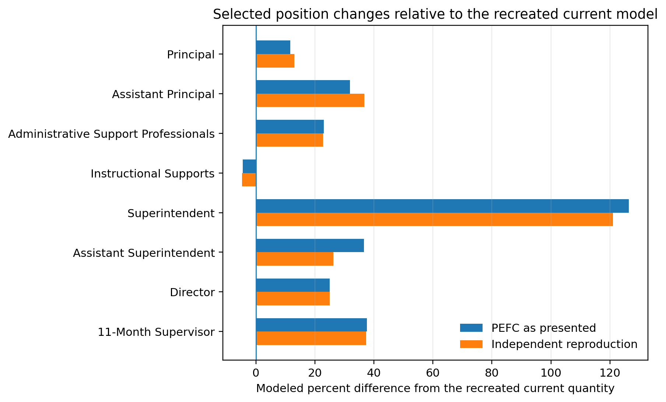
Source: 11_three_way_position_comparison.csv. Categories with partial comparability should be read as broad functional groupings, not exact one-to-one positions.
The independent reproduction produces 29 more principals than the current reconstruction because the proposed rule awards one per calculation unit and charters may have multiple calculator buildings. Assistant Principals increase by 132.85 positions, and Administrative Support Professionals increase by 239. The proposed Instructional Supports total is lower than the mapped current support total by 114.85 positions, but the categories are only partially comparable because the current model identifies individual functions separately.
Central Office changes are also substantial. The independent reproduction produces 42 Superintendents and 42 Reading Cadre positions because those proposed formulas apply to all included LEAs, compared with 19 district-only positions in the current reconstruction. Assistant Superintendents increase from 19 to 24, Directors from 60 to 75, and 11-Month Supervisors from 78.29 to 107.54.

5.3 Statewide funding comparison
Exhibit 7B. Statewide funding sections and modeled differences
Funding measure | Recreated current | PEFC as presented | Independent reproduction | Independent difference from current
Base Funding | $1,526.7M | $1,558.1M | $1,555.6M | $28.9M
Central Office Funding | $35.6M | $59.4M | $58.4M | $22.8M
Position-based Funding | $1,562.2M | $1,617.5M | $1,614.0M | $51.8M
Weighted Funding | — | $442.0M | $442.0M | —
Total modeled funding | $1,562.2M | $2,059.6M | $2,056.1M | $493.8M

Source: 11_three_way_funding_comparison.csv. Weighted and total comparisons have no directly recreated current equivalent and are gross comparisons only.
The independent Base amount is $28.9 million above the partial current Base amount. Independent Central Office Funding is $22.8 million above the incomplete current Central Office amount. Together, those sections produce the $51.8 million position-based modeled difference, or 3.3%. The $442.0 million in weighted funding has no directly recreated current section, which is why the $493.8 million full-model difference must be treated as gross rather than net.

5.4 Why the PEFC and independent estimates differ
The PEFC calculator’s displayed statewide total is $2.0596 billion, while the independent reproduction is $2.0561 billion. On the surface, PEFC is about $3.51 million higher. That comparison mixes different scopes. The PEFC calculator includes DAFB and Bryan Allen Stevenson in its source rows unless a specific formula excludes an entity; the independent reproduction reports the final 42-LEA scope.
The scope-normalized bridge separates the workbook display, the sum of PEFC LEA rows, the same 42-LEA PEFC scope, and the independent reproduction. After restricting PEFC to the same 42 LEAs, the PEFC total is $2.0519 billion, which is $4.13 million below the independent reproduction. The direction of the difference changes after scope alignment.
Exhibit 7C. PEFC scope-normalized funding bridge
Measure | PEFC displayed | PEFC final 42-LEA scope | Independent reproduction | Displayed minus independent | Aligned PEFC minus independent
Base Funding | $1,558.1M | $1,552.1M | $1,555.6M | $2.5M | $-3.5M
Central Office Funding | $59.4M | $58.7M | $58.4M | $1.0M | $0.3M
Position-based Funding | $1,617.5M | $1,610.8M | $1,614.0M | $3.5M | $-3.2M
Weighted Funding | $442.0M | $441.1M | $442.0M | $0.0M | $-0.9M
Total modeled funding | $2,059.6M | $2,051.9M | $2,056.1M | $3.5M | $-4.1M

Source: 11_pefc_scope_normalized_comparison.csv. This is a reporting bridge, not a formal causal decomposition.
Figure 2. Difference from the independent reproduction across PEFC scope stages
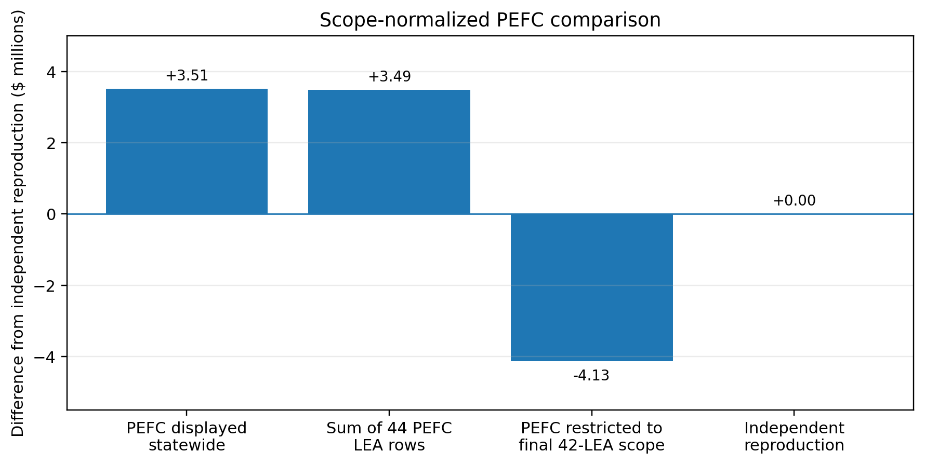
Source: 11_pefc_scope_normalized_comparison.csv. Values shown in millions of dollars.
Within the aligned scope, PEFC Base Funding is $3.51 million below the independent reproduction, PEFC Central Office Funding is $0.31 million above it, and PEFC weighted funding is $0.93 million below it. The weighted difference occurs because simply dropping excluded PEFC LEA amounts does not redistribute the fixed pools, while the independent pipeline recalculates the rates so that the full $442.0268 million is distributed across the remaining eligible weighted units.
The remaining aligned difference also reflects source inputs, calculation units, and formula interpretations. The independent reproduction has 252 principals compared with 249 in the PEFC display, retains written 0.65 and 1.65 assistant-principal awards, and uses completed thresholds for Assistant Superintendent positions rather than a proportional fractional result.

5.5 LEA-level distribution
The statewide aggregate summarizes total dollars, but it does not describe how the modeled changes are distributed across LEAs. In the preliminary position-based comparison, 41 of 42 included LEAs increase and one district, Christina, decreases by 0.4%. The median LEA change is 9.4%, with the middle half ranging from 3.1% to 15.3%.
Under the gross full-model comparison, all 42 LEAs increase. The median modeled change is 39.6%, and the middle half ranges from 29.6% to 48.4%. These larger percentages should not be read as confirmed net gains because the current baseline is incomplete and the weighted pools have not been netted against all existing appropriations.
Charters show larger percentage changes than districts in this modeling exercise. Aggregate charter position-based funding increases by 11.4%, compared with 2.3% for districts. Under the gross full model, the aggregate changes are 40.7% for charters and 30.5% for districts. Smaller LEAs can show large percentage changes even when their dollar differences are modest, so both measures should be considered together.
Figure 3. LEA modeled percentage differences by LEA type
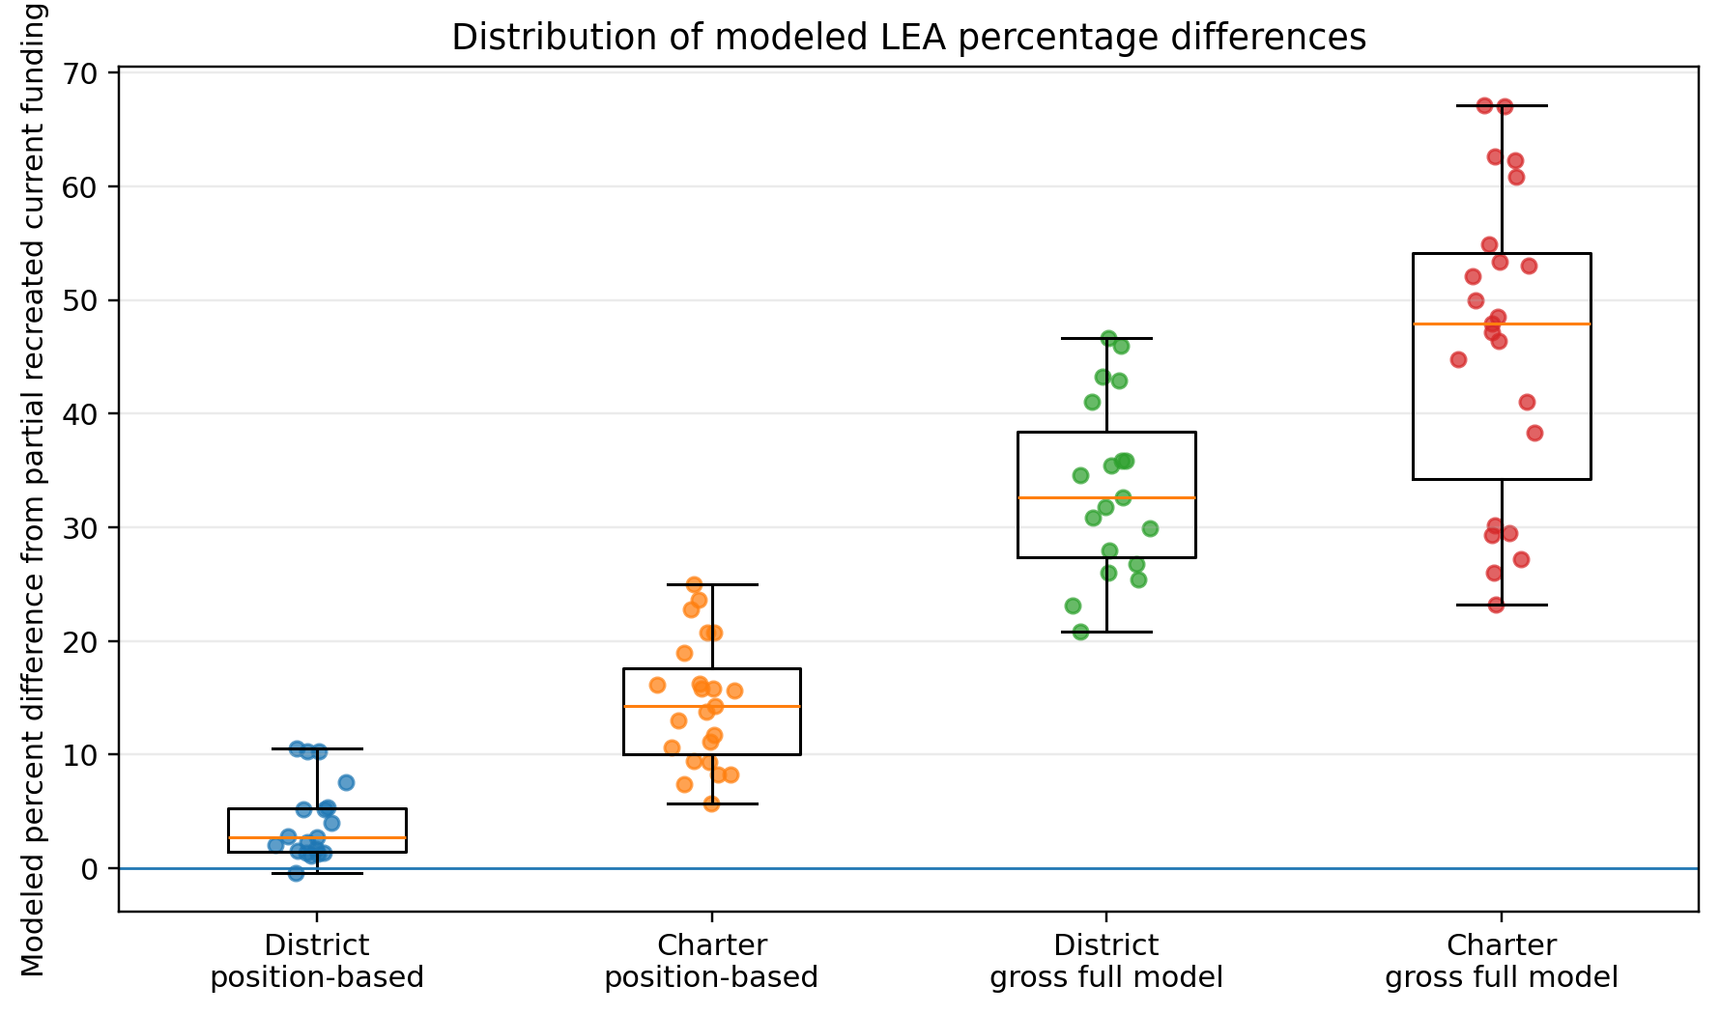
Source: 11_figure_lea_change_by_type.csv and 11_lea_distribution_for_report.csv. Percentages compare proposed modeled funding with the partial recreated current baseline.
Comparison | LEAs | Aggregate change | Median LEA change | Direction
Position-based | 42 | 3.3% | 9.4% | 41 increase; 1 decrease
Gross full model | 42 | 31.6% | 39.6% | 42 increase; 0 decrease
Charter position-based | 23 | 11.4% | 14.3% | 23 increase
District position-based | 19 | 2.3% | 2.7% | 18 increase; 1 decrease
Charter gross full model | 23 | 40.7% | 47.9% | 23 increase
District gross full model | 19 | 30.5% | 32.6% | 19 increase

Source: 11_lea_distribution_for_report.csv and 11_lea_type_for_report.csv.

6. Key Findings
The analysis supports eight main findings. These findings summarize the validated results; they do not introduce new calculations.
The proposed model changes both structure and funding method. It reorganizes position-based funding into Base and Central Office sections and adds two weighted-student pools.
Teaching-position totals are close after input and scope alignment. The current and independent Base Division I totals differ by less than one position statewide. Larger differences arise in administration and support formulas.
Charter building treatment materially affects school-based positions. The proposed model applies Base formulas to charter building rows while keeping weighted enrollment at the charter-organization level.
The proposed model consolidates current support functions. Counselors, psychologists, nurses, Academic Excellence, driver education, related services, and visiting teachers are represented through one Instructional Supports line.
Central Office eligibility expands for charters. Superintendent and Reading Cadre positions increase from 19 current district positions to 42 proposed positions across all included LEAs.
Scope alignment is necessary to interpret PEFC differences. The PEFC displayed total is $3.51 million above the independent reproduction, but the same-scope PEFC result is $4.13 million below it.
The position-based comparison is approximately +$51.8 million. This is the closest available comparison, but it remains preliminary because the current baseline is incomplete.
The $493.8 million gross difference is not a net fiscal impact. The current recreation does not include all appropriations that could continue, be consolidated, or be replaced by the proposed weighted pools.
Exhibit 8. Key comparison measures and interpretation guardrails
Measure | Result | How to interpret it
Final reporting scope | 140,706 students; 42 LEAs | DAFB and Bryan Allen Stevenson excluded.
Position-based modeled difference | +$51.8M (+3.3%) | Closest available comparison; current baseline incomplete.
Weighted funding | $442.0268M | Fixed Opportunity and Operational pools.
Gross modeled difference | +$493.8M (+31.6%) | Not a confirmed net fiscal impact.
PEFC displayed vs independent | +$3.51M | Uses different scopes.
PEFC aligned scope vs independent | −$4.13M | Same 42-LEA scope; remaining differences reflect implementation and inputs.
LEA direction | 41 of 42 position-based; 42 of 42 gross | Preliminary because current funding is partial.

Source: 11_key_report_metrics.csv; 11_pefc_scope_normalized_comparison.csv; 11_lea_distribution_for_report.csv.

7. Limitations, Unresolved Questions, and Next Steps
The pipeline establishes a reproducible comparison, but several data, policy, workbook, and fiscal questions remain. These limitations do not erase the analysis; they define how the results should be used and what work is needed before the comparison can support a complete fiscal conclusion.

7.1 Current-model data gaps
The largest limitation is the incomplete current baseline. Site-evaluated custodian positions are unavailable, as are the custodial units needed to determine Buildings and Grounds Supervisor eligibility. School-lunch indicators are missing for some LEAs, and charter satellite cafeteria counts have not been confirmed. No defensible current rate was identified for cafeteria managers or workers, and the separate district cafeteria process is not modeled.
The current Pre-K teaching quantity is also source-reported rather than independently recalculated because the underlying special education Pre-K headcount is not available in Unit Count. Missing information is left blank rather than treated as zero.

7.2 Policy and implementation questions
The current nurse fractional rule still needs confirmation. Within the proposed model, the written assistant-principal note and literal workbook formula conflict over 0.65 and 1.65 awards. The independent reproduction follows the written fractional-position rule. Assistant Superintendent eligibility also needs formal confirmation because the workbook appears to allow a proportional second position while the pipeline uses completed 300-position thresholds.
The selected Central Office position bases should be formally documented. The independent reproduction uses Total Base positions for Assistant Superintendent, Director, and 11-Month Supervisor and Base Division I for Food Services Supervisor. These treatments are explicit in the pipeline and should be updated only through a documented policy decision.

7.3 Workbook and source questions
The five PEFC Summary reconciliation differences should be reviewed with the workbook owner. The ASPIRA one-student source discrepancy should also be resolved in the authoritative source. More broadly, the intended universe of charter building calculation units should be formally confirmed because it directly affects principal and school-support positions.
The calculator includes an optional Additional State Funding mechanism without a supporting written rule. The independent reproduction excludes it. It should be added only after the amount, authority, and distribution rule are confirmed.

7.4 Requirements for a net fiscal analysis
A net fiscal comparison requires more than completing the current position lines. It also requires an appropriation-level crosswalk showing which current programs and appropriations would continue, be consolidated, be replaced, or be added under the proposed model. Until that work is complete, the weighted pools should be presented as proposed modeled allocations rather than a net new cost.
Exhibit 9. Material limitations and unresolved questions
Issue | Current status | Next step
Custodian positions and rate | Missing | Complete source positions and approve a rate.
Custodial units / Buildings and Grounds | Missing | Populate authoritative custodial units.
Food Services eligibility | Incomplete | Provide lunch-building inputs for affected LEAs.
Charter cafeteria inputs and rates | Incomplete | Confirm satellite counts and applicable rates.
Current nurse fraction | Policy question | Confirm the 30% fractional interpretation.
Assistant Principal note vs formula | Workbook conflict | Confirm intended 0.65 and 1.65 awards.
Assistant Superintendent fraction | Implementation question | Confirm whole versus proportional positions.
Selected Central Office bases | Documented interpretation | Formally confirm Total Base and Base Division I uses.
PEFC internal reconciliation | Workbook discrepancy | Confirm displayed statewide formulas or totals.
ASPIRA input discrepancy | Source discrepancy | Confirm authoritative enrollment.
Current appropriation crosswalk | Not yet complete | Identify offsets and continuing funding before net fiscal conclusions.

Source: 11_decision_discrepancy_log.csv; 04_current_model_issues.csv; 05_current_model_rate_issues.csv.

7.5 Recommended next steps
1. Complete and validate the missing current custodial, facilities, lunch-program, and cafeteria inputs and rates, then rerun the full pipeline.
2. Obtain written confirmation for the assistant-principal fractional rule, Assistant Superintendent fractional eligibility, selected Central Office position bases, and the current nurse fractional treatment.
3. Resolve the PEFC Summary reconciliation items and confirm the intended charter calculation-unit universe.
4. Create an appropriation-level current-to-proposed crosswalk before describing the gross modeled difference as a net fiscal effect.
5. Maintain all future source corrections and policy decisions in the project inputs or settings, rerun Steps 01–11, and regenerate both the main report and companion appendices from the validated outputs.
Bottom line: The analysis is ready to support technical and policy discussion about how the models differ. It is not yet ready to support a final statement of net statewide cost or final LEA gains and losses.

Companion Technical Appendices
The technical appendices will be delivered separately from this main report. They will provide the detailed proof behind the narrative without overwhelming the main document.
Appendix | Planned content
Appendix A | Source lineage, analysis version, run settings, and manifest
Appendix B | Definitional tables for inputs, formulas, quantities, rates, and major differences
Appendix C | Full current-model formulas, quantities, rate mappings, and missing components
Appendix D | PEFC workbook extraction and internal reconciliation
Appendix E | Independent reproduction decisions and evidence classifications
Appendix F | Charter building allocation and reconciliation
Appendix G | Detailed three-way input, position, rate, funding, and scope comparisons
Appendix H | LEA-level results and distribution tables
Appendix I | Quality control, rounding rules, and exhibit traceability

The main report and appendices should be treated as a matched set. The main report explains what the models do, what the independent review found, and why the differences matter. The appendices show exactly how the inputs, formulas, source choices, and quality checks support those conclusions.
END OF FIRST FULL DRAFT

