Delaware School Funding Model
Independent Verification and Validation Technical Analysis Summary
School Year 2025–26
━━━━━━━━━━━━━━━━━━━━━━━━━━━━━━━━━━
August XX, 2026

Analytical status
The staffing analysis remains partly provisional, and confirmed current-model analogues for Opportunity and Operational Funding are not yet available. This report presents the IV&V findings to date and should not be read as a final determination of net fiscal impact.

The analysis outputs, scripts, and supporting technical documentation are maintained in the School Funding Models GitHub repository. Together, these materials provide the reproducible technical record underlying the findings presented in this report.

How to read the report
The report is organized around the questions the IV&V was designed to answer: what changes under the proposed staffing rules, how the proposed weighted funding streams operate, what the combined fiscal picture shows and does not show, how the independent implementation compares with the PEFC workbook, and what still requires confirmation.
Rounding
Dollar amounts in the narrative are generally rounded to the nearest $0.1 million. Position quantities are rounded for display where doing so improves readability. Pipeline calculations and technical reconciliation files retain full precision.

Table of Contents
Executive Summary (TBD) 4
What the analysis found 4
1. What the IV&V Examined and Why 5
1.1 Scope and interpretation 6
1.2 Official school codes and funding calculation units 6
2. What Changes Under the Staffing Rules? 8
2.1 Three views of the statewide staffing comparison 8
2.2 Core teaching quantities are nearly unchanged 9
2.3 The largest differences occur outside core teaching 10
2.4 Principals show why calculation units matter 12
2.5 District and charter patterns 13
3. How Do Opportunity and Operational Funding Work? 15
3.1 Opportunity Funding 15
3.2 Operational Funding 15
3.3 Fixed pools and recalculated rates 15
3.4 Proposed allocation and current comparison status 16
3.5 LEA-level composition of proposed weighted funding 16
4. What Does the Combined Fiscal Picture Show? 20
What a net fiscal analysis still requires 20
5. How Does the IV&V Proposed Model Compare with the PEFC Workbook? 22
5.1 Principal positions show the effect of calculation-unit implementation 22
5.2 Staffing-rule interpretations produce practical differences 23
5.3 The workbook does not use one consistent organizational scope 24
5.4 Overall assessment 24
6. What Remains to Be Confirmed? 25
How the pipeline handles unresolved items 26
7. How Was the Analysis Built and Validated? 27
Technical documentation and audit trail 27
Conclusion 27
Technical Appendices 28
Appendix A. Key terms and evidence labels 28
Appendix B. Selected staffing rules 28
Appendix C. Report exhibit traceability 29
Appendix D. Interpretation guardrails 30

Executive Summary (TBD)
The IV&V analysis recreated the portions of the current staffing model that could be supported by available data, independently implemented the proposed model, and compared that implementation with the PEFC workbook as presented. The work was designed to distinguish the substantive current-versus-proposed analysis from the separate validation of the workbook itself.

What the analysis found
TBD…

1. What the IV&V Examined and Why
The IV&V analysis was designed to provide an independent and reproducible assessment of the proposed funding model while also creating a consistent basis for comparing it with the current model. The work had three closely related goals:
- Develop a common, independently verifiable set of inputs. The analysis assembled student counts, reported units, school and LEA records, and other required model inputs from sources obtained independently of the PEFC workbook. These inputs were not necessarily different from those used in the workbook, but they were retrieved, reconciled, and validated through separate processes.
- Compare the current and proposed models on a common analytical foundation. The analysis applied the same independently verifiable inputs across both models, as closely as their structures allowed. For comparable staffing categories, it also applied PEFC’s recommended current dollar rates to both the recreated current and IV&V proposed staffing quantities through maintained component mappings. This approach helps isolate differences attributable to staffing formulas, thresholds, eligibility rules, position bases, and calculation units rather than differences in source inputs or dollar-rate assumptions. Where no defensible rate or mapping was available, the amount remains missing rather than being treated as zero.
- Compare the independently implemented proposed model with the PEFC workbook. The analysis reproduced the proposed formulas and eligibility rules in a transparent pipeline and compared the resulting estimates with the workbook as presented. This comparison evaluates how closely the proposed model can be independently reproduced and identifies differences related to inputs, scope, calculation units, formula interpretation, or workbook mechanics.
Together, these goals distinguish the substantive current-versus-proposed comparison from the validation of the proposed model as represented in the PEFC workbook, while grounding both in a consistent and independently reviewed analytical framework. The resulting common-rate estimates support a consistent comparison but should not be interpreted as independently verified actual expenditures or complete costs under the current funding system.
Exhibit 1. The three analytical objects
Analytical object | Role in the analysis
Recreated current staffing model | Recreates current staffing quantities and available modeled funding estimates using Unit Count, independently obtained student counts, documented rules, maintained rate mappings, and available supplemental inputs.
IV&V proposed model | Independently implements the proposed Base, Opportunity, Operational, and Central Office formulas using common, independently sourced and reconciled inputs, along with explicit interpretation rules.
PEFC workbook as presented | Serves as the reference implementation for validating the proposed model. It is evaluated at face value, including its source inputs, calculation units, formulas, displayed totals, and scope treatment.
Source: README.md; scripts 02–11; maintained model labels in 00_settings.R.

1.1 Scope and interpretation
The primary comparison uses School Year 2025–26 data and a September 30, 2025 count date. It includes 43 LEAs: 19 districts and 24 charters. Bryan Allen Stevenson School of Excellence (BASSE) remains included. Delaware Air Force Base (DAFB) is calculated in detailed files but excluded from the primary statewide comparison pending confirmation of its final treatment.
Exhibit 2. IV&V analysis at a glance
Measure | Current IV&V status
Primary scope | 43 LEAs: 19 districts and 24 charters
Students | 140,829
Official coded schools | 229: 205 district schools and 24 charter organization records
Proposed school calculation units | 253: 205 district school codes and 48 charter building units
Weighted funding pools | $163.0M Opportunity + $279.0268M Operational
Source: 00_run_settings.csv; 11_final_qc.csv; Step 02 and Step 06 validated outputs.
The report uses several evidence labels. “Confirmed” means the comparison mapping, quantity, and common rate are established in the maintained project files. “Provisional” means a working treatment is implemented but still requires confirmation. “Not yet estimable” means a required current input, rate, or allocation is unavailable. Missing values are left missing rather than being converted to zero.

1.2 Official school codes and funding calculation units
A school code is an official administrative identifier. A calculation unit is the school or building row to which a funding formula is applied. Under the current administrative structure, district schools are generally represented by separate official school codes, while a charter organization is assigned one school code even when it operates multiple buildings or grade-span programs.
The PEFC workbook uses a different proposed representation for certain charter organizations. It identifies separate charter buildings as calculation units for school-based Base formulas. This makes the charter funding structure more similar to the district structure for formulas such as one principal per school.
Exhibit 3. Current administrative representation and proposed funding representation
Entity | Current administrative representation | Proposed funding-model representation
Districts | One official school code per recognized school building | Official school code used as proposed calculation unit
Charters | One official school code per charter organization | PEFC building rows used as proposed calculation units for school-based Base formulas
Weighted funding | Official LEA and charter totals | Official charter organization totals counted once; building rows do not duplicate students
Source: 00_settings.R; 02_shared_model_input.csv; 06_proposed_school_calculation_units.csv; 11_charter_building_treatment.csv.
Key implications
- Primary impacts: Principals, Administrative Support Professionals, and Assistant Principals because these formulas are applied separately to each school or building unit.
- Downstream effects: Assistant Superintendents, Directors, and 11-Month Supervisors because changes in school-based positions flow into Total Base positions.

2. What Changes Under the Staffing Rules?
For comparable staffing categories, the analysis applies a common, independently verified input base and holds the dollar rate constant within each category, as closely as the models’ structures allow. The common rates are drawn from the PEFC workbook and represent PEFC’s recommended current dollar rates for the relevant position categories. These rates are applied to both the recreated current and IV&V proposed staffing quantities through maintained component mappings. Where no defensible rate or mapping was available, the amount remains missing rather than being treated as zero.
This approach helps isolate differences attributable to the models’ staffing formulas, thresholds, eligibility rules, position bases, and calculation units rather than differences in source inputs or dollar-rate assumptions. The resulting estimates support a consistent comparison but should not be interpreted as independently verified actual expenditures or complete costs under the current funding system.

2.1 Three views of the statewide staffing comparison
The working staffing difference is $52.5 million. Removing the proposed Buildings and Grounds amount, for which a comparable current amount is unavailable, produces a $47.1 million comparable-amount subtotal. Restricting the analysis further to the 15 categories with confirmed mappings, quantities, and rates produces a partial difference of $35.9 million. The differences across these views reflect evidence status and completeness, not different versions of the proposed model.
Exhibit 4. Statewide staffing comparison
View | Recreated current | IV&V proposed | Difference | Categories included | How to use it
Working estimate | $1.564B | $1.616B | $52.5M | 15 confirmed categories plus four provisional categories: Administrative Support Professionals, Instructional Supports, Buildings and Grounds, and Food Services Supervisors. | Broadest view. Includes proposed Buildings and Grounds funding without a comparable current amount; custodial and cafeteria positions remain excluded from the current model.
Comparable-amount subtotal | $1.564B | $1.611B | $47.1M | 15 confirmed categories plus Administrative Support Professionals, Instructional Supports, and Food Services Supervisors. | Includes only categories with funding amounts on both sides, though some mappings or current inputs remain provisional.
Confirmed subtotal | $1.248B | $1.283B | $35.9M | 15 confirmed categories listed in the accompanying note. | Most firmly supported view. Excludes provisional and not-yet-estimable categories.
Source: 11_staffing_statewide_comparison.csv. Values rounded; detailed outputs retain full precision.
Confirmed categories
The confirmed subtotal includes 15 staffing categories with confirmed comparison mappings, quantities, and common PEFC-recommended rates:
- K–3 Regular Education Teachers; Grades 4–12 Regular Education Teachers; Basic, Intensive, and Complex Special Education Teachers; net Vocational Division I positions; Principals; Assistant Principals; Superintendents; Administrative Assistants; Assistant Superintendents; Directors; 11-Month Supervisors; Transportation Supervisors; and Reading Cadre.

2.2 Core teaching quantities are nearly unchanged
The recreated current model carries forward the Division I teaching quantities reported in the SY 2025–26 Unit Count file produced by the Data Service Center. The IV&V proposed model uses the corresponding student enrollment categories from that same file and applies the proposed staffing ratios to recalculate the teaching quantities. For these categories, the proposed ratios are the same as the Division I staffing ratios reflected in the current Unit Count quantities.
For charters, the official Unit Count totals are allocated across the building-level calculation units identified in the PEFC workbook while preserving the charter organization totals. Vocational positions and deductions are carried forward unchanged in both models.
Because the two models use the same underlying Unit Count enrollment categories and equivalent staffing ratios for these teaching categories, the statewide Base Division I totals are nearly identical. The IV&V proposed model produces only 0.26 more positions statewide. The small remaining differences are consistent with differences in calculation precision and aggregation rather than meaningful changes in statewide teaching levels.
Exhibit 5. Core teaching and vocational quantities
Category | Recreated current | IV&V proposed | Position difference
K–3 Regular Education Teachers | 2,090.01 | 2,090.06 | +0.05
Grades 4–12 Regular Education Teachers | 3,989.70 | 3,989.70 | 0.00
Basic Special Education Teachers | 1,653.86 | 1,653.93 | +0.07
Intensive Special Education Teachers | 1,152.47 | 1,152.50 | +0.03
Complex Special Education Teachers | 2,449.12 | 2,449.23 | +0.11
Net Vocational Division I Positions | 419.22 | 419.22 | 0.00
Total Base Division I | 11,754.38 | 11,754.64 | +0.26
Source: 11_staffing_component_comparison.csv. Net vocational positions combine the reported vocational positions and vocational deduction, both of which are retained unchanged in the two models.
Taken together, these results show that core teaching quantities are not the main source of the statewide staffing difference. The larger differences emerge in school administration, support positions, Central Office eligibility, position bases, and school calculation units.

2.3 The largest differences occur outside core teaching
Figure 1. Largest working staffing differences by category
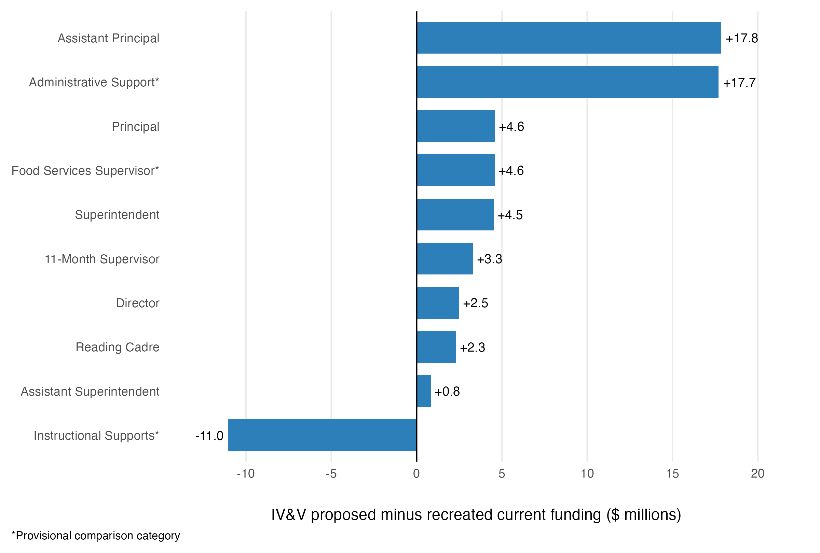Source: 11_staffing_component_comparison.csv. Asterisks identify provisional comparison categories.
Exhibit 6. Major staffing-rule drivers
Category | Current | Proposed | Position difference | Funding difference | Status
Assistant Principal | 361.75 | 494.60 | +132.85 | $17.8M | Confirmed
Administrative Support Professionals | 1,053 | 1,292 | +239.00 | $17.7M | Provisional
Instructional Supports | 2,465.81 | 2,350.93 | -114.88 | $-11.0M | Provisional
Principal | 223 | 253 | +30.00 | $4.6M | Confirmed
Superintendent | 19 | 43 | +24.00 | $4.5M | Confirmed
Food Services Supervisor | 9 | 46 | +37.00 | $4.6M | Provisional
11-Month Supervisor | 78.36 | 107.63 | +29.27 | $3.3M | Confirmed
Director | 60 | 75 | +15.00 | $2.5M | Confirmed
Reading Cadre | 19 | 43 | +24.00 | $2.3M | Confirmed
Assistant Superintendent | 19 | 24 | +5.00 | $839,290 | Confirmed
Source: 11_staffing_component_comparison.csv.
The three largest working funding differences come from Assistant Principals, Administrative Support Professionals, and Instructional Supports. Together, they produce a net increase of approximately $24.5 million, although the Administrative Support and Instructional Supports comparisons remain provisional.
- Assistant Principals increase by 132.85 positions and $17.8 million. Both models use the same threshold schedule, but the recreated current model applies it to reported Division I units, while the proposed model applies it to a broader base that also includes Administrative Support Professionals and Instructional Supports. This broader base moves more school calculation units into higher staffing thresholds, but the effect differs by sector. District school calculation units remain the same across models, allowing more schools to cross the thresholds, while dividing some charter organizations into multiple building-level units slightly reduces the proposed charter total.
- Administrative Support Professionals increase by 239 positions and $17.7 million for a similar reason. The recreated current model calculates Secretary positions from reported Division I units, while the proposed model applies the same threshold schedule to Base Division I positions, Principals, and Instructional Supports. The comparison remains provisional because current Secretaries are mapped to a broader proposed category and valued using PEFC’s recommended Administrative Support rate.
- Instructional Supports offset part of these increases, declining by 114.88 positions and $11.0 million. The proposed model sets a consolidated allocation equal to 20% of Base Division I positions, while the recreated current comparison combines several separately funded functions, including counselors and social workers, psychologists, nurses, Academic Excellence, driver education, related services, and visiting teachers. Because these functions use different formulas and do not map one-for-one to the proposed category, the result should be interpreted as a broad functional comparison rather than a direct reduction in identical positions or services.
The remaining staffing differences stem from four main features of the proposed model: the use of additional building-level calculation units for some charter organizations, as proposed in the PEFC workbook; expanded charter eligibility for certain LEA-level positions; a broader Central Office position base; and a revised Food Services Supervisor rule.
- Principals increase by 30 positions and $4.6 million. The recreated current model provides one Principal only when an official coded school has at least 15 Division I units, while the proposed model provides one for every district school code and charter building calculation unit. Of the 30-position increase, 24 reflect the additional charter building units beyond the 24 official charter organization codes, and six reflect the removal of the 15-unit threshold for five district schools and one charter.
- Superintendents and Reading Cadre each increase by 24 positions, adding $4.5 million and $2.3 million, respectively. The current model provides one of each position per district but excludes charters. The proposed model provides one per LEA, leaving the 19 district totals unchanged while adding one position for each of the 24 charter LEAs.
- Assistant Superintendents, Directors, and 11-Month Supervisors increase because the proposed model applies their formulas to a broader Central Office position base. The recreated current model uses Division I units, while the proposed model uses Total Base positions, which also include Principals, Assistant Principals, Administrative Support Professionals, and Instructional Supports. The Assistant Superintendent and Director formulas retain their existing completed thresholds, so the broader base moves some LEAs into higher staffing levels. This produces five additional Assistant Superintendents and 15 additional Directors, adding approximately $839,000 and $2.5 million. The five Assistant Superintendent positions occur entirely among districts because no charter reaches the 300-position threshold. Because 11-Month Supervisors are calculated proportionally at one per 150 positions, the broader base increases the allocation across all LEAs by 29.27 positions and $3.3 million.
- Food Services Supervisors show a working increase of 37 positions and $4.6 million, but this comparison remains provisional. The current model limits eligibility to districts and provides one position at 500 Division I units or when an LEA operates at least four lunch-program buildings. The proposed model instead provides one position per LEA, including charters, plus an additional position for each completed 500 Base Division I positions beyond the first 500. This produces one position for each of the 24 charters and a second position for three large districts. However, lunch-program building counts are still missing for ten in-scope districts below 500 units, so the current total of nine positions is incomplete and the working difference may narrow once those data are available.

2.4 Principals show why calculation units matter
An official coded school is a school represented by a distinct school code in DDOE systems. Under the DDOE interpretation reflected in the attached 2023 correspondence, each charter organization is treated as one coded school regardless of the number of buildings it operates. A school calculation unit, by contrast, is the unit to which the funding formula is applied.
The current model provides one Principal only when an official coded school has at least 15 Division I units. The proposed model provides one Principal for every school calculation unit, including the separate building-level units proposed for some charter organizations in the PEFC workbook. The resulting increase therefore reflects both the removal of the 15-unit threshold and the use of additional charter building units.
Exhibit 7. Bridge from 223 current principals to 253 proposed principals
Bridge element | Positions | Explanation
Recreated current principal positions | 223 | Current rule: one Principal for a school building or combination of school buildings once it reaches at least 15 Division I units.
Effect of additional charter building calculation units | +24 | The proposed model uses 48 charter building-level calculation units rather than 24 official charter organization codes, adding 24 units eligible for a Principal.
Effect of replacing the current 15-unit minimum | +6 | Five district coded schools and BASSE have fewer than 15 Division I units and therefore receive no Principal under the recreated current rule, but each receives one under the proposed rule.
IV&V proposed principal positions | 253 | Proposed rule: one Principal for every school calculation unit.
Source: 04_current_model_quantities.csv; 07_proposed_model_quantities.csv; 11_charter_building_treatment.csv.
The 30-position increase reflects two distinct changes. Twenty-four positions result from using 48 charter building-level calculation units rather than 24 official charter organization codes. The remaining six result from replacing the current 15-unit minimum with the proposed rule of one Principal per calculation unit. The six affected units are Capital Early Childhood Center, Pulaski Early Education Center, Stubbs Early Education Center, DelCastle ILC, First State School, and BASSE.
Interpretation
The additional charter building rows are funding calculation units used to apply school-based formulas under the proposed model. Based on the building structure presented in the PEFC workbook, they allow certain staffing rules to be applied separately to distinct charter buildings.

Charter totals are allocated across building units only for Base staffing formulas, while Opportunity and Operational Funding retain each charter organization’s students and weighted counts once. The building rows therefore affect how certain school-based positions are calculated, not the number of students funded statewide.

2.5 District and charter patterns
Exhibit 8. LEA distribution of comparable staffing amounts
LEA type | LEAs | Current | Proposed | Aggregate change | Median LEA change | Direction
Districts | 19 | $1.393B | $1.423B | +2.2% | 2.6% | 18 increase; 1 decrease
Charters | 24 | $170.7M | $187.7M | +9.9% | 12.6% | 24 increase
All LEAs | 43 | $1.564B | $1.611B | +3.0% | 8.4% | 42 increase; 1 decrease
Source: IV&V pipeline outputs. Comparable amounts include working categories with known funding amounts under both models; provisional category mappings and quantities remain included.
Charters show larger percentage increases because several proposed-model changes affect them more directly. Some charter organizations are represented by multiple building-level calculation units for school-based staffing formulas, and charters become eligible for several LEA-level positions that are limited to districts in the recreated current model. Because charters generally begin with smaller current funding totals, moderate dollar increases also translate into larger percentage changes.
Christina remains the only LEA with a negative comparable difference, at approximately -0.5%. Its confirmed subtotal, however, increases by approximately 2.2%, meaning the negative result appears only after provisional support-category comparisons are included. This contrast shows why LEA-level comparable estimates should be treated as directional rather than described as final gains or losses until the provisional mappings, quantities, and rates are resolved.
Figure 2. Distribution of comparable staffing funding
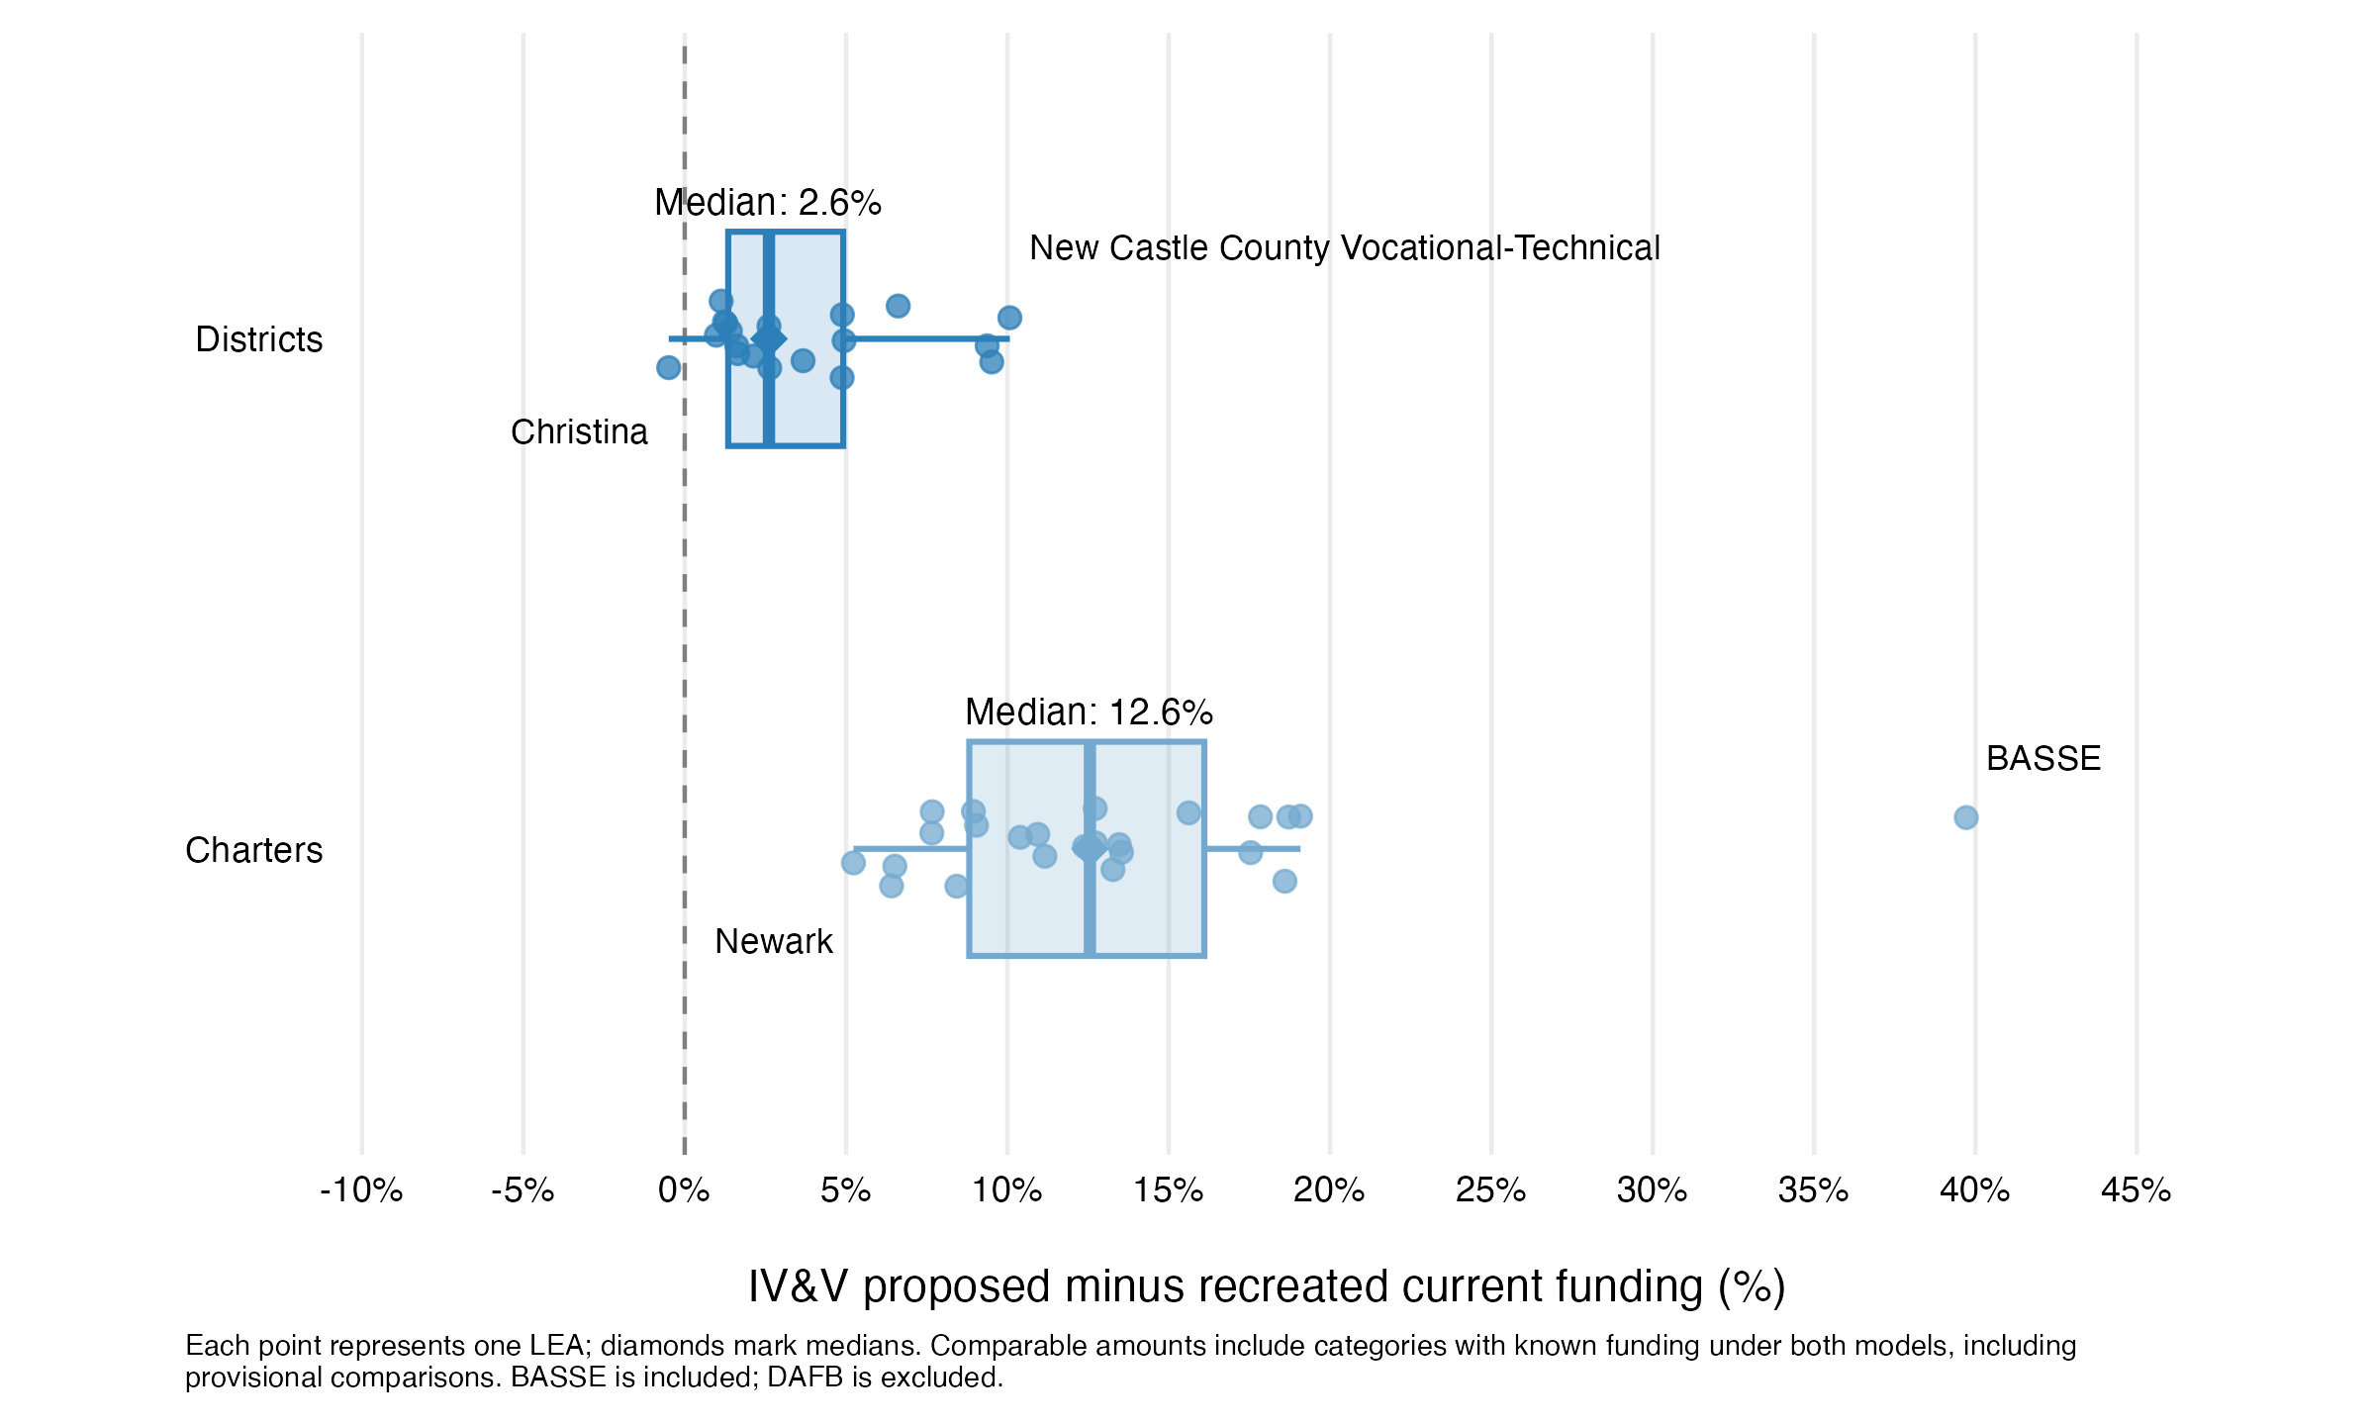
Source: IV&V analysis of SY 2025–26 staffing quantities and PEFC-recommended rates; calculations from 11_staffing_lea_comparison.csv and 08_proposed_model_funding_detail.csv.
This pattern reflects proposed-model changes that affect charters more directly, as well as the larger percentage effect of moderate dollar changes on smaller funding bases. District results are more tightly clustered around zero, with Christina the only LEA showing a negative comparable difference. Because the comparable totals still include provisional category mappings, these results should be interpreted as directional rather than final LEA-level gains or losses.
Note
BASSE contributes approximately $1.4 million to the recreated current total and $2.0 million to the proposed comparable total, a net increase of about $561,000. It is included because the analysis reflects the SY 2025–26 model scope, but BASSE will not operate in SY 2026–27.

3. How Do Opportunity and Operational Funding Work?
The proposed model adds two funding streams that are not tied to staffing positions: Opportunity Funding and Operational Funding. Each distributes a fixed statewide pool using weighted student counts. Eligible student counts are multiplied by category weights to create weighted units, and the statewide pool is divided by the total weighted units to calculate a statewide per-weighted-student rate. Each LEA’s allocation equals that rate multiplied by its weighted units.

3.1 Opportunity Funding
Opportunity Funding is distributed using low-income and active multilingual learner counts, weighted according to their respective formula weights. Within the 43-LEA primary scope, these counts produce 32,939.54 weighted units. Dividing the fixed $163.0 million pool by those units yields a rate of approximately $4,948.46 per weighted unit.

3.2 Operational Funding
Operational Funding is distributed using total enrollment and counts of low-income students, active multilingual learners, Basic special education students, Intensive special education students, Complex special education students, and vocational students, each weighted according to the formula. Within the 43-LEA primary scope, these counts produce 85,860.95 weighted units. Dividing the fixed $279.0268 million statewide pool by those units yields a rate of approximately $3,249.75 per weighted unit.
Exhibit 9. Proposed weighted funding inputs, weights, and statewide amounts
Funding stream | Input | Raw count | Weight | Weighted count
Opportunity | Low income | 36,713 | 0.675 | 24,781.275
Opportunity | Active multilingual learner | 17,358 | 0.47 | 8,158.260
Operational | Total enrollment | 140,829 | 0.20 | 28,165.800
Operational | Low income | 36,713 | 0.675 | 24,781.275
Operational | Active multilingual learner | 17,358 | 0.47 | 8,158.260
Operational | Basic special education | 13,893 | 0.48 | 6,668.640
Operational | Intensive special education | 6,915 | 0.67 | 4,633.050
Operational | Complex special education | 6,368 | 1.54 | 9,806.720
Operational | Vocational enrollment | 18,236 | 0.20 | 3,647.200
Source: 08_proposed_weighted_component_summary.csv; 08_proposed_weighted_rate_summary.csv.

3.3 Fixed pools and recalculated rates
The PEFC calculator provides the statewide pool amounts for Opportunity Funding and Operational Funding. Following implementation guidance from Nick Johnson of POLYTECH School District, the IV&V treats these amounts as fixed statewide pools rather than fixed per-student rates. The per-weighted-unit rates are therefore recalculated whenever the eligible weighted counts or reporting scope changes. This treatment reflects externally provided implementation guidance, not an assumption introduced solely for the IV&V analysis.
Rate calculation
- Opportunity rate: $163,000,000 ÷ 32,939.535 weighted units = $4,948.460869 per weighted unit
- Operational rate: $279,026,800 ÷ 85,860.945 weighted units = $3,249.752259 per weighted unit

3.4 Proposed allocation and current comparison status
Exhibit 10. Distribution of the proposed weighted funding pools
Funding stream | Statewide pool | District allocation | Charter allocation | Current comparison
Opportunity Funding | $163.0M | $143.7M (88.2%) | $19.3M (11.8%) | No confirmed current analogue provided
Operational Funding | $279.0268M | $248.3M (89.0%) | $30.8M (11.0%) | No confirmed current analogue provided
Source: IV&V pipeline output, 11_opportunity_operational_lea_comparison.csv. Primary scope includes BASSE and excludes DAFB.
The proposed allocations can be calculated and analyzed by LEA and sector. A current-versus-proposed difference cannot yet be estimated because the current-model inputs maintained for the IV&V do not include confirmed Opportunity or Operational allocations or a crosswalk to corresponding current programs. Missing current amounts remain blank and are not treated as zero.
Interpretation guardrail
The combined $442.0268 million proposed allocation should not be described as entirely new spending. Estimating the net fiscal change requires a crosswalk identifying which current programs or appropriations would continue, change, be consolidated, or be replaced under the proposed model.

3.5 LEA-level composition of proposed weighted funding
LEA allocations vary according to both eligible student counts and the weights assigned to each category. Under the proposed model, districts are allocated approximately $392.0 million, or 88.7% of the combined weighted funding pools, while charters are allocated approximately $50.1 million, or 11.3%. Median LEA allocations are $16.3 million among districts and $1.6 million among charters, reflecting differences in both enrollment scale and weighted student composition.
Exhibit 11. LEA distribution of proposed weighted funding
LEA type | LEAs | Combined allocation | Share of combined pools | Median LEA allocation
Districts | 19 | $392.0M | 88.7% | $16.3M
Charters | 24 | $50.1M | 11.3% | $1.6M
All LEAs | 43 | $442.0268M | 100.0% | $3.1M
Source: IV&V pipeline outputs, 08_proposed_model_funding_detail.csv and 11_opportunity_operational_lea_comparison.csv. Primary scope includes BASSE and excludes DAFB. Amounts may differ slightly because of rounding.
Across the full primary scope, the Opportunity and Operational low-income components together contribute approximately $203.2 million, or 46.0% of the combined weighted funding pools. Operational total enrollment contributes $91.5 million; the two active multilingual learner components contribute $66.9 million; the three Operational special education components contribute $68.6 million; and vocational enrollment contributes $11.9 million.
Figure 3. Composition of proposed weighted funding by district LEA
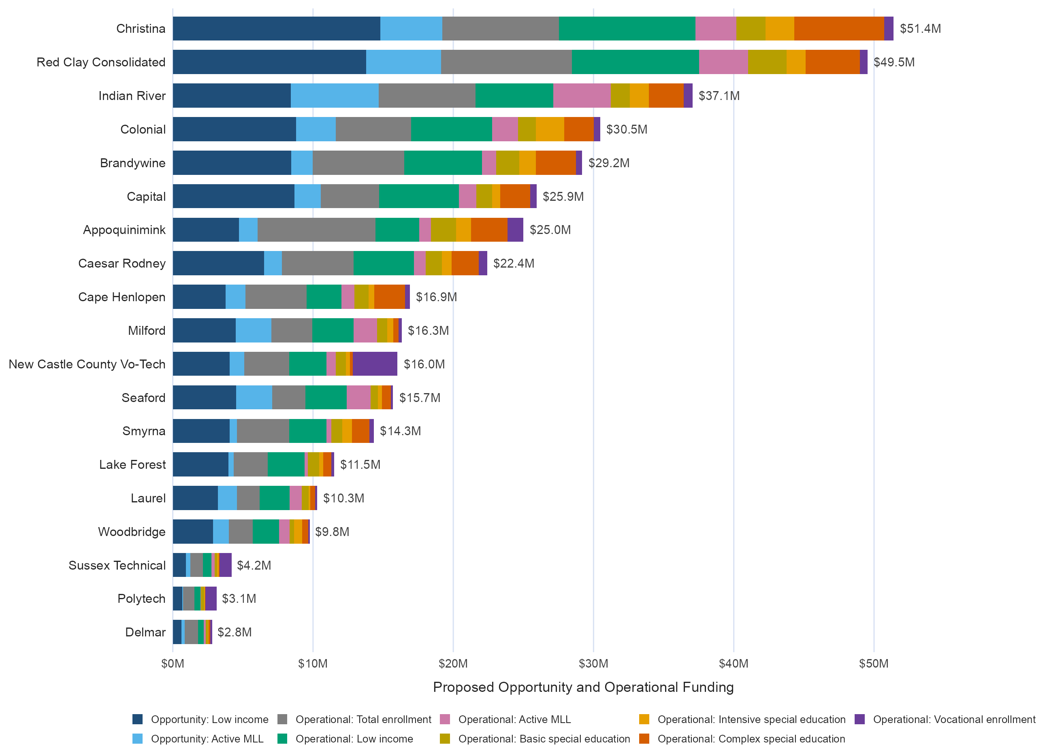
Source: IV&V pipeline output, 08_proposed_model_funding_detail.csv. District LEAs are ordered by combined Opportunity and Operational Funding.
Figure 4. Composition of proposed weighted funding by charter LEA
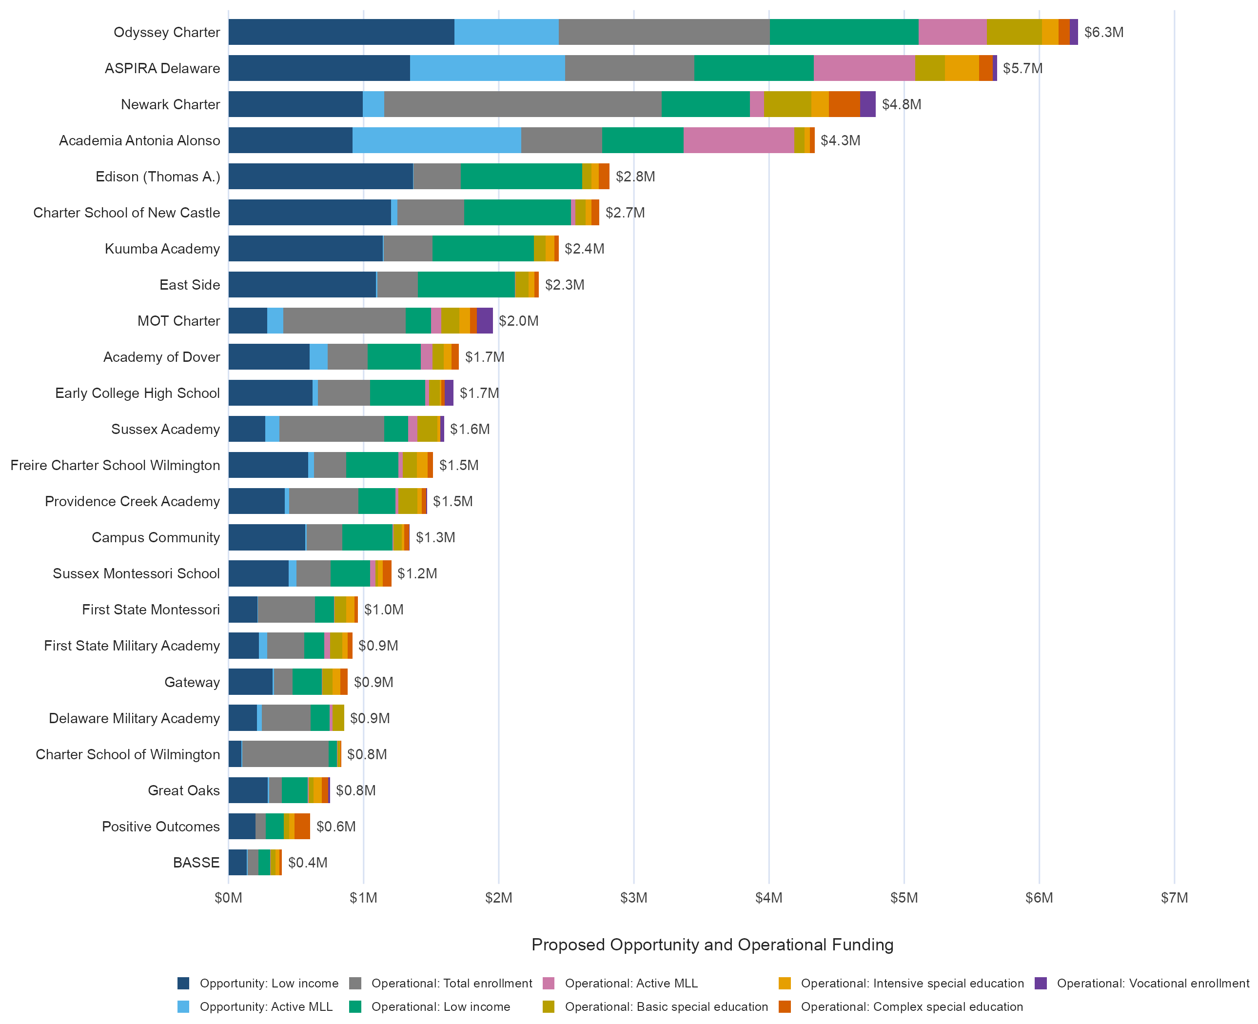
Source: IV&V pipeline output, 08_proposed_model_funding_detail.csv. Charter LEAs are ordered by combined Opportunity and Operational Funding. BASSE is included and DAFB is excluded.
Note: BASSE receives approximately $0.4 million in proposed Opportunity and Operational Funding. It is included because the analysis reflects the SY 2025–26 primary scope, but BASSE will not operate in SY 2026–27.
The charts show that allocation size generally tracks enrollment scale across the 43 LEAs (Spearman’s ρ = 0.93). Differences in weighted student composition, however, can move an LEA’s funding rank above or below what its enrollment size alone would suggest.
Among districts, the relationship is especially strong (ρ = 0.94). Red Clay ranks first in enrollment and second in weighted funding, and Christina ranks third in enrollment but first in funding. Appoquinimink is the clearest exception: it ranks second in enrollment but seventh in funding, indicating that its weighted student composition produces a smaller allocation than its enrollment rank alone would suggest. Conversely, Capital ranks ninth in enrollment but sixth in funding.
Among charters, the relationship is positive but less consistent (ρ = 0.69). Newark ranks first in enrollment and third in weighted funding, and Odyssey and ASPIRA rank second and third in enrollment but first and second in funding. Charter School of Wilmington is the clearest exception: it ranks sixth in enrollment but 21st in funding. Conversely, Edison ranks 14th in enrollment but fifth in funding.
Interpretation guardrail
The component counts are not mutually exclusive. A student may contribute to more than one weighted category, and low-income and active multilingual learner counts generate separate components within both Opportunity and Operational Funding. The chart segments therefore represent formula components, not distinct student groups or separate funding pools. These figures describe proposed allocations only. They do not show a current-versus-proposed change because no confirmed current analogues were identified in or provided to the IV&V process.

4. What Does the Combined Fiscal Picture Show?
The pipeline can assemble the proposed model across Base, Central Office, Opportunity, and Operational Funding. It cannot yet produce a complete net current-versus-proposed fiscal comparison. The recreated current staffing baseline remains partial, and confirmed current-model analogues for Opportunity and Operational Funding have not been provided.
The Opportunity and Operational amounts shown below are fixed statewide funding pools allocated through the proposed formula. They should not be interpreted as estimated increases over current funding.
Exhibit 12. Proposed modeled funding by section
Proposed section | Modeled amount
Base Funding | $1.557B
Central Office Funding | $59.0M
Opportunity Funding | $163.0M
Operational Funding | $279.0268M
Combined proposed modeled funding | $2.058B
Source: 08_proposed_model_state_summary.csv; 11_pefc_reconciliation_summary.csv. Amounts rounded.
Exhibit 13. What can and cannot be compared now
Fiscal element | Current | Proposed | Comparison status
Confirmed staffing subtotal | Available | Available | Comparable, but partial
Comparable-amount staffing subtotal | Available | Available | Preliminary; provisional mappings remain
Working staffing estimate | Available | Available | Includes proposed amounts where corresponding current amounts are unavailable
Opportunity Funding | Not provided | $163.0M | Net change not yet estimable
Operational Funding | Not provided | $279.0268M | Net change not yet estimable
Net current-versus-proposed fiscal effect | Not available | Proposed total available | Not yet estimable
Source: 11_staffing_statewide_comparison.csv; 11_opportunity_operational_comparison.csv; 11_final_readiness.csv.

What a net fiscal analysis still requires
- Current LEA-level Opportunity and Operational allocations or defensible current-model analogues.
- Current custodial, facilities, lunch-program, and cafeteria quantities and rates that remain missing or incomplete.
- Confirmation of provisional current-to-proposed support mappings and selected formula interpretations.
- An appropriation-level crosswalk identifying which current funding would continue, change form, be consolidated, be replaced, or be newly added.
Fiscal conclusion
The $2.058 billion total represents the modeled allocation produced by the proposed formula across the four included funding sections. It is not an estimate of how much state funding would increase. Because the current staffing baseline is incomplete and comparable current values for the weighted funding streams are unavailable, subtracting the partial current staffing estimate from the proposed total would not produce a valid net fiscal effect.

5. How Does the IV&V Proposed Model Compare with the PEFC Workbook?
This section compares two implementations of the proposed model: the PEFC workbook as presented and the independently reproduced IV&V proposed model (the recreated current model is not part of this validation comparison). The IV&V does not treat the workbook as an unquestioned target or assume that every difference is an error. Its purpose is to identify where the workbook and independent implementation diverge, explain the practical consequences, and isolate the rules and scope decisions that require confirmation from workbook or policy owners.
The overall structure of the proposed model can be reproduced, but the two implementations are not identical. The most meaningful differences concern which school calculation units receive positions, how selected staffing thresholds and fractional awards are applied, and which organizations are included in each funding section.

5.1 Principal positions show the effect of calculation-unit implementation
Both implementations describe the proposed principal rule as one position per school calculation unit. Principal counts therefore provide a direct test of whether the workbook and IV&V model identify and treat the same school and building universe.
Exhibit 14. Principal positions in the primary 43-LEA scope
PEFC principals | IV&V principals | Difference | Funding effect
248 | 253 | +5 | +$0.765M
Source: 10_pefc_component_comparison.csv; PEFC Summary school rows; 07_proposed_model_quantities.csv.
All 24 charter LEAs and all 48 charter building calculation units match between the PEFC workbook and the IV&V model. Charter building treatment is therefore an important driver of the current-versus-proposed principal increase described in Section 2, but it does not explain the difference between the two proposed-model implementations.
Exhibit 15. Primary-scope LEAs with different principal counts
LEA | PEFC | IV&V | Difference | Explanation
Capital | 13 | 14 | +1 | Capital Early Childhood Center receives zero in the workbook and one under the IV&V one-per-unit rule.
Christina | 27 | 29 | +2 | Pulaski and Stubbs Early Education Centers receive zero in the workbook.
New Castle County Vo-Tech | 4 | 5 | +1 | DelCastle ILC receives zero in the workbook.
Red Clay | 26 | 27 | +1 | First State School receives zero in the workbook.
Primary scope | 248 | 253 | +5 | Five district calculation units explain the primary-scope difference.
Source: PEFC Summary sheet and IV&V school calculation-unit output.
The primary-scope difference instead comes from five district school-code units for which the workbook carries zero principal positions. The IV&V applies the proposed rule literally by assigning one principal to each included school calculation unit.

5.2 Staffing-rule interpretations produce practical differences
Several additional differences arise because the workbook and IV&V implementation interpret selected staffing rules or construct their calculation bases differently.
Exhibit 16. Selected staffing-rule differences between the PEFC workbook and IV&V model
Area | Observed difference | Practical explanation
Assistant Principals | IV&V +18.25 positions; +$2.45M | The IV&V retains the written 0.65 and 1.65 fractional awards, while the workbook formula rounds those awards down.
Assistant Superintendents | IV&V -1.97 positions; -$0.33M | The IV&V applies completed 300-position thresholds, capped at two positions, while the workbook produces a proportional second position.
Instructional Supports | IV&V +3.43 positions; +$0.33M | Both implementations use a 20% factor, but some charter-wide vocational positions and deductions are not carried into the workbook’s building-level calculation bases. The IV&V applies the factor to the complete Base Division I position total.
Source: 10_pefc_component_comparison.csv; 11_open_items_and_assumptions.csv.
The Assistant Principal difference is the largest of these examples. The calculator states,
“1 Position per 30 or more Division I, Administrative Support Professional, and Instructional Support Positions or 65% of a Position for schools which earn 25 Positions, but less than 30; and a second Position when the school earns 55 Positions or 65% of a Position when earning 50 Positions, but less than 55; subsequent Positions are earned on the basis of 1 Position per 20 Positions beyond the first 55.”
The IV&V translates this schedule into 0.65 position from 25 to fewer than 30 positions, one position from 30 to fewer than 50, 1.65 positions from 50 to fewer than 55, and two positions at 55, followed by one additional position for each completed 20-position increment. The workbook formula contains these same values but applies ROUNDDOWN (which rounds positive results down to the nearest whole number) to the final result, converting 0.65 to zero and 1.65 to one. The result is 18.25 fewer Assistant Principal positions in the workbook than in the IV&V implementation.
The Assistant Superintendent difference reflects whether the current whole-position rule should continue under the proposed model. The calculator states,
“1 Position per 300 Division I Positions (max of 2).”
The recreated current model awards one Assistant Superintendent for each completed 300 Division I units, capped at two, and does not provide fractional positions. Because the proposed materials do not explicitly authorize a change to that treatment, the IV&V applies the same completed-threshold approach to Total Base positions as the current model. For example, 450 positions produce one Assistant Superintendent under the IV&V interpretation but 1.50 in the workbook, which calculates a proportional second position between 300 and 600. Confirmation is therefore needed on whether the proposed model is intended to retain the current whole-position rule or introduce fractional eligibility.
The Instructional Supports difference does not reflect a different policy percentage: both implementations use 20%. For some charters with multiple buildings, the workbook calculates Instructional Supports separately for each building. Because certain vocational positions and deductions are recorded only at the charter-wide level, they are not included in those building-level calculations. The IV&V instead applies the 20% factor to the complete Base Division I position total and retains full calculation precision. These differences produce 3.43 additional positions, or approximately $0.33 million, in the IV&V implementation.

5.3 The workbook does not use one consistent organizational scope
The PEFC workbook also does not apply one consistent organization universe across all four proposed funding sections. DAFB is included in the workbook’s Base, Opportunity, and Operational Funding calculations but excluded from Central Office Funding. The IV&V primary scope excludes DAFB consistently across all four sections pending confirmation of its final treatment.
Exhibit 17. DAFB treatment by proposed funding section
Funding section | PEFC workbook | IV&V primary scope
Base Funding | Included | Excluded
Central Office Funding | Excluded | Excluded
Opportunity Funding | Included | Excluded; fixed pool redistributed across the remaining LEAs
Operational Funding | Included | Excluded; fixed pool redistributed across the remaining LEAs
Source: 11_pefc_reconciliation_summary.csv; 11_open_items_and_assumptions.csv.
This scope difference prevents the workbook’s section totals from representing one consistent LEA universe. It also means that simply removing DAFB’s displayed Opportunity and Operational allocations does not produce the IV&V result. Because those streams distribute fixed statewide pools, excluding an LEA requires recalculating the per-weighted-unit rates and redistributing the complete pools across the remaining eligible LEAs. A final scope decision is therefore needed before the workbook and IV&V results can be placed on a fully consistent basis.

5.4 Overall assessment
The PEFC workbook’s overall proposed-model architecture can be independently reproduced. The most salient differences are concentrated in a limited number of practical implementation choices: principal treatment for five district calculation units, the handling of fractional Assistant Principal awards, the interpretation of Assistant Superintendent thresholds, the Base position total used for Instructional Supports, and the inconsistent treatment of DAFB across funding sections (Source: 11_pefc_reconciliation_summary.csv).
Smaller differences remain because of input and aggregation differences, calculation precision and rounding, and minor gaps between the workbook’s displayed statewide summaries and its summed LEA-level results. However, these differences do not materially change the overall assessment.

6. What Remains to Be Confirmed?
The pipeline has a stable technical foundation, but several current-model inputs, comparison mappings, formula interpretations, and scope decisions remain unresolved. These issues define the boundary of the current findings and the additional work required before a final net fiscal analysis can be completed.
Exhibit 18. Material outstanding confirmations
Area | Issue | Current status | Why it matters
Current operations | Custodian positions and custodial units | Missing | Needed to estimate current custodian positions and Buildings and Grounds eligibility.
Food services | Lunch-program building counts | Incomplete | Needed to complete current Food Services Supervisor eligibility.
Food services | Charter cafeteria satellites and rates | Incomplete or missing | Needed to estimate current cafeteria manager and worker funding.
Food services | District cafeteria funding process | Not modeled | Needed for a complete current operations baseline.
Weighted funding | Current Opportunity allocations | Not provided | Needed for a current-versus-proposed Opportunity Funding comparison.
Weighted funding | Current Operational allocations | Not provided | Needed for a current-versus-proposed Operational Funding comparison.
Comparison mapping | Secretary to Administrative Support Professionals | Provisional | Confirm functional comparability and whether the proposed common rate should be used.
Comparison mapping | Current support positions to Instructional Supports | Provisional | Confirm the functional grouping and whether the proposed common rate should be used.
Formula interpretation | Current nurse fractional rule | Unresolved | Confirm whether the fractional unit earns 30% of a nurse position, as implemented in the IV&V.
Formula interpretation | Proposed assistant-principal fractions | Implemented from the written schedule | Confirm that the documented 0.65 and 1.65 fractional awards are intended.
Formula interpretation | Assistant Superintendent thresholds | Provisional | Confirm whether positions are awarded only at completed 300-position thresholds or proportionally between thresholds.
Scope | DAFB treatment | Pending | Confirm whether DAFB belongs in the final statewide comparison and whether it should be included consistently across funding sections.
Fiscal interpretation | Current-to-proposed appropriation crosswalk | Not complete | Needed before any gross modeled difference can be interpreted as a net fiscal effect.
Source: 11_open_items_and_assumptions.csv; 11_final_readiness.csv; current supplemental input templates.

How the pipeline handles unresolved items
Open items are maintained explicitly in source inputs, crosswalks, settings, and the final assumptions output. The pipeline does not fill missing quantities or rates with assumed values, and provisional mappings remain labeled as such. When an authoritative source or policy decision becomes available, the maintained input should be updated and the full pipeline rerun rather than adjusting report totals manually.
Readiness status
The working staffing comparison and PEFC workbook reconciliation are available and reproducible. The confirmed staffing subtotal remains partial, and current-versus-proposed comparisons for Opportunity and Operational Funding are not yet estimable. The project is ready to support technical and policy discussion, but not a final determination of net fiscal impact.

7. How Was the Analysis Built and Validated?
The project uses a linear, auditable pipeline that separates source preparation, current-model calculations, proposed-model calculations, model comparison, workbook validation, and final reporting. Quantities are calculated and reviewed before rates are applied, and detailed school-, calculation-unit-, and LEA-level outputs remain available behind the statewide summaries.
Validation is built into each stage through input reconciliation, maintained scope and entity crosswalks, formula and component comparisons, detailed audit outputs, and final integrity and readiness checks. The current pipeline run passed all 21 final integrity checks. Readiness checks are reported separately so that a technically complete calculation is not mistaken for a fully confirmed fiscal estimate.
Exhibit 19. Pipeline from source data to final IV&V outputs
Step | Purpose | Validation role
01 | Student-count SQL export | Creates enrollment, low-income, active multilingual learner, K–8, and Grade 10 counts.
02 | Shared validated input | Reconciles student counts to Unit Count and establishes a common school, LEA, and statewide universe.
03–05 | Recreated current staffing rules | Prepares current inputs, calculates positions, applies comparison rates, and records missing or provisional items.
06–08 | IV&V proposed model | Creates calculation units, allocates charter counts, calculates staffing and weighted units, and applies rates.
09 | Current-versus-proposed comparison | Produces staffing comparisons and separate Opportunity and Operational comparison files.
10 | PEFC workbook comparison | Compares the workbook as presented with the independently implemented proposed model.
11 | Final outputs and readiness | Packages report-ready comparisons, assumptions, technical QC, reconciliation results, and readiness status.
Source: README.md; RUN_PIPELINE.R; scripts 00–11.

Technical documentation and audit trail
The analysis scripts, maintained inputs, generated outputs, and technical documentation are available in the School Funding Models GitHub repository. The Delaware School Funding Model Pipeline Definitions document provides the detailed source lineage, implemented calculation rules, comparison mappings, status definitions, open items, and PEFC reconciliation framework underlying this report.

Conclusion
The IV&V establishes a reproducible basis for understanding both the proposed funding structure and its differences from the recreated current staffing rules. It identifies where the largest modeled staffing changes occur, clarifies the importance of school calculation units, reproduces the proposed weighted funding pools, and documents the differences between the PEFC workbook and the independent implementation.
The analysis is technically ready to support review and policy discussion. Completing the remaining current operations inputs, weighted-funding analogues, provisional mappings, scope decisions, and appropriation crosswalk is the next step toward a final net fiscal assessment.

Technical Appendices
The appendices provide concise technical support for the narrative. The complete project retains more detailed school-, calculation-unit-, LEA-, component-, audit-, and QC-level files than are reproduced here. The full analysis scripts, outputs, and supporting documentation are available in the School Funding Models GitHub repository. The Delaware School Funding Model Pipeline Definitions document provides the complete source lineage, implemented rules, comparison mappings, evidence labels, and readiness framework.

Appendix A. Key terms and evidence labels
Term | Meaning
Official school code | Administrative identifier assigned to an official district school or charter organization.
Calculation unit | School or building row to which a school-based funding formula is applied.
Confirmed | The implemented mapping, quantity, and rate are supported for the current analysis.
Provisional | A working treatment is implemented but still requires confirmation.
Not yet estimable | A required current input, rate, mapping, or allocation is unavailable.
Working staffing estimate | Includes available current amounts and all proposed amounts for working categories. It may include a proposed amount where the corresponding current amount is not yet estimable.
Comparable-amount subtotal | Includes working categories with funding amounts available on both sides. Provisional mappings may remain.
Confirmed subtotal | Includes only categories with confirmed mappings, quantities, and rates.
Technical integrity | The pipeline ran and reconciled according to its implemented rules.
Analytical readiness | Required inputs and decisions are complete enough to support the intended substantive conclusion.

Appendix B. Selected staffing rules
Category | Recreated current rule | IV&V proposed rule | Comparison note
Core teaching | Uses reported Unit Count Division I positions. | Divides enrollment by the proposed staffing ratios for each student category. | Statewide current and proposed quantities are closely aligned.
Principal | One position when a coded school has at least 15 current Division I units. | One position per school calculation unit. | The proposed result depends on the calculation-unit universe and removes the current 15-unit threshold.
Assistant Principal | Applies the current 25-, 30-, 50-, 55-, and additional 20-unit thresholds. | Applies the proposed thresholds to the constructed Base position total and retains the documented 0.65 and 1.65 fractional awards. | Produces one of the larger confirmed staffing differences. The PEFC workbook rounds the fractional awards down.
Administrative support | Secretary formula: one per 10 positions through 100, then one per completed 12 positions. | Administrative Support Professionals formula using the same tiered structure. | The Secretary-to-Administrative Support Professionals mapping and current-side comparison rate remain provisional.
Instructional supports | Models separate counselors, psychologists, nurses, Academic Excellence positions, driver education teachers, related-services specialists, and visiting teachers. | Provides Instructional Supports equal to 20% of Base Division I positions. | This is a broad functional comparison, not a one-to-one position match.
Superintendent | One per district; charters are ineligible. | One per included LEA. | Expands eligibility to charter LEAs.
Assistant Superintendent | One per completed 300 current Division I units, capped at two; districts only. | One per completed 300 Total Base positions, capped at two. | The IV&V applies completed whole-position thresholds pending confirmation that proportional fractions are not intended.
Director | One at 200 current Division I units, plus one per completed additional 100 units, capped at six. | Applies the same thresholds to Total Base positions. | The proposed rule uses a broader position base.
11-Month Supervisor | Current Division I units divided by 150. | Total Base positions divided by 150. | Fractions are retained under both implementations, but the proposed calculation uses a broader base.
Buildings and Grounds | One position when current custodial units reach 95. | One position per included LEA. | The current quantity is not yet estimable because custodial-unit inputs are missing.
Source: 04_current_model_rules.csv; 07_proposed_model_rules.csv; model_comparison_crosswalk.csv; Delaware School Funding Model Pipeline Definitions.

Appendix C. Report exhibit traceability
Report topic | Primary project output
Staffing statewide views | 11_staffing_statewide_comparison.csv
Staffing categories and drivers | 11_staffing_component_comparison.csv
LEA staffing distribution | 11_staffing_lea_comparison.csv
Opportunity and Operational comparison status | 11_opportunity_operational_comparison.csv
LEA weighted allocations | 11_opportunity_operational_lea_comparison.csv
PEFC statewide reconciliation | 11_pefc_reconciliation_summary.csv
Detailed PEFC component comparison | 10_pefc_component_comparison.csv
Charter building treatment | 11_charter_building_treatment.csv
Open items and assumptions | 11_open_items_and_assumptions.csv
Final technical QC | 11_final_qc.csv
Analytical readiness | 11_final_readiness.csv
Run settings and manifest | 00_run_settings.csv; 00_run_manifest.csv
Full implementation definitions and source lineage | Delaware School Funding Model Pipeline Definitions; README.md
Source: final reporting outputs, audit files, project README, and the Delaware School Funding Model Pipeline Definitions.

Appendix D. Interpretation guardrails
- Missing current values are not zero and remain excluded from confirmed comparisons.
- The recreated current funding amount is a comparison estimate, not the complete cost of Delaware’s current system.
- Broad functional mappings support comparison across models but do not mean the positions are identical.
- Charter building rows are used for proposed Base calculations, while official charter organization totals are retained for weighted funding so students are counted once.
- Opportunity and Operational Funding are fixed statewide pools. Changes in scope redistribute those pools rather than simply removing an LEA’s allocation.
- The proposed modeled total is not an estimate of increased state spending, and gross modeled differences are not confirmed net fiscal impacts.
- Preliminary LEA differences should not be interpreted as final gains or losses.
- The PEFC workbook comparison and the current-versus-proposed analysis answer different questions.
- Passing technical QC confirms that the pipeline ran and reconciled as designed. It does not resolve missing data, provisional mappings, or open policy decisions.

