**Design Specification**

Authors: Michael Moscariello, Sean O’Connell, Joe Mecca, Michael Crinite, Andrew Genova, Matthew Gimbut

Login -> Main Page: enter mileage, bring up necessary tuneups and intervals

Have an encyclopedia for car manuals.

Have search buttons for car mechanics and vehicle part stores.

Notify user to update their information (User can set up weekly, monthly or daily?)

First time setup; have user enter in all necessary info

Username, email, email confirmation, password, password confirmation, car model, mileage

Login Screen

Take to homescreen

Profile and car info

User class

Car Class

Mileage

Oil Change

Tire pressure/rotation

Model, year, make

Trim

Brakes

Fluids

Spark Plugs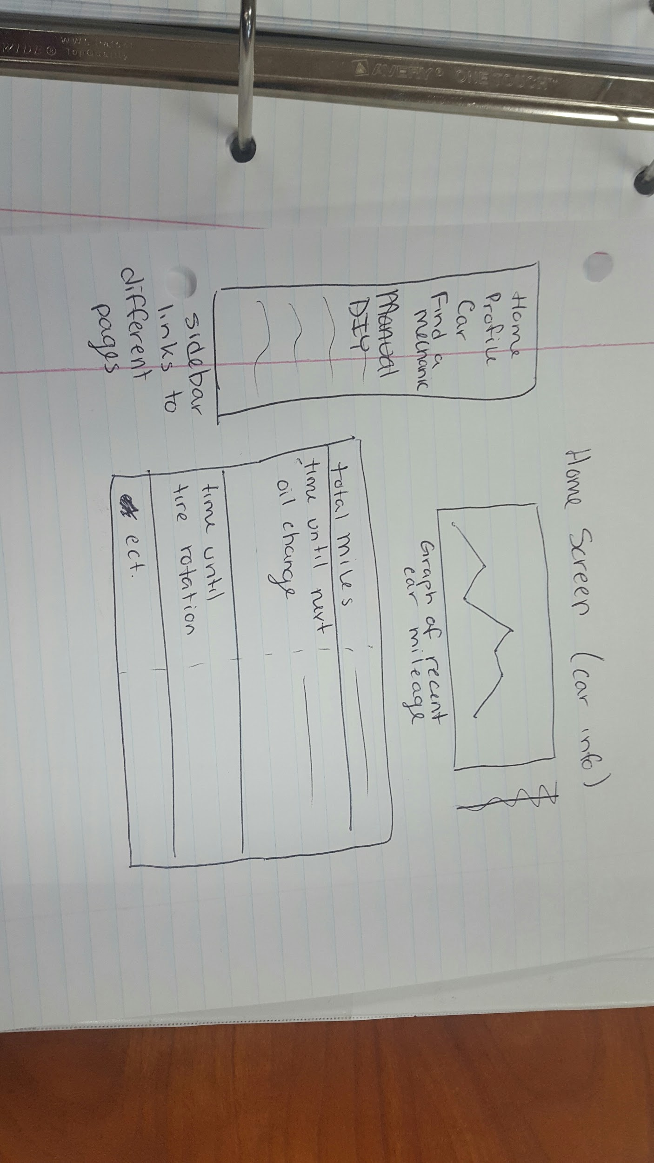

Battery check

Car manual

Link to manual in database