ATOMiK
State-aware compute evaluation for edge and embedded teams constrained by battery, heat, bandwidth, latency, reliability, or hardware footprint.

The Customer Problem
Many constrained systems spend too much work rediscovering what changed. They move, scan, sync, replay, or rebuild state even when only a compact delta matters. In edge and embedded systems, that waste can become battery drain, thermal pressure, latency, bandwidth pressure, field-service risk, and hardware overbuild.
Data-center power, cooling, water, and sustainability pressures matter, but they are second-order expansion narratives until ATOMiK has workload-specific measurement in that environment.

What Customers Get
ATOMiK is evaluated where avoided state work may create business value:
- Lower state-movement cost: fewer bytes moved, transfers avoided, or scans skipped.
- Faster constrained state paths: lower update or reconstruction latency where the path fits.
- Lower bandwidth pressure: move compact deltas instead of repeated full-state updates when measured.
- Power or thermal pressure reduction: evaluation target when instrumentation or a responsible proxy exists.
- Clear fit/no-fit evidence: a decision about whether the workload justifies deeper evaluation.
Battery, heat, cooling, water, footprint, and hardware-profile improvements are evaluation targets until measured on a specific workload.

What ATOMiK Is
ATOMiK makes change the unit of compute:
state = reference_state XOR accumulated_delta
It keeps a known reference state, accumulates compact deltas, reconstructs only when needed, and commits clean state epochs. The architecture is intended for state-heavy workloads where repeated scans, sync, replay, reconstruction, or full-state movement dominate the cost; it is not positioned as a general-purpose CPU replacement.

Hardware-Validated UI Proof
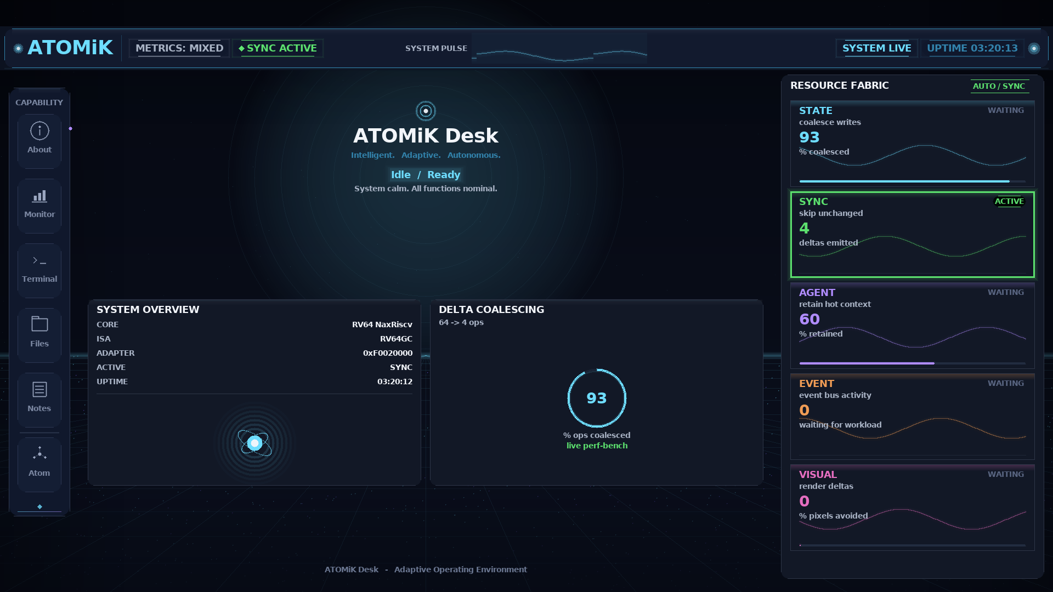
ATOMiK Desk v0.40-A prototype UI captured live from the framebuffer on Zynq hardware
HARDWARE_VALIDATED: ATOMiK Desk v0.40-A prototype UI captured from /dev/fb0 on live Zynq hardware, with on-screen metrics driven by real measured on-board data. This proves the current live demo surface, not commercial product maturity, performance, power, thermal, battery, water, or footprint outcomes.

Proof Stack
Proof | Label | Status
Zynq Desk v0.40-A | HARDWARE_VALIDATED | current public proof image, captured from /dev/fb0
Parallel-bank throughput on AX7020 | LIVE_MEASURED | 8-bank accumulator scales 1/2/4/8x, byte-identical to software
Linux userspace to FPGA path | HARDWARE_VALIDATED | documented OS-to-bus validation path
AX7020 board run matrix | LIVE_MEASURED | raw artifact with interpretation caveats and workload-specific wins/losses
Formal proof work | SOFTWARE_VALIDATED | algebraic proof work in repo; avoid public counts until audited across materials
Standalone SD boot artifacts | BUILD_ARTIFACT | local build output exists; public power-on artifact is still a gate

Target Use Cases
Segment | Buyer pain | Evaluation metric
Edge / embedded systems | battery budget, enclosure heat, intermittent links, reliability | bytes moved, update latency, bandwidth, power proxy
AI at the edge | context/state movement, memory pressure, local response | transfers avoided, context retained, response latency
Remote / industrial / robotics / defense-adjacent | wattage, packet budget, field runtime, size/weight | runtime proxy, packet budget, update cost, reliability signal
Data center / infrastructure | power bill, cooling, water pressure, rack density | bytes moved, power/thermal proxy, measured workload energy path
The lead customer is the edge or embedded team that can bring one state-heavy workload, one current baseline, and one painful constraint.

Evaluation Offer
Give us one state-heavy workload, your current baseline, and the constraint that already hurts. We evaluate where state movement creates waste and whether ATOMiK can improve the path. You receive a workload map, baseline comparison, evidence map, fit/no-fit recommendation, and next-step plan. Success looks like measured improvement against one agreed metric while preserving correctness.

Business Path
Near term: paid proof reviews, technical evaluations, design partners, IP strengthening, and ASIC feasibility review.
Longer term: strategic licensing or integration partnership optionality only if workload proof and IP diligence justify it.

Pre-Seed Use Of Funds
- Convert provisional IP protection into stronger patent coverage.
- Run customer workload evaluations around state paths tied to battery, heat, power, bandwidth, latency, and footprint pressure.
- Bring in fractional CFO support for valuation and financing structure.
- Add ASIC mentorship before any tape-out decision.
- Package the Zynq demo into a lower-friction investor and customer proof system.

Financial Discipline
The current working ask is a $2.0M target pre-seed, with a $1.25M minimum viable close and a $2.75M stretch plan. The round funds customer workload measurements, IP strengthening, CFO-reviewed financing structure, demo hardening, and ASIC feasibility. It does not fund tape-out.
Market benchmarks are context only: IEA/LBNL support the energy, cooling, and water-pressure urgency; Carta/PitchBook/NVCA support financing market context; SIA/WSTS supports the semiconductor-market backdrop. None of those sources prove ATOMiK savings or set ATOMiK’s valuation.

Ask
ATOMiK is seeking a $2.0M target pre-seed, design-partner introductions, ASIC/IP diligence support, and customer workloads where battery, heat, power, bandwidth, latency, reliability, or footprint are already painful. Final financing terms require CFO/counsel approval.

Contact
Request an investor briefing, technical evaluation, or design-partner conversation: matthew.h.rockwell@gmail.com

Evidence Boundary
Live screenshots show current prototypes. Concept visuals show product direction and are not represented as current commercial functionality. Performance, thermal, water, battery, and footprint claims are only stated when backed by measured artifacts for that exact claim.

