CERF Pi: Software setup steps

## Supplies needed

* Raspberry Pi
* Power Adapter
* 16 GB micro SD card with Raspbian OS preinstalled
* USB wifi dongle (Raspberry Pi 3 **DOES NOT NEED** the wifi dongle)
* USB keyboard
* Monitor
  + The Pi uses HDMI for graphical output, so the monitor should support HDMI or use an HDMI converter for the monitor of your choice
* HDMI Cable (HDMI Converter if necessary)

## Step 0: Initial Start-Up

* Insert the microSD card into the Raspberry Pi. See Figure 1. (Do NOT power yet)

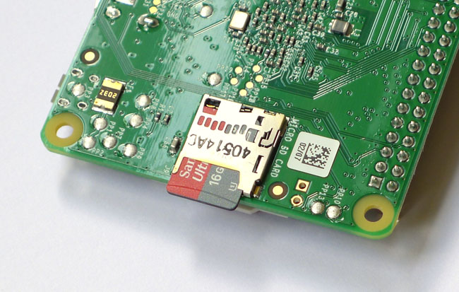

*placement of Micro SD Card*

* Plug in the mouse, keyboard, and wifi dongle into the USB Ports.
* Connect the Raspberry Pi to the monitor using the HDMI Cable
* Finally; provide power to the Pi by plugging it in with the power adapter
  + There is no power button. Once it is plugged in the pi is turned on.

## Step 1: Config Settings

* Now that the Pi is powered there should be lines streaming on the monitor (Boot Text). Once this is finished you will be presented with the configuration tool shown in Figure 2. If it goes straight to desktop, you can get here by typing **sudo raspi-config** in the terminal.

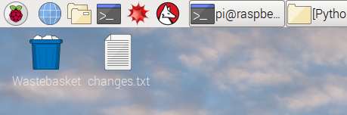

*quick way to open a terminal*

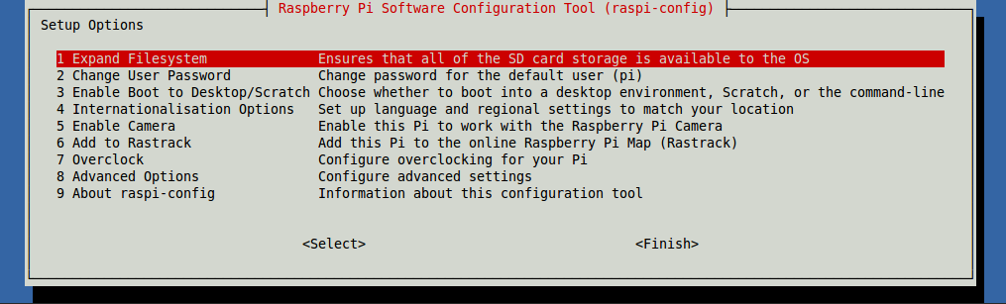

*configuration tool*

* From this screen use the arrow keys and enter to choose **Advanced Options > Expand Filesystem.** It will alert you that on the next reboot the change will take place. Hit **<OK>** to select okay and return to the main config tool.
* Now choose **Boot Options > Desktop/CLI**: In this screen select the second option **Desktop Autologin …** . This will bring you back to the main screen.
* From the setup options page now choose option 4: **Localisation Options**. From this screen choose **Change Timezone**, and then **US**, finally **Michigan**.
* Additionally under **Localisation Options**, choose **Change Keyboard Layout**, then **Generic-104-key PC**, then **English (US)** [You will probably have to select **Other** to find this option], then **English (US)** again. The defaults should be fine for all of the following settings. So chose **The default for the keyboard layout**, then **No compose key**, then **<No>**. The keyboard changes won’t take effect until after the reboot.
* Lastly under **Localisation Options**, go to **Change Wi-Fi Country** and select the **US**.
* In **Interfacing Options**, enable SSH as well as I2C. Start by navigating to **SSH**, then **<Enable>**, and finally **<Ok>**. Go back to **Interfacing Options** and choose **I2C**, then **<Yes>**, **<Ok>**.
* This is all that will need to be done in this Configuration tool. To finish the setup hit **[TAB]** then the **[Right Arrow]** to select **<Finish>**. It will then prompt you for a reboot - select **<Yes>**.

**Step 2: Cloning the Git Repository**

* For this step plug the raspberry pi into a wired ethernet connection. Leave the monitor, keyboard, mouse, etc. plugged in. Open a terminal.
* Once the terminal is open you should change directories to the Desktop using the command

|  |
| --- |
| pi@raspberrypi ~ $ cd Desktop |

* On the desktop we will pull in the CERF files from GitHub using the following command: **(be sure to use single quotes)** (to move the cursor use the arrow keys)

|  |
| --- |
| pi@raspberrypi ~/Desktop $ git clone ‘https://github.com/MatthewHeun/CERF-DAQ.git’ |

* Once it is done downloading from GitHub, there will be a new directory on the Desktop named CERF-DAQ

**Step 3: Running the Setup Script**

* To execute the setup script perform the following command:
  + NOTE: This will delete all of the data (if any) on the Pi
  + If it does not run, try navigating to the folder and typing **chmod +x pi-setup** and try again

|  |
| --- |
| pi@raspberrypi ~/Desktop $ sudo CERF-DAQ/pi-setup |

*command to start the setup script*

* It will prompt you for the Pi’s Number (Enter the desired number in cerfpi**X**)
* It will then ask you if you would like to continue
* you will also be asked to change the system password (**Record this**)

|  |
| --- |
| Proceeding...  Changing Hostname...  We will now update the Pi password.  The default password is ‘raspberry’  Please record the new password, it will be used for SSH  ENTER new UNIX password: |

*prompt for changing the password*

* It will now execute a multitude of commands to update system packages
  + This may take a few minutes
  + If it prompts you: “After this operation, x.xxMB of additional disk space will be used. Do you want to continue? [Y/n]. Type **y** and press enter.
* Next it will begin the wifi setup. It will prompt you for your Calvin email and password. Make sure to type your **email** and not your username.
* The following image shows what to put into the wpa_supplicant.conf file (can be gotten to using **sudo nano /etc/wpa_supplicant/wpa_supplicant.conf** in a terminal). Double check to make sure it is correct.

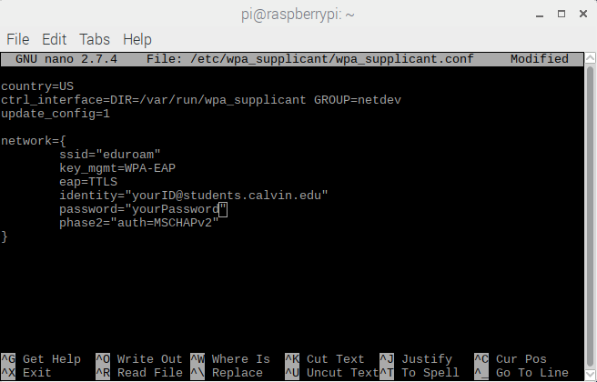

*the wpa_supplicant.conf file*

* The Wifi installation is complete! Disconnect the ethernet cable from the pi. Open a terminal window again and type the command: “**ifconfig**”. If everything is working correctly you should see an ip address under the wlan0 heading (highlighted in red)

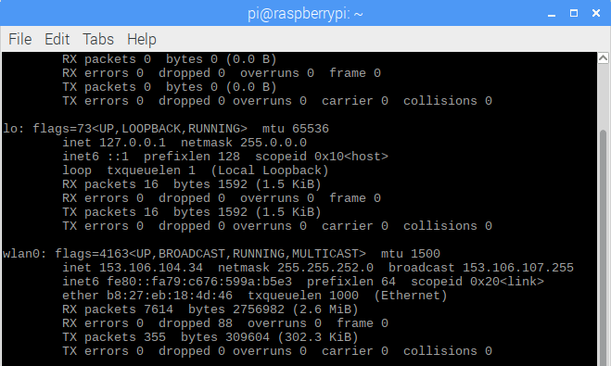

*where to find the IP address of the pi*

* You can now use this address in place of the web address “cerfpiX.calvin.edu”, until you give the MAC address to Jeff Greenfield and tell him what number you would like to give the pi. The MAC address is highlighted in yellow. After Jeff has linked the IP address to the web address, input the new identity and password to

use cerfpiX.calvin.edu to connect to the pi instead of the IP address.



*where to find the MAC address of the pi*

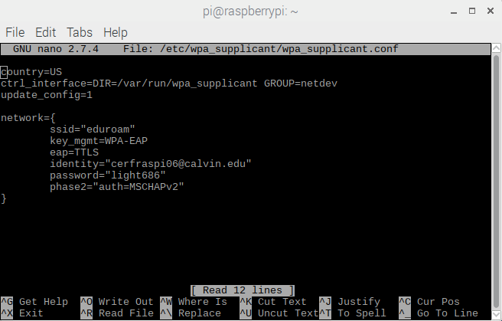

*example of new identity and password for the wpa_supplicant.conf file*

* TEST OUT THE WEBSITE! Go to the IP address highlighted above in red by typing it into any browser.

**Step 3: Connecting to the Pi remotely**

Using SSH

* SSH provides you a command line interface to the pi
* Refer to the hardware setup guide to connect the sensors
* At this time the Pi can be placed in the spot where it will be collecting data
* No mouse or keyboard will need to be plugged into the Pi. Just the power and sensors.

*Mac/Linux instructions :*

* Now that the pi is connected to the internet on Calvin’s network, you will be able to SSH into it from an external computer using the command on a **mac’s** terminal:

|  |
| --- |
| user@yourcomputer ~ $ ssh pi@cerfpiX.calvin.edu //replace X with Pi # |

* + If this is the first time you will warned about host authenticity. Answer Yes to continue connecting.
  + On a **pc** there is a utility called Putty which allows you to SSH seen in Figure 7 below.

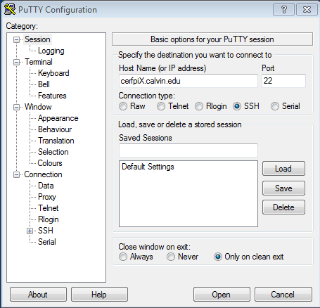

*Putty instructions :*

* Putty can be found on all campus computers
* Enter the “cerfpiX.calvin.edu” into HostName (**replace X with pi number**)
* Click open to start the connection. A pop up may open - click yes.
* **Login as**: pi

Instructions for both types of connections:

* **PASSWORD:** raspberry (default, unless you changed it)
  + It will appear as nothing is happening when you type the password
  + Just hit enter when you have typed it in
  + There is a list of usernames/passwords at the end of the document

*Updating the Pi :*

* Before making any changes to the pi, make sure to backup any necessary data by downloading it through the website or acquiring it through the SSH connection.
* When you are ready to update the pi, upload the new code to GitHub, then recall the git clone terminal command to get the updated code.

|  |
| --- |
| pi@raspberrypi ~/Desktop $ git clone ‘https://github.com/MatthewHeun/CERF-DAQ.git’ |

**Other Options: Manual Commands**

The following commands can be run on the pi at anytime

* Reset Pi (Clear all Data)

|  |
| --- |
| pi@raspberrypi ~ $ reset-pi.sh |

* You may want to download the data from the pi’s website prior to this
* Pause Cron (the task scheduler that takes in data, analyzes, and updates the pi)

|  |
| --- |
| pi@raspberrypi ~ $ pause-pi.sh |

* Resume Cron

|  |
| --- |
| pi@raspberrypi ~ $ start-pi.sh |

* Zip Raw and Summary data

|  |
| --- |
| pi@raspberrypi ~ $ zip-data.sh |

* This command runs every night at midnight
* Analyze Data

|  |
| --- |
| pi@raspberrypi ~ $ sudo ~/Desktop/CERF-DAQ/Python/runAnalysis.sh |

* This command runs every night at midnight
* Get sensor data

|  |
| --- |
| pi@raspberrypi ~ $ sudo ~/Desktop/CERF-DAQ/Python/runpython.sh |

* This command runs every min
* Update Software via apt-get

|  |
| --- |
| pi@raspberrypi ~ $ update-pi |

* This command runs every week
* Editing the cron schedule

|  |
| --- |
| pi@raspberrypi ~ $ sudo crontab -e |

* This file shows the commands that are scheduled using cron
* It would be smart to google how cron works before editing the schedule put in place

**Possible Issues/Other:**

* Although the pi-setup document should take care of installing necessary software, it is possible that software updates make older versions unavailable (for example, the package for php was out of date and couldn’t install the older version). **If something isn’t working, assure that all packages are properly installed, and if not, try installing the more recent version.**
* The pi may default its web directory to the wrong location. To fix this, type **sudo nano /etc/apache2/sites-enabled/000-default.conf** into a terminal, change the directory (DocumentRoot) to **/var/www/** then save the file.
* **Usernames and Passwords**
  + Heiminga Hall Pis – **User:** pi **Pass:** CerfHH2017