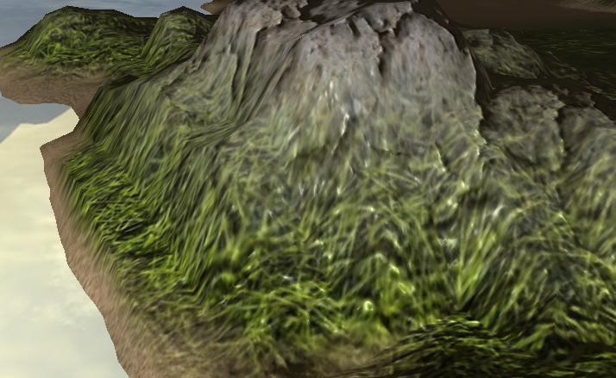

Texture blending based on height of vertex, as well as bump map blending based on textures

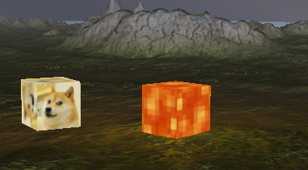

Multiple lights in one scene, one orange point light and a white directional light

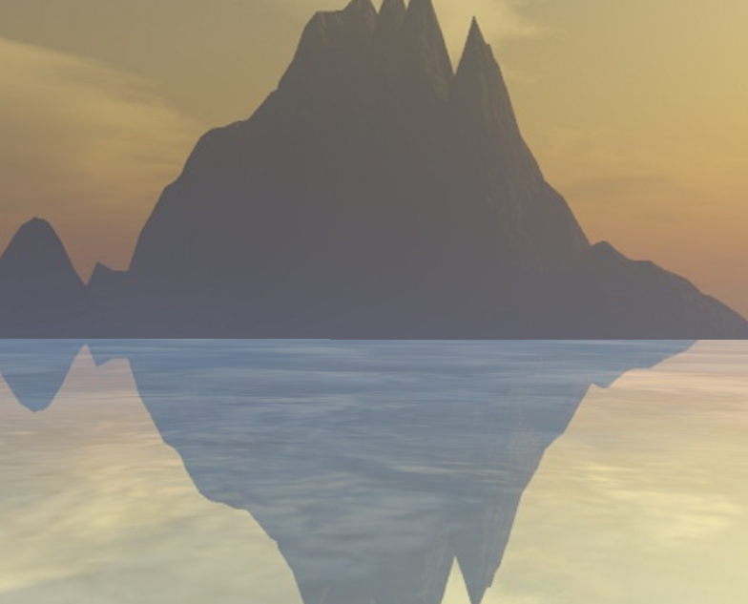

Skybox and reflective water

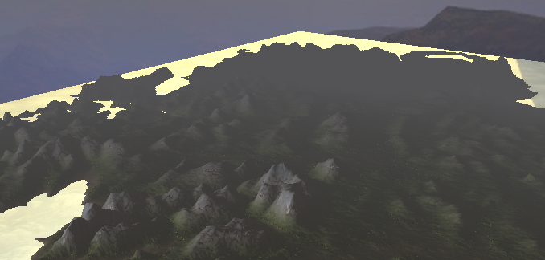

Fog effect that makes pixels grey based on distance to camera

Controls

F5: reload shaders

WASD: forward, left, backward and right strafe

P: loop through camera motions and lock camera

O: cancel camera loop and unlock camera

ESCP: close project window