**ELEC 4700**

**Assignment - 2**

**Finite Difference Method**

**Written by:**

**Matthew Janok**

**101036060**

**Question 1**

1. In this question the Finite Difference Method in matrix form was used to solve the electrostatic potential in the rectangular region L x W for V = Vo at x=0 and V = 0 at x=L.

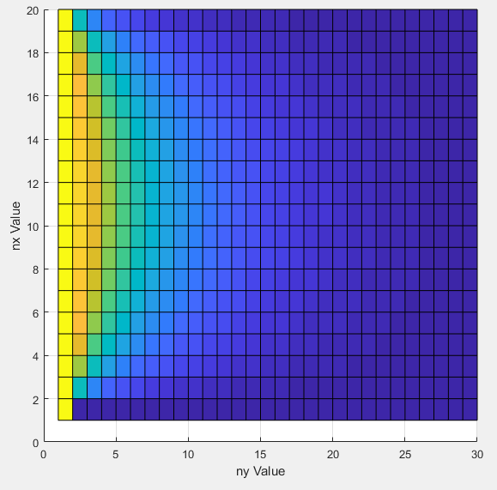

**Figure 1:** 2D view of V solved using Finite Difference method

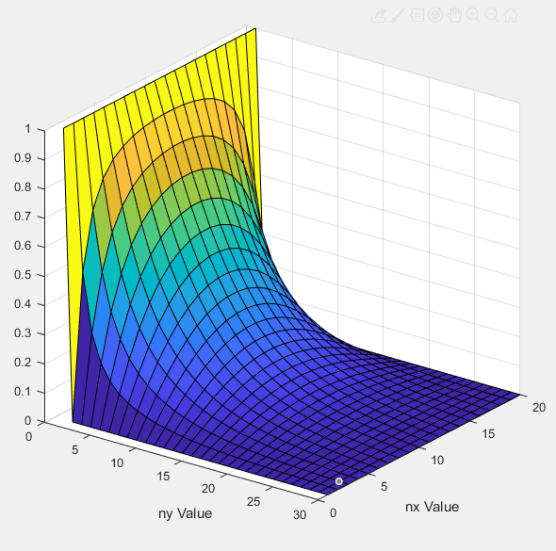

**Figure 2:** 3D view of V solved using Finite Difference method

1. This question was solved the same way as a) with V = Vo at x = 0 and x = L while V = 0 at y = 0 and y = L. This problem was also solved using an analytical method where we could tell that with a finer mesh, we were closer to the real analytical solution.

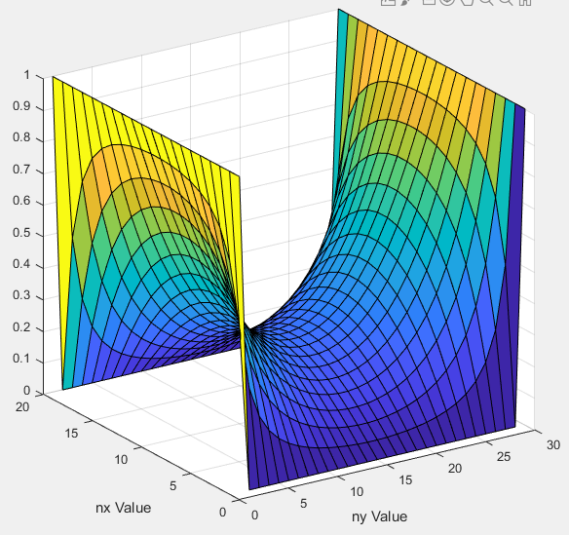

**Figure 3:** 3D view of numerical solution when V = Vo at x=0 and x=L

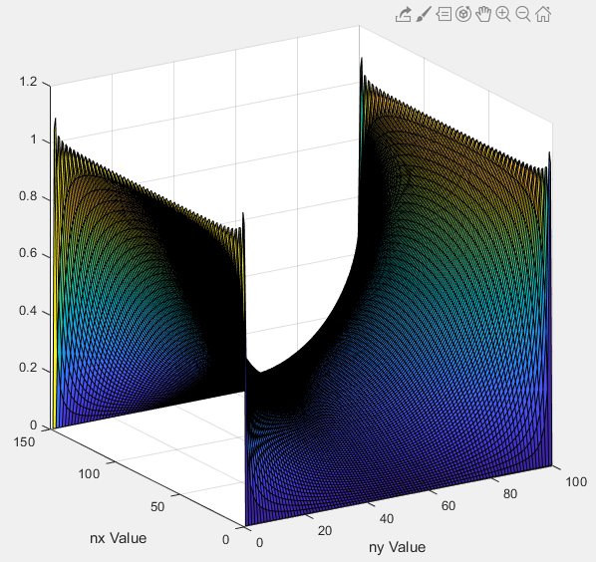

**Figure 3:** 3D view of Analytical solution when V = Vo at x=0 and x=L

With a coarse mesh in both cases, there is more uncertainty in the actual value of the meshed squares which makes them less valuable. In the analytical solution, we could see jagged edges on the ends of the graph which made the solutions ambiguous. As the mesh grew finer, the jagged edges were still present but were much more small oscillating about the correct bounds of 1. This finer mesh also gives us more accuracy to the solutions in the middle of the graph, but we keep in mind that there are still explicit errors in both types of this solution.

We know when to stop the analytical series when the differences from iteration to iteration attenuate to a minimum difference. For example, we knew the mesh was fine enough when we could tell the jagged edges at the boundary were oscillating about 1 with next to no ambiguity.

Some advantages of the analytical method are that it’s exact and gives us more context for the information we receive. Having an equation can let us know beforehand how a system will react and how complex the system really is. Some disadvantages are that it takes a longer time to evaluate the equation for finer meshes since the computer must evaluate the equation at every point.

An advantage to the numerical method is that we can use this for a variety of problems since most problems don’t have an analytical solution. Also, if we use a matrix approach, we can solve the system all at once which makes this calculation much faster than the analytical solution. Unfortunately, this method trades off accuracy for speed, but we can mitigate this trade off by simply specifying the necessary mesh size.

**Question 2**

1. The current was found to be 0.4297 A at the two contacts.

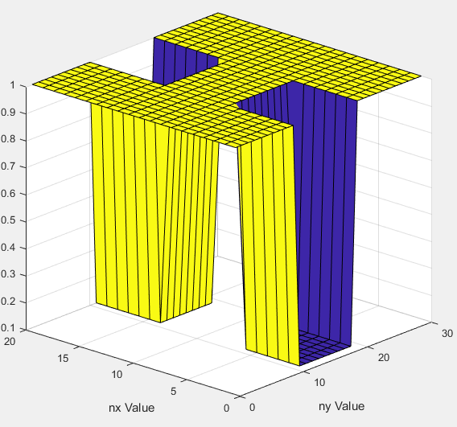

**Figure 4:** 3D view of Conduction Map

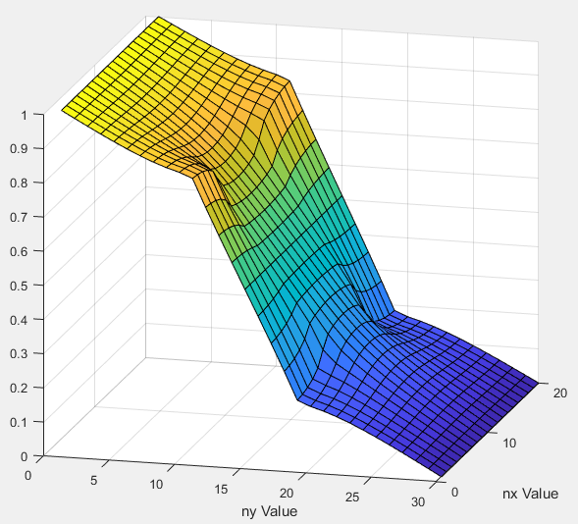

**Figure 5:** 3D view of Potential(V)

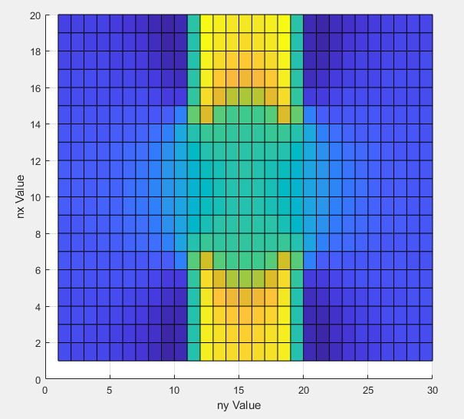

**Figure 6:** 2D view of Ex

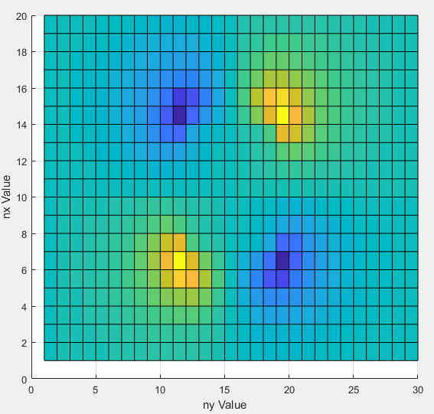

**Figure 7:** 2D view of Ey

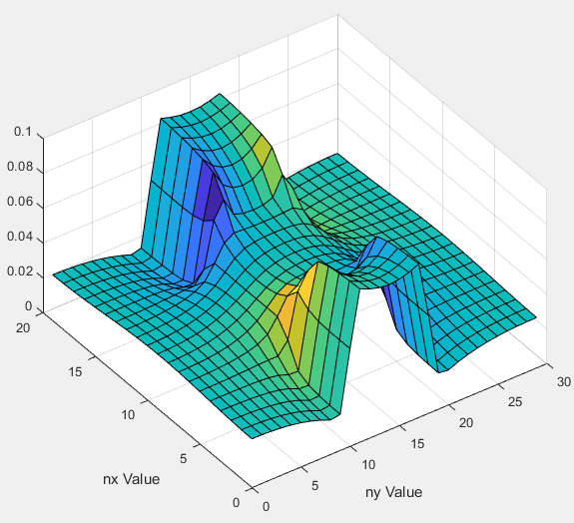

**Figure 8:** 3D view of Ex and Ey

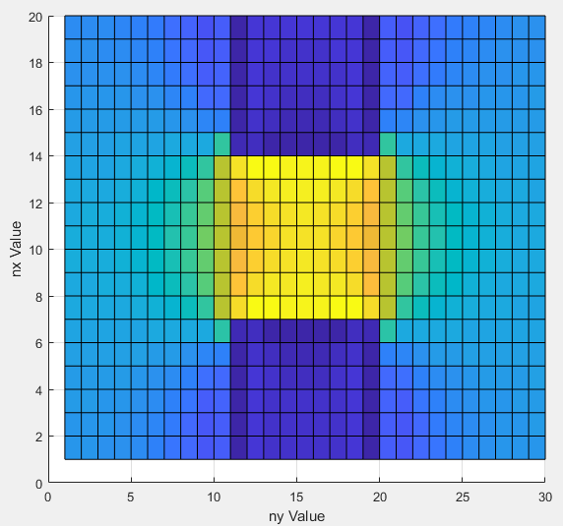

**Figure 9:** 2D view of Jx

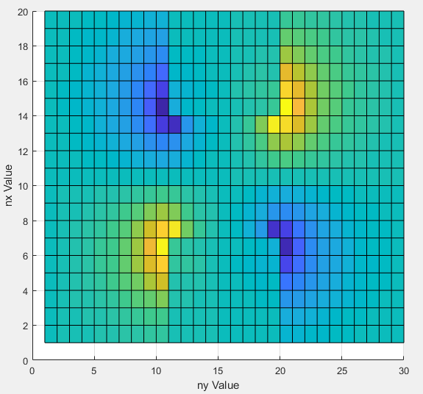

**Figure 10:** 2D view of Jy

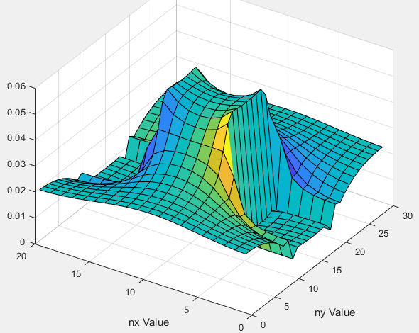

**Figure 11:** 3D view of Jx and Jy

1. This task could not be completed because the way my code was written, if I change nx or ny the simulation breaks and the reason is unknown. However, speculation can be made that with a finer mesh size, the current value will increase because there will be less “loss” from large discretizations.
2. As we vary the bottle neck position, we can see that as the bottle neck closes in on the gap the current gets smaller. This is what we expect since there is less space for the current to flow, therefore, less current can pass.

|  |  |
| --- | --- |
| **Bottle-neck Position** | **Current Value** |
| (i<((0.3/3)*nx))  (i>((2.7/3)*nx) | 0.6600 A |
| (i<((0.5/3)*nx))  (i>((2.5/3)*nx)) | 0.5488 A |
| (i<((0.8/3)*nx))  (i>((2.2/3)*nx)) | 0.4656 A |
| (i<((1/3)*nx))  (i>((2/3)*nx)) | 0.4297 A |
| (i<((1.2/3)*nx))  (i>((1.8/3)*nx)) | 0.3872 A |
| (i<((1.4/3)*nx))  (i>((1.6/3)*nx)) | 0.3200 A |

1. 