**ELEC 4700**

**Assignment - 3**

**Monte-Carlo/Finite Difference Method**

**Written by:**

**Matthew Janok**

**101036060**

**Question 1**

1. If a voltage of 0.1V is applied across the x dimension of the semiconductor, the electric field on the electrons can be found because we know the units of electric field are V/m so we can divide 0.1/2E-7 which was found in Matlab to be **5.00E+5 V/m**.
2. The force acting on each electron will be the same since all electrons have the same mass and charge. The force was found by multiplying the E-field by the charge of the electron to get an answer of **8.01E-17 N/m.**
3. The acceleration on the electrons at a 0.1V potential was found to be **8.7925E+16 m/s^2.** Using this in our model to update the velocity of each electron at each time step curves the trajectory of the electrons since the force will slowly accelerate the electrons in the opposite direction of the E-field. Increasing the X and Y fields to make an observable curve we obtain Figure 1 below.

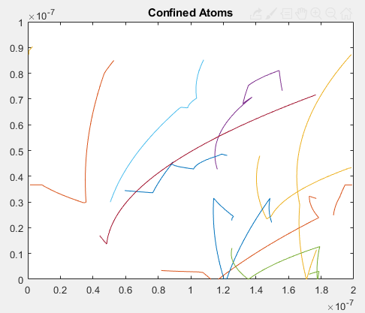

1. The relationship between the electron drift current density and average carrier velocity is linear. We can see this behaviour when we plot the current density in the x and y directions with a potential of 0.8V. We can see that the longer the simulation runs, the larger separation there is between the Jx and Jy. This means the current behaviour will be more and more directional over time until a saturation velocity is reached where the current density will hit an asymptote as seen in Figure 2 below.

The current formula used was written in Matlab as:

%Find Drift Current Density

PDCX = velocityX > 0; %find positive velocities

NDCX = velocityX <= 0;%find negative velocities

driftCurrentX=(mean(velocityX(PDCX))-mean(velocityX(NDCX)))*q*NumElec*(1e-7*2e-7); %Find average drift velocity and convert to current

Jx = driftCurrentX/(1e-7*2e-7); %J=I/A

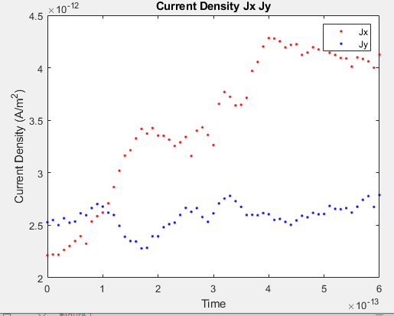

Figure : Current Density in the x and y Directions

1. Generating the electron temperature and density graphs in Figures 3 and 4 respectively for an applied potential of 0.8V in the x direction with 100 particles we observe:

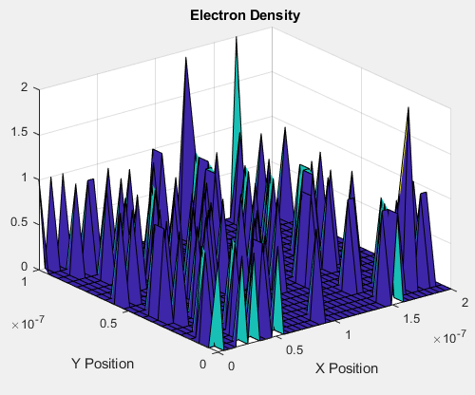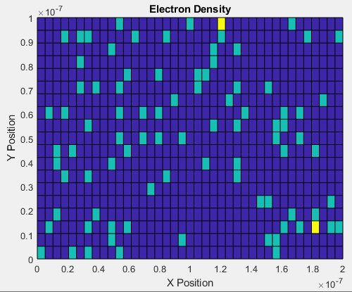

Figure : Electron Density Plot

Figure : Electron Temperature Plot

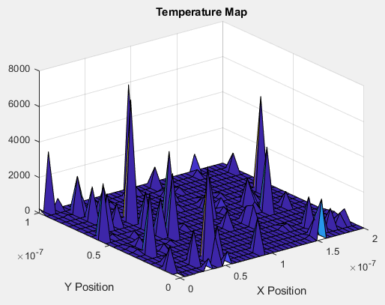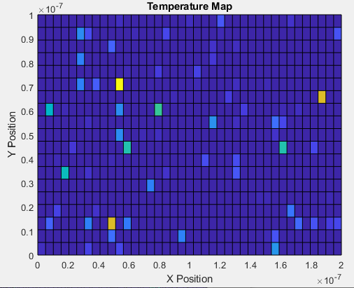

**Question 2**

1. The potential with the bottle neck inserted at an X potential of 0.8V was found to be:

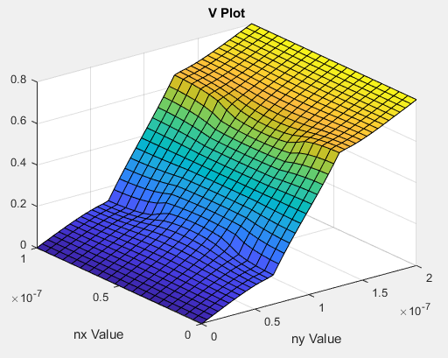

Figure : Surface Plot of V(x,y)

1. The electric field calculated from the potential was found in Matlab and plotted as a 2D vector field as seen in Figure 6.

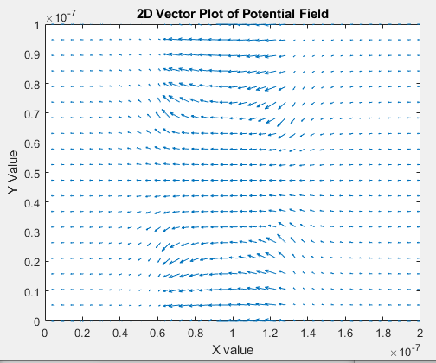

Figure : 2D Vector Plot using quiver()

1. Using the field calculated from the bottle neck in the question above as an input into the Monte-Carlo simulation in part 1, we simulated for 100 time steps with 500 particles to obtain the particle trajectories seen in Figure 7.

Figure : Particle Trajectories Using Bottleneck E-Field

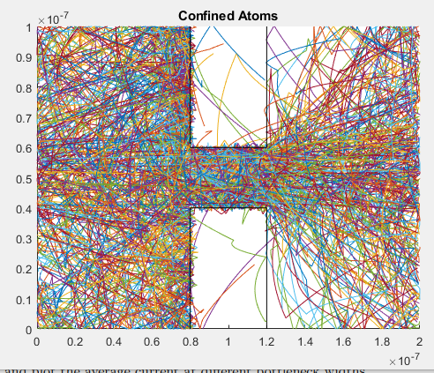

**Question 3**

1. The density map in Figure 8 shows that at the bottleneck acts like a resistor limiting the amount of current that passes through at a point. We can see there are many particles on the left side of the bottleneck because as they pass and accelerate from the left side to the right side, they hit the bottleneck and deflect/scatter until they make it through to the other side. There is then a gaussian distribution on the right side of the bottleneck which is much less dense than the left side that shows us the main path of electrons within 1 std of the opening, while the other electrons have scattered about the main path mostly in line with the E-field.

Plotting the density field from Figure 7 we observe:

Figure : Electron Density of 500 particles over 100 timesteps

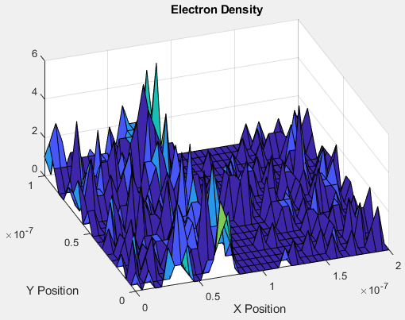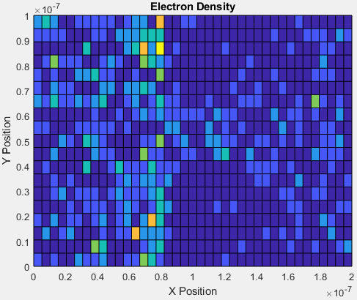

1. Calculating and plotting the average current at different bottleneck widths was done in Matlab over 4 different widths as seen in Figure 9 below.

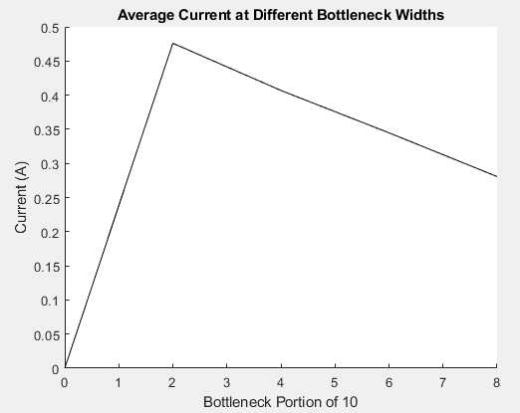

Figure : Average current at different bottleneck widths

1. This simulation was done using the E-field to calculate an electron flow where we find the average current due to forces in the system. To make this simulation more accurate we should track the flow of each individual electron and their energies to find the charges that pass a point at the end of the bottleneck where we know after that point the electrons can flow into a given system.

To make the rest of the simulation more accurate, we could add quantum tunneling effects, photoelectric effects, or even lattice effects, all of which will affect electron positions, electron concentrations, or electron mobility. Adding these effects will give better resolution and insight into the environmental impact on an electrical system under these external conditions.